Intro Raspberry pi

Objectives
- Configure the Raspberry Pi image
- Establish a remote connection with the Pi
- Safely connect Projects Kit to the Pi
- Program the GPIO pins using Python

* Sections with FYI are For Your Information, this is not direct knowledge you need to know/study

Introduction
The Raspberry Pi is a full-fledged PC the size of a credit card, featuring an ARM processor. Various models exist, including Model A, Model B, Model B+, and the Raspberry Pi 2 and 3 Model B. Key differences include connectivity options (26 or 40-pin connector) and the processor. Starting with the Raspberry Pi 2, Windows 10 IoT Core can also be run. Subsequent models, like the Pi 3 and the current Pi 4, offer Bluetooth 4.0 or Bluetooth Low Energy and WiFi. Recently the Pi 5 was released, which is again faster (cpu and ram), has newer Wifi and Bluetooth chips and the ability the interface with PCI devices. The Pi 5 is available with varying amounts of RAM. The Pi Zero, available for $5, is a very compact version that requires additional connectors but could be interesting for advanced prototype stages due to its small size and low power consumption.
The Pi supports various OSes, databases, and web server configurations.
https://www.raspberrypi.org/

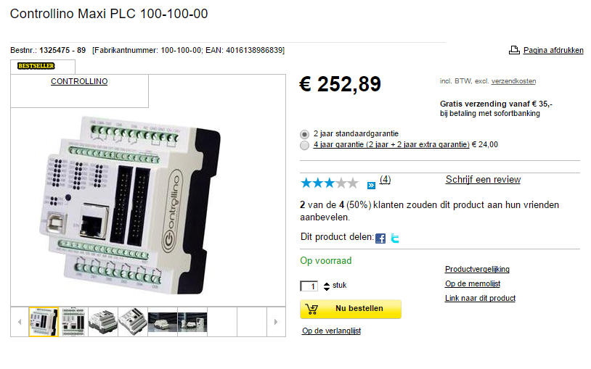
Note:
A rapsberry pi (or other similar hardware) is primarily used for prototyping. For a more reliable solution, a PLC might be preferable due to its robustness and better-protected inputs and outputs.

Image
Just like any regular computer, the Pi needs an operating system. While we can run (a modified version) of Windows on the Pi, we’ll be installing and running an operating system provided by the Raspberry Pi organisation.
For an easy start with the Pi, visit the Raspberry Pi website to install various operating systems. You can easily install various OS including Raspberry Pi OS, Ubuntu, RetroPie, etc., through NOOBS, which has a more complex directory structure and makes configuration more difficult since you can have different OS installed.
However, we prefer to install only Bookworm as OS.

We will write this ourselves on the SD card and adjust it so that we can configure it according to our needs.

Please refer to “Week00_RPi_config.docx” for an in-depth installation manual
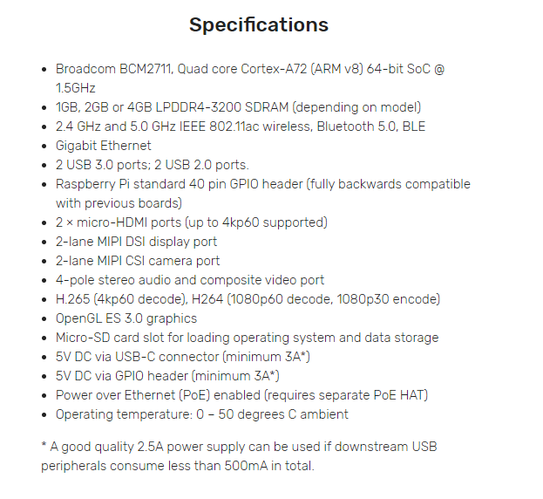

Raspberry pi board
Raspberry Pi Board Notes:
- The Pi lacks a voltage regulator, so only use power sources that provide exactly 5V or a laptop's USB port.
- The GPIO pins allow connection of various sensors and actuators. There are libraries for using these pins in C or Python.
- Beware: GPIO (General Purpose Input Output) pins are fragile!

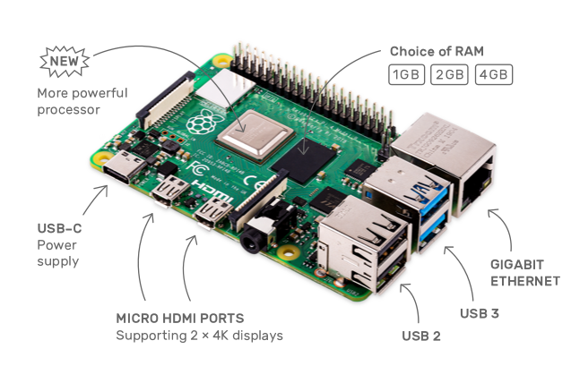

GPIO-connector
General Purpose Input Output pins
These are digital pins (digital = binary = 0 or 1 ; false or true)
So these pins can have 2 states, On or Off
A high/1/On signal means 3.3V
A low/0/Off signal means 0V (= GND)
They can do this in both directions; meaning:
- Input (read a value; e.g. if a battery were to be connected, when you feel nothing the value is 0/low; when you feel tingling the signal is high/1)
- Output (write/put some value on the pin, like turning a battery on or off)

These IO pins are unprotected and directly connected to the Pi. Mistakes could damage the Pi. When connecting buttons and LEDs, always use a resistor in series and switch to 0 Volt or ground. - In this course we will not have to do this ourselves, but fyi

Some rules of thumb:

- When connecting a button and LED: Always use a resistor in series.
- When connecting a button and LED: Always switch to 0 Volts or ground!

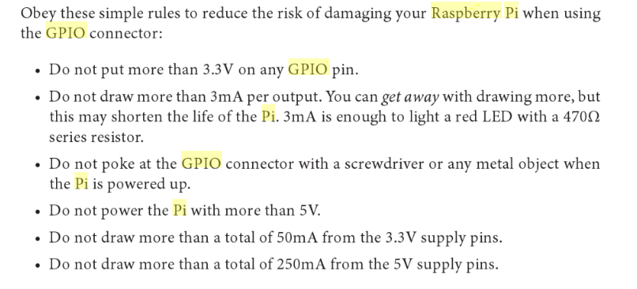
There are different modes for setting the GPIO pins, namely the wiringPi and the BCM GPIO. We will use the BCM GPIO because our extension board is provided with that BCM numbering. Beware: the Pi has power pins of 3.3 Volts and of 5 Volts. So, NEVER use the 5-volt power pin for reading buttons, for example. The Pi has 5V power pins to supply ICs with power.
(ICs = Intergrated Circuits = microchips)

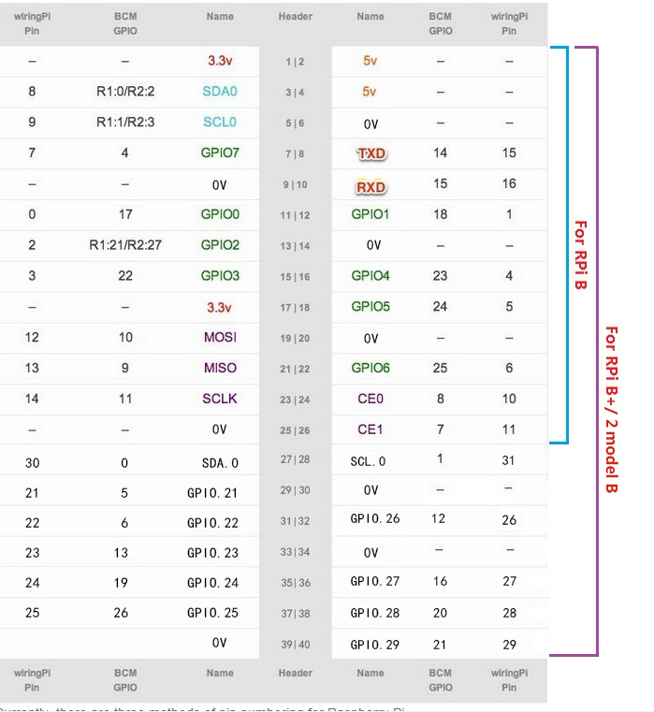

Some pins are special
On the figure below, you get a clear overview of the different pins. Some pins are used to connect buses such as UART, SPI, or I2C. Buttons and LEDs are best connected to the ordinary GPIO pins. These are the pins marked in yellow in the figure below.

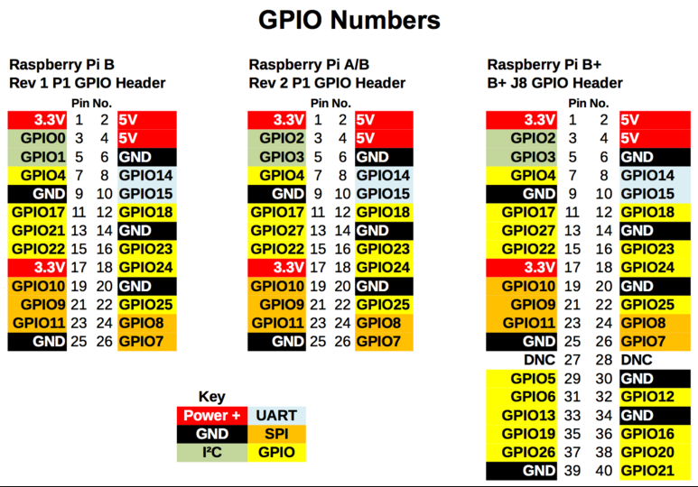

Hardware

FYI: Breadboard
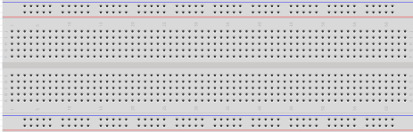
With this board, we can make electronic circuits without needing a soldering iron. It is important to know that all the holes of the red and blue lines are connected to each other. Vertically, 5 holes are always connected to each other.

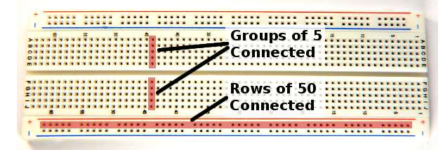
In case of this error, the LED cannot light up.
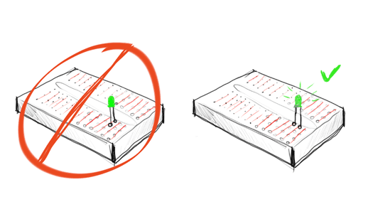
This error (below) means PI RIP. Here, the resistor is parallel to a conductor and is thus actually short-circuited.
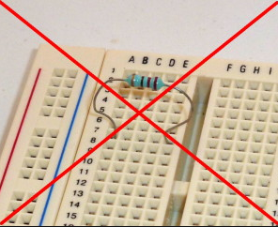

FYI
Why use a 470 Ω resistor? We have a voltage of 3.3V at our output pin. (GPIO) The LED causes a voltage drop of 1.8V and burns optimally at a current of 10mA.
Ohm's law: R = Ur/I
We, therefore, have R = (3.3-1.8)/0.01 = 160 Ohm (minimum resistance value) With a 470 Ω resistor, we thus have a current of about 3 mA. Enough to make the LED burn.
More than 3mA per pin can shorten the lifespan of the PI (see above)

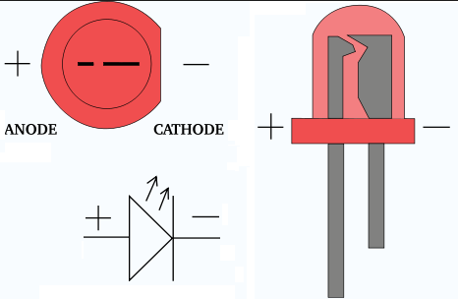

Digital Output
When a pin is configured as an output, it comes in a low impedance (resistance) status and can supply current to an electronic circuit. You can supply both a positive current and receive a negative current. The pin can handle a maximum current of 16mA (not recommended). This is enough to drive a LED, transistor, etc.
For certain components like motors, relays, etc., we need an external power supply.

So a pin can both supply and receive current. We can thus connect an LED in two ways.
I suggest that you only let the pin supply current. This way, you cannot accidentally connect 5V to the pin.
In code: if we set the status of the pin to HIGH, there will be 3.3 V DC voltage on the pin.
The current can flow back to the ground through the LED and the series resistor. If we set the status of the pin to LOW, there is 0 V voltage on the pin, and thus we have no voltage difference.

Beware!!! Short circuits or too high currents can damage the transistors of the Raspberry Pi

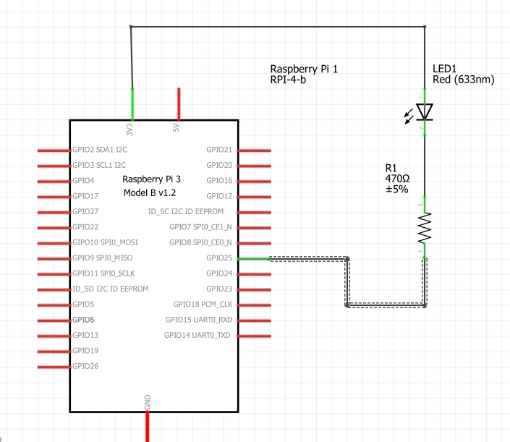
Supplying current => more error prone receiving current => safer
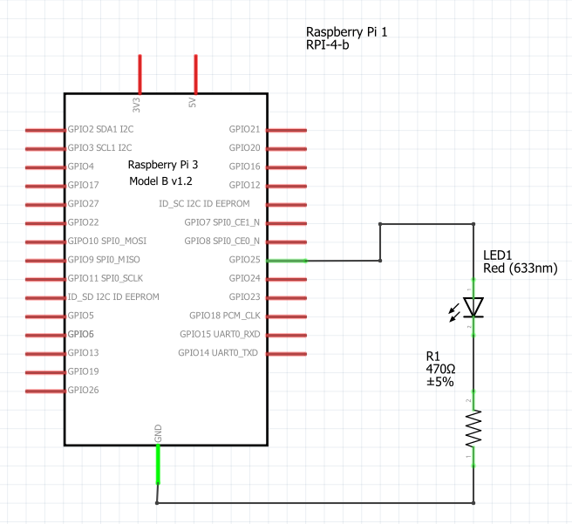

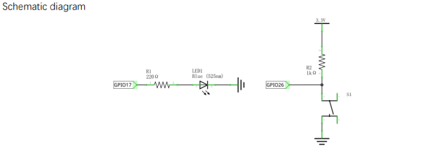

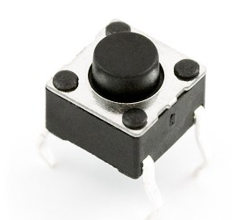
FYI: Tactile push button

Digital Pins
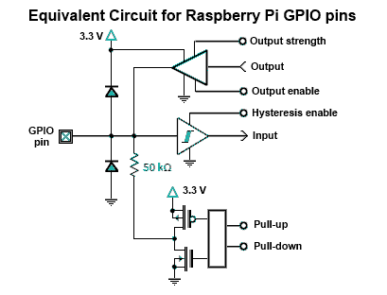
Each digital pin can be configured as an input or output. By default, the pins are set as inputs with a high impedance. A good practice is to configure every pin you use.

Digital Input
A digital input requires only a very small current equivalent to a 50KΩ resistor. Therefore, we can connect a button directly to an input without using an extra resistor. The inputs are also very sensitive; a small current can already be detected.
If we do not connect anything to such an input, it is very sensitive to interference.
However, there are 50K pull-up resistors built into the chip. We can set them using the software with the setup function.
For example, if we connect a button to a pull-up input, we must connect the other end of the button to the ground. If the button is open, we will read a HIGH at the input. If we press the button, we have a current circuit from our pull-up input (+3.3V) to the ground, and we will read a LOW.
I suggest using only pull-up inputs so you cannot accidentally connect 5V, and your pin (or Pi) does not break.

FIY: Extension board
You should place it on the breadboard in the following manner. This way, the red line of positive voltages is at the top. The extension board does nothing more than connect the Pi's connector with the breadboard. It is very handy that the names of the pins are mentioned on the extension board. Make sure you connect the connector on the correct side. The arrow point of the connector must be connected to pin one on the Pi. Pin 1 of the Pi can be recognized by the square soldering at the bottom of the Pi.
Beware: the connector is not foolproof on the Pi side.

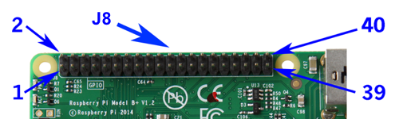
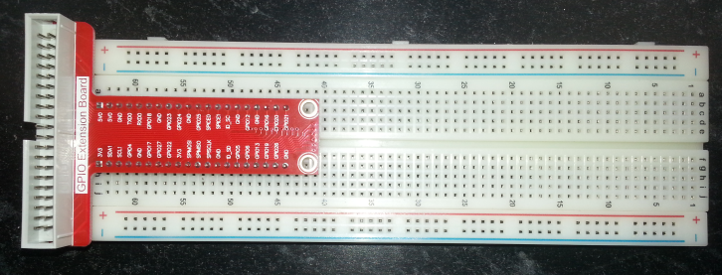

Python
Python is a scripting language and is therefore somewhat slower than C (+/- 100x). On the Pi, Python is usually used; if speed is really an issue, you can solve the problem in C.
We will, of course, start with the mandatory "Hello world."
Python is installed by default in Bullseye.
`$ cd /` shows us the root of the system.
In the directory `/usr/local/lib`, you can find the Python libraries. Python 3.11 is installed by default. Using the command `whereis`, you can easily find the location of files.
For example, `whereis python`.

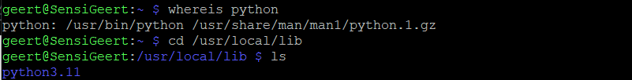

Freenove Projects Kit for Raspberry Pi

https://store.freenove.com/products/fnk0054
Docs: https://docs.freenove.com/projects/fnk0054/en/latest/

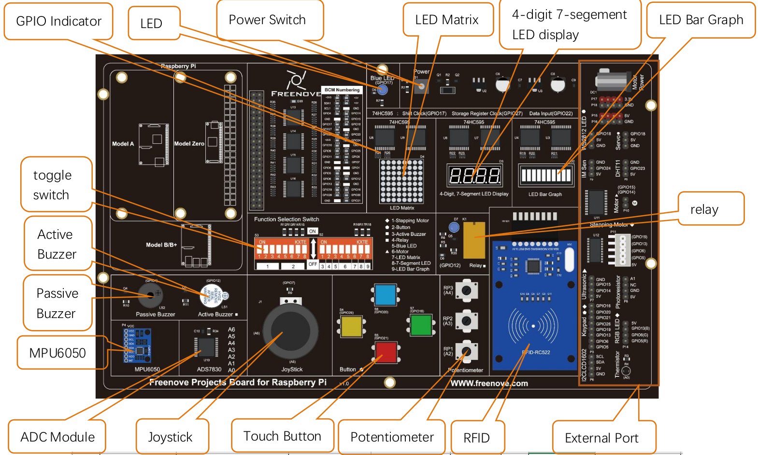
We’ve selected this kit so no real electrical knowledge is needed. (At least in the beginning)
Most of the sensors/actuators on this board are plug and play (or plug and code)

We can install our flex cable between the pi and our board. If you want you can secure your Pi to the board and install the bottom plate to avoid shorting something out:
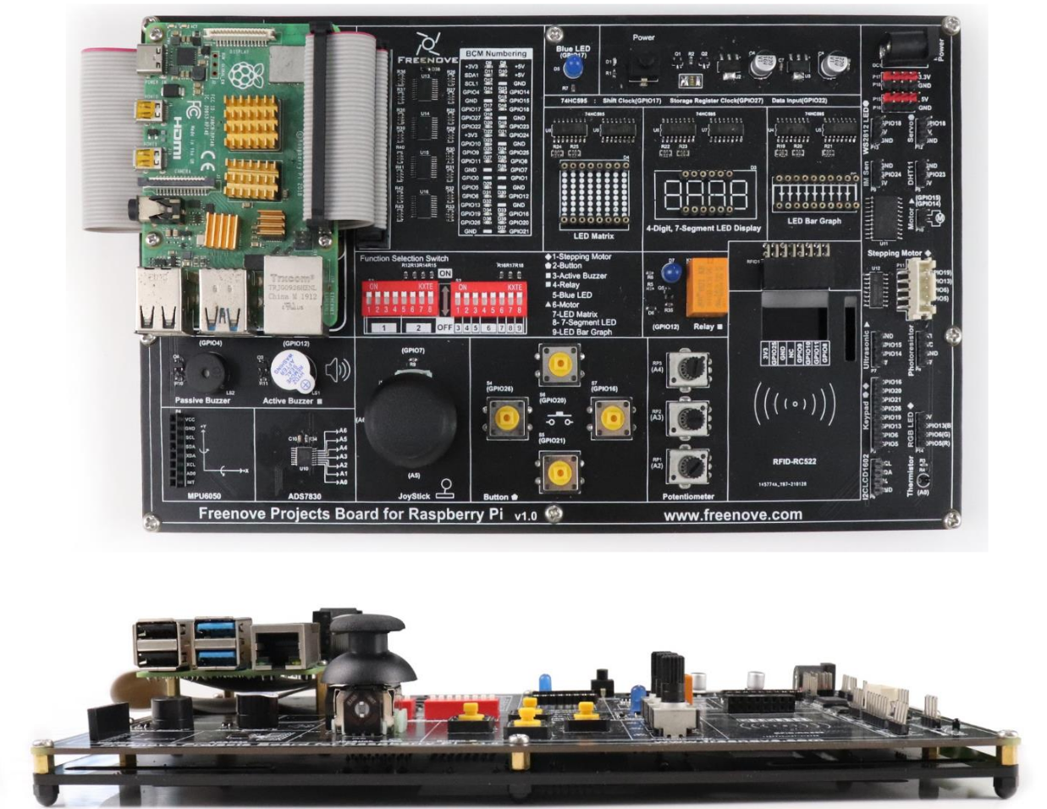

Action sells a tech case which is almost made for our board + RPi: https://www.action.com/nl-be/p/3011812/lab31-opbergcase/ (is optional)



Demo: ”hello world” with hardware (led and button)
Use the button on GPIO20 and the led on GPIO17 (look at the board, GPIO is labeled for each hardware part)
When the button is pressed, the LED lights up

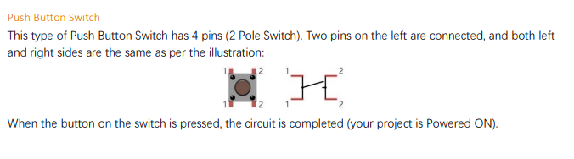


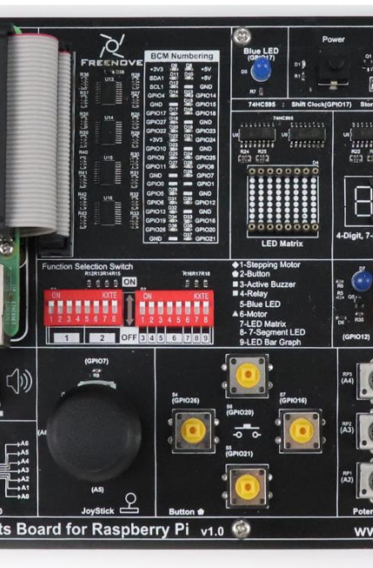

We will have to enable the functionality of the buttons and the led with the dip-switches (Marked in yellow above)
In that picture, all the swicthes are in the ‘on’ position, which I wouldn’t recommend, even tough this could work. Make sure you only turn on the switches for the components you need)
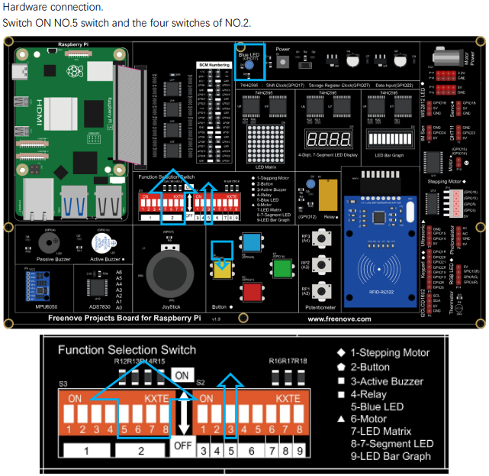

Prepare/write SD card and configuring the RPi
Use the document: “Week00_RPi_config.docx” to write the image and make the initial settings.

Next check or make sure you do the following things:
- Make sure you have a valid unique hostname. Make sure you do not use spaces in the name!
- Create a folder "sandi" in your home folder
- Install the VNC viewer on your laptop. (https://www.realvnc.com/en/connect/download/viewer/)

Thonny IDE
Open Thonny IDE, and save your file in ~/sandi/week01/demo.py
(So create a folder sandi in your home folder, en then we’ll create a new folder for each week)
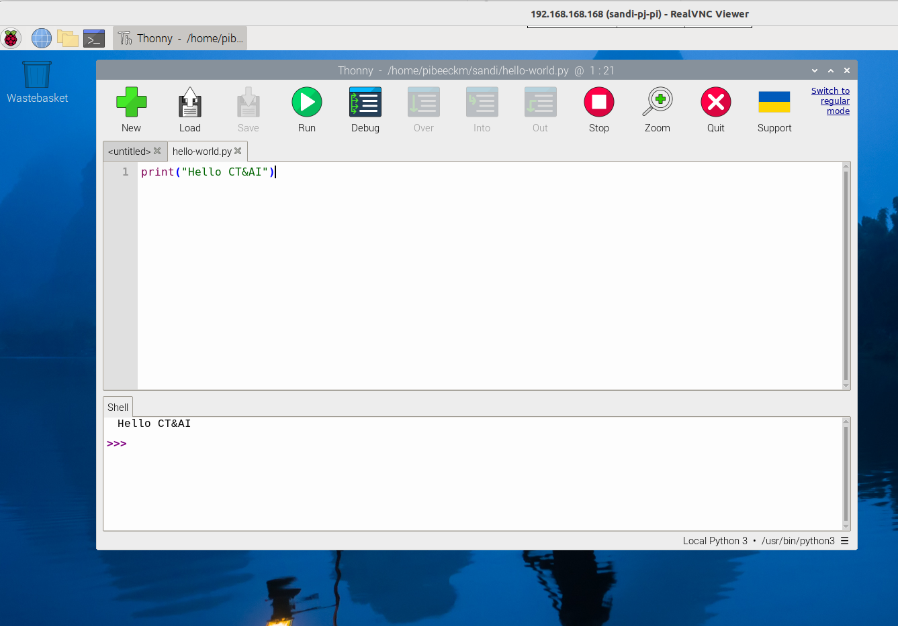

Beware if you put an "infinite" loop in your code, then you must stop the code in Thonny first and then you can run the new code!

The RPi.GPIO-library
How can we “work” with the RPi pins? Using python and a library!
This library is installed by default on the raspberry pi

Setup
To use the GPIO pins, you must first (copy and) import the RPi.GPIO library:

from RPi import GPIO

Then you must choose which pin numbering you want to use (always mandatory!!!)

GPIO.setmode(GPIO.BCM)

Here we must first configure the pin using the function GPIO.setup(channel, mode). The parameter channel indicates the pin, which can be either a single pin number or a list. Mode is a predefined constant: GPIO.IN or GPIO.OUT. For example:

GPIO.setup(9, GPIO.IN)
GPIO.setup((10, 11, 12), GPIO.OUT)

To configure a pull-up/down resistor, setup has a parameter pull_up_down. The value thereof must be one of the constants PUD_UP or PUD_DOWN that the GPIO module defines (or None for neither).

GPIO.setup(7, GPIO.IN, pull_up_down=GPIO.PUD_UP)

Setting and Reading Pins
It is, of course, neater to store the pin number in a variable. Then you can read the pins with input(channel) or set them with output(channel, value):

btn = 9
GPIO.setup(btn, GPIO.IN, pull_up_down=GPIO.PUD_UP)
value = GPIO.input(btn)

print('The value of pin {0} is {1}'.format(btn, value))

led = 10
GPIO.setup(led, GPIO.OUT)
GPIO.output(led, GPIO.HIGH)

Instead of GPIO.HIGH and GPIO.LOW, you can also just give a boolean or int (1/0) as the output value. Note that you can also use the input() function on an output pin to read the current value:

value = GPIO.input(led)
GPIO.output(led, not value)

Cleanup
After use, you must clean up the GPIO library. You do this with the function cleanup(pin) either for a single pin if you want to give it another function:

GPIO.cleanup(led)

And at the end of your program, you just clean everything up at once:

GPIO.cleanup()

Beware: sometimes the cleanup can turn things off at the end, causing some sensors and outputs to "change weirdly"

Python
You can simply start Python in the command line and execute lines of code.
To light up an LED, the following would be possible:
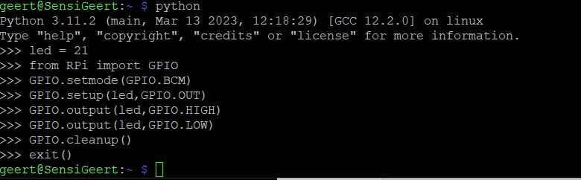(if the RPi folder is present)

Exception Handling
It can, of course, happen that your program encounters an error and stops. In that case, the cleanup function is never called, and you get a warning the next time you test your script. We must ensure that our cleanup is called at the end. From Basic Programming, you learned how to catch errors (exception handling):

try:
... # dangerous things
except ... as e:
... # handle error
finally:
... # make sure everything is cleaned up

In the finally clause, we must call GPIO.cleanup(). Moreover, you should know that the key combination <Ctrl+C> to stop the script is converted by Python into an Exception, namely KeyboardInterrupt. We can safely ignore this, which we indicate by the keyword pass. If you press the stop button in PyCharm, it also just sends a Ctrl+C. This brings us to the following pattern that we will use in all scripts.

GPIO.setmode(GPIO.BCM)
try:
# do your thing
except KeyboardInterrupt:
pass # just ignore keyboard interrupt; other errors will still throw
finally:
GPIO.cleanup() # Release the GPIO pins

REMEMBER


So btn NOT pressed gives

Solution for classroom demo

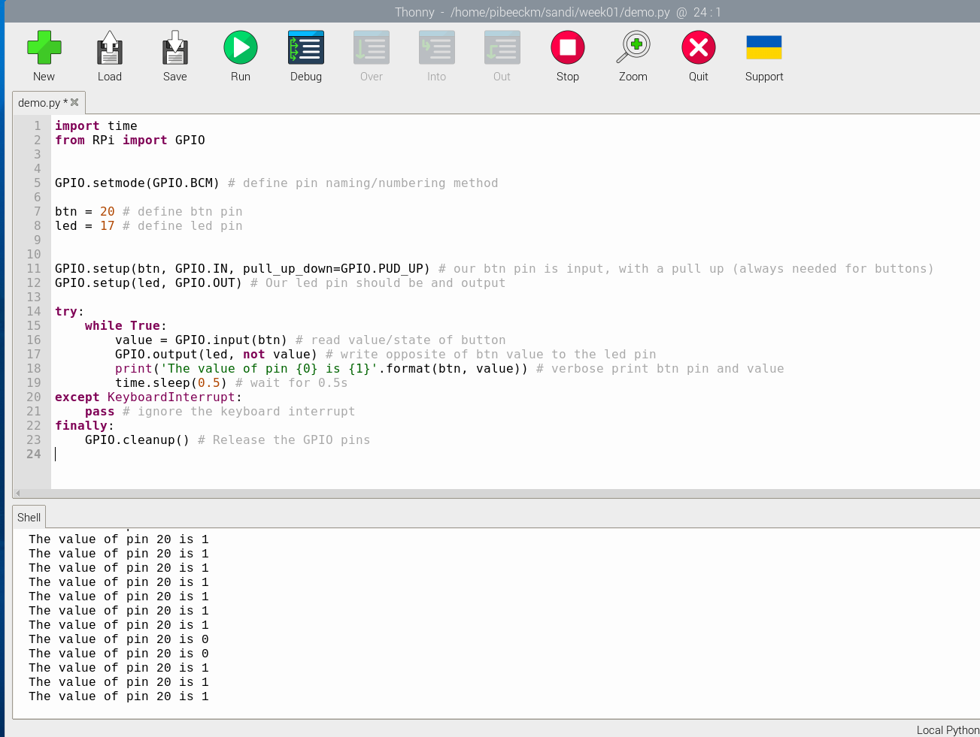

The method GPIO.cleanup() ensures that all GPIO pins are reset as a digital input. The try-catch block ensures that we turn off the LEDs when we close the program with a "ctrl + C".

Assignments

TOGGLE
Transform the example into a toggle system.

Use the button connected to GPIO20 as a toggle switch for the led on GPIO17
Toggling means 1 press : turn on ; stay on until the next press; turn off; stay off until next press ; ...

Multi button

Use the 4 buttons connected to GPIO20, GPIO21, GPIO16 and GPIO26.
When pressed on the bottom button: turn the led off
When pressed on the upper button: turn led on (steady)
When pressed on the left button: blink led slow
When pressed on the right button: blink led fast
> until another action is made; or the program is stopped

