Toggle, Edge detection and data logging

Goals
- Practice basic programming structures
- Read input from buttons
- Control outputs
- Understand what contact bounce is
- Know how to implement edge detection
- Write data to the filesystem
- Create / use python virtual environment
- Plot data

Introduction
Last week we started writing our first Python programs. This week, we'll build on that and aim to control an LED using a push button. Pressing the button once should turn the LED on and pressing it again should turn it off. While this task may seem straightforward at first glance, there are a few key factors we need to consider. We will also collect some data from this and write this to our filesystem. Some of the things we'll need to use to complete these tasks are control structures and comparison operators.

Backup (before / during break)
Let’s all make a backup during the break, see Week00_RPi_config.docx on leho

Recap: Control Structures
This lesson assumes you've learned about Python control structures in the "Basic Programming" module. Even so, we'll begin with a quick review to make sure everyone feels comfortable with the concepts.

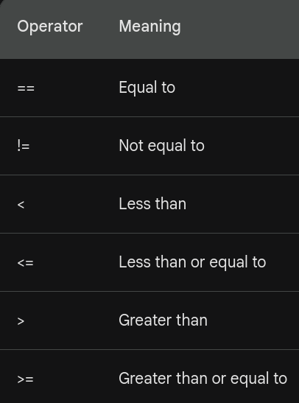

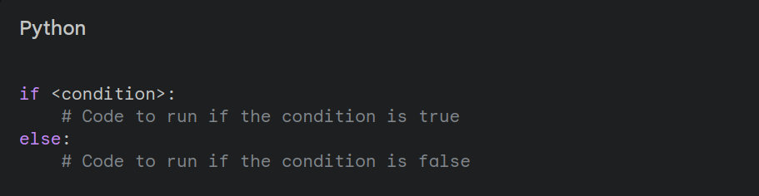

Recap: Digital Input
Digital input pins on the Raspberry Pi detect small amounts of current. If we leave a pin unconnected, they can be sensitive to electrical noise. We often connect inputs to the ground with a pull-down resistor, or to the positive voltage with a pull-up resistor.

Luckily, the Raspberry Pi has internal pull-up resistors we can use with software.
Using internal pull-ups means a button connected to the pin should also be connected to ground. Pressing the button will read as LOW

GPIO.setup(26, GPIO.IN) # no pullup
GPIO.setup(20, GPIO.IN, pull_up_down=GPIO.PUD_UP) # pullup

Understanding Internal Pull-ups
Pull-up resistors create a default HIGH state: When the button is not pressed, the input pin is connected to the positive voltage through the internal resistor - we'll read a HIGH value.
Button press connects to ground: When you press the button, it creates a direct path from the input pin to ground, overriding the pull-up resistor. This results in a LOW reading.
Why this is safer
This method is considered safer for a few reasons:
- Short-circuit protection: If you accidentally connected your button directly to the positive voltage without a resistor, pressing the button would create a direct short circuit, potentially damaging your Raspberry Pi. With the pull-up and button connected to ground, this scenario is much less risky.
- Predictable inactive state: An unconnected digital input can be influenced by electrical noise, leading to unpredictable readings. The pull-up resistor ensures the default state of the pin is a stable HIGH.

Safely shut down Raspberry Pi in 3 ways:

- VNC > raspberry icon (top left) > shutdown > shutdown
or shutdown > reboot
- Via terminal (ssh/vnc) : sudo poweroff
or sudo reboot
- Press twice on the power button (next to led LED)

!!! Just removing power can cause corruption on your micro-SD card

Recap: Lab 1

You should now be able to connect via ssh to your Raspberry Pi and via VNC.
> If not, check out the videos on Leho
Ideally (hopefully 🙏) you also succeeded in running the demo code from the course document
> And you also tested if it works by pressing the button and seeing the led light up?

The assignment was to turn this hold-down button into a real on/off switch, a toggle button. You might have noticed this isn’t as easy (to make a good toggle button) as it sounds. (If you haven’t, you will soon)

Any problems anywhere?

If you don’t have any issues, but other students do, try implementing the toggle button or the challenge assignment from last week while we are busy or go to the next part and try to follow along with the video (with headphones)

VSCode with Remote SSH

Last week we used Thonny IDE via VNC. This is a good starting point, but we can drive up our productivity by using a tool like VSCode for programming.
By using the VSCode extension “Remote SSH”, we can connect via the SSH tunnel (like in the terminal) and use VSCode in our laptop while controlling/running on the RPi. So, opening or saving a file/folder will do this on the micro-SD card. The terminal is also running on the Pi, just as if we ssh’d ourselves like last week.
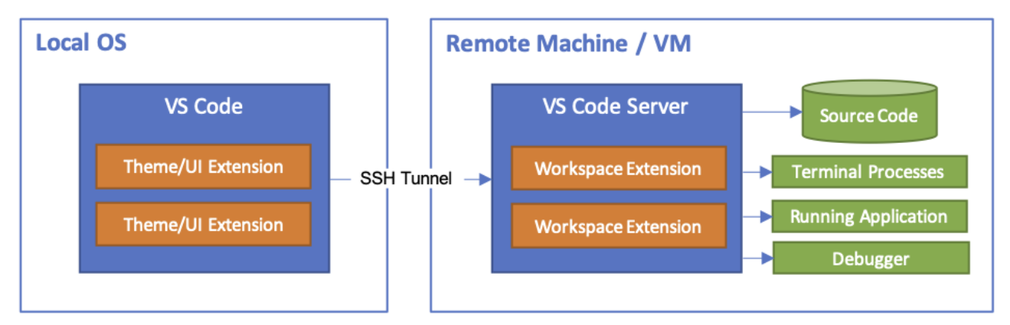
See the video VSCODE_REMOTE_SSH in week00 on Leho if you have problems, otherwise follow along in the lab. If you have connection problems, see ERROR_VIDEO on Leho to clear your known_hosts

Don’t forget to select an interpreter (bottom right), you can select /usr/bin/python
(If you don’t see this button, also install the python VSCode extension)
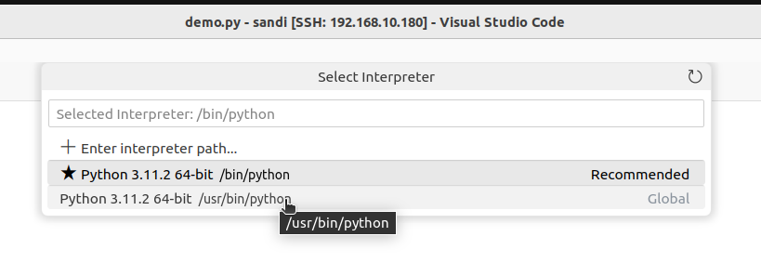
If you press ‘Debug Python file’ (top right, arrow next to play button), you’ll get more graphical controls for stopping and restarting your code

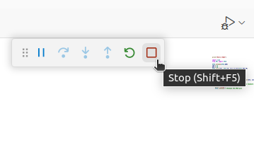
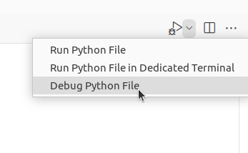

Password-less login

When connecting to the RPi we have to provide our password every time. We can also use a private/public key pair to cryptographically verify our identity, and login without needing to input the password.

See the video MAC_PASSWORDLESS_SSH or WIN_PASSWORDLESS_SSH in week00 on Leho if you have problems, otherwise follow along in the lab.
The steps are outlined below (and also in a document in week00):

- Generate a public/private key pair
Run ssh-keygen -t rsa -b 4096 in terminal
- Keep the default location
(~/.ssh/id_rsa on Mac or $HOME/.ssh/id_rsa on Win)
- Passphrase can be left empty, otherwise this password will need to be entered everytime we use the private key

!! Make sure the RPi has a folder ~/.ssh
Ssh into the RPi and run “mkdir ~/.ssh" to make sure the .ssh folder exists in the pi's home folder

Check if new files are created and copy to RPi
First check the contents of ~/.ssh by running the following command:
ls ~/.ssh (Mac) or dir $HOME/.ssh (Win)
Aside from one or more known_hosts files, you should see the id_rsa and id_rsa.pub files
These are respectively the private and public (.pub) key files.
Next we will transfer the public key to the authorized_keys file on the RPi with this command:

Mac
ssh-copy-id -i ~/.ssh/id_rsa.pub pibeeckm@192.168.168.168
(Remember to change pibeeckm for your username; maybe id_rsa.pub also needs to be id_ed25519.pub)

Windows (POWERSHELL!!)
type "$HOME/.ssh/id_rsa.pub" | ssh user@192.168.168.168 "cat >> .ssh/authorized_keys"
(Remember to change pibeeckm for your username)

VSCode Remote SSH
Now you should be able to ssh into your Raspberry Pi without password.

Optional (not needed if you followed the steps above)
If you've opted to not use id_rsa / your default ssh key in the first step, you will need to provide the private key in the connection settings
'Open SSH Config file' in VSCode, select the one you used when adding the connection (normally the one in .ssh)
You'll see an entry like this:
Host 192.168.168.168
HostName 192.168.168.168
User pibeeckm
We'll also add a reference to the private key file to use when connecting:
Host 192.168.168.168
HostName 192.168.168.168
IdentityFile ~/.ssh/custom_rsa
User pibeeckm
Now we can also connect to our RPi via VSCode without entering a password

Toggle
The issues you might run into:
- Push down gets registered more than once
- Short/fast push isn’t registered at all
- Led doesn’t stay on
- While holding the button the led toggles on/off
- ... (things I can’t imagine at the moment, but surely possible)

We are going to go step by step and encounter these problems, as well as fix them

Let’s implement this, from scratch.?

import time
from RPi import GPIO

GPIO.setmode(GPIO.BCM)
led = 17
btn = 20
GPIO.setup(btn, GPIO.IN, pull_up_down=GPIO.PUD_UP)
GPIO.setup(led, GPIO.OUT)
try:
# do your thing

while True:
value = GPIO.input(btn)
GPIO.output(led, not value)
print('The value of pin {0} is {1}'.format(btn, value))
time.sleep(0.5)
except KeyboardInterrupt:
print("ctrl + c pressed")
finally:
print("cleanup")
GPIO.cleanup() # Release the GPIO pins

- What value has GPIO.input(btn) when the button is pressed?
> “value” is a confusing variable name, let’s use btn_state instead
- Do the toggle ONLY when the button is pressed
- How to know to turn the led on or off?
> read the led_state with GPIO.input(led_pin)
> keep track in variable (I prefer this method)

Let's also count the number of presses

...
n_presses = 0
led_state = 0 # turn led off by default
GPIO.output(led_pin, led_state)
while True:
Btn_state = GPIO.input(btn)
if btn_state == ... :
led_state = not led_state
GPIO.output(led_pin, led_state)
print('Button is pressed, led is now {}'.format(state))
n_presses = n_presses + 1
print('Pressed {} times'.format(n_presses))
time.sleep(0.5)
...

> short presses are not registered (because of the 0.5s delay)
> remove the delay

Contact Bounce
What is Contact Bounce?

- The Bouncy Problem: When you press a physical button, it seems like a single clean action. However, the metal contacts inside the button don't connect perfectly the first time. They bounce against each other for a few milliseconds before settling into a closed state.
- Electrical Chatter: These rapid bounces create very quick on-off-on-off electrical signals, instead of a single clean transition from off to on.
- Impact on Electronics: If your code is reading the button input without any handling, it might register these bounces as multiple button presses instead of one.
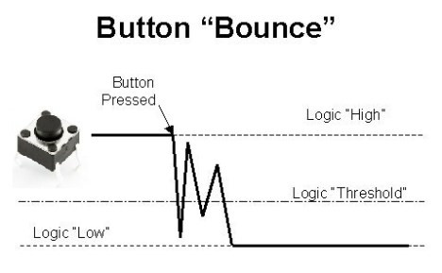
How to Handle Contact Bounce

There are two main ways to handle contact bounce:

- Software Debouncing:
Introduce a short delay (e.g., 20-50 milliseconds) after a button press is detected.
Within that delay, ignore any further changes in the button signal.
After the delay, check the signal again to determine the true, settled state of the button.
- Hardware Debouncing:
Add a small capacitor across the button's connections. This capacitor smooths out the bouncing signal, creating a cleaner transition for your electronics to read.

> add small delay 20-50 milliseconds (maybe 100 – 200)
What do we notice? If we hold the btn down longer then the delay, it gets registered as another press. This is not how this should work
Let’s take a closer look at what happens (DISCO)

What we need is edge detection

Edge detection is a fundamental technique in computer vision and related applications. In the context of buttons, it means detecting the precise moment when a button is pressed or released. This is more accurate than simply checking if a button's input pin is high or low. Why?
- Bouncing: Mechanical buttons don't make clean contact when pressed. They can "bounce" for a few milliseconds, causing multiple quick transitions between high and low. This can be mistaken for multiple button presses.
- Accurate Timing: Edge detection gives you the exact moment of the button press or release, important for time-sensitive applications.
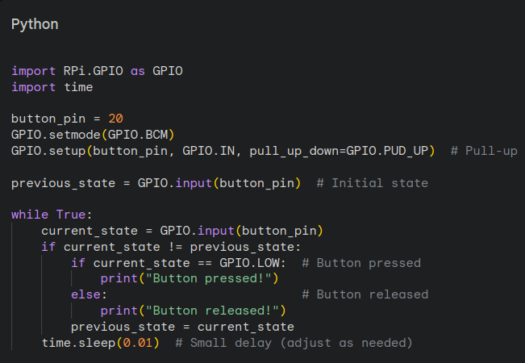

We can have a falling edge (going from HIGH to LOW) or a rising edge (going from LOW to HIGH)

Exercises (maybe hand in #2 (depending on time))
- Complete the basic toggle demo
> use a small delay to get rid of contact bounce
> use edge detection for clean results
- Use 3 leds. Our board only has 1 (or 2) real leds, but we can just use any GPIO pin and look at the header/pins on our board.
Use pins 9, 10 and 11 for the 3 leds, also use 2 buttons (Remove the RFID module in case you had already connected this)
By pressing the first button a first time, we turn on led1, the second press turn off led1 and turn on led2, third press turn off led2 and led3 on, fourth press led3 (all leds) off
Next repeat that cycle
While holding down button2 we toggle (turn on/off) all leds simultanious. When we release this button, all leds turn off (and button1 still toggles between the leds)
- Make a traffic light
> GPIO9 = green light; GPIO10 is orange/yellow light; GPIO11 is green light
(Remove the RFID module in case you had already connected this)
Loop through all the lights in 10 seconds (5s green, 1s yellow, 4s red)
- Traffic light with pedestrian button
Based on the previous assignment, add a button which will make the traffic light (if it’s green for the cars) go to yellow and red so pedestrians can cross the street

Storing the data
We can already read sensor data and display it in real time, but when gathering data, it’s nice to be able to use the data afterwards. (Like using it as training data)
To do this, we can keep track of our data points, and write these to a csv file (in real time, or when exiting the program)
In program loop:
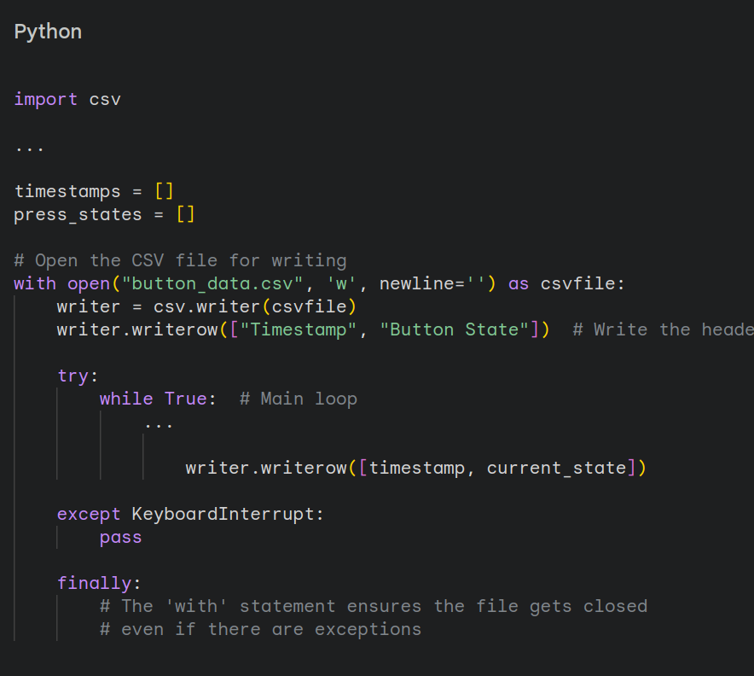
On program exit:
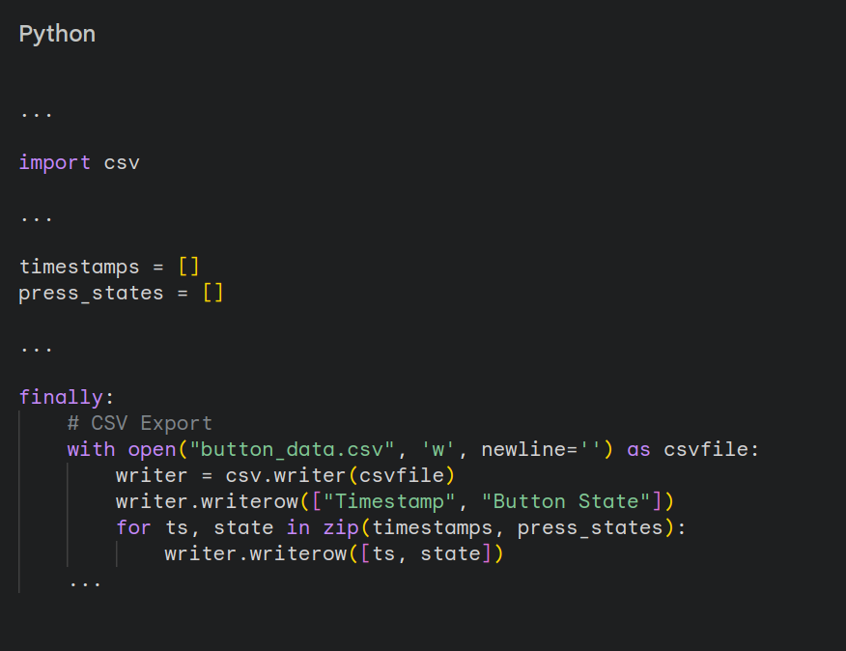

When running the above code, we will overwrite our button_data.csv file every time we restart our program.
We can fix this by adding a unique part to each filename, e.g. the current date and time.
We can do this with the time library

Working with time
We already used time.sleep(), now we will use time.strftime() (string from time)
The time.strftime() function converts a datetime object into a formatted string according to a user-specified format. This is essential for making raw time data human readable.
If no datetime object is supplied (as second argument) the current time will be formatted
The first argument is a string which consists of directives (special codes starting with %) that tell strftime() how to arrange elements of the time, see https://strftime.org/
Common Directives:
- %Y - Year with century (e.g., 2024)
- %m - Month (01-12)
- %d - Day of the month (01-31)
- %H - Hour (24-hour clock)
- %M - Minute
- %S - Second
- %A - Weekday name (full)
- %a - Weekday name (abbreviated)
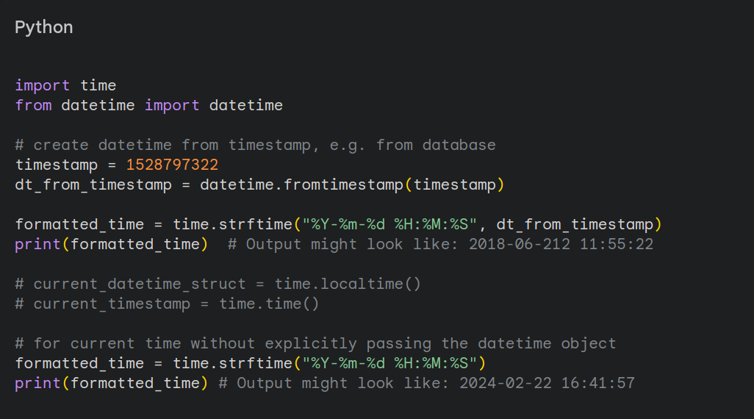
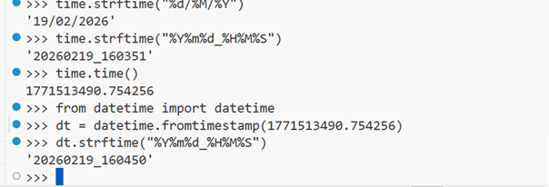
In the code above you can see multiple mentions of timestamp. A timestamp is a representation of time by counting the number of seconds (or milliseconds on some systems/languages) since January 1st, 1970, at 00:00:00 UTC (time.time())
This is used a lot when storing data, because it is a uniform format not changing by geographical location and is easily sortable.
We can also use this value to count the time that has elapsed. If we keep track of the value at the start of our program and subtract this from the current value in the loop, we get the number of seconds that have passed since the program started. (Or since you assigned your subtract timestamp)

https://epochconverter.com

Demo (lab)
Let’s make a program that tracks the state of 1 (or more?) buttons
Whenever the state changes (so when an edge is detected) store that timestamp, which button and the state.
You can either write it to a csv every state change, but it’s more efficient to store the data in memory instead of writing (sometimes) multiple times per second.
The csv file will be stored in a data directory, and each filename will be of format YYYYMMDD_HHMMSS_button_states.csv where YYYYMMDD_HHMMSS will have the correct year, month, day, hours, minutes and seconds

EXTRA
We can also plot this using matplotlib and we’ll need to install this library.

Before we do that, we’ll first create a new python virtual environment.
We do have to enable system packages for our RPi library to keep working.

python -m venv .venv --system-site-packages

To activate this environment:

- Linux/macOS:
source .venv/bin/activate
- Windows (Command Prompt):
.venv\Scripts\activate
- Windows (PowerShell):
.venv\Scripts\Activate.ps1

Also make sure (if this hasn’t happened automatically) to select to new python interpreter within the .venv/bin folder (bottom right of VSCode)
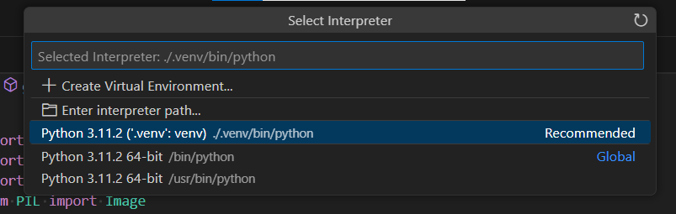

Next, we can install the library with the command:

pip install matplotlib

Or we can install this via apt; system wide
sudo apt update
sudo apt install matplotlib

Here is some example code on how to plot a list of timestamps and button states:

import matplotlib.pyplot as plt
import matplotlib.dates as mdates
# ...
fig, ax = plt.subplots(figsize=(8, 4))
ax.plot(times, states, marker='o', linestyle='-', color='b', label="State")
ax.xaxis.set_major_formatter(mdates.DateFormatter('%H:%M:%S'))
fig.autofmt_xdate()
ax.set_xlabel("Time")
ax.set_ylabel("Button Stat")
ax.set_title("Realtime Button State")
ax.legend()
plt.tight_layout()
plt.savefig("button_timing.png") # Can also do .pdf
plt.close() # Clear figure/memory

Correct datetime format for Matplotlib times list is: datetime.now()

See docs on: https://matplotlib.org/stable/users/explain/quick_start.html
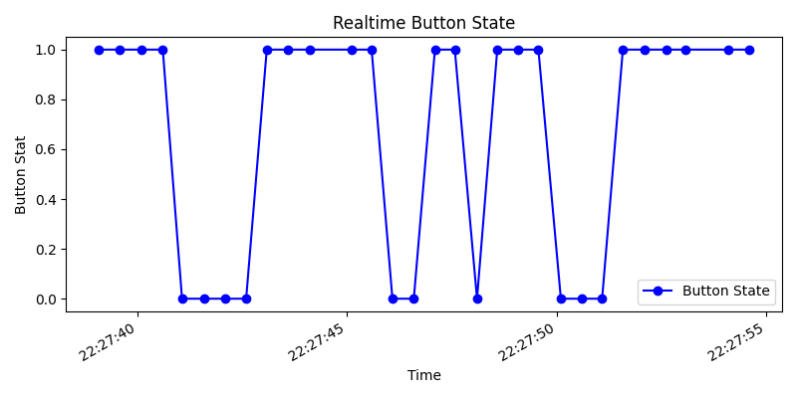

Assignment (homework)

Create a python script which will measure how long a button is pressed for
Save this data in a csv file called "btn_timings.csv" in the data folder
The csv file contains a header row, and each data row has a human readable timestamp in the format of "YYYY-MM-DD HH:MM:SS" and the duration in seconds
If you can plot this data nicely, that would be a nice addition too

Extra/challenge: When stopping and restarting your code, if the csv file already exists append the data (not an extra header row too!) instead of rewriting the file

Extra (2): Grad.io
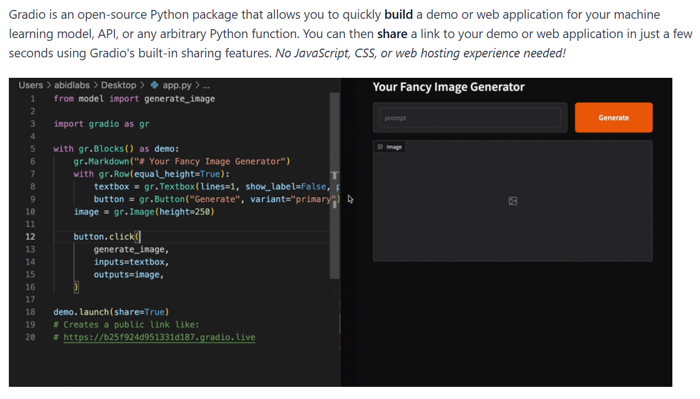See: https://www.gradio.app/guides/quickstart

pip install gradio

And I’ll provide some example code:

SEE LEHO

See: https://www.gradio.app/docs/gradio/introduction

First complete the code for all readings to be recorded and plotted (and displayed on the webpage)
Next update the code so only “edge events” are recorded and displayed
