Bitwise operations & events

Objectives
- Logical operators
- Learning to work with bits and bytes
- Interrupts & Event

Bits & bytes
You probably already know that a byte consists of 8 bits. Bit operations apply to numbers of arbitrary length, but for convenience, we will refer to them as bytes here. The bits in a byte have values (from right to left) as consecutive powers of 2:
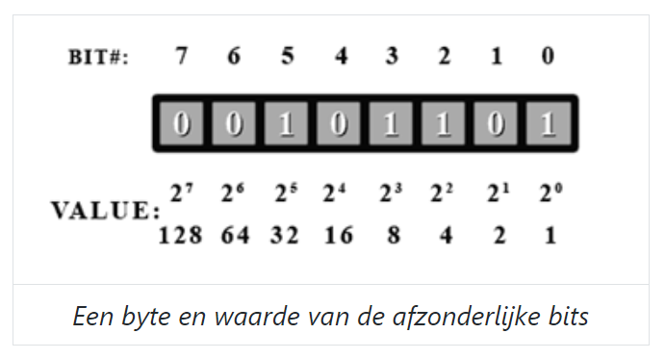
Bits are always numbered starting from 0 and from right to left, which corresponds to the numbering of powers of 2. Bit 0 is the least significant bit (LSB) and is located all the way to the right, while the leftmost bit is the most significant bit (MSB) and has the highest value. This is no different from decimal numbers.
Just like with decimal numbers, you can omit leading zeros (zeros on the left-hand side). For clarity, I will include them here to have complete bytes, but Python does not bother with them, and most code snippets are direct output from the Python REPL (recognizable by the >>>).
When working with bits and bytes, decimal notation is usually not very intuitive, but binary notation is quite cumbersome. A nice compromise is hexadecimal notation, as a byte neatly consists of exactly 2 digits (each 4 bits, also called a nibble).
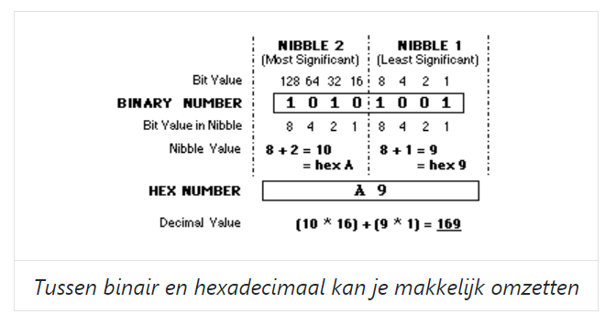
You can easily go from Hex <> bin
Note: In the byte 0xff, all bits are 1; in 0x80, only the MSB is set; in 0x88, the MSB of each nibble is set. In 0xfe, only the LSB is 0, and in 0x7f, only the MSB is set, and so on.

Python
You can use `bin()` and `hex()` to convert a number to a binary/hex string, and `int()` to read such a string:
(start Python by typing `python` in the terminal)

>>> bin(0xcafe)
'0b1100101011111110'
>>> hex(48879)
'0xbeef'
>>> int(0xbabe)
47806
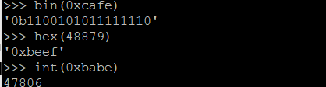
When using `format()` to replace variables in a string, you can specify the desired format after a colon (`:`):

>>> print("Decimaal = {i:d}, hexadecimaal = {i:x} en binair = {i:b}".format(i=199))
Decimaal = 199, hexadecimaal = c7 en binair = 11000111

Bitwise operators

Boolean vs. bitwise operators
You should already be familiar with the logical or boolean operators AND, OR, NOT, and XOR. For the sake of completeness, let's repeat the truth table for all of them:

X | Y | X and Y | X or Y | not X | not Y | X xor Y
0 | 0 | 0 | 0 | 1 | 1 | 0
0 | 1 | 0 | 1 | 1 | 0 | 1
1 | 0 | 0 | 1 | 0 | 1 | 1
1 | 1 | 1 | 1 | 0 | 0 | 0

In Python, these operators are written in words (and, or, not), in C and derivatives as &&, ||, and ! (XOR is a bit different here, as XOR on booleans is essentially a check if both values are different). You can use them on two booleans, for example, in an if...else statement, and they will produce a boolean as the result.
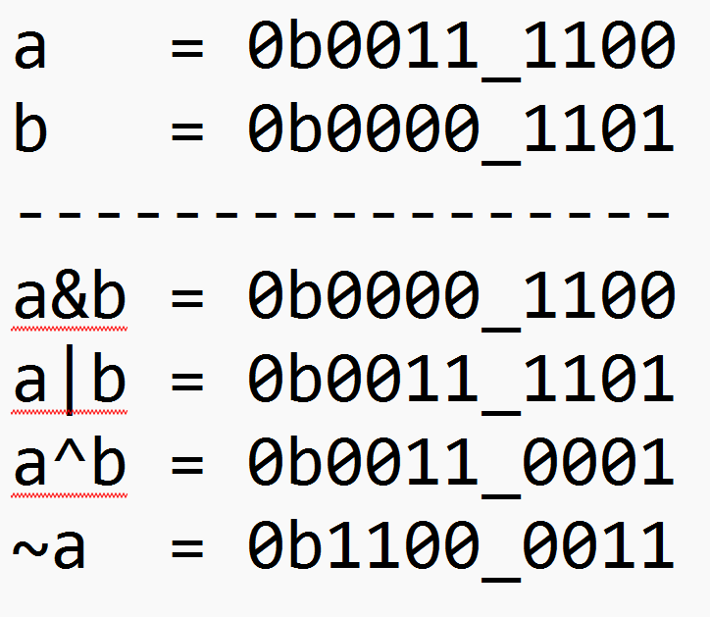
However, all these operators also have a variant that operates not on booleans, but on the bits within whole bytes (or ints, or whatever). These operators are called bitwise operators or bit operations because they perform their operation bit by bit on two arbitrarily long binary numbers, ultimately resulting in a (usually equally long) number as the output.
- and: &
- or: |
- not: ~
- xor: ^

Bit operations are important because they allow you to manipulate individual bits in a number. For example, an IC (Integrated Circuit) may have a configuration register where you need to set a specific bit to 1 in order to configure something. Conversely, one or several bit(s) in a status register may represent a certain state that needs to be read. Take the serial port as another example: it all sounds great, "sending bits one by one" - but how do you even accomplish that? Well, with bitwise operations.

So, we can use the following operations:

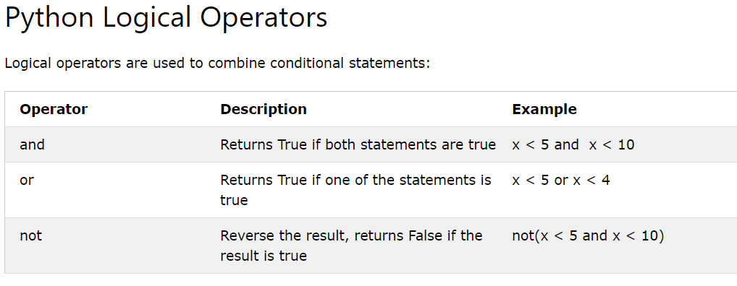
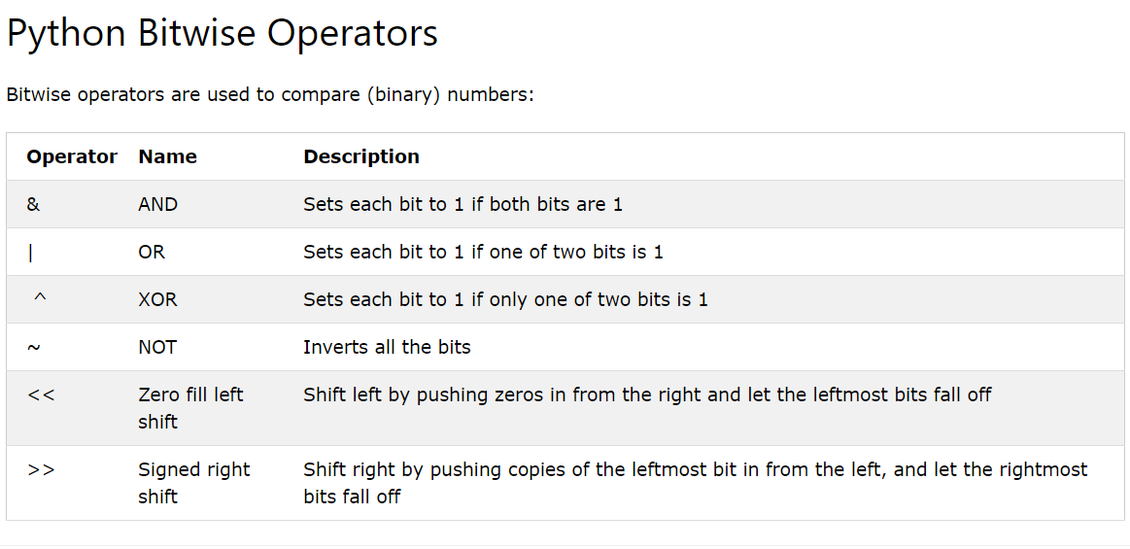

Bitwise OR
The first operator is the | or bitwise OR. If a bit is 1 in either of the inputs, it will always result in 1 in the output when using |. In the example below, we have created two numbers, "in1" and "in2". We apply the bitwise | OR operator to these two numbers and compare the result with the number "out".

>>> in1 = 0b11001010
>>> in2 = 0b00111100
>>> # | -----------
>>> out = 0b11111110
>>>
>>> in1 | in2 == out
True
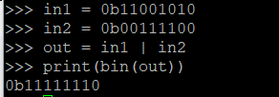

Set bits
You can use the OR operator to set one or more bits to "on" (set), regardless of their current value. Suppose you need to set the third bit (b2) in a register to 1 in order to configure a component:

>>> have = 0b11001010 # current value of register
>>> mask = 0b00000100 # make a number where ONLY bit 2 is “on”

>>> xxxx = 0b11001110 # the result which I want
>>>

>>> result = have | mask # use the bit OR operation to change the have into result with our mask
>>> xxxx == result
True

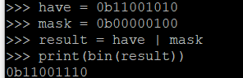

The value of the mask is thus used to select only those bits that you need and to leave the rest untouched; it serves as a sort of mask that you lay over the number. Therefore, this is called a bitmask, or simply a mask.

Note that the result remains the same if the bit was already "on":

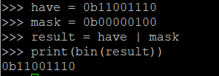

Combining Bits
Another application is the combining or "sticking" of bits into another number when you are certain that those bits are currently 0.
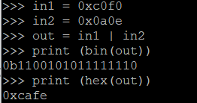

This example may be a bit contrived, but later we will see how you can use "|" to concatenate multiple bytes together, for example, to reconstruct a 32-bit value that you received in separate bytes (but then we also need to perform shifting, which we will see shortly).

Bitwise AND
The & operator performs a bitwise AND operation. This means that for each bit in the two operands, the result will be 1 if both bits are 1, and 0 otherwise.

>>> in1 = 0b11001010
>>> in2 = 0b00111100
>>> # & -----------
>>> out = 0b00001000
>>>
>>> in1 & in2 == out
True
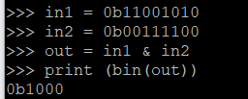

Clear bits
By making a bit in the mask 0, you know that it will also become 0 in the result with &. Consequently, you can use this operator to turn bits "off" (clear), regardless of their current state:

>>> have = 0b11001110 # the register now
>>> want = 0b10001110 # what I want: bit 6 is now "off", the rest remains unchanged
>>>
>>> mask = 0b10111111 # so I make a mask with ONLY bit 6 "off"
>>>
>>> want == have & mask # and use the & operator to "clear" the bit
True
>>> want == want & mask # here too, the initial state doesn't matter, if the bit was # already 0 it stays that way
True

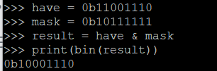

The same obviously works for multiple bits at once:

>>> 0xbabe & 0xf0f0 == 0xb0b0 # everywhere my mask is 0, the result becomes 0, the rest stays
True
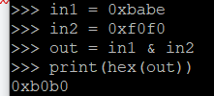

Filter bits
Another handy application of & is filtering one (or more) bits by setting all the rest to 0. Suppose bit 2 in the UART status register indicates whether data can be sent:

>>> uart_reg = 0b11001110 # contents of the register
>>> tx_ready = 0b00000100 # I'm only interested in b2
>>>
>>> if uart_reg & tx_ready: # I filter the bit from the register,
... transmit(data) # and only if it's 1 do I send data

Note that the bit retains its original value, in this case, 4. Since any number except 0 evaluates as True, that's good enough for an if, but if you need a 0 or 1, you'll need to read on.

Bitwise XOR
The ^ or bitwise XOR results in a 1 for bits that are different in the two inputs and a 0 for bits that are the same.

>>> in1 = 0b11001010
>>> in2 = 0b00001100
>>> # ^ -----------
>>> out = 0b11000110
>>>
>>> in1 ^ in2 == out
True

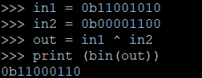

Toggle bits
For both set and clear, it doesn't matter what the current value is, the result is definitely 1 or 0, respectively. Sometimes, however, you want to "flip" a bit, in other words, change its current value from 1 to 0 or vice versa. For this, you can use XOR, bits that are 1 in the mask are definitely changed (toggle) in the result.

>>> 0x11110000 ^ 0x10000001 == 0x01110001 # MSB and LSB are toggled, the rest stays the same
True

Bitwise NOT
Just like the boolean not or !, a bitwise NOT ~ works on 1 operand, of which all bits are inverted (complement) in the result. Not difficult in itself, were it not that in Python a number is "infinitely" long and preceded by infinitely many zeros. If you then invert that, you get... infinitely many ones, but of course, you can't just omit those anymore. Moreover, that makes the number negative (see 2's complement).

>>> ~0b11001010 == 0b00110101 # hmmmmm...
False
>>> bin(~0b11001010) # since when is `-` a binary digit?!?
'-0b11001011'
>>> bin(~0b11001010 & 0xff) # aha!
'0b110101'
>>> ~0b11001010 & 0xff == 0b00110101 # thanks for nothing, Python...
True
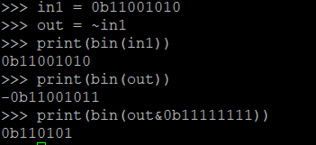

By masking the result with an AND to a sensible length, you get the result you expect and which you would immediately get in almost any other programming language.

A bitwise NOT is the same as an XOR with a 1 everywhere in the mask:

>>> 0xbabeface ^ 0xffffffff == ~0xbabeface # Ah yes... sigh
False
>>> 0xbabeface ^ 0xffffffff == ~0xbabeface & 0xffffffff
True

Shift left/right:
The last operator in our assortment makes no sense for the type boolean and consequently only exists bitwise: a shift or bitshift shifts all bits in a number a number of places to the left (<<) or right (>>). The "empty" places that arise on the other side are simply filled with zeros.

>>> print(bin(0b00010100 << 3)) # shift 3 bits to the left
0b10100000
>>> 0b00010100 >> 2 == 0b00000101 # shift 2 bits to the right
True

Bits that shift out on the right are gone for good, the same normally applies to the left, except in Python where a number is "infinitely" long.

>>> 0b00010100 >> 4 == 0b00000001
True
>>> 0b11001010 << 4 == 0b110010100000
True
>>> 0b11001010 << 8 == 0b1100101000000000 # in C or Java a `byte` would now be empty
True

Note that a shift 1 place to the left corresponds to multiplying by 2, a shift to the right by dividing by 2 - as long as no bits "fall off" of course. Consequently, a shift of N places is the same as dividing/multiplying by 2^N.

In-place operators
Just like for + and -, there also exists an in-place variant for bit operations that adjusts and stores the value of a variable in one motion.

>>> x += 2 # x = x + 2
>>> x -= 2 # x = x – 2
>>>
>>> x |= 4 # x = x | 0x04 --> bit 2 is now 1
>>> x &= 253 # x = x & 0xfd --> bit 1 is now 0
>>> x ^= 0xf0 # x = x ^ 0xf0 --> 4 MSB are toggled
>>>
>>> x <<= 2 # x = x << 2 --> all bits moved 2 places to the left (or: x multiplied by 4)
>>> x >>= 3 # x = x >> 3 --> all bits moved 3 places to the right (or: x divided by 8)

Order of Operations
Bit operations, like mathematical operations, have a fixed order in which they are performed:

- not (~)
- shift (<<, >>)
- and (&)
- xor (^)
- or (|)

In turn, mathematical operations take precedence over bit operations, which take precedence over comparisons (==, !=, <, ...) and finally, the logical operators (and, not, ...).

Moral of the story: better to use parentheses right away than to have to search for the mistake later! Better too many parentheses than too few...

Putting things together
By combining bit operations, you can now read or set individual bits of a number to your heart's content. Usually, there are different ways to Rome; here are some examples.

Isolating a Bit
With &, you could already filter a bit, then you can shift it to get a 0 or 1 result:

>>> value = 0x44 # bit 6 and 2 are 1
>>> value & 0b01000000 # filter all other bits, the bit retains its value
64
>>> (value & 0b01000000) >> 6 # so you have to shift it to the LSB position
1

Or somewhat more conveniently in reverse order (note that >> takes precedence over &):

>>> value >> 6 & 1 # first shift the bit to LSB, then mask the rest away
1

Mask like a pro
For a clear or toggle on a single bit, you need a mask that is 0 everywhere except for this bit. Instead of writing that out fully, you can simply shift that one bit into place. Suppose you want to clear bit 13:

>>> noob_mask = 0b0010000000000000
>>> my_mask = 1 << 13
>>> my_mask == noob_mask
True

For a bit-set, the mask looked just the opposite, but you can easily solve that with a NOT:

>>> data = 0xf00d
>>> noob_mask = 0b1101111111111111
>>> my_mask = ~(1 << 13) # has again an infinite row of ones
>>> data & my_mask == data & noob_mask # but that doesn't matter for masking:)
True

Thanks to the in-place operators, you can now modify several bits without too much effort:

>>> register = 0xdeadbeefbabecafe # 8 bytes = 64 bit
>>> bin(register)
'0b1101111010101101101111101110111110111010101111101100101011111110'
>>>
>>> register >> 54 & 1 # test bit
0
>>> register |= 1 << 54 # set bit
>>> register >> 54 & 1
1
>>> register &= ~(1 << 54) # clear bit
>>> register >> 54 & 1
0
>>> register ^= 1 << 54 # toggle bit
>>> register >> 54 & 1
1
>>> register ^= 1 << 54 # toggle again
>>> register >> 54 & 1
0
>>> hex(register) # back where we started and other bits unchanged
'0xdeadbeefbabecafe'

Sticking Bytes Together
With |, you could already stick bits and bytes together, provided there are zeros where those bits must come. With a shift, you can just make that place yourself, for example, to put two bytes back to back:

>>> byte0 = 0xfe # LSByte
>>> byte1 = 0xca # MSByte
>>>
>>> hex(byte1 << 8) # first make space / put MSByte in its place
'0xca00'
>>> hex(byte1 << 8 | byte0) # then you can stick the LSByte to it with OR
'0xcafe'

Suppose you received a 32-bit value serially in a list of bytes:

>>> data = [0xce, 0xfa, 0xbe, 0xba]
>>>
>>> value = data[3] << 24 | data[2] << 16 | data[1] << 8 | data[0]
>>> hex(value)
'0xbabeface'
Or in a loop:
>>> value = 0
>>> for i in range(4):
... value |= data[i] << 8 * i
...
>>> hex(value)
'0xbabeface'

NB: the order in which you have to put the bytes back to back can differ: https://en.wikipedia.org/wiki/Endianness

Shifting Bits In and Out
Next week, we’ll use the Led Bar Graph. This component consists of 10 leds, connected to a shift register. This lets us control the 10 leds with only 3 GPIO pins (instead of 10)
We need to pass the data serially to the shift register.
Serial communication means the data (bytes) is sent bit by bit over 1 wire
Parrellel communication means the data (bytes) is sent multiple bits at a time over multiple wires.

Here’s an example on how to shift a byte out: (means outputting the value on a pin)
from RPi.GPIO import input, output

tx_pin = 14

def shift_byte_out(data):
""" Serial transmit 1 byte, LSB first """
for i in range(8):
output(tx_pin, data >> i & 1)

We can also receive data serially:

from RPi.GPIO import input, output

rx_pin = 15

def shift_byte_in():
""" Serial receive 1 byte, LSB first """
data = 0
for i in range(8):
data |= input(rx_pin) << i
return data

Binary Coded Decimals (BCD)
In BCD, 4 bits (= a nibble) are used to represent 1 decimal digit.

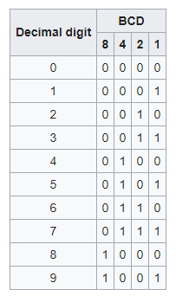

For the number "91", groups of 4 bits are used to represent each number.
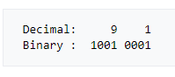
Note: you cannot just apply mathematical operations to a BCD code. The binary value of the number "91" is indeed 128+16+1 = 145

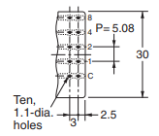
BCD teller
During this lab, we will use a mechanical counter. The value of the counter can be read digitally. Each digit is provided with a "+" and a "-" button. Each digit is a separate module that can be combined. For example, you can group 4 modules so that you can count up to 9999. You can get these modules in 2 versions, one with 4 inputs and one with 10 inputs. With the 10-input version, each input corresponds to a digit. With the 4-input version, a BCD code is formed.

Each counter is equipped with a common terminal (C) and the four BCD terminals (1,2,4,8).

The counters in the lab are of the BCD type. This lab can be perfectly simulated at home with 4 push buttons.
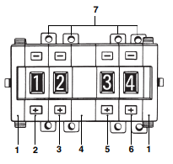
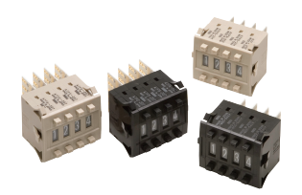

Circuit
We are going to “extend” the pins where our buttons are connected to (GPIO 16, 20, 21 and 26), to the BCD counter. The BCD counter has 4 wires, because we also need to connect to GND.
To be safe, we will add a safety resistor in series.
I pre-made some cables so they have a resistor. We will use that wire to connect to a GND pin, and another 4 wires from your kit to connect to the GPIOs mentioned above.
The BCD wires are labeled (if you look closely)
You’ll see 1,2,4,8 (bit values) and G (for ground) The bits need to be connected to the GPIO pins (the act like buttons)
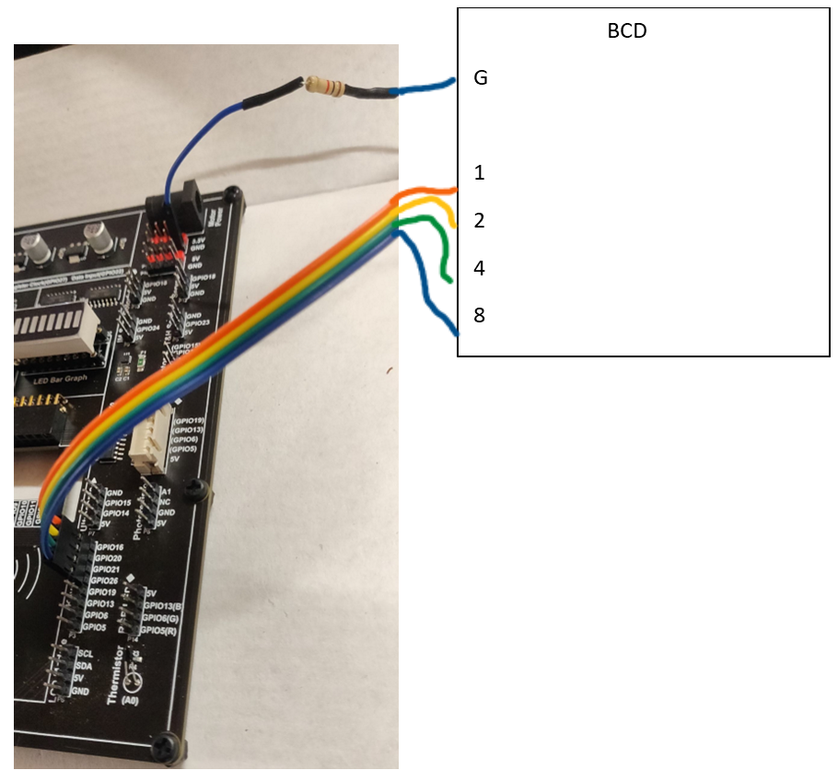
Make sure to connect G wire of BCD to GND, with resistor wire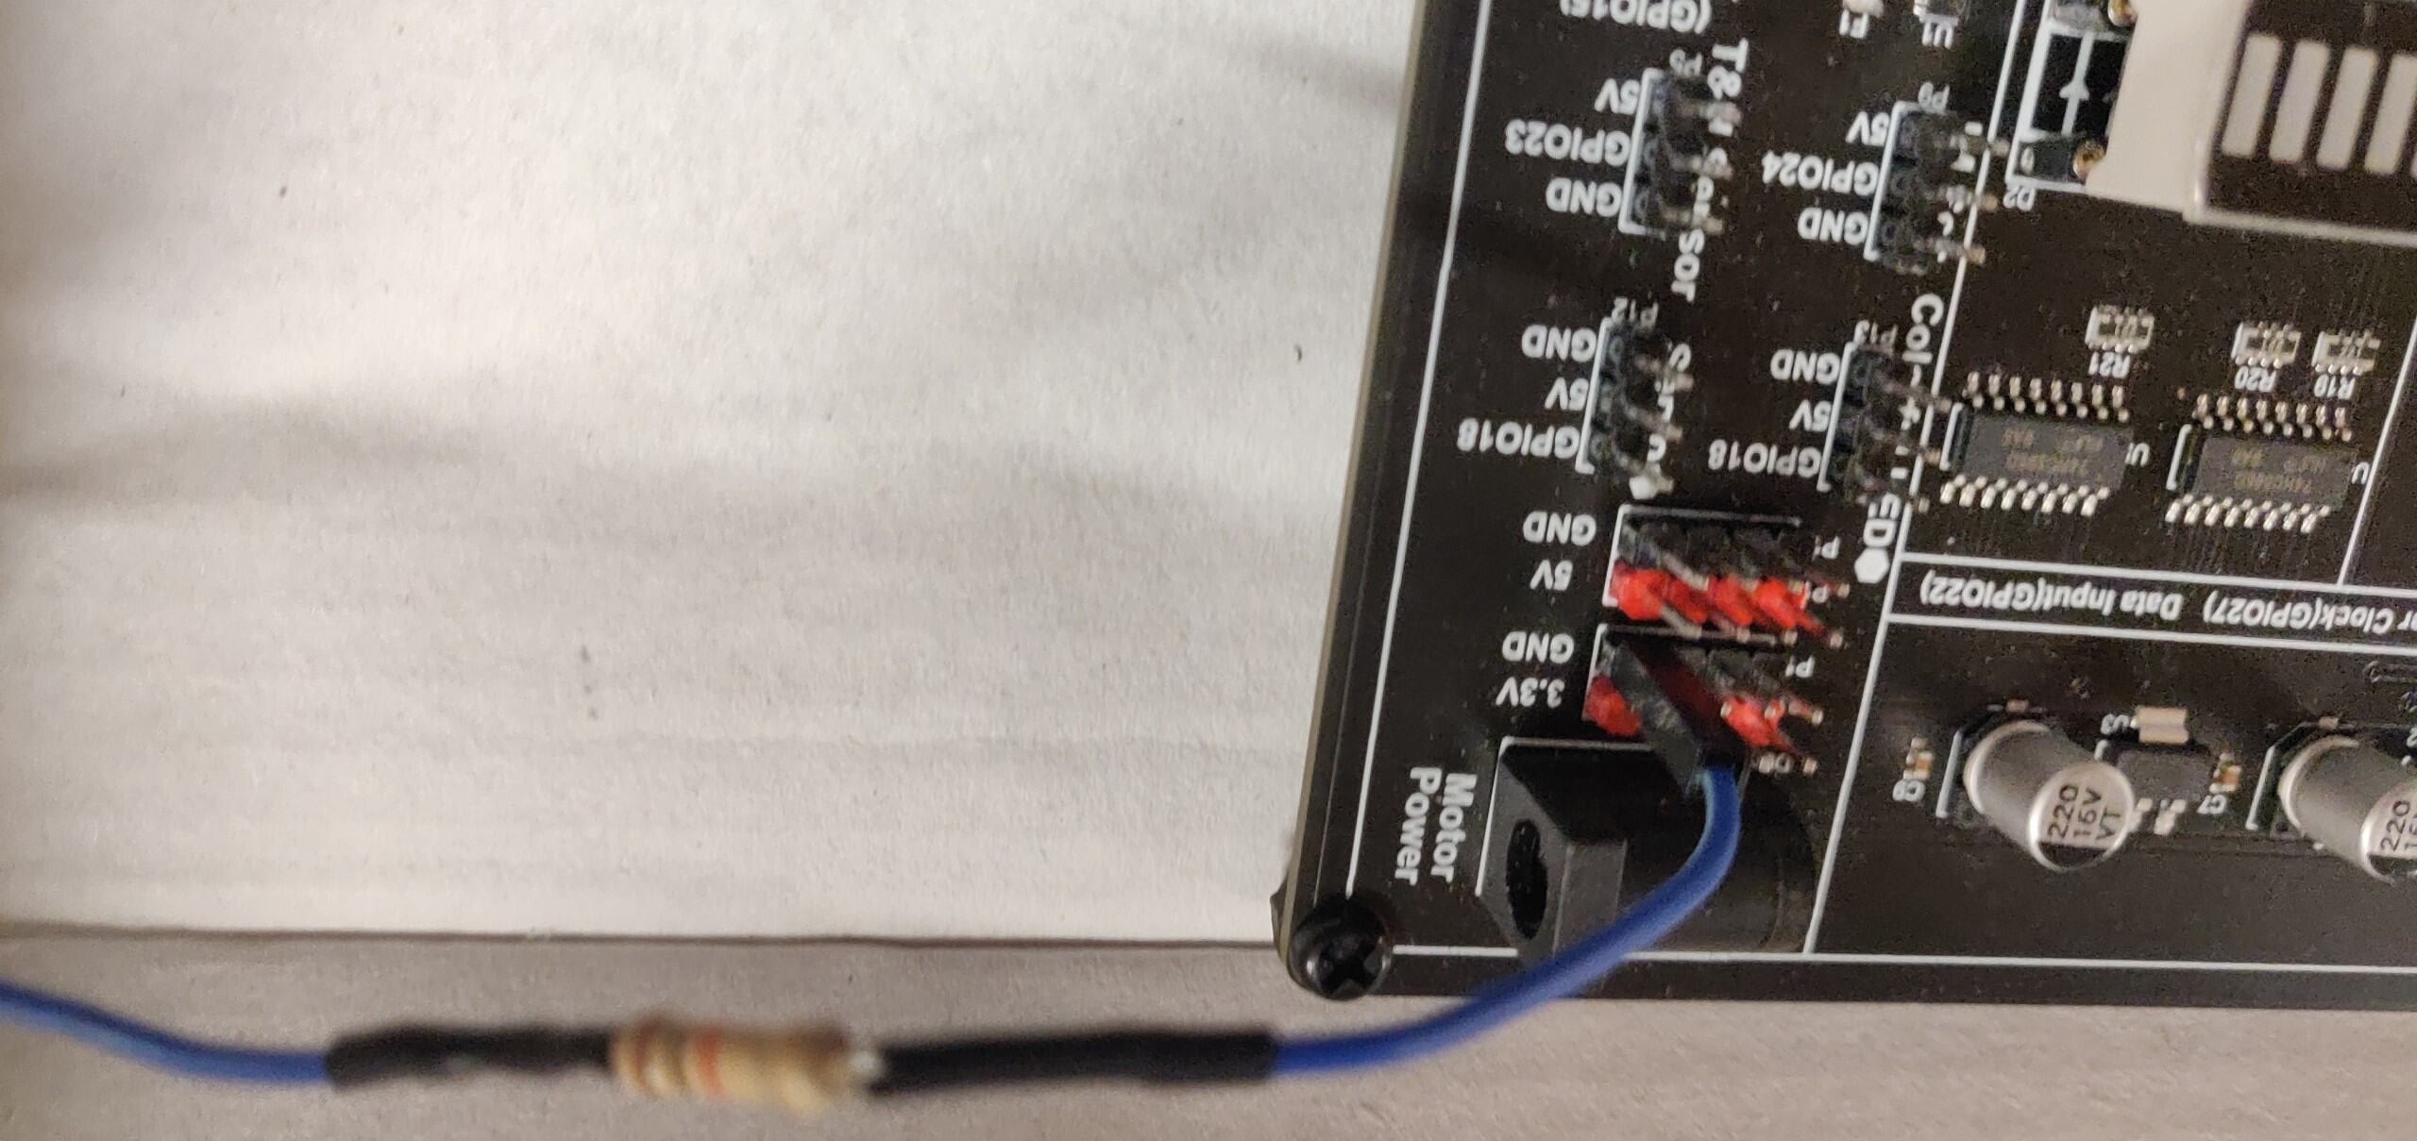

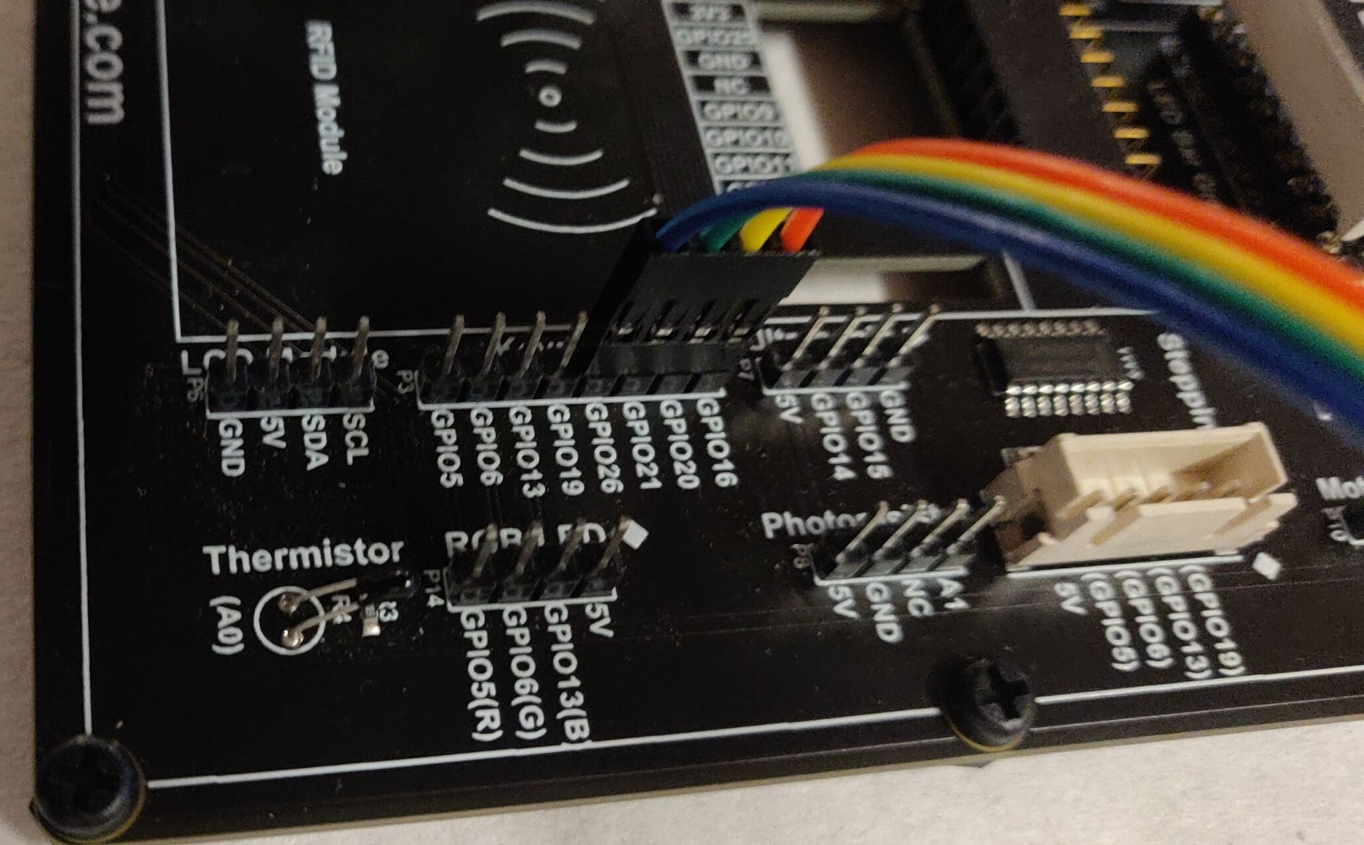

You can create a similar assignment with a dip switch
Too bad we can’t use the dip switches on our board because we can’t control what the pins connect to

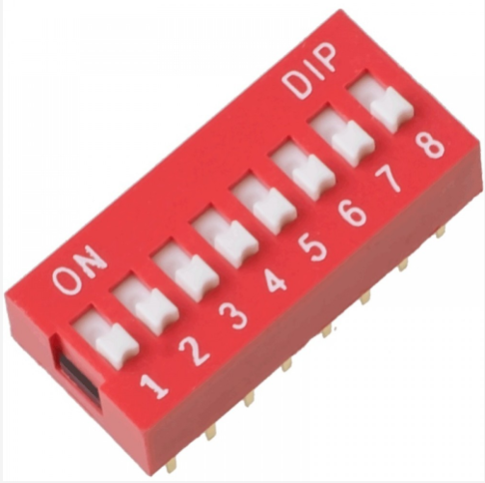
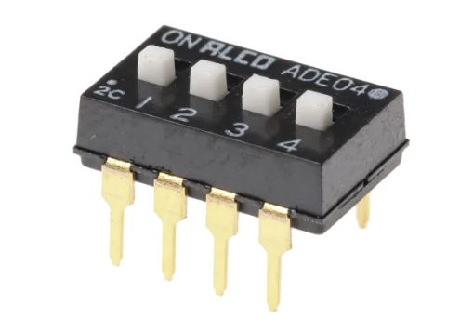

Here you have a number of switches where switch 1 is bit 0, switch 2 is bit 1, etc.
So the following combination (see photo below)
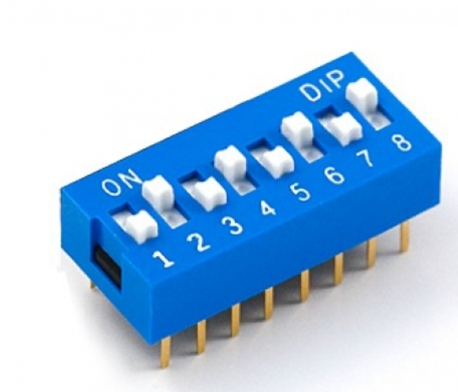
Gives as value

0 x 1
1 x 2
0 x 4
1 x 8
0 x 16
1 x 32
0 x 64
1 x 128

Total: 170 decimal.

Assignment 1 (BCD polling class demo)
Construct the circuit, configure the input pins as pull-up, and read the BCD (Binary Coded Decimal) code from the counter. Convert the BCD code into its corresponding decimal number using BIT OPERATIONS.

- Configure 4 inputs as pull-up. Utilize a list.
- In the loop: read each input individually and invert the bit. Print each bit separately in the console.
- Combine the 4 obtained bits into one nibble (using 4 if statements).
- Use a loop structure to replace the 4 if structures.

Expanded Instructions:

- Circuit Setup: Start by constructing your circuit. Ensure that your input pins are correctly connected to the BCD counter and configured as pull-up inputs. This configuration is crucial for accurately reading the signals from the BCD counter.
- Input Configuration: In your code, configure 4 GPIO pins as input with pull-up resistors. This step is necessary to ensure the pins are ready to read the high (1) or low (0) state effectively. Utilizing a pull-up resistor configures the pin to default to a high state, ensuring a more stable reading when the pin is not actively driven low.
- Reading Inputs and Inversion: Create a loop to iterate through your 4 input pins. For each pin, read its state (high or low) and then invert this state. This inversion is a common step when dealing with certain types of switches or logic where the active state is low rather than high. After inverting, print the state of each bit to the console for verification. This process not only helps in debugging but also ensures you're correctly reading and interpreting the signals.
- Combining Bits into a Nibble: After reading and inverting the individual bits, you need to combine them into a single 4-bit nibble. This step is typically done using bitwise operations. You might initially think of using four if statements to individually check each bit's state and then combine them into a nibble. However, this method, while straightforward, is not the most efficient.
- Loop Structure for Efficiency: To improve efficiency and reduce redundancy, replace the four if statements with a loop structure. This loop should iterate through each input bit, read and invert its state, and then use bitwise operations to combine these bits into a single nibble. This approach not only streamlines your code but also makes it more adaptable to changes, such as reading from more or fewer bits.
- Calculating the Decimal Value: Once you have your 4-bit nibble, the final step is to convert this BCD representation into its decimal equivalent. BCD encoding represents each decimal digit with its binary equivalent in a separate nibble. Therefore, your 4-bit nibble directly corresponds to a decimal digit between 0 and 9. The calculation is straightforward since the binary to decimal conversion in this case does not require any additional steps due to the BCD's direct representation nature.

EXTRA: Only print the value to the console whenever it changes

** Intellisense / code suggestions work if you downgrade the VSCode pylance and python extensions to the latest version of 2025 **

Interrupts and edge detection

Polling
See also: https://sourceforge.net/p/raspberry-gpio-python/wiki/Inputs/

Last weeks, we explored how to read a button.

btn = 20
GPIO.setup(btn, GPIO.IN, pull_up_down=GPIO.PUD_UP)
pressed = not GPIO.input(btn)

You might have noticed, in the traffic light with pedestrian button exercise, it’s hard to both wait (while a led is on for a certain time) but also check for button presses.
This if because while we are in ‘sleep’, we can’t read our button state. Our program needs to read the state in order for us to do something with the value.

while GPIO.input(channel) == GPIO.LOW:
time.sleep(0.01) # wait 10 ms to give CPU chance to do other things

This method is referred to as polling: repeatedly checking whether the event we are waiting for has occurred. However, this approach does not progress well when we wish to perform other tasks simultaneously. Moreover, it is quite taxing on the CPU, which must continuously check. Ideally, we would prefer to spontaneously react to the pressing of the button.

Interrupts
An interrupt is a mechanism to inform the processor of a certain event. The CPU will then interrupt its current work and execute an Interrupt Service Routine (ISR), also known as an Interrupt Handler. Upon completion, it resumes the task it was previously working on. This method prevents wasting CPU power waiting for events.

Events
The GPIO library refers to signal transitions as events. To register these, one must first declare it through the function add_event_detect(channel, edge).

The edge parameter is a constant indicating the transition type: GPIO.RISING is a transition from 0 to 1, and GPIO.FALLING is from 1 to 0. If we wish to detect both transitions, we can use GPIO.BOTH. The significant advantage of this method is that, unlike polling, no events can be missed.

Subsequently, one can check at any moment whether the event in question has occurred:

GPIO.add_event_detect(channel, GPIO.RISING) # add rising edge detection
do_something_else() # threat is busy with other things
if GPIO.event_detected(channel):
print('Button released')

Callbacks
In Python, a function is considered a 'first-class object'. This means you can copy a function, store it in a data structure, or pass it as a parameter just like any other object. This is done by simply using the function name without parentheses and arguments. When a function is passed to another function or method to be called later, it is referred to as a callback function. This is utilized to spontaneously react to an event: with the function add_event_callback(channel, callback), you ensure that the callback function is called as soon as the event occurs.
The GPIO library uses threads behind the scenes for this purpose. This means that the code runs in the background, allowing your code to continue working undisturbed.

def my_callback(channel):
print('This is a edge event callback function!')
print('Edge detected on channel %s'%channel)
print('This is run in a different thread to your main program')

GPIO.add_event_detect(channel, GPIO.RISING, callback=my_callback) # add rising edge detection on a channel
...the rest of your program...

As you see, it's required that your callback function accepts a single parameter, through which the GPIO library passes the pin number. This allows you to recycle the same callback function for multiple pins.
You can also register multiple callbacks on the same pin:
def my_callback_one(channel):
print('Callback one')

def my_callback_two(channel):
print('Callback two')

GPIO.add_event_detect(channel, GPIO.RISING)
GPIO.add_event_callback(channel, my_callback_one)
GPIO.add_event_callback(channel, my_callback_two)

Bouncetime
Both add_event_detect and add_event_callback have an additional parameter bouncetime, which allows you to specify a number of milliseconds to debounce the button. As known, you can achieve the same result by placing a small capacitor in parallel with the button or using a combination of both.

# add rising edge detection on a channel, ignoring further edges for 200ms for switch bounce handling
GPIO.add_event_detect(channel, GPIO.RISING, callback=my_callback, bouncetime=200)
or

GPIO.add_event_callback(channel, my_callback, bouncetime=200)

When you no longer wish to detect transitions on a pin, you can remove the event detection:

GPIO.remove_event_detect(channel)

Multithreading
A single-thread application performs all tasks sequentially. Using a sleep() function essentially blocks our application, preventing it from responding to events. This way, we will miss events. You might think that callbacks will solve everything for us and that we can freely use the sleep() function. However, this is not the case. The RPi.GPIO will start a second thread to detect events. If we now call a second callback function, they will be executed sequentially. If you want to create a blinking light, for example, you should definitely not use the sleep() function in the callbacks, otherwise, you will miss events again.

Thus, only in the main thread should you use the sleep() function or, even better, use a clock to create, for example, a blinking light.

Classroom Demo
Demonstration on interrupts and callbacks, extended csv button logging.

Git – Github

Normally you’ve already covered steps 1, 2 and 3 in the basic programming module

Step 1: Installing GIT
You can install GIT by following the following link: https://git-scm.com/ and pressing Downloads


Step 2: Create your account on Github
Don't confuse GIT with Github
Github is based on Git, but it is not the same thing. Here are some key differences:

- Github is an online client for the Git version control system. This means that you can use Github to manage your Git repositories online.
- Github is a hosting provider for free software. This means that you can use Github to store and share your free software projects.
- Github adds extra functionality to Git. This includes things like access control, issue tracking, and wikis.
To create a personal account on Github:

Go to https://github.com/join?source=login.
Enter your name, email address, and password.
Click on the "Create Account" button.
Standards we use:
- Use your Howest email address.
- Your username must be in the format <Last Name><First Name>.
- For your password, it is best not to use your Howest password.
Instead, use a new, strong password.

Step 3: Installing Git Desktop (or GitKraken or other Git GUI tool)
Download the installer via https://desktop.github.com/
Log in using the credentials from step 2

Step 4 : Using Git in Sensors & Interfacing
The Python scripts created are only stored on the SD Card of the Raspberry Pi. If we can push our script from the Pi to Git, we immediately have a backup of our assignments, and we can also view the scripts without needing a connection to the Pi.

What is expected?
- At the beginning of the lab, create a new branch for this week
- At the end of the lab session, push the created scripts.
- Merge the week branch to main branch

Browse the following link to get a repository in one of the available Howest-classrooms. This repository can also be monitored by the lab instructor.

https://classroom.github.com/a/U6StD_V0

Choose Sandi Classroom

(screenshots are from last year's version)

You are prompted to accept:
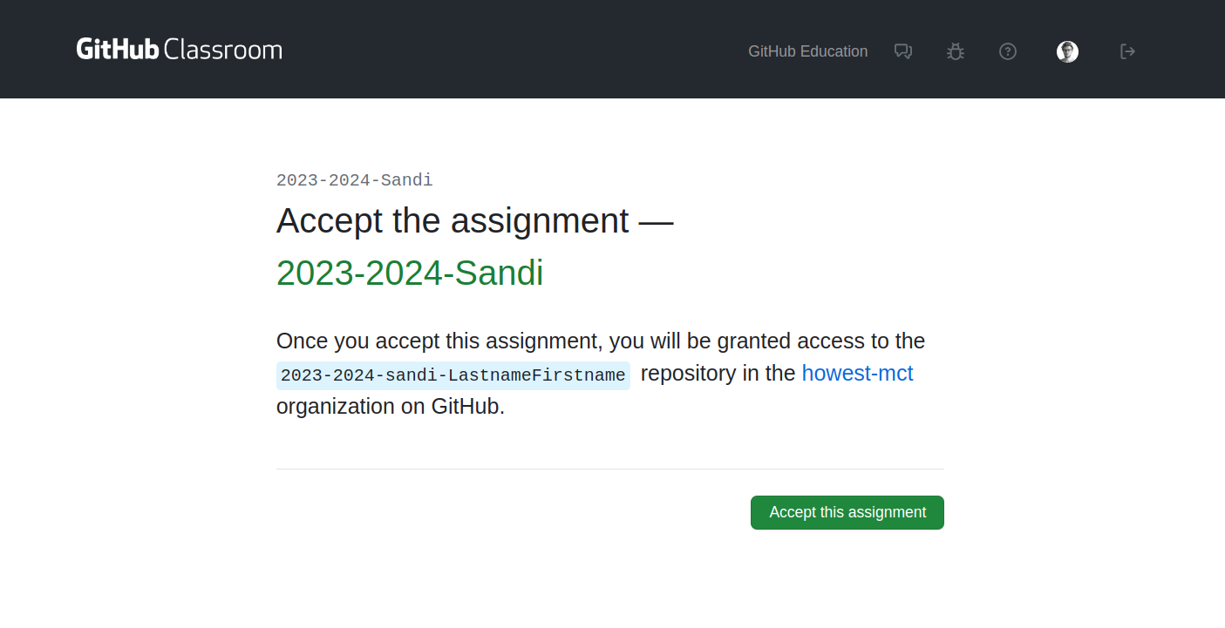
After accepting your personal Git Repo will be created within the Sandi Classroom.


This will take 1-2 minutes, after refreshing you will see your git repo url.

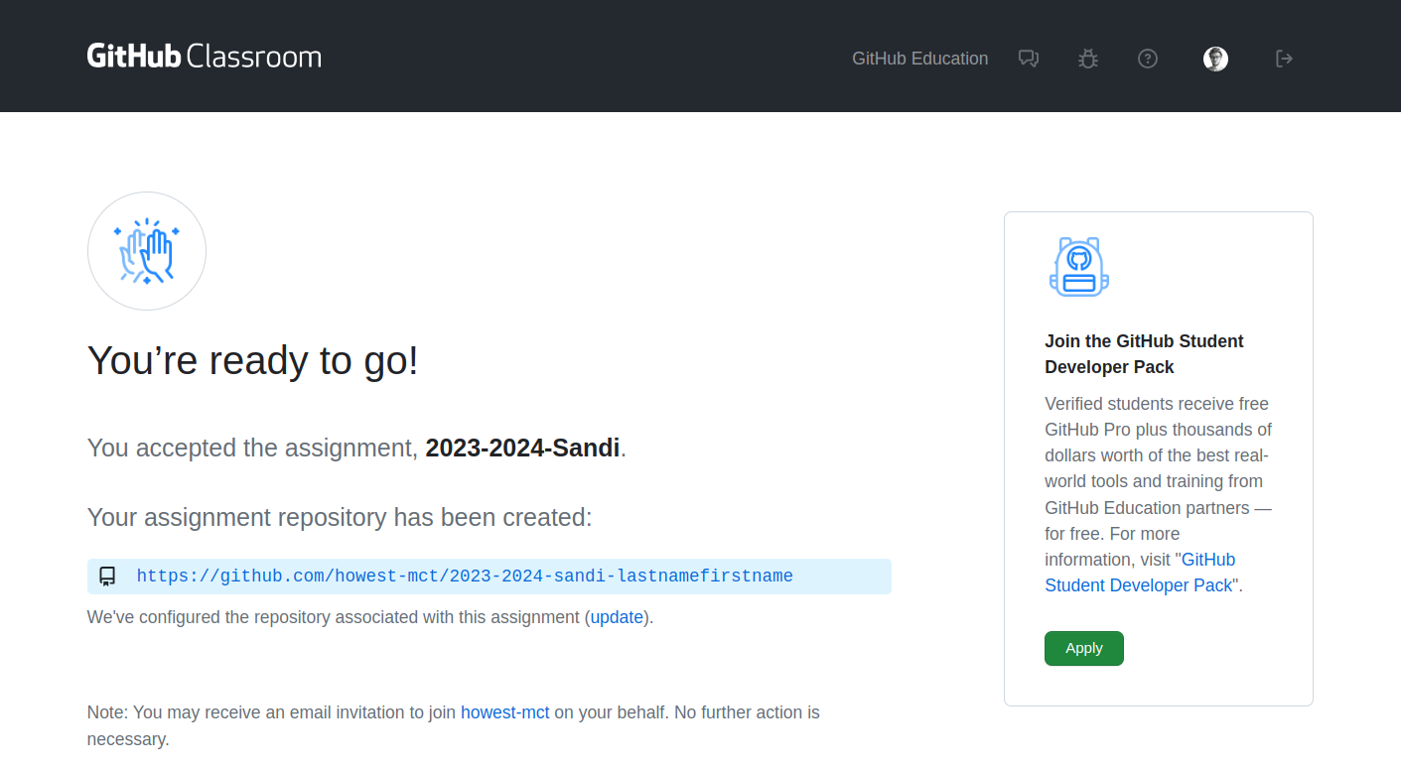
Stay on this screen, we’ll need this url later

Step 5: Configuring Git on the RPi
Normally, Git is already installed in Raspbian. Test this by entering the command "git" in the console.
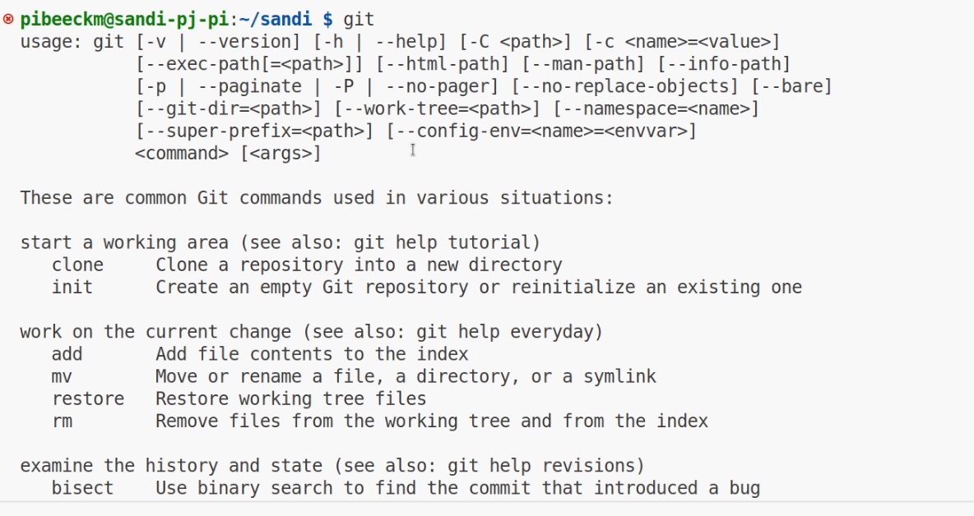

If Git is not installed, you can install Git using the following instruction:

sudo apt install git

Now, we need to set our name and email so that Git knows who the user is. Use the details from your account from step 2.
Note: if you are using a different user, you will need to set this up again!
By using the command `git config --list`, we can request the Git configuration.

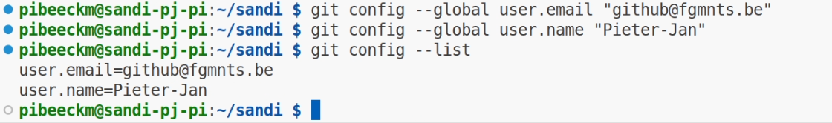
git config --global user.email "you@example.com"
git config --global user.name "Pieter-Jan"

Step 6: Getting Started in Visual Studio Code
Make an SSH connection to your RPi. Select a workspace where you want to make the clone of your Git repository.
Open the "Sandi" folder we created last week.
Open the command palette of VS Code with ctrl/cmd+shift+p or via the menu.
Search for the Git Clone command.

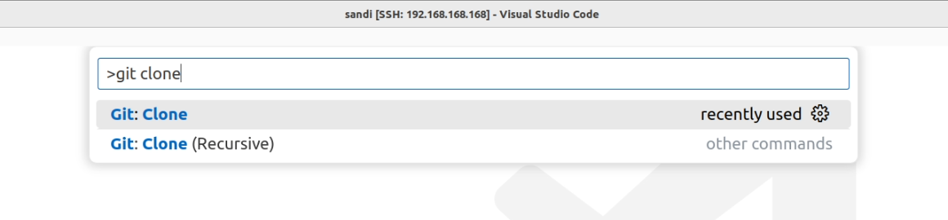
Paste the git URL of your git repository in the field.

https://github.com/howest-mct/2025-2026-sandi-lastnamefirstname

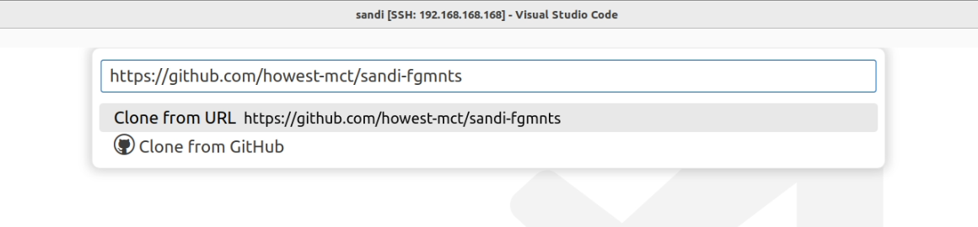
Select the path on the Pi (under /home/user/sandi) where the clone of the repo should be placed.
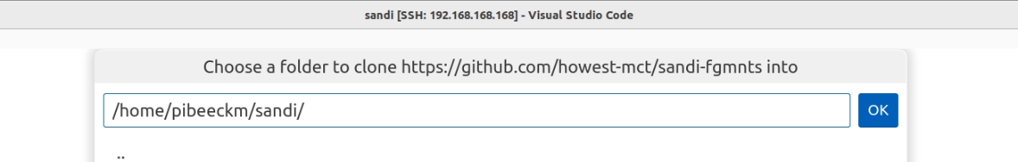

It's best to give Visual Studio all rights for Github, otherwise, you will have to enter your credentials every time you push!



Now, in this clone, create a new branch and folder every week where the lab assignments will be stored.

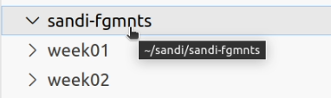

Step 7: Commit to Git
You should have already seen this part in Basic Programming.

Create a Python script, try to commit it, and then push it.
VSCode will then ask for our username and password.
If you see the following error message, it's best to repeat step 5.

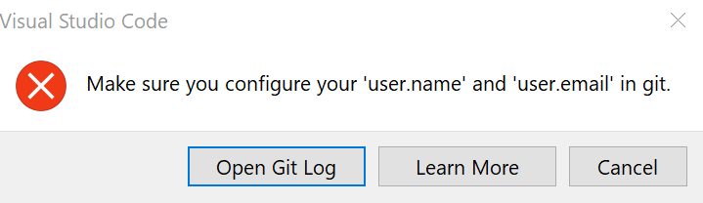

Select the Source Control icon in the left column:



You will see the following screen. Note that the letter 'U' is mentioned. This letter means "Untracked". For now, this file is not being monitored for changes.

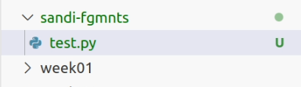

Of course, this is not what we want.
If you now click on source control, you can enter an appropriate message.

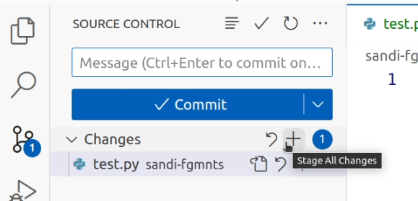

Then click on the "Commit" icon (checkmark at source control). For the first time, an 'untracked' file will be 'tracked' (meaning: prepared) and immediately committed. The changes are registered.

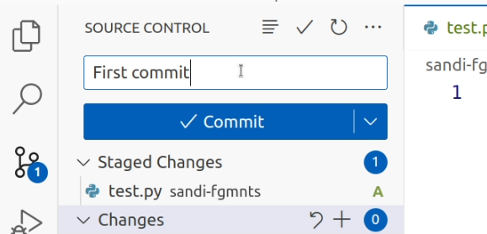

For your information: at the next adjustment, the letter will not be 'U' but 'M' for 'Modified'. Again, enter an appropriate message each time and commit these adjustments.
You can always click on 'Always' for the following message.

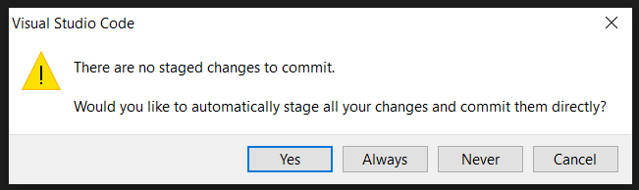

Be careful: nothing has changed in the online repository on Github yet. A final step is missing.

Step 8: Pushing Adjustments to Github.com
You should have already seen this part in Basic Programming.
Select the source control on the left Press the 3 dots to push!

In Visual Studio Code:
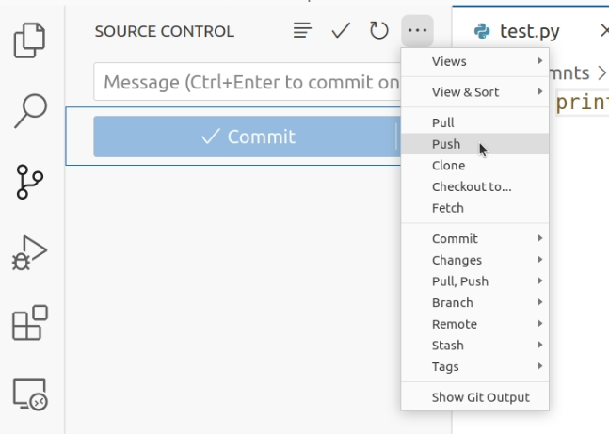
Check if you can see all the changes on github.com. (after clicking your repo link on the screen from step 4)

Step 9 : merge side branch into main
After pushing to your branch, git will tell you you’re able to merge this branch into main. Follow the link, confirm and accept the merge.
In VSCode, switch to your main branch (new files are “gone”) and press sync in source control (now the files are back again!)

First make sure the BCD counter works with your previous code

Exercise 2: BCD + Led blinks
Next add events for reading the BCD output
Use your BCD value (0 – 9) as the number of times a led needs to toggle in 1 second. (So with value 0 the led stays the same/on, with value 1: 1 time toggle, so halfway your second, toggle the led, ...
If you want to continue this exercise at home, you can just use your buttons as BCD bit values
Hand in this assignment by next week

Don’t forget to make a backup of your SD card
We are now at week 3. Besides your code (which is safe in github now, if you’ve committed) you already customized your RPi installation/setup. You probably added your home WiFi, now we’ve configured our Git user.
It might be a good idea to make a backup of your raspberry pi micro-sd card. This way, if anything should happen to it, you can get this exact state of your pi back. You would only need to run git pull in order to be fully up-to-date.
Use Win32DiskImager on windows, or use the command line on mac (or ask a classmate to make a backup on windows, and transfer the file)

