WEEK 04: Events & Analog signals
- Simulate analog signals (output) via PWM
- Learn about I²C bus
- Read analog values via ADC
- Work with RGB

ANALOG SIGNALS
Digital signals have a distinct 0 or 1 (LOW/HIGH) value
Analog values have no distinct on or off state, but you can have “a little bit” of something, or a bit more (without saying ALL or NOTHING)
Like light, temperature, gas throttle on your car, ...

The Rapsberry Pi does not have any analog input our output capabilities by itself.
It can simulate analog output signals via PWM (Pulse Width Modulation) or use an external component to output real analog values (Digital Analog Converter, or DAC).
It can’t read analog values without external components. Our kit has such a component included, an Analog Digital Converter (ADC)

Pulse Width Modulation (PWM)

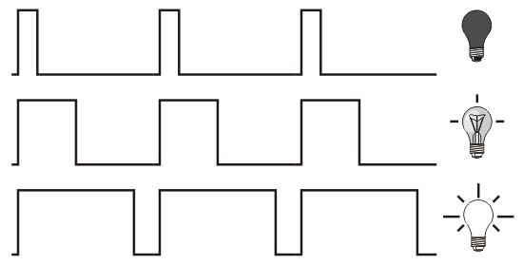

The Raspberry Pi does not have true analog outputs. However, for most purposes, we can simulate analog behavior by rapidly switching between a high and low output, and varying the time interval during which the output is high (PWM).

The frequency of a PWM signal is the number of times per second the signal goes from low to high and back to low, expressed in Hertz [Hz]. The duty cycle is the ratio of the time the output is high to the total period of the signal, expressed as a percentage.

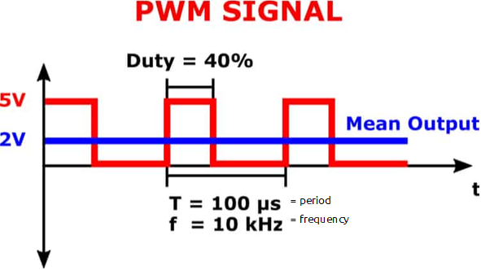
3.3V
1.3V

PWM can be implemented using hardware timers, which are therefore very accurate, but they are already in use to generate clock signals for the various data buses that we will see in future lessons. However, the GPIO library provides the ability to provide software PWM outputs, which should be sufficient for most purposes. For this, we use the function GPIO.PWM(channel, frequency):

GPIO.setmode(GPIO.BCM)
led = 17
GPIO.setup(led, GPIO.OUT)
pwm_led1 = GPIO.PWM(led, 1000)

This creates a software PWM object with a frequency of 1kHz (1000Hz). We can then start the signal with the start(dc) method:

pwm_led1.start(50)

This will create a square wave on the pin with a duty cycle of 50%, so a connected LED would light up at half intensity. We can of course change the duty cycle:

pwm_led1.ChangeDutyCycle(25)

... reduces the intensity to 1/4. The frequency can also be changed:

pwm_led1.ChangeFrequency(100)

This gives the PWM wave a frequency of 100Hz. After use, we can stop the wave to avoid unnecessary CPU load:

pwm_led1.stop()
del pwm_led1

Before programming:

On RPi: check git config, complete if needed

On RPi: commit + push any changes left in working directory

On RPi: create a new branch PWM
Try to make a LED (GPIO17) blink with the following pattern:
0.5 sec 10%; 0.5 sec off; 0.5 sec 100%; 0.5 sec off

After programming:

On RPi: commit, push

Online/in browser: merge branch into

On RPi: switch to main branch and perform sync / pull action
(making sure your PWM code is accessible/visible/runnable)

Analog Inputs

Introduction
A digital input (e.g. a button) has only two states: HIGH/LOW. Analog signals can take on many different values, e.g. temperature sensors, light sensors, humidity sensors, etc. The Arduino Uno has 6 analog inputs, a Raspberry Pi, on the other hand, has NO analog inputs.
However, there are several solutions to be able to read analog signals. Today we will work with an IC (integrated circuit) that can exchange the values of the analog inputs with the Raspberry Pi via a protocol.

Resolution
For a digital input, one bit in the computer memory is sufficient, the button is pressed or not.
For an analog input, we need more intermediate steps. Below is an example of a 3 bit analog input. There are 3 bits of space per input to display all possible intermediate steps. So we have 2^3 = 8 intermediate steps. The figure below shows that a 3-bit approach to an analog signal is not very accurate. We always have big steps to simulate or imitate the signal.

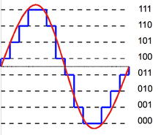

In the following figure, we have simulated an analog signal with a 3 bit analog input and a 16 bit or 2^16 = 65 536 intermediate steps. With a 16-bit signal, the difference with the original analog signal is no longer noticeable.
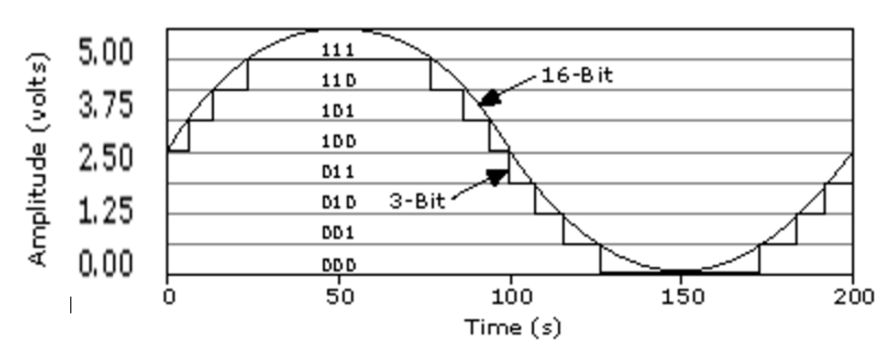
Our ADS7830 has 8 bit analog inputs or 2^8 = 256 intermediate steps. So, we can determine the voltage with an accuracy of 3V3/256 steps = 12.9mV (per ‘step’) if we use the 3.3 volts as a voltage source and reference.
Voltage (V) | Binary number | Decimal value
0 | 0000 0000 | 0
0.66 | 0011 0011 | 51
1,32 | 0110 0110 | 102
1.65 | 0111 1111 | 127
2.1 | 1010 0010 | 162
2,64 | 1100 1100 | 204
3,3 | 1111 1111 | 255

Sampling
In the real world, everything is analogue: the tension between two dots can basically take on any value, with an infinite number of digits after the decimal point. You can also measure at any time and you will always get a result.
It's different for computers. First, they operate at a certain clock frequency, and their state can only change once per clock cycle. Second, no computer can represent an infinite number of digits after the decimal point - you would need an infinite number of bits for that. So, we will have to make compromises if we want to represent the analog world through our computer.
Next, we need to measure or sample reality at specific moments, in English sampling. If you do this often enough (Nyquist frequency, see theory) no information will be lost. There is only one wave that goes nicely through all measurement points that do not contain frequencies that are greater than double the sample rate. The ADC we use in this lab can measure 70k samples/sec, so we can digitize signals with a bandwidth < 35kHz.
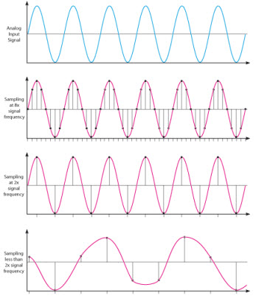
x 8
x 2
< 2

I2C DEVICES

Introduction
We have already been introduced to digital pins/signals, now we are going to get acquainted with the I2C bus. We will use an I2C Analog Digital Converter (ADC), namely the ADS7830. The Raspberry Pi has an integrated I²C bus, so we can use the predefined SDA and SCL pins.
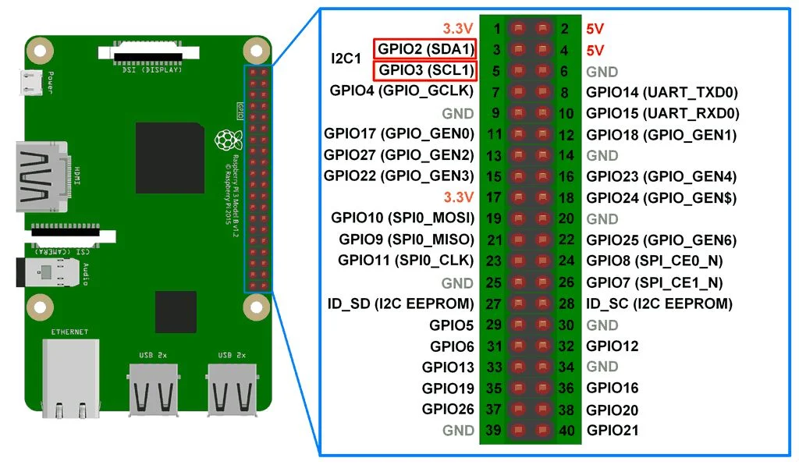

I²C bus (inter-integrated circuit bus)
The Inter-Integrated Circuit (I2C, I-squared-C) bus is a synchronous, multi-master/multi-slave, two-wire serial bus bus developed in 1982 by Philips (now NXP). It was developed and still is used for connecting relatively slow external ICs to a microcontroller on the same PCB or over short distances.
I2C has two wires, a clock signal (SCL) for synchronization and a bidirectional data line (SDA). The clock signal has a standard frequency of 100kHz, later versions also brought speeds of 400kHz and 1MHz.
On an I²C bus, you can connect several participants, each with their own address. The addresses are not unique as with the OneWire bus and can be found in the datasheets of the manufacturers or in Linux. To distinguish slaves on the bus from each other, 7-bit addresses are used, so far too few to provide a unique address for each chip. The address will therefore depend on the model of the IC and can be found in the datasheet. Often there are a few addresses that you can choose between by connecting one or more pins of the chip high/low, so you can still connect multiple devices of the same type.

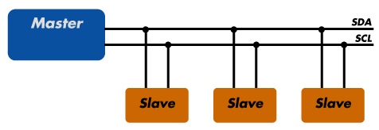

2 devices are connected, 1 with addres 0x48 (the ADC) and also 0x27 (the LCD display, which is externally connected)
So the RPi is the master, and the ADC and LCD are 2 slaves
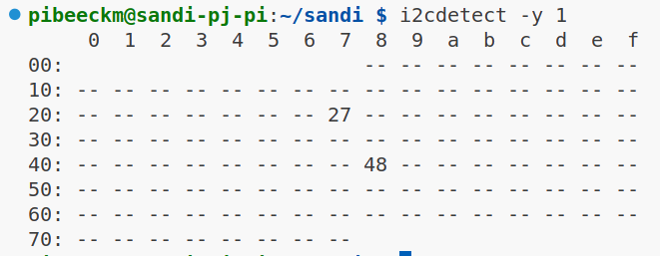

THIS BUS IS NOT ENABLED BY DEFAULT, SEE INSTRUCTIONS BELOW
So this command won’t work (yet) for you

I²C-protocol
The bus is high at rest, for communication a clock signal is generated by the master on SCL. A transmission then always starts with a START condition and ends with a STOP condition.
With an I²C, a byte of data is exchanged each time, we can both read and write on an I²C bus. However, we only have 1 data line, so we will have to clock the byte of information serially. So, we will have to send bit by bit. With the standard I²C protocol, the MSB (most significant bit) is always used. The big difference with the shift register is that each component has a unique address. Next we can send our data directly to the correct device.

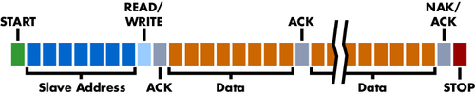
The slave address consists of 7 bits, supplemented by an R/W bit. We will have to shift the slave address 1 bit to the left and complete it with the read/write bit.
With an I²C bus, a start condition must first be given. An address is then sent. A slave that recognizes his address will issue an acknowledge (ACK). Data can then be exchanged with that slave. The communication is concluded by the master by generating a stop condition.

Start and stop condition
The I²C bus is in a resting state when both lines are in a high state. As soon as we bring the data line down while the clock line is high, we give the starting signal. The stop condition is to bring the data line to a high voltage level while the clock line is high.
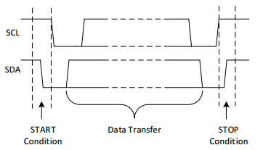

Forwarding data or a command
Sending a command or data will have to be done in the same way. We will have to send one byte serially (one after the other). So we will have to send 8 bits in a row. At I²C, the MSB is always forwarded first. The Raspberry Pi is the master in our case, the master will have to prepare the data as well as generate the clock signal.
A high bit means bringing the data line to a high voltage level. A low bit means a low data signal. You can clearly read the timing on the one below. It is very important that we first prepare the data, then we must bring the clock from a low to a high voltage level. If the clock is high, the dates should not change. After all, that would mean a start or stop condition.
If we program this ourselves, we don't need to provide an extra drag to process the bit, since Python is slower than the I2C bus timings.... If you program this in C, you must take into account a short delay

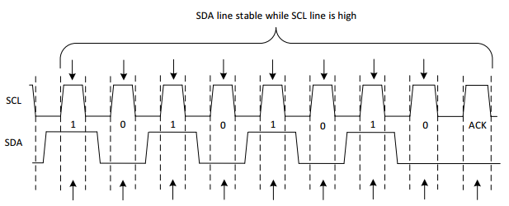

Recognize
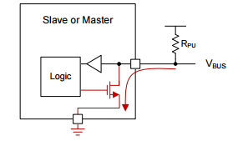
After every 8 bits, the slave can display whether or not he has received the data correctly. To do this, the master has to generate an extra clock pulse.
All the IC can do is bring the data line to a low voltage level. To do this, we create a pull-up input of the data line for the ACK. With a pull-up, we immediately get a high voltage, which can be pulled to the ground by the IC. You can compare this to the way we read a push button. If the data line is pulled down by the chip, the chip has received the data correctly. If the data line remains high, something has gone wrong. At the end of the ACK we have to make an output of the DA pin again.

Write to I²C bus
To write data to the I²C device, we first need to clock the address of the device, then we send the data. Note that the slave responds with an ACK after every 8 bits, for which an additional clock cycle is provided by the master. After a stop condition, we first must generate a new start condition and send the address before we can send data again.
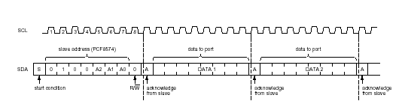

Summarized
Start Condition => Address + R/W => ACK => Data > ACK => ...=>ACK =>Stop

ADS7830 8-Bit, 8-Channel Sampling A/D Converter with I2C Interface
On the outside it looks like this:
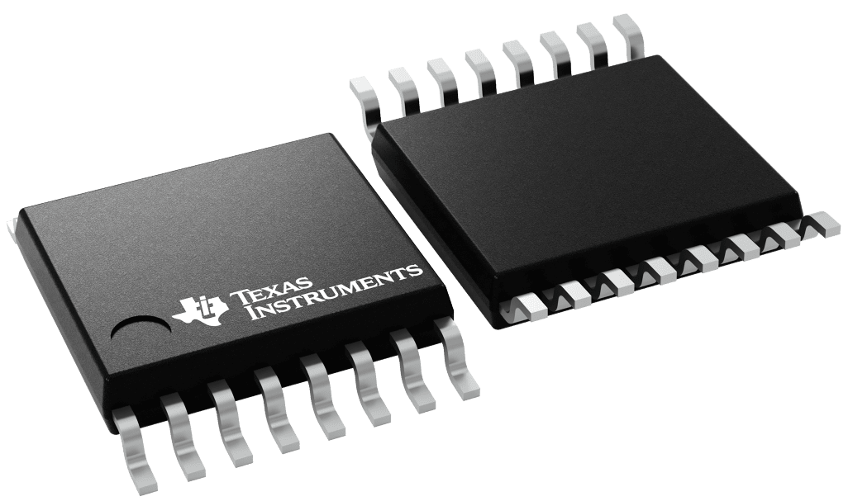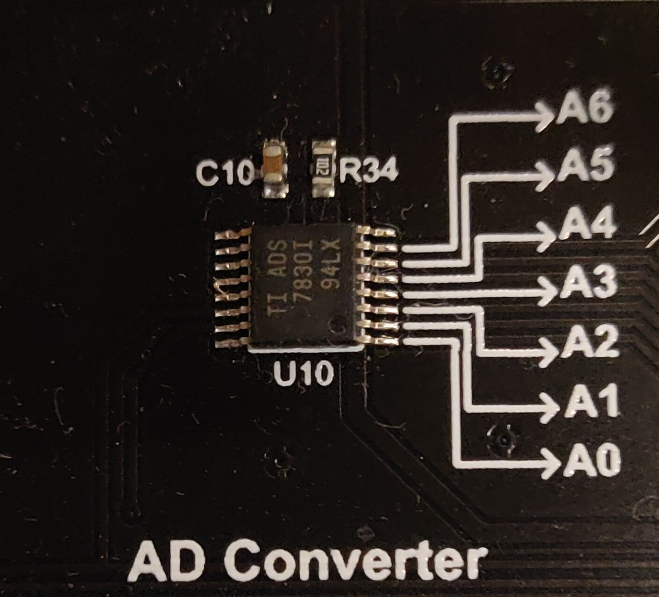

On the inside is ‘looks’ like this:
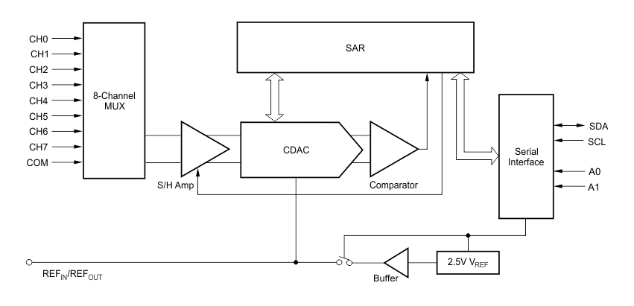

On the left we have 8 channels (0 – 7) which are our different analog inputs
On our board only 7 of them are connected
On the right side we see SDA and SCL (our data and clock pins) but also A0 and A1
These pins are used to select the lowest 2 bits of the address (in case you want to use up to 4 of these devices on the same i²c bus)
(In the middle we have the electronics which measures what we ask it to measure, voltage of a single channel compared to ground, or comparing 2 channels)
On our board the pins A0 and A1 are connected to ground
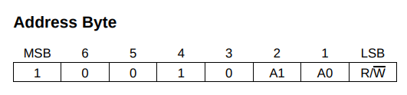
So our address is 0b 100 10[A1][A0] = 0b 0100 1000 = 0x48

Because this chip has multiple channels to read the value from, we’ll have to “say” to the device which channel we want to read. (This is the data byte we are sending, before reading a data byte with the response)
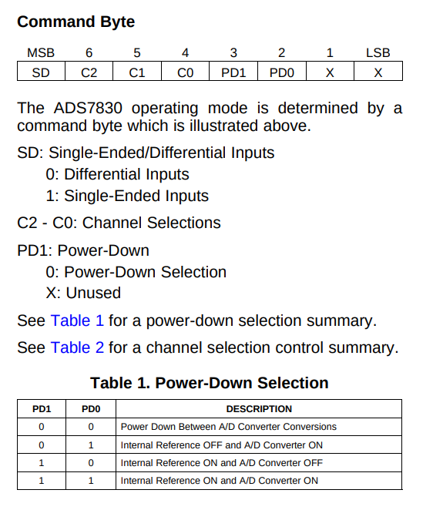
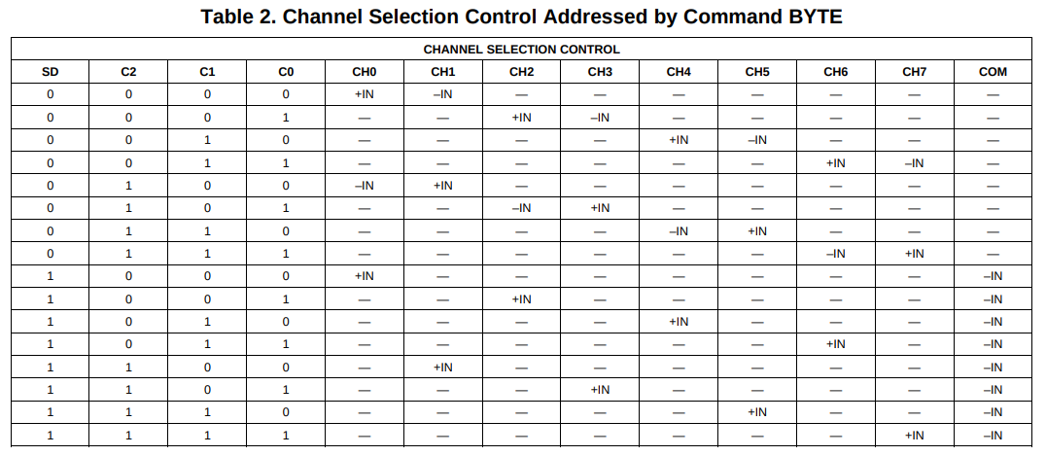

So if we want to read our potentiometer connected to A2 (channel 2), we have to ask for:
CH2 is +IN, COM (common or ground) is –IN
So bit7 (SD) = 1; bit6 (C2) = 0; bit5 (C1) = 0 and bit 4 (C0) = 1
(Bit7 will always be 1 if you want to read a single channel)
This is the Most Significant nibble of the data byte
The lowest nibble is PD1 PD0 X X
The lowest 2 bits (the X’s) are ‘not used’, so it doesn’t matter which state these are (but I put them low by default)
PD1 and PD0 define the power state. 00 is off, we want 01 or 11 (the external reference is the same as the internal, so doesn’t matter if enabled or not. The AD Converter needs to be enabled)
So for channel 2:
0b 1001 0100 = 0x94
For channel 3:
0b 1101 0100 = 0xd4

The output or result will by an 8 bit value (exactly 1 byte!!)
This means it can represent decimal numbers from 0 – 255 (2⁸ = 256 values)

This means the input voltage gets transformed from 0V – 3.3V to 0 – 255

I²C bus on the Raspberry Pi
THIS BUS IS NOT ENABLED BY DEFAULT, SEE INSTRUCTIONS BELOW
The address of an I²C device consists of 7 bits supplemented by the R/W bit. So we can have 128 possible addresses. Because a number of them are reserved, both at the beginning and at the end, there are 112 addresses left that can be used for slaves.
Via the command "i2cdetect -y 1" you can find all devices on the I²C bus of your pi. In the table below you will find 8*16 = 128 memory slots. The addresses are written hexadecimal WITHOUT the R/W bit.
On our kit has the ADS7830 connected by default, so it should always show up in a I2C scan
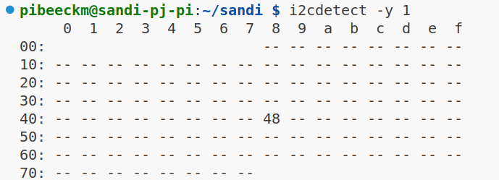

SM Bus (System Management Bus)
The Raspberry Pi features the SM-Bus technology, which is an interface based on I²C with, among other things, stricter parameters for timing and voltage and a number of fixed transactions. It was originally developed by Intel for use on PC motherboards and is still used there. The datasheet can be found via the link below.

https://www.nxp.com/docs/en/application-note/AN4471.pdf

By using this bus and the accompanying Python library, a lot of work is taken off your hands. The bus will take care of the start and stop condition, acknowledges and sends the data.
All we have to do is call the correct instruction, provide the address, and prepare or read the data. The library has the following commands:
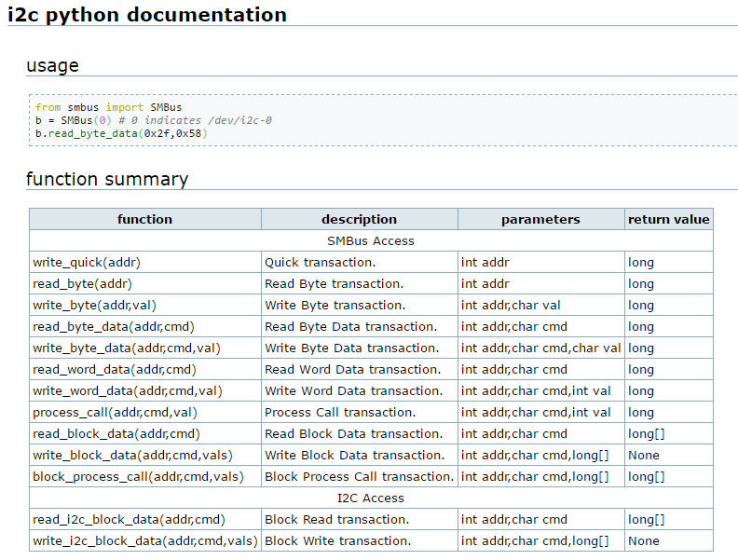

Of course, we also must open and close the I²C bus

below is an example
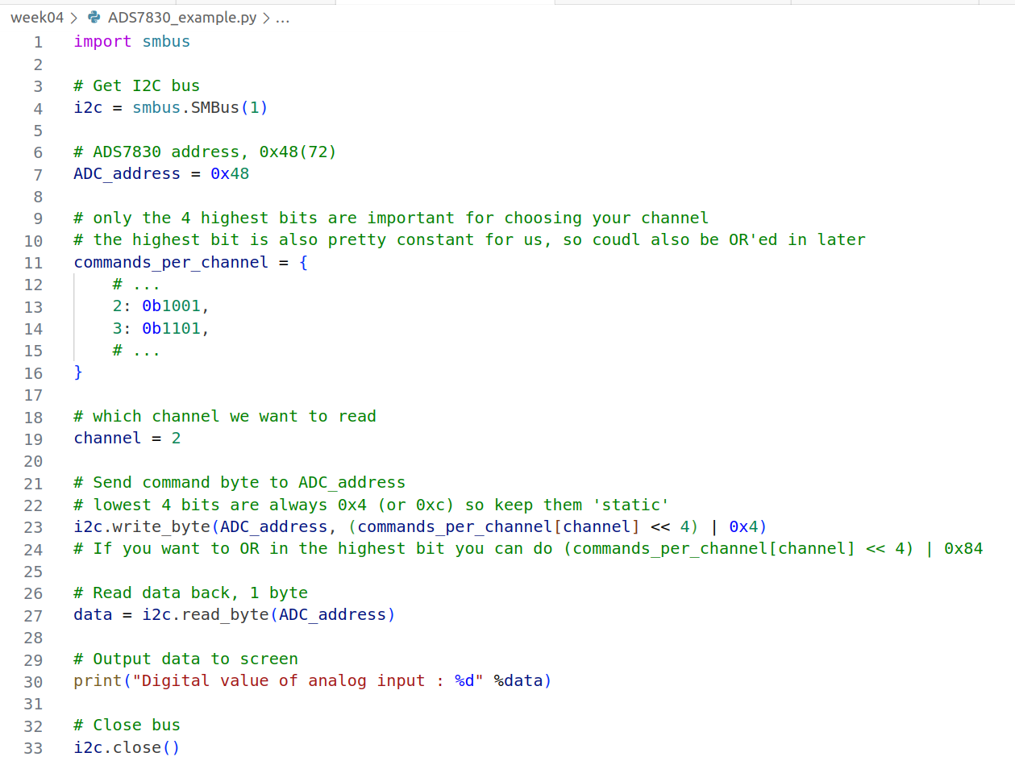
We can now read to values of:
- 2 axes of the joysticks (channel 6 and 5)
- 3 potentiometers (Channels 4, 3 and 2)
- Temperature sensor (Channel 0)
- (External) Photoresistor (Channel 1)
Or any other analog sensor you connect to the pin.

Assignment I²C

Before programming: create a git branch ADC and commit your changes in this branch (I can easily check the existence of branches via the ClassRoom, your git usage will influence your marks)

Make sure your I2C bus is on with raspi-config
sudo raspi-config > Interface Options > I2C > YES
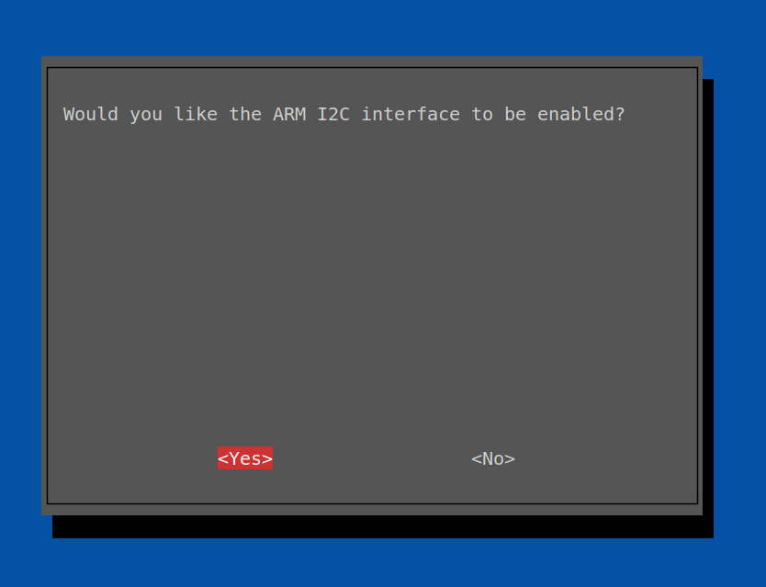

Check (with i2cdetect) if your component is visible. If not, adjust the speed of the bus to 100000 or lower

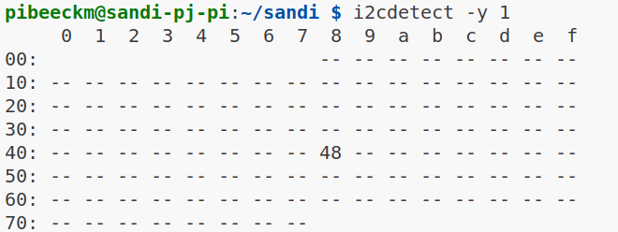

Adjust speed if your component is connected correctly, but still not visible

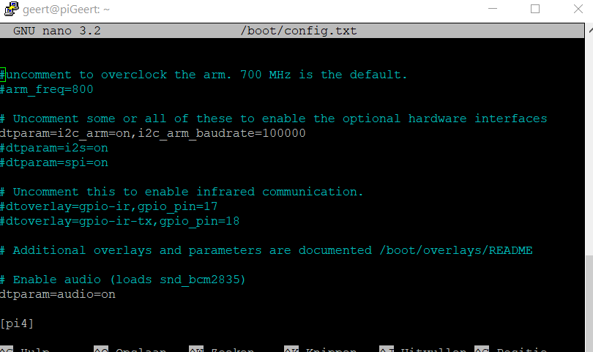

For example, if you later use an i2c o-led display, a lot of data must be transmitted, it is useful to check if you can't place the I2C bus again (400000 = 400 kHz)

Read the value of 1 of the potentiometers (A4, A3 or A2) and convert back into Volts
Modify the example code
- Add the correct command for the channel you’ll use (or maybe for all channels already?)
- Read the potentiometer value (see example script above)
- Transform into Volt (0 – 5V)

A potentiometer is a variable resistor. The voltage will divide itself over the 2 parts created by “splitting” the resistance. We measure the voltage over 1 of these parts with our ADC.
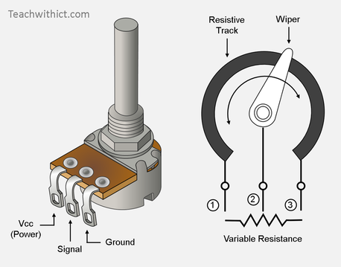

With the RGB Led
We can now read the analog input values of our 3 potentiometers, and use these values ( 0 – 255 ) to control the brightness of each ‘segment’ of a RGB led with PWM (0 – 100) (Duty Cycle)

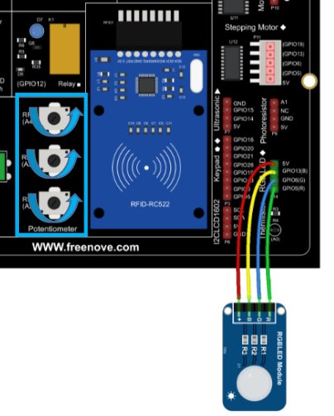
Common Anode vs Common Cathode

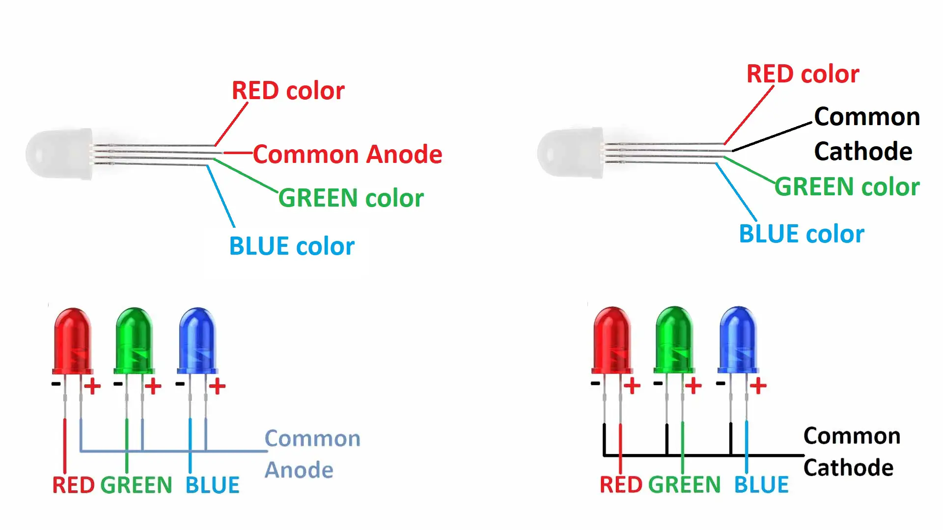
When RGB leds are configured as Common Cathode, this means all 3 leds share a common connection to ground/GND. This means each pin is responsible for supplying the current the light up the corresponding led. (0V = off, 3.3V = on)
In our case, the leds are configured as Common Anode, or shared power in. This means the leds are supplied with current by default, and each pin is responsible of stopping the incoming current. So when we apply 0V to the pin, it will block nothing and the led will shine in full brightness. If we apply 1V we will have a smaller voltage drop, so less current, so less brightness. When we apply 3.3V (the maximum of our GPIO pins) the led should be off.
Our board is wired wrong and the common voltage is not 3.3V but 5V. This means, even if we supply the full 3.3V our pins can give, there will always be some voltage left, so the led segments will never truly be off.
So when we want the RED led to light up, in common cathode we would use the RGB/PWM values 100,0,0
But in our case, this would block the red led, and allow green and blue to shine as bright as they can
We will need to invert our values, so 100, 0, 0 would become 0, 100, 100

Assignment:
Write a program that can read the values of the 3 potentiometers, and use them to control the RGB led segments (PWM)
Use 1 of the 4 buttons to turn the “system” on and off (but the RGB led will never be completely off....) using events

DON’T FORGET TO GIT COMMIT and SYNC

Go to source control tab
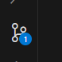

Press the “+” button next to the files you want to commit

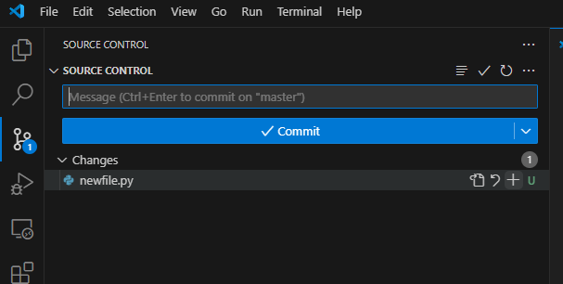
These files will be staged
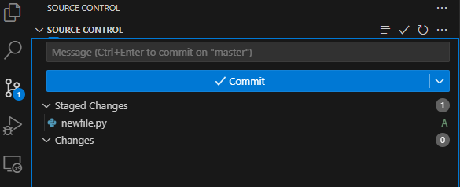

Next, we can enter a message (telling about the changes we’ve made) and press commit
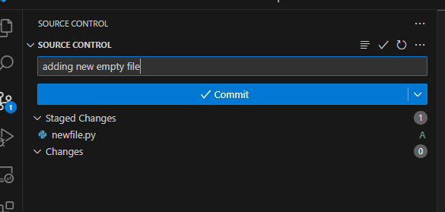

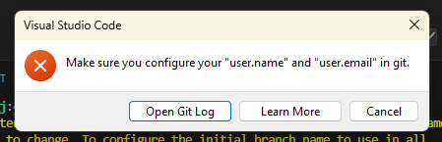
When first committing you’ll need to tell the system (Raspberry Pi) who you are, see: https://support.atlassian.com/bitbucket-cloud/docs/configure-your-dvcs-username-for-commits/

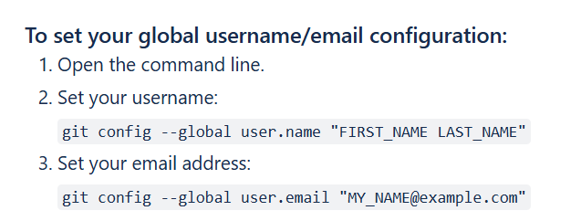

After committing we can sync or push with the cloud/internet

