Text, Serial & Parallel communication + Servo
(with 16x2 Lcd-display)

Objective
- Building communication with a text - LCD display
- Use of Bit Operations
- Serial vs parallel communication
- Learn how to implement the controller datasheet.
- Understanding timing diagram and ability to convert into code.
- Working with hexadecimal numbers.
- Building protocol in 4-bit
- Creating and using classes in Python.
- Servo motor

Introduction
Remember how you used bitwise operations to control individual bits within numbers, and how those bits can be sent one-by-one (serial) or in groups/at the same time (parallel)? Similar principles apply when you work with text. Under the hood, text is represented by sequences of numbers (character codes).

ASCII
We know how to represent numbers as binary (the way computers think) but we can (must) also make a binary representation of text. There is a standardized way of doing this by transforming each character into a byte. This is done according to the ASCII table:
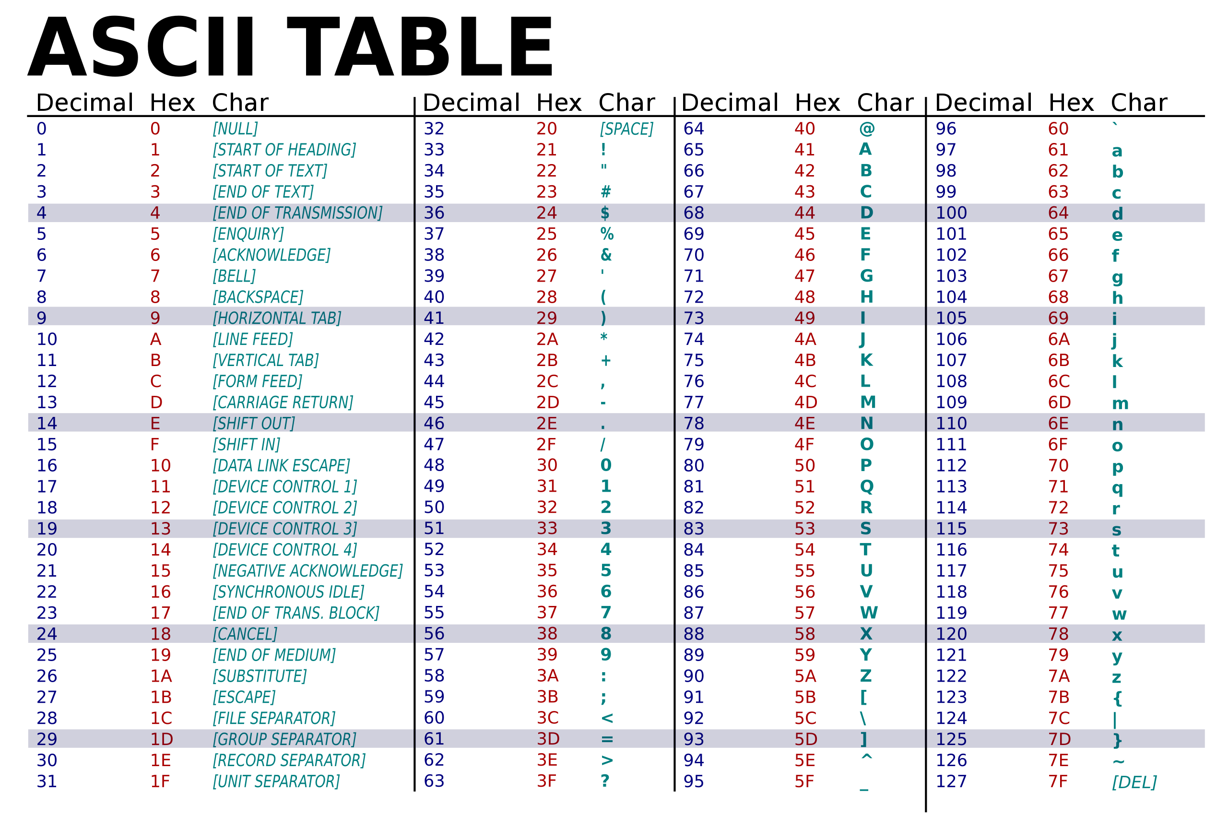
As you can see, each character (visible and invisible/special characters too) can be represented as a number (be it decimal, hexadecimal or binary)
We can use the ord(char) method in python the get the ASCII value for the given character.
Ord stands for ordinal data type, which is a data type that can be used to calculate.
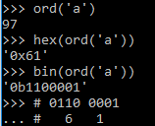
For example, if we want to send the letter 'a', we will first have to request the ASCII code and the letter 'a'. The ASCII code of 'a'=97 or 0x61.
When we clock out these bit values one after the other for every character in a string, we’ve invented/implemented serial communication.

UART / Serial protocol
The serial port on the PC (also known as RS-232, after the standard in which the interface is defined) is what is called an asynchronous serial interface meaning there is no synchronization or clock signal on the port, so characters can be sent at any given interval. The transmission of the data can start at any time, and it is the recipient's job to detect when a message starts and ends. By the word serial, we mean that the information is transmitted bit by bit.
This makes the hardware very simple: one wire to send data, one to receive data and a common ground are in principle sufficient for full-duplex operation. It is a point-to-point connection, there are only two participants and therefore there is no need for addressing.
The chip that controls such a serial interface is therefore called a UART (Universal Asynchronous Receiver/Transmitter). The terms UART, RS-232, and serial port are often used interchangeably. The term RS-232 or Recommended Standard 232 describes connectors, electrical properties, etc.
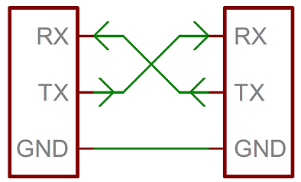

Hardware (layer 1)
Originally, a logical 0 of space was defined as 3-15V and a 1 or mark as -3 to -15V, signal levels between -3 and +3V are invalid. Soon many devices were working at -5 and +5V and nowadays the same protocol is often used at TTL level (0 and 5V).
In addition, the bus is high by default, which in this case is regulated by the UART itself, so we don't have to provide a pull-up as was the case with 1-Wire.

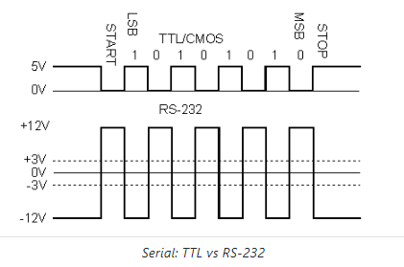
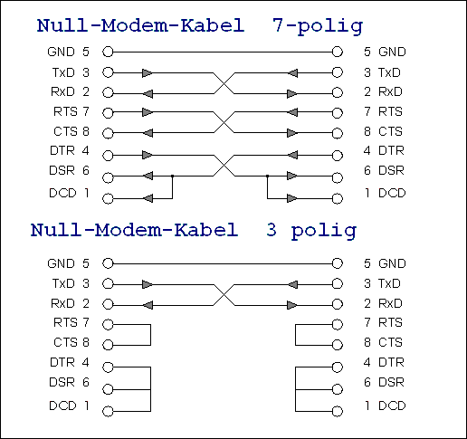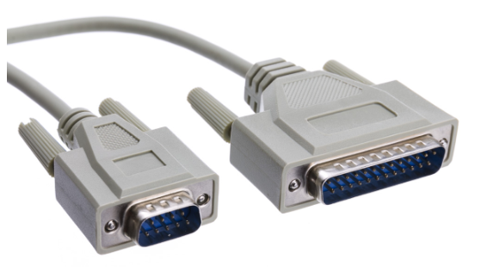Null-modemkabel 
Note that we need a "crossed" cable to exchange data from host to host via the serial port. The Tx pin of the transmitter must be connected to the Rx pin of the receiver and vice versa. (In the context of the old serial port, such a crossed cable is called a null modem cable. Serial connections were widely used for connecting a modem to your PC, and with such a null modem cable you could connect 2 computers directly without the modems in between.)
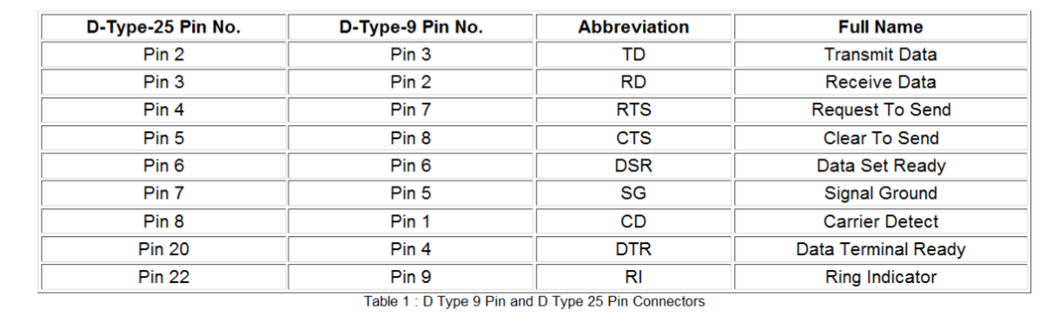

Protocol (layer 2)
All data bits are located between a start and stop signal. The start bit is one 0-bit, the next seven or eight bits form a data byte. Optionally, a parity bit can be added as a check. The character is terminated by one or two stop bits. On the receiver side, the data is recognized by the start and stop signals. The number of start, data and stop bits can be set and must of course be the same on both sides.

Baudrate
The speed is expressed in baud or symbols per second and is therefore also called baud rate. The serial port has only 2 symbols, mark and space, so the baud rate corresponds to the gross bitrate. However, this is not necessarily the case!
Let's say we're working with 8 data bits plus a start and a stop bit, then we need to divide the baud rate by 10 (8 + 1 + 1) to know the net transmission rate in bytes/sec.
Not just any baud rate is possible, some commonly used ones are:
- 9600 baud (Today standard, but slow. Supported by virtually every UART)
- 19200, 57600, 115200 baud (Note: all multiples of 9600, which in turn was a multiple of 300!)
- 64k baud and multiples
- 1M baud and multiples
Not every UART supports all speeds, especially higher ones, so check in advance. It goes without saying that high baud rates (100k+) place higher demands in terms of electrical connection and accuracy of timing.
Both the transmitter and receiver must have the same baud rate. After the first bit has been received, the receiver calculates when the next data bits can be expected. The lower the baud rate, the slower the communication, but the greater the maximum cable length can be.
Note that a positive voltage means a low bit, the negative voltage is a high bit.

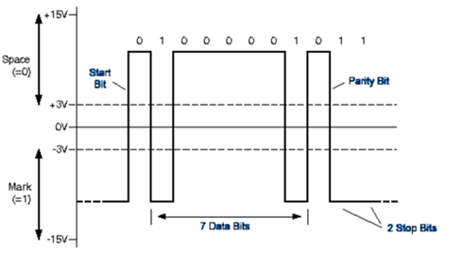

Flow control
A final option that we can set is flow control. This is a mechanism by which sender and receiver can notify each other when they are ready for data transmission. This can be done either in hardware (i.e. with extra signal wires), or in software with special characters.
Hardware:
- RTS/CTS: Request To Send/Clear To Send pins are used to indicate that the device is ready to send/receive data
- DSR/DTR: Data Set Ready/Data Terminal Ready lines that actually indicate that the device is online and ready are sometimes abused for flow control
Software:
- XON/XOFF: Are special ASCII control characters that are sent as data from receiver to sender to start/stop transmission
Flow control used to be very important to connect a modem, but is no longer widely used today. So we are not going to apply it either, the above is just for information.

Different serial communication options
The Raspberry Pi 5 has 2 Serial Ports by default:
- Serial0 > /dev/ttyAMA10
Debug UART, always active and enabled (but special tiny cable required)
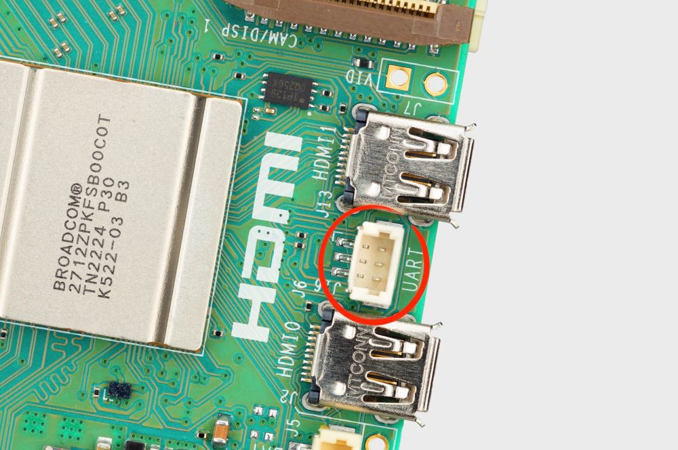
- Serial1 > /dev/ttyAMA0
Using GPIO pins
Needs to be activated via sudo raspi-config > interface options > Serial port
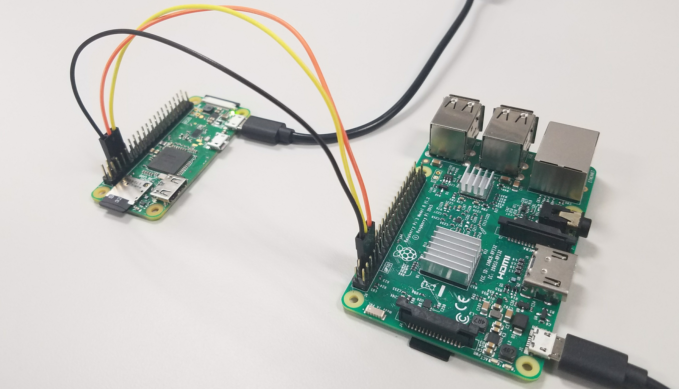
Notice the cross connection of RX and TX pins!

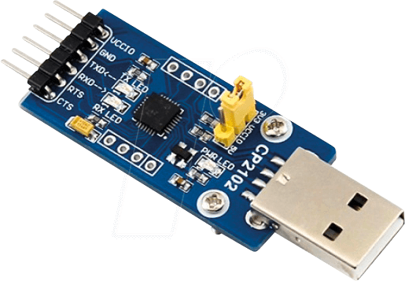
A lot of USB devices create a new serial port when connected. This can be /dev/ttyUSB0. For devices like your laptop, which don’t have GPIO pins available, you can also buy special USB sticks whose sole function is to act as a serial port.
(e.g. https://www.reichelt.com/be/nl/ontwikkelaarsboards-usb-type-a-op-uart-cp2102-debo-usb2uart-2-p266051.html)

Assignment: send a message via a light signal
Our RX and TX pins are not ‘broken out’ by our kit, so we will just use our blue LED as TX (transmitting) pin.

We will send a message via a GPIO pin, e.g. the text 'hello'. So we will have to parse character by character of this string into 8 serial bits and send them one after the other.
- send_byte(byte) Function:
  - Takes a single byte (ASCII character) as input.
  - Loops through bits (most significant first), sending each bit to the LED:
    - Print "1" or "0" to the console for each bit.
    - Set the GPIO pin high or low to match the bit.
    - Add a 200ms delay between bits.
- Transmit Your Message:
  - Create a string (e.g., "hello").
  - Loop through each character, calling send_byte() to transmit it.
  - Insert a 1s delay between characters.
Remember: Review bitwise operations and ASCII character encoding if needed.

- ord
- for c in piece_of_text:

Before programming:

On RPi: check git config, complete if needed

On RPi: commit + push any changes left in working directory

On RPi: create a new branch Serial or UART
Do the exercise

After programming:

On RPi: commit, push

Online/in browser: merge branch into main

On RPi: switch to main branch and perform sync / pull action
(making sure your PWM code is accessible/visible/runnable)

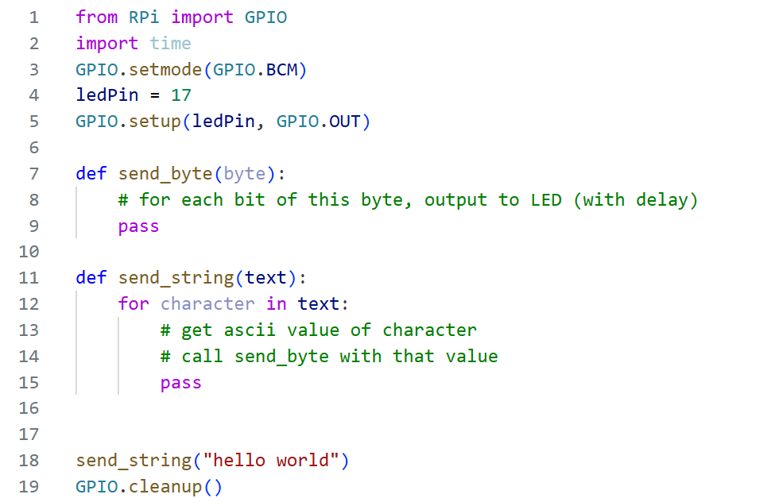

Configuration
(if you want to use the real serial port, we won’t use this because of our board)
sudo raspi-config
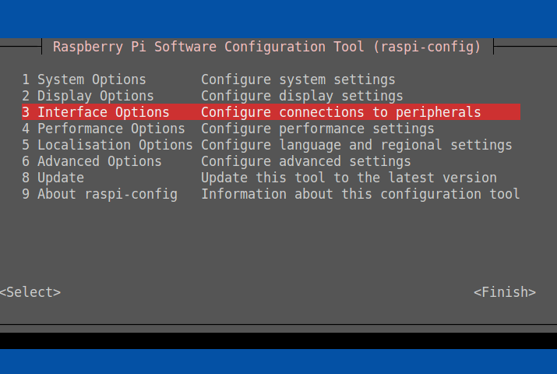
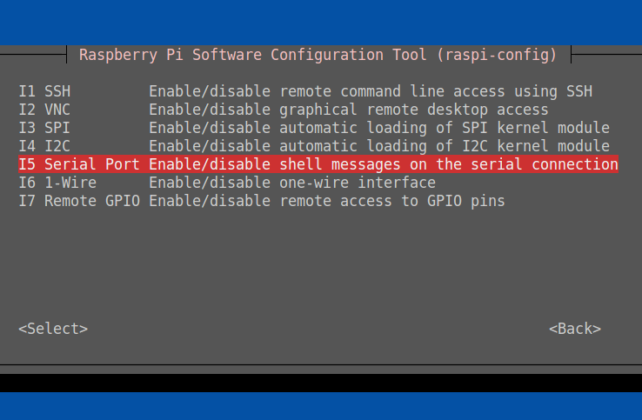
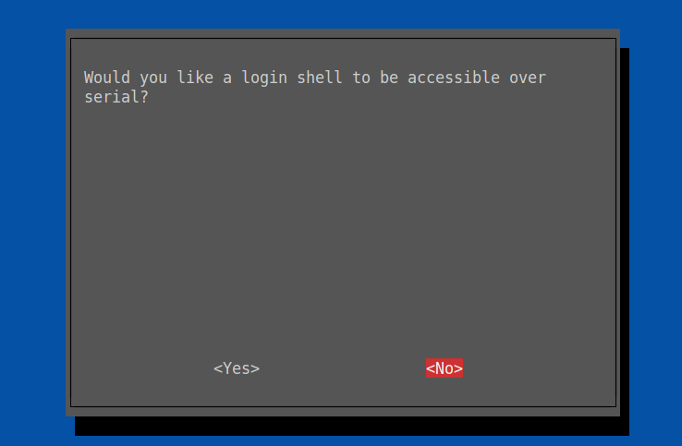

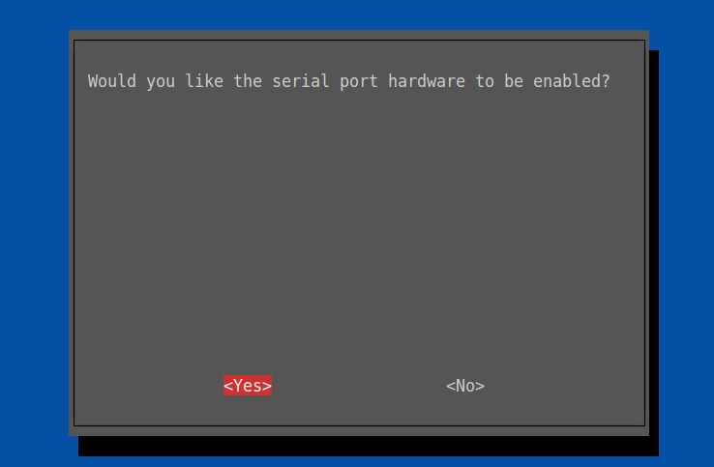
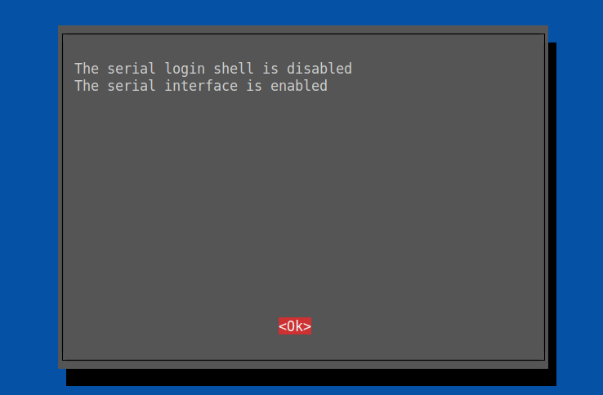

Since the release of Raspbian Jessie, the GPIO Serial Port has been disabled by default. Via the raspi-config menu you can enable the serial port. When setting up, select only that you want the serial port, and don't want to log in via the serial port.

After rebooting, we can check this with the following command:
ls -l /dev/se*
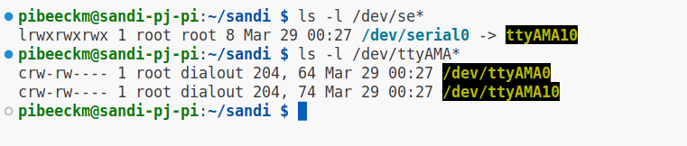
The blue color indicates that a file is a link, and the arrow reveals where the link is pointing.

Note that the file is owned by the dialout group, so you need to be a member of that group to use the port. Check:

me@my-rpi:~ $ groups
adm dialout cdrom sudo audio video plugdev games users input netdev gpio i2c spi

Python : PySerial
In Python, you can use the pySerial to easily open a serial port. This is normally already installed
You can use the Serial class from this package to open a serial port, e.g. with default settings (9600 8/N/1):

>>> import serial
>>> ser = serial. Serial('/dev/ttyAMA0') # open serial port
>>> print(ser.name) # check which port was really used
>>> ser.write(b'hello') # write a string
>>> ser.close() # close port

The API of "serial " can be found at the following link:
https://pypi.org/project/pyserial/
http://pyserial.readthedocs.io/en/latest/shortintro.html?highlight=readline
Depending on your setting, you can use "/dev/ttyS0" or "/dev/ttyAMA0". Better yet is to use the alias: "/dev/serial0". Then your script will work on the pi2 as well as the pi3 and pi4, regardless of the configuration. Print the text in the console.
The Serial class also has a Context Manager, so you can use with:

from serial import Serial, PARITY_NONE

# simple echo server
with Serial('/dev/ttyAMA0', 115200, bytesize=8, parity=PARITY_NONE, stopbits=1) as port:
while True:
line = port.readline()
port.write(line)

Level shifter (FYI)
The (logic-)level shifter is a module that we can use to digitally connect components that operate at different voltages. To be able to convert in two directions, we need a bidirectional variant. Internally, the level shifter consists of a transistor circuit, think of how we used a transistor to drive a motor at a higher voltage than the RPi can tolerate. Of course, a directional shifter will be a bit more complicated, with multiple transistors.

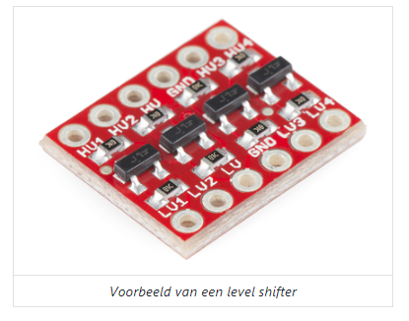
Level shifters come in variants with a different number of connections. One side is low voltage (LV), the other side is high voltage (HV), so you can NOT switch sides between 3.3V and 5V devices! At the LV and HV connections you have to connect the respective supply voltage. Furthermore, each side has a connection for the corresponding ground (GND) that you need to connect. Finally, there are connections for the data lines, indicated with LVx and HVx in the picture and on the diagram with Ax and Bx.
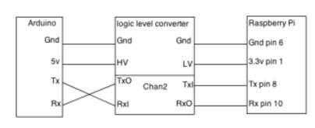

LCD Display

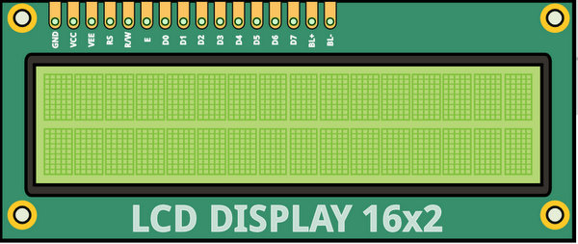
There are several libraries to control the LCD display in parallel or via i2c, but in this lab we will write a class OURSELVES to control the LCD display in parallel. In this way, we also learn a parallel protocol. The LCD display can be controlled in either four or eight data bits. The advantage of the 4-bit mode is that you need four GPIO pins less. The disadvantage is that you have a bit more programming work and that controlling the LCD display becomes a bit slower.
The controller of the LCD displays is a HD44780, this controller is used to control different types of LCD displays including 4*20 display, 2*16,...

Pin Numbering LCD Display
Pin 1 and 2 are the power supply of the LCD display. The power supply pins of the Raspberry Pi can provide enough power to power the LCD display. But we still recommend feeding via the external power supply.
Pin 3 is the contrast pin of the LCD display. We can connect a trimmer to pin 3 so that we can regulate the voltage at pin 3 between 0V and 5V (if the display is powered at 5 volts).
Pin 4, 5 and 6 are the control signals. Pin 5, the R/W is often connected directly to the ground because usually nothing has to be read from the LCD display.
Next, we have the 8 data lines. Of which we have to connect four or eight to the GPIO pins, this according to the choice of sending 8 or 4 bits.
With pins 15 and 16 we can light up the backlight. These are the anode and the cathode, respectively.
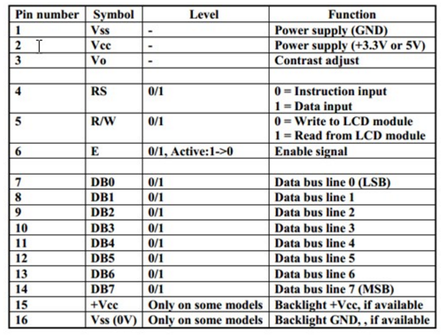

Controlling LCD Display Controller (HD44780/KS0066)

The graphs below can be found in the datasheets of the display. The enable signal E can be compared to the clock signal SCL of the SPI bus or the shift register. The enable signal determines when the display controller will process the data. In contrast to the past few weeks, the data is now processed during the descending flank. 8 bits of data are now also processed per clock pulse.

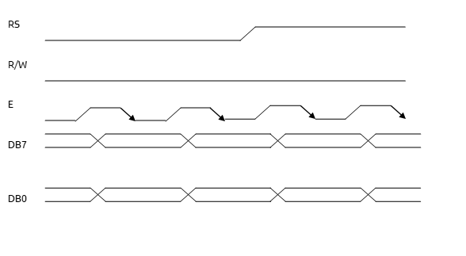
The SEQUENCE of the signals is also very important. We first bring the enable signal to a high voltage level, then we prepare the data.
If we now bring the enable signal back to 0V , the data is processed by the display controller. Via a wait (sleep) instruction, the display controller must be given some extra time to process the data.

In summary, our program should be as follows:
=> E = high => Preparing data => E = low => wait => E = high => ....
However, there are still two lines of control:
- The control signal R/W determines whether we read or write data to the display. A low signal is writing, a high signal is reading. We limit ourselves to writing data. So that this line may remain on low for our lesson.
- Finally, we have the register select signal (RS), which determines whether an instruction or a character is sent. Move the cursor, the shape of the cursor,... are examples of instructions. If the RS signal has a value low, we send instructions to the display controller, if the signal is high, we send characters to the display controller.

Hexadecimal arithmetic (Per 4 bits) repetition
The big advantage of hexadecimal arithmetic is that you have almost no calculations when converting a binary number to a hexadecimal number. After all, one hexadecimal digit corresponds to 4 bits.
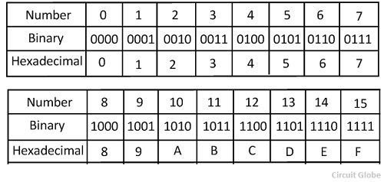

E.g.: 1111 0100 0011 1101
= 0x F 4 3 D

Protocol LCD display
Since we limit ourselves to writing to the LCD display, the signal R/W always remains at a low voltage level and we can connect it directly to our circuit without a GPIO pin.

We can program the following subroutines :
def send_instruction(value):
...
time.sleep(0.01)

def send_character(value):
...
time.sleep(0.01)
These functions will take care of the E and RS signal and in turn both use a function to bring the 8 data pins to the right level. At the end of an instruction we have to build in a small delay.

def set_data_bits(value):
...
This should become a routine that extracts the bits from the byte, but instead of sending them serially, we now prepare them in parallel on the 8 GPIO pins of the data bus
TIP: Put your GPIO pins for the data bus in the right order in a list, then you can prepare the pins in a for-loop with 1 line! The list index and bit number will match nicely. Of course, you will have to use bit operations to filter out the value of that bit.

Some Basic Instructions
 | RS | RW | DB7 | DB6 | DB5 | DB4 | DB3 | DB2 | DB1 | DB0
Clear display  & Cursor home | 0 | 0 | 0 | 0 | 0 | 0 | 0 | 0 | 0 | 1
Cursor home | 0 | 0 | 0 | 0 | 0 | 0 | 0 | 0 | 1 | *
Display on  Sets On/Off of all display (D), cursor On/Off (C) and blink of cursor position character (B). | 0 | 0 | 0 | 0 | 0 | 0 | 1 | D  I=ON  0=off | C  I=ON  0=off | B  I=ON  0=off
Function set  Sets interface data length (DL), number of display line (N) and character font(F). | 0 | 0 | 0 | 0 | 1 | DL  I=8bit  0=4bit | N  I=2lines  0=1line | F  0:5x7  I:5x10 | * | *
Sets DDRAM | 0 | 0 | 1 | DDRAM address
In the table above you will find the most important instructions to initialize the display. You can find the full list of instructions in the datasheets. The controller recognizes the instruction by the first, most significant bit, with the following bits we can then give different options or display a cursor position.
To initialize the display we must invoke the following instructions:
- Function set
- Display on
- Clear display in home cursor.
With the instruction "function set" we have to indicate the type of display. Our display has 2 lines and characters of 5x7 pixels. You can set the data length to 8 bits. Because we use this instruction to determine whether we are working in four-bit or eight-bit mode, this should be the first instruction. For example, if we want to set the "function set", the controller recognizes the function because we set bit 5 (DB5) high. With DB2,3,4 we can then determine the type of our display. In the place of the asterisk we can set anything.
With the instruction "display on" we can switch the display on and off, we can also set the cursor. Optionally, we can also move the cursor to its home position and clear the display.

Memory addresses of the LCD display
The controller of the LCD display can also control a display of 4 x 20 characters, which is why the controller also has 40 memory addresses. The visible memory locations of the display are the addresses 0x00 to 0x0F for the first line. The second line has the addresses 0x40 to 0x4F
The addresses of the cursor positions can be obtained from the table below.
DDRAM address:
Tip: with this DDRAM you need to add data bit 7. You can easily do that with bit surgery.

PCF8574 8-bits I/O-expander for I²C-bus
Our LCD display has an extra component to it: a PCF8574 / backpack
A PCF has the same functionality as a single shift register: 8 GPIO pins become available. Unlike the shift register, this component works on the I2C bus (like our ADC)
We’ll have to, again, use the smbus library in combination with a device address in order to communicate with this device/our LCD.
The PCF8574 has 3 pins that determine the lowest 3 bits of the address, so you could connect 2³ = 8 devices on the same bus. The base address means these 3 address pins (A2, A1 and A0) are connected to GND.
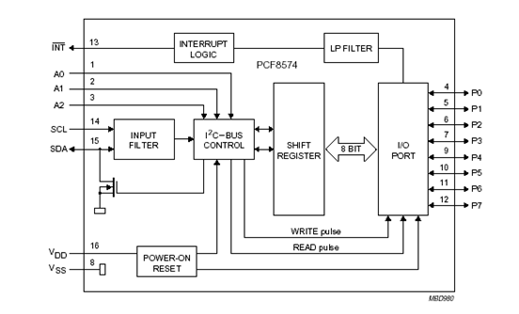
There are two types of the PCF8574:
- PCF8574: Has a fixed base address of 32 (0x20)
- PCF8574A: Has a fixed base address of 56 (0x38)
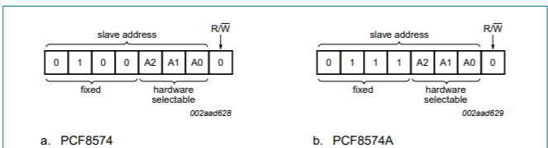

Pin Lay-out

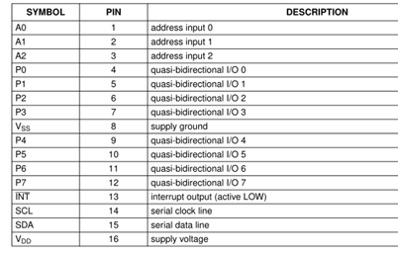
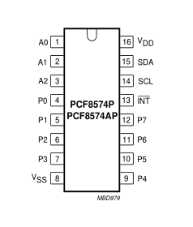
This chip only has 8 output pins, but the LCD needs 8 datapins, E, RS, R/W optionally
10 (11) > 8, so we kind of have a problem
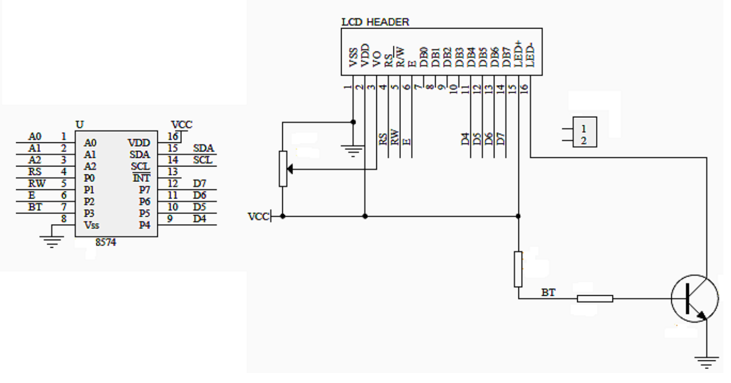

4 Bit mode
As mentioned before, the LCD can be driven in with only 4 databits
What we need to do is serially clock the 2 groups of 4 databits
We have to split our data byte into 2 nibbles, and send both of them to the 4 highest datapins. First the Most Significant part (0xF0) give a clockpulse and wait, next the Least Significant nibble (0x0f)
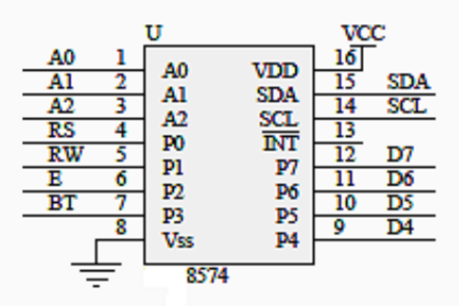
When sending the nibble, we are only using bit4-7 of the byte we’re sending to the PCF
Bit0-3 do still have a function, so we have to be mindful of them. (Meaning we have to actively set to correct value for what we want to do)
Bit0 of our data byte we’ll send via I2C is connected to the RS pin (instruction or data pin)
Bit1 is the RW pin (Read/Write pin)
Bit2 is the E pin (Clock pin)
Bit3 is BT (Backlight Toggle pin)
When we send our 4 data bits (as bit4-7 of our i2c data byte), when we toggle the E pin (bit2), we also need to “say” if it’s an instruction or data, if we are reading or writing and if the backlight should be on. (bit operations!)
To toggle our E pin, we will need to send 2 bytes of data to our device, once with bit2 high, and once with bit2 low.
We’ll have to modify the set_data_bits method:

def set_data_bits(value, mode): # mode instruction or data
MSNibble = ...
LSNibble = ...
... # send MSNibble with E bit high, BT bit high and RS bit according to # “mode” and little delay
... # send MSNibble with E bit low, BT bit high and RS bit according to # “mode” and little delay
... # send LSNibble with E bit high, BT bit high and RS bit according to # “mode” and little delay
... # send LSNibble with E bit low, BT bit high and RS bit according to # “mode” and little delay

You can see the repeating part with the E pulse, for which we can create a dedicated method:

def send_byte_with_e_toggle(bits):
# Toggle enable
time.sleep(E_DELAY)
# write data to i2c with E bit HIGH
time.sleep(E_PULSE)
# write data to i2c with E bit LOW
time.sleep(E_DELAY)

We are still not done....
When the LCD starts (after being powered down) it will always be/expect an 8 bit instruction.
When we (re)start our program, the LCD can be either in 4 or 8 bit mode. This will break things because the behaviour of the LCD is not consistent.
We can make it consistent by doing a little “trick” (a.k.a. spamming):
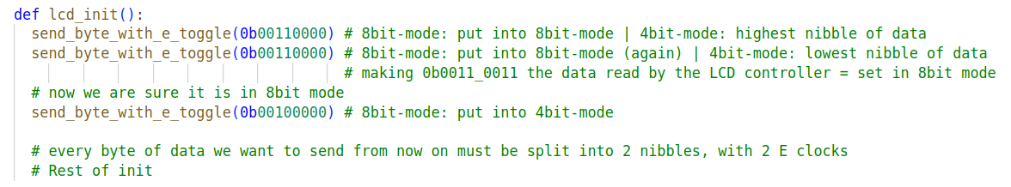
Bit0 always needs to be 0, in order for the LCD controller to interpret this as an instruction

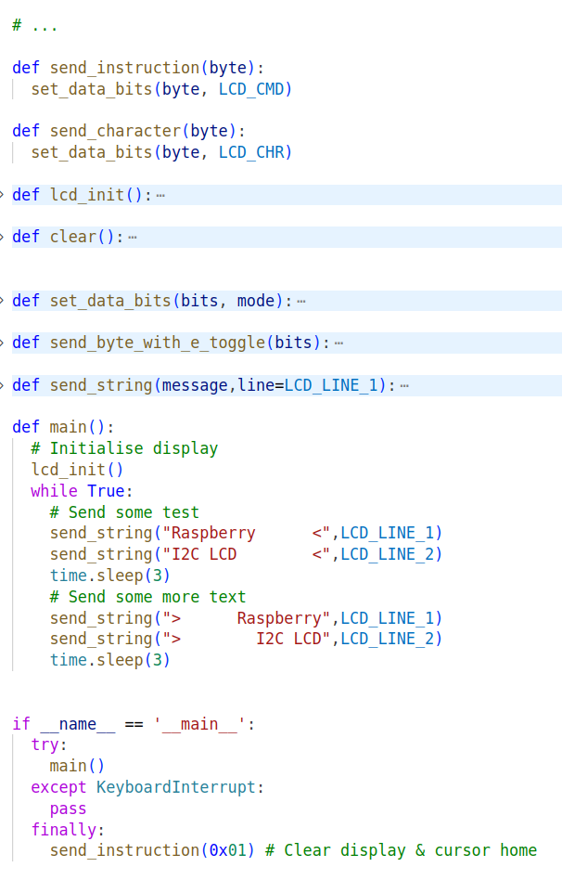

Driving the LCD display
- Connect the LCD, make sure to match the correct pins!
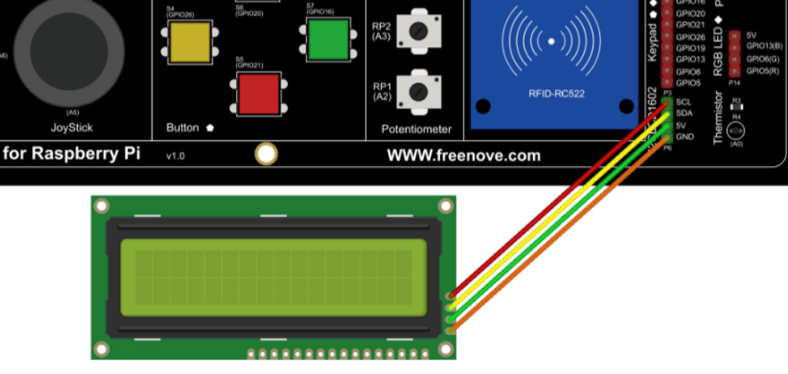
- Create some constants to use; I have defined the following values:
I2C_ADDR = # I2C device address
LCD_WIDTH = # Maximum characters per line
LCD_CHR = # bit value for bit0; sets mode - Sending data
LCD_CMD = # bit value for bit0; bit0 sets mode - Sending command
LCD_LINE_1 = # Instruction to go to beginning of line 1
LCD_LINE_2 = # Instruction to go to beginning of line 2
LCD_BACKLIGHT = # Data bit value to turn backlight on
ENABLE = # Enable bit value
E_PULSE = 0.0002
E_DELAY = 0.0002
- Initialize an i2c object
- Write an init_LCD() method. In this definition, you first “force” the LCD into 4bit mode, next you invoke the instruction function set, display on, and clear display & cursor home. So forward 3 instructions in a row (in the right order)
If you call this method, you should see your cursor blinking in the beginning of the first row
- Create the method send_byte_with_e_toggle(byte) as outlined before
you’ll have to transfer the byte 2 time to the PCF, 1 time with bit2 high, the other with bit2 low.
Don’t forget the small delays
- Write the set_data_bits(bits, mode) function, again, as outlined before
Split the incoming bits into 4 highest and 4 lowest bits, use these as the 4 higest bits of the new data bytes
Add the correct lowest 4 bits to both databytes (add mode, enable backlight), and send them using send_byte_with_e_toggle

- Write the send_instruction(value). This method will simply call set_data_bits with the correct mode
- Write the send_character(value). Same as before, use correct mode bit value.
- Now you can test the code for the first time by sending individual characters to the LCD
- Test the send_character(value) method. For example, enter the ascii code 65 and the letter 'A' should appear on the display.
- Write a def send_string(message, line). This method first places the cursor on the right place using send_instruction, next it goes through the message and writes character by character to the LCD display.
- Ask for input from the user. You can print the entered text on the display. Also, make sure that the text is displayed correctly if the text is more than 16 characters. Solve this by using an extra instruction in between.
- Allow the user to set a number of options of the cursor. Solve this by using bit operations.
- Make the class LCD, an example is on the right, but you have to work with a ruse instead of separate pins... You are free to modify and expand it (e.g. with an extra argument/parameter to turn the displayOn on and off; or for example also turn a cursor on and off...
- Advanced: If the requested text is longer than 32 characters, you can let the display scroll.

- Create a class by which you have full control of the LCD
- Create a simple program displaying some text / showing you are in control of the LCD

Servo motor
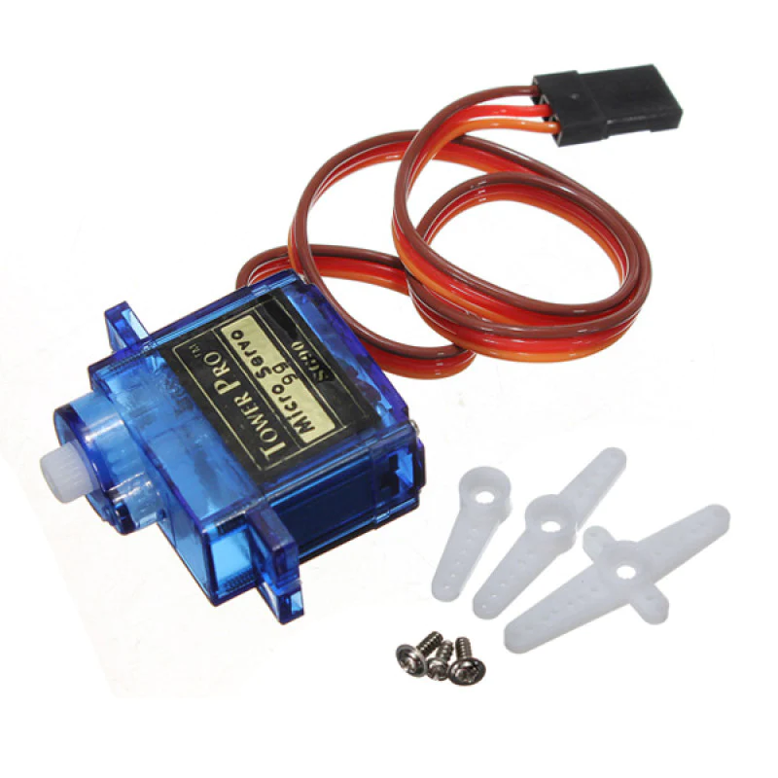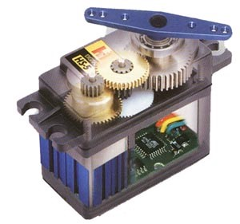

How they work:
- Built on a DC motor: They include a DC motor as their base but have several significant additions.
- Gears: A gearbox reduces the speed of the motor and increases its available torque.
- Potentiometer: This sensor measures the current rotation of the output shaft.
- Control Circuit: A small circuit board compares the desired position (input from your control signal) to the actual position (from the potentiometer). It adjusts the motor to minimize the error between the two.
Control:
- PWM Signals: The width of the PWM pulse determines the target position. Standard servos usually offer a 180-degree range of motion.
Advantages:
- Precise position control: The closed-loop feedback provides excellent precision.
- Good torque: The gearbox increases the available torque at the output shaft.
- Holds position: Actively resists forces trying to move it away from its set position.
- Can run without external power supply
Disadvantages
- Limited rotation: Most standard servos are limited to 180 degrees (though modifications and continuous rotation servos exist).
- Cost: More expensive than simple DC motors due to the extra components and control circuitry.

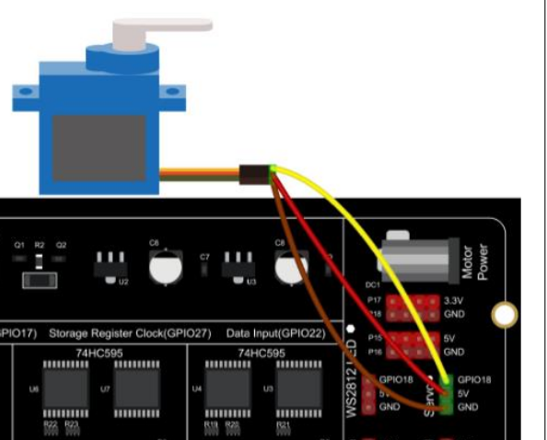
How to program?
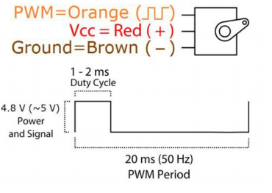

We need to create a PWM signal with a frequency of 50 Hz, or a period of 20ms
According to the datasheet we have to create a high signal for 1ms (so 1ms out of the 20ms, or 5% duty cycle) to create an angle of 0 degrees, and 2ms (or 10% duty cycle) to create an angle of 180 degrees (max angle)
Experience taught us they won’t give us the full range, and you will have to adjust the range from 1ms – 2ms to 0.6ms - 2.4ms

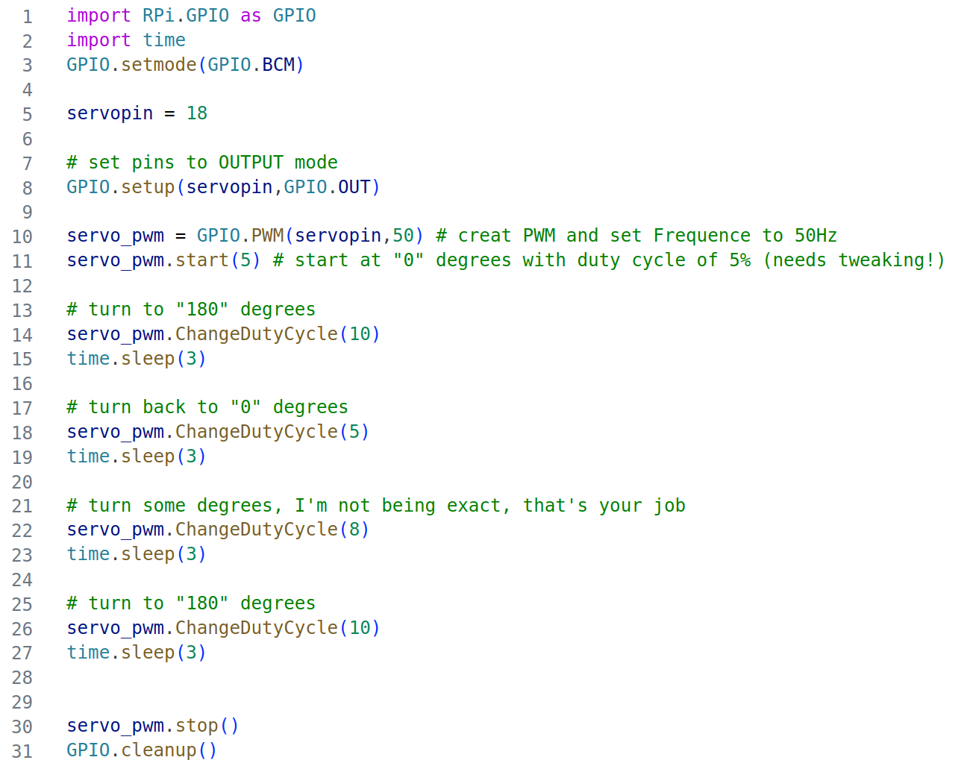
> also do “del servo_pwm” before cleanup()

Tweak this example code so you get the full 180 degrees range (play with timings)
Create a function/method that accepts an angle as a parameter and will return the matching duty cycle

Before programming:

On RPi: check git config, complete if needed

On RPi: commit + push any changes left in working directory

On RPi: create a new branch SERVO
Do the exercise

After programming:

On RPi: commit, push

Online/in browser: merge branch into main

On RPi: switch to main branch and perform sync / pull action
(making sure your PWM code is accessible/visible/runnable)

Assignment
Create a program which can control the servo by turning 1 of the potentiometers (A4)
The full range of the potentiometer controls the full range of the servo

Show the current analog value of the potentiometer (0 – 255) on line 1 of the LCD
Show the current angle of the servo on line 2 of the LCD

Extra: use a button to be able to turn the system “on” and “off”

