MPU6050, Neopixel & more

Objectives
- Connecting different I²C devices.
- Understanding data communication protocols
- Understanding datasheets.
- Using Bit Operations
- Making Use of Classes
- Extra sensors

SM-bus (System Management bus) revision.
The Raspberry Pi features the SM-Bus technology, which is an interface based on I²C with, among other things, stricter parameters for timing and voltage and a number of fixed transactions. It was originally developed by Intel for use on PC motherboards and is still used there.
By using this bus and the accompanying Python library, a lot of work is taken off your hands. The bus will take care of the start and stop condition, acknowledges and sends the data.
All we have to do is call the correct instruction, provide the address, and prepare or read the data. The library has the following commands:
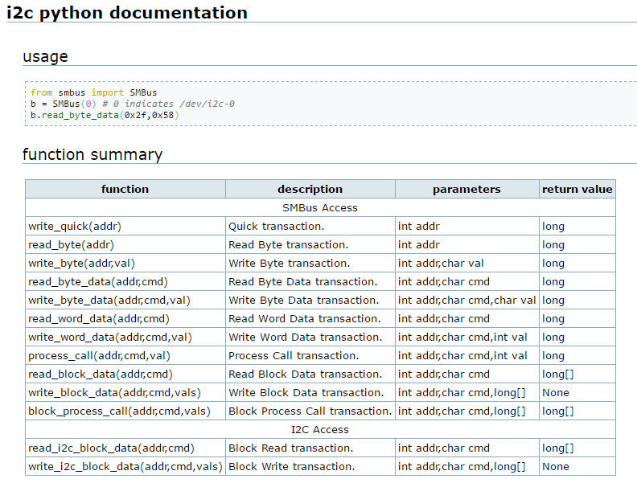
Via the command "i2cdetect -y 1" you can find all devices on the I²C bus of your pi. In the table below you will find 8*16 = 128 memory slots. The addresses are written hexadecimal WITHOUT the R/W bit. Address 0x50 can be used by the Raspberry Pi for internal cooking.
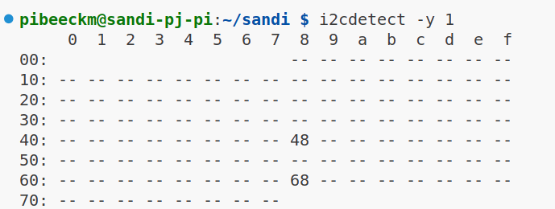

Inertial Measurement Unit
An Inertial Measurement Unit (IMU) is a module to determine movement and/or orientation in 3D. To do this, one or more sensors are used, each of which gives a result for the 3 axes (X, Y, Z). They are used in smartphones, aircraft and spacecraft (rockets, satellites, landers), game controllers, etc.
IMUs are classified according to the number of degrees of freedom (DOF): an accelerometer gives 3 axes, by adding a gyroscope you get a 6-DOF IMU, and with another magnetometer you get a 9-DOF IMU. These sensors are so-called Micro Electro-Mechanical Systems (MEMS) that work with minuscule mechanical components on a chip.

Accelerometer
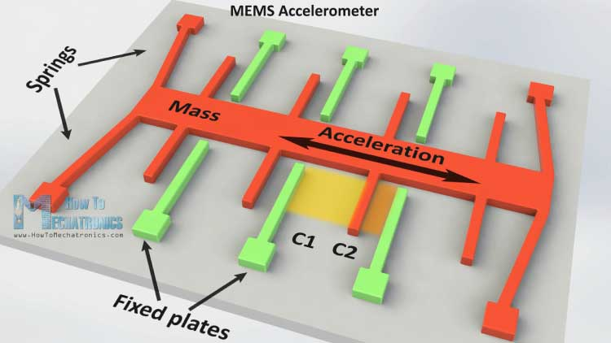
An accelerometer measures acceleration in 3 dimensions, expressed in m/s². In other words, you can use it to register a change in movement (you can't just register constant movement: in a moving car you don't feel whether you're moving or not).
A MEMS accelerometer consists of a number of fixed plates with a moving mass in between that is suspended from a kind of spring system and can therefore shift in 1 direction. Solid plate and moving mass together form a capacitor whose capacitance can be measured by the sensor.

At rest, the capacity is constant. However, when the sensor experiences acceleration, the position of the moving mass will shift relative to the plate and their distance from each other will change. As a result, the capacitance of the capacitor changes and the sensor can calculate the acceleration based on this. An accelerometer contains 3 such setups, one for each dimension.
Acceleration is also expressed in g-forces: 1g = 9.81m/s2, where 9.81 is the Earth's gravitational constant. That's because gravity is also a kind of acceleration, which you can therefore also measure with the accelerometer. When stationary, the acceleration on one of the three axes will always be equal to 1g (if the sensor is nice and horizontal), only in free fall you will measure a 0 everywhere. This allows you to determine the orientation of a device in relation to the ground, but it requires quite a bit of mathematics. The disadvantage is that you can't measure rotation around the axis of gravity with an accelerometer. If you rotate the module while it is lying flat on the table, you will see that the measurement is unchanged. As a result, we can only determine the orientation in 2 directions with certainty. Of course, you can also use it to detect vibrations from your device (e.g. smart safe...)

Gyroscope
A gyroscope measures angular velocity or changes in orientation angle, again in 3 dimensions and expressed in °/s. For a MEMS gyroscope, a similar setup is used as for the accelerometer, but with a mass that can rotate instead of shift. If the initial orientation is known, you can also determine the current orientation by continuously adding the change. With the combination of accelerometer and gyroscope, you can determine the current orientation and position, if the initial value of both is known. It goes without saying that this is not obvious because any mistakes keep piling up (drift), but in this way they have succeeded in putting people on the moon! 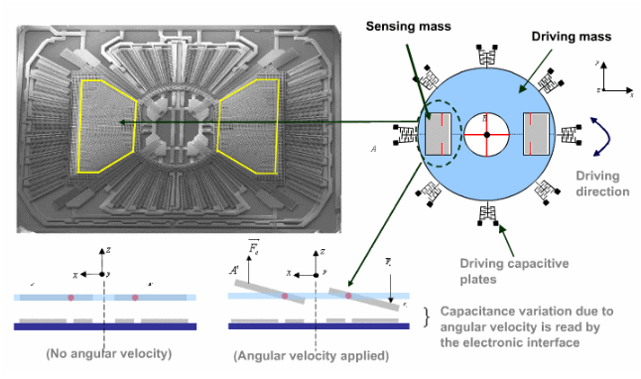

Magnetometer
However, as long as we stay here on Earth, we can add a third tool to determine the current orientation and improve the accuracy: a magnetometer measures the strength of the magnetic field in 3 directions, expressed in (micro- or nano-) Tesla. With a magnetometer we can add a compass to the measurement and the whole thing becomes a lot more reliable.

MPU-6050

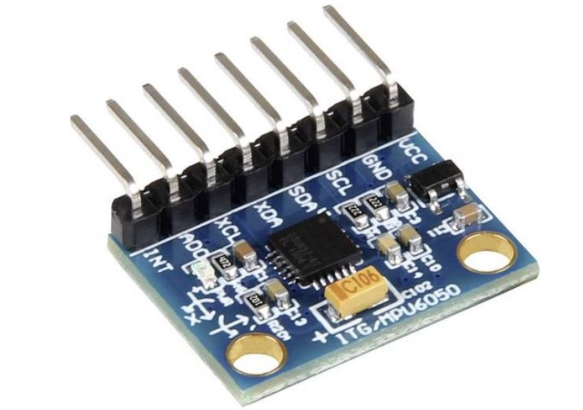
The GY-521 module from the kit contains the MPU-6050 chip (datasheet, registers), a 6-DOF IMU from TDK/InvenSense to which an extra magnetometer can be connected. The same manufacturer also supplies with the MPU-9250 a 9-DOF IMU formed by the combination of MPU-6050 and magnetometer in 1 chip. The MPU6050 also has a Digital Motion Processor (DMP) that can take a large part of the math off your hands and, for example, directly return a position in 3D. Unfortunately, this DMP requires a firmware that is closed-source and that we don't get on the chip right away in Python.
So we can use this module to determine both the acceleration and the orientation, and it also has a temperature sensor. The measurements are digitized with a 16-bit ADC whose range can be set (+/- 2 to 16g for the accelerometer, 250 -200 °/s for the gyro) according to the intended target. You can also have the chip detect when it is in free fall and generate an interrupt signal on the provided pin. You can then read that into the RPi and process it in the same way as pressing a button.

Reading in measurement results
The GY-521 module can communicate via an SPI or I²C bus. The module can tolerate a supply voltage of 2.0 to 3.6 Volts, so we will feed it with the external 3V3 of the breadboard power supply.
We can measure the acceleration in 3 directions, following the X, Y or Z axis, with a maximum accuracy of 4mg. Acceleration is expressed in m/s² or g-forces (1g = 9.81m/s²).
The datasheet can be found via the following link:
https://invensense.tdk.com/wp-content/uploads/2015/02/MPU-6000-Datasheet1.pdf
The MPU6050 digitizes the measurements with a 16-bit ADC, so each value takes up 2 registers and is stored in "big-endian" format: the first register contains the MSB, the second the LSB. You will have to combine the 2 read bytes (in big endian format) in the right order to produce a 16-bit measurement result.
Big-endian is a sequence in which the "big end" is stored first, i.e. in the lowest memory register. In the case of little-endian, the "little end" is stored first.
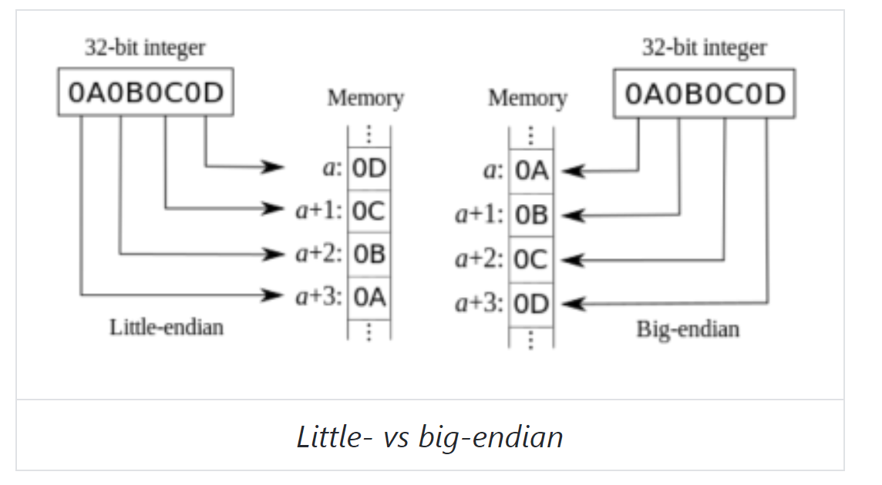

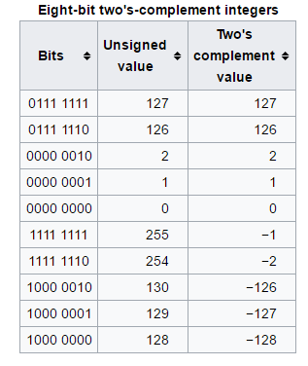
Because the value can also be negative, it is stored in 2-complement, and in Python that is a bit difficult to convert thanks to the "infinitely" long numbers. One possible method is:
- check of de sign-bit (MSB) 1 is
- if so, subtract 2N from the number to make it negative, with N = #bits (in this case, 16)
>>> n = 16
>>> value = 0xf00f
>>> value # value without 2 complement
61455
>>> value & 0x8000: # check sign bit
True
>>> value -= 2 ** n # sign=1, so make it negative
>>> value
-4081

8-bit example.
Readout value is 129 (decimal) = 0x81.
Is the highest bit at 1? Yes - > then we need to make the value negative
Value = value – (2 **8) = value – 256 = -127 as a result.

Or explained in another way to convert 2 complement notation to decimal : filter out the highest bit and if it is in , make it negative and add the rest back :

E.g. 129 = 1000 0001 = -128 + 1 = -127
E.g. 0xF00F = 1111 0000 0000 1111 = - 1000 0000 0000 0000 + 0111 0000 0000 1111 = -32768 + 28687 = -4081
Or in another way for 2 complement to decimal : if the highest bit is 1 : invert remainder and add 1 (then gives a negative number)

E.g. 129 = 1000 0001 : highest bit is at 1 -> invert 0111 1110 + 0000 0001 = 0111 1111 = 127 but with a minus before it (highest bit was at 1)

The reason for using 2-complement is that operations like addition and subtraction continue to work like this without any additional logic. It is also useful that the MSB can serve as a sign-bit: if it is 1, the number is negative. If they are set to 1 : invert and 1 when adding (or by any other means as described above).

Now you have a number between -32768 and 32767, which obviously can't be the right reading. There's another scaling factor you'll need to factor in depending on the set range. By default, the (A)FS_SEL flag (full-scale range) is set to 0 and thus the smallest range is set.
For a consistent result, it is important that all measured values (3 axes accelero + 3 axes gyro) are set to the same scale and read in at the same time. The easiest way to ensure that is to read them all at once. Since the temperature is sandwiched between the two, we have to take it with us right away. This means that we must read a total of 7 (3 + 3 + 1) measurement results of 16 bits, or 14 registers of 8 bits starting from 0x3B (see further registers).
With the method "read_i2c_block_data" we can read a number of registers in 1 go, the second parameter is the start register, the third parameter is the number of registers we want to read.
data = i2c.read_i2c_block_data(0x68, 0x3B, 14)

whereby
0x68 the address is on the I2C bus
0x3B the start register of our device where we want to start reading
14 the number of registers that we will read

Registers
The MPU6050 has a lot of registers. Below we make an overview of the most important registers and settings. Fortunately, we don't need many of them to implement the basic features.
https://invensense.tdk.com/wp-content/uploads/2015/02/MPU-6000-Register-Map1.pdf

Power management – Settings register 0x6B
At start-up, the sensor is in "sleep" mode by default and does not take any measurements. To wake him up, you have to turn off the SLEEP bit in the registry PWR_MGMT_1. You can also set the CLKSEL field to 001, which is a bit more accurate.

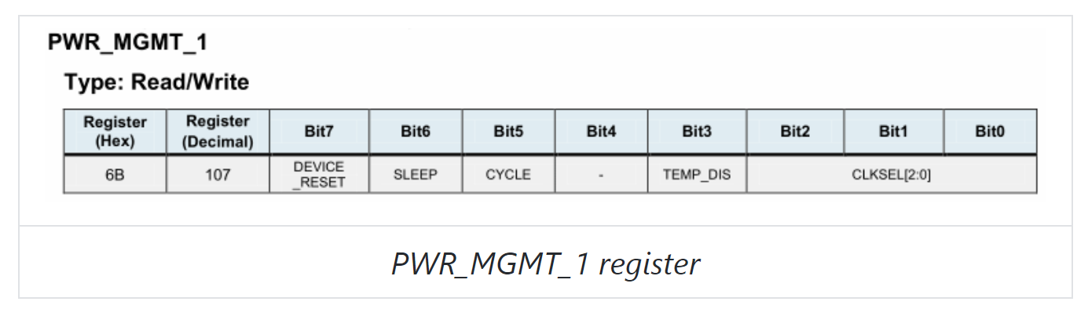
The other bits in this register should also be/remain 0 anyway, so you shouldn't care about the current content. So you can just write a 1 to this register.

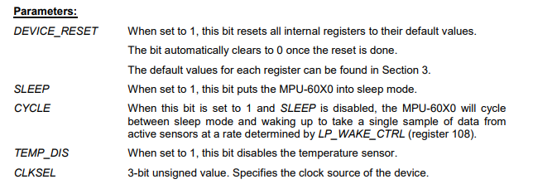

Accelerometer – Settings register 0x1C
The accelerometer can be configured via register 0x1C:
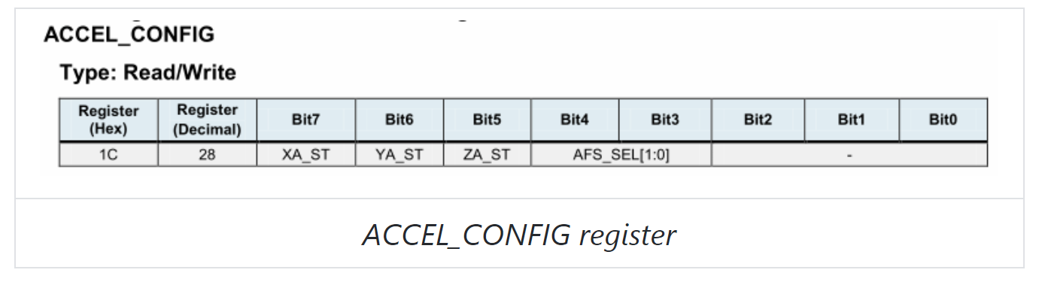
Bits 7-5 are in ACCEL_CONFIG for a self-test and must therefore remain 0, with bit 4-3 you can set the measuring range:
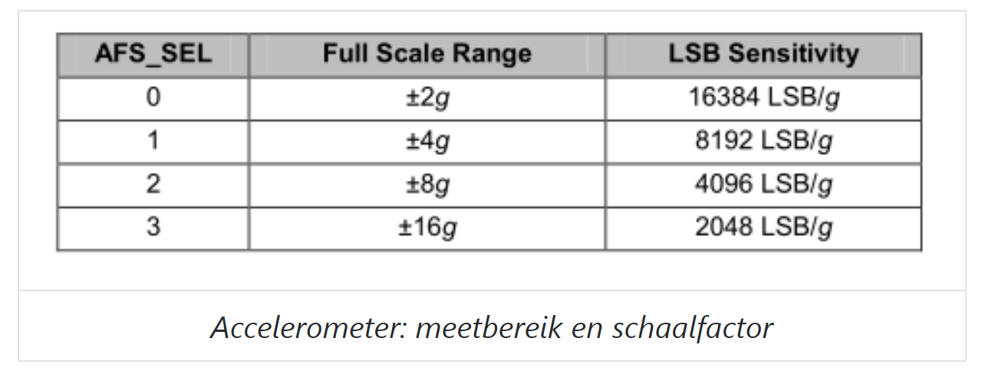
So if you want to measure on the scale of 2g, you have to write a 0x00 to the register 1C
For example, if you choose the scale range of +/- 2g, then you have 2¹⁶⁼⁶⁵ ⁵³⁶ steps to represent the range from -2g to +2g. So you have 65,536/4 or 16,384 bits per g of force. If you read e.g. 16 384 inside with the sensor, you have exactly 1g. If you hold the sensor still with 1 axis parallel to gravity, you have to read a +1g or -1g on that axis. The other axes will then return about a zero.

Accelerometer - Data registers 0x3B -> 0x40
The measurements are 0x3B - 0x40: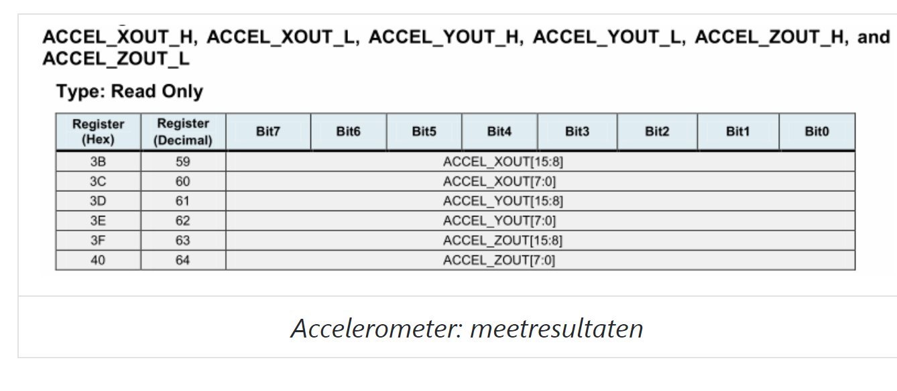

Gyroscoop – Settings register 0x1B
The gyroscope can be configured via register 0x1B

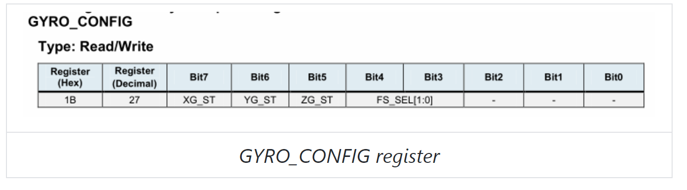
Bits 7-5 are in GYRO_CONFIG for a self-test and must therefore remain 0, with bit 4-3 you can set the measuring range:
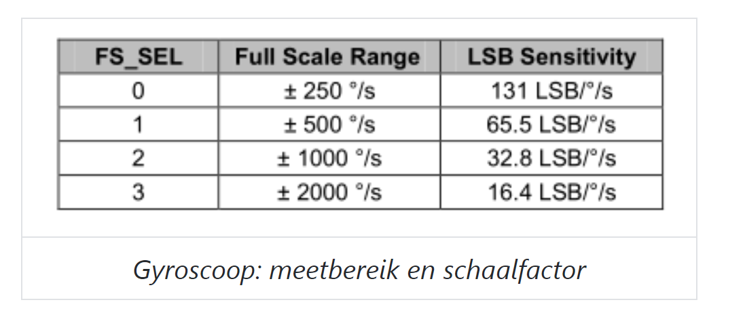
We have 16 bits available per measurement. If we take e.g. the scale range of +/-250 °/s then we have 2¹⁶ ⁼ 65.536 bits per 500° = > we have 131 LSB/°/S
So if you set the sensor to a sensitivity of +/- 250°/s, you have to divide the result by 131 to get the degrees of rotation per second. At rest we should get three zeros here, in practice I get about 1°/s at rest.

Gyroscoop – Data registers 0x43 -> 0x48
The measurements are recorded in registers 0x43 - 0x48:
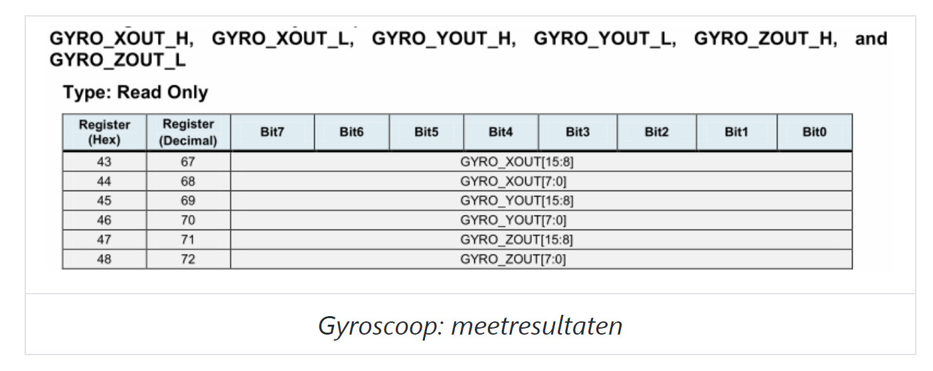

Temperature – Data registers 0x41 -> 0x42
The temperature is between accelerometer and gyroscope in registers 0x41 - 0x42.
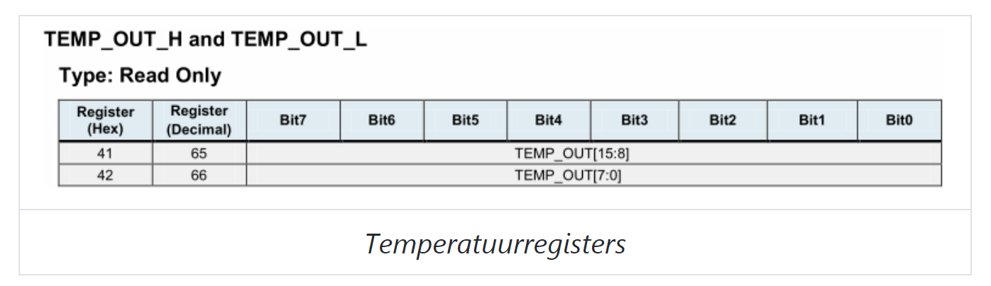
There's nothing to set up, but the conversion is just a little more special. According to the datasheet:
Temperature in degrees C = (TEMP_OUT Register Value as a signed quantity) / 340 + 36.53

So not only is there a scale factor of 340, but also an offset of 36.53 that you have to add afterwards! The temperature is probably the most obvious way to see if your conversion of big-endian and 2-complement is correct, since you can compare the result with the temperature in the vicinity of your component.

Assignment 1 . I²C MPU 6050

SMBus Pi Configuration
- Enable the I2C via raspi-config, if it hasn't already done so.
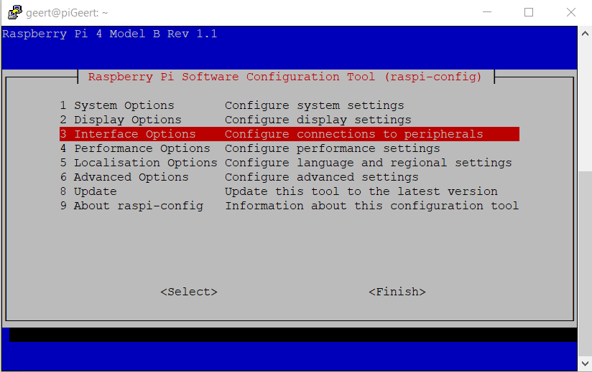

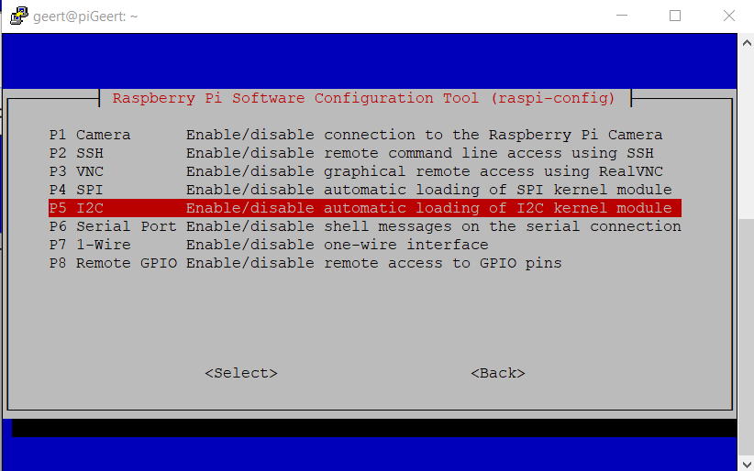

- Check the file /boot/config.txt è dtparam=i2c_arm=on should be off comment
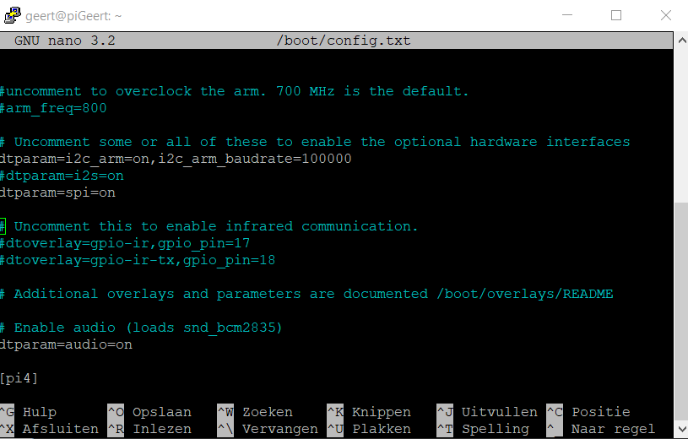

- Requesting the I²C addresses. The default address of the MPU6050 is 0x68. If you don't see an address, then either the I²C is badly configured or the sensor is badly connected.


0x48 is the ADC
0x68 is the MPU

start with the code : Initialization SMbus
You can use the following code to initialize the SMbus.
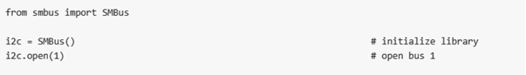
To configure the sensor, we will use the instruction i2c.write_byte_data(slave_address, register, value). With this instruction we can write a value (configuration) to a certain register of our sensor. The registers can contain 1 byte each.
In order to properly read the measurement results from the sensor, it is important to read the accelero and gyro values of the three axes at once or in other words at the same time. To do this, we will use the method read_i2c_block_data(slave_address, register, count). So we will read in x number of (count) bytes from the start register. This method returns us a list of bytes.
In summary, we can use the following instructions : use these functions in d. and e. and ....
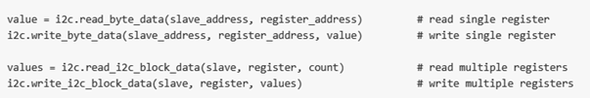

Removing the sensor from sleep mode
Use the method write_byte_data(slave_address, register, value) to write a 1 (value : see above in the course : registers) to the power management register (0x6B).


Reading the temperature
The value of this sensor is hidden on two registers. In order to read measurement results from the sensor, we will have to glue the two bytes of the temperature together each time. We will, of course, do this using bit operations. Reading the temperature is the easiest way to check whether we have done this correctly, as we will quickly notice a deviating value.
Read the two bytes in 1 go using the read_i2c_block_data(slave_address, register, count) method.
Write a method with the parameters (MSB,LSB) in that method you shift the MSB to the left and paste the LSB to it. Keep in mind that there may also be negative numbers.
- check of de sign-bit (MSB) 1 is
- if so, subtract 2N from the number to make it negative, with N = #bits (in this case, 16)


You have to settle the obtained value (TEMP_OUT Register Value) with the formula below.

Temperature in degrees C = (TEMP_OUT Register Value as a signed quantity) / 340 + 36.53

Reading the accelero registers.
Set the registry to a sensitivity of +/- 2g. To do this, write the correct settings to bit 4 and bit 3 of register 0x1C (see above in the course: chapter registers)

The measurement results are now entered in the following registers:


Read these 6 registers in 1 go. You will have to glue the registers 3B and 3C of the X-axis together and calculate the possible two complement. To do this, use the method you used to determine the temperature.
Do the same for the accelero values of the Y-axis and the Z-axis.
We will still have to convert the values we obtain into g-forces. If you have set the sensitivity to +/- 2g, you will have to divide the value by 16384. (See course.
If you place the sensor horizontally on your desk, you should get a 1g for the Z-axis.
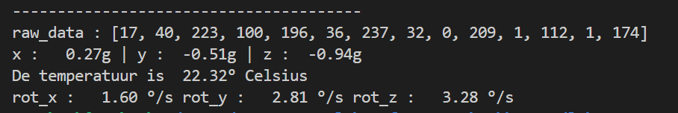

Reading the gyroscope.
Set the gyroscope with a sensitivity of 250°/s. Read the measurement results of the 3 axes, glue the registers together and settle the two-complement. Then you have to convert the measurement results to obtain a number of degrees per second.

The class MPU6050
- Create a class where you can give the I²C address to the constructor
- Write a method setup() to set the three configuration registers (2 x scale factor + 1 x wake the sensor).
- Write a private (or protected) method read_data() that returns the acceleration on the 3 axes:
  - Retrieve the 6 bytes from the registers in 1 transaction
  - From this, determine the three 16-bit measured values, taking into account the big-endian format
  - Programming tip: In Python, a function can return more than 1 value!
- Write a static method that pastes two bytes together and interprets a 2-complement value.
- Now display the acceleration in the 3 directions
  - When stationary and flat on the table, you should measure (approximately) 1g on the Z-axis, and 0 on X and Y
- Write a private (or protected) method read_data() that returns the gyroscope on the 3 axes:
  - Retrieve the 6 bytes from the registers in 1 transaction
  - From this, determine the three 16-bit measured values, taking into account the big-endian format

Expansion:
- Add a property range to set the range to +/- 2, 4, 8 or 16g and the gyro range to +/- 250, 500, 1000 or 2000

- Don't forget that the range from –n to +n has a magnitude of 2n!

ASSIGNMENT 2 :
Create a program that uses your class (if possible, otherwise without class (but with negatives) ), where the temperature, the x,y and z value of the accelero sensor and the x,y and z value of the gyroscope are displayed per second

So, the output should look something like this:

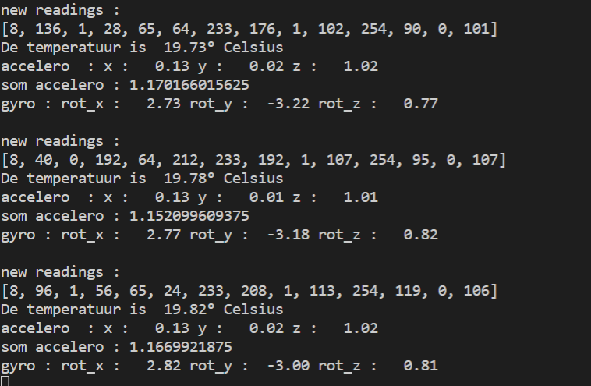

ASSIGNMENT 3:
Create a program that takes advantage of your class, where you set off a buzzer (GPIO12) with every movement of your sensor. Make sure you can easily adjust the sensitivity. ( > using a potentiometer?)

