Motors
Your kit contains 3 types of motors:
- Servomotor > Already saw this in W5
- Stepper motor
- DC motor

Each of them has their own properties/purposes. We’ll go into this a bit more and learn to control these types of motors.

DC motor
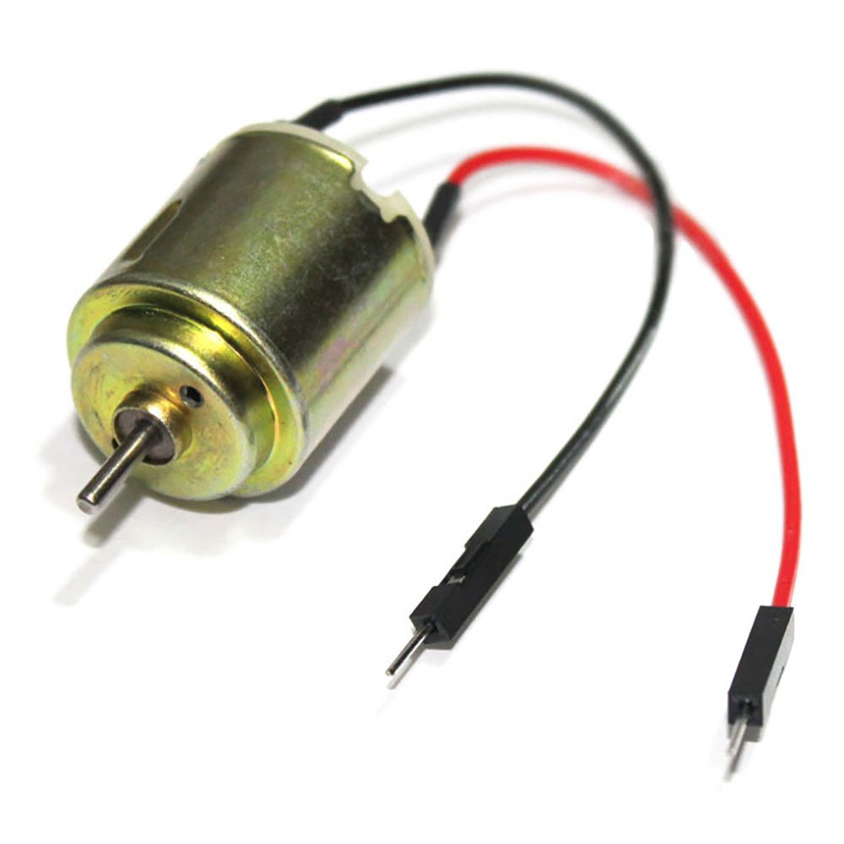
How they work: DC motors convert electrical energy into mechanical energy through electromagnetic interaction. Current flows through a coil of wire within a magnetic field. This generates a force that causes the coil and the attached motor shaft to rotate.
Control:
- Direction: Controlled by reversing the polarity of the applied voltage. This can be done manually with a switch or electronically using an H-bridge circuit.
- Speed: Controlled using Pulse Width Modulation (PWM). PWM signals rapidly switch the power on and off, effectively changing the average voltage delivered to the motor.
Advantages:
- Simple and inexpensive: They are widely available and among the most affordable motor options.
- High speed potential: Some DC motors can achieve very high RPMs (rotations per minute).
- Variety: Come in a vast range of sizes and power ratings.
Disadvantages:
- No inherent position control: They provide no way to determine the shaft's current position.
- Limited torque at low speeds: They often need gearing to increase torque, especially at the start.
- Requires additional sensors for precise control: Integrating encoders for position or speed feedback adds complexity.
- Requires external power source because GPIO pins can’t provide enough current
  - 9V battery + connector included in kit
  - AC-DC Adapter provided during lab (Or any other 7V – 12V DC adapter you have at home)
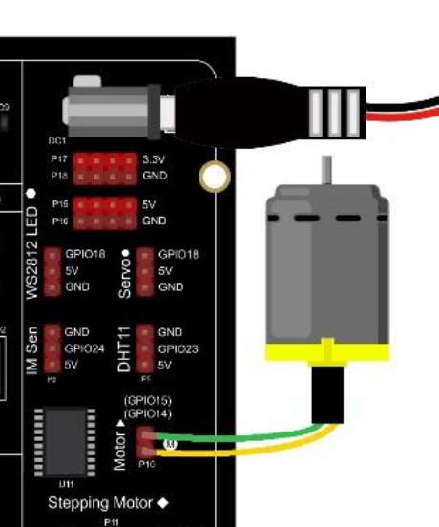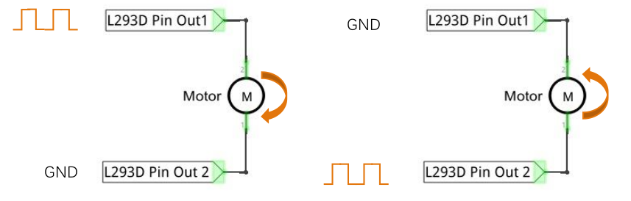

L293D IC is a dual H-bridge motor driver IC

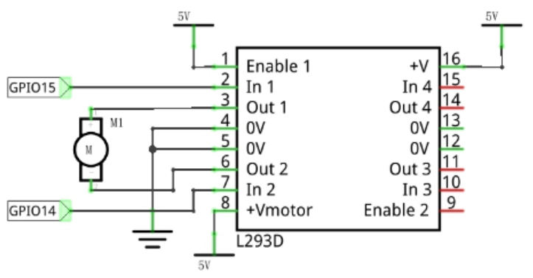
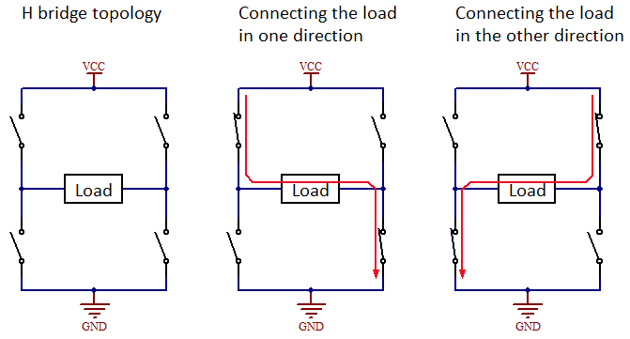

How to program?
We have 2 GPIO pins (BCM) 14 and 15
These are the 2 control pins of our H-bridge
So 1 pin always needs to be LOW, the other pin we can control with PWM to control the motor speed
By swapping which pin is LOW/gnd and which pin gets driven by PWM, you change the direction of rotation

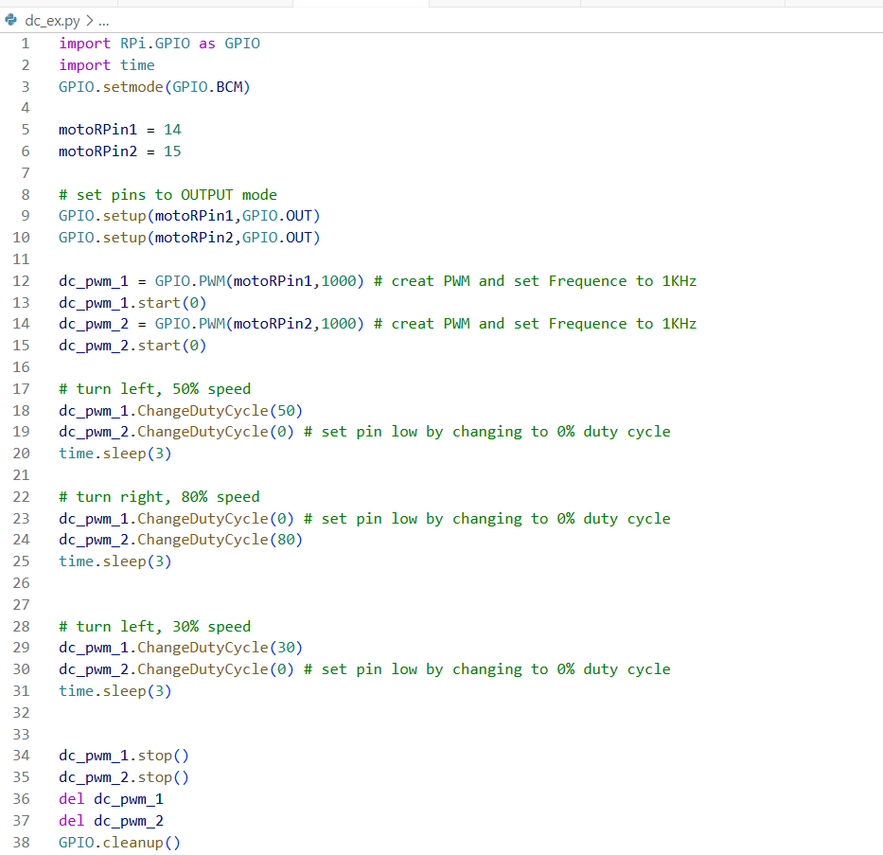

Stepper Motors
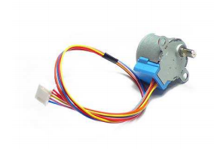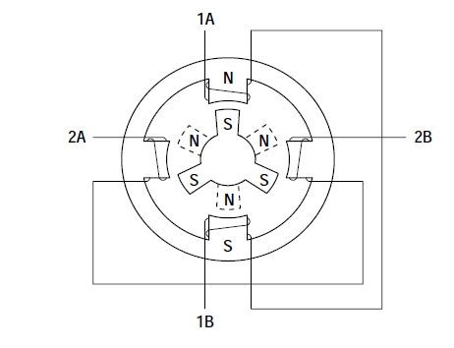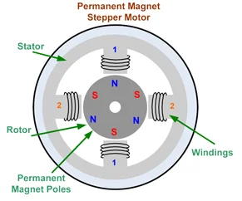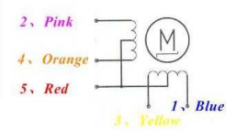
How they work:
- Electromagnets: Multiple sets of electromagnet coils (phases) are arranged around a central gear-shaped metal rotor.
- Step Sequences: Energizing the coils in specific sequences causes the rotor to turn in precise increments, or steps.
Control:
- Driver Boards: Stepper motors require driver boards (like the ULN2003A) to handle the coil switching patterns.
- Stepping Modes: Different step sequences (full-step, half-step, micro-stepping) offer trade-offs in precision vs. torque.

Advantages:
- Open-loop position control: They can be accurately positioned without extra position sensors within their torque limits.
- Excellent holding torque: They maintain their position very well, even when powered off.
- Precise: Each step corresponds to a known angular rotation.
Disadvantages:
- Missed steps: They can miss steps if overloaded, leading to positioning errors.
- Limited top speed: Generally slower than DC motors.

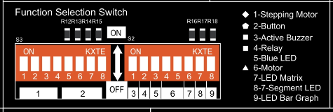
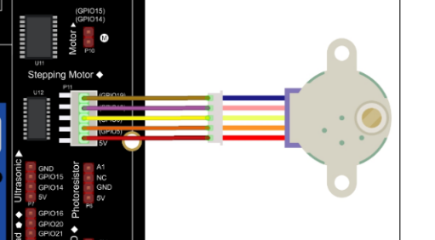

Orange is GPIO
Red is 5V
Brown is GND

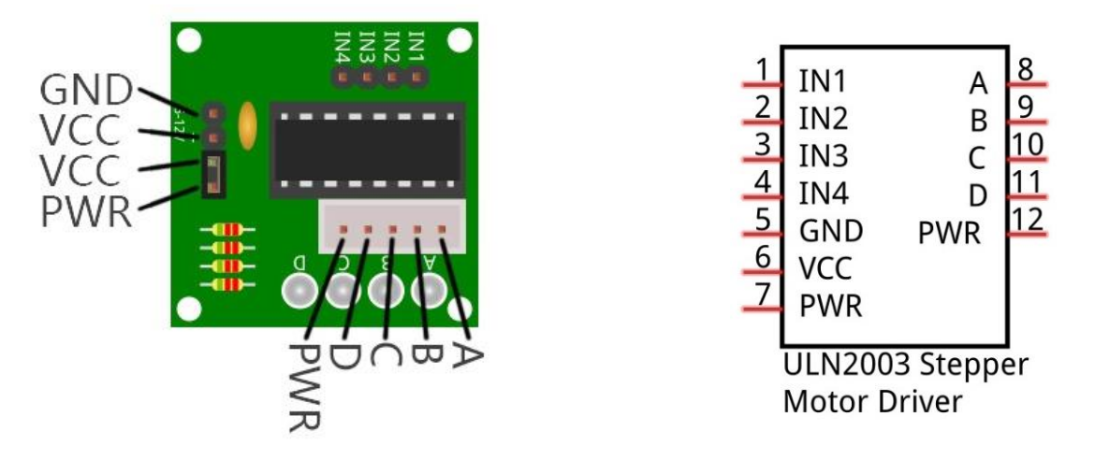
A ULN2003 Stepper Motor Driver is used to convert weak signals into more powerful control signals in order to drive the Stepper Motor. In the illustration above, the input signal IN1-IN4 corresponds to the output signal A-D, and 4 LEDs are integrated into the board to indicate the state of these signals. The PWR interface can be used as a power supply for the Stepper Motor.
By default, PWR and VCC are connected.

How to program?
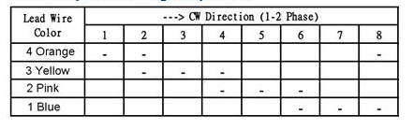
We need 8 steps to make 1 “rotation”. But this is only 1/512 of a full real rotation (because of the inner gears, in order to create more torque)
Between each step, we need to give to motor time to physically go to the new position (by using a time.sleep of 1ms (or 0.9ms)

We can program this the long way: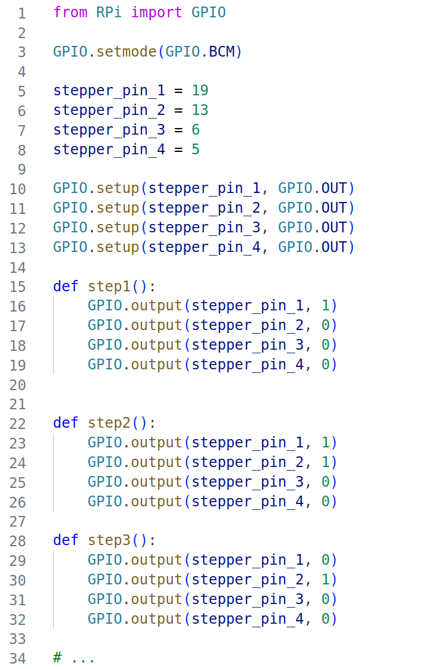
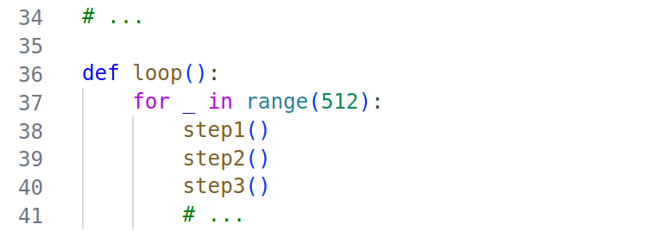
But this gets old quickly
We could also make use of lists/tuples and/or loops
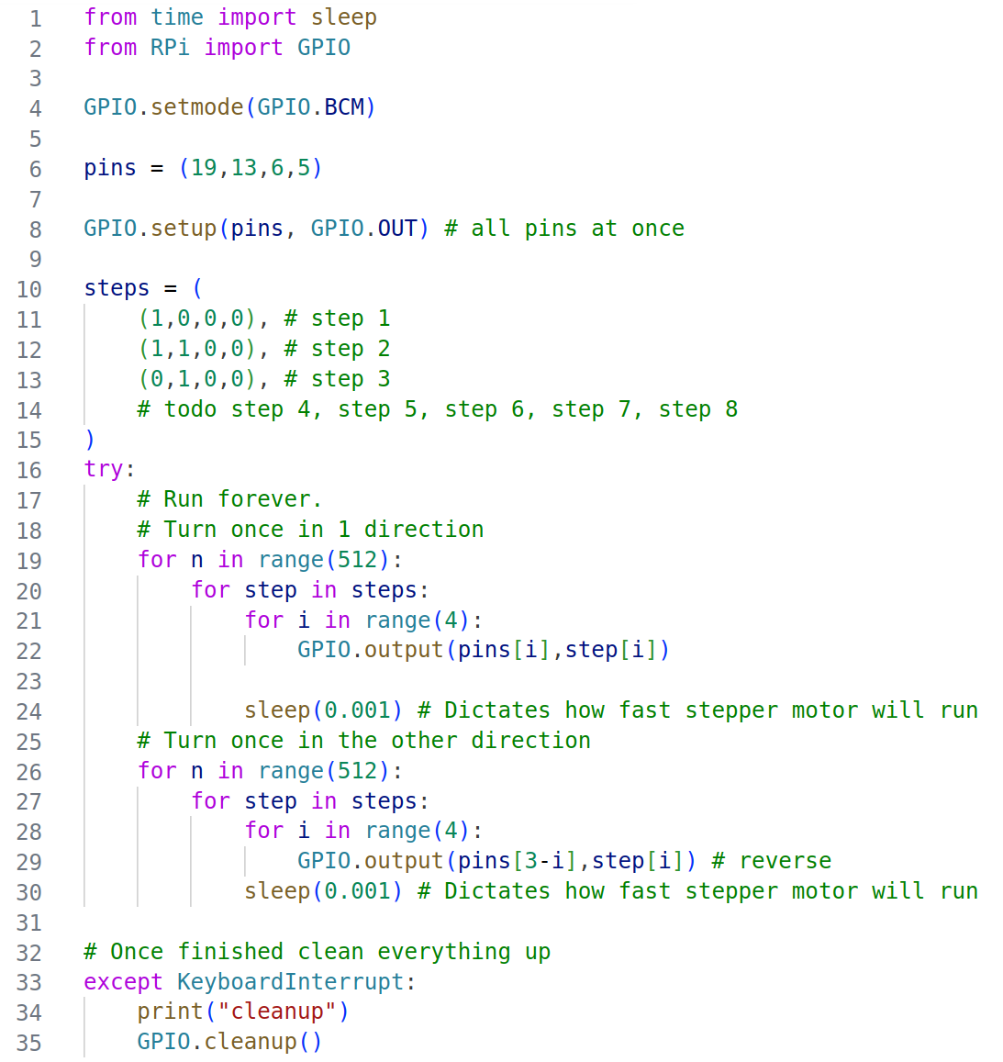

Exercise(s):
A) While holding down GPIO 20, turn the stepper motor left (until release)
B) While holding GPIO 21, turn the stepper motor right
C) With GPIO 16 you can toggle to DC motor between these states: OFF / TURN LEFT / TURN RIGHT
Use 1 of the potentiometers as speed control
>> if you don’t have external power, print out the values to console so you can test later
D) With GPIO 26 you can turn on/off the servo motor
The position of the servo motor gets set by the X-axis of the joystick (ADC channel 6)

First make a python script per part, afterwards combine all parts (A, B, C and D) together
Make use of interrupts/events for handling button interactions

Bluetooth UART service
We can turn our Raspberry Pi into a Bluetooth device where we can connect to (with our phone, or our laptop)
We can do this be starting a BLE (Bluetooth Low Energy) GATT service.
GATT is an acronym for the Generic ATTribute Profile, and it defines the way that two Bluetooth Low Energy devices transfer data back and forth using concepts called Services and Characteristics. It makes use of a generic data protocol called the Attribute Protocol (ATT), which is used to store Services, Characteristics and related data in a simple lookup table using 16-bit IDs for each entry in the table.
See also: https://learn.adafruit.com/introduction-to-bluetooth-low-energy/gatt

GATT comes into play once a dedicated connection is established between two devices, meaning that you have already gone through the advertising process governed by GAP.

The most important thing to keep in mind with GATT and connections is that connections are exclusive. What is meant by that is that a BLE peripheral can only be connected to one central device (a mobile phone, etc.) at a time! As soon as a peripheral connects to a central device, it will stop advertising itself, and other devices will no longer be able to see it or connect to it until the existing connection is broken.

Establishing a connection is also the only way to allow two-way communication, where the central device can send meaningful data to the peripheral and vice versa.

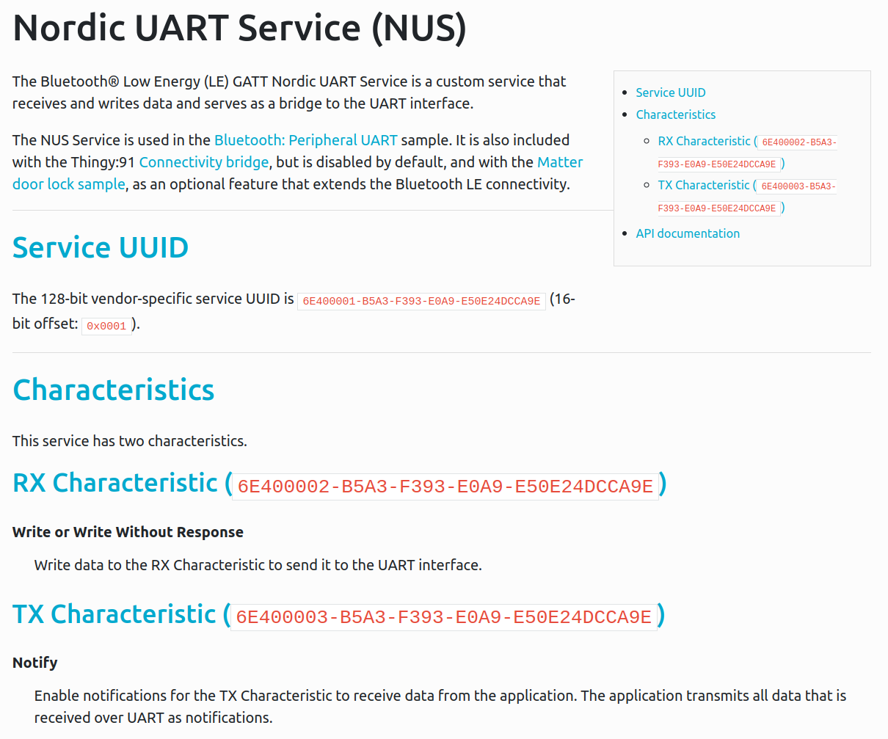
To enable our RPi to do this, we’ll use the BlueZ software: https://github.com/bluez/bluez
We are in luck, because

Using some examples from https://github.com/bluez/bluez/blob/master/test/ I made a class (with 2 helper files) which enables a GATT UART service on your Raspberry Pi.
You can download the files from Leho
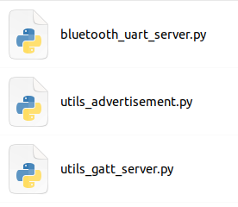
You’ll see I’m using the same 16bit UUID’s as described in the Nordic UART Service specification:
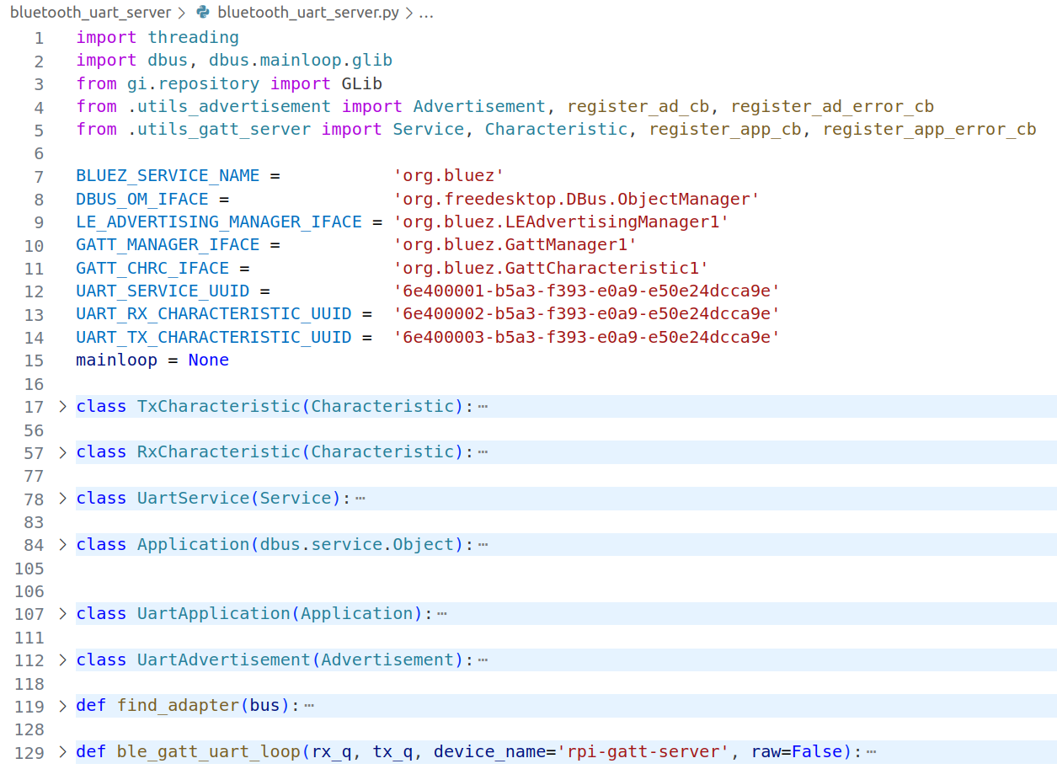

You can import the method ble_gatt_uart_loop from bluetooth_uart_server.py. This is the “loop” method, or method that needs to continuously run in order for the BLE GATT service to be active.

We can put our own logic into this loop, but this gives us a big chance of breaking things. The better thing to do is let that loop run in its own thread. (It will be running as a different program, next to our code)

To be able to pass data between these 2 programs or threads, we can pass 2 Queues to this thread. We can also pass a third argument: the name of your Bluetooth device (how the device will show up in Bluetooth scans)

We can read from the RX queue, and add data to the TX queue:

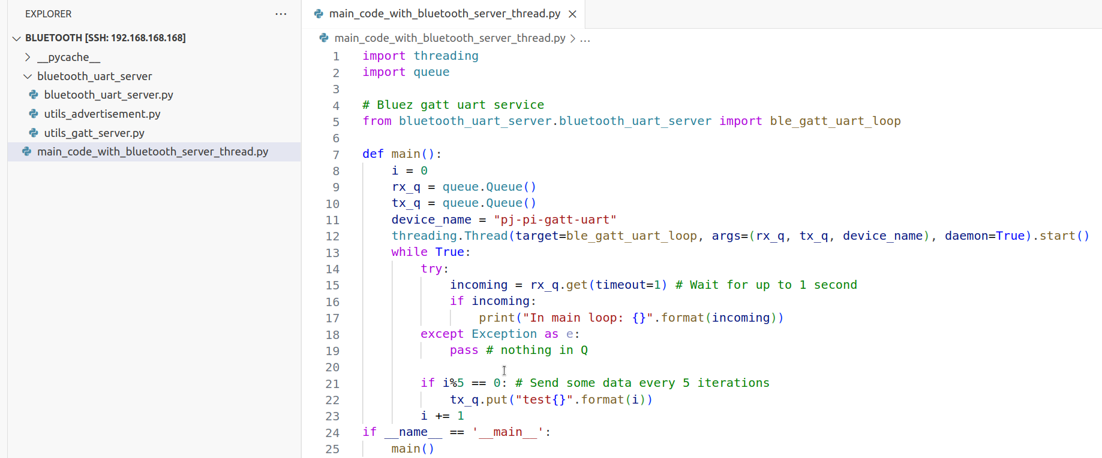

You can use windows/mac as a client, but then you’ll need to install some extra software.
Today we’ll be using our mobile phone, with the nRF Toolbox app:
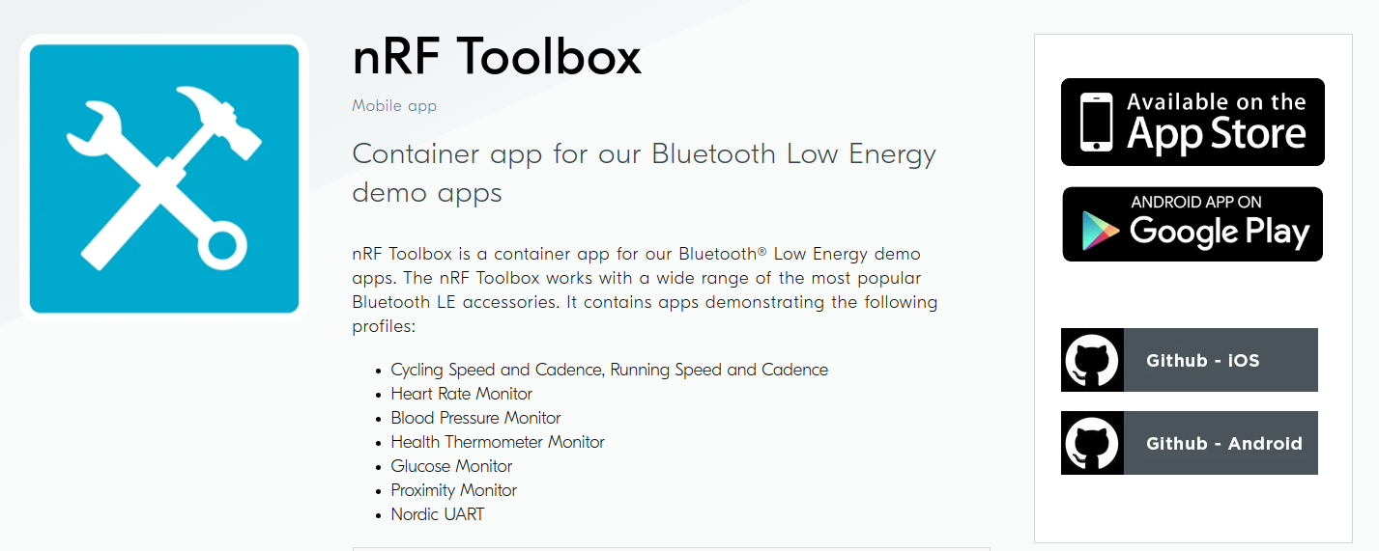

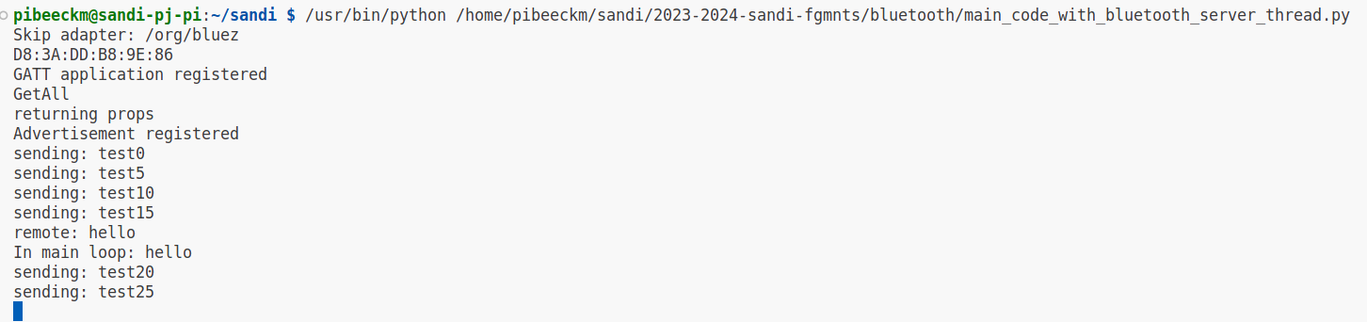

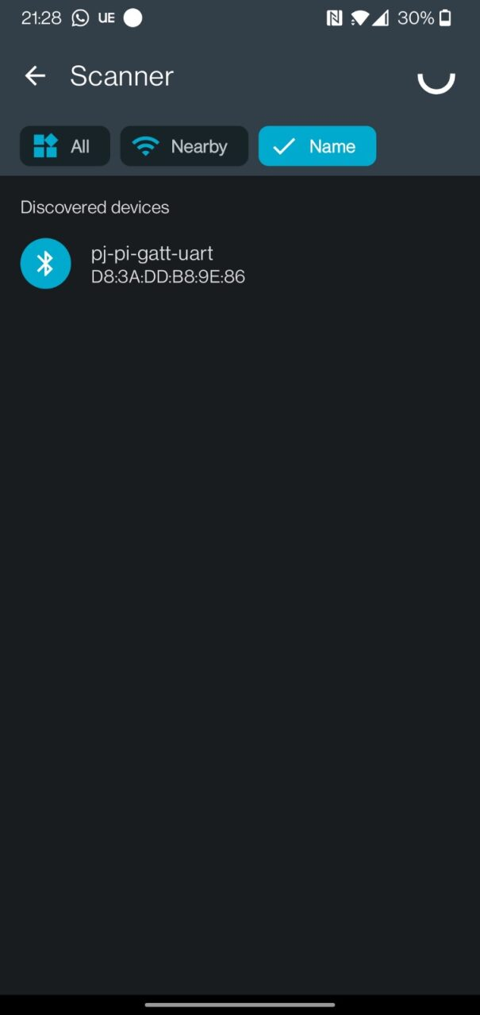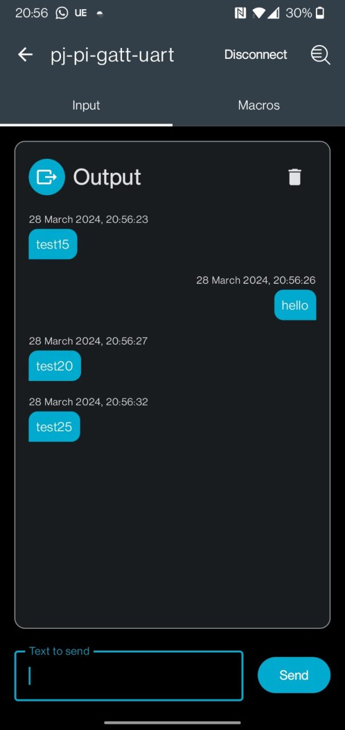

On windows you can use the python Bleak package to connect and send messages back and forth, you can find the example code on LeHo

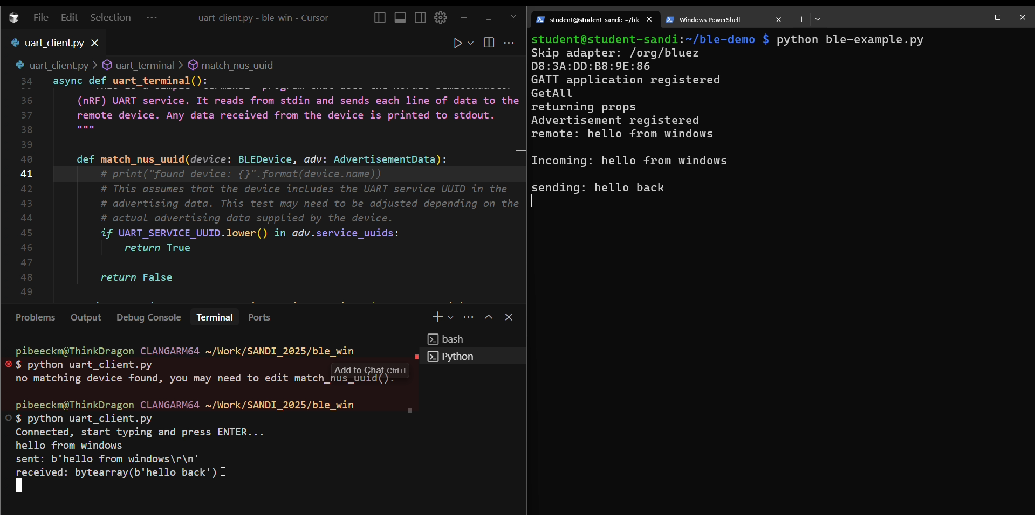

Assignment (rest of class)
Try and send messages back and forth between your mobile phone and the Raspberry Pi

Extend the motors assignment by control with BLE:
DC-left; DC-right; DC-stop;
Sweep-left; Sweep-right;
Step-right (Half a turn); Step-left (half a turn);
Step ### (where ### is a number representing degrees, positive is 1 direction, negative numbers are the opposite direction)

With https://pypi.org/project/ble-serial/ you can also turn your RPi into a BLE client (like our phone) and make a virtual serial port once connected.
You can also run this on mac and windows, to communicate between your Pi and your AI python script on your main machine?

