Shiftregister

Objective
- Use of bit operations to convert a byte serially.
- Converting a timing diagram to code
- Building communication with a shift register
- Use of a LED bar
- Optimizing the code using bit operations
- Buzzer

Introduction
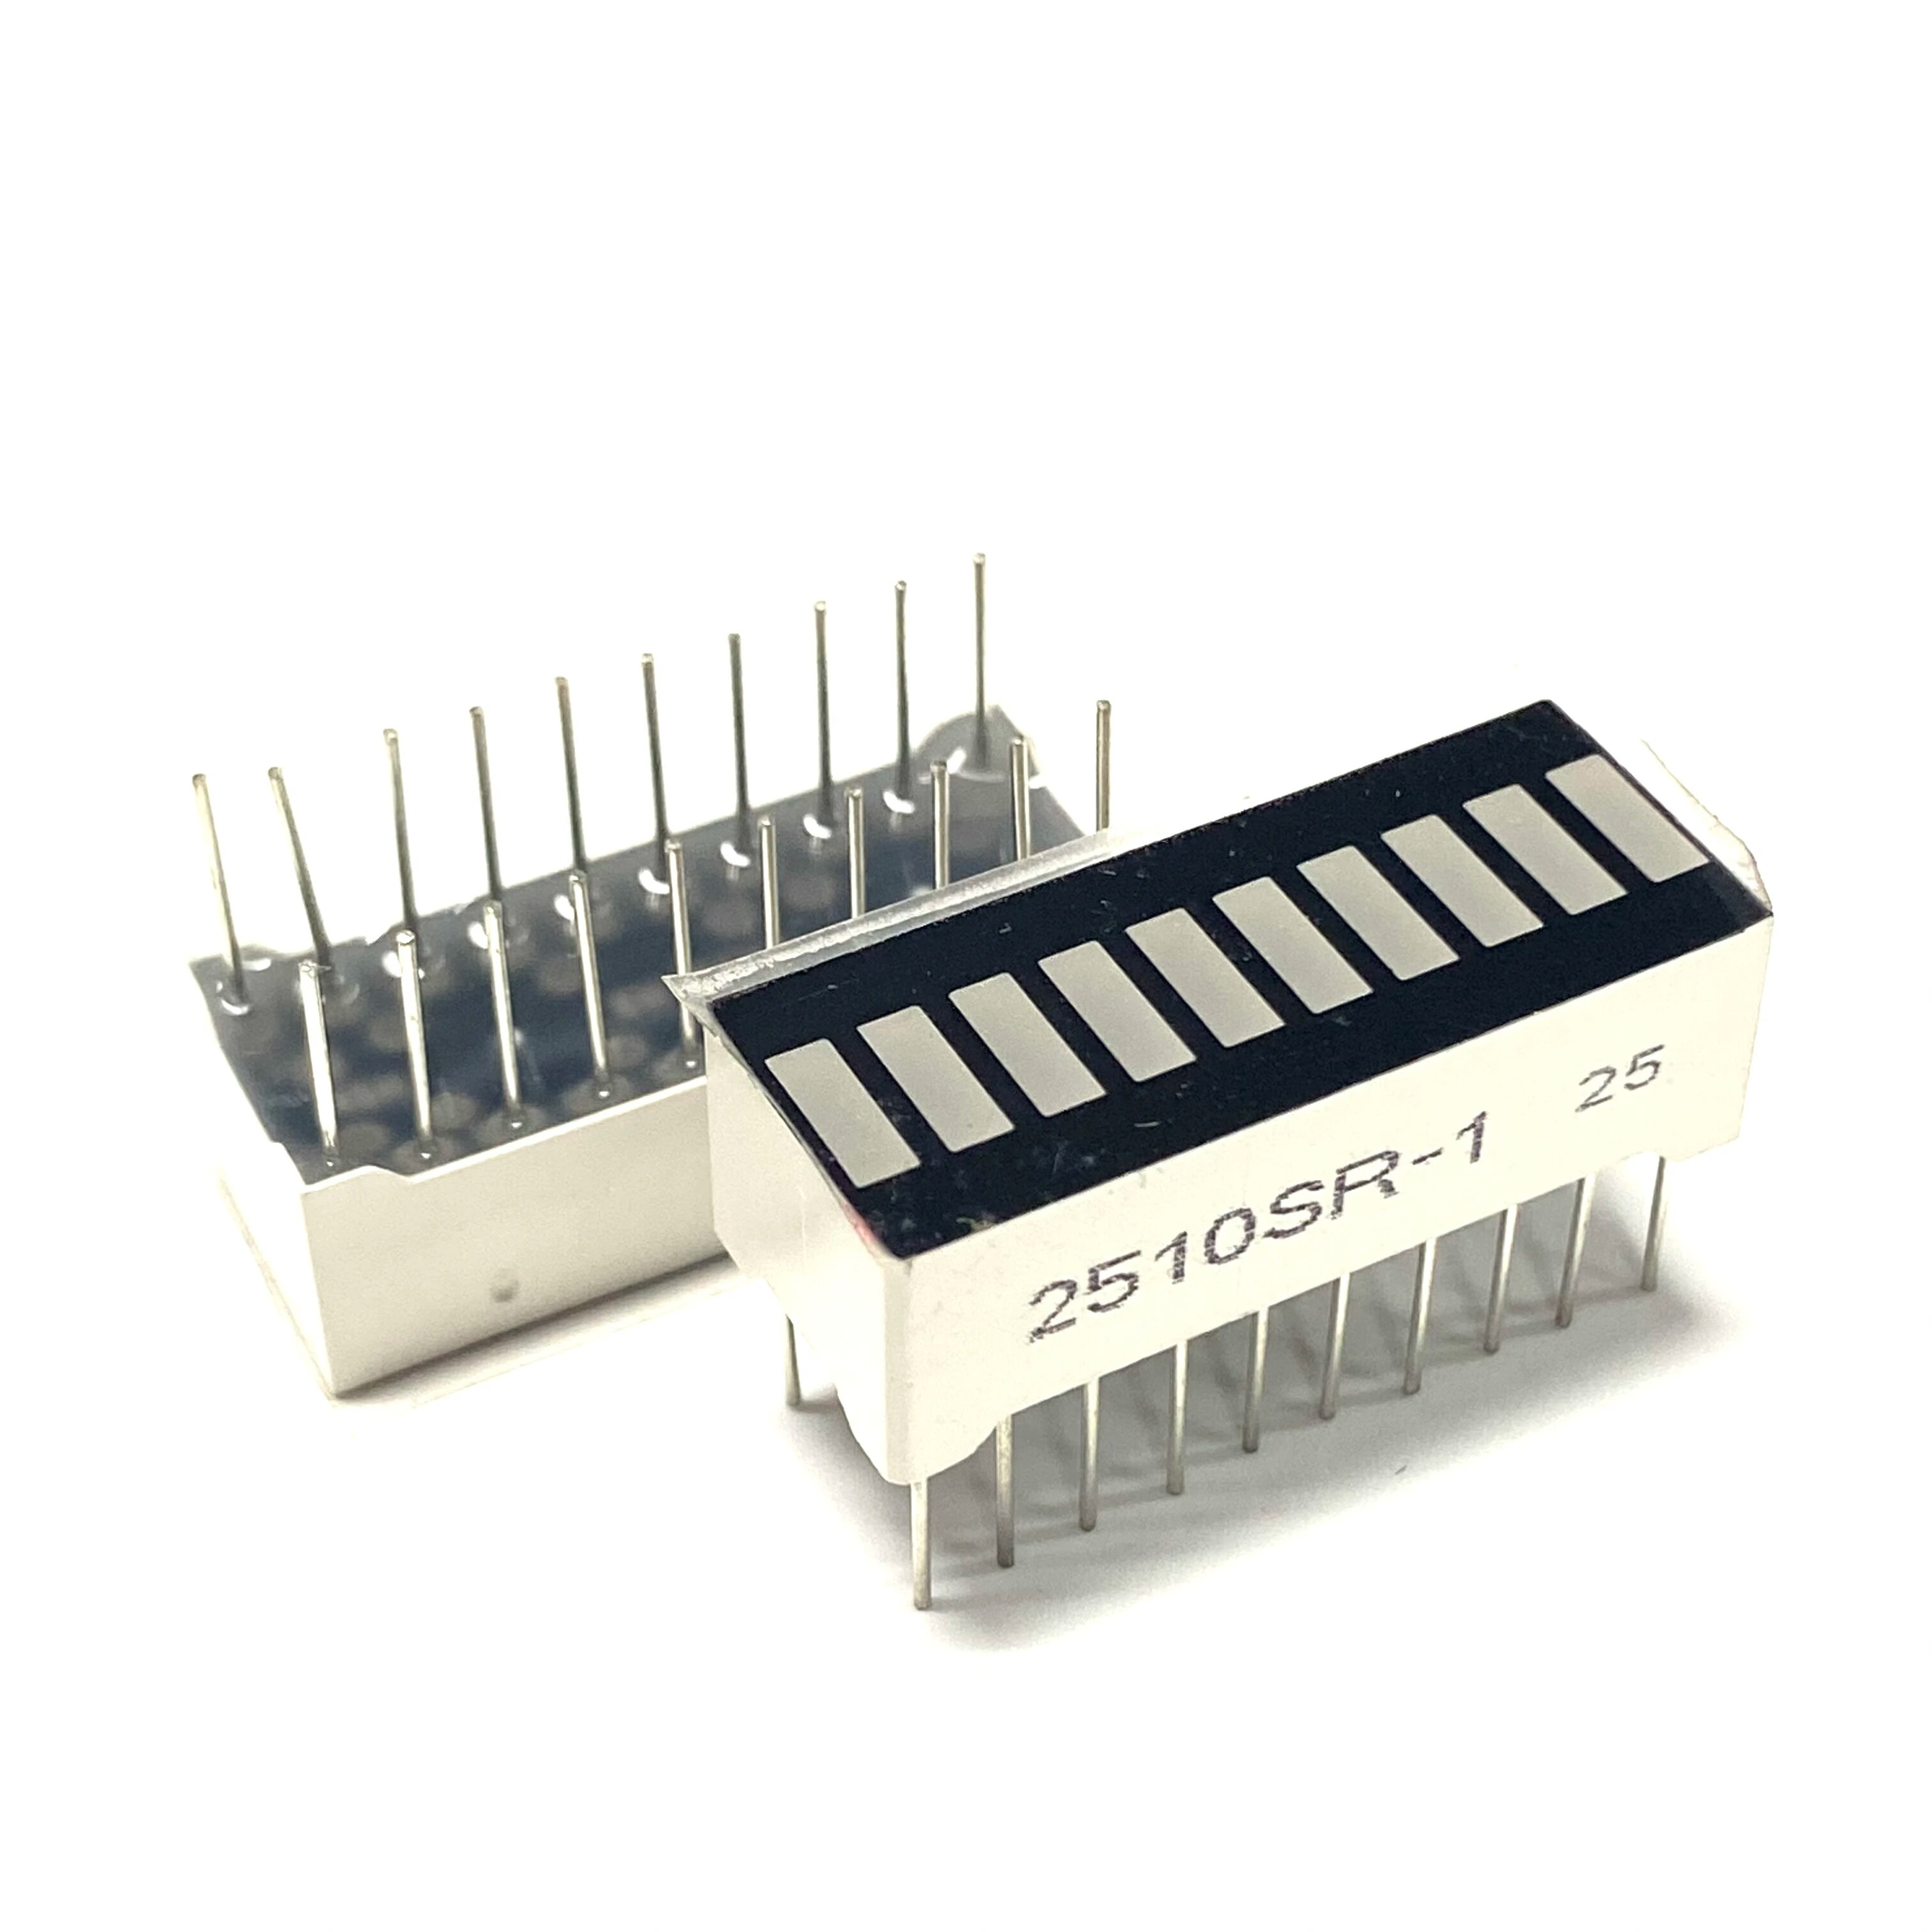
The number of digital inputs and outputs of a board are fairly limited in number. Our Raspberry Pi has 26 pins that we can use as a digital output. Suppose we want to make a clock with four 7-segment displays, then we already need 4 times 8 outputs and we can throw the idea in the trash. (Or with the led dot matrix display, 8 times 8 leds = 64 pins!)
Fortunately, there are many solutions to be able to control a lot of things with a limited number of inputs or outputs. Using a shift register is one of them.
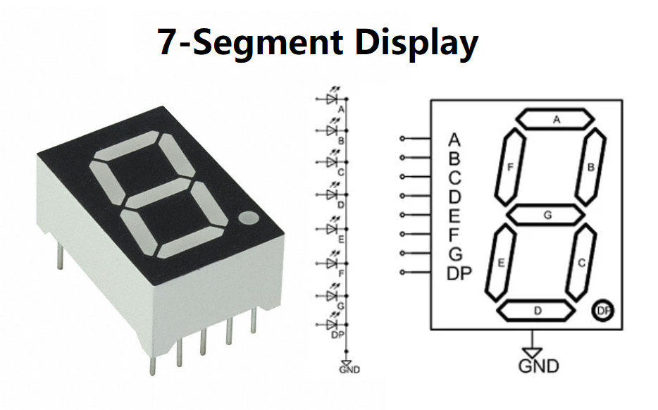
In the previous lessons we have already been extensively acquainted with serial communication, and last week we used a library that did the conversion of a byte to serial communication for us (i2c). This week we connect a shift register to which we have to clock serial data ourselves.

Shiftregister
A shift register receives a number of bits in series that are released in parallel. In this way, we can create multiple outputs via one data pin of our Raspberry Pi.
A shift register is made up of a number of electronic components (flip flops and latches) that are connected in series with each other and share the same clock. The figure below shows how a data bit is prepared on the left. For each pulse of the clock, that data bit is pushed to the next flip flop and we have four parallel outputs Q1, Q2, Q3 and Q4. Only after the fourth clock pulse do all outputs have the desired value. The output of each flip flop is used as the input to the next. Such a circuit is also called a cascade (waterfall) circuit. In this way, you can also connect multiple shift registers to each other.
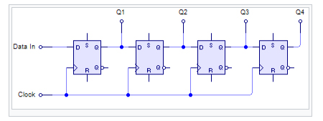

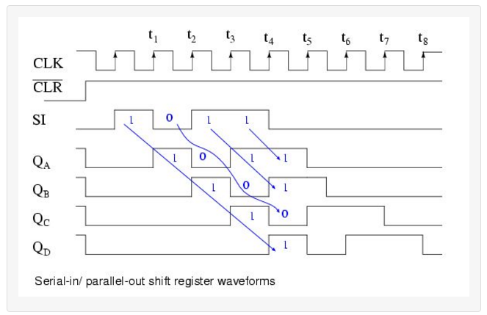
In the figure above you can clearly see how a data bit bubbles through the shift register. For each tick of the clock, the bit is transmitted one position to the right.
See also: https://www.youtube.com/watch?v=6nsQuKBRyl4

Shiftregister 74HC595
The shift registers of your kit are high speed 8-bit serial in parallel out registers. So we can send 8 bits in a row to the registry, those bits are then brought to 8 parallel outputs. Ideal for controlling a 7-segment display. If you want to control multiple 7-segment displays, you can cascade the shift registers.
This register also has a number of "options". Among other things, it has a storage register. We can copy the data in the shift register to the storage register. In this way, e.g. data can shift in the registry, while the storage registry remains unchanged. While sending data, the 7-segment display can continue to show its previous value.
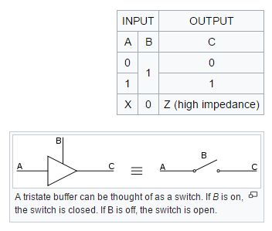
The register has a 3-state output. This means that we can place any output high or low, but we can also turn off that output. This is also called a high-impedance OFF state, you can compare this to an open switch.
> The GPIO pin needed for this is not connected in our pin (the Output Enabled/OE pin, see below)

Pin numbering
The Master Reset (MR), the two clocks (SHCP and STCP), the output enable (OE) and the Serial Data (DS) need to be connected to a GPIO pin of the Raspberry Pi. Q0 to Q0 Q7 are the outputs that we need to connect to the 7-segment display. We can use the Q'7 to connect the next shift register. By using 5 GPIO pins, we now have 8 digital outputs. If we use 2 shift registers, we have 16 outputs with our 5 GPIO pins.
If you need even more outputs, you can cascade different shift registers together. (Which is the case for our board. We well control the LED bar, with 10 LEDs, so we’ll need 10 outputs, so 2 shift registers cascaded)
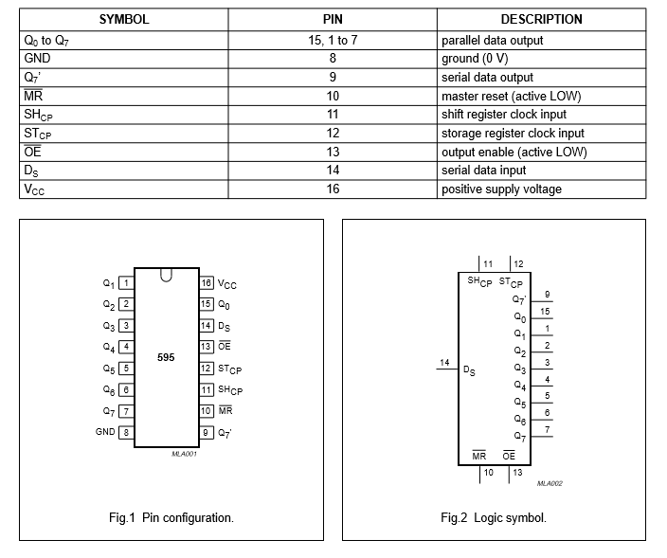

Function Block Diagram
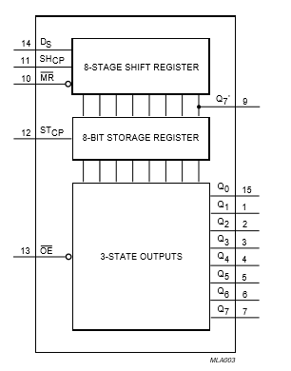
On the following diagram we can clearly see that the shift register and the storage register both have a separate clock. The output enable and the master reset are active low signals, i.e. if we want to bring out the outputs, we have to place a LOW on the output enable line.
For example, if we want to delete all the data in the shift register, we place a LOW on the MR line.

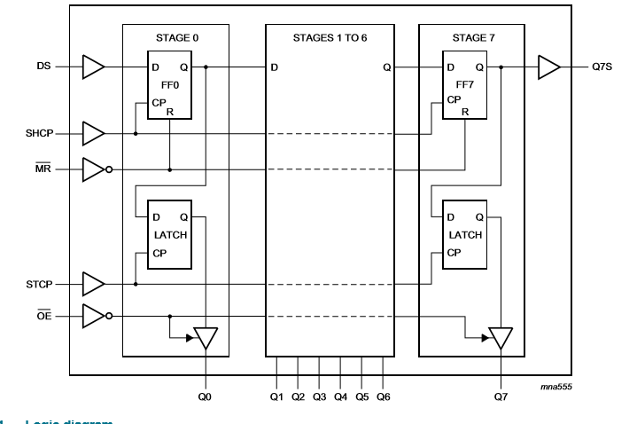

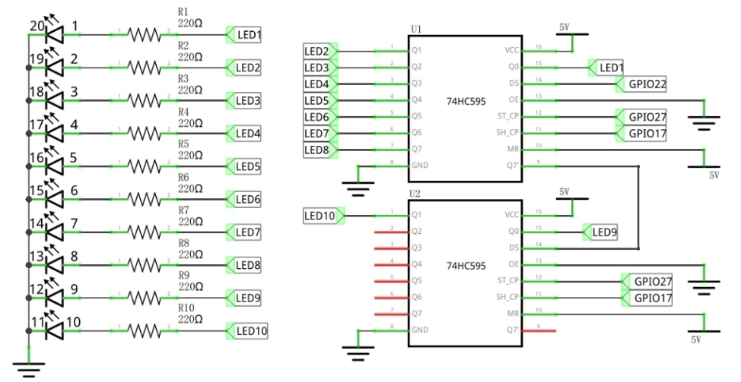

Our kit only has SHCP, STCP and DS connected to the GPIO pins, OE and MR are “fixed” to LOW and HIGH respectively, so Output is Enabled and Master Reset is not triggered.

We won’t be able to turn on/off the pins/output or reset the shift register/memory cells.
We can clear the shift register(s) by shifting in all zeros.

Cascade switching of shift registers
The clock lines and the OE and MR are connected in parallel to the next shift register. The last bit, which in principle would be lost, is made available on the output Q7'S after a pulse on the SHCP. The output Q7' is connected to the DS of the second register.
Below is an example of 4 shift registers cascaded.
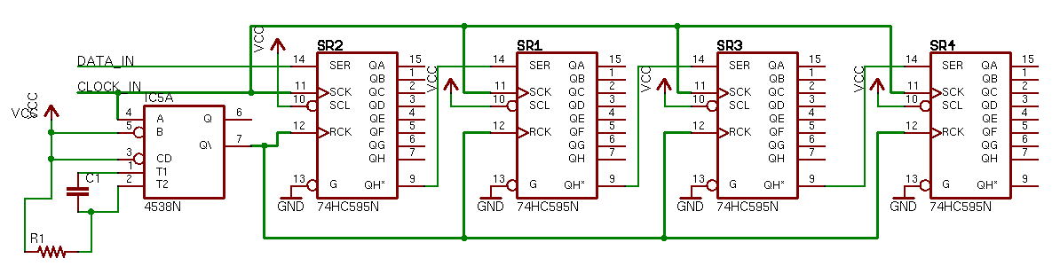 (You can also see this on the figure above from our projects kit)
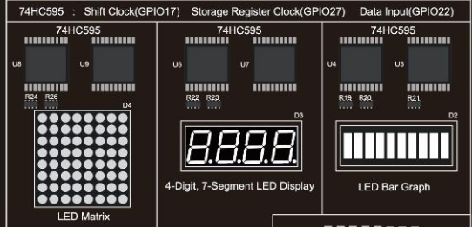

The led matrix, 4-Digit 7 segment display and the LED Bar Graph all make use of shift registers.
The shift registers for the actuators are not all connected in cascade.
Each component has its own 2 shift registers (in cascade) which are all connected in parallel (or over each other/together) on the same GPIO pins.
We can only use 1 of these 3 components at the same time (because sending data to 1 will send data to the other components too).

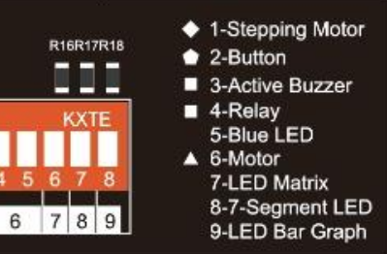
Make sure to turn ON the LED Bar Graph (the last switch needs to be up)
The switches for Led Matrix and 7-segment should be down

Protocol
If we want to send something, we will first and foremost have to make sure that we place the Master Reset (MR) line at a high level. We also can't forget to set the Output Enable low.
In order for something to happen on the shift register, a clock pulse must also be continuously made to the shift register SHCP, every time the pulse goes from a low to high level, an action is taken.
If the clock of the storage register goes from a low to a high level, the data from the shift register is copied to the storage register. In fact, we don't have to copy all the data per shift of the shift register, you can also decide to only transfer the data if all 8 bits are correct in the shift register. To get the shift register up and running, the following methods will have to be programmed:
- setup() => initialize all necessary GPIO pins
- init_shift_register() => Bring all signals to the correct level.
MR and OE are always correct for use, but we can bring the clock lines to the correct level
- write_one_bit(bit) => 1 bit forwarding
- write_one_byte(data_byte) => 8 times a bit of clocking
- copy_to_storage_register() => clock pulse on the storage registry to copy data.

Timing diagram
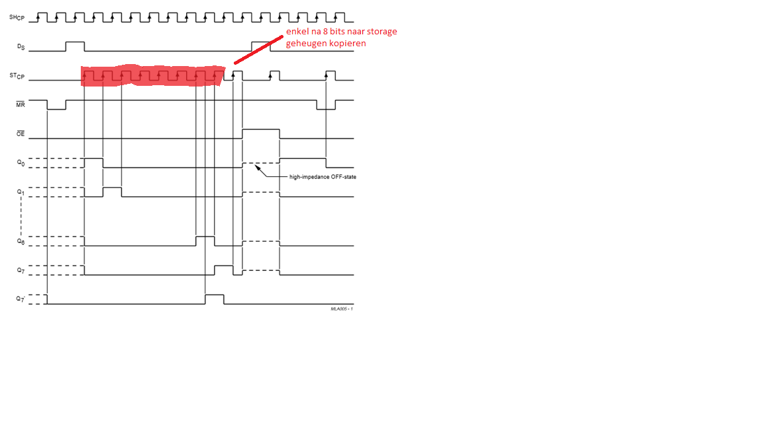

1-bit clock-through
So we will have to program this timing diagram in a python script. A low signal corresponds to a GPIO.LOW a high signal with a GPIO.HIGH. We also need to look closely at the order of the signals. For example, if we want to clock through a binary 1 we have to make sure that the clock is SHCP low, then we set the bit DS ready, clock SHCP up and back down. With each rising edge on SHCP, the value of DS is read and stored as b0 of the shift register. The remaining bits all move up 1 place and the value of b7 moves to the output of Q7S.
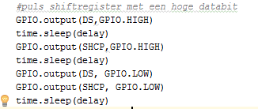
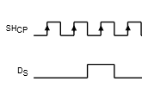

The shift register runs at a maximum clock speed of 100Mhz, the clock pulse may also be slower. This means a period of 10 nano seconds. Our python script doesn't reach that speed, so we can set the delay to 0s.

Extra methods
To make working with the shift register a bit more pleasant, we can write a number of additional methods. For example, we can write a method to clear the register, turn the display on and off.
If the MR pin becomes low, the entire contents of the shift registry will be erased, but not the storage registry! To clear that as well, you also have to copy the empty content again with a pulse on STCP.
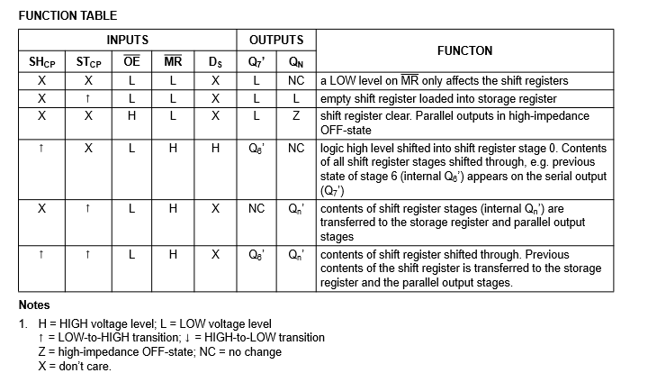
It’s still true what is written above, but because our MR en OE have a fixed state (they are not connected to GPIO pin) we can’t control these pin states, so we can’t trigger these methods.

LED Bar Graph


A LED Bar Graph has 10 LEDs integrated into one compact component. The two rows of pins at its bottom are paired to identify each LED

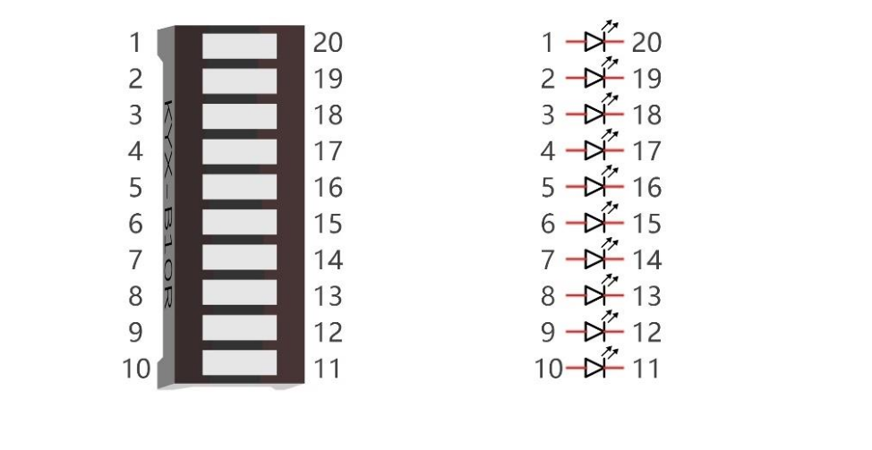
.

Shift Register Command
- Create a python script using the following methods:
  - setup(),write_one_bit(bit),copy_to_storage_register(), reset_storage_register(),
Your main script will look like this:
setup()
write_one_bit(True)
write_one_bit(True)
write_one_bit(True)
write_one_bit(True)

write_one_bit(True)
write_one_bit(True)
write_one_bit(True)
write_one_bit(True)

copy_to_storage_register()

With the above code we wrote 1’s to all 8 memory cells of the first shift register. Next, we moved everything over to the storage register.
This should light up the first 8 LEDs.
If we run this code again, we pushed another 8 bits to the first register, but this one overflowed to the next register. Both are now filled with all 1’s, so all LEDs should also be on.

write_one_bit will put the correct value on DS GPIO, next give a pulse on the SHCP pin (HIGH; LOW)

copy_to_storage_register will give a pulse on the STCP (HIGH; LOW)

If we want to turn all of the LEDs off, we should clock AT LEAST 10 bits with value 0 into the register(s), and then move these values into the storage register.
We can write some custom code to shift 10 bits out, but then this would only be useable for this application. The better solution is to *always* write out 2 bytes, from which, for this application, we only use the 10 Lowest Significant Bits

Let’s extend our code with the ability to transfer 1 byte at a time
  - Byte Analysis with Bit Operations
The above code looks a bit sad, instead of calling the method write_one_bit(bit) 8 times, it would be better to say a method write_byte(data_byte). In this method, we will decompose the data_byte using bit operations so that we can call the method write_one_bit(bit) from a forlus with the desired bit as the parameter.
Complete the definition below.
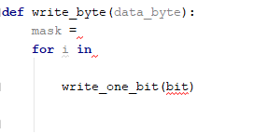
Think about the mask. The first bit we clock out, well end up as the last bit of the second shiftregister (if we send 2 bytes after each other)

  - Now we might as well create another method write_16bit_data
Here we will split the 16bit data into 2 bytes (of 8 bits)
This method looks like the write_byte method, we will do something 2 (instead of 8) times, again with a mask (where we have to consider in which register the lowest / highest byte will end up)
  - Create a method which accepts a number from 0 – 10 and will turn on that specific segment (using the previously created methods)
(0 = no segments on, 1 = first segment on, 10 = last segment on)
  - Modify the previous method the accept an optional parameter “fill”
Give it a default value (you can choose True or False)
If the value is True, don’t light up a single LED, but also all previous LEDs
(0 = no segments on, 1 = first segment on, 10 = all segments on when fill is enabled)
  - Ask the user for a number between 0 and 10 and display it on the LED bar
(also ask if it needs to be filled?)
  - Write a method to clear the register (turn all LEDs off)
(we’ll need to do this “manually” for our project board because not all the shiftregister pins are connected to RPi GPIO pins)
  - Create a helper class for the shift register, with the general setup for any shift register component, but also the specific methods for our Cascading setup, as well as the specific “Bar Graph” method we created in steps D and E
This class/these classes can be extended with specific methods/functionality for the Led Matrix and 7 Segments display later on.

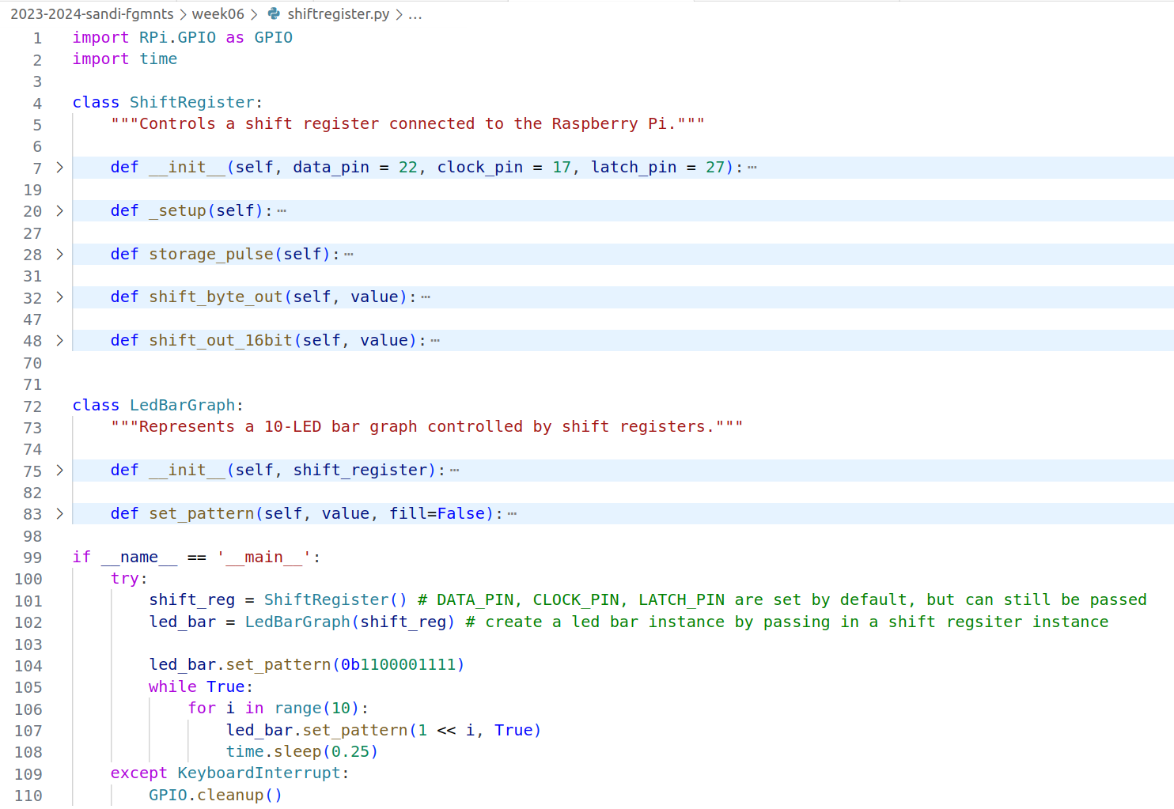
The method set_pattern will call self.shift_register.shift_out_16bit to update the Bar graph

Create some programs to practice working with the shift register / bit operations:

- Display to state of your 4 buttons we the first 4 LEDs of the bar
- Display the value of an Axis of your potentiometer (be default middle 2 LEDs are activated, moving joystick left light up more light to that side, etc)
- ... (anything you can think of?)

Buzzer
This LED bar is a good way of giving visual feedback
There are other ways we give feedback, e.g. by sound!
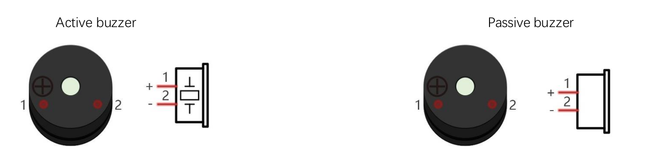
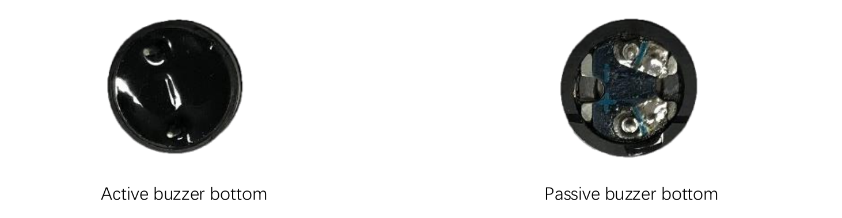
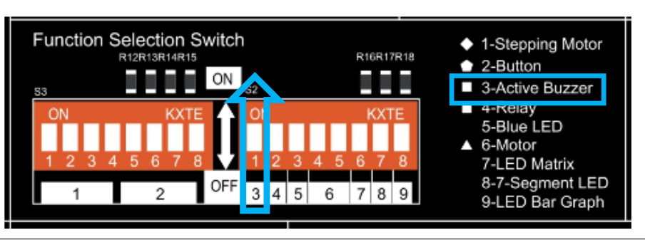

Our projects kit has 2 types of “speakers” included:
- Active buzzer
  - Have a built-in oscillator that generates a fixed-frequency sound (often around 2kHz).
  - Require only a DC power supply to produce a tone.
  - Simpler to use.
- Passive buzzer
  - Act like tiny speakers; they don't produce sound on their own.
  - Need an external AC signal (usually a square wave) at a specific frequency to produce a sound.
  - Offer more flexibility in pitch and tone control.

For both buzzers we can use GPIO.PWM !

For our active buzzer (GPIO 12) we can use PWM (with a high enough frequency) to modulate the volume output (of a “constant” tone)
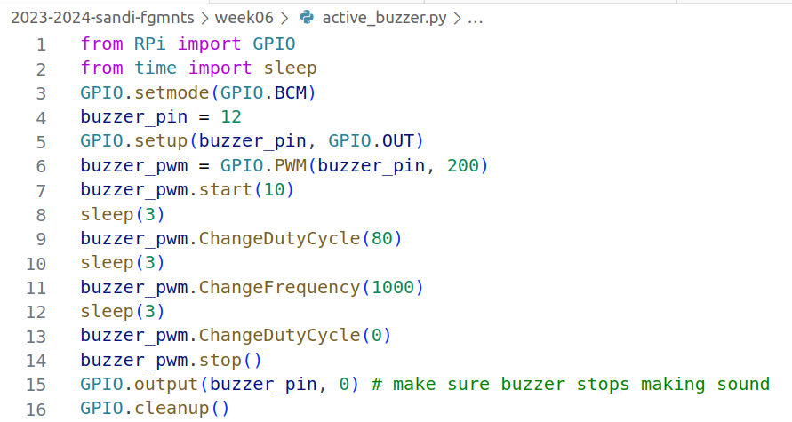
The passive buzzers need to be driven by the frequency of the sound we want to create, so we can use PWM.ChangeFrequency to update to output frequency:

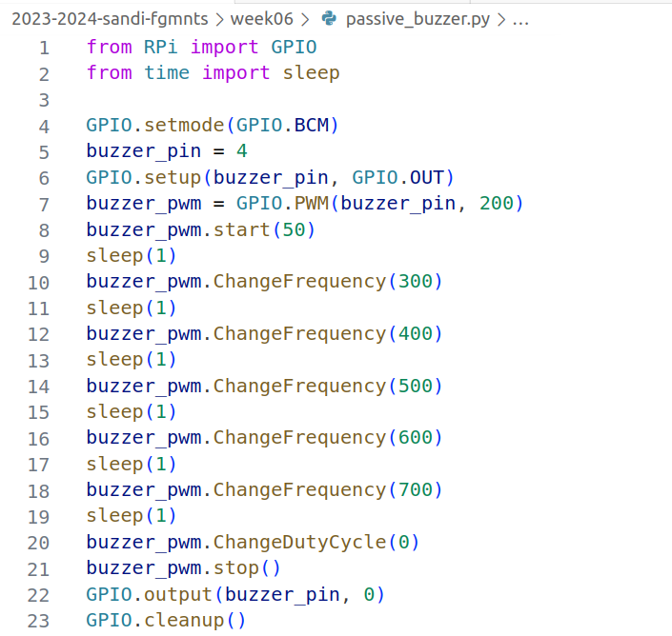

Try and update the previous code by adding some auditive feedback.
(Working with the analog signal can create a nice effect)

Assignment in class
Read potentiometer (A2)
Scale this value into 1-10 range, show on LED Bar Graph
Create a low pitch tone for lower values, and increase the pitch of the sound while the analog value increases
Use button GPIO 20 to toggle between “filling” the LED Bar graph, or just showing a single LED (event/interrupt)
Make sure the buzzer stops outputting sound when the program ends.

