Multiplexing
(4 Digits 7 Segments Display, Led Matrix, Keypad)

Objective
- Recap of shift register
- Understanding multiplexing
- Learn how 7 segment displays work
- Learn how led matrix works
- Use of Bit Operations

Introduction
In this lab, we'll explore the fundamentals of multiplexing, a key technique in digital electronics that allows us to handle multiple signals with just one communication channel. We'll work hands-on with three main components: a 4-digit 7-segment display, an 8x8 LED matrix, and a keypad. Through these devices, you'll learn how digital systems efficiently manage inputs and outputs.

7-segment display
A 7-segment display essentially consists of 8 segments when counting the decimal point (DP). These segments are typically LEDs, and most 7-segment displays require external resistors to limit current through these LEDs. Each segment can display hexadecimal characters, which include the numbers 0-9 and letters A-F.
There are two primary types of 7-segment displays: those with a common cathode (where the negative terminals of the LEDs are connected via a common pin) and those with a common anode (where the positive terminals are connected via a common pin). The type of display determines how you will control it, particularly in terms of how you apply voltage to illuminate the segments.
For practical applications, particularly in a laboratory setting using a Raspberry Pi, you will manage the display using multiplexing. This technique involves controlling multiple digits by sharing the segment pins across all digits and individually activating each digit's common pin (anode or cathode) sequentially. This rapid activation cycle creates the illusion of all digits being displayed simultaneously, thanks to the persistence of vision.
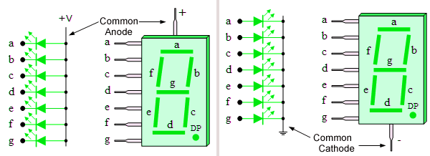
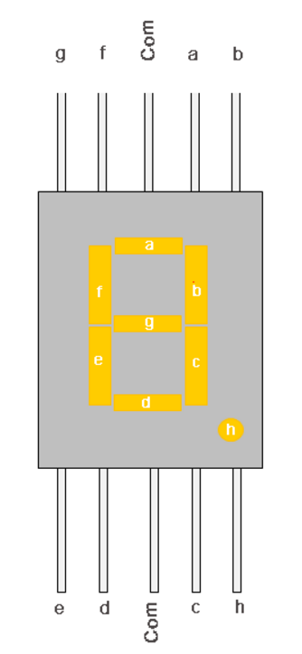
Below are a few possible types:
5101AS Common Cathode
5101BS Common Anode
SMA4105 Common AnodeSMA4205 Common Cathode
In principle, you should connect one resistor in series per LED. For simple tasks, one resistor between the common cathode and the mass will suffice. If only one resistive is used, there may be a difference in intensity between a number one and an eight. If different displays are used next to each other, this can be disturbing. On a "real" device, it is best to use 8 resistors. On a breadboard/while prototyping, 1 resistor may suffice.
> We can’t place the resistors ourselves, but they are included for every segment

In our kit the 78 segments (=LEDs) of a digit (= one 7 segment display) are connected to a shift register (like our Led Bar Graph).
The output / memory cell Q0 is connected to the LED for segment A.
The output / memory cell Q1 is connected to the LED for segment B.
...
The output / memory cell Q7 is connected to the led for segment DP.
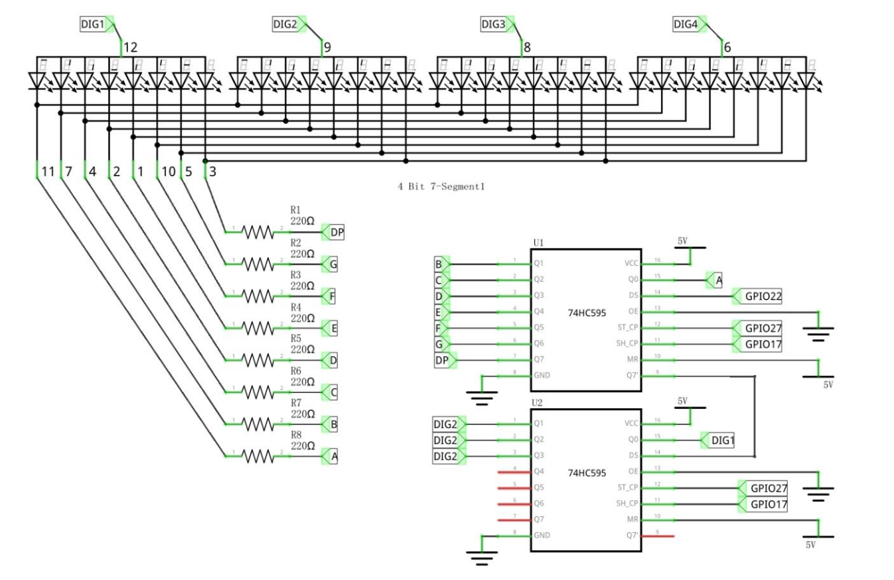

8 led segments, 8 bits in a byte, .... If we want to display 1 we should light up segments B and C
This would translate into 0b0000_0110 for a common cathode (-) display
Our component is a common anode (+) display, so the LEDs are on by default, and we need to block the segments which need to be off
This would translate into 0b1111_1001 (block all segments except bit1 and bit2 (B and C)) or 0xF9
To make this easier, we can define our bit values for each segment/LED
Next combine the needed segments per digit (0-9, A-F) in a dictionary

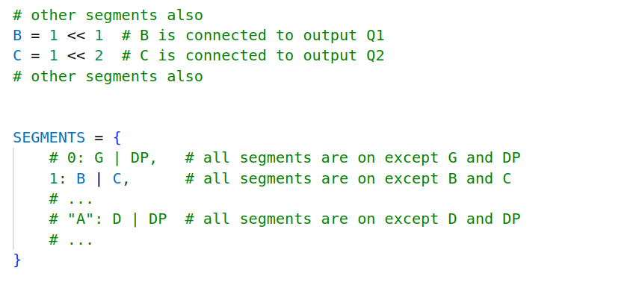
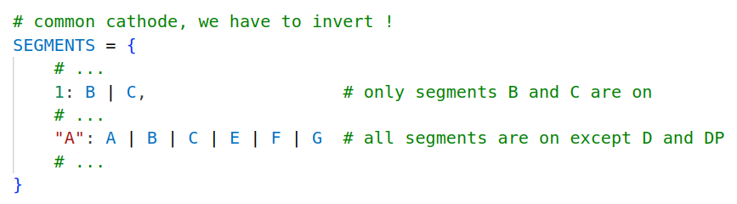
This way you can get the byte value for each “char” by selecting SEGMENTS[1] or SEGMENTS["A"] etc.. IF WE HAVE A COMMON CATHODE DISPLAY, WHICH WE DON’T!
We need to either invert the byte (and only keep the lowest 8 bytes, remember?? See bit operations doc if not..) or you can modify your SEGMENTS dict by “selecting” the opposite segments
>> So 1 would become all segments, except B and C, so A | D | E | F | G | DP etc

4 DIGIT 7-segment display
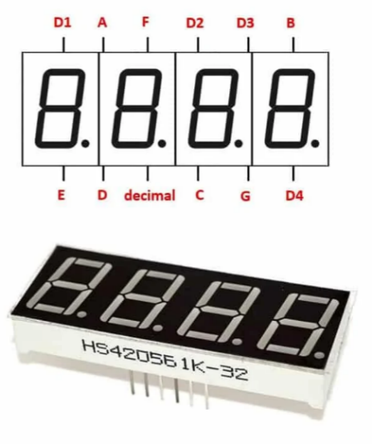
If you think:
Per digit we have 8(+1) pins, so 4 digits = 4 * 8(9) = 32(36) pins !
That’d wrong, we only need 12
(3 pins more, 3 digits more)
We will use the same “data/segment/led pins” for each digit but control which digit(s) are on by controlling the common anode for each digit.
This is a technique called multiplexing
Multiplexing is an essential technique that allows for efficient use of GPIO (General Purpose Input/Output) pins. The key to multiplexing a 4-digit display lies in the shared use of segment connections across all digits.
Each of the 7 segments, along with the decimal point, making up 8 segments per digit, is connected in parallel across the four digits. This setup means that each segment pin on the Raspberry Pi controls the same segment on all four digits simultaneously. Additionally, each digit has a common anode that can be controlled individually, allowing for precise management of which digit is active at any given time.
To drive the display, the Raspberry Pi activates one digit at a time by turning on its common connection while sending the correct signals to the segments to form the desired number or character. It then quickly switches to the next digit, updating the segment signals as needed.
This rapid switching happens faster than the human eye can detect (just like PWM brightness control), making all four digits appear as if they are continuously displayed. This method not only reduces the number of GPIO pins required—8 for the segments and 4 for the common digit connections, totaling 12—compared to 32 pins if each segment of each digit were independently controlled, but also simplifies the control logic needed to manage the display.

Multiplexing thus provides a practical and resource-efficient way to utilize a Raspberry Pi for controlling multi-digit 7-segment displays.
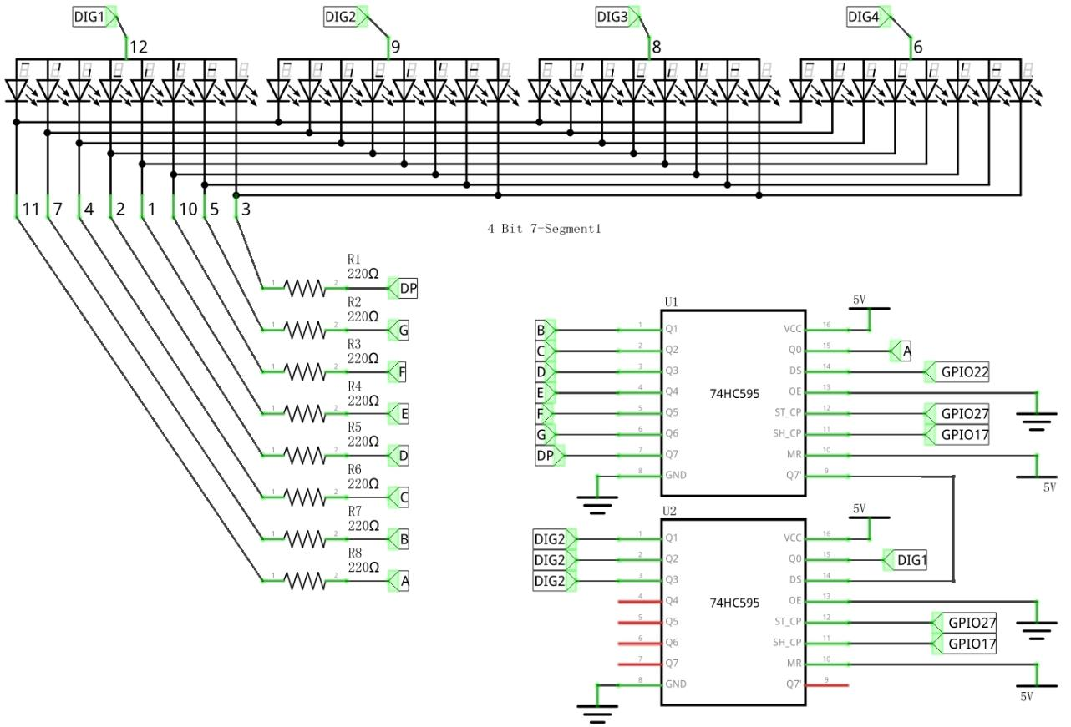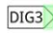
The common pin for digit 1 is connected to Q0 (of shift register 2)
Digit 2 to Q1, digit 3 to Q2 and digit 4 to Q3

To turn on all segment at the same time, the byte value of the second shift register should be:
0b0000_1111
To only turn on the first digit (counting from left) the byte value should be 0b0000_0001
Together with our other byte (to control the LED segments, the first shift register) this would make 0b0000_0001_1111_1001 (or 0x01F9) to display a 1 on the first digit
(if we clock from MSB to LSB)
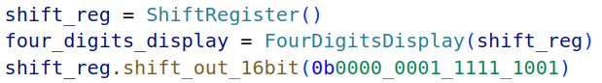
Making use and extending the ShiftRegister class from a couple of weeks ago

We can also define a dictionary for these digits:
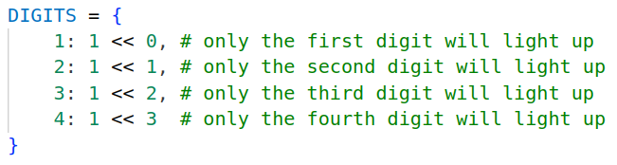
This way we can create our 16bit value that we’ll need to clock trough the shift register.
The Most Significant Byte consists of 1 or more DIGITS[] values, combined together (don’t forget to move it to the right “place” before merging with LSB)
The Least Significant Byte is our byte selected from the SEGMENTS dict
(maybe inverted? Depending on your method)
When we merge/combine these 2 bytes (with bit operations) together you’ll have the value to shift into the 2 shift registers

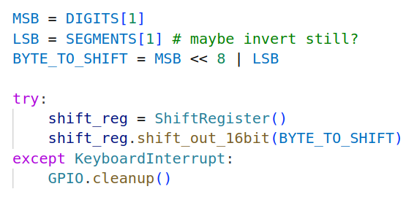
Print “1” to digit 1
If we do this rapidly for each digit it’ll seem like they are all lit up together:
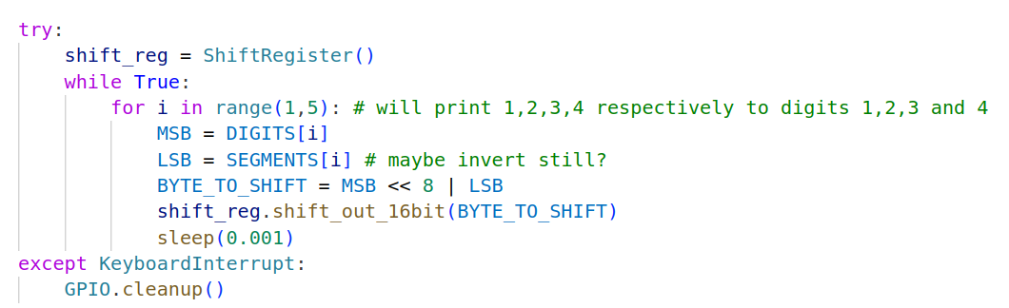

Led Matrix
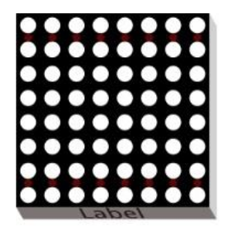
* if the led matrix doesn’t work, take it out of it’s socket, rotate it 180° and put is back

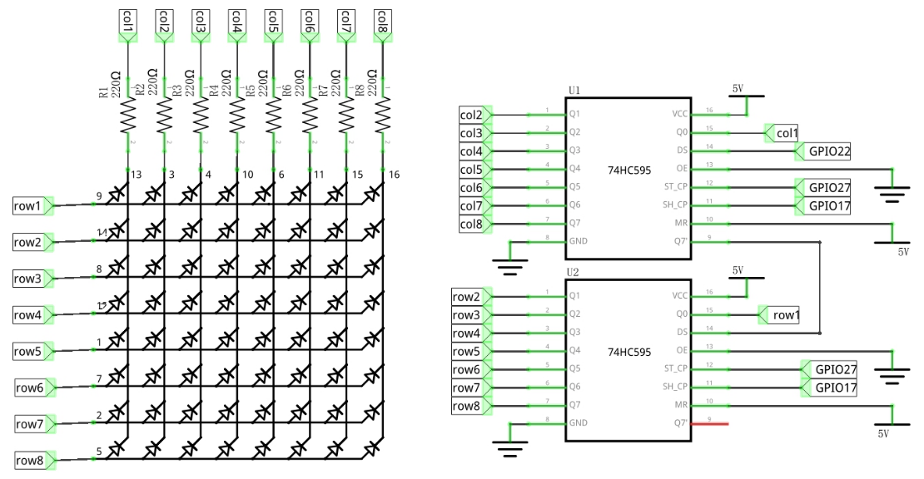
The LED matrix consists of 8 rows, each connected to 8 LEDs (the cols)
We have 8 x 8 LEDs = 64 LEDs
This would mean 64 GPIO pins if we wanted to drive them “traditionally”
Luckily, we now know about multiplexing, so we only need 16 pins.

We do need 64 bits of memory to store the state of each LED. We can do this in 1 (very) long binary number, but it’s easier/more manageable to keep track of each (8) row with a byte (8 bits, 1 bit per led)
This also comes both in common cathode and common anode, our component is a common anode type LED matrix.
The rows are controlled by the second shift register, so this is the MSB. This value needs to be all zero’s, except for the row which needs to be (partly) activated
The cols are controlled by the first shift register, so LSB
The value needs to be, just like before with the 7 segment display, in reverse. We need to block the LEDs from going (the one we don’t want to be on)
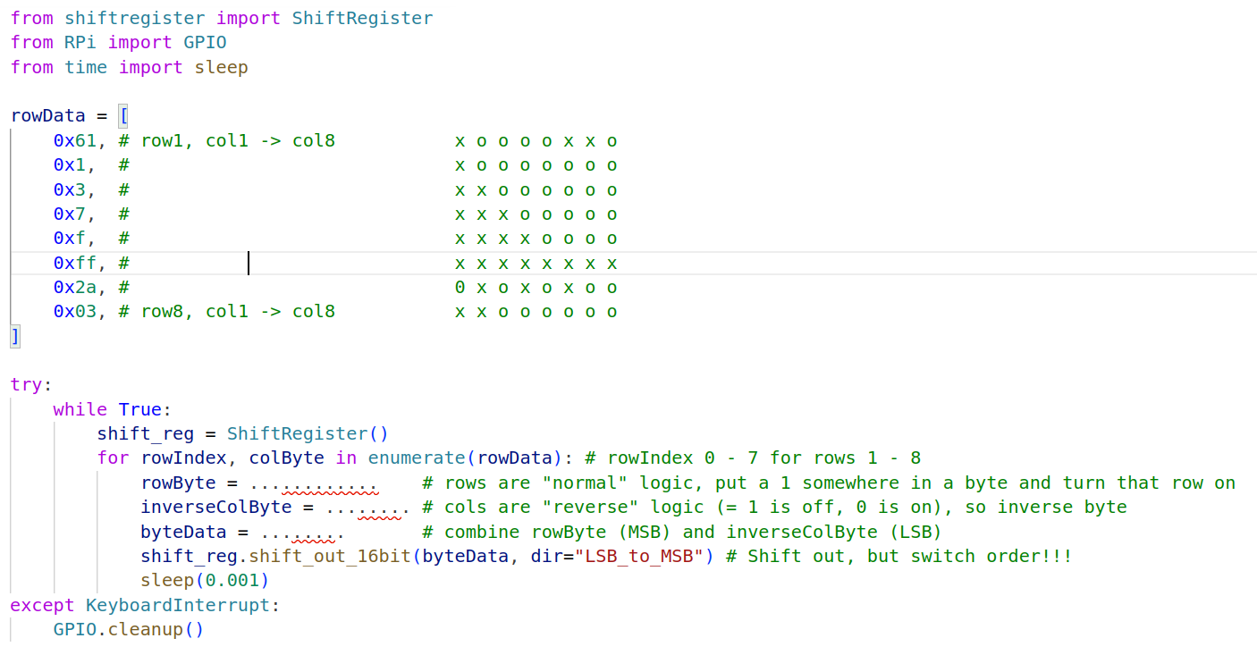
You can also program characters on this display, each character is 64 bits or 8 bytes “long”
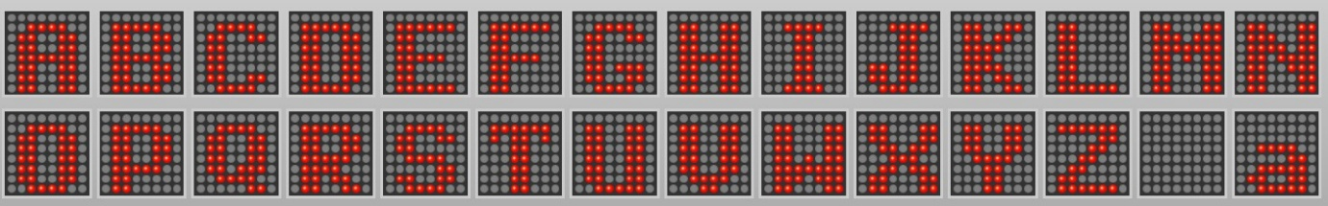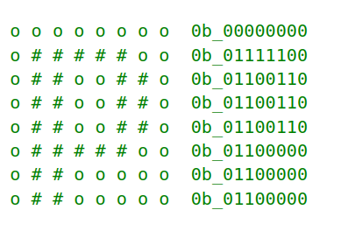

Keypad
We can also do multiplexing the other way around! Simple keypads contain several switches organized in a grid. Internal wires connect the individual rows and columns of switches so that when a user press one of the switches, that switch electrically connects a single row to a specific column.
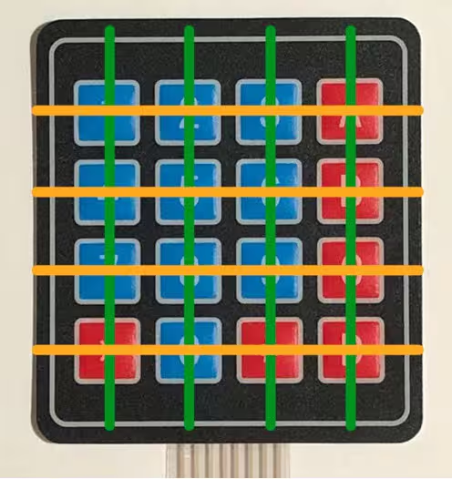
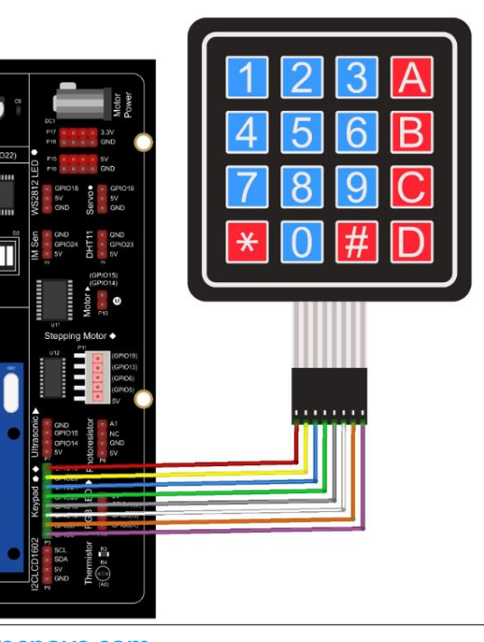
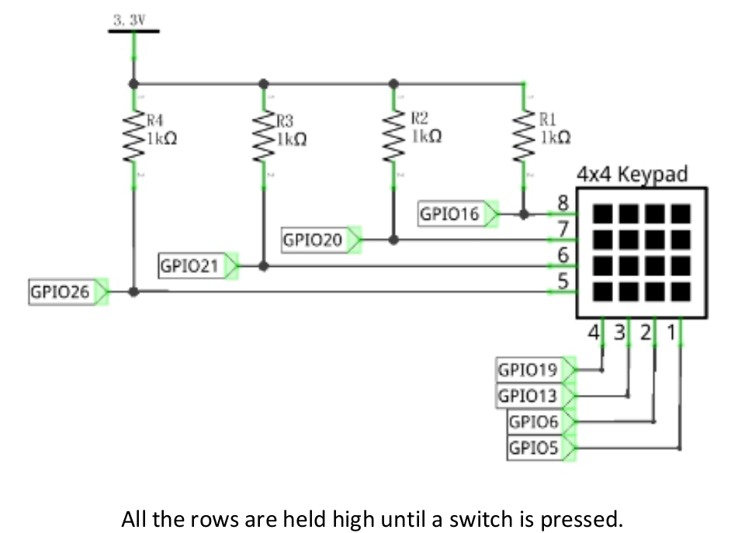
The keypad works with regular GPIO pins instead of the shift register
One of the ways to read the values of these buttons is to make 2 lists, 1 for the row pins, 1 for the col pins.

Row pins are output, LOW by default
Col pins are input (already pulled up)
We can also define a valuesDict where the key is the row number, and the value is an array of the keypad values

Loop over each rowPin, put that pin high (for rowNumber in range(4))
In the loop:
Loop over each colPin, read the state of the pin (for colNumber in range(4))
If the pin is HIGH, get the value from the values dict ( valuesDict[rowNumber][colNumber] )
put rowPin LOW again

(A slightly different implementation/explanation (but same principle) can be found at https://www.digikey.be/en/maker/tutorials/2021/how-to-connect-a-keypad-to-a-raspberry-pi)

Don't forget to turn on the needed hardware
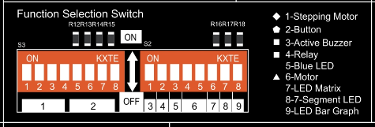

Assignment / TODO
Begin with the 4-digit 7 segment display.
(using the ShiftRegister class that you’ve already made)
- Define some numbers/characters (bytes)
(good efficient way, or the long way)
- Try and display a single value on a single digit
- Display this single value on every digit at the same time
- Display this single value on every digit 1 at a time
- Display a unique value per digit (decrease sleep time until all digits seem on concurrently)
- Create a new thread that will continuously update the Digits display, and use a Queue to pass new values to the display. (Like my example code for BLE)
make it so you can pass all hex characters (so you’ll need to work with strings)
- Extend the ShiftRegister class (create a new class for the FourDigit7Segment that will use the ShiftRegister class, just like we did with the LedBarGraph class)
Create some specific methods in this class, e.g.:
  - putValue: here you can pass a string like “1” or “12” or “ABC”
  - > left aligned? Right aligned? Define some parameters

  - putFilledValue: same as putValue, but you can add an extra character (= (optional) parameter?) which will fill up the remaining space (at the front, or back?)
  - e.g.: 1 can become 0001 or 1000 ; 12 > 0012 or 1200 ; ...

  - setCounter: set (and display) a numerical value (using putValue/putFilledValue?)

  - Increment: increment the previous counter value (and display)

  - Decrement: decrement the previous counter value (and display)

Led Matrix
Try and figure out how this works.
> Send some bytes to the shift register and see what happens
>> Send e.g. 0x8001, or 0x0110, ... log everything and try to understand how the data needs to be structured
I also updated my shift_byte_out method in the ShiftRegister class. It now has an extra argument by which i decide if I want to clock out the data for MSB to LSB or vice versa.
(you’ll also have to modify the method shift_out_16bit to accept the argument and pass it along in its call of shift_byte_out)
For led bar graph and 7 segments display we use(d) MSB to LSB, but for the led Matrix we can use LSB to MSB.
Try and create some custom patterns/displays/...

W9 Assignment:
Create a program where you get a blinking LED (on the matrix) as a “cursor”
Use the 4 buttons to “move” the cursor around on the matrix
Use the click from the joystick as “pen down” action, which will save the position of the cursor and add it to the relevant rowData entry
When the cursor moves away, the LED will stay on. Multiple dots can be drawn.
Extra: A drawn dot can also be removed again by selecting it and clicking on joystick again.
(simple etch-a-sketch)

Keypad

Try and read the value(s) of the keypad

