Sensors & Interfacing — Exam Questions
Original exam paper. Answers marked in the source are shown in bold (fill-in answers in blue). Explanations, verifications and corrections are attached as comments on each question heading.

Question 1 — 3 pts
A periodic signal with a period time of 4s has a frequency in Hz of
0.25

Question 2 — 3 pts
A periodic signal with a frequency of 2Hz has a period time in seconds of
0.5

Question 3 — 3 pts
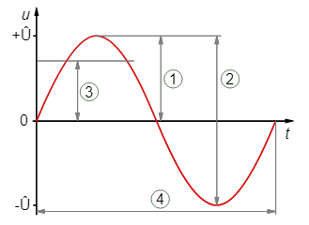
The parameter indicated in the image with the number 3 is:
Group of answer choices
The amplitude
The frequency
The Duty-Cycle
The peak-to-peak value
The pulse width
The period
The sinus
The RMS value
The phase

Question 4 — 3 pts
A PWM signal is high for 10ms, then remains low for 40ms. The Duty-cycle of this signal is:
Group of answer choices
25ms
10%
100ms
25%
20%
10ms
50ms
40%

Question 5 — 3 pts

The parameter indicated in the image with the number 1 is:
Group of answer choices
The Duty-Cycle
The phase
The amplitude
The peak-to-peak value
The period
The sinus
The pulse width
The frequency
The RMS value

Question 6 — 3 pts
A transducer is
Group of answer choices
An element that converts a voltage into a voltage of a different value
Required for analog communication
An element that converts an analog signal or physical parameter into a communication signal
An element that converts a digital signal into an analog signal
An element that converts an analog signal or physical parameter into another analog signal or physical parameter
An element that converts an analog signal into a digital signal

Question 7 — 3 pts
The following examples of measurable parameters are analog in nature:
Group of answer choices
Visitor counter at a trade fair
Temperature in an oven
The state of a standard Belgian traffic light
Distance to an obstacle measured with an ultrasonic sensor
If a night lamp is turned on
The speed of a bicycle
Air pressure in a car tire
Free space on a hard disk
Precipitation measured in mm/hour

Question 8 — 3 pts

The parameter indicated in the image with the number 4 is:
Group of answer choices
The amplitude
The frequency
The peak-to-peak value
The pulse width
The Duty-Cycle
The sinus
The period
The RMS value
The phase

Question 9 — 3 pts
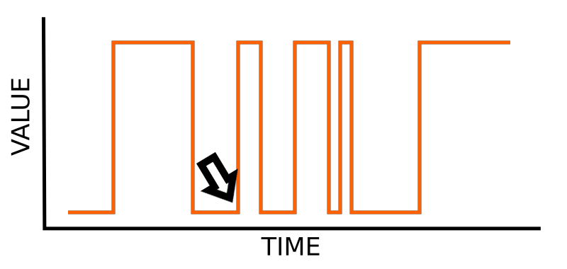
The indicated moment in the signal is:
Group of answer choices
The RMS-time
The duty-cycle
The falling edge
The period time
The rising edge

Question 10 — 3 pts
A periodic signal with a frequency of 50Hz has a period time in ms of
20

Question 11 — 3 pts
A sensor
Group of answer choices
Measures a value and makes it digitally readable
Modulates a signal onto a carrier wave
Converts a physical parameter into a signal
Can only measure analog physical values

Question 12 — 3 pts
A PWM signal is high for 10ms, then remains low for 40ms. The PWM-frequency of this signal is:
Group of answer choices
100Hz
0.05Hz
10ms
20Hz
50ms
20ms

Question 13 — 3 pts
A periodic signal with a period time of 200ms has a frequency in Hz of
5

Question 14 — 3 pts
An actuator
Group of answer choices
Converts a carrier wave into a movement of something
Always makes something move based on a digital value
Converts a signal into a physical change
Can only measure analog physical values
Can measure digital values

Question 15 — 3 pts
The following examples of measurable parameters are digital in nature:
Group of answer choices
The state of a standard Belgian traffic light
If a night lamp is turned on
Distance to an obstacle measured with an ultrasonic sensor
Precipitation measured in mm/hour
The speed of a bicycle
Visitor counter at a trade fair
Air pressure in a car tire
Temperature in an oven
Free space on a hard disk

Question 16 — 3 pts

The parameter indicated in the image with the number 2 is:
Group of answer choices
The frequency
The sinus
The pulse width
The amplitude
The RMS value
The peak-to-peak value
The Duty-Cycle
The phase
The period

Question 17 — 3 pts
[The image belonging to this question could not be displayed in the source file.]
The blue signal is a [ Select ] ["AC", "DC"] voltage. → marked: DC
The red signal is a [ Select ] ["AC", "DC"] voltage. → marked: DC
The green signal is a [ Select ] ["DC", "AC"] voltage. → marked: AC
The grey signal is a [ Select ] ["DC", "AC"] voltage. → marked: AC

Question 18 — 3 pts
[The image belonging to this question could not be displayed in the source file.]
The depicted signal is represented in the [ Select ] ["Frequency domain", "Time domain"].
Frequency domain

Question 19 — 3 pts
You want to digitize a signal while preserving all the information in this signal.
The analog signal has a maximum peak-to-peak value of 3V.
The highest frequency of the signal can be 10 kHz.
What value should be the minimum sample rate in kHz of the A/D converter you have chosen?
20

Question 20 — 3 pts
The quantization noise of an AD converter can be reduced by
Group of answer choices
Lowering the sample rate
Increasing the signal frequency
Applying aliasing
Adding noise to the analog signal
Removing the noise with a low-pass filter

Question 21 — 3 pts
The accuracy of an AD converter is determined by
Group of answer choices
Its resolution
Both its range and its resolution
The number of digits in the reading
Its range

Question 22 — 3 pts
An AD converter has a range between -1.5V and +1.5V, and a resolution of 8 bits.
The value of the LSB is approximately:
Group of answer choices
0.00586V
12mV
0.1176V
1Bit
256Bit
3V

Question 23 — 3 pts
An AD converter with a range between 0V and 5V and a resolution of 8 bits gives a reading: 0b00000101
The value of the analog input in millivolts (mV) is approximately:
98

Question 24 — 4 pts
An RS232 connection uses the following communication parameters: 1200-8E2
How long does it take, in seconds, to transmit a data packet of 1200 bytes?
12

Question 25 — 4 pts
The conversion between a serial and a parallel interface can be done with a:
Group of answer choices
(de-)multiplexer
FIFO-buffer
Shift register
DMA-controller
Transducer
Databus

Question 26 — 4 pts
An RS232 connection uses the following communication parameters: 1200-8E2
How many bits need to be sent to transmit 1 byte of data?
12

Question 27 — 4 pts
Simultaneous communication in two directions is called: [ Select ] ["full-duplex", "phased", "I2C", "parallel", "serial", "simplex", "SPI", "half-duplex"] communication
Communication in a single direction is called: [ Select ] ["PSP", "I2C", "phased", "parallel", "serial", "simplex", "full-duplex", "half-duplex"] communication
Bi-directional communication in one direction at a certain moment is called: [ Select ] ["full-duplex", "half-duplex", "I2C", "phased", "parallel", "serial", "SPI", "multimaster", "simplex"] communication

Question 28 — 4 pts
A MOSI I/O pin on a slave device on a bus is an [ Select ] ["output", "input"].
A MISO I/O pin on a slave device on a bus is an [ Select ] ["input", "output"].

Question 29 — 4 pts
The I²C bus is [ Select ] ["asynchronous", "synchronous"].
The SPI bus is [ Select ] ["asynchronous", "synchronous"].

Question 30 — 4 pts
Manchester encoding:
Group of answer choices
Is necessary in I²C communication
Requires a seperate clock signal
Ensures that there are no long periods where the signal level remains the same
Is very suitable for use in wireless ASK connections

Question 31 — 4 pts
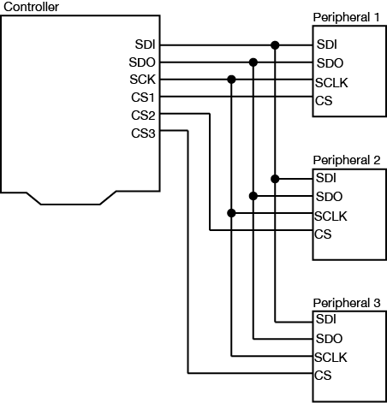
The above image depicts a [ Select ] ["multiplexed", "parallel", "serial", "multimaster"] communication bus.
serial
[Second image could not be displayed in the source file.]
The above image despicts a [ Select ] ["multilayer", "parallel", "multiplexed", "serial"] communication bus.
serial

Question 32 — 4 pts
An RS232 communication interface has the following parameters: 9600-8N1
How long does it take, approximately, in minutes, to transmit 1MB of data?
18.2

Question 33 — 4 pts
To increase the noise immunity of a digital communication bus of any length, it's best to:
Group of answer choices
Reduce the voltage
Use differential signals
Lower the frequency
Use a narrowband signal
Increase the frequency

Question 34 — 4 pts
If an I²C slave cannot process the data from the master quickly enough, then:
Group of answer choices
The master will notice this due to the flow control, and it will send data to the slave at a slower rate
The slave can use clock stretching by pulling the clock line low itself
The slave can send an Xoff Flow-control signal to the master, causing it to temporarily stop sending.
Communication will fail, and the system wil not work

Question 35 — 4 pts
How many I/O connections are necessary on a controller (master) to connect 5 slaves using an SPI bus? (using the most standard way to implement this bus)
8

Question 36 — 4 pts
Polling is often necessary in master/slave communication because:
Group of answer choices
It is necessary to know the addresses of the slaves
The slave cannot autonomously send data to the master.
The master might otherwise lose its position in the bus.
The FIFO buffer in the slave might otherwise become full.

Question 37 — 4 pts
Compare the SPI and I²C interfaces.
In most cases, this interface is faster: [ Select ] ["I²C", "SPI"]
This interface typically consumes less energy in a system: [ Select ] ["I²C", "SPI"]
This interface is easier to implement because bidirectional I/Os are not required: [ Select ] ["I²C", "SPI"]

Question 38 — 4 pts
In SPI [ Select ] ["Only one master can be present on a bus.", "Potentially, multiple masters can use the same bus"]
In I²C [ Select ] ["Potentially, multiple masters can use the same bus.", "Only one master can be present on a bus."]

Question 39 — 4 pts
Pull-up resistors are necessary on an SPI bus.
Group of answer choices
True
False

Question 40 — 4 pts
An I²C bus is always [ Select ] ["full-duplex", "differential", "half-duplex", "integral", "simplex"], while an SPI bus is often [ Select ] ["half-duplex", "differential", "simplex", "full-duplex", "integral"].
marked: half-duplex / full-duplex

Question 41 — 4 pts
How many I/O connections are necessary on a controller (master) to connect 5 slaves using an I²C bus? (using the most standard way to implement this bus)
2

Question 42 — 4 pts
Pull-up resistors are necessary on an I²C bus.
Group of answer choices
True
False

Question 43 — 4 pts
In I²C, the timing is determined by the [ Select ] ["slave", "master"]
In SPi, the timing is determined by the [ Select ] ["slave", "master"]
marked: master / master

Question 44 — 3 pts
Which modulation technique is the carrier wave depicted below modulated with?
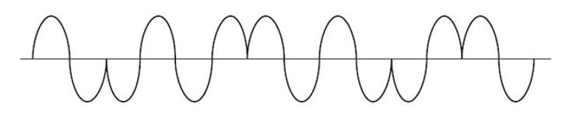
Group of answer choices
ASK
CW
PSK
FSK
FM
AM

Question 45 — 3 pts
Which analog modulation technique always transmits the same power, regardless of the signal?
Group of answer choices
QAM-256
CPCW
AM
BPSK
FM

Question 46 — 3 pts
Sending a carrier wave in several different amplitude levels to achieve digital communication is called:
Group of answer choices
OAM-1
ASK
FSK
BPSK
AM

Question 47 — 3 pts
Which modulation technique for digital signals offers the highest noise immunity among the proposed choises?
(Assuming they are transmitted by a transmitter with equal power and on the same frequency)
Group of answer choices
FSK
BPSK
QAM-256
OFM-2

Question 48 — 3 pts
Analog SSB modulation is a form of [ Select ] ["CW", "AM", "FM"] where only a single side band is transmitted.
If the part above the carrier is filtered out, we call this [ Select ] ["Firewire", "USB", "LSB"] modulation.
If the part below the carrier is filtered out, we call this [ Select ] ["LSB", "Firewire", "USB"] modulation.
The advantage of SSB modulation is that the bandwidth of the signal is [ Select ] ["decreased", "increased"] and consequently, the required power for the same range is [ Select ] ["increased", "decreased"].

Question 49 — 3 pts
Sending a carrier wave with a number of different frequency shifts to achieve digital communication is called:
Group of answer choices
OAM
FSK
ASK
BPSK
DTMF

Question 50 — 3 pts
Which modulation technique for digital signals achieves the highest data rate among the proposed choices?
(Assuming they are transmitted by a transmitter with equal power and on the same frequency)
Group of answer choices
BPSK
QPSK
QAM-256
FSK
CW
ASK

Question 51 — 3 pts
The specification of a passive antenna states that it has a "gain" of 24dB. It is clear that:
Group of answer choices
This is an omnidirectional antenna.
This specification may not be accurate.
This antenna is an isotropic radiator.
This is a discone antenna.
This is a directional antenna.

Question 52 — 3 pts
The attenuation of an RF signal in free space without any interfering factors (also known as free-path loss) depends on:
Group of answer choices
Only the frequency.
Only the distance.
The type of modulation, the frequency, and the distance.
Both the frequency of the carrier wave and the distance.
The antenna system and the distance.
The modulation technique and the distance.

Question 53 — 3 pts
You measure the antenna of a radio receiver. it measures 12.5cm.
You know that this is a classic, non-shortened dipole antenna.
Make an estimate of the frequency for which this receiver is designed. Provide the frequency in MHz.
1.2

Question 54 — 3 pts
[ Select ] ["Higher", "Lower"] RF frequencies travel further in open space, [ Select ] ["Lower", "Higher"] RF frequencies can penetrate walls better.

Question 55 — 3 pts
The transmitter of a remote-controlled toy car states that it operates at a frequency of 27MHz.
What is the wavelength of this transmitter in meters?
11.11

Question 56 — 3 pts
If we safeguard a value of 2 bytes with a CRC, using the CRC polynomial x²+1, how long is the resulting bit string in bits (in total)?
18

Question 57 — 3 pts
with ECC codes like a CRC, you can secure your system against:
Group of answer choices
Incorrect data during a communication problem such as a collision on the bus
Bit errors caused by disturbances in a cable
Deliberate manipulation of a bitstream

Question 58 — 3 pts
Complete with the correct parity bit for EVEN parity:
Group of answer choices
1001 0110 [ Choose ] 1 / 0
0101 0100 [ Choose ] 1 / 0
0001 0001 [ Choose ] 1 / 0
1110 1100 [ Choose ] 1 / 0

Question 59 — 3 pts
A CRC algorithm with a well-chosen polynomial can:
Group of answer choices
Detect 1-bit errors in all cases
Never detect all possible errors in a bitstream
In certain cases even detect errors where more bits are incorrect than the length of its polynomial

Question 60 — 3 pts
Given a CRC polynomial: x³+x+1
You want to provide a CRC check for the byte: 1110 0011. Add the CRC bits to this data.
The resulting bit string is (provide the full bit pattern including the original bits):
11100011011

