- The upper transistor in a source-follower, is a PFET right?
NFET
- 45:00 : “to stay in saturation, V_ds > 4U_t” ???????
- Slide 18: I don’t understand the last 2 steps
- Why is it stable in feedback
- Which one is the positive/negative
- 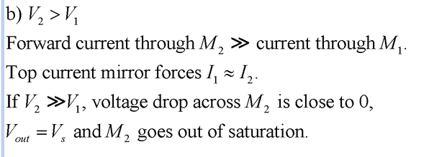slide 25

- Diff between exp. 3.3 and 3.4??

