Group Assignment 1
Photo | Name | Student ID | Nationality | Sex | Email
 | PASCAL STOLL  帕斯卡 | 2559273 | GERMAN  德国 | MALE  男 | st190102@stud.uni-stuttgart.de
 | PHILIPP EXLER  菲利普 | 2559274 | GERMAN  德国 | MALE  男 | st187461@stud.uni-stuttgart.de


- A photo of your group
Figure 1: A picture of our student group.

- Choose a previous project that interested you, download their final reports and their code if they had. Read though those materials. Connect with those previous students and review them.
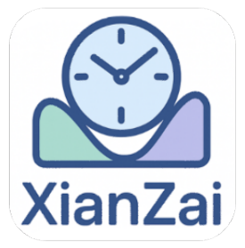
We were most interested in the “XianZai” app. The idea of an app combining productivity and time management inspired us. We reached out to Amedeo and Thierry, the developer of the app, and asked the following questions. We did not only state their answers but also reflect on our thoughts and learnings we keep in mind for our software engineering project.
Figure 1: The logo of the XianZai app.

  - Does your app actively work now?
Unfortunately, their app is not active anymore and was never available in app stores to download. Perhaps they developed this project for this class exclusively and had no intention of publishing it. Maybe not all features of the app were fully implemented due to time constraints, which would render a release more difficult. There are many obstacles from transforming a prototypical university project into a real-life working product.
For our project, we therefore set the goal of developing a software product whose features are fully implemented. We want to provide a coherent user experience where all necessary features are available. Knowing the scope of the project, prioritizing and focusing on the more important features first are important aspects to keep in mind.
Furthermore, we are aware of the challenging gap between development and production of a software product, and we will try to bridge this gap by continuous deployment. Therefore, choosing a suitable software process model and executing it are considered key success factors by us.

  - What’re your experience and lessons during their software development project?
Amedeo and Thierry reported that teamwork played a crucial role in the project’s success. They learned how to coordinate with each other, split the work and create suitable workflows. We concluded from their final report (user manual) that they used an agile process model and developed the app in three cycles. In our project, we will focus on clear responsibilities within our team and employ to make our teamwork more efficient.
They also highlighted the amount of work and steps it takes before the start of the implementation. We see that reflected in the number of requirements, and the number of models, such as data models, UML diagrams, data flow diagrams, and many more, that the two developers provide in their report. This demonstrates how versatile software engineering tasks are and it showed us that we should not save time on this step in our own software project but embrace it. We learned that solid planning and modeling is the foundation of a good software product.

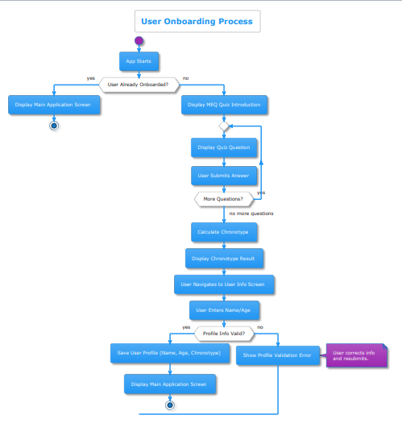
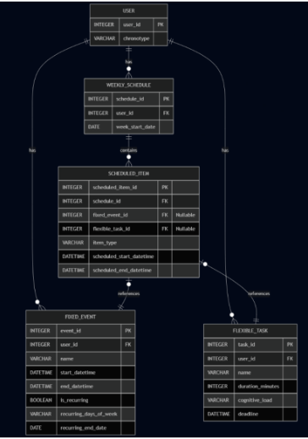
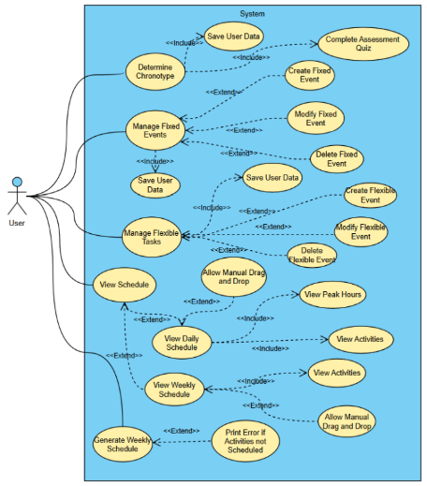
Figure 2: The use case diagram, an Entity-Relationship Diagram (ER-diagram), and activity diagram from the XianZai projects’ final report (user manual) which highlight the amount of conceptional tasks necessary in a software project.

  - What are your recommendations for learning this course?
First, Amedeo and Thierry suggested that we think of an original idea for our project. The idea should be sellable to actual customers and have a good business plan. They stated that this part was especially difficult for them. We are grateful for this recommendation and will consider this perspective in our brainstorming when searching for an idea on our own. Switching the point of view from the developer’s side to the customer’s side, or the business side, can be challenging for people with a technical background, but we think it is crucial when making a meaningful project.
The second recommendation of the two developers regarded time management. They suggest organizing one’s time to complete the final project in due time. As a strategy, they recommend dividing the project into small targets, and setting deadlines for each of them. We are grateful for this tip, and we will emphasize good time management for our own project planning. We will aim to work continuously on the project so that work does not pile up right before a deadline.
We are thankful for the valuable insights provided by Amedeo and Thierry from the “XianZai” project and we are excited for our own project in this course.

