**Supplementary Information**

In this section, we present the fitting trend for the three phases i.e. Train, Test and All (Train + Test) of the model presented in this study.

1. **This Study**
2. Oil relative permeability

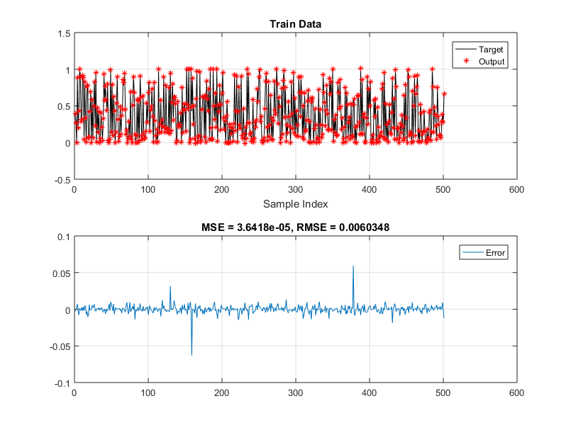

Fig. D1. Predictive accuracy of the oil relative permeability for the training phase using SCM

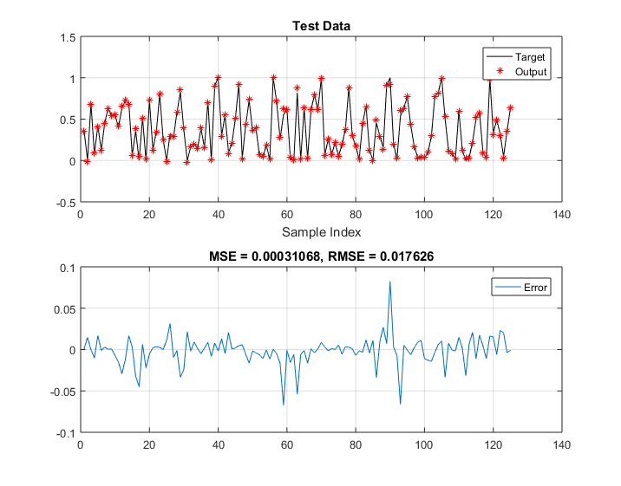

Fig. D2. Predictive accuracy of the oil relative permeability for the testing phase using SCM

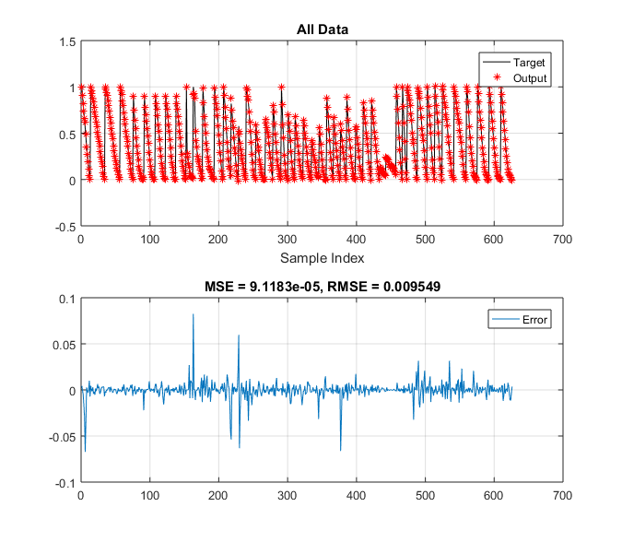

Fig. D3. Predictive accuracy of the oil relative permeability for the combined (Train + Test) phase using SCM



Fig. D4. Predictive accuracy of the oil relative permeability for the training phase using FCM

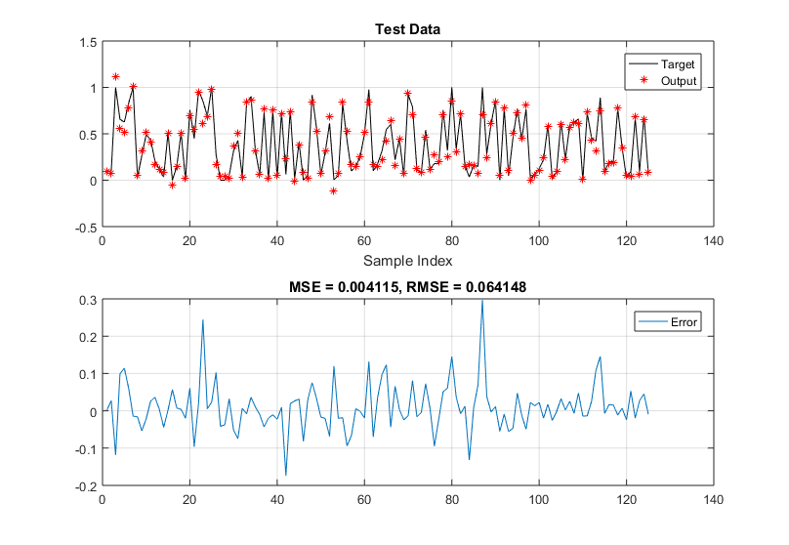

Fig. D5. Predictive accuracy of the oil relative permeability for the testing phase using FCM

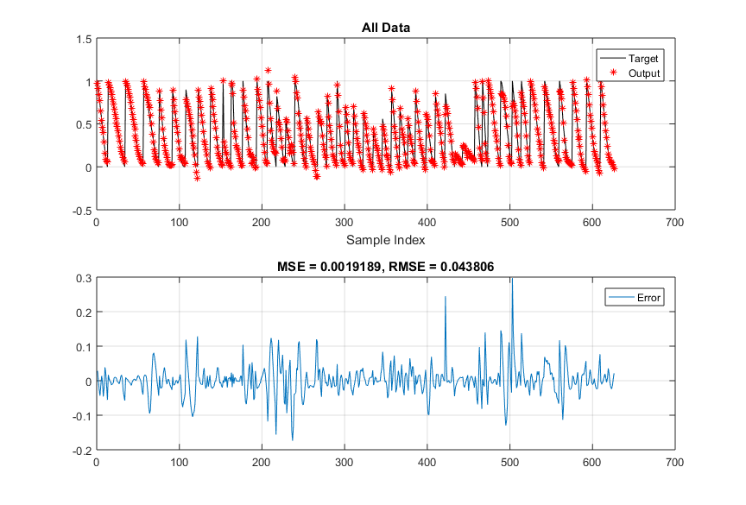

Fig. D6. Predictive accuracy of the oil relative permeability for the combined (Train + Test) phase using SCM

1. Water relative permeability

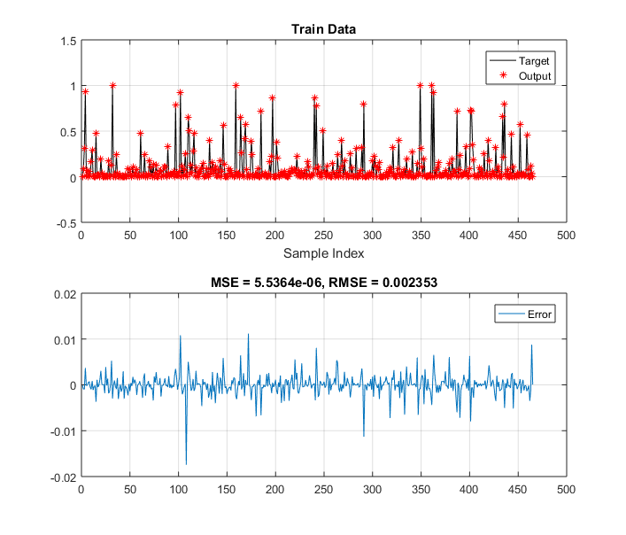

Fig. D7. Predictive accuracy of the water relative permeability for the training phase using SCM

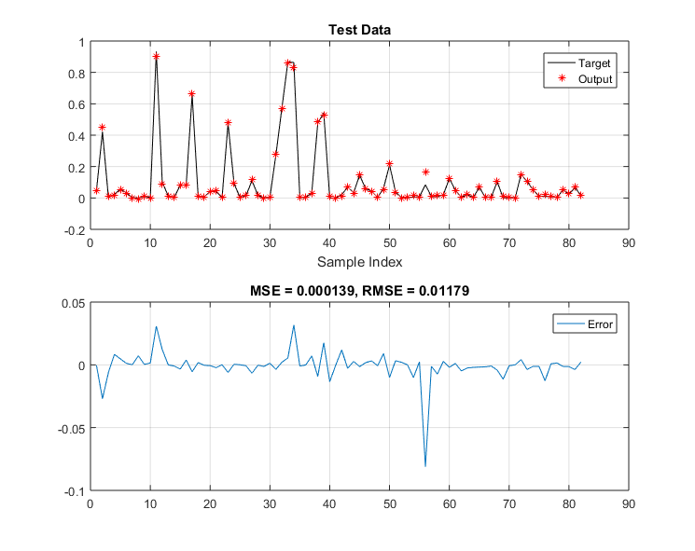

Fig. D8. Predictive accuracy of the water relative permeability for the testing phase using SCM

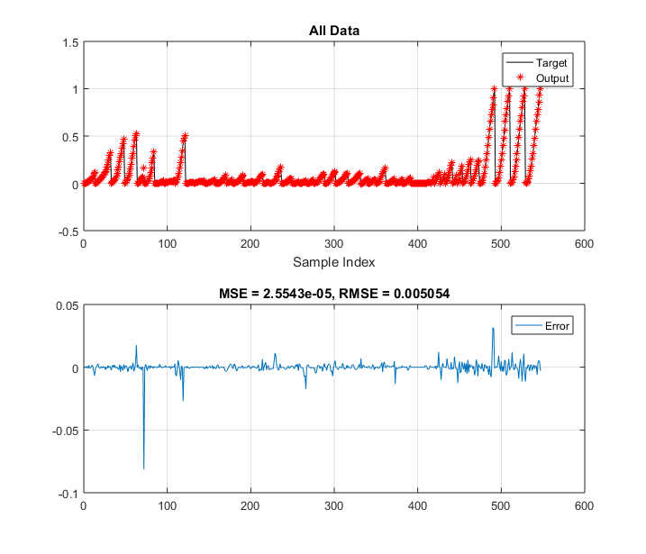

Fig. D9. Predictive accuracy of the water relative permeability for the combined (Train +Test) phase using SCM

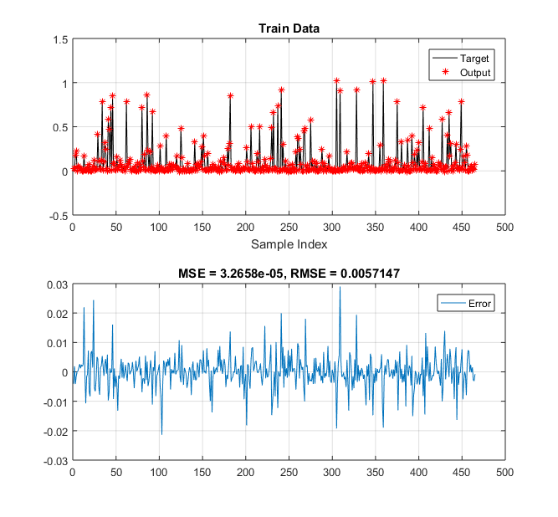

Fig. D10. Predictive accuracy of the water relative permeability for the training phase using FCM

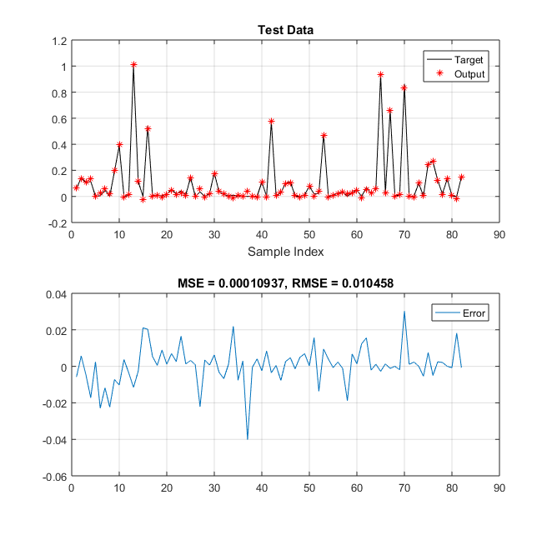

Fig. D11. Predictive accuracy of the water relative permeability for the testing phase using FCM

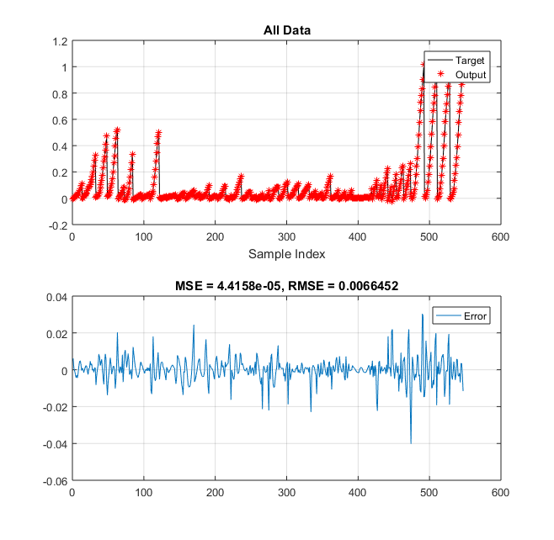

Fig. D12. Predictive accuracy of the water relative permeability for the combined (Train + Test) phase using SCM

1. LSSVM

In applying the model proposed by Esmaeili et al[1], the training and testing phase.

1. Oil relative permeability

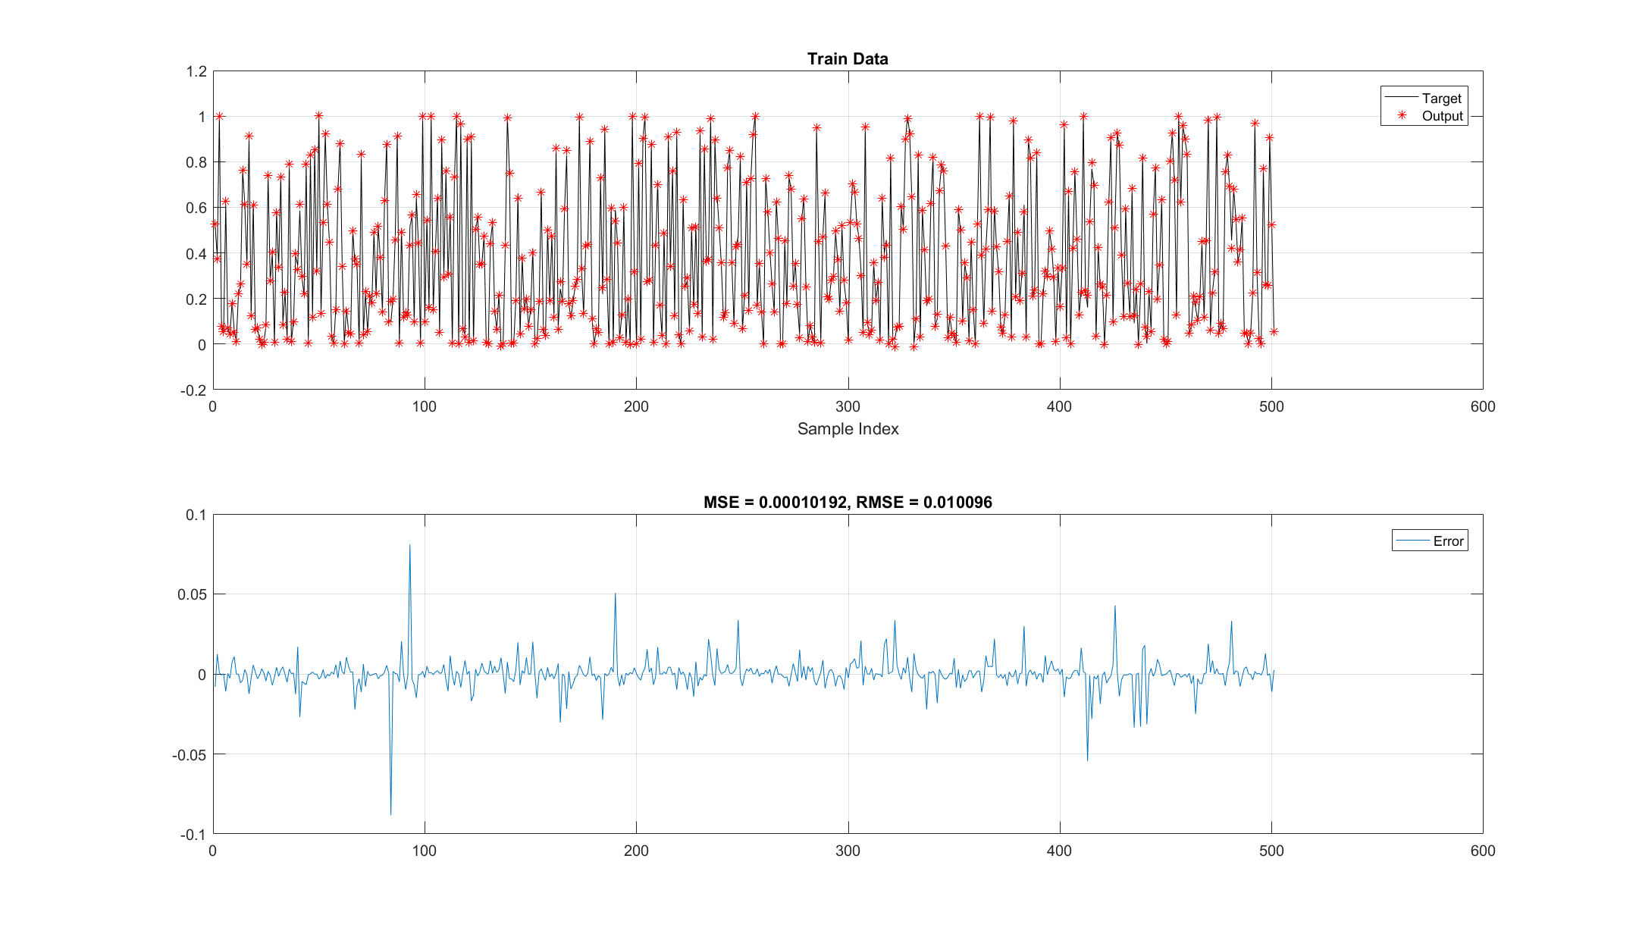

Fig. D13. Predictive accuracy of the oil relative permeability for the training phase using LSSVM

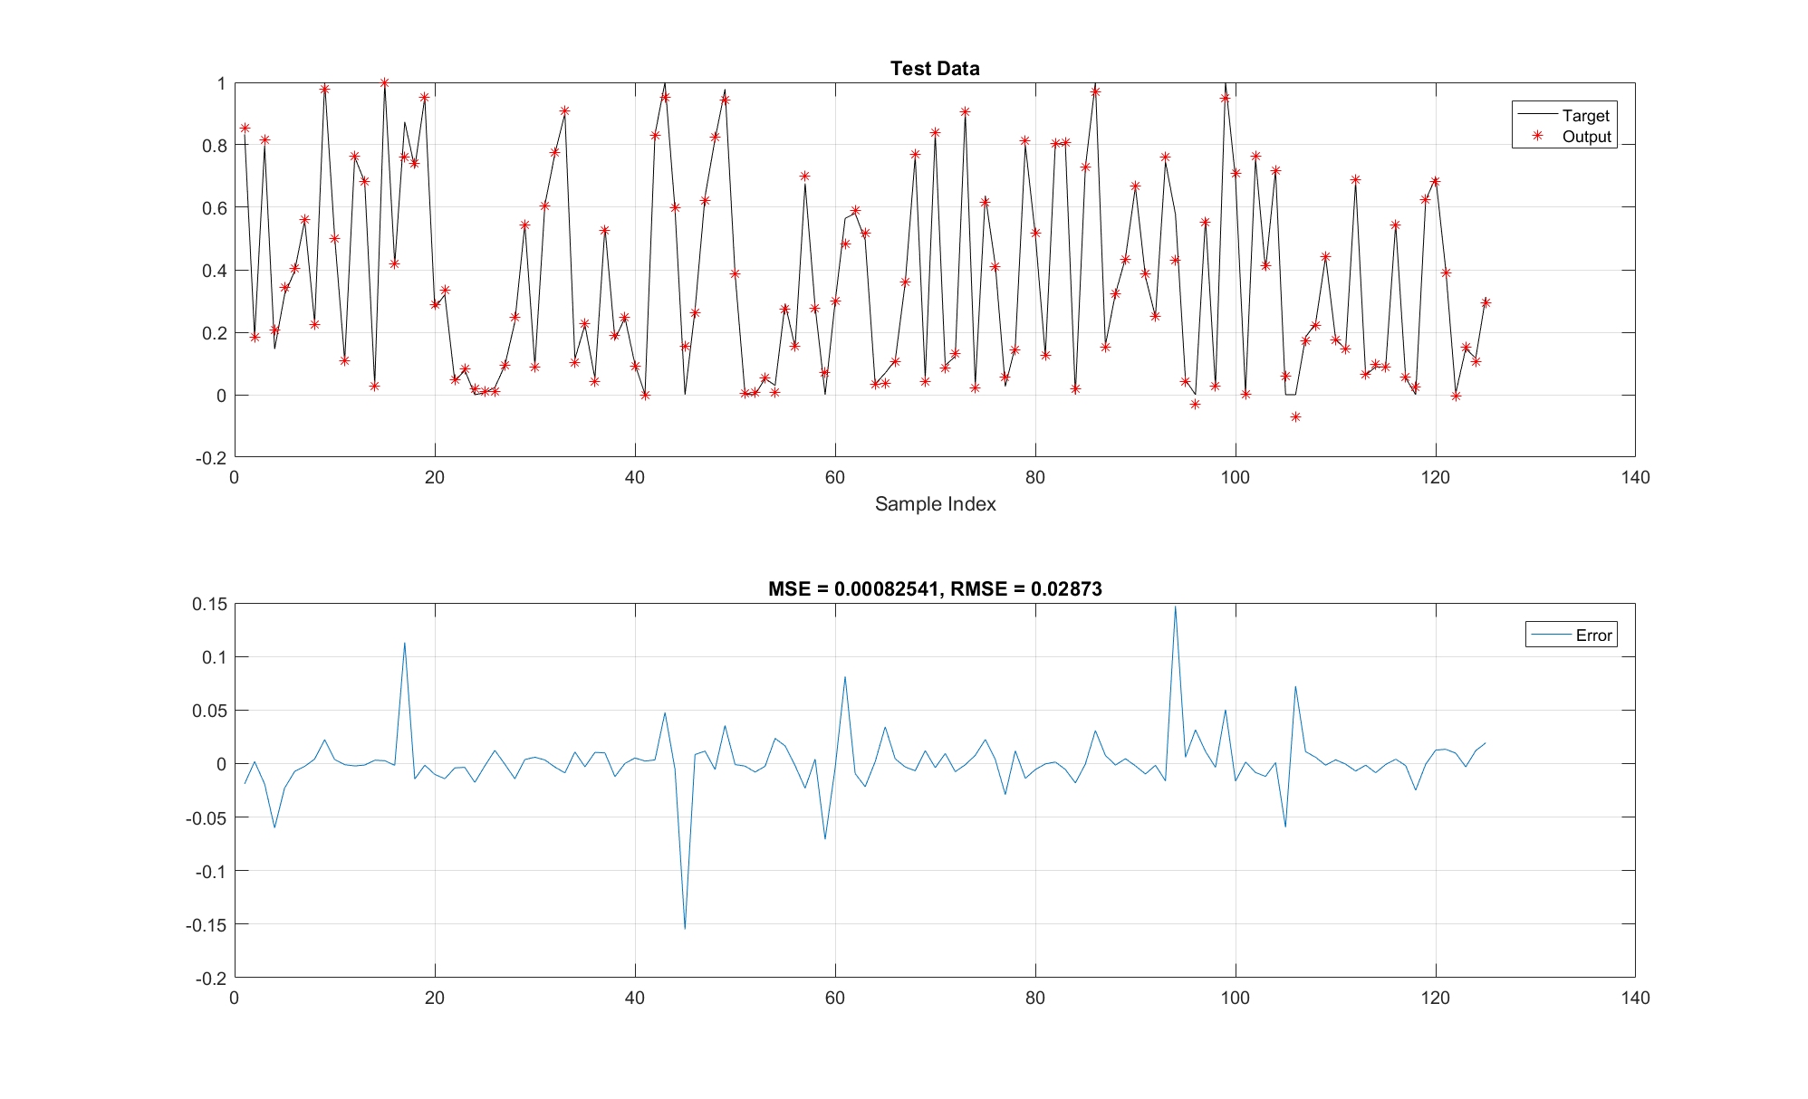

Fig. D14. Predictive accuracy of the oil relative permeability for the Test phase using LSSVM

1. Water relative permeability

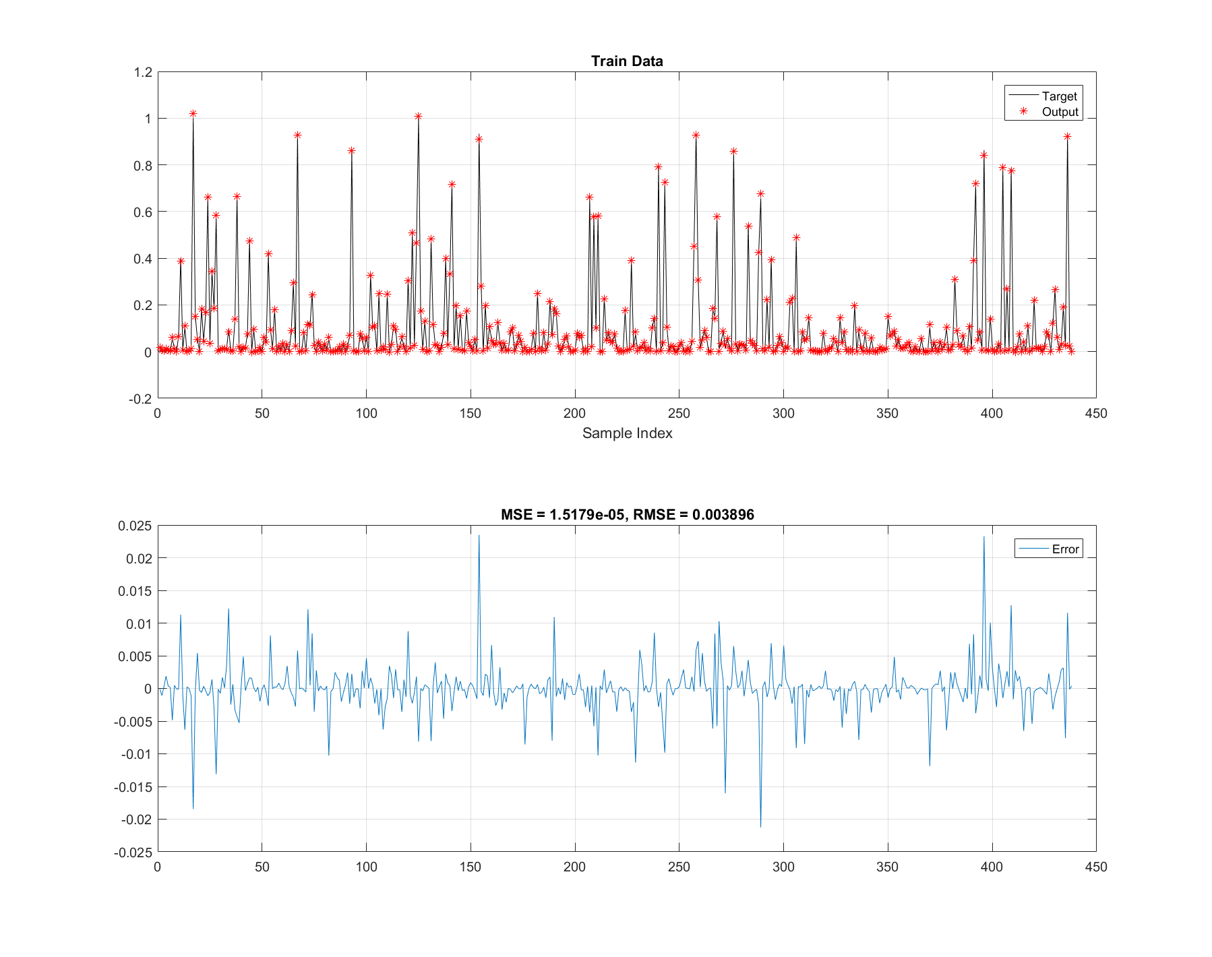

Fig. D15. Predictive accuracy of the water relative permeability for the Train phase using LSSVM

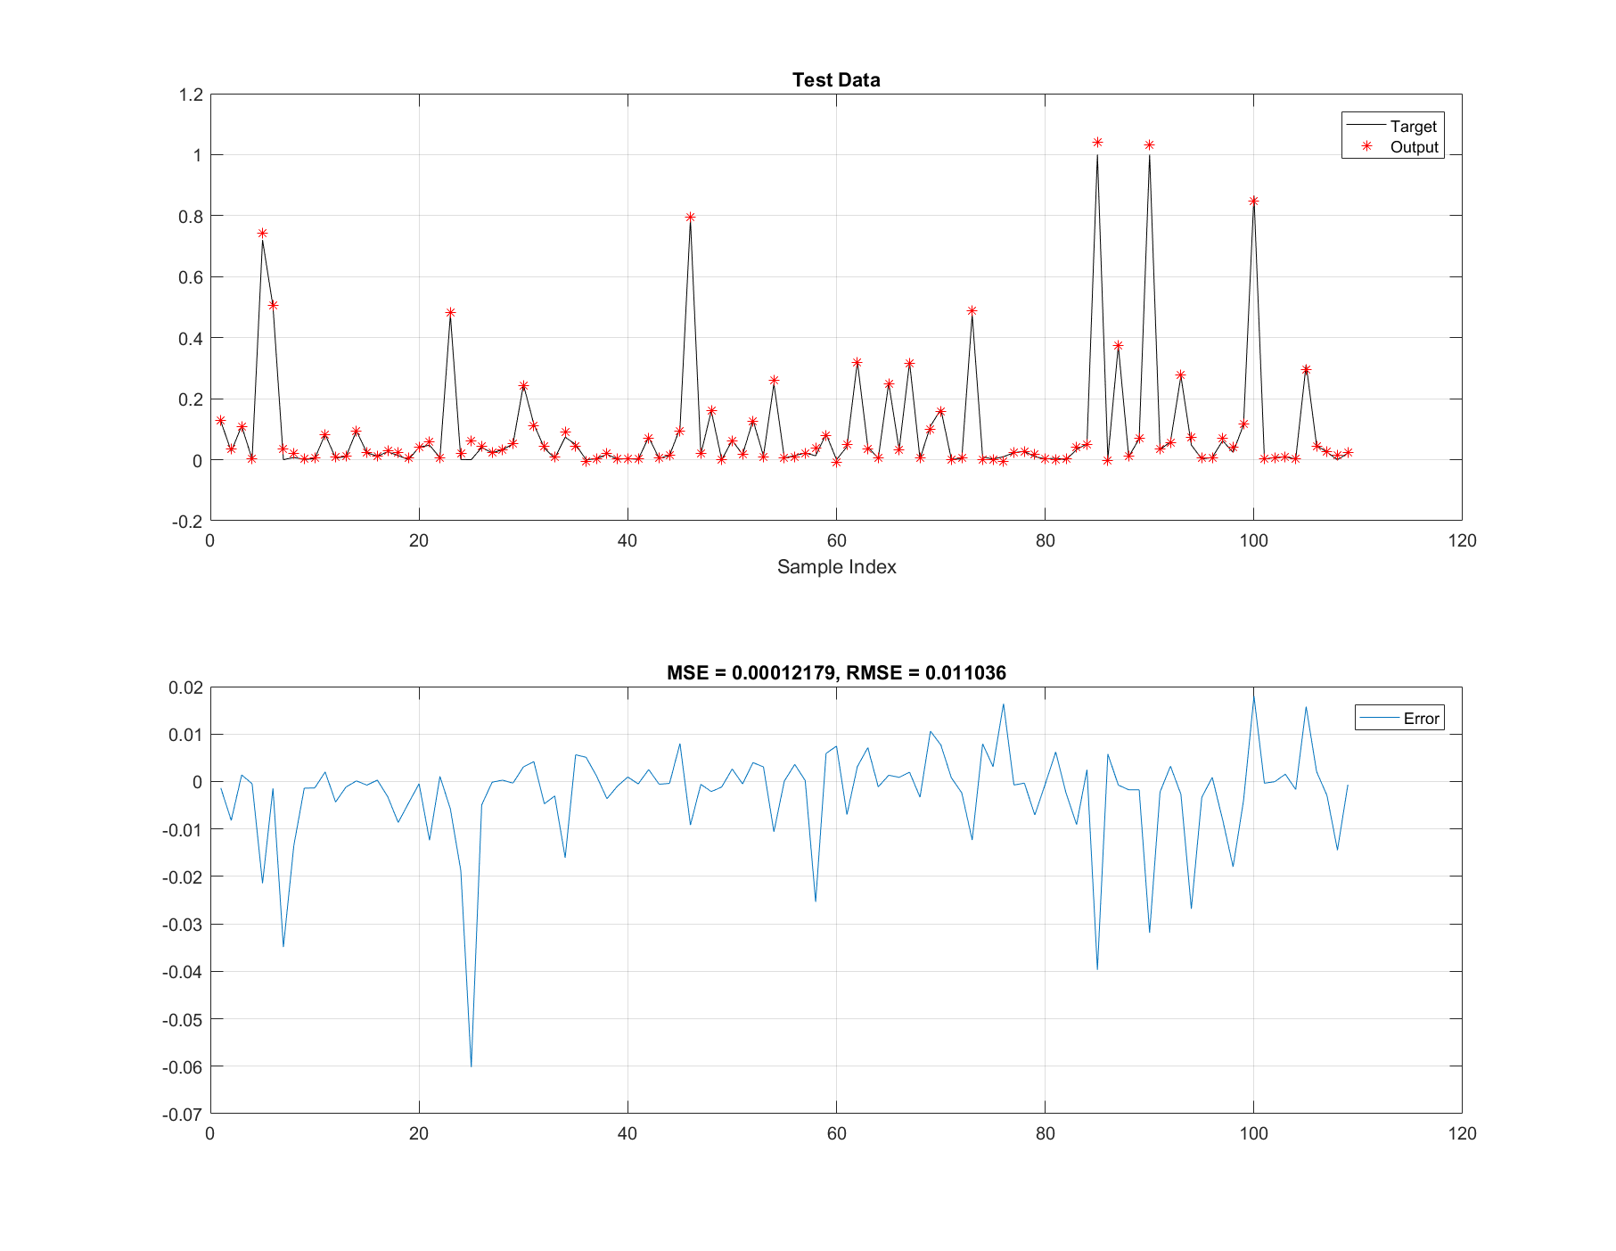

Fig. D16. Predictive accuracy of the water relative permeability for the Test phase using LSSVM

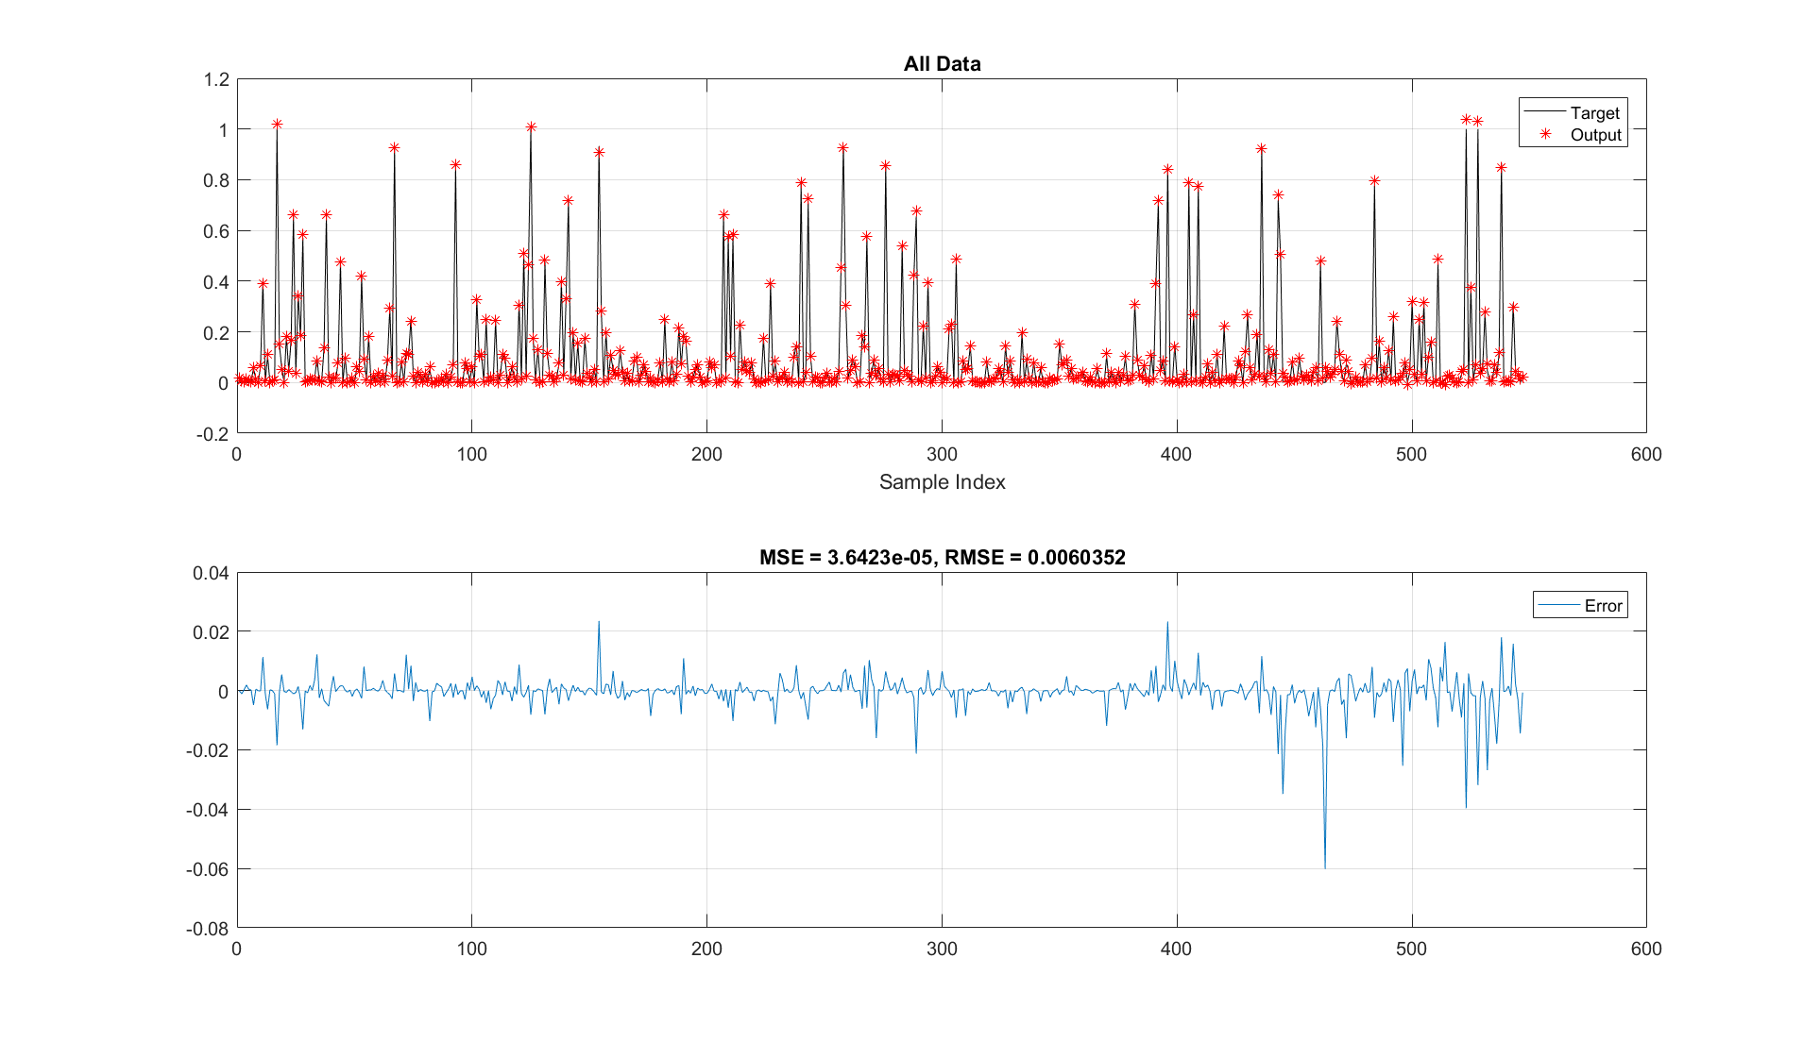

Fig. D17. Predictive accuracy of the water relative permeability for the combined (Train + Test) phase using LSSVM