STA6166 Statistical Methods I
Final Project: Multiple Linear Regression and Variable Selection
Total: 100 Points
Student Name: ___________________________________ Date: __________________

Project Overview
You will analyze a dataset containing one continuous response variable Y and 15 candidate predictors X₁, …, X₁₅. The data were generated from a multiple linear regression model in which exactly 5 predictors have nonzero population regression coefficients; the other 10 have coefficients equal to zero. The identities of the 5 true predictors will not be provided.
Your tasks are to fit the full regression model, examine its assumptions, select predictors using one classical model-selection approach, fit a LASSO regression with a cross-validated tuning parameter, and compare the resulting models. Complete the analysis in R. Unless otherwise stated, use a 5% significance level.

Part 1. Full Multiple Linear Regression and Diagnostics (20 Points)
Question 1. Fit the full model (5 points). Fit the model $Y_{i}=β_{0}+\sum_{j=1}^{15}{ }β_{j}X_{j}+ϵ_{i}$ Report the coefficient estimates, standard errors, t-statistics, and p-values. Include the model’s R² and adjusted R².
Fill in the following table using the R output from the full model with 15 predictors.
Coefficient | Point estimate | Standard error | t-statistic | p-value
β₁ | 1.9115 | 0.7175 | 2.664 | 0.009253
β₂ | 0.2025 | 0.6982 | 0.290 | 0.772483
β₃ | -0.3949 | 0.6771 | -0.583 | 0.561335
β₄ | -2.6473 | 0.8055 | -3.287 | 0.001481
β₅ | 1.1445 | 0.7498 | 1.526 | 0.130681
β₆ | 0.9065 | 0.7347 | 1.234 | 0.220698
β₇ | 1.2767 | 0.6619 | 1.929 | 0.057121
β₈ | 0.2487 | 0.7648 | 0.325 | 0.745818
β₉ | -0.1041 | 0.6638 | -0.157 | 0.875731
β₁₀ | 7.2157 | 0.7176 | 10.056 | 4.49e-16
β₁₁ | -0.1946 | 0.6258 | -0.311 | 0.756631
β₁₂ | 0.3334 | 0.6508 | 0.512 | 0.609722
β₁₃ | -2.6675 | 0.6812 | -3.916 | 0.000183
β₁₄ | -1.6059 | 0.6871 | -2.337 | 0.021801
β₁₅ | 0.5023 | 0.6974 | 0.720 | 0.473400
Rows in bold are significant at α = 0.05.
$R^{2}=0.6506$ and $R_{\text{adj}}^{2}=0.5882$. The overall F-test is highly significant ($F=10.43$ on 15 and 84 DF, $p=1.442×{10}^{−13}$). At the 5% level, X1, X4, X10, X13 and X14 are significant predictors; X7 is borderline ($p=0.057121$).
> summary(full_model) # last lines of the output
Residual standard error: 6.427 on 84 degrees of freedom
Multiple R-squared: 0.6506, Adjusted R-squared: 0.5882
F-statistic: 10.43 on 15 and 84 DF, p-value: 1.442e-13
Question 2. Unequal error variances (5 points). Apply the Breusch–Pagan test to the full regression model.
(a) State the null and alternative hypothesis.
$H_{0}:\text{Var}\left(ε_{i}\right)=σ^{2}$ for all $i$ (constant error variance, homoscedasticity).
$H_{1}:\text{Var}\left(ε_{i}\right)$ is not constant; it depends on the predictors $X_{1},…,X_{15}$ (heteroscedasticity).
(b) Write down the test statistic and p-value you get from the R function.
Test statistic $\text{BP}=17.673$ with $\text{df}=15$; $p\text{-value}=0.2802$.
> print(bp_result)
studentized Breusch-Pagan test

data: full_model
BP = 17.673, df = 15, p-value = 0.2802
(c) State if you have enough evidence to reject H₀.
No. Since $p=0.2802>α=0.05$, we fail to reject $H_{0}$. There is not enough evidence of unequal error variances.
Question 3. Normality diagnostic (5 points). Apply the Shapiro–Wilk test to test the normality of residuals of the full regression model.
(a) State the null and alternative hypothesis.
$H_{0}$: the residuals come from a normal distribution.
$H_{1}$: the residuals do not come from a normal distribution.
(b) Write down the test statistic and p-value you get from the R function.
Test statistic $W=0.99144$; $p\text{-value}=0.7795$.
> print(shapiro_result)
Shapiro-Wilk normality test

data: res
W = 0.99144, p-value = 0.7795
(c) State if you have enough evidence to reject H₀.
No. Since $p=0.7795>α=0.05$, we fail to reject $H_{0}$. There is not enough evidence that the residuals depart from normality.
Question 4. Diagnostic plots (5 points). Provide (a) a residuals-versus-fitted plot and (b) a normal Q–Q plot. Briefly discuss whether the plots are consistent with constant error variance and normality.
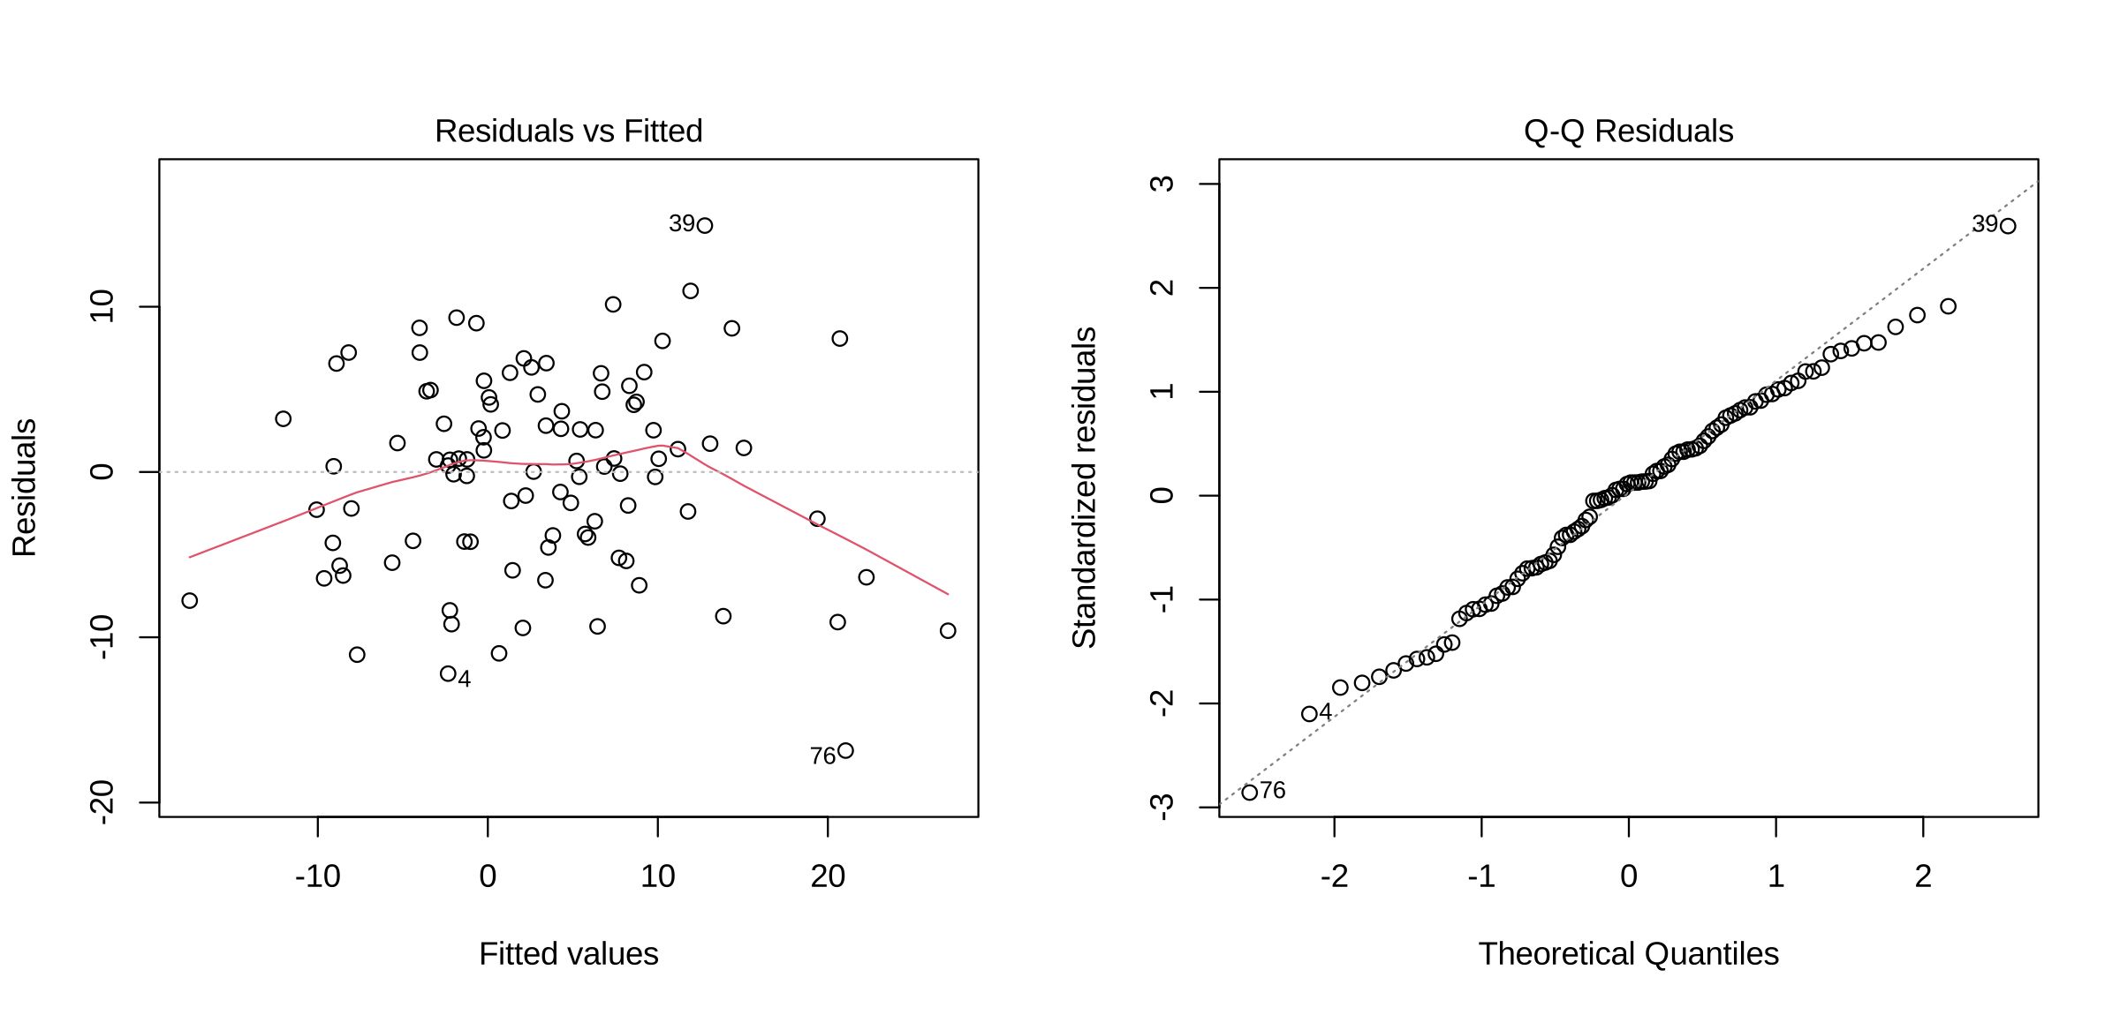
Figure 1. (a) Residuals versus fitted values and (b) normal Q–Q plot for the full model.
(a) Residuals vs fitted: the residuals are scattered randomly around zero with roughly the same spread across all fitted values, and there is no funnel shape. The slight bend in the red line at the ends comes from a few extreme points (e.g., observation 76), not a systematic pattern. This is consistent with constant error variance.
(b) Normal Q–Q: the points lie close to the reference line, with only small deviations in the tails (observations 39, 76 and 4). This is consistent with normality.
Both plots agree with the Breusch–Pagan and Shapiro–Wilk results.

Part 2. Classical Variable Selection (30 Points)
Question 5. Choose a search procedure (5 points). Choose ONE procedure: forward selection, backward elimination, or bidirectional stepwise selection. Explain how the procedure (the ONE procedure you choose) adds or removes variables.
I chose bidirectional stepwise selection.
- It starts from the intercept-only model, $Y=β_{0}+ε$.
- At each step it considers adding each predictor not yet in the model and removing each predictor already in the model, and it makes the one move that improves the criterion most.
- Because removal is allowed at every step, a predictor added earlier can be dropped later if it is no longer useful.
- It stops when no single addition or removal improves the criterion.
Question 6. Choose one selection criterion (5 points). Choose exactly one criterion: AIC, BIC, Mallows’ Cₚ, or adjusted R². Explain what the criterion measures and why you chose it. Once selected, keep this criterion fixed throughout Part 2; do not switch criteria after seeing the results.
For AIC or BIC, you may use stats::step() with forward, backward, or bidirectional search. For Cₚ or adjusted R², you may use leaps::regsubsets() with forward or backward search. The seqrep method in regsubsets() is sequential replacement, not bidirectional stepwise regression. If you choose an unsupported combination, you must implement and document the search algorithm yourself. You may revise your initial choice of search procedure before running the analysis to use one of the supported combinations.
I chose BIC (Bayesian Information Criterion).
$$\text{BIC}=−2\text{log}L+p\text{log}N=N\text{log}\left(\frac{\text{RSS}}{N}\right)+p\text{log}N+\text{constant}$$
where $L$ is the maximized likelihood, $p$ is the number of estimated parameters and $N=100$ is the sample size. The first term measures lack of fit and the second penalizes model complexity; the model with the smallest BIC is preferred.
I chose BIC because its penalty per parameter, $\text{log}\left(100\right)≈4.61$, is heavier than the AIC penalty of 2, so it favours simpler models. This suits the project, where only 5 of the 15 predictors are truly nonzero. BIC with bidirectional search is supported by stats::step(), using $k=\text{log}N$.
> stepwise_BIC <- step(null_model,
+ scope = list(lower = formula(null_model), upper = formula(full_model)),
+ direction = "both",
+ k = log(N), trace = 0)
Question 7. Select predictors (10 points). Apply the chosen search procedure and fixed criterion.
(a) List the predictors in the final selected model.
X1, X4, X10, X13 and X14.
(b) Report the final model formula.
Y ~ X10 + X4 + X13 + X14 + X1, that is,
$$\hat{Y}=1.9307+1.6604X_{1}−2.6507X_{4}+7.2586X_{10}−2.3389X_{13}−1.8656X_{14}$$
> formula(stepwise_BIC)
Y ~ X10 + X4 + X13 + X14 + X1
(c) Report the chosen criterion’s value for the selected model.
$\text{BIC}=680.8865$
> BIC(stepwise_BIC)
[1] 680.8865
(d) State the number of selected predictors, excluding the intercept. Briefly describe how you identified the final model along the search path.
5 predictors (excluding the intercept).
Starting from the intercept-only model, step() added the predictors one at a time in the order they appear in the formula: X10, X4, X13, X14 and then X1. At each step it also checked whether removing a predictor would lower BIC, but none was removed. The search stopped when no further addition or removal lowered BIC, and that model was taken as the final model. The forward and backward BIC searches (sections 6.4 and 6.5 of the code) gave the same five predictors.
Question 8. Examine the selected model (10 points). Refit an ordinary least-squares model using the selected predictors.
(a) Fill in the following table using the R output from the model with selected predictors. If a variable is not selected, leave it empty.
Coefficient | Point estimate | Standard error | t-statistic | p-value
β₁ | 1.6604 | 0.6892 | 2.409 | 0.017936
β₂
β₃
β₄ | -2.6507 | 0.7873 | -3.367 | 0.001103
β₅
β₆
β₇
β₈
β₉
β₁₀ | 7.2586 | 0.6732 | 10.782 | < 2e-16
β₁₁
β₁₂
β₁₃ | -2.3389 | 0.6343 | -3.687 | 0.000379
β₁₄ | -1.8656 | 0.6545 | -2.850 | 0.005366
β₁₅
(b) Report adjusted R².
$R_{\text{adj}}^{2}=0.5925$
> summary(stepwise_BIC) # last lines of the output
Residual standard error: 6.393 on 94 degrees of freedom
Multiple R-squared: 0.6131, Adjusted R-squared: 0.5925
F-statistic: 29.79 on 5 and 94 DF, p-value: < 2.2e-16
(c) Compare its adjusted R² with that of the full model.
The selected model has $R_{\text{adj}}^{2}=0.5925$, slightly higher than the full model's $R_{\text{adj}}^{2}=0.5882$, even though it uses 10 fewer predictors. The extra predictors in the full model did not improve the fit enough to justify their cost.
(d) Discuss whether the selected model is simpler and what information may have been lost by excluding predictors.
Yes, the selected model is simpler: 5 predictors instead of 15, and all five are significant at the 5% level (largest $p=0.017936$).
Information lost: $R^{2}$ falls from $0.6506$ to $0.6131$, so the excluded predictors explained about 3.75% of the variation in $Y$. If any of them has a small real effect, it is no longer in the model. X7 ($p=0.057$ in the full model) and X5 are the most likely examples, since AIC and Mallows' $C_{p}$ kept both.

Part 3. LASSO Regression (30 Points)
Question 9. Explain LASSO (5 points). Consider the LASSO objective: min over $β_{0}$, $β$ of $\frac{1}{2N}\sum_{i=1}^{N}{{\left(Y_{i}-β_{0}-\sum_{j=1}^{15}{X_{ij}}β_{j}\right)}^{2}}+λ\sum_{j=1}^{15}{\left|β_{j}\right|}$.
(a) Explain the role of λ.
$λ≥0$ is the tuning parameter that controls the strength of the penalty $λ\sum_{j=1}^{15}{\left|β_{j}\right|}$.
- When $λ=0$ there is no penalty and LASSO gives the ordinary least-squares estimates.
- As $λ$ increases, the coefficients are shrunk more toward zero and more of them become exactly zero.
- When $λ$ is very large, all slope coefficients $β_{1},…,β_{15}$ are zero.
So $λ$ balances fitting the data well against keeping the model simple.
(b) Explain why LASSO can produce exactly zero coefficient estimates. The intercept is not penalized.
The penalty uses absolute values $\left|β_{j}\right|$, which have a sharp corner at zero. Because of this corner, the best solution for a weak predictor is often exactly ${\hat{β}}_{j}=0$. With standardized predictors, each LASSO estimate is a soft-thresholded value:
$${\hat{β}}_{j}=\text{sign}\left(z_{j}\right) \text{max}\left(\left|z_{j}\right|−λ, 0\right)$$
where $z_{j}$ measures the association between $X_{j}$ and the current residuals. Whenever $\left|z_{j}\right|≤λ$, the estimate is set exactly to zero rather than just made small. Geometrically, the constraint region $\sum_{j=1}^{15}{\left|β_{j}\right|}≤t$ is a diamond with corners on the axes, and the solution often falls on a corner, where some coefficients are zero. The intercept $β_{0}$ is not penalized, so it is never shrunk.
Question 10. Choose λ by cross-validation (10 points). Use glmnet::cv.glmnet() with 10-fold cross-validation and Gaussian squared-error loss. Use a fixed random seed for reproducibility and standardize predictors using the package’s default behavior.
(a) Include the cross-validation plot, plot the cross-validation MSE over λ.
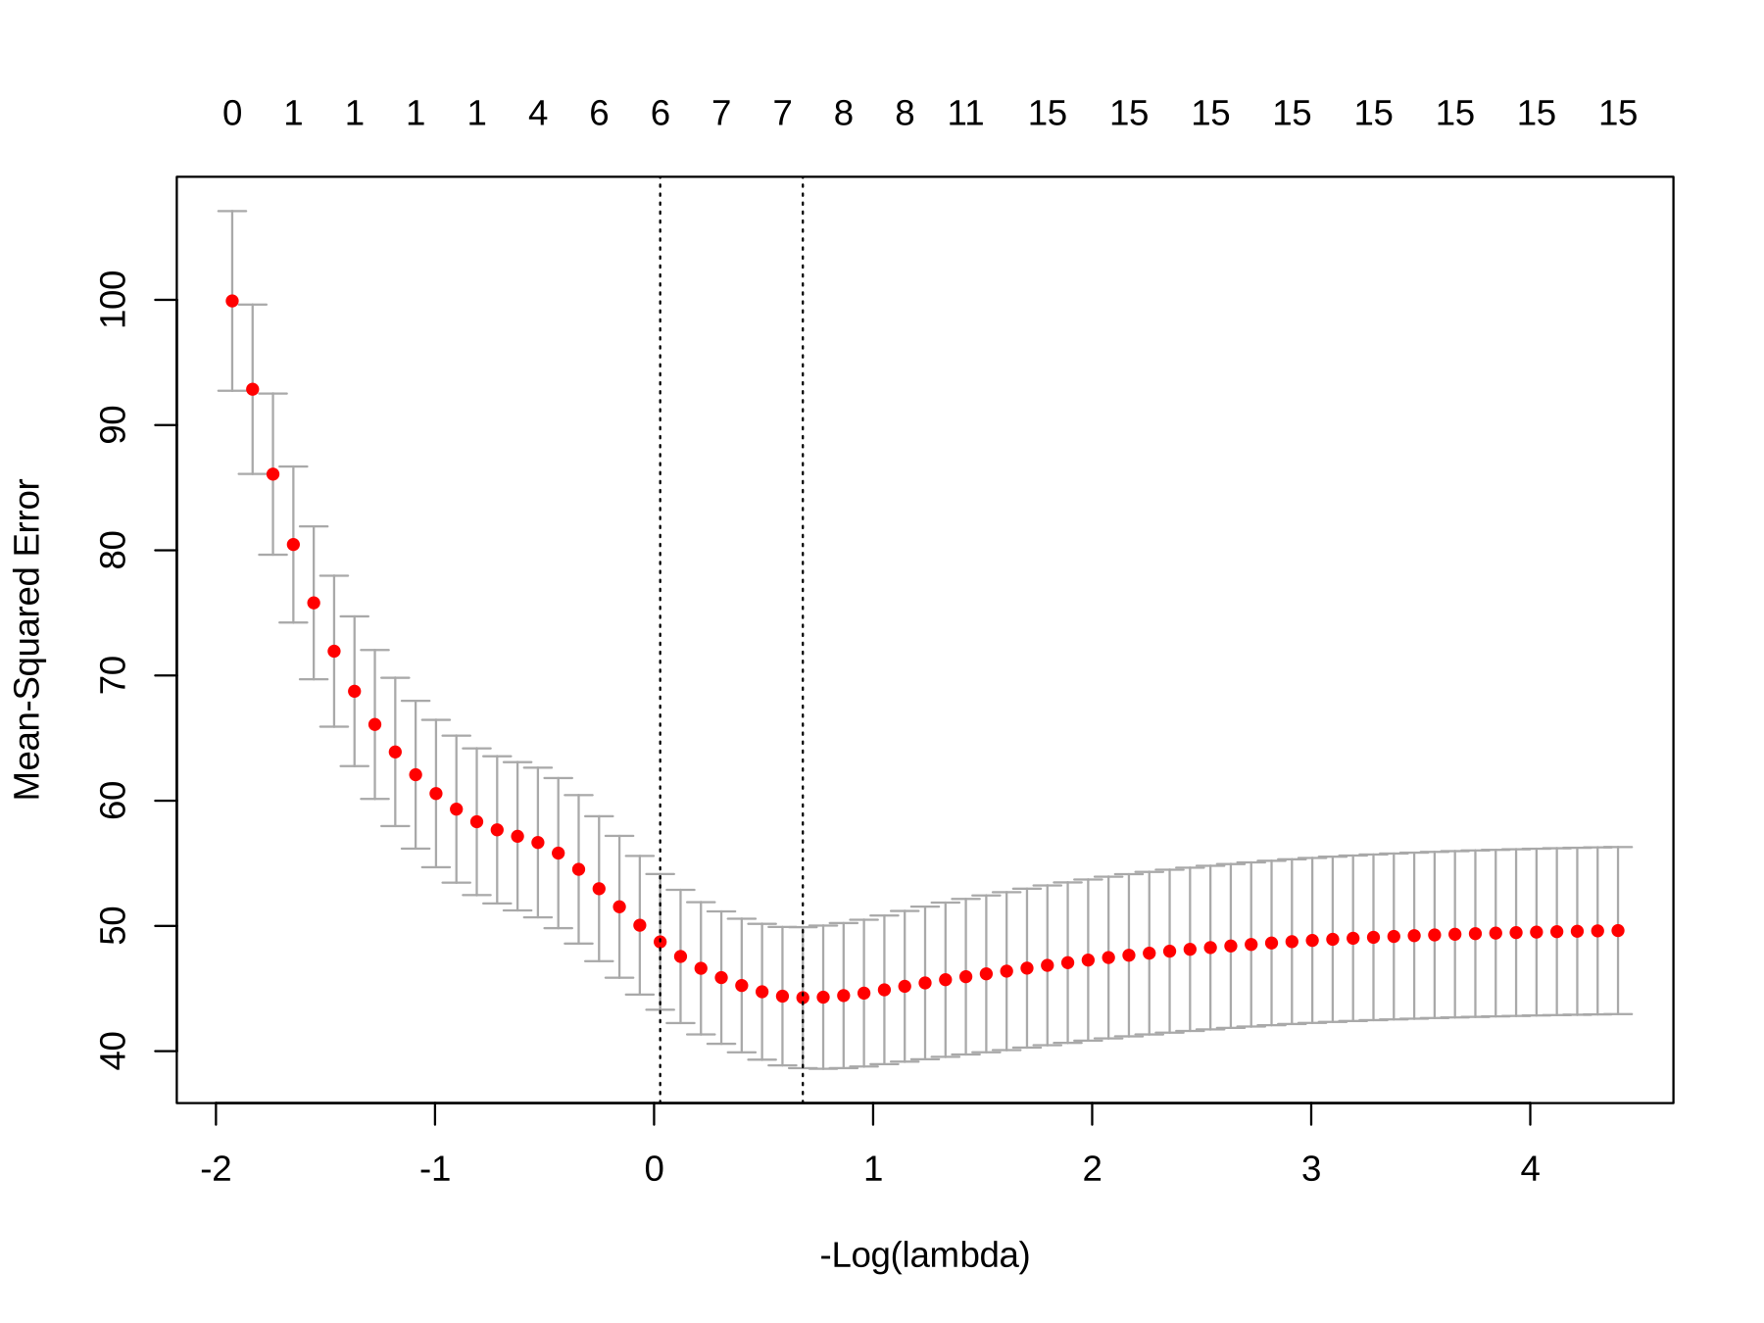
Figure 2. 10-fold cross-validation MSE versus −log(λ) (λ decreases from left to right). The right dashed line marks lambda.min and the left one lambda.1se; the numbers on top are the number of nonzero coefficients.
(b) Report lambda.min, the λ giving the smallest cross-validation MSE.
$λ_{\text{min}}=0.5070394$ (lambda.min), giving the smallest cross-validation MSE of $44.2725$.
> print(cv_lasso)

Call: cv.glmnet(x = X, y = Y, type.measure = "mse", nfolds = 10, alpha = 1,
family = "gaussian", standardize = TRUE)

Measure: Mean-Squared Error

Lambda Index Measure SE Nonzero
min 0.5070 29 44.27 5.628 8
1se 0.9725 22 48.73 5.419 6
> lambda_selected
[1] 0.5070394
(c) Explain how the cross-validation criterion selects λ. Use lambda.min throughout the remaining LASSO analysis; do not switch to lambda.1se.
The data are randomly split into 10 folds (seed 6166). For each value of $λ$, the LASSO model is fitted on 9 folds and its mean squared error ${\text{MSE}}_{k}\left(λ\right)$ is computed on the left-out fold $k$. Repeating this so that each fold is left out once and averaging gives the cross-validation error:
$$\text{CV}\left(λ\right)=\frac{1}{10}\sum_{k=1}^{10}{{\text{MSE}}_{k}}\left(λ\right), λ_{\text{min}}=\text{arg}{\text{min}}_{λ} \text{CV}\left(λ\right)$$
The $λ$ with the smallest average MSE is lambda.min. A $λ$ that is too small overfits the data, and one that is too large shrinks the coefficients too much, so the minimum lies in between. lambda.min is used for the rest of the analysis.
Question 11. Fit LASSO and identify variables (10 points). Using the selected λ, obtain the LASSO coefficient estimates.
(a) Report the coefficients.
Enter the LASSO point estimate for each predictor. If LASSO does not select a predictor, enter 0.
Coefficient | LASSO point estimate
β₁ | 1.07944426
β₂ | 0.00000000
β₃ | 0.00000000
β₄ | -1.92849719
β₅ | 0.41838736
β₆ | 0.06818692
β₇ | 0.89926976
β₈ | 0.00000000
β₉ | 0.00000000
β₁₀ | 6.62840784
β₁₁ | 0.00000000
β₁₂ | 0.00000000
β₁₃ | -1.62217204
β₁₄ | -1.16931949
β₁₅ | 0.00000000
(b) List all predictors with nonzero coefficients.
X1, X4, X5, X6, X7, X10, X13, X14
> print(selected_predictors)
[1] "X1" "X4" "X5" "X6" "X7" "X10" "X13" "X14"
(c) State how many predictors LASSO selected. Exclude the intercept from the count.
LASSO selected 8 predictors.
> length(selected_predictors)
[1] 8
Question 12. Interpret LASSO (5 points). Explain how the penalty affects the fitted coefficients and why some predictors are excluded. Discuss the relationship between the size of λ and model sparsity.
Effect on the coefficients: the penalty shrinks the coefficients toward zero compared with ordinary least squares. For example, ${\hat{β}}_{10}$ drops from $7.2157$ (full model) to $6.6284$, and ${\hat{β}}_{13}$ from $−2.6675$ to $−1.6222$. Weak predictors shrink the most: ${\hat{β}}_{6}$ drops from $0.9065$ to only $0.0682$.
Why some are excluded: a predictor whose contribution to reducing the squared error is smaller than the penalty is set exactly to zero (${\hat{β}}_{j}=0$). Here X2, X3, X8, X9, X11, X12 and X15 were excluded; they were all far from significant in the full model.
λ and sparsity: the larger $λ$ is, the sparser the model. The numbers on top of Figure 2 show the number of nonzero coefficients falling from 15 at small $λ$, to 8 at lambda.min, 6 at lambda.1se, and 0 at the largest $λ$.

Part 4. Comparison and Discussion (20 Points)
Question 13. Compare selected predictors (10 points). Create a table with one row for each of X₁, …, X₁₅ and two columns indicating whether each predictor was selected by (i) classical variable selection and (ii) LASSO. Report (a) the number selected by each method, (b) the predictors selected by both, and (c) those selected by only one method.
Predictor | Classical selection (Yes/No) | LASSO (Yes/No)
X1 | Yes | Yes
X2 | No | No
X3 | No | No
X4 | Yes | Yes
X5 | No | Yes
X6 | No | Yes
X7 | No | Yes
X8 | No | No
X9 | No | No
X10 | Yes | Yes
X11 | No | No
X12 | No | No
X13 | Yes | Yes
X14 | Yes | Yes
X15 | No | No
(a) Classical selection (stepwise BIC) selected 5 predictors; LASSO selected 8 predictors.
(b) Selected by both: X1, X4, X10, X13, X14.
(c) Selected by only one method: X5, X6, X7 (LASSO only). No predictor was selected only by the classical method.
Question 14. Explain differences (5 points). Do the methods select the same predictors? Which selects fewer? Explain at least two reasons the selected sets may differ, considering the criteria, coefficient shrinkage, and correlation among predictors.
No. Both methods select X1, X4, X10, X13 and X14, but LASSO also selects X5, X6 and X7. The classical method (BIC) selects fewer predictors (5 vs 8). Reasons the sets differ:
- Different criteria: BIC has a heavy penalty for each extra predictor and aims for a simple model, whereas lambda.min minimizes cross-validation prediction error, which often keeps a few weak predictors. In the code, AIC and $C_{p}$ also kept 7 predictors and adjusted $R^{2}$ kept the same 8 as LASSO.
- Coefficient shrinkage: LASSO can keep a weak predictor with a very small coefficient (e.g., ${\hat{β}}_{6}=0.068$), while classical selection must include a predictor at its full OLS estimate or drop it completely.
- Correlation among predictors: when predictors are correlated, they share information. Stepwise selection may keep one and drop the other, while LASSO may keep both with smaller coefficients, which leads to different selected sets.
Question 15. Final discussion (5 points). State which method you prefer for this dataset and justify your choice using model simplicity, the selected predictors, and the results of your analysis. Do not assume that a selected predictor is necessarily a true predictor: the identities of the 5 nonzero population coefficients are unknown to you.
I prefer the classical bidirectional stepwise model with BIC (X1, X4, X10, X13, X14).
- Model simplicity: it uses 5 predictors instead of 8, and all five are significant at the 5% level.
- Selected predictors: its five predictors are exactly the ones both methods agree on. The three extra LASSO predictors have small coefficients (${\hat{β}}_{5}=0.418$, ${\hat{β}}_{6}=0.068$, ${\hat{β}}_{7}=0.899$) and were not significant in the full model.
- Results of the analysis: its $R_{\text{adj}}^{2}=0.5925$ is higher than the full model's $0.5882$, the forward, backward and stepwise BIC searches all gave the same model, and print(cv_lasso) shows that the more conservative lambda.1se would keep only 6 predictors.
However, a selected predictor is not necessarily a true predictor, since the 5 true predictors are unknown. X7 is borderline and could be a weak real effect.

Submission Requirements

Submit only the completed Microsoft Word document (.docx) containing your answers to all project questions.
No additional files are required.

Grading Summary
Component | Points
Part 1. Full regression and diagnostics | 20
Part 2. Classical variable selection | 30
Part 3. LASSO regression | 30
Part 4. Comparison and discussion | 20
Total | 100

