Locating freeway service patrol stations with deep spatio-temporal incident forecasting: a predict-then-optimise study of FDOT District 2, Northeast Florida
Pascal Antwi¹, Thobias Sando^{2,*}
¹ Department of Mathematics and Statistics, College of Arts and Sciences, University of North Florida, Jacksonville, FL, USA
² School of Civil Engineering, College of Computing, Engineering and Construction, University of North Florida, Jacksonville, FL, USA
* Corresponding author: Thobias Sando, t.sando@unf.edu

Abstract
Freeway service patrols reduce incident duration, congestion and secondary crashes, but their effectiveness depends on where patrol units are stationed and how many are deployed. This study develops a data-driven decision-support framework for freeway service patrol deployment and applies it to Florida’s Road Ranger programme in FDOT District 2, using three years of incident records linked to traffic volumes, precipitation observations and a direction-aware road network. The framework combines Getis-Ord Gi* network screening on incident counts and exposure-based rates; day-ahead incident forecasting with three deep spatio-temporal neural networks (LSTM, Graph WaveNet and a spatio-temporal Transformer) benchmarked against statistical and gradient-boosting models; maximal covering location optimisation of station sites; and discrete-event simulation of busy units. Incident hotspots were concentrated at interchanges and bridges in Jacksonville and persisted across years, whereas rate-based hotspots highlighted rural interstate segments; heavy rain increased crash rates by about 70%. The deep learning models did not outperform a Poisson log-linear model or LightGBM, and forecast-driven daily staging offered no advantage over fixed stations. Ten optimised stations reached about 81% of incidents within 15 minutes, compared with about half for stations placed at the busiest locations or at random, and the recommended sites were robust to demand resampling and travel-speed assumptions. When units could be busy, this coverage required two to three units per station. Station locations and fleet size should therefore be planned jointly, and deep learning is better directed at real-time incident management than at day-ahead patrol planning.
Keywords: freeway service patrol; traffic incident management; maximal covering location problem; spatio-temporal graph neural networks; hotspot analysis; discrete-event simulation

1. Introduction
Traffic incidents, including crashes, disabled vehicles and debris, are a leading source of non-recurrent congestion on freeways. Every minute that an incident occupies the travel lanes reduces capacity, adds travel-time delay and raises the risk of secondary crashes for motorists and responders [1], [2]. Traffic incident management programmes therefore aim to shorten each stage of the incident timeline, from detection and response to clearance and recovery. Freeway service patrols are among the most cost-effective tools for this purpose: patrol units detect incidents, assist stranded motorists and clear minor obstructions before congestion builds. Evaluations have consistently reported benefits well above programme costs, both in Los Angeles [3] and for Florida’s Road Ranger programme [4]. Because these benefits depend on how quickly a unit reaches the scene, two planning decisions largely determine the performance of a patrol programme: where units are stationed and how many units are deployed.
Transportation engineering research has approached these decisions mainly with operations research models. Simulation has been used to design patrol beats and fleets [5], and optimisation models have allocated patrol vehicles to beats under uncertain incident scenarios [6], [7] or assigned service vehicles to depots under probabilistic service-level constraints [8]. These studies build on classic emergency facility location models, namely the location set covering [9], p-median [10] and maximal covering location problems [11], and on their extensions to busy units [12] and dynamic relocation [13], [14]. Applications to service patrols have generally been limited to individual corridors or a few patrol beats, have represented demand by historical averages or synthetic scenarios, and have measured travel times on simplified networks that ignore travel direction and interchange access. Coverage-based formulations also commonly assume that the nearest unit is available, even though a single crash can occupy a unit for an hour or more.
A second line of research addresses network screening, that is, identifying where incidents concentrate. Kernel density estimation [15], [16], its network-constrained form [17] and local spatial statistics such as the Getis-Ord Gi* [18], [19] are widely used to locate high-crash segments. Screening on incident counts and on exposure-based rates, such as incidents per vehicle-kilometre travelled, can identify different locations, because high counts may simply reflect high traffic volumes; yet few studies compare the two or translate screening results into the placement of response resources. Incident frequency also varies with roadway and environmental conditions, notably precipitation [20], [21], but the condition fields recorded in traffic management centre logs are rarely validated against independent observations.
A third line of research forecasts incidents with deep learning. Spatio-temporal graph neural networks, which learn dependencies between road locations from the network structure and from the data, have become the state of the art in traffic forecasting; examples include the diffusion convolutional recurrent neural network [22], spatio-temporal graph convolutional networks [23] and Graph WaveNet [24]. Similar architectures have been adapted to predict crash risk on urban grids [25], [26], [27], [28]. These models are typically judged by prediction error alone, whereas the predict-then-optimise literature argues that forecasts intended for operational decisions should be judged by the quality of the decisions they support [29]. It therefore remains unclear whether deep learning models outperform well-specified statistical and gradient-boosting models when incidents are sparse and spread along a freeway network, and whether more accurate forecasts translate into better patrol deployment.
Four gaps follow from this review. First, freeway service patrol siting has rarely been studied at the scale of an entire highway district, with multi-year incident records and a road network that represents travel direction. Second, network screening results are seldom linked to response coverage. Third, the operational value of deep learning forecasts for patrol deployment, as distinct from their statistical accuracy, has not been established. Fourth, the effect of busy units on the coverage that location models promise has received little attention for freeway service patrols.
This study addresses these gaps by developing a data-driven decision-support framework for freeway service patrol deployment and applying it to the Road Ranger programme in FDOT District 2, Northeast Florida. The framework (i) screens the network for incident hotspots using both counts and traffic-exposure rates, and quantifies the effect of precipitation on incident rates; (ii) compares deep spatio-temporal neural networks with statistical and gradient-boosting models for day-ahead incident forecasting; (iii) optimises Road Ranger station locations on a direction-aware road network and tests whether forecast-driven daily staging of units improves on fixed stations; and (iv) estimates the fleet size needed to meet response-time targets when units can be busy. For transportation agencies, the framework provides evidence on where to station patrol units, how many units are required and whether advanced forecasting is worth adopting. Section 2 describes the data and methods, Section 3 presents the results, Section 4 discusses their implications for practice and Section 5 concludes.

2. Methodology

2.1 Study area
The study area is Florida Department of Transportation (FDOT) District 2, which covers 18 counties of Northeast and North Central Florida: Alachua, Baker, Bradford, Clay, Columbia, Dixie, Duval, Gilchrist, Hamilton, Lafayette, Levy, Madison, Nassau, Putnam, St. Johns, Suwannee, Taylor and Union (Figure 1a). It combines the Jacksonville metropolitan area (Duval County), a second urban centre at Gainesville (Alachua County) and large rural areas. The limited-access network comprises three interstates and an urban beltway. I-95 follows the Atlantic coast through Nassau, Duval and St. Johns counties; I-10 runs west from Jacksonville through Baker, Columbia, Suwannee and Madison counties; and I-75 crosses Hamilton, Columbia and Alachua counties, meeting I-10 near Lake City. I-295 encircles Jacksonville, and limited-access state roads such as SR-202 (J. Turner Butler Boulevard), SR-9B and SR-115 (Arlington Expressway) link it with the city centre and the beaches (Figure 1b). These roads are patrolled by FDOT’s Road Ranger freeway service patrol, which provides free roadside assistance and incident support as part of the state’s traffic incident management programme. The incidents analysed (Section 2.2) lie in 15 of the 18 counties; Gilchrist, Lafayette and Union counties, which have no interstate highway, recorded none. The region’s humid subtropical climate, with frequent warm-season storms, motivates the inclusion of precipitation (Section 2.6).
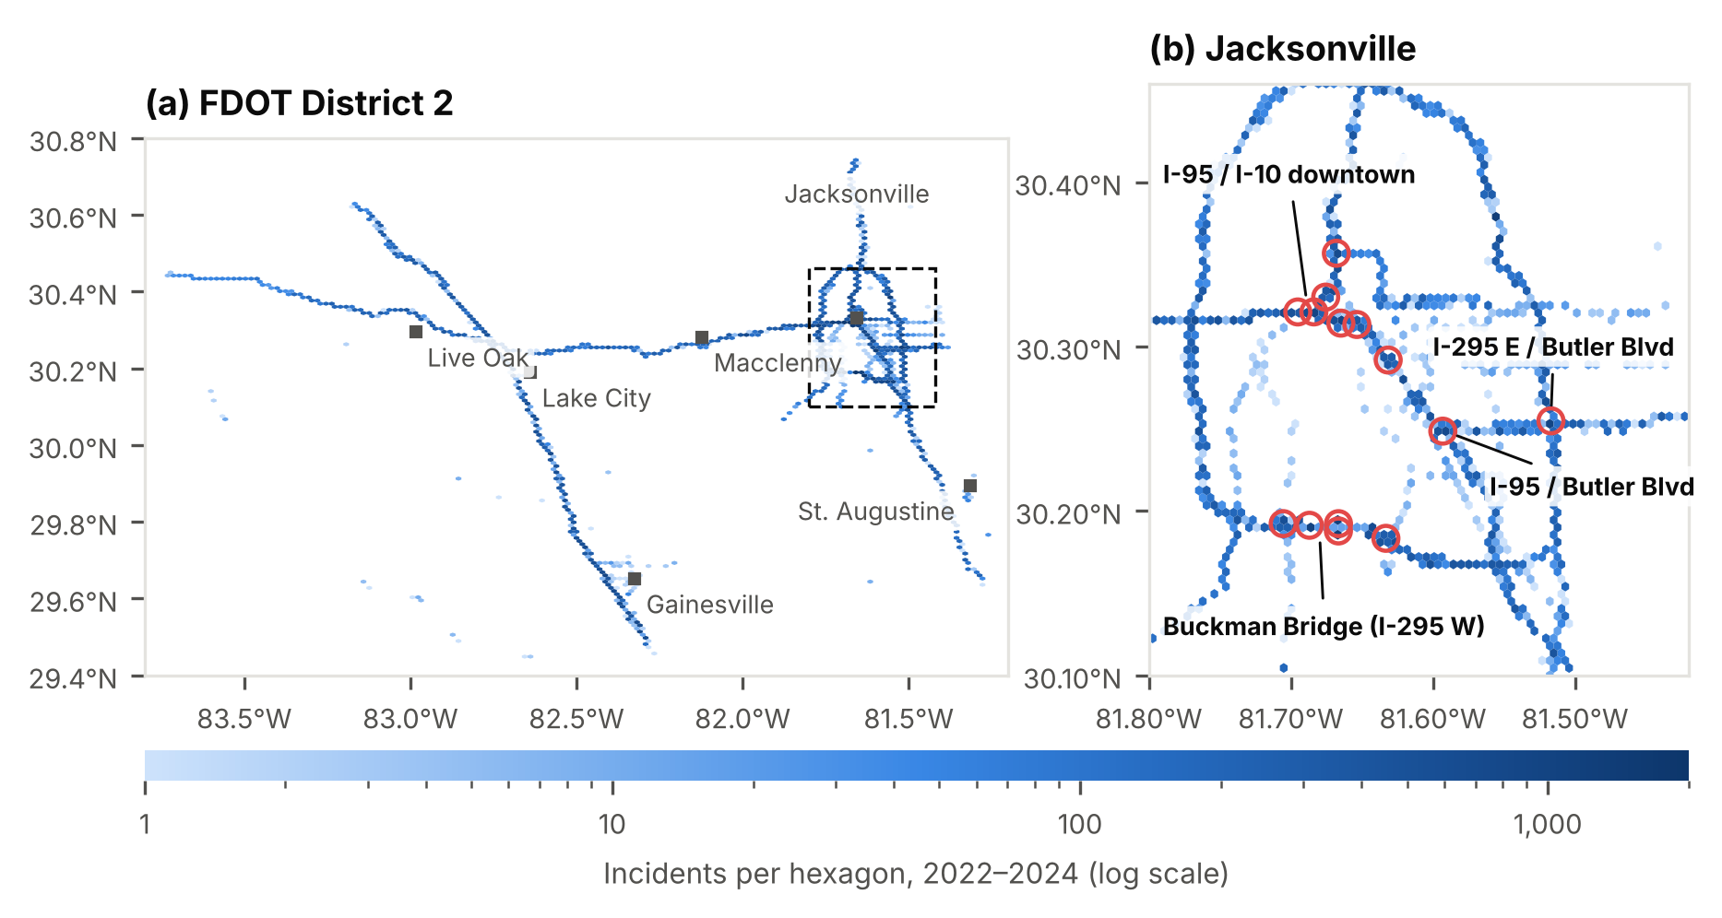
Figure 1. Spatial distribution of incidents in FDOT District 2, 2022–2024: (a) district overview, with the area of panel (b) outlined; (b) central Jacksonville, with circles marking 14 of the 15 busiest 1 km cells. Shading shows the number of incidents per hexagon on a logarithmic scale.

2.2 Data
Incident records. Incident data for 1 January 2022 to 31 December 2024 were obtained from the event chronology of the FDOT District 2 traffic management system [Author note: confirm the system name and data-use permission]. The export holds 9,206,764 records for 227,196 events; each record is one update to an event and gives the event type, time stamp, creating account, roadway description (county, route, direction and landmark or mile marker), coordinates and coded severity, surface, weather and lighting conditions. The four event types attended by Road Rangers (disabled vehicles, crashes, debris and abandoned vehicles) form the analysis sample of 173,198 incidents (Section 2.3). Traffic volumes. Segment-level annual average daily traffic (AADT) for 2021–2024 was taken from FDOT’s historical AADT data [30]. Weather. Hourly precipitation for 2022–2024 was obtained from NOAA’s Integrated Surface Database [31] for the 11 stations in or near the district with sufficient records (Section 2.6). Road network and candidate sites. Motorways, trunk and primary roads and their ramps were extracted from OpenStreetMap [32] and converted with OSMnx [33] to a directed graph of 8,944 nodes and 14,483 links with length, travel direction and, where tagged, speed limit. Its interchanges, rest areas and service plazas provided candidate station sites. U.S. Census TIGER/Line county boundaries and primary and secondary roads [34] were used to assign sites to counties and as an alternative network in the sensitivity analysis. Calendar and daylight. Federal holidays were taken from the U.S. federal holiday calendar, and solar elevation was computed from standard solar position equations [35].

2.3 Data processing
Time stamps were converted to local time and coordinates from micro-degrees to decimal degrees. Five records with an invalid time stamp and 458 with missing or out-of-state coordinates were removed, leaving 9,206,301; none were duplicated, and four fields missing in more than half of the records were dropped. Records were grouped into 227,196 events: event type, creation time, creating account and condition codes were taken from the first record, location from the latest record, and duration as the time between the first and last update. The roadway description was parsed into county, route, direction and mile marker. The four Road Ranger event types gave 173,198 incidents. Questionable records were flagged: implausible durations (under 1 minute or over 24 hours; 5,189 incidents, excluded only from duration analyses), near-duplicates (same route and direction within 0.5 km and 15 minutes; 1.8%) and incidents created by the avlrrsubsystem account (49.8%). The last two were tested in robustness checks (Section 2.10). Daylight, twilight and darkness were assigned from solar elevation (thresholds −0.833° and −6°). Recorded condition codes varied little (99.9% minor severity; lighting code undocumented) and contradicted independent data: 94.9% of incidents logged during NOAA-recorded precipitation were coded as clear weather. Precipitation and darkness were therefore taken from NOAA and solar position (Table S1). Incidents were assigned to 1 km × 1 km grid cells in a local equirectangular projection; the 983 cells with incidents form the spatial units. Time was divided into 8,768 three-hour windows, giving a cell-by-window panel (mean 0.020 incidents; 98.1% of cell-windows empty).

2.4 Research framework
The study follows a predict-then-optimise framework in four stages (Figure 2). The incident records, road cells, traffic and weather data, and calendar and daylight variables are first combined into a cell graph, in which neighbouring 1 km cells are linked and each cell carries incident counts for consecutive three-hour windows (Sections 2.3 and 2.6). In the first stage, persistent concentrations of incidents are identified with the Getis-Ord Gi* statistic [18] on incident counts and on traffic-adjusted incident rates, with significance adjusted for multiple testing by the false discovery rate [36] (Section 2.7). In the second stage, incidents are forecast one day ahead for every cell and window. Three baselines, a historical average, a Poisson log-linear model and gradient-boosted trees (LightGBM [37]), are compared with three deep learning models: a long short-term memory network [38], Graph WaveNet [24] and a spatio-temporal Transformer [39] (Section 2.8). In the third stage, the observed and predicted demand is used to locate Road Ranger stations at candidate interchanges, rest areas and service plazas with the maximal covering location problem [11], as fixed stations and as day-ahead staging of units (Section 2.9). In the fourth stage, all models are fitted on data up to 30 September 2023, tuned on October–December 2023 and evaluated on the unseen incidents of 2024. Evaluation covers forecast error and the share of incidents reached within 10, 15 and 20 minutes, followed by sensitivity analyses, temporal validation and a simulation in which units can be busy (Sections 2.10 and 2.11).
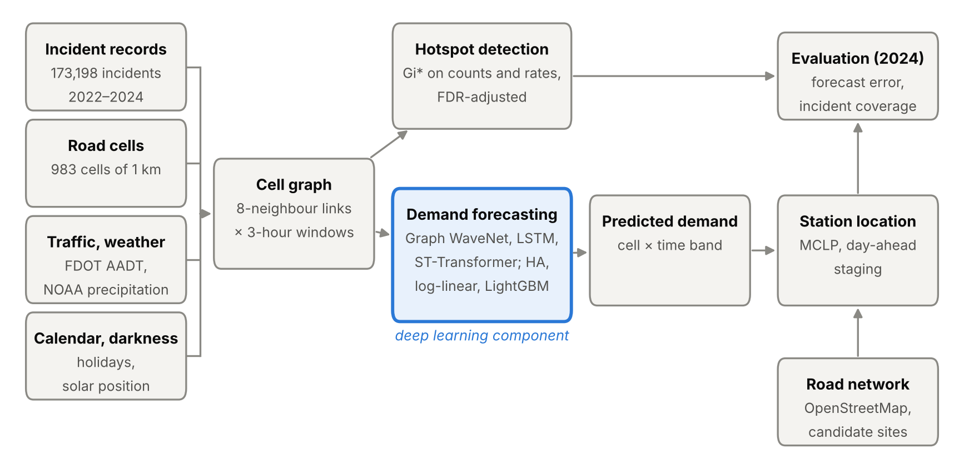
Figure 2. Research framework. AADT = annual average daily traffic; NOAA = National Oceanic and Atmospheric Administration; LSTM = long short-term memory network; ST-Transformer = spatio-temporal Transformer; HA = historical average; FDR = false discovery rate; MCLP = maximal covering location problem.

2.5 Exploratory data analysis
Exploratory analysis described the composition, timing, location and duration of incidents. Incident types were summarised by year, weekday share, share in the afternoon peak (15:00–17:59) and share created through the vehicle-location subsystem (Table 1), and all recorded event types were compared with the analysis sample (Figure S1). Temporal patterns were examined as monthly counts by type (Figure S2), mean hourly counts by hour and day of week (Figure 3) and the hourly distribution within each type (Figure S3). Spatial patterns were mapped as hexagonal-bin densities on a logarithmic scale (Figure 1). Concentration was measured by ranking the 1 km cells by mean annual incidents and computing the share of all incidents held by the busiest cells (Figure 4), and counts by route and type were compared for the eight busiest routes (Figure S4). Event duration was summarised by type with medians, interquartile ranges and 5th–95th percentiles, excluding flagged durations (Figure 5). Finally, the completeness and variability of the recorded condition codes were tabulated to decide which variables could enter the models (Table S1).

2.6 Traffic exposure, precipitation and road network
Traffic exposure. Each incident was matched to the nearest AADT segment of its own year within 150 m (96.9% matched). FDOT roadways with at least 20 matched incidents (594 roadway identifiers) were taken as the patrolled network, and the vehicle-kilometres travelled in each cell and year were computed as the sum, over these segments, of AADT × segment length within the cell × days in the year. Exposure was available for 944 cells holding 99.1% of incidents. Rates per million vehicle-kilometres were smoothed with a global empirical Bayes estimator [40] for hotspot analysis (Section 2.7); the forecasting models use the previous year’s exposure, the latest available at forecast time. Precipitation. Hourly totals were taken from each station’s routine hourly report; special reports, which carry partial accumulations, were not added. Totals were summed to three-hour windows and assigned to each cell from its nearest station (median distance 15.3 km). Incident rates in wet and dry windows were compared by incident type and precipitation class (light, < 2.5 mm; moderate, 2.5–10 mm; heavy, ≥ 10 mm per window) with Mantel–Haenszel rate ratios [41] stratified by window of day, month and day type, with Greenland–Robins confidence intervals [42]. Road network and sites. Two-way OpenStreetMap links were represented in both directions, and the largest strongly connected component was retained (92.5% of links). Off-peak speeds were the posted limits (56.0% of links) or class defaults (motorway 65, trunk 55, primary 45 and ramps 30–35 mph); peak speeds (weekdays 06:00–08:59 and 15:00–17:59) were set to two-thirds of off-peak. Incidents were snapped to the nearest link within 200 m whose heading matched their recorded direction (95.1% of incidents), otherwise to the nearest link. Candidate sites in District 2 within 0.5 km of each other were merged, giving 307 sites (275 interchanges, 19 service plazas and 13 rest areas); a unit leaves a site from any network node within 300 m.

2.7 Hotspot detection
Hotspots were identified with the Getis-Ord Gi* statistic [18], [19], applied to the mean annual number of incidents xⱼ in each of the n = 983 cells, with binary weights wᵢⱼ = 1 for cells within 2 km of cell i, including i itself:
Gi*=j​wijxj−xj​wijsnj​wij2−j​wij2/n−1,
where x̄ and s are the mean and standard deviation of x. Two-sided p-values from the standard normal distribution were adjusted for the false discovery rate [36], and cells were classified at q < 0.01, 0.05 and 0.10; cells with a positive statistic and q < 0.05 are termed hot. Contiguous hot cells were grouped into clusters and named after their busiest cell. Persistence was assessed by repeating the analysis for each year and counting the years in which each cell was hot. Robustness was assessed by repeating it without incidents created through the vehicle-location subsystem, without near-duplicates and for crashes only, with agreement measured as the share of hot cells retained and the Jaccard index. A second analysis applied the same procedure to empirical Bayes-smoothed rates per million vehicle-kilometres for the 944 cells with exposure data (Section 2.6).

2.8 Demand forecasting
Task and data split. At the start of each day, incidents are forecast for each of the eight three-hour windows in every cell, using only data up to the end of the previous day. Models were trained on 29 January 2022 – 30 September 2023 (610 days; the first 28 days of 2022 supply lagged inputs), tuned and early-stopped on 1 October – 31 December 2023 (92 days) and tested on 2024 (366 days). Inputs. The historical mean for each cell, window and day type (weekday, or weekend and federal holiday) over the training days; counts in the same window one and seven days earlier; cell totals over the previous 1, 7 and 28 days; the neighbouring cells’ 7-day total; the district total on the previous day; window, weekday, month and holiday indicators; the share of the window in darkness; cell coordinates; the previous year’s traffic exposure; and the previous day’s precipitation. Baselines. (i) The historical mean; (ii) a Poisson log-linear model with cell, window × day type and month main effects, fitted by iterative proportional fitting; and (iii) LightGBM [37] with a Poisson objective (learning rate 0.05, 63 leaves, at least 500 observations per leaf, early stopping after 100 rounds without improvement). An ablation refitted LightGBM without the exposure and precipitation inputs, and with the observed precipitation in the target window as a perfect-forecast bound. Deep learning models. Each model encodes the last 16 windows (two days) of counts and precipitation in every cell, with time-of-day and weekend indicators, into a cell representation; a shared output layer combines it with the inputs above and predicts the log-rate, offset by the log historical mean, under a Poisson likelihood. The LSTM [38] encodes each cell separately, without spatial information; Graph WaveNet [24] combines gated dilated temporal convolutions with diffusion convolution over the cell graph and a learned adjacency matrix; and the spatio-temporal Transformer [39] applies attention over time within each cell and then across cells. Models were trained with Adam [43] on batches of eight days with early stopping (patience 3). Hidden size (32 or 64) and learning rate (10⁻³ or 3 × 10⁻⁴) were tuned on the validation period; differences in validation deviance below 0.1% were treated as ties, and the smaller configuration was retained (Table S7). LightGBM and each deep model were trained with five random seeds.

2.9 Station location optimisation
Demand and coverage. Demand points are the directed links with at least one incident in 2022–2023 (1,708 links), weighted by their mean annual number of incidents aᵢʳ in each speed regime r (peak, off-peak). A candidate site j covers link i in regime r if the travel time from j to the midpoint of i is at most T minutes; Nᵢʳ is the set of such sites.
Fixed stations. p stations were located with the maximal covering location problem [11], extended to the two speed regimes:
maxr​i​airyir s.t. j∈Nir​xj≥yir ∀i,r, j​xj=p, xj∈{0,1}, 0≤yir≤1,
where xⱼ = 1 if a station is placed at site j and yᵢʳ is the covered share of the demand at link i. The problem was solved exactly as a mixed-integer program with the HiGHS solver [44] through SciPy [45], for p = 1–20 and T = 10, 15 and 20 minutes.
Day-ahead staging. For each day of 2024 and four time bands (night, 18:00–05:59; morning peak, 06:00–08:59; midday, 09:00–14:59; afternoon peak, 15:00–17:59), p staging sites were selected by greedy maximal covering of the forecast demand in that band, with each cell’s forecast distributed over its links in proportion to their 2022–2023 incidents. An oracle using the band’s actual incidents gives an upper bound.
Comparison layouts. Two layouts without optimisation were also evaluated: the candidate sites nearest the busiest 2022–2023 cells, and randomly drawn sites (mean of 200 draws).

2.10 Evaluation and sensitivity analysis
Forecasts. On the 2024 test year, models were compared by the mean absolute error, root mean squared error and mean Poisson deviance over cell-windows, and by the daily hit rate, the share of a day’s incidents falling in the 5% of cells with the highest predicted daily demand, together with the predictive accuracy index (hit rate ÷ share of cells) [46]. Differences in deviance from LightGBM were assessed with a bootstrap over days (2,000 resamples) using seed-averaged predictions; results are reported as mean ± standard deviation over seeds.
Station layouts. Each layout was evaluated on the 59,981 incidents of 2024 by the share reached within T minutes from the nearest station or staged unit, using each incident’s exact location and the speed regime at its time, and by the mean travel time.
Sensitivity and robustness. For 10 stations and T = 15 minutes, the fixed layout was re-solved with peak speeds of 50% and 83% of off-peak; with off-peak speeds 15% lower and higher; with demand excluding incidents created through the vehicle-location subsystem, excluding near-duplicates, and for crashes only; and with two alternative travel-time models on the road cells, the undirected Census network and a cell graph with distances inflated by a circuity factor of 1.2. For temporal validation, sites were selected on 2022 and evaluated on 2023, and selected on 2023 and evaluated on 2024. Finally, the problem was re-solved on 200 bootstrap samples of 2022–2023 days, on each year alone and under each scenario, recording how often each recommended site, or a site within 5 km of it, was selected, and the coverage lost by the recommended layout relative to the layout optimised for each speed scenario.

2.11 Simulation with busy units
The coverage model assumes that every unit is free when an incident occurs. A discrete-event simulation of 2024 relaxed this assumption. Incidents were processed in the order they were logged and assigned to the unit that could reach them first: a free unit departs immediately, and a busy unit departs from its station once it has returned from its current job. A unit is busy for the travel time to the incident, the on-scene time and the travel time back to its station on the directed network, at the speed regime of the incident’s time. On-scene time was the logged event duration, replaced by the median for the incident type where flagged (Section 2.3). Every incident was assumed to require a unit, and units were assumed to operate around the clock. Layouts of 10, 15 and 20 stations (T = 15 minutes) were simulated with fleets of one to three units per station on average, allocated either equally or in proportion to each station’s 2022–2023 demand (largest remainder, with at least one unit per station). Outcomes were the share of incidents reached within 10, 15 and 20 minutes of being logged, the mean and 90th percentile response times, the share of incidents delayed because a closer unit was busy, and unit utilisation. Two variants halved the on-scene times and excluded incidents created through the vehicle-location subsystem, which a patrolling unit had already found.

3. Results

3.1 Incident characteristics
Between 1 January 2022 and 31 December 2024, the traffic management system logged 227,196 events in District 2, of which 173,198 (76.2%) were of the four types attended by Road Rangers (Table 1). Disabled vehicles were the most frequent type (101,933; 58.9%), followed by crashes (44,158; 25.5%), debris on the roadway (16,979; 9.8%) and abandoned vehicles (10,128; 5.8%). The most common events outside the analysis sample were congestion (22,053), scheduled road work (12,658) and reduced visibility (6,653) (Figure S1). Annual totals ranged from 56,450 in 2023 to 59,981 in 2024, a difference of 6.3%. The increase in 2024 came mainly from disabled vehicles (9.2% more than in 2023) and abandoned vehicles (22.2% more), whereas annual crash counts differed by less than 5% across the three years (Figure S2). Monthly totals ranged from 3,897 (February 2023) to 5,621 (May 2024), with a mean of 4,811. The incident types differed in how they were reported and how long they lasted. Half of all incidents (49.8%) were created through the vehicle-location subsystem, ranging from 4.9% of crashes to 67.9% of disabled vehicles and 86.8% of abandoned vehicles. The median event duration was 18.9 minutes, ranging from 4.7 minutes for abandoned vehicles to 56.7 minutes for crashes (Section 3.4). The shares of incidents occurring on weekdays (75.0–78.0%) were similar across types, whereas the share between 15:00 and 17:59 was about half as large for abandoned vehicles (12.5%) as for the other types (22.1–25.3%).

Table 1. Characteristics of incidents by type, FDOT District 2, 2022–2024. Duration excludes 5,189 events shorter than 1 min or longer than 24 h. AVL = automatic vehicle location; IQR = interquartile range.
Incident type | Incidents | Share (%) | 2022 | 2023 | 2024 | Median duration, min (IQR) | Weekday (%) | 15:00–17:59 (%) | Created via AVL (%)
Disabled vehicle | 101,933 | 58.9 | 33,260 | 32,828 | 35,845 | 13.4 (4.9–31.7) | 75.4 | 23.0 | 67.9
Crash | 44,158 | 25.5 | 14,401 | 15,013 | 14,744 | 56.7 (29.9–88.2) | 77.4 | 25.3 | 4.9
Debris on roadway | 16,979 | 9.8 | 5,822 | 5,529 | 5,628 | 12.8 (3.8–28.6) | 78.0 | 22.1 | 36.3
Abandoned vehicle | 10,128 | 5.8 | 3,284 | 3,080 | 3,764 | 4.7 (3.0–9.9) | 75.0 | 12.5 | 86.8
All | 173,198 | 100.0 | 56,767 | 56,450 | 59,981 | 18.9 (5.7–45.6) | 76.2 | 22.9 | 49.8

3.2 Temporal patterns
Incidents followed a weekday commuting pattern (Figure 3). On average, 168.7 incidents were logged per weekday and 131.5 per weekend day. On weekdays, the hourly rate rose from 1.7 incidents per hour at 03:00–04:59 to a morning peak of 11.3 at 08:00–08:59, stayed between 9.0 and 10.1 from 09:00 to 13:59, and reached its maximum of 13.2–13.7 between 15:00 and 17:59 before falling to 3.0 by 23:00. The highest rate in any hour of the week, 14.8 incidents per hour, occurred on Fridays between 15:00 and 15:59, and the lowest, 1.4, on Tuesdays between 04:00 and 04:59. Weekend days had no morning peak; their rate rose gradually to a broad maximum of 8.0–8.9 incidents per hour between 12:00 and 16:59, and between midnight and 04:59 it was higher than on weekdays (2.2–3.1 against 1.7–2.3).
The timing differed by incident type (Figure S3). Disabled vehicles and crashes peaked at 17:00–17:59 (7.7% and 9.0% of each type), with 23.0% and 25.3% occurring between 15:00 and 17:59. Debris on the roadway peaked earlier, at 14:00–14:59 (8.2%), and had the smallest share between midnight and 05:59 (4.7%, against 8.5–9.1% for the other types). Abandoned vehicles peaked in the morning, at 08:00–08:59 (12.4%), with 27.5% occurring between 06:00 and 08:59.
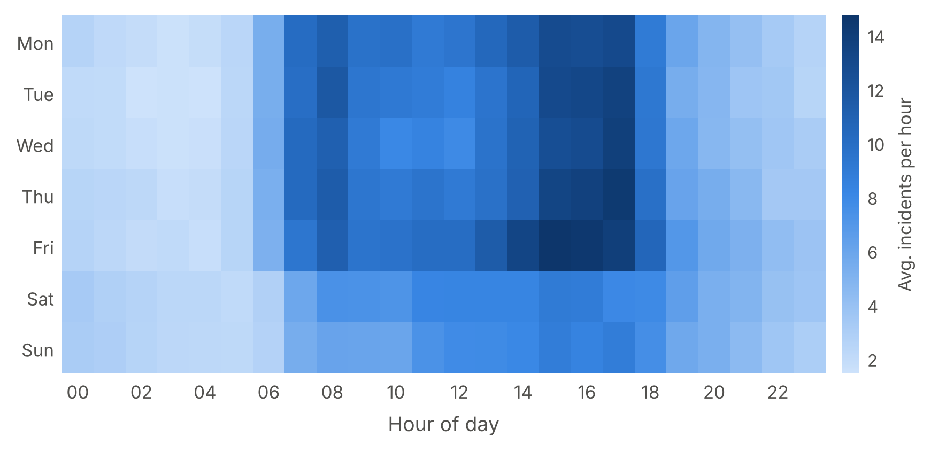
Figure 3. Mean number of incidents per hour by hour of day and day of week, FDOT District 2, 2022–2024.

3.3 Spatial distribution and concentration
Incidents were concentrated in Duval County, which accounted for 53.2% of the total, followed by Alachua (12.8%), Columbia (10.6%), St. Johns (5.5%) and Hamilton (5.0%) counties (Figure 1). Interstates carried 91.3% of incidents: I-75 (26.3%), I-295 (23.2%; 14.4% on the western and 8.8% on the eastern half), I-95 (22.3%) and I-10 (18.5%).
Within the network, incidents were concentrated in a small share of the 983 cells. The busiest 145 cells (14.8%) contained half of all incidents and 333 cells (33.9%) contained 80%, whereas 195 cells (19.8%) recorded on average no more than one incident per year; the median cell recorded 35.3 incidents per year. The 15 busiest cells held 9.9% of incidents, and 14 of them lay in central Jacksonville (Figure 4). The busiest cell, on I-295 W between San Jose Boulevard and the Buckman Bridge, recorded 531 incidents per year, followed by I-95 at the ramp to I-10 (480) and two further Buckman Bridge cells (429 and 408); the only busiest-15 cell outside Duval County was on I-75 near mile marker 386 in Alachua County (313 per year). The crash share in these cells ranged from 6.3% at the western end of the Buckman Bridge to 48.3% on I-95 at the Martin Luther King Jr. Parkway.
The mix of incident types also differed between routes (Figure S4). Crashes made up 8.9% of incidents on I-75, 19.7% on I-10, 27.5% on I-295 W, 34.8% on I-95 and 36.3% on I-295 E, and 96.4% on SR-21 (Blanding Boulevard), where disabled vehicles made up 2.7%.
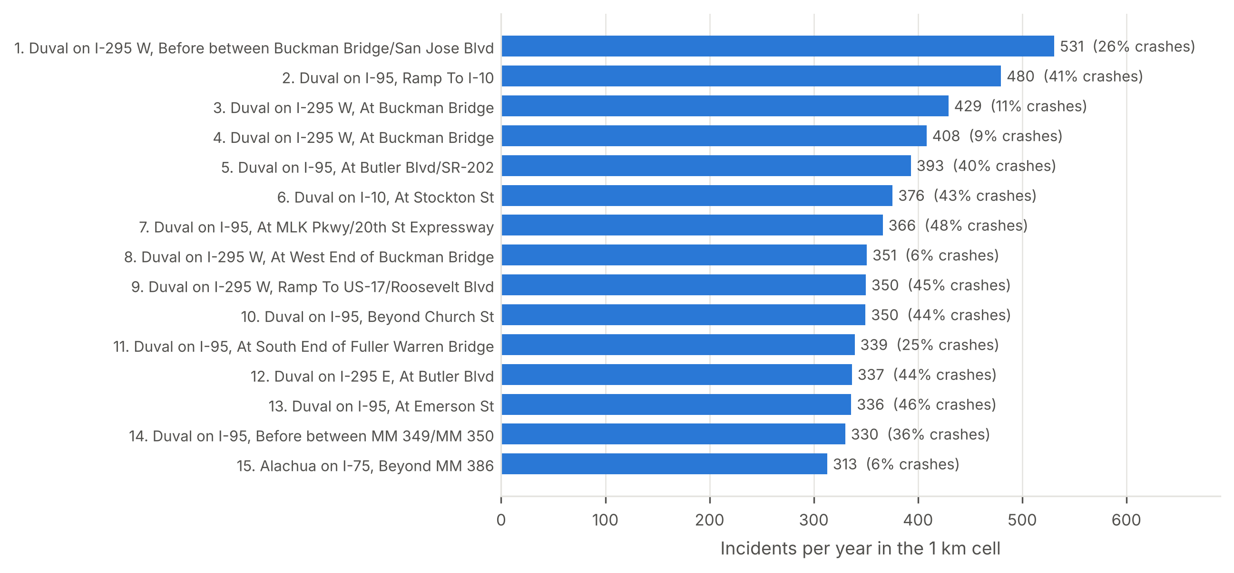
Figure 4. The 15 one-kilometre cells with the highest mean annual number of incidents, 2022–2024. Labels give each cell’s most frequent location description; values give incidents per year and the share of crashes.

3.4 Event duration
Event duration, measured from the first to the last logged update, differed markedly between incident types (Figure 5; Table 1). After excluding 5,189 flagged durations, the median was 18.9 minutes, the 95th percentile 108.3 minutes, and 17.6% of incidents lasted more than one hour. Crashes lasted longest, with a median of 56.7 minutes (interquartile range 29.9–88.2; 95th percentile 158.2); 47.0% of crashes lasted more than one hour and 11.3% more than two hours. Disabled vehicles (median 13.4 minutes; interquartile range 4.9–31.7) and debris on the roadway (12.8; 3.8–28.6) had similar distributions, with 8.5% and 6.2%, respectively, lasting more than one hour. Abandoned vehicles had the shortest events (median 4.7 minutes; interquartile range 3.0–9.9), although their 95th percentile reached 50.3 minutes.
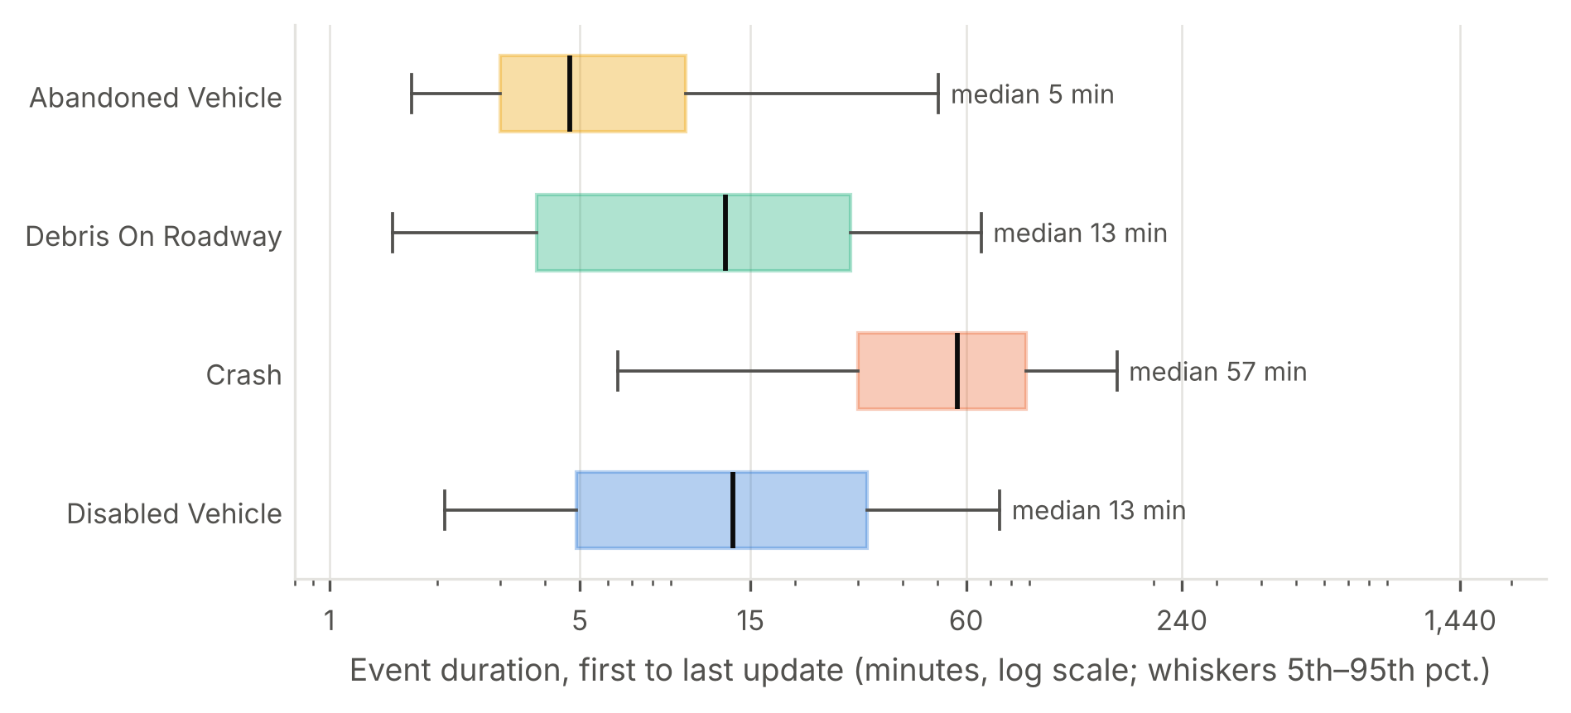
Figure 5. Distribution of event duration by incident type, 2022–2024. Boxes show the median and interquartile range, and whiskers the 5th and 95th percentiles, on a logarithmic scale. Duration is the time between the first and last logged update; 5,189 events shorter than 1 min or longer than 24 h are excluded.

3.5 Precipitation and incident rates
During 2022–2024, the nearest station recorded precipitation in 8.4% of cell-windows, and 10.0% of incidents occurred in these wet windows (Figure S8). After stratification by window of day, month and day type, the incident rate was 5.3% higher in wet than in dry windows (rate ratio 1.053; 95% confidence interval 1.036–1.070). Crashes accounted for most of this difference: the crash rate was 1.43 times as high in wet windows (1.39–1.47) and rose with the amount of precipitation, from 1.28 (1.24–1.33) for light through 1.52 (1.45–1.60) for moderate to 1.71 (1.61–1.81) for heavy precipitation. Disabled vehicles, in contrast, were 8.1% less frequent in wet windows (0.919; 0.899–0.939), with similar ratios for light and moderate precipitation and no significant difference for heavy precipitation (0.969; 0.921–1.020). Abandoned vehicles were also less frequent in wet windows (0.890; 0.825–0.961), whereas debris on the roadway showed no difference in any precipitation class (0.996; 0.946–1.049). For all incidents combined, light precipitation was not associated with a higher rate (1.007; 0.986–1.029), whereas moderate (1.072; 1.042–1.104) and heavy precipitation (1.157; 1.116–1.199) were.

3.6 Hotspots
Of the 983 cells, 35 (3.6%) were significant hot spots at q < 0.05, 30 of them at q < 0.01; a further 10 cells were significant at q < 0.10, and no cell was a significant cold spot (Figure 6). The hot cells contained 13.1% of incidents, all lay in Duval County and formed eight clusters (Table 2). The two largest, H1 (I-95 at the ramp to I-10; 14 cells, 3,290 incidents per year) and H2 (I-295 W at the Buckman Bridge; 11 cells, 2,382 per year), contained 25 of the 35 hot cells. Crash shares across clusters ranged from 17.1% (H2) to 55.3% (H7, I-295 E at St Johns Bluff Road), and rates from 1.38 (H8) to 5.92 (H4) incidents per million vehicle-kilometres, against a district average of 2.80.
Thirty-one of the 35 hot cells (88.6%) were hot in each of the three years (Figure S5). Excluding near-duplicates changed no hot cell; excluding incidents created through the vehicle-location subsystem retained 34 of the 35 hot cells (97.1%) but added 34 others (Jaccard index 0.49); and the crash-only analysis retained 23 (65.7%) among 80 hot cells (Jaccard index 0.25).
Hotspots of incident rates differed from those of counts (Figure S7; Table S2). Although cell counts and rates were correlated (Spearman’s ρ = 0.83), the 15 rate hot spots (q < 0.05) held 2.7% of incidents in four clusters, and only 3 of them were also count hot spots (Jaccard index 0.06). Two rate clusters lay outside Jacksonville, on I-10 in Baker County (R2; 5.94 incidents per million vehicle-kilometres) and on I-75 in Columbia County (R3; 5.73), and one (R1; 6.28) overlapped H2 at the Buckman Bridge.
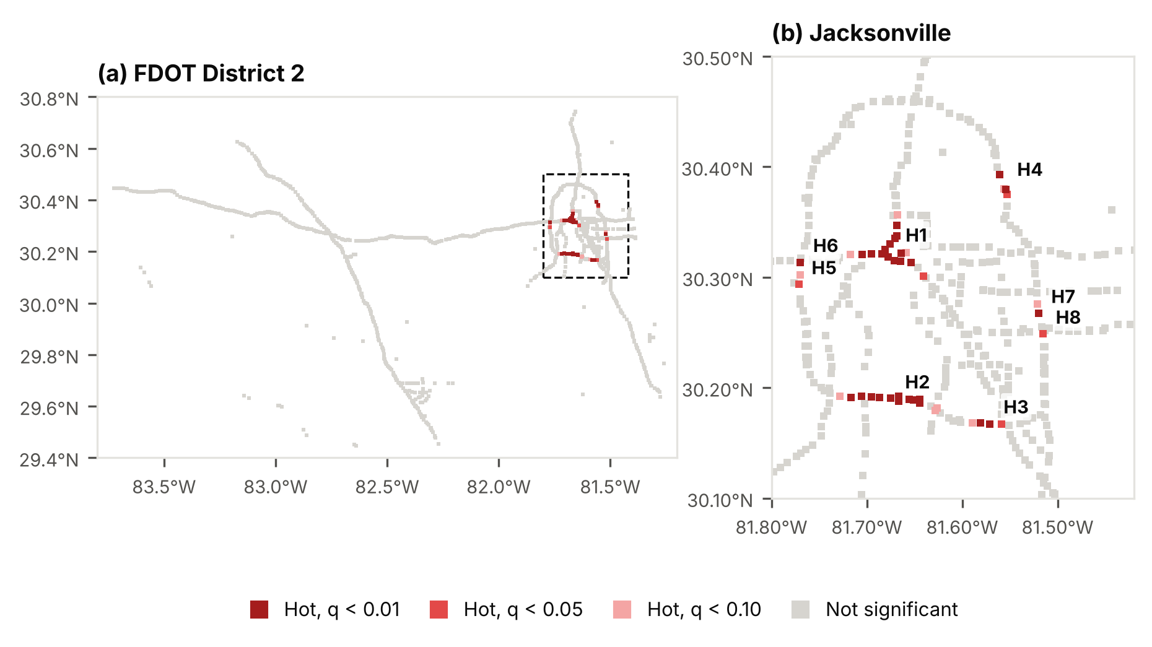
Figure 6. Incident hotspots identified with the Getis-Ord Gi* statistic, 2022–2024: (a) FDOT District 2; (b) Jacksonville, with hotspot clusters H1–H8 (Table 2). Classes are based on false-discovery-rate-adjusted q-values; spatial weights are binary within 2 km.

Table 2. Incident hotspot clusters (contiguous Gi* hot cells, q < 0.05), 2022–2024, named after the busiest cell in each cluster. Incidents and vehicle-kilometres are cluster totals; vehicle-kilometres are derived from FDOT annual average daily traffic (mean of 2022–2024).
ID | Hotspot location | Routes | Cells | Incidents per year | Crash share (%) | Cells hot in all 3 years | Maximum Gi* z-score | Million vehicle-km per year | Incidents per million vehicle-km
H1 | I-95 at ramp to I-10 (Duval County) | Acosta Bridge, I-10, I-95 | 14 | 3,290 | 40.8 | 13 of 14 | 7.77 | 787.8 | 4.18
H2 | I-295 W at Buckman Bridge (Duval County) | I-295 W | 11 | 2,382 | 17.1 | 11 of 11 | 6.96 | 422.4 | 5.64
H3 | I-295 W at I-95S/I-295 E (Duval County, MM 1) | I-295 W | 3 | 554 | 23.6 | 2 of 3 | 4.25 | 216.9 | 2.56
H4 | I-295 E at Dames Point Bridge (Duval County) | I-295 E | 3 | 409 | 17.2 | 2 of 3 | 3.69 | 69.1 | 5.92
H5 | I-295 W at ramp to Normandy Blvd/SR-228 (Duval County, MM 18) | I-295 W | 1 | 287 | 32.6 | 0 of 1 | 3.37 | 56.5 | 5.08
H6 | I-295 W at I-10 (Duval County, MM 20) | I-295 W | 1 | 256 | 38.3 | 1 of 1 | 3.76 | 98.7 | 2.59
H7 | I-295 E at St Johns Bluff Rd/UNF (Duval County) | I-295 E | 1 | 203 | 55.3 | 1 of 1 | 4.15 | 65.4 | 3.10
H8 | I-295 E at ramp to Butler Blvd EB ramp (Duval County, MM 54) | I-295 E | 1 | 185 | 37.0 | 1 of 1 | 3.26 | 133.5 | 1.38

3.7 Forecasting performance
The Poisson log-linear model and LightGBM gave the lowest mean Poisson deviance on 2024 (13.259 and 13.266 × 10⁻²), and their difference was not significant (bootstrap mean difference −0.005 × 10⁻²; 95% confidence interval −0.029 to 0.020) (Table 3). The three deep learning models had higher deviance than LightGBM: Graph WaveNet by 0.46% (13.327 × 10⁻²; bootstrap difference 0.057, 0.050–0.066), the LSTM by 0.47% (13.329; 0.060, 0.053–0.069) and the ST-Transformer by 0.58% (13.343; 0.074, 0.065–0.083); the historical average was 9.1% higher (14.471). LightGBM had the highest daily hit rate (23.59% of incidents in the top 5% of cells; predictive accuracy index 4.64), followed by Graph WaveNet (23.49%), the LSTM (23.48%), the ST-Transformer (23.37%), the historical average (23.26%) and the log-linear model (22.85%).
The deep models’ deviance exceeded LightGBM’s in all eight windows, by 0.29–0.91%, with the largest differences between 03:00 and 05:59 (Figure 7a); between midnight and 05:59, the log-linear model was 1.6–1.7% better than LightGBM. Observed and predicted 2024 totals per cell were closely related (Graph WaveNet: r = 0.969 on a logarithmic scale; Figure 7b). On the validation period, the default configuration was best or tied for each deep model (Table S7), and training ran for 4–15 epochs. In LightGBM, the historical mean accounted for 80.9% of the total split gain and the 28-day count for 11.4%; the previous year’s exposure and the previous day’s precipitation together accounted for 0.7%. Removing these two inputs lowered the deviance slightly (by 0.011 × 10⁻²; 0.009–0.012), whereas adding the observed precipitation in the target window lowered it by 0.014 × 10⁻² (0.012–0.016) (Table S3).
Table 3. Day-ahead forecast performance on the 2024 test year (366 days × 8 windows × 983 cells). Values are means ± standard deviations over five random seeds where applicable. MAE = mean absolute error; RMSE = root mean squared error; PAI = predictive accuracy index.
Model | Seeds | MAE (×10⁻²) | RMSE (×10⁻²) | Poisson deviance (×10⁻²) | Hit rate, top 5% of cells (%) | PAI
Historical average | 1 | 3.796 | 15.068 | 14.471 | 23.26 | 4.57
Poisson log-linear | 1 | 3.781 | 15.054 | 13.259 | 22.85 | 4.49
LightGBM | 5 | 3.801 ± 0.002 | 15.044 ± 0.001 | 13.266 ± 0.006 | 23.59 ± 0.04 | 4.64 ± 0.01
LSTM (no graph) | 5 | 3.832 ± 0.029 | 15.054 ± 0.005 | 13.329 ± 0.018 | 23.48 ± 0.12 | 4.62 ± 0.02
Graph WaveNet | 5 | 3.838 ± 0.020 | 15.054 ± 0.005 | 13.327 ± 0.022 | 23.49 ± 0.10 | 4.62 ± 0.02
ST-Transformer | 5 | 3.866 ± 0.052 | 15.058 ± 0.005 | 13.343 ± 0.017 | 23.37 ± 0.12 | 4.59 ± 0.02
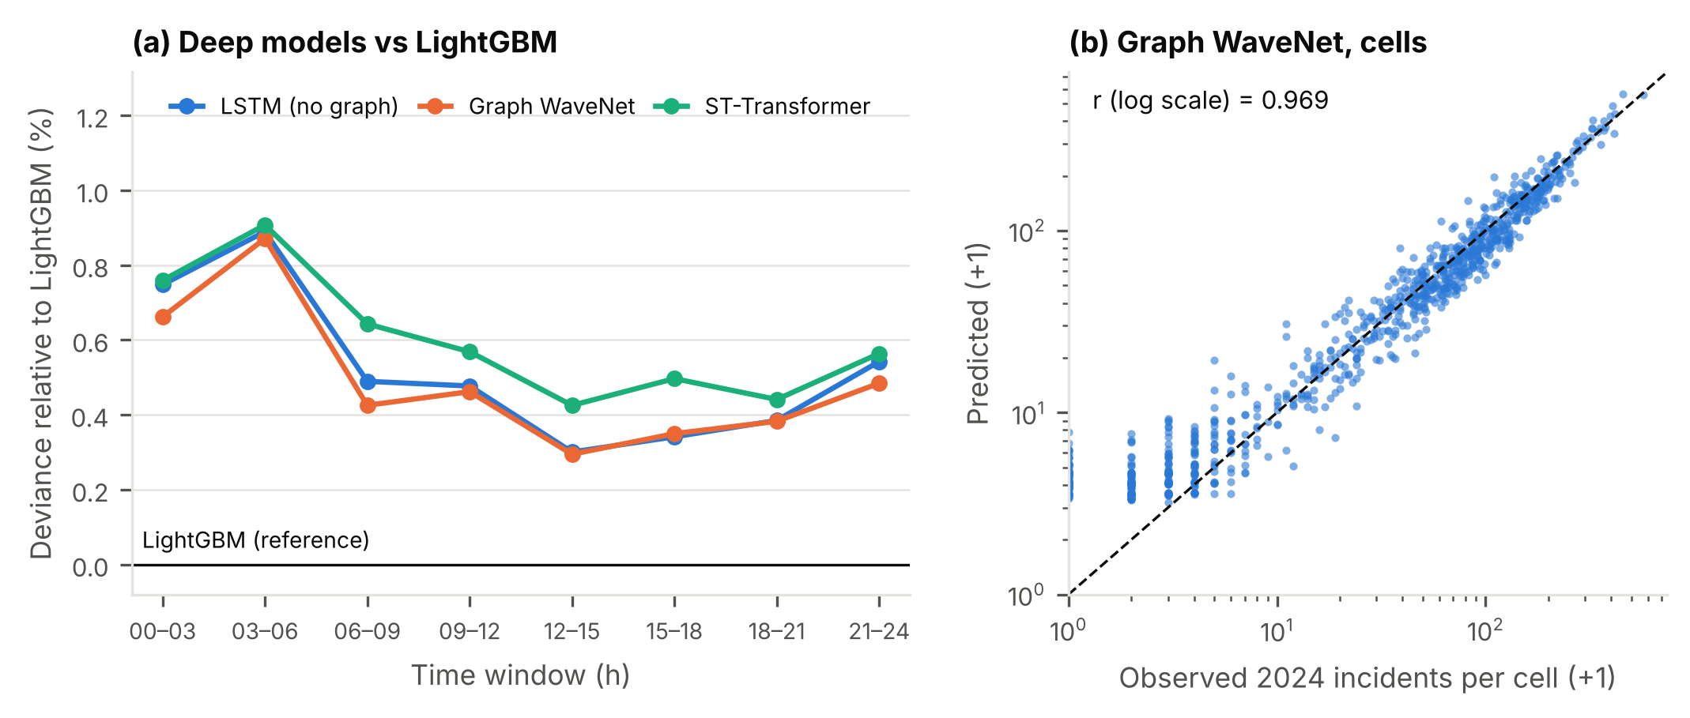
Figure 7. Day-ahead forecast performance on the 2024 test year: (a) mean Poisson deviance of the deep learning models relative to LightGBM, by three-hour window; (b) observed and predicted (Graph WaveNet) incidents per cell on logarithmic scales, with the line of equality (dashed).

3.8 Station locations and coverage
Coverage of 2024 incidents by fixed stations optimised on 2022–2023 demand increased with the number of stations and the response-time standard (Figure 8). Within 15 minutes, one station covered 24.6% of incidents, five 64.5%, ten 80.7%, fifteen 88.7% and twenty 94.2%; 10 stations were needed to cover 80% and 16 to cover 90%. Within 10 minutes, 20 stations covered 81.8%, and within 20 minutes, 10 stations covered 91.4%.
With 10 stations (Table 4), the optimised layout covered 80.7% of incidents within 15 minutes, with a mean travel time of 11.7 minutes, against 52.7% (22.5 minutes) for randomly drawn sites and 47.1% (40.5 minutes) for the sites nearest the busiest cells. Day-ahead staging covered 80.5–80.6% within 15 minutes, whichever forecast was used. Across all numbers of stations and response-time standards, the five forecasts differed by at most 0.5 percentage points, and staging differed from fixed stations by −2.3 to +4.5 points. Staging with perfect knowledge of each band’s incidents covered 91.3% within 15 minutes, with a mean travel time of 10.1 minutes.
The recommended layout (10 stations, 15-minute standard) places four stations in Duval County (S1–S3, S6), two in Alachua (S7, S8) and one each in Columbia (S4), Suwannee (S5), St. Johns (S9) and Baker (S10) (Figure 9; Table 5). S1 (I-295 Exit 54) and S2 (I-10 Exit 358) were the nearest station for 17.1% and 16.0% of 2024 incidents, respectively. The share of each station’s incidents reached within 15 minutes ranged from 32.3% (S5, I-10 Exit 283) to 97.7% (S3, I-295 Exit 10). [Author note: comparison with current Road Ranger stations pending FDOT data.]
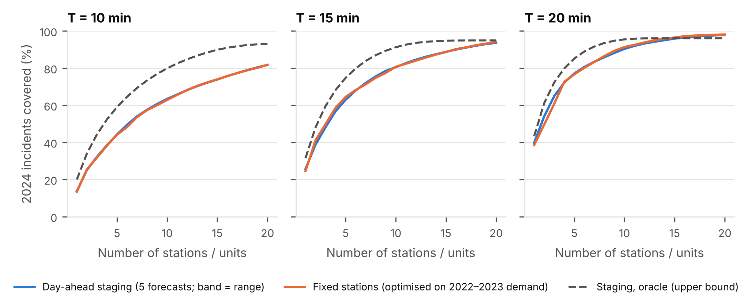
Figure 8. Share of 2024 incidents reached within 10, 15 and 20 min (left to right) of the nearest station or staged unit, by number of stations or units. Fixed stations are optimised on 2022–2023 demand; day-ahead staging is shown as the mean (line) and range (band) of five forecasts; the oracle uses the actual incidents and gives an upper bound.
Table 4. Coverage of the 59,981 incidents of 2024 by layouts of 10 stations or staged units. Comparison layouts are not optimised; fixed stations are optimised separately for each response-time standard on 2022–2023 demand, and their mean travel time refers to the 15-min layout. Travel times are computed on the directed OpenStreetMap network.
Layout | Stations or units | Covered ≤ 10 min (%) | ≤ 15 min (%) | ≤ 20 min (%) | Mean travel time (min)
Current Road Ranger stations | 10 | [pending] | [pending] | [pending] | [pending]
Sites nearest the busiest cells | 10 | 37.9 | 47.1 | 52.2 | 40.5
Random candidate sites (mean of 200 draws) | 10 | 34.8 | 52.7 | 63.8 | 22.5
Fixed stations, optimised on 2022–2023 demand | 10 | 62.9 | 80.7 | 91.4 | 11.7
Day-ahead staging, historical average | 10 | 63.5 | 80.5 | 90.4 | 12.4
Day-ahead staging, LightGBM | 10 | 63.2 | 80.6 | 90.3 | 12.3
Day-ahead staging, LSTM | 10 | 63.5 | 80.5 | 90.4 | 12.4
Day-ahead staging, Graph WaveNet | 10 | 63.5 | 80.5 | 90.4 | 12.3
Day-ahead staging, ST-Transformer | 10 | 63.5 | 80.5 | 90.4 | 12.4
Day-ahead staging, oracle (actual incidents) | 10 | 79.9 | 91.3 | 95.5 | 10.1
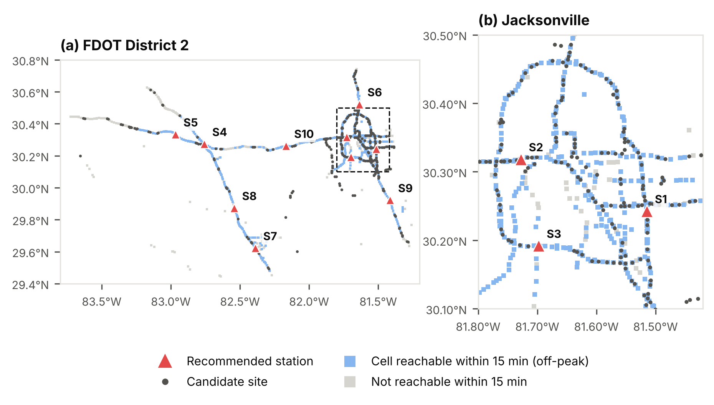
Figure 9. Recommended fixed station sites S1–S10 (10 stations, 15-min standard) and the 307 candidate sites: (a) FDOT District 2; (b) Jacksonville. Shaded cells are those in which at least half of the 2024 incidents can be reached within 15 min at off-peak speed.
Table 5. Recommended fixed station sites (10 stations, 15-min standard, 2022–2023 demand), selected from 307 candidate interchanges, rest areas and service plazas. Coordinates are WGS84; the nearest incident landmark is the location description of the closest road cell.
ID | Station site | Nearest incident landmark | Latitude | Longitude | 2024 incidents nearest to station | Share of 2024 incidents (%) | Of these, reached within 15 min (%)
S1 | I-295 Exit 54, Duval County | I-295 E at Gate Parkway | 30.2425 | -81.5146 | 10,274 | 17.1 | 89.2
S2 | I-10 Exit 358, Duval County | I-10 at Cassat Ave | 30.3182 | -81.7278 | 9,580 | 16.0 | 92.2
S3 | I-295 Exit 10, Duval County | I-295 W between Buckman Bridge and US-17 | 30.1918 | -81.6975 | 6,849 | 11.4 | 97.7
S4 | I-75 Exit 435, Columbia County | I-75 at ramp to I-10 | 30.2733 | -82.7582 | 6,411 | 10.7 | 77.5
S5 | I-10 Exit 283, Suwannee County | I-10 at US-129 | 30.3332 | -82.9664 | 5,757 | 9.6 | 32.3
S6 | I-95 Exit 366, Duval County | I-95 at ramp from Pecan Park Rd | 30.5222 | -81.6357 | 5,478 | 9.1 | 86.2
S7 | I-75 Exit 384, Alachua County | I-75 at ramp from SR-24/Archer Rd | 29.6220 | -82.3895 | 5,038 | 8.4 | 77.3
S8 | I-75 Exit 404, Alachua County | I-75 at ramp to CR-236 | 29.8729 | -82.5424 | 4,223 | 7.0 | 85.5
S9 | I-95 Exit 318, St. Johns County | I-95 at SR-16 | 29.9221 | -81.4139 | 3,384 | 5.6 | 77.7
S10 | I-10 Exit 333, Baker County | I-10 at CR-125 | 30.2615 | -82.1657 | 2,987 | 5.0 | 68.9

3.9 Sensitivity analysis and temporal validation
With 10 stations and a 15-minute standard, coverage of 2024 incidents ranged from 73.2% to 85.9% across speed scenarios, against 80.7% in the base case (Figure S6): 75.1% and 85.3% with peak speeds of 50% and 83% of off-peak, and 73.2% and 85.9% with off-peak speeds 15% lower and higher. Alternative demand definitions gave 79.5% (excluding incidents created through the vehicle-location subsystem), 80.6% (excluding near-duplicates) and 79.3% (crashes only). The two cell-based travel-time models gave higher coverage: 93.2% for the undirected Census network and 90.8% for the road-cell graph.
Coverage was stable over time (Table S4). Sites selected on 2022 covered 81.4% of 2023 incidents, and sites selected on 2023 covered 80.5% of 2024 incidents, against 81.3% and 80.6% for layouts optimised on the evaluation year itself.
The recommended sites were reselected to different degrees (Figure S9; Table S5). Layouts re-solved on bootstrap samples shared on average 7.1 of the 10 sites, and 49 distinct sites were selected across all 209 re-solved layouts. The four stations on I-75 and western I-10 (S4, S5, S7 and S8) were selected in 97.6–100% of layouts, S9 in 80.9%, S6 in 70.3% and S10 in 66.0%. In Duval County, S2 itself was selected in 33.5% of layouts but a site within 5 km of it in 91.9%; S1 was selected in 20.1% (within 5 km, 59.3%) and S3 in 33.5% (34.0%). Under each speed scenario, the recommended layout covered at most 0.55 percentage points fewer incidents than the layout optimised for that scenario, while sharing only 3–5 of its sites (Table S6).

3.10 Fleet size with busy units
When units could be busy, the share of incidents reached in time depended on fleet size (Table 6; Figure 10). With one unit at each of 10 stations, demand exceeded capacity (utilisation 108%) and 0.6% of incidents were reached within 15 minutes. With 20 units at the 10 stations, 52.4% were reached within 15 minutes when units were distributed equally and 57.4% when they were allocated in proportion to demand, against 80.7% if units were always free; with 30 units, the shares were 71.6% and 75.1%. For the same fleet, larger layouts reached more incidents once there were at least two units per station. With 30 units and proportional allocation, 15 stations reached 79.2% of incidents within 15 minutes (mean response 11.6 minutes) against 75.1% for 10 stations, and with 40 units, 20 stations reached 89.5%. With 60 units at 20 stations, 93.2% were reached within 15 minutes, against 94.2% if units were always free; the mean response time was 7.8 minutes, 2.1% of incidents were delayed by busy units, and utilisation was 10.4%. Proportional allocation reached 1.2–6.3 percentage points more incidents within 15 minutes than equal allocation of the same fleet. For 10 stations and 20 units, halving the on-scene time raised the share reached within 15 minutes from 57.4% to 68.6%, and excluding incidents created through the vehicle-location subsystem raised it to 69.8%.

Table 6. Discrete-event simulation of the response to the 59,981 incidents of 2024 with busy units, by layout, fleet size and unit allocation. A unit is busy for travel to the incident, on-scene time and return to its station; utilisation above 100% indicates that demand exceeds capacity. Sensitivity scenarios use 10 stations and 20 units allocated in proportion to demand.
Scenario | Stations | Units | Unit allocation | Reached ≤ 10 min (%) | ≤ 15 min (%) | ≤ 20 min (%) | ≤ 15 min, units always free (%) | Mean response (min) | 90th percentile (min) | Delayed by busy units (%) | Utilisation (%)
Base case | 10 | 10 | Equal | 0.4 | 0.6 | 0.7 | 80.7 | overloaded | overloaded | 99.4 | 108.0
Base case | 10 | 20 | Equal | 34.8 | 52.4 | 63.3 | 80.7 | 27.0 | 59.8 | 43.0 | 39.2
Base case | 10 | 20 | Proportional | 38.8 | 57.4 | 67.7 | 80.7 | 24.9 | 54.2 | 37.4 | 38.2
Base case | 10 | 30 | Equal | 49.0 | 71.6 | 82.3 | 80.7 | 14.3 | 30.6 | 16.8 | 23.8
Base case | 10 | 30 | Proportional | 52.2 | 75.1 | 85.0 | 80.7 | 13.6 | 26.3 | 11.3 | 23.5
Base case | 15 | 15 | Equal | 16.2 | 25.1 | 31.5 | 88.7 | 91.5 | 232.4 | 78.0 | 62.5
Base case | 15 | 30 | Equal | 51.3 | 72.9 | 83.1 | 88.7 | 13.5 | 26.6 | 26.7 | 23.0
Base case | 15 | 30 | Proportional | 57.7 | 79.2 | 88.4 | 88.7 | 11.6 | 21.4 | 17.2 | 22.4
Base case | 15 | 45 | Equal | 61.9 | 84.5 | 93.0 | 88.7 | 9.9 | 17.5 | 9.0 | 14.5
Base case | 15 | 45 | Proportional | 64.7 | 86.7 | 94.3 | 88.7 | 9.5 | 16.4 | 4.2 | 14.4
Base case | 20 | 20 | Equal | 33.3 | 47.6 | 56.7 | 94.2 | 34.9 | 88.3 | 61.9 | 40.8
Base case | 20 | 40 | Equal | 66.5 | 85.1 | 92.3 | 94.2 | 9.5 | 17.9 | 18.5 | 16.1
Base case | 20 | 40 | Proportional | 71.8 | 89.5 | 95.1 | 94.2 | 8.6 | 15.3 | 10.1 | 15.8
Base case | 20 | 60 | Equal | 74.4 | 92.0 | 96.9 | 94.2 | 7.9 | 14.2 | 5.9 | 10.4
Base case | 20 | 60 | Proportional | 76.4 | 93.2 | 97.1 | 94.2 | 7.8 | 13.5 | 2.1 | 10.4
On-scene time halved | 10 | 20 | Proportional | 47.3 | 68.6 | 79.1 | 80.7 | 15.7 | 34.8 | 22.7 | 26.5
AVL-created incidents excluded | 10 | 20 | Proportional | 48.4 | 69.8 | 79.7 | 84.4 | 17.0 | 34.9 | 22.5 | 23.1

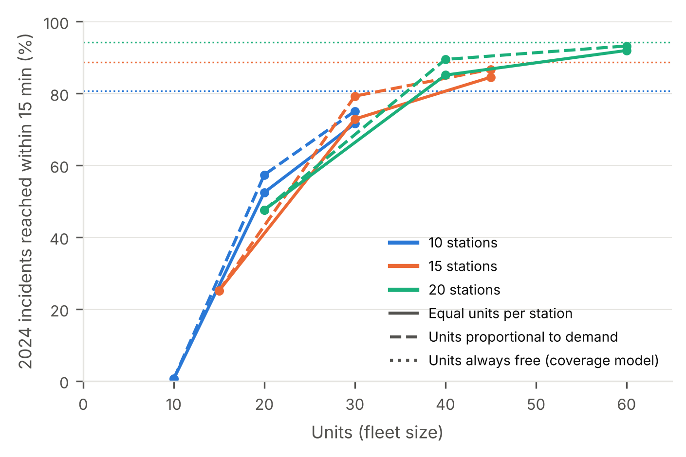
Figure 10. Simulated share of 2024 incidents reached within 15 min by fleet size, for layouts of 10, 15 and 20 stations, with units distributed equally (solid lines) or in proportion to 2022–2023 demand (dashed lines). Dotted lines show coverage when units are always available.

4. Discussion

4.1 Network screening: counts, rates and conditions
Incidents attended by Road Rangers were concentrated at a small number of interchanges and bridges in Jacksonville, and these hotspots were persistent: almost nine in ten hot cells were hot in each of the three years (Section 3.6). This stability is what makes fixed station siting defensible, because a layout chosen on past demand remains well placed in later years, as the temporal validation confirmed (Section 3.9). Screening on exposure-based rates, as recommended for network screening in the Highway Safety Manual [47], identified a largely different set of locations, including rural segments of I-10 and I-75 where incidents per vehicle-kilometre are high but counts are moderate. The two screening approaches answer different questions. Count-based hotspots describe where response demand arises and are the relevant input for siting patrol units, whereas rate-based hotspots, ideally adjusted for regression to the mean by empirical Bayes methods [48], [40], point to segments where the risk per vehicle is elevated and engineering countermeasures may be warranted. The Buckman Bridge on I-295 appeared under both criteria; there, disabled vehicles rather than crashes dominated, which may reflect the limited refuge space on long bridges rather than elevated crash risk.
The precipitation analysis showed a clear dose–response relationship for crashes, consistent with earlier findings on wet-weather crash risk [20], [21], whereas disabled-vehicle incidents became slightly less frequent in wet conditions. For incident management this means that rain changes the mix of incidents as well as their number, shifting demand towards longer, crash-related responses. The analysis also exposed a data-quality problem with practical consequences: the weather recorded in the traffic management log was almost always “clear”, even when measurable rain was falling. Agencies that rely on these fields for performance reporting or safety analysis would understate the role of weather; linking incident records automatically to observed weather would be more reliable than manual coding.

4.2 The value of deep learning forecasts
The three deep spatio-temporal networks did not improve day-ahead forecasts over a Poisson log-linear model and gradient-boosted trees, and tuning did not change this result (Section 3.7). This contrasts with the gains reported for crash-risk prediction on urban grids [25], [26], [27], [28], but it is consistent with broader evidence that well-specified statistical and tree-based models often match or outperform neural networks in forecasting and on tabular data [49], [50], and with the nature of the data. Incident counts on a freeway network are sparse, with most cells and three-hour windows recording no incident, and their predictable part is dominated by stable spatial and time-of-day patterns, which simpler models capture well; in the gradient-boosting model, the historical mean alone accounted for four-fifths of the explanatory contribution. Graph neural networks are designed to learn spatial dependencies from dense, continuously varying signals such as traffic speeds and flows, and they had little short-term structure to exploit here.
The decision-level results reinforce this conclusion. Day-ahead staging produced almost identical coverage whichever forecast was used, and it did not improve on fixed stations (Section 3.8). In the sense of the predict-then-optimise literature [29], the information that matters for siting patrol units is the long-run spatial distribution of demand, which every model estimates equally well. The gap between realistic staging and staging with perfect knowledge of each day’s incidents shows that substantial gains are possible in principle, but they would require information on where incidents will occur within the day that day-ahead forecasts cannot provide; real-time dispatching and relocation of units, as developed for emergency medical services [13], [51], is the natural route to capturing part of this gap. Deep learning is therefore more likely to add value in real-time applications that use detector, probe-vehicle or connected-vehicle data [52], or for event-level tasks such as predicting clearance time [53], than in day-ahead station planning. For agencies, the practical message is that a well-specified statistical model is sufficient for planning patrol deployment, and investment in advanced forecasting should be directed at real-time operations.

4.3 Implications for Road Ranger deployment
Three findings are directly relevant to programme planning. First, station siting is a network problem rather than a hotspot problem. Placing stations next to the busiest locations concentrated them in Jacksonville and left the rural interstates uncovered, giving lower coverage than randomly chosen interchanges, whereas the optimised layout reached about four in five incidents within 15 minutes with the same number of stations (Section 3.8). Second, the robustness analysis separates firm recommendations from flexible ones. The stations on I-75 and western I-10 were selected in almost every re-solved layout and can be treated as firm, whereas in Jacksonville the analysis identifies the area in which a station should be placed rather than a single interchange, so the final choice can take account of land availability, access and cost without a material loss of coverage, in line with the emphasis of the facility location literature on solutions that remain good across plausible scenarios [54] (Section 3.9). Third, fleet size is at least as important as station location, as queueing-based and availability-based location models have long recognised [55], [56], [12]. When units can be busy, a layout of ten stations with one unit each is overloaded, and coverage approaches its theoretical value only with two to three units per station; allocating units in proportion to station demand improves coverage at no additional cost (Section 3.10). Because longer response delays prolong incidents, and longer incidents are associated with more secondary incidents [2], [57], under-provision of units carries safety as well as delay costs. Station locations and fleet size should therefore be planned together, and benefit–cost evaluations of patrol programmes [3], [4] should account for unit availability as well as location.
The comparison of travel-time models also has methodological implications. Models that ignore travel direction overstated coverage by 10 to 12 percentage points, because a patrol unit on a divided freeway must often travel to the next interchange to reverse direction. Siting studies that rely on straight-line or undirected network distances may therefore overestimate the performance of their recommended layouts.

4.4 Limitations and future research
Some limitations qualify these findings. First, the optimised layouts could not yet be compared with the current Road Ranger staging locations and patrol beats, and Road Rangers patrol their beats rather than wait at fixed stations; the stations modelled here should be interpreted as staging bases, and the comparison with current operations is the most important next step. Second, the incident records come from the traffic management centre log, in which about half of the incidents were created through the Road Ranger vehicle-location subsystem; incidents found by patrolling units may over-represent patrolled locations, although the hotspots and layouts were robust to excluding them. Independent crash records would allow this detection effect to be tested directly. Third, travel times rely on posted speed limits and an assumed peak-period reduction rather than observed speeds; probe-vehicle speed data would allow time-of-day travel times by segment. Fourth, event duration from the log approximates on-scene time, and the simulation assumes that every incident requires a unit and that units operate around the clock. Finally, the study covers a single district with a mix of urban and rural interstates; applying the framework to other districts would show how far the findings generalise. Future work should also examine decision-focused learning, in which forecasting models are trained directly on deployment outcomes [58], [59], and the joint design of patrol beats, staging locations and fleet size.

5. Conclusion
This study developed a data-driven decision-support framework for freeway service patrol deployment, combining network screening, deep learning forecasting, station location optimisation and simulation, and applied it to the Road Ranger programme in FDOT District 2. Incident demand was concentrated at a few interchanges and bridges in Jacksonville and was stable from year to year, which supports planning fixed staging locations from historical records. Rate-based screening highlighted different, largely rural segments that are better suited to engineering countermeasures. Heavy rain raised crash rates by about 70%, while the weather recorded in incident logs proved unreliable. For day-ahead planning, deep spatio-temporal neural networks did not outperform well-specified statistical and gradient-boosting models, and forecast-driven staging offered no advantage over fixed stations; deep learning is better directed at real-time operations. Optimised siting on a direction-aware network reached about 81% of incidents within 15 minutes, compared with about half for intuitive placement. When units can be busy, this coverage is achieved only with two to three units per station. Station locations and fleet size should therefore be planned together. Comparison with current Road Ranger operations, calibration with probe-vehicle speeds and real-time dispatching are the next steps.

References
[1] Federal Highway Administration, “Traffic incident management handbook,” U.S. Dept. of Transportation, Washington, DC, USA, Rep. FHWA-HOP-10-013, 2010. [Online]. Available: https://rosap.ntl.bts.gov/view/dot/41014
[2] M. G. Karlaftis, S. P. Latoski, N. J. Richards, and K. C. Sinha, “ITS impacts on safety and traffic management: An investigation of secondary crash causes,” J. Intell. Transp. Syst., vol. 5, no. 1, pp. 39–52, 1999, doi: 10.1080/10248079908903756.
[3] A. Skabardonis, K. Petty, P. Varaiya, and R. Bertini, “Evaluation of the freeway service patrol (FSP) in Los Angeles,” California PATH Program, Univ. of California, Berkeley, CA, USA, Res. Rep. UCB-ITS-PRR-98-31, 1998. [Online]. Available: https://its.berkeley.edu/publications/evaluation-freeway-service-patrol-f-s-p-los-angeles
[4] P.-S. Lin, A. Fabregas, and H. Chen, “Cost benefit analysis of freeway service patrol programs: A case study in Florida,” in Sustainable Transportation Systems: Plan, Design, Build, Manage, and Maintain (Proc. 9th Asia Pacific Transp. Develop. Conf.), Chongqing, China, 2012, pp. 1–8, doi: 10.1061/9780784412299.0001.
[5] R. Pal and K. C. Sinha, “Simulation model for evaluating and improving effectiveness of freeway service patrol programs,” J. Transp. Eng., vol. 128, no. 4, pp. 355–365, 2002, doi: 10.1061/(ASCE)0733-947X(2002)128:4(355).
[6] Y. Yin, “A scenario-based model for fleet allocation of freeway service patrols,” Netw. Spat. Econ., vol. 8, no. 4, pp. 407–417, 2008, doi: 10.1007/s11067-006-9015-2.
[7] Y. Lou, Y. Yin, and S. Lawphongpanich, “Freeway service patrol deployment planning for incident management and congestion mitigation,” Transp. Res. Part C Emerg. Technol., vol. 19, no. 2, pp. 283–295, 2011.
[8] K. Ozbay, C. Iyigun, M. Baykal-Gürsoy, and W. Xiao, “Probabilistic programming models for traffic incident management operations planning,” Ann. Oper. Res., vol. 203, no. 1, pp. 389–406, 2013, doi: 10.1007/s10479-012-1174-6.
[9] C. Toregas, R. Swain, C. ReVelle, and L. Bergman, “The location of emergency service facilities,” Oper. Res., vol. 19, no. 6, pp. 1363–1373, 1971, doi: 10.1287/opre.19.6.1363.
[10] S. L. Hakimi, “Optimum locations of switching centers and the absolute centers and medians of a graph,” Oper. Res., vol. 12, no. 3, pp. 450–459, 1964, doi: 10.1287/opre.12.3.450.
[11] R. Church and C. ReVelle, “The maximal covering location problem,” Pap. Reg. Sci. Assoc., vol. 32, pp. 101–118, 1974, doi: 10.1007/BF01942293.
[12] M. S. Daskin, “A maximum expected covering location model: Formulation, properties and heuristic solution,” Transp. Sci., vol. 17, no. 1, pp. 48–70, 1983, doi: 10.1287/trsc.17.1.48.
[13] M. Gendreau, G. Laporte, and F. Semet, “A dynamic model and parallel tabu search heuristic for real-time ambulance relocation,” Parallel Comput., vol. 27, no. 12, pp. 1641–1653, 2001, doi: 10.1016/S0167-8191(01)00103-X.
[14] L. Brotcorne, G. Laporte, and F. Semet, “Ambulance location and relocation models,” Eur. J. Oper. Res., vol. 147, no. 3, pp. 451–463, 2003, doi: 10.1016/S0377-2217(02)00364-8.
[15] Z. Xie and J. Yan, “Kernel density estimation of traffic accidents in a network space,” Comput. Environ. Urban Syst., vol. 32, no. 5, pp. 396–406, 2008, doi: 10.1016/j.compenvurbsys.2008.05.001.
[16] T. K. Anderson, “Kernel density estimation and K-means clustering to profile road accident hotspots,” Accid. Anal. Prev., vol. 41, no. 3, pp. 359–364, 2009, doi: 10.1016/j.aap.2008.12.014.
[17] A. Okabe, T. Satoh, and K. Sugihara, “A kernel density estimation method for networks, its computational method and a GIS-based tool,” Int. J. Geogr. Inf. Sci., vol. 23, no. 1, pp. 7–32, 2009, doi: 10.1080/13658810802475491.
[18] A. Getis and J. K. Ord, “The analysis of spatial association by use of distance statistics,” Geogr. Anal., vol. 24, no. 3, pp. 189–206, 1992, doi: 10.1111/j.1538-4632.1992.tb00261.x.
[19] J. K. Ord and A. Getis, “Local spatial autocorrelation statistics: Distributional issues and an application,” Geogr. Anal., vol. 27, no. 4, pp. 286–306, 1995, doi: 10.1111/j.1538-4632.1995.tb00912.x.
[20] D. Eisenberg, “The mixed effects of precipitation on traffic crashes,” Accid. Anal. Prev., vol. 36, no. 4, pp. 637–647, 2004, doi: 10.1016/S0001-4575(03)00085-X.
[21] A. Theofilatos and G. Yannis, “A review of the effect of traffic and weather characteristics on road safety,” Accid. Anal. Prev., vol. 72, pp. 244–256, 2014. [Online]. Available: https://www.nrso.ntua.gr/a-review-of-the-effect-of-traffic-and-weather-characteristics-on-road-safety-2014/
[22] Y. Li, R. Yu, C. Shahabi, and Y. Liu, “Diffusion convolutional recurrent neural network: Data-driven traffic forecasting,” in Proc. Int. Conf. Learn. Represent. (ICLR), 2018. [Online]. Available: https://iclr.cc/virtual/2018/poster/80
[23] B. Yu, H. Yin, and Z. Zhu, “Spatio-temporal graph convolutional networks: A deep learning framework for traffic forecasting,” in Proc. 27th Int. Joint Conf. Artif. Intell. (IJCAI), 2018, pp. 3634–3640, doi: 10.24963/ijcai.2018/505.
[24] Z. Wu, S. Pan, G. Long, J. Jiang, and C. Zhang, “Graph WaveNet for deep spatial-temporal graph modeling,” in Proc. 28th Int. Joint Conf. Artif. Intell. (IJCAI), 2019, pp. 1907–1913, doi: 10.24963/ijcai.2019/264.
[25] Z. Yuan, X. Zhou, and T. Yang, “Hetero-ConvLSTM: A deep learning approach to traffic accident prediction on heterogeneous spatio-temporal data,” in Proc. 24th ACM SIGKDD Int. Conf. Knowl. Discov. Data Min., 2018, pp. 984–992, doi: 10.1145/3219819.3219922.
[26] H. Ren, Y. Song, J. Wang, Y. Hu, and J. Lei, “A deep learning approach to the citywide traffic accident risk prediction,” in Proc. 21st Int. Conf. Intell. Transp. Syst. (ITSC), 2018, pp. 3346–3351, doi: 10.1109/ITSC.2018.8569437.
[27] Z. Zhou, Y. Wang, X. Xie, L. Chen, and H. Liu, “RiskOracle: A minute-level citywide traffic accident forecasting framework,” in Proc. AAAI Conf. Artif. Intell., vol. 34, no. 1, 2020, pp. 1258–1265, doi: 10.1609/aaai.v34i01.5480.
[28] B. Wang, Y. Lin, S. Guo, and H. Wan, “GSNet: Learning spatial-temporal correlations from geographical and semantic aspects for traffic accident risk forecasting,” in Proc. AAAI Conf. Artif. Intell., vol. 35, no. 5, 2021, pp. 4402–4409, doi: 10.1609/aaai.v35i5.16566.
[29] A. N. Elmachtoub and P. Grigas, “Smart ‘predict, then optimize’,” Manage. Sci., vol. 68, no. 1, pp. 9–26, 2022, doi: 10.1287/mnsc.2020.3922.
[30] Florida Department of Transportation, “Annual Average Daily Traffic Historical,” Transportation Data and Analytics Office, Tallahassee, FL, USA. [Online]. Available: https://www.fdot.gov/statistics/gis
[31] National Centers for Environmental Information, “Global Hourly – Integrated Surface Database (ISD),” NOAA, Asheville, NC, USA. [Online]. Available: https://www.ncei.noaa.gov/products/land-based-station/integrated-surface-database
[32] OpenStreetMap contributors, “OpenStreetMap,” Florida extract distributed by Geofabrik GmbH, 2026. [Online]. Available: https://download.geofabrik.de/north-america/us/florida.html
[33] G. Boeing, “OSMnx: New methods for acquiring, constructing, analyzing, and visualizing complex street networks,” Comput. Environ. Urban Syst., vol. 65, pp. 126–139, 2017, doi: 10.1016/j.compenvurbsys.2017.05.004.
[34] U.S. Census Bureau, “TIGER/Line Shapefiles 2023: Counties; Primary and secondary roads, Florida,” Washington, DC, USA, 2023. [Online]. Available: https://www.census.gov/geographies/mapping-files/time-series/geo/tiger-line-file.2023.html
[35] J. W. Spencer, “Fourier series representation of the position of the sun,” Search, vol. 2, no. 5, p. 172, 1971.
[36] Y. Benjamini and Y. Hochberg, “Controlling the false discovery rate: A practical and powerful approach to multiple testing,” J. R. Stat. Soc. Ser. B, vol. 57, no. 1, pp. 289–300, 1995, doi: 10.1111/j.2517-6161.1995.tb02031.x.
[37] G. Ke, Q. Meng, T. Finley, T. Wang, W. Chen, W. Ma, Q. Ye, and T.-Y. Liu, “LightGBM: A highly efficient gradient boosting decision tree,” in Adv. Neural Inf. Process. Syst., vol. 30, 2017, pp. 3146–3154. [Online]. Available: https://proceedings.neurips.cc/paper/2017/file/6449f44a102fde848669bdd9eb6b76fa-Paper.pdf
[38] S. Hochreiter and J. Schmidhuber, “Long short-term memory,” Neural Comput., vol. 9, no. 8, pp. 1735–1780, 1997, doi: 10.1162/neco.1997.9.8.1735.
[39] A. Vaswani, N. Shazeer, N. Parmar, J. Uszkoreit, L. Jones, A. N. Gomez, Ł. Kaiser, and I. Polosukhin, “Attention is all you need,” in Adv. Neural Inf. Process. Syst., vol. 30, 2017, pp. 5998–6008. [Online]. Available: https://papers.nips.cc/paper/7181-attention-is-all-you-need
[40] R. J. Marshall, “Mapping disease and mortality rates using empirical Bayes estimators,” J. R. Stat. Soc. Ser. C (Appl. Stat.), vol. 40, no. 2, pp. 283–294, 1991, doi: 10.2307/2347593.
[41] N. Mantel and W. Haenszel, “Statistical aspects of the analysis of data from retrospective studies of disease,” J. Natl. Cancer Inst., vol. 22, no. 4, pp. 719–748, 1959, doi: 10.1093/jnci/22.4.719.
[42] S. Greenland and J. M. Robins, “Estimation of a common effect parameter from sparse follow-up data,” Biometrics, vol. 41, no. 1, pp. 55–68, 1985, doi: 10.2307/2530643.
[43] D. P. Kingma and J. Ba, “Adam: A method for stochastic optimization,” in Proc. Int. Conf. Learn. Represent. (ICLR), 2015. [Online]. Available: https://arxiv.org/abs/1412.6980
[44] Q. Huangfu and J. A. J. Hall, “Parallelizing the dual revised simplex method,” Math. Program. Comput., vol. 10, no. 1, pp. 119–142, 2018, doi: 10.1007/s12532-017-0130-5.
[45] P. Virtanen et al., “SciPy 1.0: Fundamental algorithms for scientific computing in Python,” Nat. Methods, vol. 17, no. 3, pp. 261–272, 2020, doi: 10.1038/s41592-019-0686-2.
[46] S. Chainey, L. Tompson, and S. Uhlig, “The utility of hotspot mapping for predicting spatial patterns of crime,” Secur. J., vol. 21, no. 1–2, pp. 4–28, 2008, doi: 10.1057/palgrave.sj.8350066.
[47] American Association of State Highway and Transportation Officials, Highway Safety Manual, 1st ed. Washington, DC, USA: AASHTO, 2010. [Online]. Available: https://www.highwaysafetymanual.org
[48] E. Hauer, D. W. Harwood, F. M. Council, and M. S. Griffith, “Estimating safety by the empirical Bayes method: A tutorial,” Transp. Res. Rec., no. 1784, pp. 126–131, 2002, doi: 10.3141/1784-16.
[49] S. Makridakis, E. Spiliotis, and V. Assimakopoulos, “Statistical and machine learning forecasting methods: Concerns and ways forward,” PLoS ONE, vol. 13, no. 3, e0194889, 2018, doi: 10.1371/journal.pone.0194889.
[50] L. Grinsztajn, E. Oyallon, and G. Varoquaux, “Why do tree-based models still outperform deep learning on typical tabular data?” in Adv. Neural Inf. Process. Syst., vol. 35, 2022, pp. 507–520. [Online]. Available: https://papers.nips.cc/paper_files/paper/2022/file/0378c7692da36807bdec87ab043cdadc-Paper-Datasets_and_Benchmarks.pdf
[51] V. Bélanger, A. Ruiz, and P. Soriano, “Recent optimization models and trends in location, relocation, and dispatching of emergency medical vehicles,” Eur. J. Oper. Res., vol. 272, no. 1, pp. 1–23, 2019, doi: 10.1016/j.ejor.2018.02.055.
[52] M. Abdel-Aty and A. Pande, “Identifying crash propensity using specific traffic speed conditions,” J. Saf. Res., vol. 36, no. 1, pp. 97–108, 2005, doi: 10.1016/j.jsr.2004.11.002.
[53] R. Li, F. C. Pereira, and M. E. Ben-Akiva, “Overview of traffic incident duration analysis and prediction,” Eur. Transp. Res. Rev., vol. 10, no. 2, art. 22, 2018, doi: 10.1186/s12544-018-0300-1.
[54] L. V. Snyder, “Facility location under uncertainty: A review,” IIE Trans., vol. 38, no. 7, pp. 547–564, 2006, doi: 10.1080/07408170500216480.
[55] R. C. Larson, “A hypercube queuing model for facility location and redistricting in urban emergency services,” Comput. Oper. Res., vol. 1, no. 1, pp. 67–95, 1974, doi: 10.1016/0305-0548(74)90076-8.
[56] C. ReVelle and K. Hogan, “The maximum availability location problem,” Transp. Sci., vol. 23, no. 3, pp. 192–200, 1989, doi: 10.1287/trsc.23.3.192.
[57] A. J. Khattak, X. Wang, and H. Zhang, “Are incident durations and secondary incidents interdependent?” Transp. Res. Rec., no. 2099, pp. 39–49, 2009, doi: 10.3141/2099-05.
[58] B. Wilder, B. Dilkina, and M. Tambe, “Melding the data-decisions pipeline: Decision-focused learning for combinatorial optimization,” in Proc. AAAI Conf. Artif. Intell., vol. 33, 2019, pp. 1658–1665, doi: 10.1609/aaai.v33i01.33011658.
[59] J. Mandi, J. Kotary, S. Berden, M. Mulamba, V. Bucarey, T. Guns, and F. Fioretto, “Decision-focused learning: Foundations, state of the art, benchmark and future opportunities,” J. Artif. Intell. Res., vol. 80, pp. 1623–1701, 2024, doi: 10.1613/jair.1.15320.

Appendix. Supplementary material
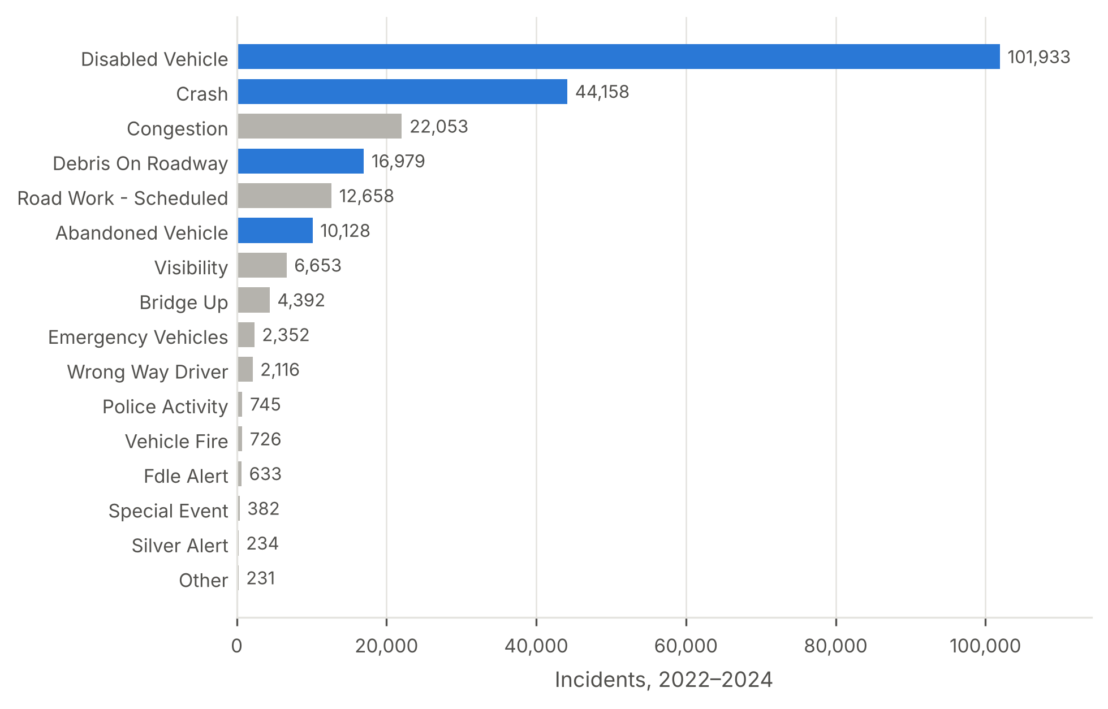
Figure S1. Number of events by event type, FDOT District 2, 2022–2024. Highlighted bars indicate the four incident types analysed.
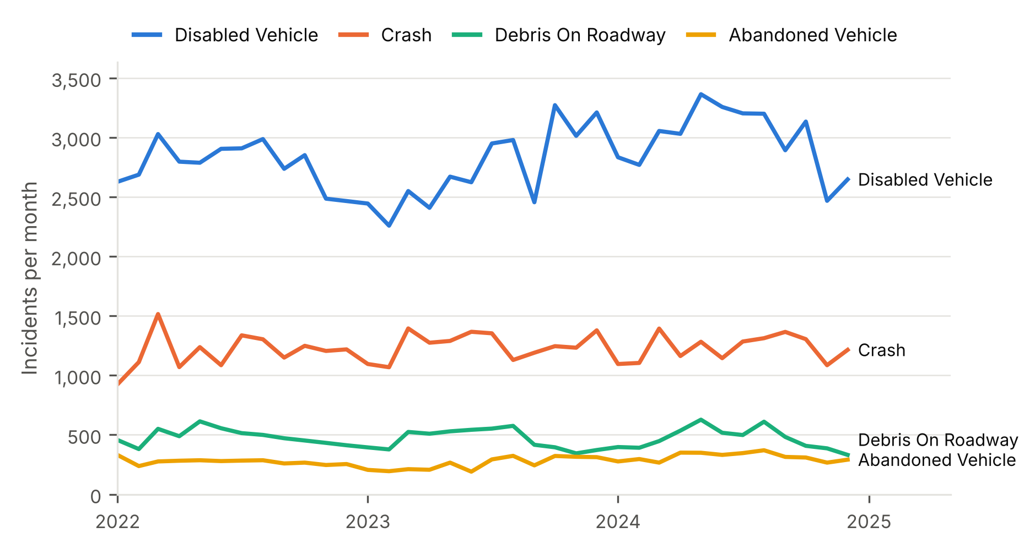
Figure S2. Monthly number of incidents by type, January 2022–December 2024.
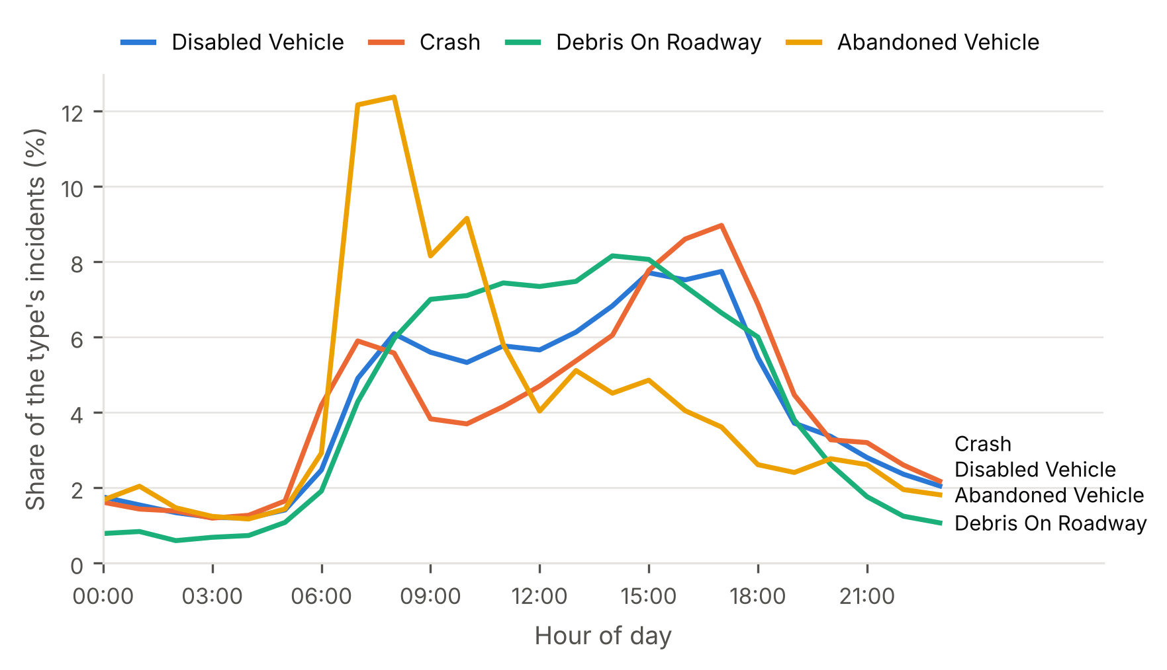
Figure S3. Distribution of incidents by hour of day within each incident type, 2022–2024 (percentage of each type’s total).
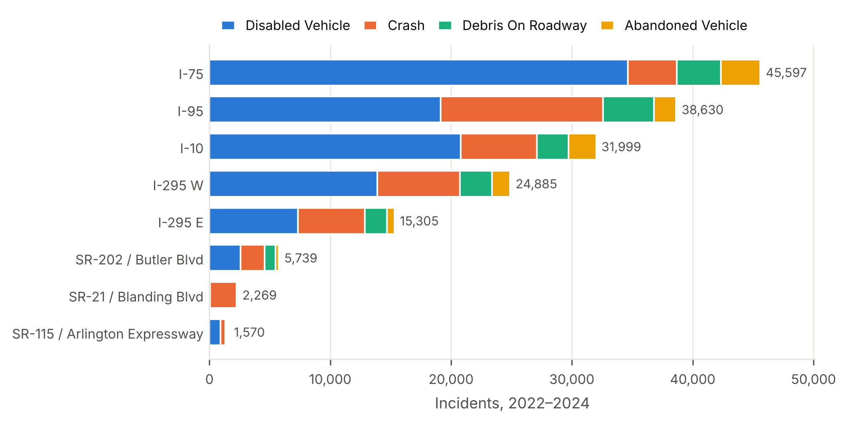
Figure S4. Number of incidents by route and incident type for the eight routes with the most incidents, 2022–2024.
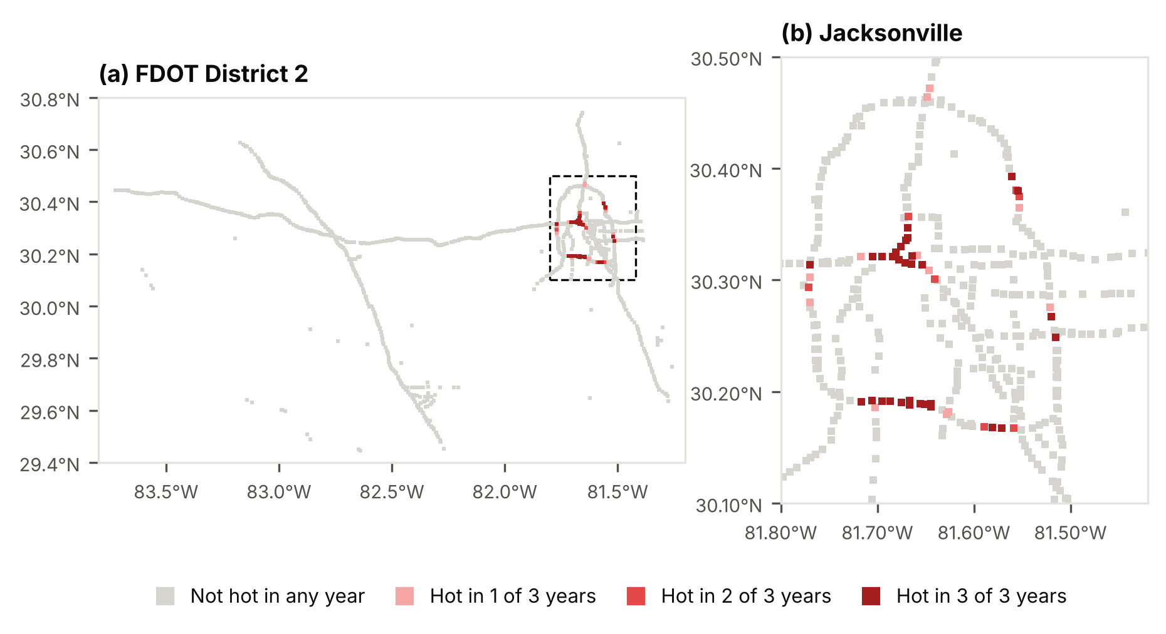
Figure S5. Persistence of incident hotspots: number of years (2022, 2023 and 2024) in which each cell was a Gi* hot spot (q < 0.05) in the annual analyses.
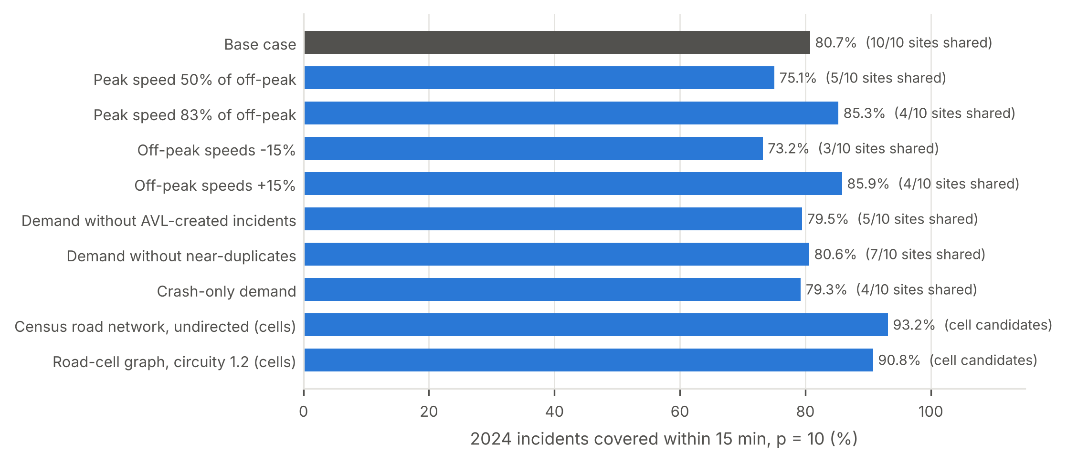
Figure S6. Sensitivity of the recommended layout (10 stations, 15-min standard) to travel speeds, demand definitions and travel-time models: share of 2024 incidents reached within 15 min and number of sites shared with the base case. The cell-based travel-time models use road cells as candidate sites, so shared sites are not reported for them.
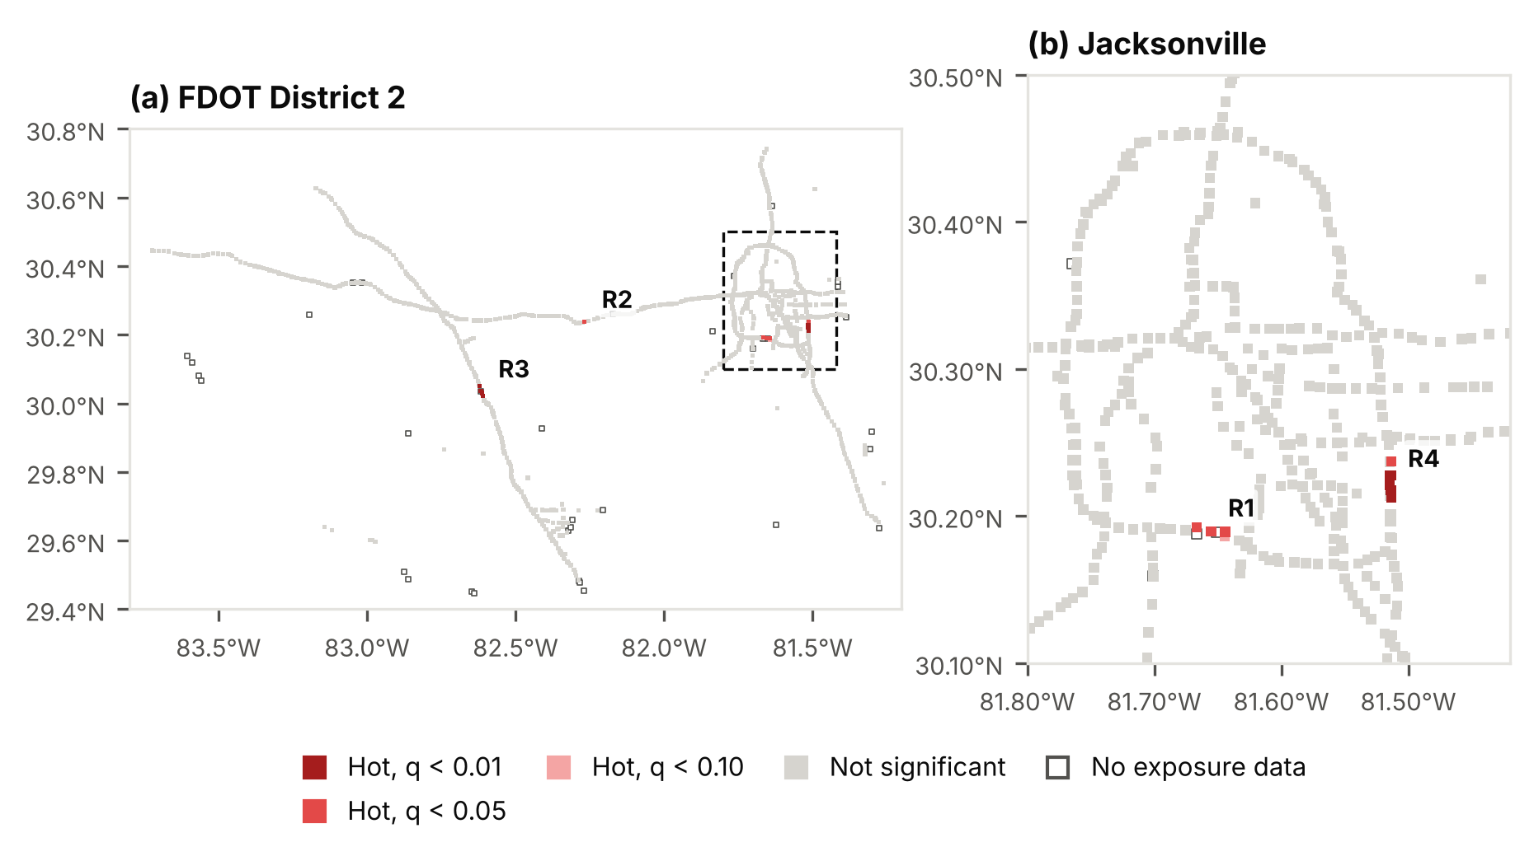
Figure S7. Hotspots of incident rates per million vehicle-kilometres (empirical Bayes-smoothed) identified with the Getis-Ord Gi* statistic, 2022–2024: (a) FDOT District 2; (b) Jacksonville. Labels R1–R4 mark rate hotspot clusters (Table S2); open squares mark cells without traffic-volume data.
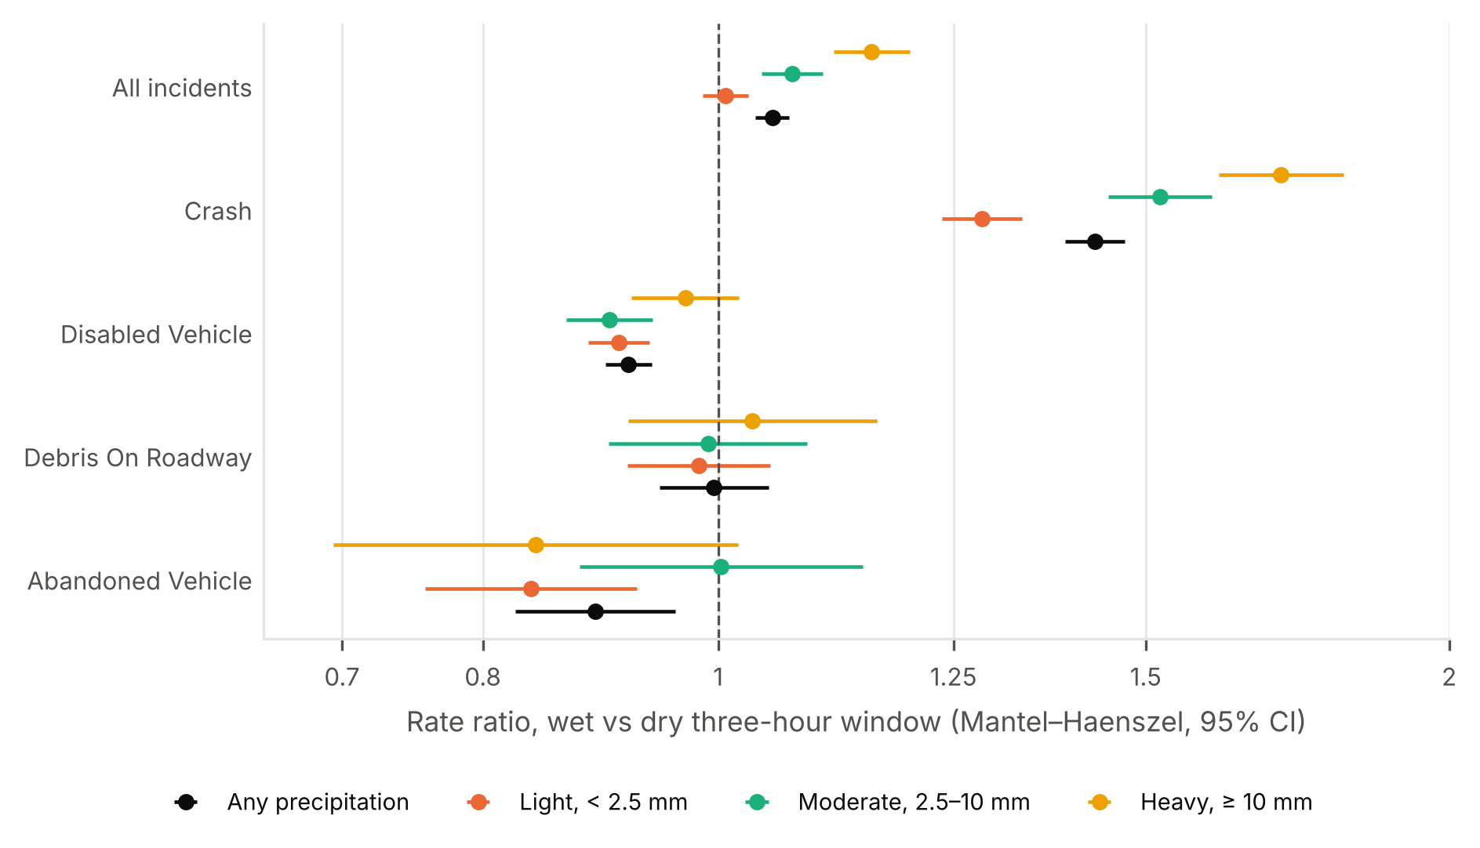
Figure S8. Incident rate ratios for three-hour windows with and without precipitation, by incident type and precipitation total (light, < 2.5 mm; moderate, 2.5–10 mm; heavy, ≥ 10 mm). Mantel–Haenszel estimates stratified by window of day, month and day type, with 95% confidence intervals, on a logarithmic scale.
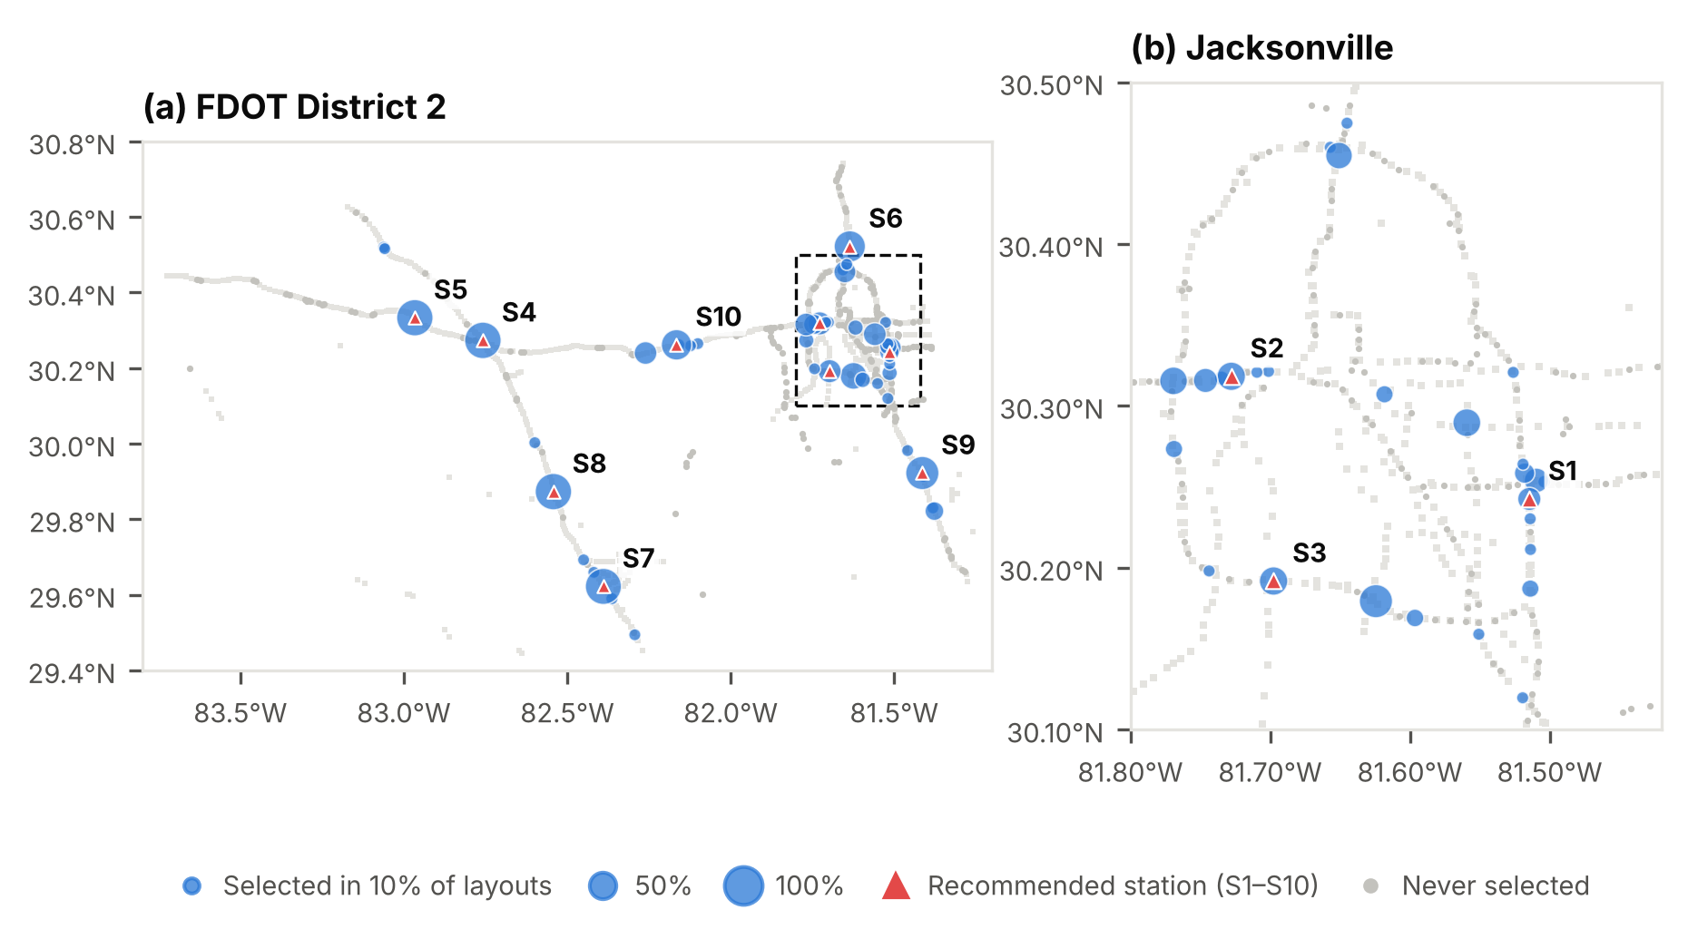
Figure S9. Selection frequency of candidate sites across 209 re-solved layouts (10 stations, 15-min standard): 200 bootstrap samples of 2022–2023 days, each year alone, and seven speed and demand scenarios: (a) FDOT District 2; (b) Jacksonville. Triangles mark the recommended sites S1–S10.
Table S1. Completeness and variability of recorded incident attributes (n = 173,198). AVL = automatic vehicle location.
Indicator | Share of incidents (%)
Severity recorded as “minor” | 99.9
Road surface “Dry” | 98.8
Weather “Clear” | 98.3
Weather “Clear” in three-hour windows with NOAA-recorded precipitation (n = 17,323) | 94.9
Lighting code 16 (code meaning undocumented) | 91.7
Mile marker missing | 53.0
Created via the AVL subsystem (avlrrsubsystem account) | 49.8
Duration > 24 h (flagged) | 2.3
Duration < 1 min (flagged) | 0.7
Dark at time of incident (solar elevation below −6°) | 21.7
Near-duplicate (same route and direction, ≤ 0.5 km, ≤ 15 min) | 1.8

Table S2. Rate hotspot clusters (contiguous Gi* hot cells, q < 0.05, based on empirical Bayes-smoothed incidents per million vehicle-kilometres), 2022–2024. Rates are cluster totals; the analysis covers the 944 cells with traffic-volume data.
ID | Hotspot location | Routes | Cells | Incidents per year | Million vehicle-km per year | Incidents per million vehicle-km | Crash share (%) | Maximum Gi* z-score | Overlaps a count hotspot
R1 | I-295 W at Buckman Bridge (Duval County) | I-295 W | 3 | 649 | 103.4 | 6.28 | 10.4 | 3.81 | Yes
R2 | I-10 at ramp from CR-229 (Baker County, MM 326) | I-10 | 1 | 59 | 10.0 | 5.94 | 10.1 | 3.62 | No
R3 | I-75 (Columbia County, MM 417) | I-75 | 5 | 511 | 89.1 | 5.73 | 7.6 | 10.45 | No
R4 | I-295 E at Baymeadows Rd (Duval County, MM 57) | 295 East Express, I-295 E | 6 | 356 | 170.1 | 2.09 | 27.1 | 5.35 | No

Table S3. Contribution of traffic-volume and precipitation inputs to LightGBM day-ahead forecasts on the 2024 test year (means ± standard deviations over five seeds). Differences are day-level bootstrap estimates (2,000 resamples) relative to the day-ahead model. PAI = predictive accuracy index.
LightGBM inputs | Seeds | Poisson deviance (×10⁻²) | Hit rate, top 5% of cells (%) | PAI | Deviance difference vs day-ahead model (×10⁻², 95% CI)
Base inputs only (no AADT, no precipitation) | 5 | 13.256 ± 0.011 | 23.59 | 4.64 | -0.011 (-0.012 to -0.009)
Base inputs + AADT exposure | 5 | 13.264 ± 0.013 | 23.58 | 4.64 | -0.002 (-0.003 to -0.001)
Base inputs + AADT exposure + previous-day precipitation (day-ahead model) | 5 | 13.266 ± 0.006 | 23.59 | 4.64 | —
As above + observed precipitation in the target window (perfect-forecast bound) | 5 | 13.253 ± 0.007 | 23.63 | 4.65 | -0.014 (-0.016 to -0.012)
Table S4. Temporal validation of fixed station layouts (10 stations, 15-min standard): sites selected on one period and evaluated on the following year, compared with the layout optimised on the evaluation year itself.
Sites selected on | Evaluated on | Covered ≤ 15 min (%) | Layout optimised on the evaluation year (%) | Sites shared with that layout | Sites shared with the recommended layout
2022 | 2023 | 81.4 | 81.3 | 5 of 10 | 10 of 10
2023 | 2024 | 80.5 | 80.6 | 6 of 10 | 5 of 10
2022–2023 | 2024 | 80.7 | 80.6 | 7 of 10 | 10 of 10
Table S5. Selection frequency of the recommended station sites across re-solved layouts: share of layouts selecting each site, or any candidate site within 5 km of it. Demand resamples are 200 bootstrap samples of 2022–2023 days; all layouts add 2022 and 2023 alone and seven speed and demand scenarios (209 layouts).
ID | Station site | Selected, demand resamples (%) | Site within 5 km selected, demand resamples (%) | Selected, all re-solved layouts (%) | Site within 5 km selected, all layouts (%)
S1 | I-295 Exit 54, Duval County | 20.5 | 58.5 | 20.1 | 59.3
S2 | I-10 Exit 358, Duval County | 34.0 | 91.5 | 33.5 | 91.9
S3 | I-295 Exit 10, Duval County | 33.0 | 33.0 | 33.5 | 34.0
S4 | I-75 Exit 435, Columbia County | 100.0 | 100.0 | 100.0 | 100.0
S5 | I-10 Exit 283, Suwannee County | 100.0 | 100.0 | 99.0 | 99.0
S6 | I-95 Exit 366, Duval County | 71.0 | 71.0 | 70.3 | 70.3
S7 | I-75 Exit 384, Alachua County | 100.0 | 100.0 | 97.6 | 99.0
S8 | I-75 Exit 404, Alachua County | 100.0 | 100.0 | 99.5 | 99.5
S9 | I-95 Exit 318, St. Johns County | 82.5 | 82.5 | 80.9 | 81.3
S10 | I-10 Exit 333, Baker County | 67.5 | 68.5 | 66.0 | 67.9
Table S6. Coverage of 2024 incidents within 15 min under alternative travel speeds: the recommended layout compared with the layout optimised for each scenario. Negative differences arise because layouts are optimised at road-link midpoints but evaluated at exact incident locations.
Travel-speed scenario | Recommended layout, covered ≤ 15 min (%) | Layout optimised for the scenario (%) | Difference (percentage points) | Sites shared
Base case | 80.7 | 80.7 | 0.0 | 10 of 10
Peak speed 50% of off-peak | 74.5 | 75.1 | 0.5 | 5 of 10
Peak speed 83% of off-peak | 84.8 | 85.3 | 0.4 | 4 of 10
Off-peak speeds −15% | 72.7 | 73.2 | 0.6 | 3 of 10
Off-peak speeds +15% | 86.5 | 85.9 | -0.6 | 4 of 10
Table S7. Hyperparameter tuning of the deep learning models on the validation period (1 October–31 December 2023), with one seed per configuration, at most 30 epochs and early stopping (patience 3). Bold values are the lowest validation deviance for each model; differences below 0.1% were treated as ties and the smaller configuration was retained.
Model | Hidden size | Learning rate | Validation deviance (×10⁻²) | Epochs to best | Parameters
LSTM (no graph) | 32 | 0.001 | 13.6037 | 8 | 40,609
LSTM (no graph) | 64 | 0.001 | 13.6060 | 10 | 87,297
LSTM (no graph) | 32 | 0.0003 | 13.6484 | 1 | 40,609
LSTM (no graph) | 64 | 0.0003 | 13.6571 | 4 | 87,297
Graph WaveNet | 32 | 0.001 | 13.6014 | 8 | 61,645
Graph WaveNet | 64 | 0.001 | 13.6009 | 8 | 175,245
Graph WaveNet | 32 | 0.0003 | 13.6256 | 12 | 61,645
Graph WaveNet | 64 | 0.0003 | 13.6333 | 4 | 175,245
ST-Transformer | 32 | 0.001 | 13.6056 | 8 | 53,409
ST-Transformer | 64 | 0.001 | 13.6125 | 8 | 137,473
ST-Transformer | 32 | 0.0003 | 13.6374 | 4 | 53,409
ST-Transformer | 64 | 0.0003 | 13.6357 | 1 | 137,473

