# Howto

## Version

Version 02.78 of the “HDS_Performance_Analyse_Tool.exe”

## Classification

HDS Internal Only

## Release Notes

01.14 error converting uc to ms.  
01.14 DF storage shows response time on LU view  
01.15 block size name corrected  
01.18 df - hdd operation rate and hdd tag count added  
01.19 df – while creating the csv files if you changed focus the application did not update the files processed and the application seemed to hang.  
01.20 if a performance file does not exist the graph is skipped and no error occur.  
01.22 if hsd is spread over two performance blockst he summry was wrongly calculated (thanks wolfgang)  
01.24 sometimes the lu calculation crashed (thanks Wolfgang)  
01.26 lu server response time summary was wrongly calculated  
01.30 report window introduced  
01.31 the hsd level in the LU section it should show the cumulated iops(stacked read write), transfers (stacked read write), hit rate (fastline read write). This is useful if you use the sizing tool CPK_VSP  
01.31 last chosen path is now saved in the configuration file  
01.32 LU Port view shows all hsd as fastline (iops and transfer)  
01.33 error in change of stacked view to line view solved  
01.34 error in data gathering solved  
01.35 LU hsd view level 2 crash; LU hsd view level 2 negative values (thanks Wolfgang)  
01.36 MPPK data chart did not work if you used a time range  
01.37 scalability option is switched off for mppk data and treeview level 2  
01.38 port transfer level 0 und 1 did not work correctly  
01.38 a click on the legend series removes the series  
01.40 port response time level 1 showed wrong values (thanks billy)  
01.42 in the series name the average value is not shown if it is 0  
01.42 checkboxes in section LU at level 2 (hsd) added.  
01.42 31.05.2013 bug 0000, level 3 lu transfer showed wrong values.  
01.45 in the lu section you can now select some luns of a server and click on the servername to just view these luns. No stacked view available for this selection.  
01.45 the legend can be hidden if the label checkbox is unchecked  
01.46 hus-vm processor data was not shown after unzipping the data  
01.47 hus-vm backend data can be displayed  
01.48 menu introduced. labels, background color and the max value are now in the menu.  
01.49 the "save configuration" option can be found in the menu under „settings“. This option can be selected if you wish to save your configuration for the next time.  
01.50 the max value of a chart series is shown in the legend name.  
01.51 adjusted the clipboard frame that it looks nicer (thanks to rdu)  
01.52 checkboxes added for the pg, mp, cache, port sections. Now you can select only the elements you wish in one graph  
01.54 the “clear all checkboxes” option is added to deselect all checkboxes  
01.55 the HUR response time was falsely divided by 1000.  
01.58 regional settings problem with other languages solved.  
01.59 "cache usage" and "cache allocate" added.  
01.60 lu c2d and d2c added.  
01.61 series name changed that lu d2c has a more self-explaining name.  
02.00 most vsp graphs changed to use the new data gathering engine.  
02.02 lu response time on port level (level 1) added.  
02.03 lu bocksize added at hsd level (thanks to Andrej).  
02.09: ldeveachofcu populate treeview did not show the LDEV section  
02.10 “kb” changed to “kB” on the blocksize chart (thanks to Wolfgang)  
02.11 Remote IO changed from IO/min to a more common unit -> value[IO] / interval[min] * 60[s] (thanks to sven).  
02.12 you can modify by chart (right click) the label on/off and the max value of the y-axis (thanks to Sam).  
02.13 context menu (right click) supports to change (toggle) from fast line graphs to stacked area graphs (thanks to Sam).  
02.15 hus-vm populate treeview problem fixed(thanks to steve).  
02.16 if there are fixed max y-axis values these will be set automatically (thanks to wolfgang)  
02.18 mppk data added  
02.19 mppk procedure implemented. top 20 ldevs cpu und cpu by type  
02.20 initiator ports values (iops, transfer, response) added. the remote transfer view had KB/s units. changed it to MB/s and removed the KB/s in the series naming  
02.21 mppk type data changed -> thanks to Wolfgang  
02.24 read/write ratio auf hsd level eingeführt -> thanks to Haresh  
02.25 LU section \ read/write ratio added on lun level  
02.26 fix port checkbox problem -> thanks to wolfgang hahn  
02.28 added checkboxes for the backend data on VSP and HUS-VM-> thaks to Joerg Backschues  
02.29 "Backend" changed to "Path". thanks to Wolfgang  
02.31 started raidcom parse get ldevlist def  
02.32 problem bug 0001 horst stoeckl fixed. Extraction of midrange performance files failed.  
02.33 midrange performance export \ works also if only the unzipped folder is existent.  
02.34 midrange storage \ top 20 lu \ iops, transfer and lun tag count  
02.35 DF \ added the response time files (total, read, write)  
02.36 collect data progress bar improved  
02.37 Top x graphs in section LDEV (level 0). iops, seq read iops, rand read iops, seq write iops, rand write iops, transfer, read transfer, write transfer  
02.40 port initiator ports, open ports added for vsp, usp-v  
02.41 bug in calculation the hit ratio and lun response time on hsd level. thanks to wolfgang.  
02.42 VSP G1000 support  
02.43 bug 0003 mppk data "-1" error fixed  
02.44 bug. if the pfm file was skipped then the program crashed. now it just skips the files.  
02.45 backcolor now really white, clipboard adjustments (dani ruch)  
02.46 bug. raidcom data read buggy. Switched it off.  
02.47 hm800 populate treeview ok, treeview level 0 display data ok  
02.48 hm800 treeview level 1 and 2 ok  
02.49 treeview level 3 ok  
02.50 Gx00 Support ok. MPPK is missing as i have no performance data with mppk  
02.51 Gx00 and G1000 - treeview level 3 responsetime added (mark butterworth)  
02.52 ALL - HSD display bug that some hsd's were shown in separate hsd's (mark butterworth)  
02.53 G1000, VSP - cache treeview level 1 checkbox subselect bug (mark butterworth)  
02.54 create missing data elements with value 0  
02.55 performance export format to identify storage system has changed (VSP G800 -> VSP G800 and VSP F800) (Richard Thalhammer)  
02.56 change to support old and new style of storage identifier (Joerg Backschues)  
02.57 bug – storage identifier falsely set for VSP G1000(Mark Butterworth)  
02.58 G800 support with more than 4 cores per CPU(Mark Butterworth)  
02.59 Graph enhancement – Errors in Graph are not shown (Long Nguyen)  
02.60 Gx00 - Cache Allocation, Cache Used Chart wrong (Mark Butterworth)  
02.62 Fixed New G100 Storage Type Name from "VSP G100" to "VSP G100/G200" (NAKADE，KAZUHIRO)  
02.63 General support for F370 and F700 (Likas Belovsky)  
02.64 Support for F370 and F700 – Support for more Processor Cores (Likas Belovsky)  
02.65 Support for G/F900 (Mark Butterworth and Erol Fazlaoglu)  
02.66 Bug fixed with MPB naming (Mark Butterworth)  
02.67 Support for G/F350 (Mark Butterworth)  
02.68 Support for G130 (Alan Hopla)  
02.69 Support for VSP 5000  
02.70 Bug fixed LDEV section not show with VSP5x00 (Simon Leibundgut)  
02.71 Support for Backend HIE data on the VSP5x00 (Simon Leibundgut)  
02.72 Datepicker was chosen wrongly because data in file was wrong (Eduardo Furtado)  
02.73 MF Ports added (Juergen Steiger)  
02.74 additional MF Port charts (Juergen Steiger)  
02.75 all MF Port Data added, changed order of charts (Juergen Steiger)  
02.76 fixed some typos - added MF OpenExchanges and MF Port Blocksize (Matthias Lechner) – fixed LU Transfer and LU Response not shown for VSP5x00 (Carlos Mazaro)  
02.77 Support for E990 (Leandro Gomez Chavarria)  
02.78 Support for new export tool output format VSP 5x000 (Carlos Mazaro)  
02.79 Support for Ex90 with SVP Perf Export /not Monitor2 (Petr Prerost)

## Supportmatrix PC

Any Windows PC that has Dot Net version 4 installed.

## Supported Storage systems

### AMS

Supported. you need the pfm files (concatenation is not supported). It creates csv files similar to the high end performance output. These files have to be created before the analyse

auperform -unit AMS -auto 1 -pfmstatis -count 1440

Data that can be analyzed if data available:

* Cache
* Drive Operate
* LU
* Port
* Processor

### HUS

Supported. Supported. you need the pfm files (concatenation is not supported). It creates csv files similar to the high end performance output. These files have to be created before the analyse

auperform -unit HUS -auto 1 -pfmstatis -count 1440

Data that can be analyzed if data available:

* Cache
* Drive Operate
* LU
* Port
* Processor

### USP

Partially supported. I do no testing anymore. Stays as is but if you succeed in corrupt me then …

Data that can be analyzed if data available:

* Cache
* LDEV
* LU
* Parity Group
* Port
* True Copy

### USP-V / USP-VM

Supported.

Data that can be analyzed if data available:

* Cache
* LDEV
* LU
* Parity Group
* Port
* Processor
* True Copy

### VSP

Supported

Data that can be analyzed if data available:

* Cache
* ESW
* HUR
* LDEV
* LU
* Parity Group
* Port
* Processor
* True Copy

A best practice command.txt to use could look like

svpip 10.00.00.00

login export "password"

show

group PhyPG

group PhyLDEV

group PhyProc

group PhyExG

group PhyExLDEV

group PhyESW

group PhyMPPK

group PG

group Port

group PortWWN

group LU

;group LDEV

group PPCGWWN

group RemoteCopy

group UniversalReplicator

group URJNL

group RCLU

group RCLDEV

group LDEVEachOfCU

shortrange -2400:

outpath "output"

option compress

apply

### HM700 (HUS-VM)

Supported

Data that can be analyzed if data available:

* Backend
* Cache
* LDEV
* LU
* Parity Group
* Port
* Processor
* True Copy

A best practice command.txt to use could look like

svpip 10.00.00.00

login export "password"

show

group PhyPG

group PhyLDEV

group PhyProc

group PhyExG

group PhyExLDEV

group PhyESW

group PhyMPPK

group PG

group Port

group PortWWN

group LU

;group LDEV

group PPCGWWN

group RemoteCopy

group UniversalReplicator

group URJNL

group RCLU

group RCLDEV

group LDEVEachOfCU

shortrange -2400:

outpath "output"

option compress

apply

### VSP G-1000

Supported

Data that can be analyzed if data available:

* Cache
* CMPK
* HUR
* LDEV
* LU
* Parity Group
* Port
* Processor
* True Copy

A best practice command.txt to use could look like

svpip 10.00.00.00

login export "password"

show

group PhyPG

group PhyLDEV

group PhyProc

group PhyExG

group PhyExLDEV

group PhyCMPK

group PhyMPPK

group PG

group Port

goup MFPort

group PortWWN

group LU

;group LDEV

group PPCGWWN

group RemoteCopy

group UniversalReplicator

group URJNL

group RCLU

group RCLDEV

group LDEVEachOfCU

shortrange -2400:

outpath "output"

option compress

apply

### VSP Gx00 (G/F200, G/F400, G/F600, G/F800)

Supported

Data that can be analyzed if data available:

* Cache
* LDEV
* LU
* Parity Group
* Port
* Processor
* True Copy
* HUR

A best practice command.txt to use could look like

ip 10.0.0.0 ; Specifies IP address of SVP <===== Change to IP Address of SVP

dkcsn 420101 ; Specifies Serial Number of DKC <===== Change to Serial Number of DKC

login maintenance "raid-maintenance" ; Logs user into DKC <===== Change to predefined Userid/password for exclusive use by export tool

show ; Outputs storing period & gethering interval to standard output

; +---------------------------------------------------------------------------------------------------+

; | Group commands define the data to be exported.

; +---------------------------------------------------------------------------------------------------+

group PhyPG ; Parity Groups

group PhyLDEV ; Logical Volumes

group PhyProc ; Micro-Processor usage

group PhyExG ; External Volume Group usage

group PhyExLDEV ; External Volume usage

group PhyMPU ; Access Paths and Write Pending

; +---------------------------------------------------------------------------------------------------+

group PG ; Parity Group Statistics

;group LDEV ; LDEV usage in PGs, External Volume Groups or V-VOL Groups

; ; Not required when using LDEVEachOfCU

group Port ; Port usage

group PortWWN ; Stats for HBAs connected to ports.

group LU ; LDEV usage Summarised by LU Path

group PPCGWWN ; Stats about HBAs

group RemoteCopy ; Remote Copy Usage Summarized by Subsystem

group RCLU ; Remote Copy Usage Summarized by LU path

group RCLDEV ; Remote Copy Usage Summarized by LDEV

group UniversalReplicator ; Remote Copy Usage by UR Summarized by Subsystem

group URJNL ; Remote Copy Usage by UR Summarized by Journal Group

group URLU ; Remote Copy Usage by UR Summarized by LU Path

group URLDEV ; Remote Copy Usage by UR Summarized by LDEV

group LDEVEachOfCU ; LDEV usage in CUs - Recommended

; +---------------------------------------------------------------------------------------------------+

; | end of group statements

; +---------------------------------------------------------------------------------------------------+

; +---------------------------------------------------------------------------------------------------+

; | To limit the data collection within a date/time range, use the following sub-commands:-

; | range start_timestamp:end_timestamp

; | Where start_timestamp and end_timestamp are in the format:- yyyyMMddHHmm

; | For example:-

; | yyyyMMddHHmm:yyyyMMddHHmm

; | range 200607101200:200607111159

; | The above example will collect range data between 12:00 on 10th July 2006

; | and 11:59 on 11th July 2006

; | NB - this is the time on the SVP - not on your server.

; | Example below says get the latest 24 hours

; | (hhmm format)

; | range -2400:

; +---------------------------------------------------------------------------------------------------+

range -2400:

; +---------------------------------------------------------------------------------------------------+

; | end of time statements

; +---------------------------------------------------------------------------------------------------+

## outpath out ; Specifies the sub-directory in which files will be saved

## option compress ; Specifies whether to compress files

## apply ; Executes processing for saving monitoring data in files

## The Menu options

### Save the configuration

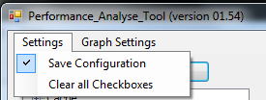

If you set the “Save Configuration” the a file will be saves in the same folder as the Performance Analyse Tool (PAT) was executed. Be sure that you have enough right to write into the folder otherwise disable this option.

### Clear all Checkboxes



The “Clear all Checkboxes” is used to deselect all Checkboxes.

### No background color

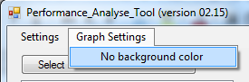

This option sets the background color of the surrounding of the graph to white if you print or printscreen. Click on this option to switch back to show the colors.

### Hide error numbers in graph

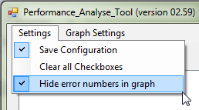

This option is used to hide the error values (minus values) in the performance export data series name

### Top X value

This option sets globally the number of Top X elements should be set. The default is 20. This is used in the LU and the CPU section.

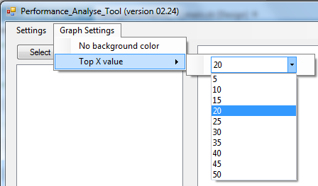

## Load performance data

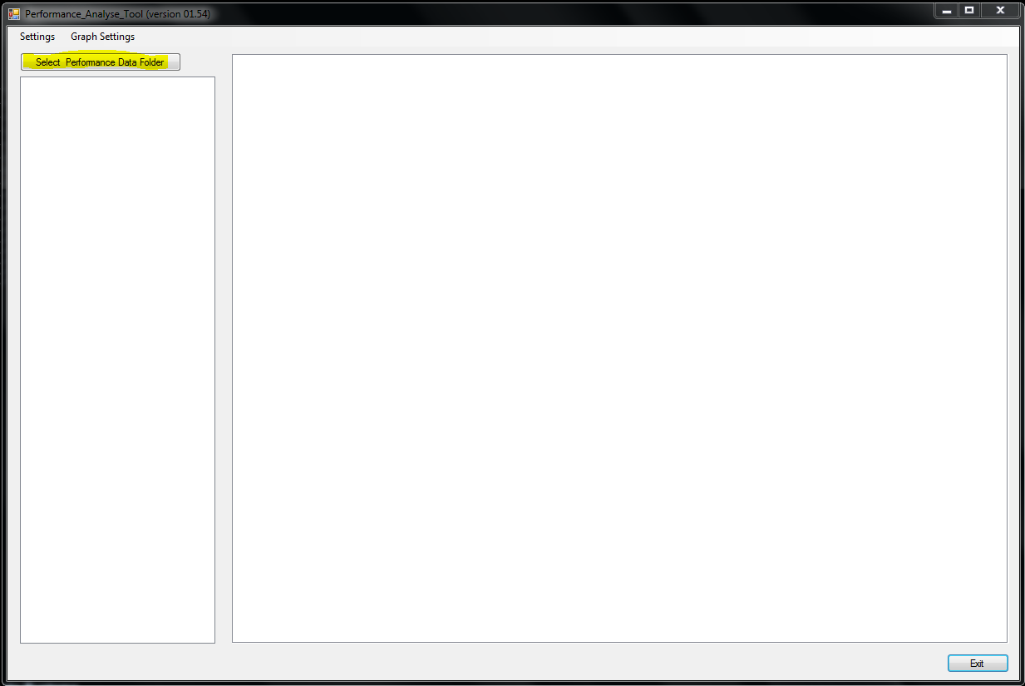

Press the „Select Performance Data Folder“

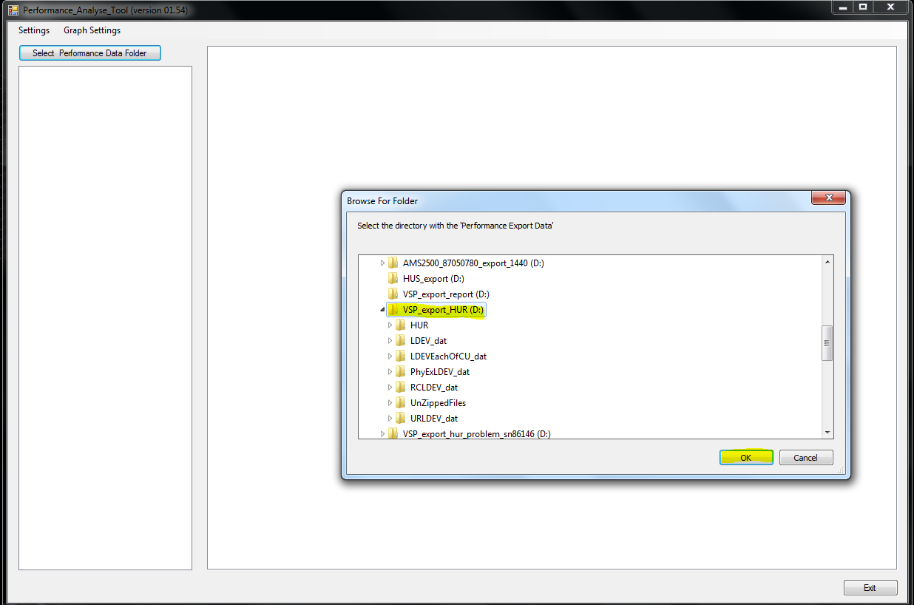

Select the folder containing the “ZIP” files.

Now the PAT starts to unzip the zip files.

## Work with the GUI

### Treeview

#### General

You have to click on the element itself to get a graph. So it depends on the level you click on in the treeview to get different graphs. The settings of the checkboxes only apply when you click on an element.

Some Treeview sections do not show any graphs and are just for separating the data. These are:

* ESW/Backend
* HUR
* LDEV
* LU
* True Copy

#### Checkboxes

For example if you click on “Cache” all Write Pending Rates of all MPs and Cache Partitions will be shown.

If you click on “1MA” the Write Pending Rates of MP “1MA” and all its Cache Partitions as shown.

If you select none or all checkboxes in the hierarchy below all graphs are shown the next time you click on the element.

If you check just some checkboxes the next time you click on “1MA” it only shows the CLPRs 00(CLPR0) and 02(CLPR2).

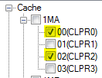

In the next example you see that this works over all hierarchies.

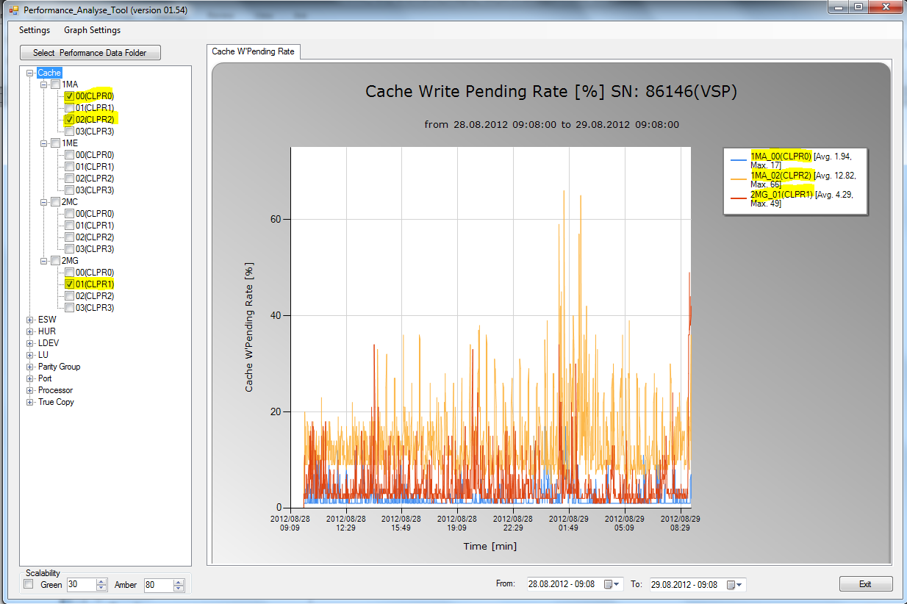

The checkbox in the higher hierarchy is to set all checkboxes in the hierarchy below or unset all.

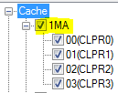

### Hide/Unhide Series

If you click on the series name in the legend you can hide or unhide a series.

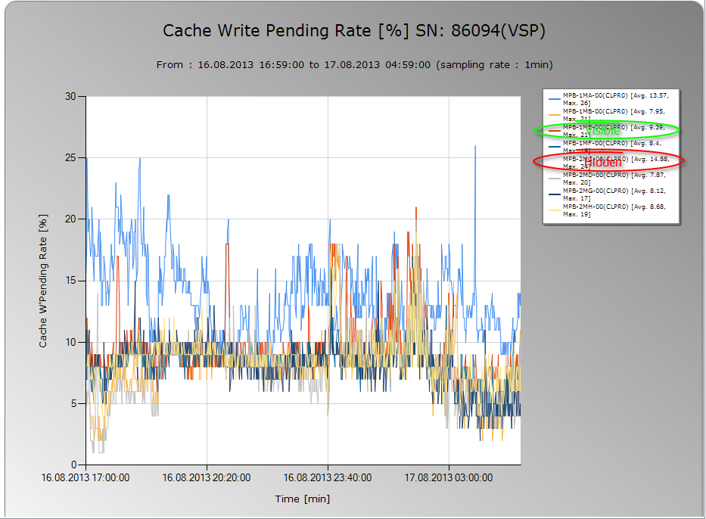

### Report Window

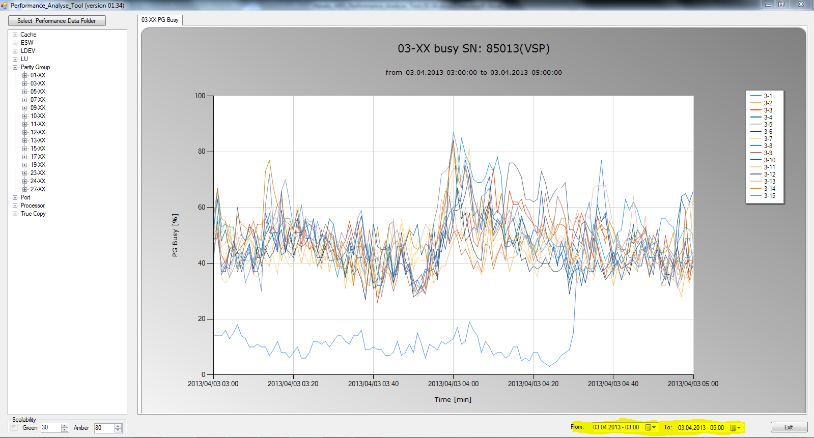

In the “Report Windows” date selector you can specify the date and time from where you want to start showing the date and to where. With this option you always have the same section. This setting can enormously improve the collection time and the creation time of the graph.

### Tabs

Some selections have several charts that are created in separated tabs.

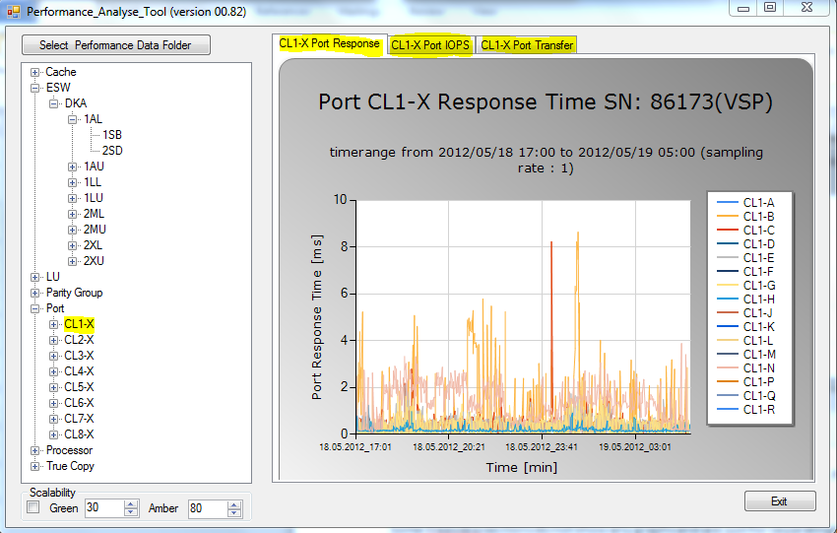

## Zooming chart

#### Zooming in

In the chart you can zoom an area you like by left click the mouse and select the area.

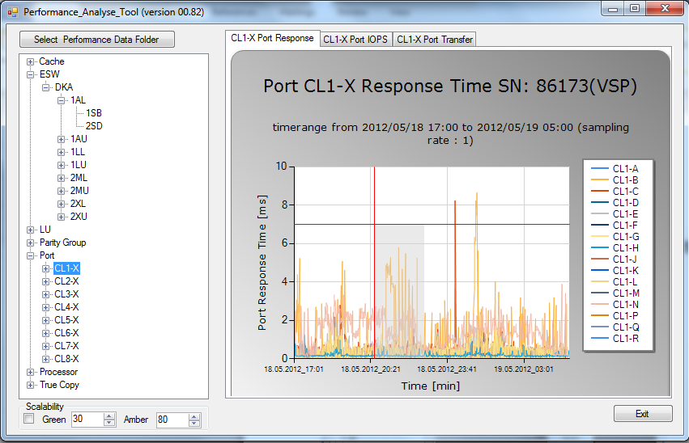

After that you get the zoom of the area selected before

### Zooming out

To zoom out you have to leftclick on the circle next to the axes.

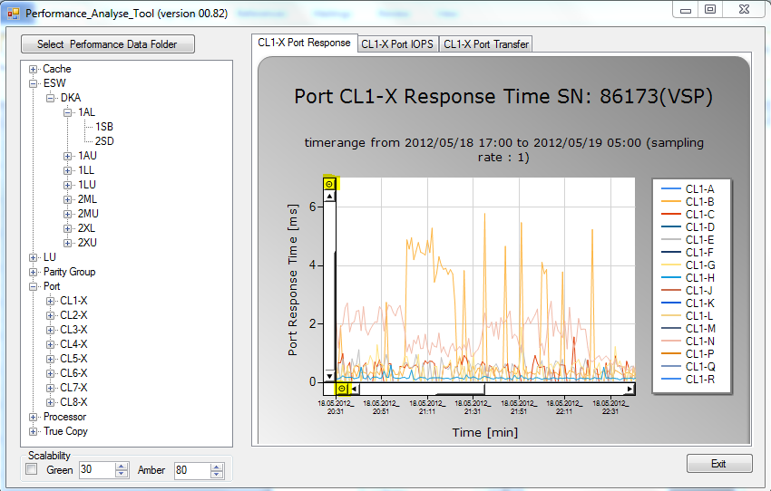

## Date Time Picker

With this Date Time Picker you can select what time frame you want to analyze. All graphs are shown in the same time frame.

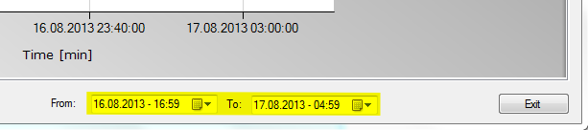

This selection does only apply for the following graphs.

## Legend

To switch off the Legend uncheck the legend checkbox

## Tooltip to show the data series name$

If you move over a datapoint in the graph a tooltip is shown with the name of the data series.

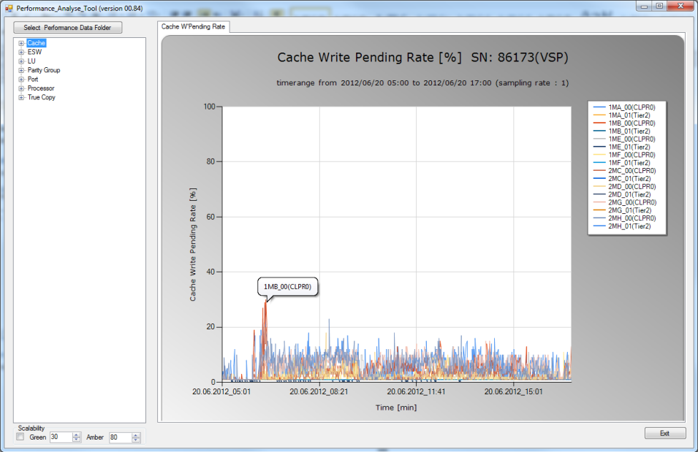

## Printing a chart

Right click on the chart.

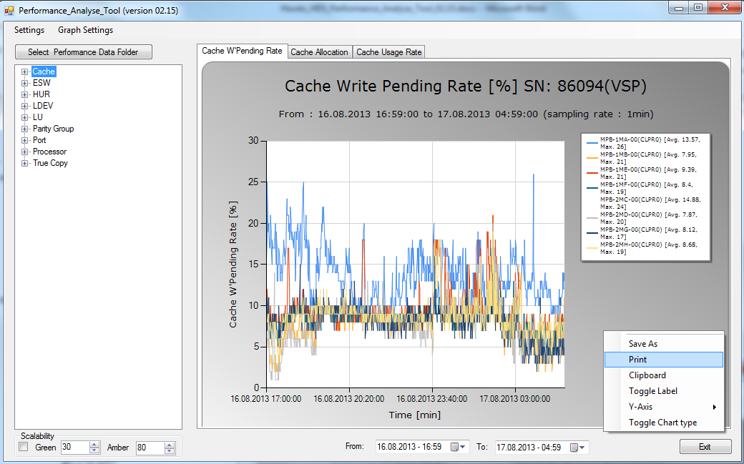

## Save a chart

Right click on the chart.

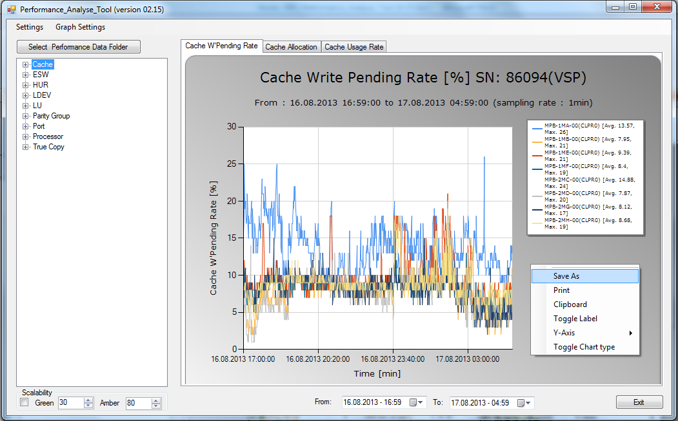

## Copy to Clipboard

Right click on the chart.

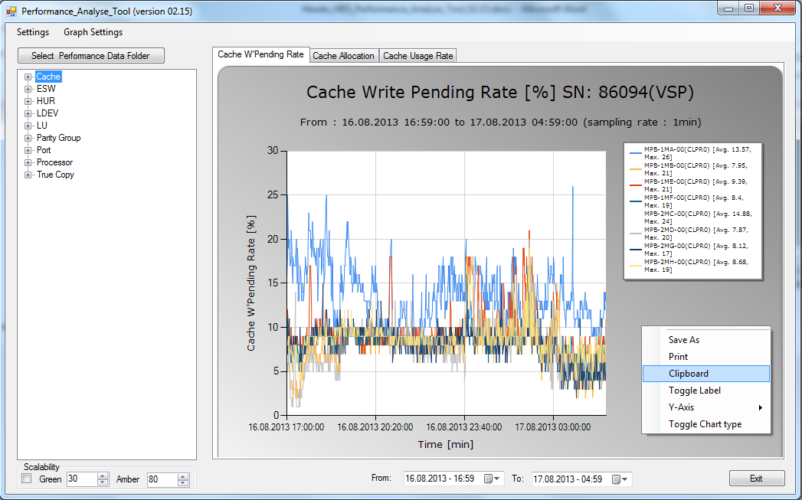

## Hide/Unhide Label

Right click on the chart.

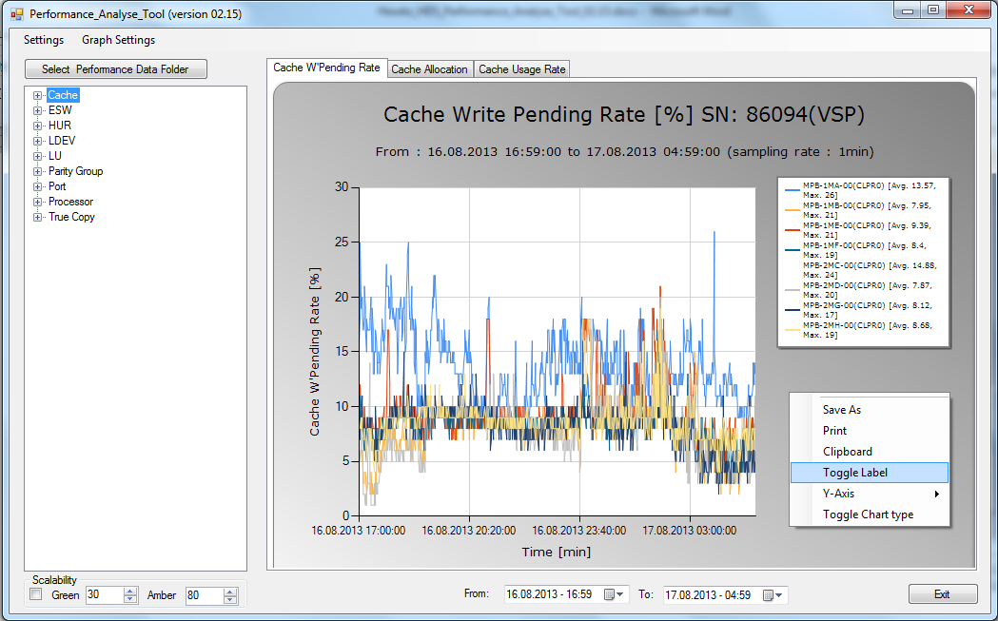

## Set max value for the Y-Axis

Right click on the chart. Then move the mouse pointer to the Y-Axis item. Then specify the max value for the Y-Axis and commit with the enter key. Then the graph immediately changes the Y-Axis.

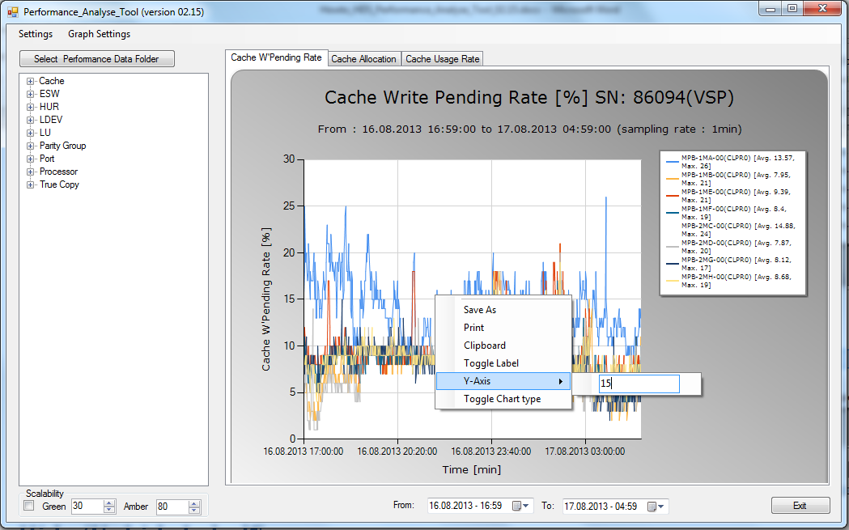

## Toggle the graph type between line or stacked area

Right click on the chart. By clicking on the “Toggle Chart type” the chart switches between fast line or stacked area graphs.

