# Howto

## Version

Version 00:95 of the “HDS_Performance_Analyse_Tool.exe”

## Release Notes

## Supportmatrix PC

Any Windows PC that has Dot Net version 4 installed.

## Supported Storage systems

### AMS

Supported. you need the pfm files (concatenation is not supported). It creates csv files similar to the high end performance output. These files have to be created before the analyse

### HUS

Supported. Supported. you need the pfm files (concatenation is not supported). It creates csv files similar to the high end performance output. These files have to be created before the analyse

### USP

Supported, but CHP busy does not work

### USP-V

Supported

### VSP

Supported

A best practice command.txt to use could look like

svpip 10.00.00.00

login export "password"

show

group PhyPG

group PhyLDEV

group PhyProc

group PhyExG

group PhyExLDEV

group PhyESW

group PhyMPPK

group PG

group Port

group PortWWN

group LU

group PPCGWWN

group RemoteCopy

group RCLU

group RCLDEV

group LDEVEachOfCU

shortrange -2400:

outpath "output"

option compress

apply

### HM700

Supported

A best practice command.txt to use could look like

svpip 10.00.00.00

login export "password"

show

group PhyPG

group PhyLDEV

group PhyProc

group PhyExG

group PhyExLDEV

group PhyESW

group PhyMPPK

group PG

group Port

group PortWWN

group LU

group PPCGWWN

group RemoteCopy

group RCLU

group RCLDEV

group LDEVEachOfCU

shortrange -2400:

outpath "output"

option compress

apply

## Load performance data

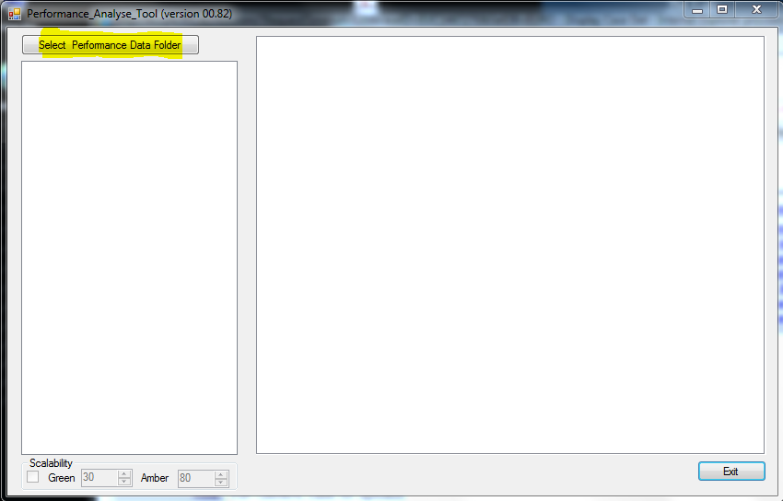

Press the „Select Performance Data Folder“

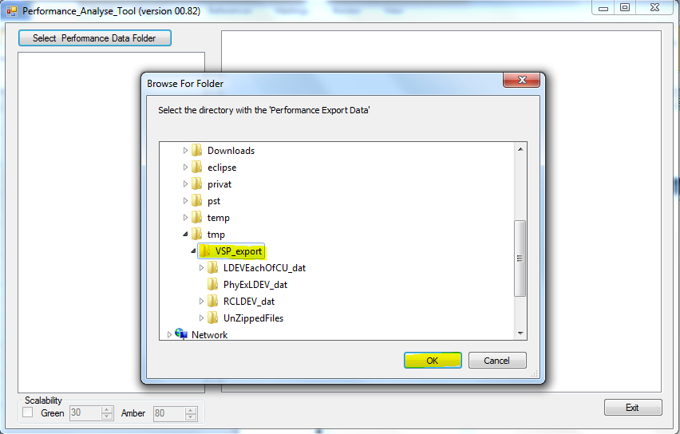

Select the folder containing the “ZIP” files.

## Work with the GUI

### Treeview

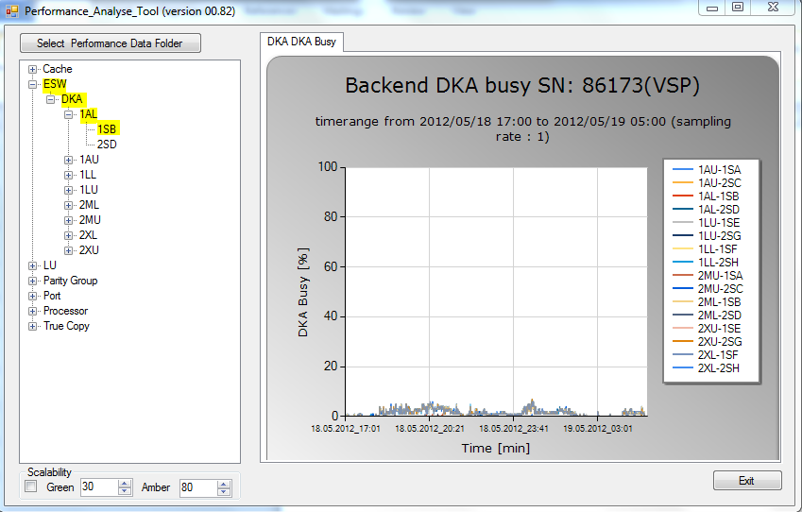

It depends on the level you click on in the treeview to get different graphs. The deeper the level the more detailed the graphs.

Some Treeview sections do not show any graphs and are just for separating the data. These are:

* ESW
* LU
* LU\CLx-y
* True Copy

### Tabs

Some selections have several charts that are created in separated tabs.

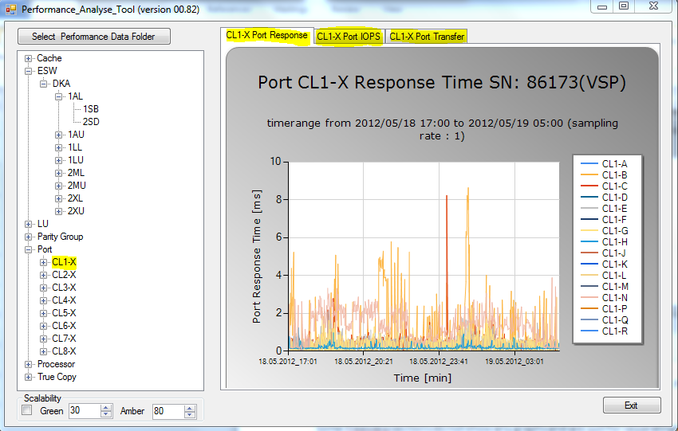

## Zooming chart

#### Zooming in

In the chart you can zoom an area you like by left click the mouse and select the area.

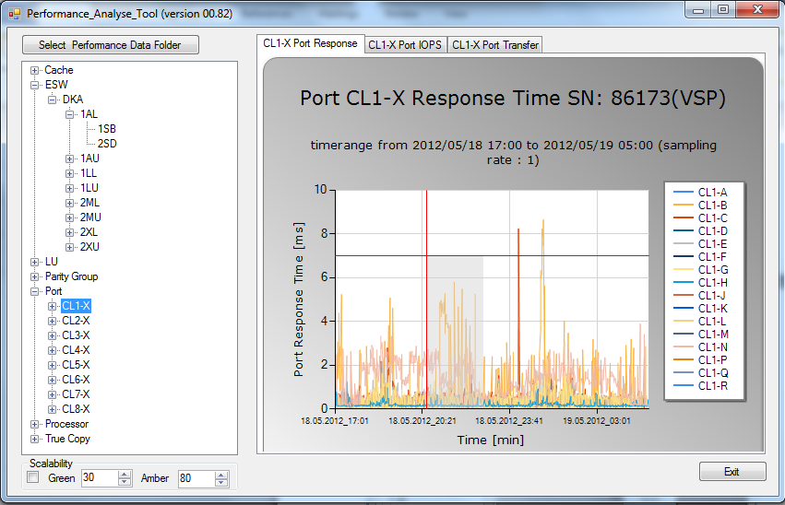

After that you get the zoom of the area selected before

### Zooming out

To zoom out you have to leftclick on the circle next to the axes.

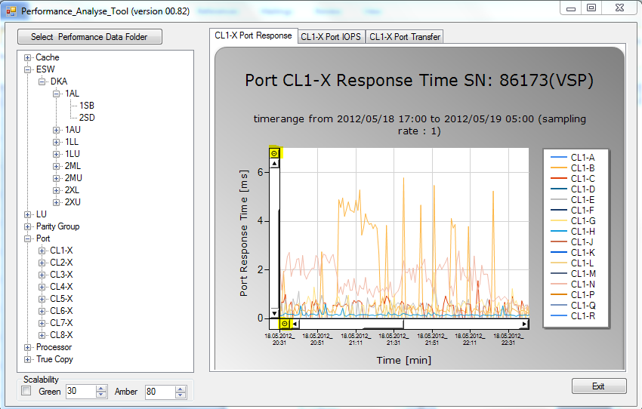

## Tooltip to show the data series name$

If you move over a datapoint in the graph a tooltip is shown with the name of the data series.

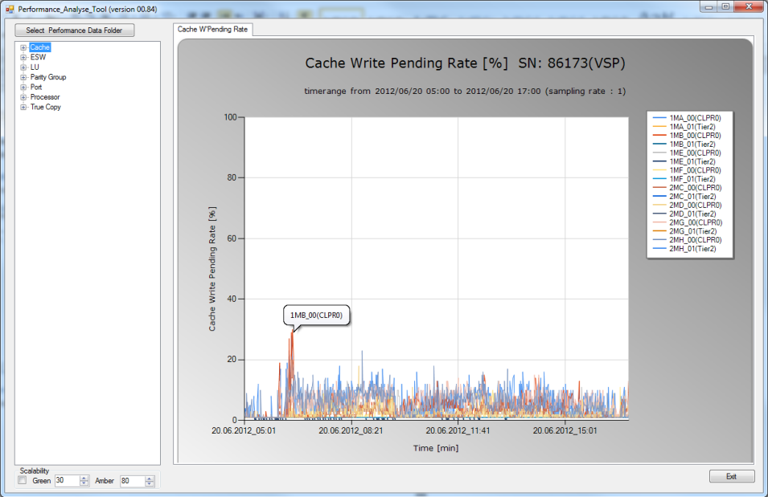

### Scalability

This option helps you to visualize what values are good (green) or ok (amber). You have to click the checkbox before you create the graph.

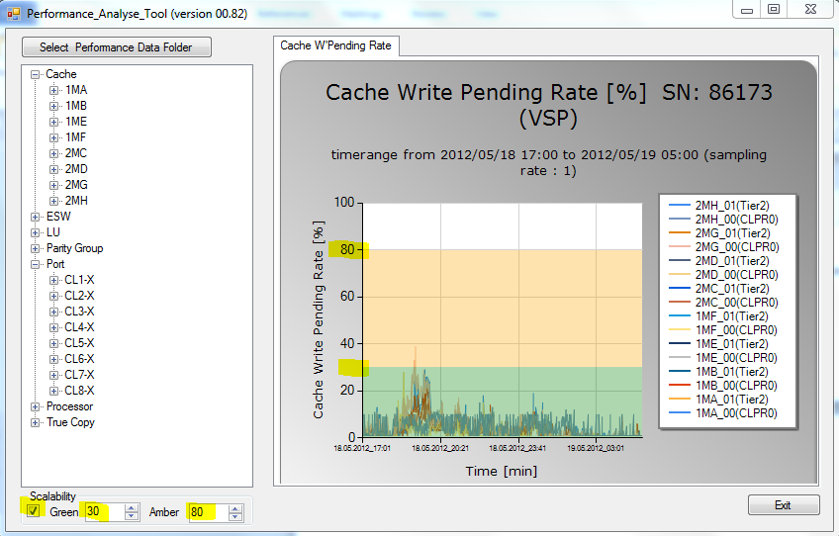

Unselect the checkbox to disable that feature. After unchecking the next graph does not show the scalability values

## Printing a chart

Right click on the chart.

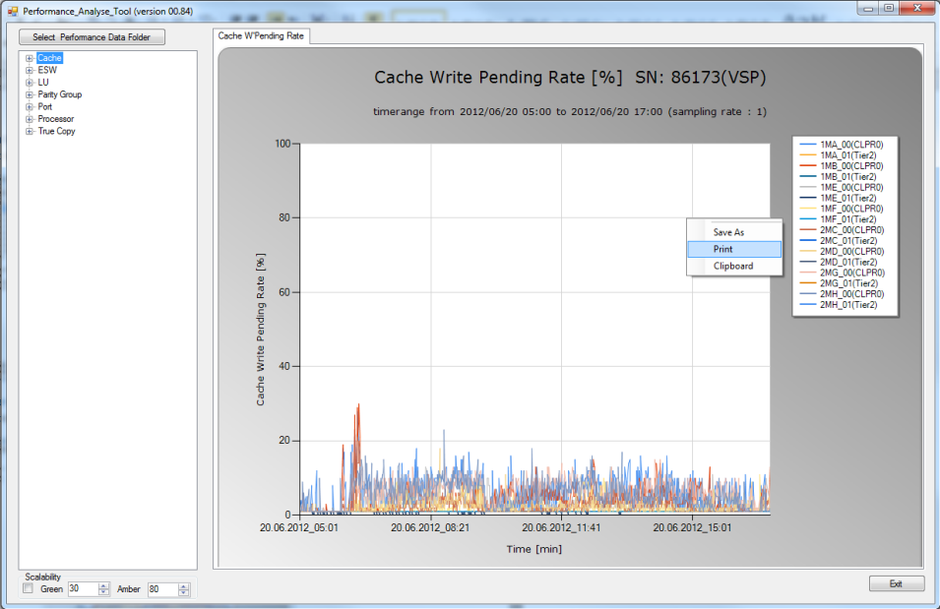

## Save a chart

Right click on the chart.

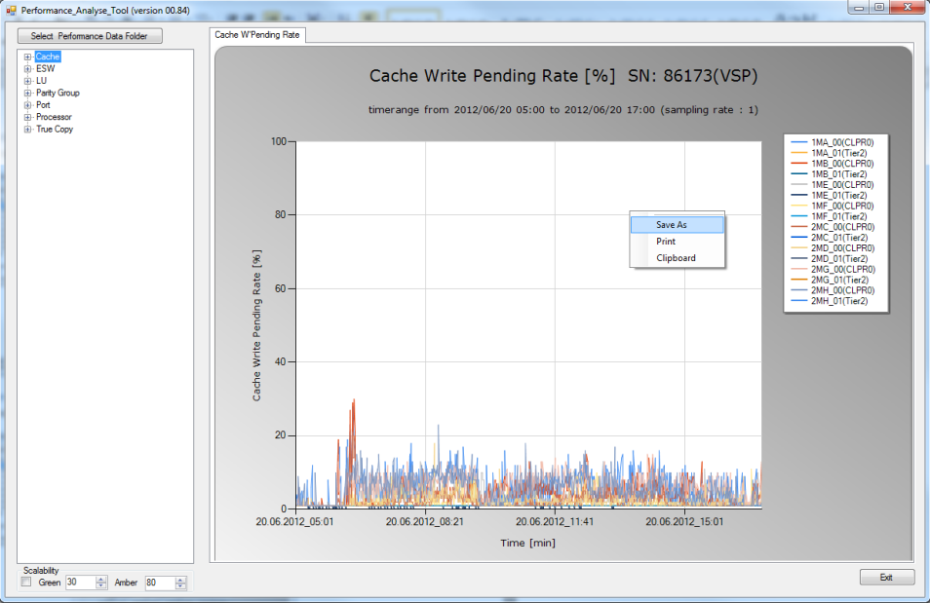

## Copy to Clipboard

Right click on the chart.

