

Functional Safety Concept Lane Assistance

**Document Version: 1.0**

**Template Version 1.0, Released on 2017-06-21**



# Document history

|  |  |  |  |
| --- | --- | --- | --- |
| Date | Version | Editor | Description |
| 6/25/18 | 1.0 | Pascal Irminger | Functional Safety Concept (init) |
|  |  |  |  |

# Table of Contents

Document history

Table of Contents

Purpose of the Functional Safety Concept

Inputs to the Functional Safety Analysis

Safety goals from the Hazard Analysis and Risk Assessment

Preliminary Architecture

Description of architecture elements

Functional Safety Concept

Functional Safety Analysis

Functional Safety Requirements

Refinement of the System Architecture

Allocation of Functional Safety Requirements to Architecture Elements

Warning and Degradation Concept

# Purpose of the Functional Safety Concept

The Functional Safety Concept documents the identified system high-level requirements without going into technical details. The goal is to identify safety requirements and then allocate those requirements to relevant parts of the system architecture. From the result of this document, technical safety requirements can be derived within a subsequent Technical Safety Concept.

# Inputs to the Functional Safety Concept

## Safety goals from the Hazard Analysis and Risk Assessment

|  |  |
| --- | --- |
| **ID** | **Safety Goal** |
| Safety_Goal_01 | The oscillating steering torque from the LDW function shall be limited. |
| Safety_Goal_02 | The LKA function shall be time limited and the additional steering torque shall end after a given time interval so that the driver cannot misuse the system for autonomous driving. |
| Safety_Goal_03 | The LDW function shall be deactivated when the camera sensors stop working. |
| Safety_Goal_04 | The LKA function shall always react on time or inform the driver that it has a malfunction and turns itself off. |

## Preliminary Architecture

The following figure describes the preliminary architecture for the lane assistance item:

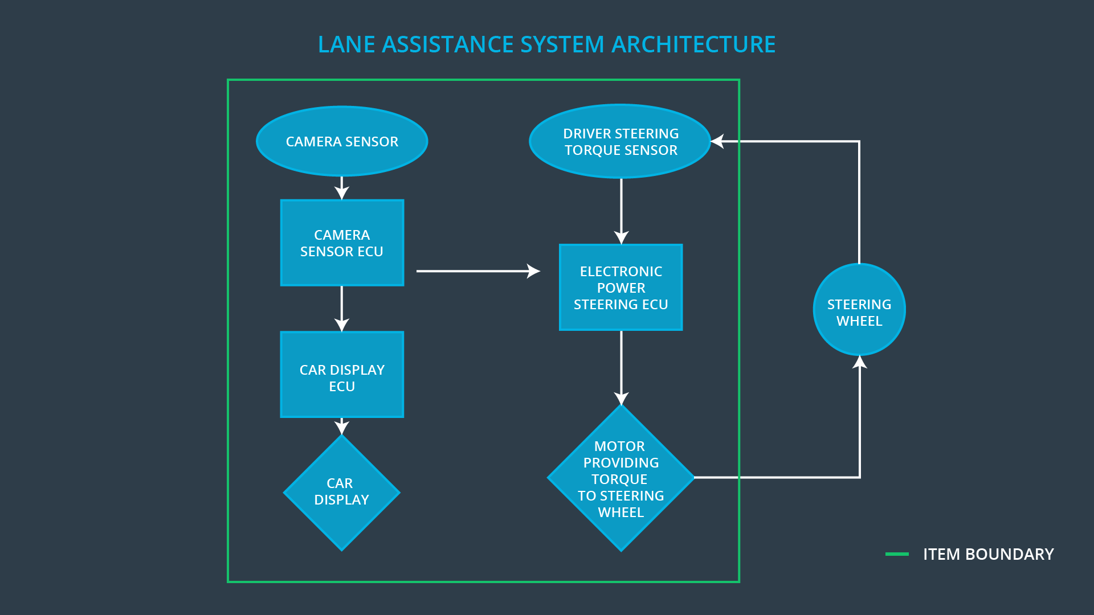

### Description of architecture elements

| **Element** | **Description** |
| --- | --- |
| Camera Sensor | Captures road images and provides them to the Camera Sensor ECU. |
| Camera Sensor ECU | Analyzes provided images to calculate the car’s position on the road with respect to the road lanes. |
| Car Display | Provides feedback to the driver by displaying warnings and the LDA function status. |
| Car Display ECU | Generates warning signals triggered by inputs from the Camera Sensor ECU. |
| Driver Steering Torque Sensor | Measures the torque applied to the steering wheel by the driver. |
| Electronic Power Steering ECU | Uses the information received from the Driver Steering Torque Sensor and the torque requested by the LKA and requests the according torque to be applied by the motor actuator. |
| Motor | Applies the torque indicated by the Electronic Power Steering ECU to the steering wheel. |

# Functional Safety Concept

The functional safety concept consists of:

* Functional safety analysis
* Functional safety requirements
* Functional safety architecture
* Warning and degradation concept

## Functional Safety Analysis

| **Malfunction ID** | **Main Function of the Item Related to Safety Goal Violations** | **Guidewords (NO, WRONG, EARLY, LATE, MORE, LESS)** | **Resulting Malfunction** |
| --- | --- | --- | --- |
| Malfunction_01 | Lane Departure Warning (LDW) function shall apply an oscillating steering torque to provide the driver a haptic feedback | MORE | The LDW function applies an oscillating torque with very high torque amplitude (above limit). |
| Malfunction_02 | Lane Departure Warning (LDW) function shall apply an oscillating steering torque to provide the driver a haptic feedback | MORE | The LDW function applies an oscillating torque with very high torque frequency (above limit). |
| Malfunction_03 | Lane Keeping Assistance (LKA) function shall apply the steering torque when active in order to stay in ego lane | NO | The LKA function is not limited in time duration which leads to misuse as an autonomous driving function. |
| Malfunction_04 | Lane Departure Warning (LDW) function shall apply an oscillating steering torque to provide the driver a haptic feedback | NO | The camera sensor ECU is not able to find lane lines during snowfall (degraded view). |
| Malfunction_05 | Lane Keeping Assistance (LKA) function shall apply the steering torque when active in order to stay in ego lane | WRONG | The camera sensor ECU does not detect yellow lane lines at construction site correctly. |

## Functional Safety Requirements

Lane Departure Warning (LDW) Requirements:

|  |  |  |  |  |
| --- | --- | --- | --- | --- |
| **ID** | **Functional Safety Requirement** | **ASIL** | **Fault Tolerant Time Interval** | **Safe State** |
| Functional  Safety  Requirement  01-01 | The lane keeping item shall ensure that the lane departure oscillating torque amplitude is below Max_Torque_Amplitude. | C | 50 ms | LDW function is turned off. |
| Functional  Safety  Requirement  01-02 | The lane keeping item shall ensure that the lane departure oscillating torque frequency is below Max_Torque_Frequency. | C | 50 ms | LDW function is turned off. |
| Functional  Safety  Requirement  01-03 | The lane keeping item shall ensure that the lane departure oscillating torque is zero if Lane_Not_Found is stated true by the camera sensor ECU. | B | 10 ms | LDW function is turned off. |

Lane Departure Warning (LDW) Verification and Validation Acceptance Criteria:

|  |  |  |
| --- | --- | --- |
| **ID** | **Validation Acceptance**  **Criteria and Method** | **Verification Acceptance**  **Criteria and Method** |
| Functional  Safety  Requirement  01-01 | Validate that Max_Torque_Amplitude is low enough that the driver does not loose control over the car. | Verify that the system turns off whenever the lane departure oscillating torque amplitude exceeds Max_Torque_Amplitude. |
| Functional  Safety  Requirement  01-02 | Validate that Max_Torque_Frequency is low enough that the driver does not loose control over the car. | Verify that the system turns off whenever the lane departure oscillating torque frequency exceeds Max_Torque_Frequency. |
| Functional  Safety  Requirement  01-03 | Validate that Lane_Not_Found is stated correctly if lane lines cannot be detected. | Verify that the system turns off whenever Lane_Not_Found is true. |

Lane Keeping Assistance (LKA) Requirements:

|  |  |  |  |  |
| --- | --- | --- | --- | --- |
| **ID** | **Functional Safety Requirement** | **ASIL** | **Fault Tolerant Time Interval** | **Safe State** |
| Functional  Safety  Requirement  02-01 | The electronic power steering ECU shall ensure that the lane keeping assistance torque is applied for only Max_Duration | B | 500 ms | LKA function is turned off. |
| Functional  Safety  Requirement  02-02 | The lane keeping item shall not request torque if Lane_Is_Yellow is stated true by the camera sensor ECU. | A | 25 ms | LKA function is turned off. |

Lane Keeping Assistance (LKA) Verification and Validation Acceptance Criteria:

| **ID** | **Validation Acceptance**  **Criteria and Method** | **Verification Acceptance**  **Criteria and Method** |
| --- | --- | --- |
| Functional  Safety  Requirement  02-01 | Validate that Max_Duration really did dissuade drivers from taking their hands off the steering wheel. | Verify that the system turns off whenever the lane keeping assistance exceeds Max_Duration. |
| Functional  Safety  Requirement  02-02 | Validate that Lane_Is_Yellow is stated correctly if lane lines turn yellow. | Verify that the system turns off whenever Lane_Is_Yellow is true. |

## Refinement of the System Architecture

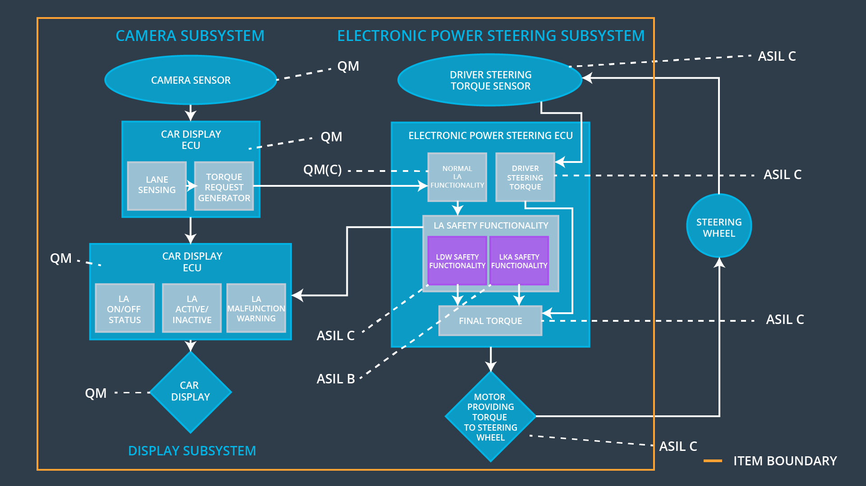

## Allocation of Functional Safety Requirements to Architecture Elements

| **ID** | **Functional Safety Requirement** | **Electronic Power Steering ECU** | **Camera ECU** | **Car Display ECU** |
| --- | --- | --- | --- | --- |
| Functional  Safety  Requirement  01-01 | The electronic power steering ECU shall ensure that the lane departure warning oscillating torque amplitude is below Max_Torque_Amplitude. | **x** |  |  |
| Functional  Safety  Requirement  01-02 | The electronic power steering ECU shall ensure that the lane departure warning oscillating torque frequency is below Max_Torque_Frequency. | **x** |  |  |
| Functional  Safety  Requirement  01-03 | The electronic power steering ECU shall ensure that the lane departure oscillating torque is zero if Lane_Not_Found is stated true by the camera sensor ECU. | **x** |  |  |
| Functional  Safety  Requirement  02-01 | The electronic power steering ECU shall ensure that the lane keeping assistance torque is applied for only Max_Duration | **x** |  |  |
| Functional  Safety  Requirement  02-02 | The electronic power steering ECU shall not request torque if Lane_Is_Yellow is stated true by the camera sensor ECU. | **x** |  |  |

## Warning and Degradation Concept

|  |  |  |  |  |
| --- | --- | --- | --- | --- |
| **ID** | **Degradation Mode** | **Trigger for Degradation Mode** | **Safe State invoked?** | **Driver Warning** |
| WDC-01 | Turn off LDW function | Malfunction_01,  Malfunction_02,  Malfunction_03 | Yes | LDW malfunction warning on car display |
| WDC-02 | Turn off LKA function | Malfunction_04,  Malfunction_05 | Yes | LKA malfunction warning on car display |