

Technical Safety Concept Lane Assistance

**Document Version: 1.1**

**Template Version 1.0, Released on 2017-06-21**



# Document history

|  |  |  |  |
| --- | --- | --- | --- |
| Date | Version | Editor | Description |
| 6/25/18 | 1.0 | Pascal Irminger | Technical Safety Concept (init) |
| 6/28/18 | 1.1 | Pascal Irminger | Safe State Refinement |

# Table of Contents

Document history

Table of Contents

Purpose of the Technical Safety Concept

Inputs to the Technical Safety Concept

Functional Safety Requirements

Refined System Architecture from Functional Safety Concept

Functional overview of architecture elements

Technical Safety Concept

Technical Safety Requirements

Refinement of the System Architecture

Allocation of Technical Safety Requirements to Architecture Elements

Warning and Degradation Concept

# Purpose of the Technical Safety Concept

The Technical Safety Concept document refines the functional safety requirements established in the Functional Safety Concept into technical safety requirements and assigns them to the system architecture.

# Inputs to the Technical Safety Concept

## Functional Safety Requirements

|  |  |  |  |  |
| --- | --- | --- | --- | --- |
| **ID** | **Functional Safety Requirement** | **ASIL** | **Fault Tolerant Time Interval** | **Safe State** |
| Functional  Safety  Requirement  01-01 | The electronic power steering ECU shall ensure that the lane departure warning oscillating torque amplitude is below Max_Torque_Amplitude. | C | 50 ms | Oscillation torque amplitude below Max_Torque_Amplitude. |
| Functional  Safety  Requirement  01-02 | The electronic power steering ECU shall ensure that the lane departure warning oscillating torque frequency is below Max_Torque_Frequency. | C | 50 ms | Oscillation torque frequency below Max_Torque_Frequency. |
| Functional  Safety  Requirement  01-03 | The electronic power steering ECU shall ensure that the lane departure oscillating torque is zero if Lane_Not_Found is stated true by the camera sensor ECU. | B | 10 ms | LDW function is turned off. |
| Functional  Safety  Requirement  02-01 | The electronic power steering ECU shall ensure that the lane keeping assistance torque is applied for only Max_Duration | B | 500 ms | LKA torque is zero. |
| Functional  Safety  Requirement  02-02 | The electronic power steering ECU shall not request torque if Lane_Is_Yellow is stated true by the camera sensor ECU. | A | 25 ms | LKA function is turned off. |

## Refined System Architecture from Functional Safety Concept

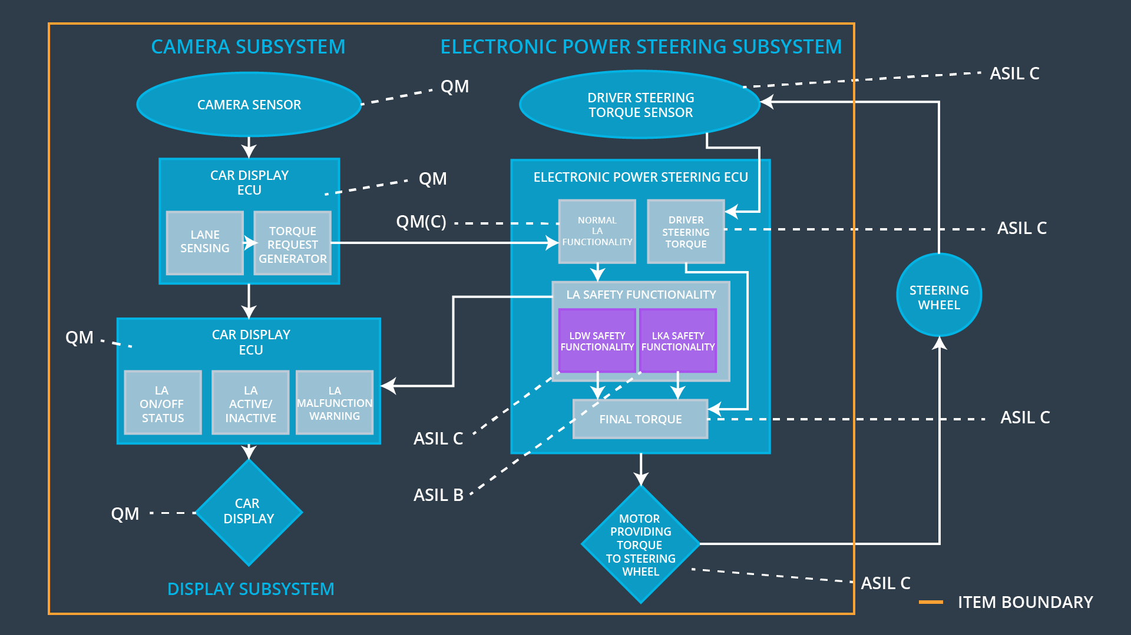

### Functional overview of architecture elements

| **Element** | **Description** |
| --- | --- |
| Camera Sensor | Captures road images and provides them to the Camera Sensor ECU. |
| Camera Sensor ECU - Lane Sensing | Software module detecting lane line positions from the Camera Sensor images. |
| Camera Sensor ECU - Torque request generator | Software module calculating the necessary torque to be requested to the Electronic Power Steering (EPS) ECU. |
| Car Display | Provides feedback to the driver by displaying warnings and the LDA function status. |
| Car Display ECU - Lane Assistance On/Off Status | Indicates the status of the Lane Assistance functionality (On/Off). |
| Car Display ECU - Lane Assistant Active/Inactive | Indicates the status of the Lane Assistance functionality (Active/Inactive). |
| Car Display ECU - Lane Assistance malfunction warning | Indicates a malfunction of the Lane Assistance functionality. |
| Driver Steering Torque Sensor | Measures the torque applied to the steering wheel by the driver. |
| Electronic Power Steering (EPS) ECU - Driver Steering Torque | Software module receiving the torque request from the steering wheel. |
| EPS ECU - Normal Lane Assistance Functionality | Software module receiving the torque request from the Camera Sensor ECU. |
| EPS ECU - Lane Departure Warning Safety Functionality | Software module ensuring the LDW function torque amplitude is below Max_Torque_Amplitude and the torque frequency is below Max_Torque_Frequency. |
| EPS ECU - Lane Keeping Assistant Safety Functionality | Software module ensuring the LKA function is not activate more than Max_Duration. |
| EPS ECU - Final Torque | Software module combining the torque requests from the LDW function and the LKA function and sending the final torque to the steering wheels. |
| Motor | Applies the torque indicated by the Electronic Power Steering ECU to the steering wheel. |

# Technical Safety Concept

## Technical Safety Requirements

**Lane Departure Warning (LDW) Requirements:**

Functional Safety Requirement 01-01 with its associated system elements

(derived in the functional safety concept)

|  |  |  |  |  |
| --- | --- | --- | --- | --- |
| **ID** | **Functional Safety Requirement** | **Electronic Power Steering ECU** | **Camera ECU** | **Car Display ECU** |
| Functional  Safety  Requirement  01-01 | The lane keeping item shall ensure that the lane departure oscillating torque amplitude is below Max_Torque_Amplitude | X |  |  |

Technical Safety Requirements related to Functional Safety Requirement 01-01 are:

|  |  |  |  |  |  |
| --- | --- | --- | --- | --- | --- |
| **ID** | **Technical Safety Requirement** | **ASIL** | **Fault Tolerant Time Interval** | **Architecture Allocation** | **Safe State** |
| Technical  Safety  Requirement  01-01-01 | The LDW safety component shall ensure that the amplitude of the ‚LDW_Torque_Request‘ sent to the ‚Final EPS Torque‘ component is below ‚Max_Torque_Amplitude‘. | C | 50 ms | LDW Safety | LDW Torque Request Amplitude is zero. |
| Technical  Safety  Requirement  01-01-02 | As soon as a failure is detected by the LDW function, it shall deactivate the LDW feature and the ‚LDW_Torque_Request‘ shall be set to zero. | C | 50 ms | LDW Safety | LDW Torque Request Amplitude is zero. |
| Technical  Safety  Requirement  01-01-03 | As soon as the LDW function deactivates the LDW feature, the ‚LDW Safety‘ software block shall send a signal to the car display ECU to turn on a warning light. | C | 50 ms | LDW Safety | LDW Torque Request Amplitude is zero. |
| Technical  Safety  Requirement  01-01-04 | The validity and integrity of the data transmission for ‚LDW_Torque_Request‘ signal shall be ensured. | C | 50 ms | Data Transmission Integrity Check | LDW Torque Request Amplitude is zero. |
| Technical  Safety  Requirement  01-01-05 | Memory test shall be conducted at start up of the EPS ECU to check for any faults in memory. | A | Length of vehicle ignition cycle | Memory Test | LDW Torque Request Amplitude is zero. |

Functional Safety Requirement 01-02 with its associated system elements

(derived in the functional safety concept)

|  |  |  |  |  |
| --- | --- | --- | --- | --- |
| **ID** | **Functional Safety Requirement** | **Electronic Power Steering ECU** | **Camera ECU** | **Car Display ECU** |
| Functional  Safety  Requirement  01-02 | The lane keeping item shall ensure that the lane departure oscillating torque frequency is below Max_Torque_Frequency | X |  |  |

Technical Safety Requirements related to Functional Safety Requirement 01-02 are:

|  |  |  |  |  |  |
| --- | --- | --- | --- | --- | --- |
| **ID** | **Technical Safety Requirement** | **ASIL** | **Fault Tolerant Time Interval** | **Architecture Allocation** | **Safe State** |
| Technical  Safety  Requirement  01-02-01 | The LDW safety component shall ensure that the frequency of the ‚LDW_Torque_Request‘ sent to the ‚Final EPS Torque‘ component is below ‚Max_Torque_Frequency‘. | C | 50 ms | LDW Safety | LDW Torque Request Frequency is zero. |

**Lane Keeping Assistance (LKA) Requirements:**

Functional Safety Requirement 02-01 with its associated system elements

(derived in the functional safety concept)

|  |  |  |  |  |
| --- | --- | --- | --- | --- |
| **ID** | **Functional Safety Requirement** | **Electronic Power Steering ECU** | **Camera ECU** | **Car Display ECU** |
| Functional  Safety  Requirement  02-01 | The lane keeping item shall ensure that the lane keeping assistance torque is applied for only Max_Duration | X |  |  |

Technical Safety Requirements related to Functional Safety Requirement 02-01 are:

|  |  |  |  |  |  |
| --- | --- | --- | --- | --- | --- |
| **ID** | **Technical Safety Requirement** | **ASIL** | **Fault Tolerant Time Interval** | **Allocation to Architecture** | **Safe State** |
| Technical  Safety  Requirement  02-01-01 | The LKA safety component shall ensure that the duration of the lane keeping assistance torque is applied for less than ‚Max_Duration‘. | B | 500 ms | LKA Safety | LKA torque is zero. |
| Technical  Safety  Requirement  02-01-02 | As soon as a failure is detected by the LKA function, it shall deactivate the LKA feature and the ‚LKA_Torque_Request‘ shall be set to zero. | C | 50 ms | LKA Safety | LKA torque is zero. |
| Technical  Safety  Requirement  02-01-03 | As soon as the LKA function deactivates the LKA feature, the ‚LKA Safety‘ software block shall send a signal to the car display ECU to turn on a warning light. | C | 50 ms | LKA Safety | LKA torque is zero. |
| Technical  Safety  Requirement  02-01-04 | The validity and integrity of the data transmission for ‚LKA_Torque_Request‘ signal shall be ensured. | C | 50 ms | Data Transmission Integrity Check | LKA torque is zero. |
| Technical  Safety  Requirement  02-01-05 | Memory test shall be conducted at start up of the EPS ECU to check for any faults in memory. | A | Length of vehicle ignition cycle | Memory Test | LKA torque is zero. |

## Refinement of the System Architecture

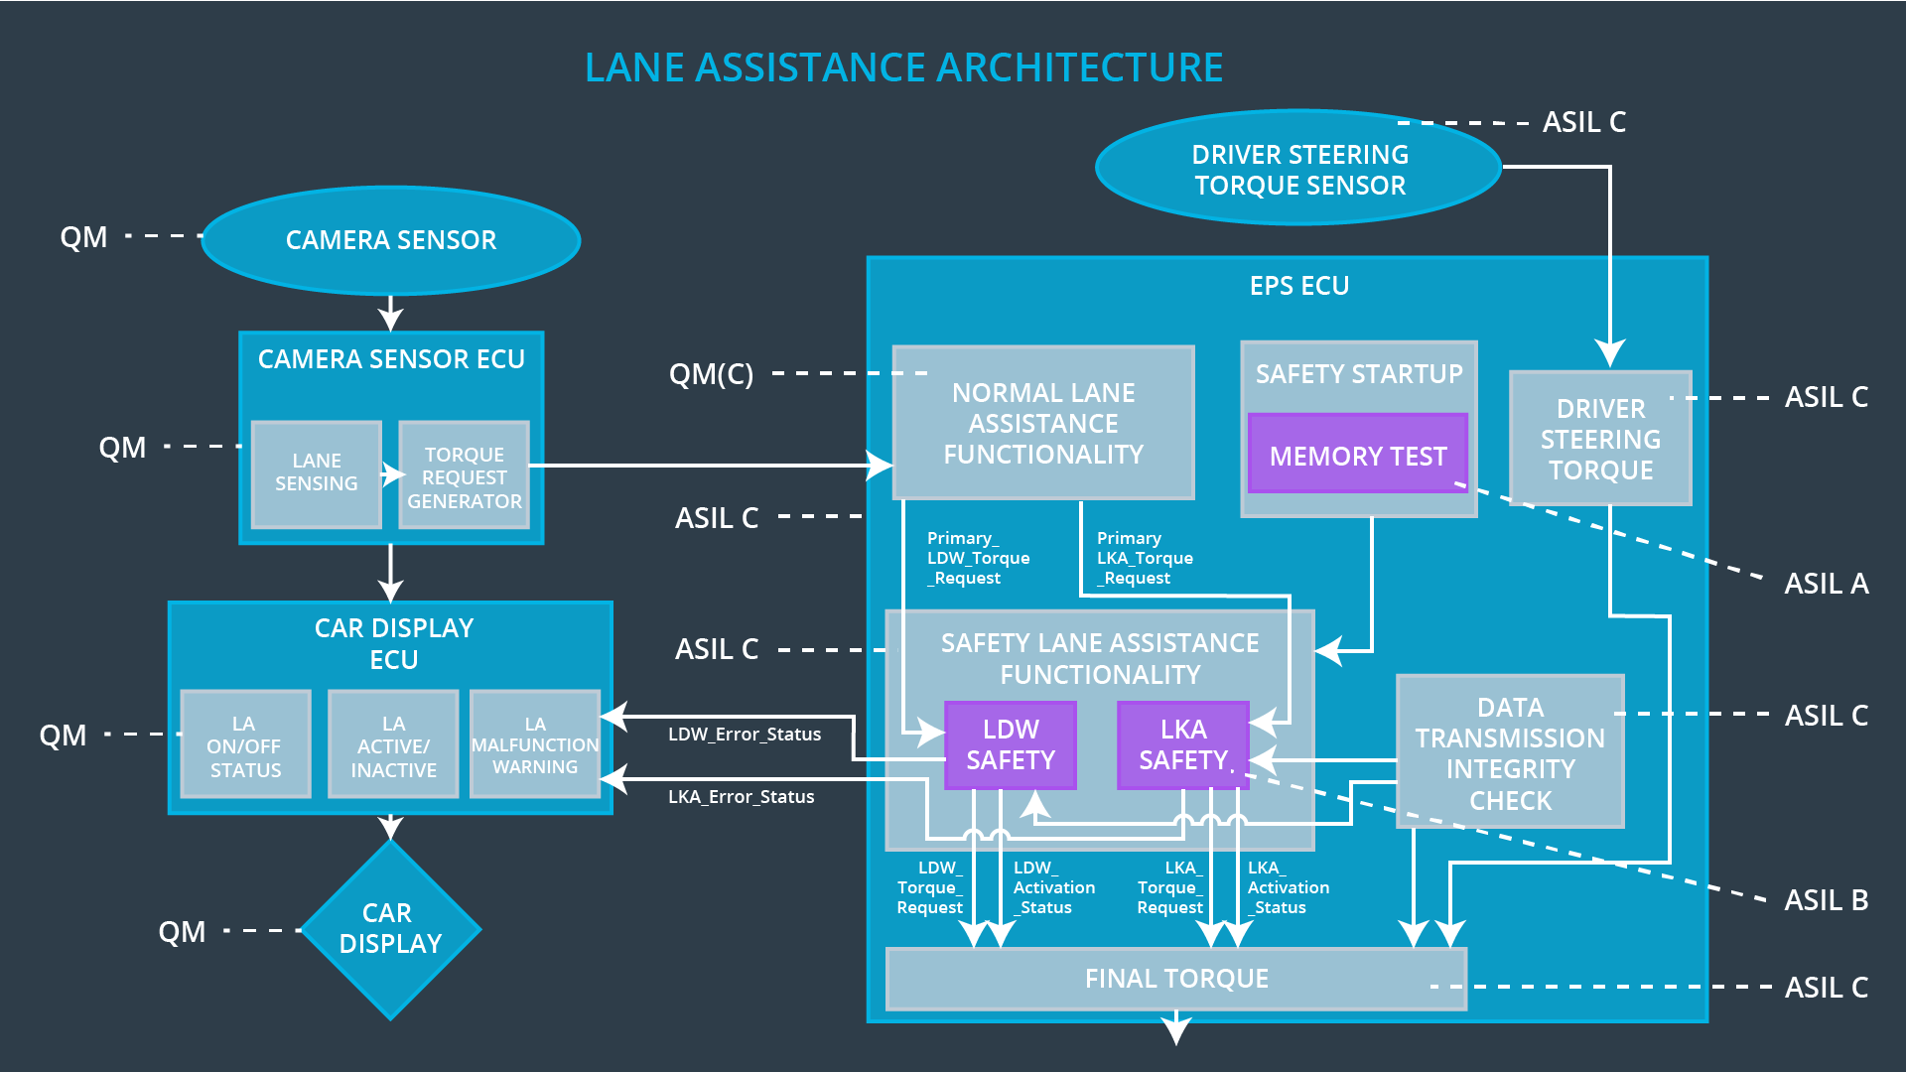

## Allocation of Technical Safety Requirements to Architecture Elements

All technical safety requirements are allocated to the Electronic Power Steering (EPS) ECU. For the exact allocation within EPS ECU compare the technical safety requirement tables above.

## Warning and Degradation Concept

|  |  |  |  |  |
| --- | --- | --- | --- | --- |
| **ID** | **Degradation Mode** | **Trigger for Degradation Mode** | **Safe State invoked?** | **Driver Warning** |
| WDC-01 | Turn off LDW function | Malfunction_01,  Malfunction_02,  Malfunction_03 | Yes | LDW malfunction warning on car display |
| WDC-02 | Turn off LKA function | Malfunction_04,  Malfunction_05 | Yes | LKA malfunction warning on car display |