**Dokumentasi Program Sederhana**

**Aplikasi Pengelolaan Keuangan menggunakan PHP & MYSQL**

1. Register Success

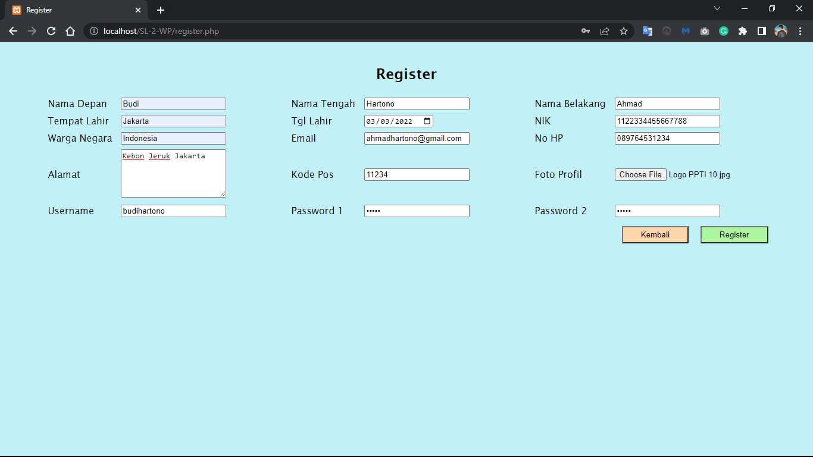

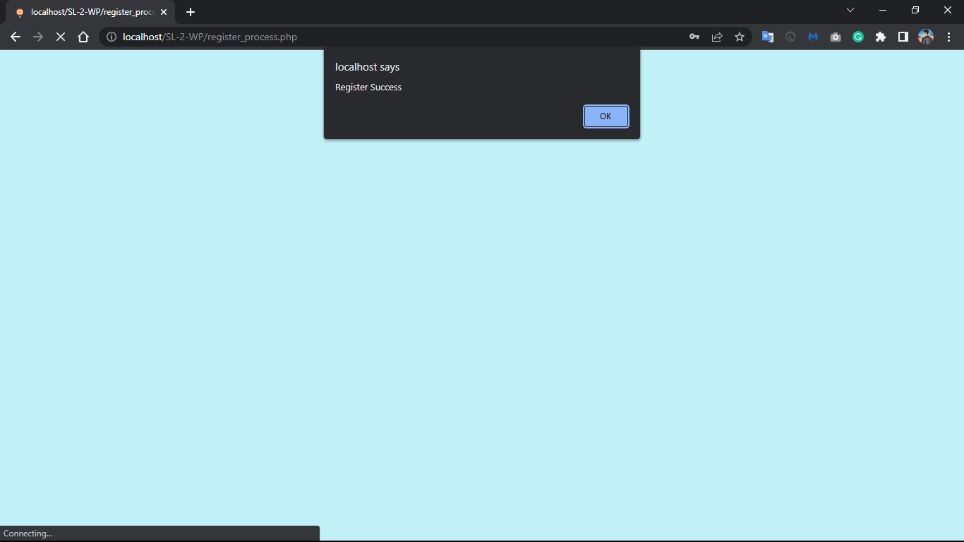

1. Login

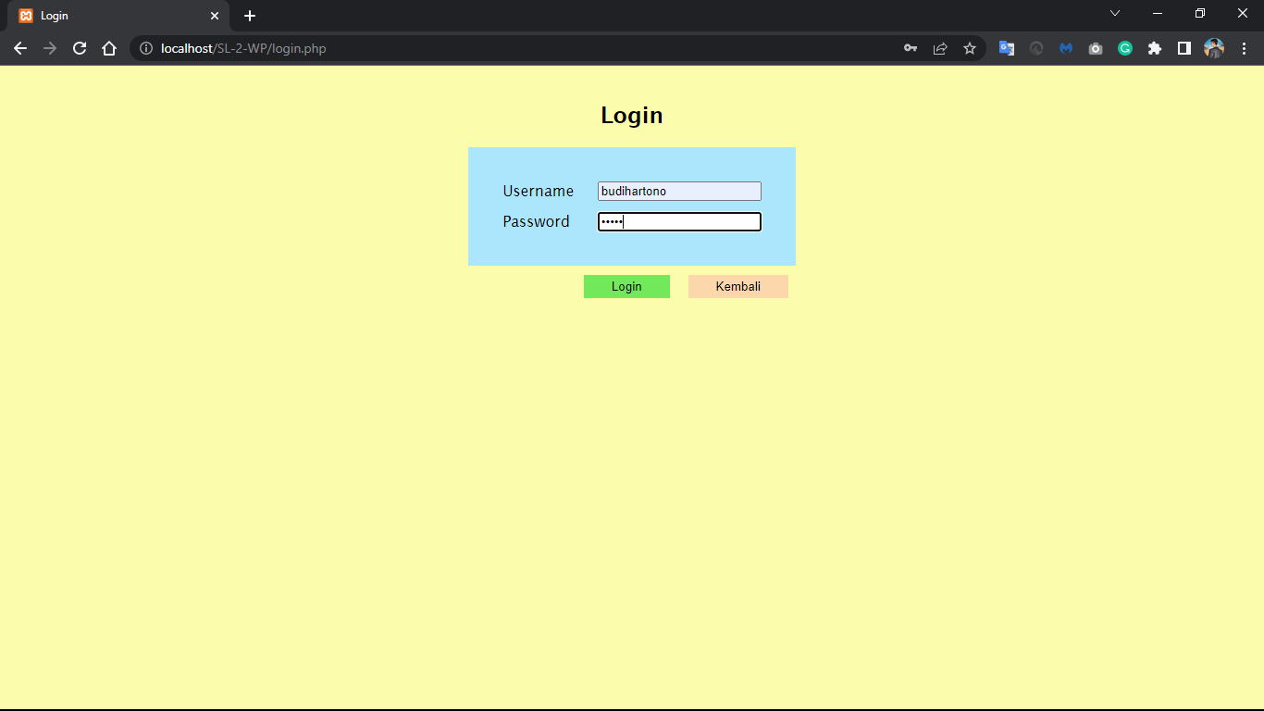

1. Edit Profile

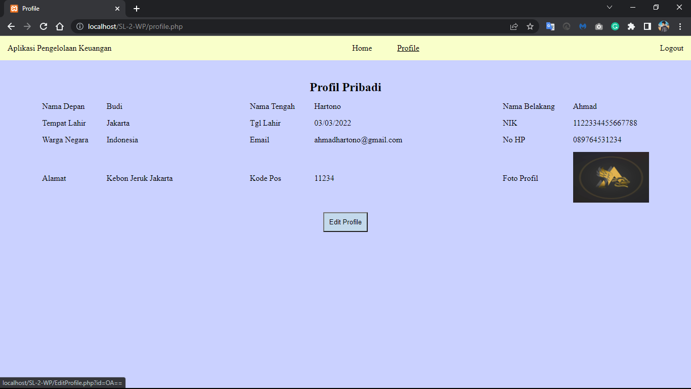

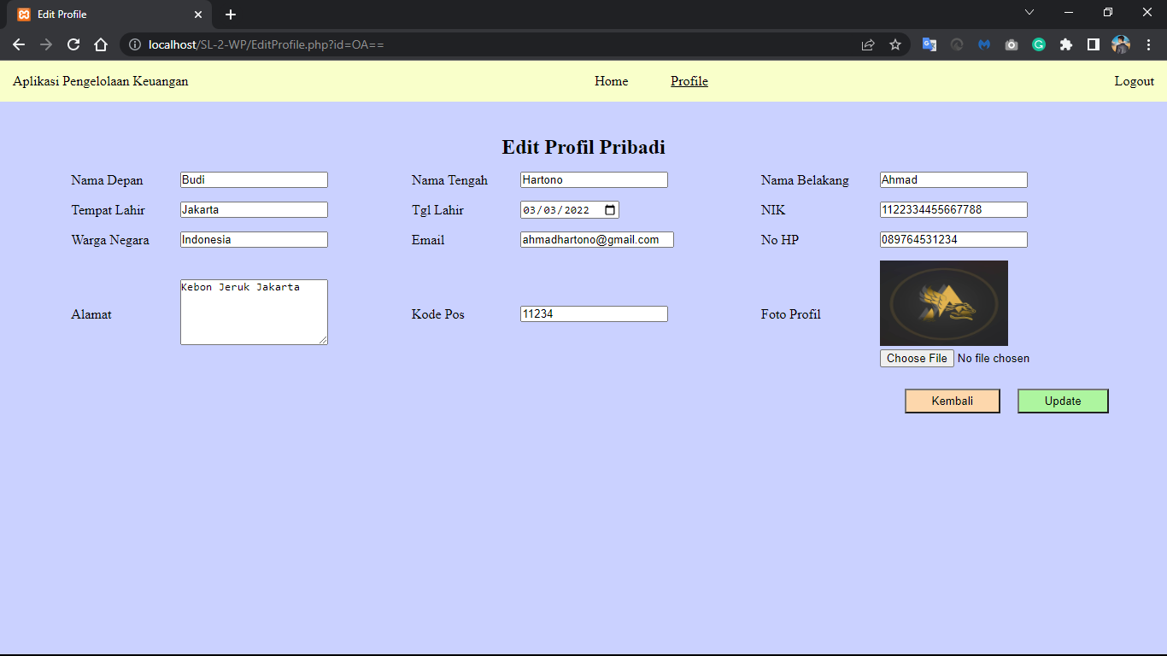

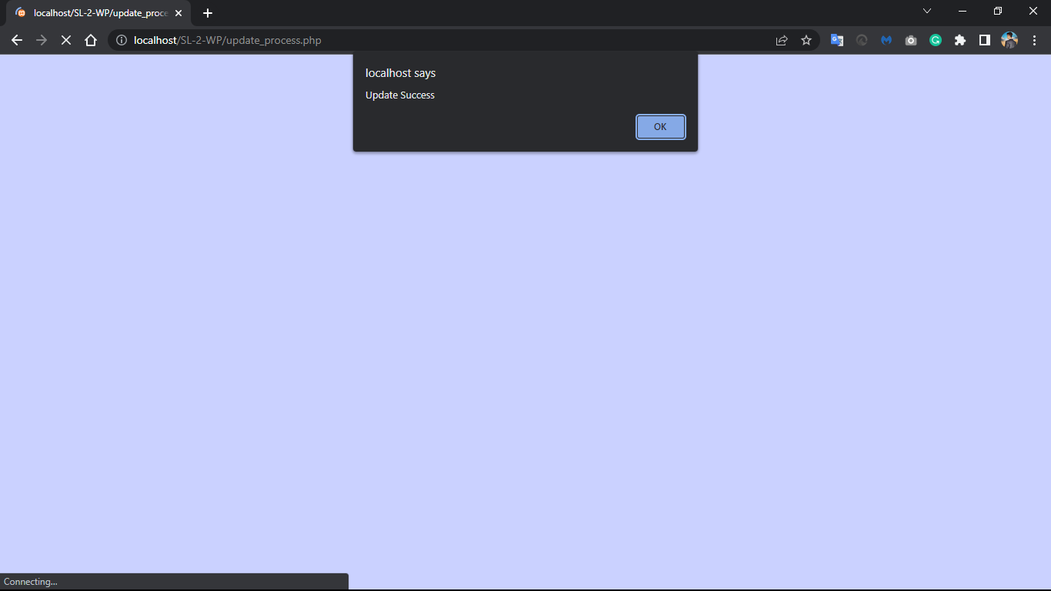

Repository Github:

<https://github.com/pascalwilman28/SL_web-programming>