1. Open portal <https://portal.azure.com>
2. Navigate to Azure Active directory:

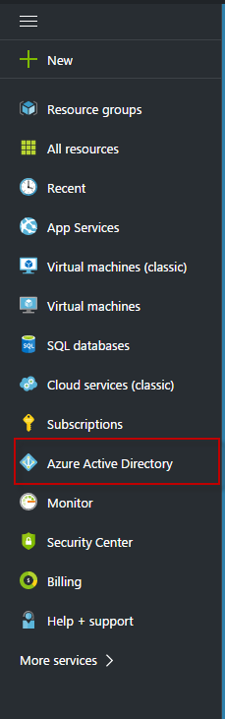

1. Click on App registrations:

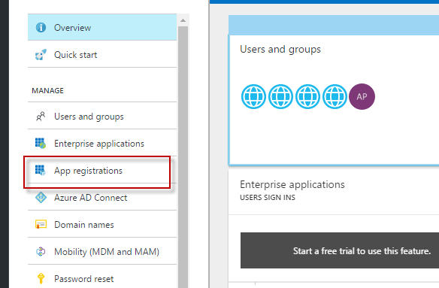

1. Click on Add:

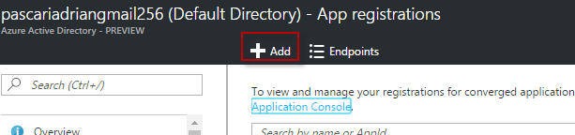

1. In Crete section – insert these values:

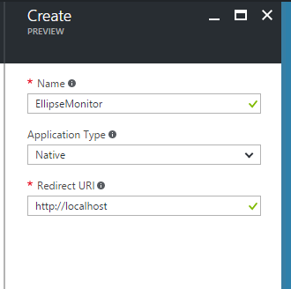

1. Click Create:

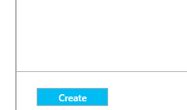

1. Click on EllipseMonotor application:

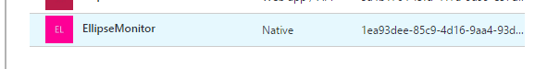

1. Click on Keys:

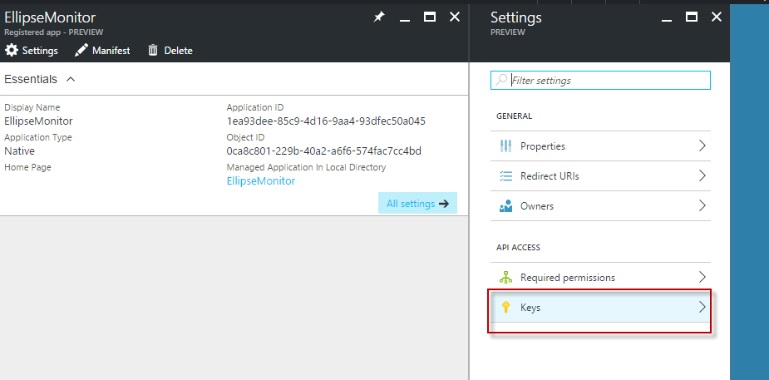

1. In description insert ‘Ellipse’. Expires= Never expires:

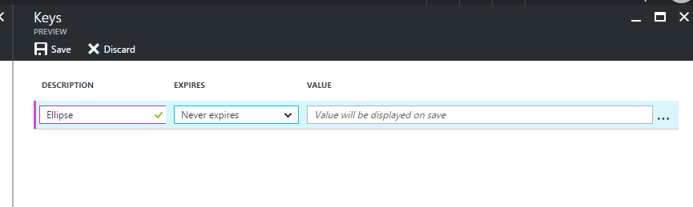

1. Click on save:

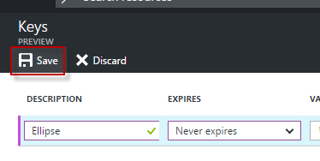

1. Copy the key and store it somewhere. This is **client Secret**: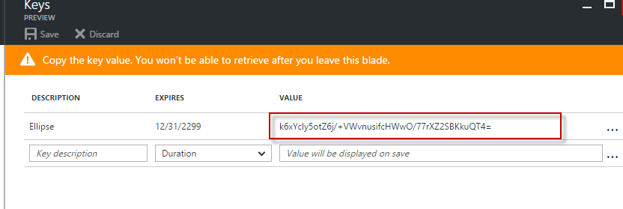
2. Click on Required permissions:

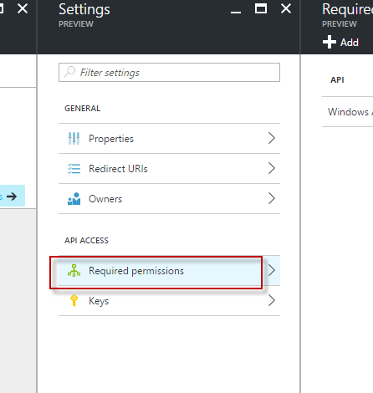

1. Click on Add:

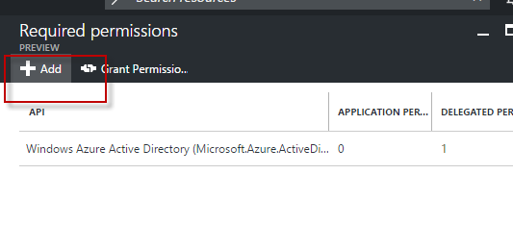

1. Click on Select API. Select Windows Azure service Management API. Click Select:

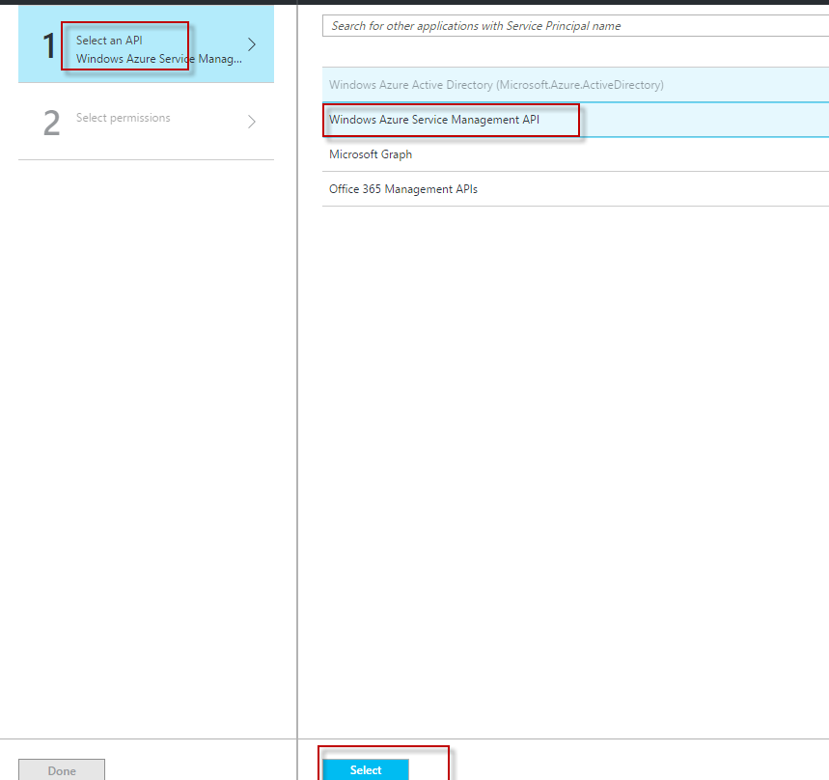

1. Check the check box and click Select:

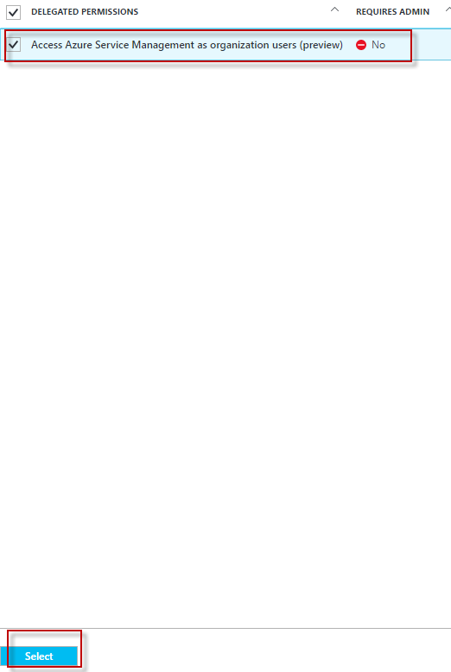

1. Select the same for Permissions:

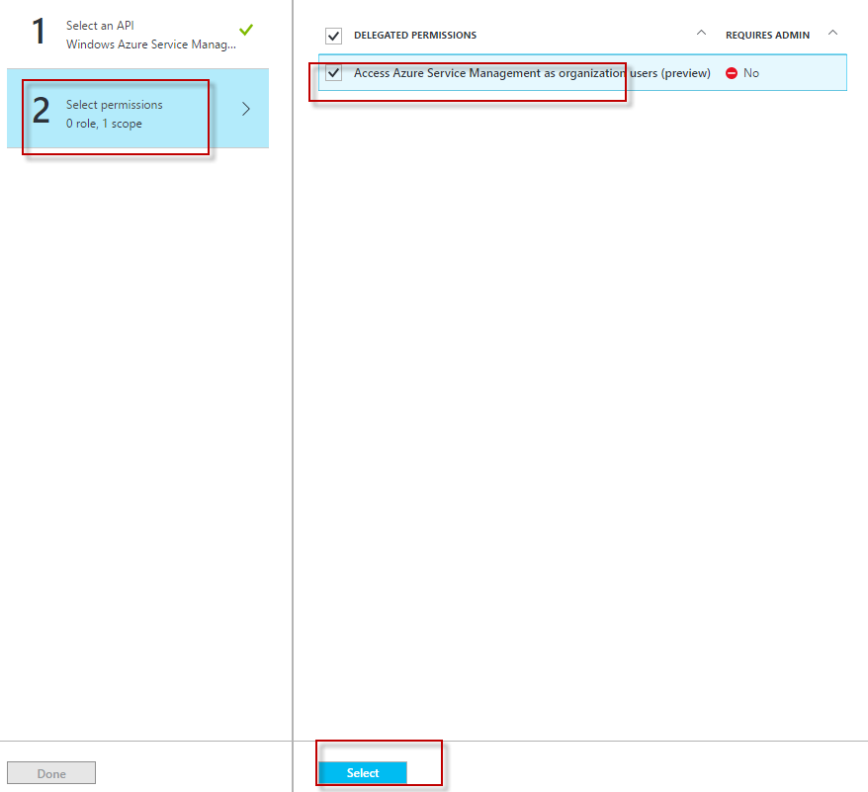

1. Click on Done:

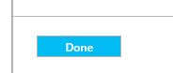

1. Copy application ID somewhere in notepad. This is **ClientId.**

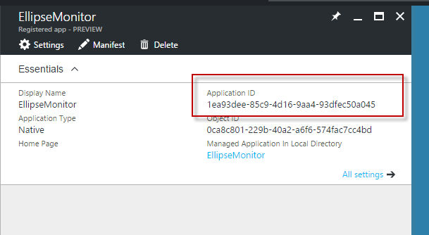

1. Click on Endpoints:

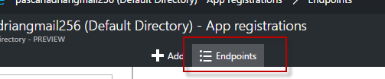

1. Get the value between ‘windos.net/’ and “/oauth2”. This is **TenantID**:

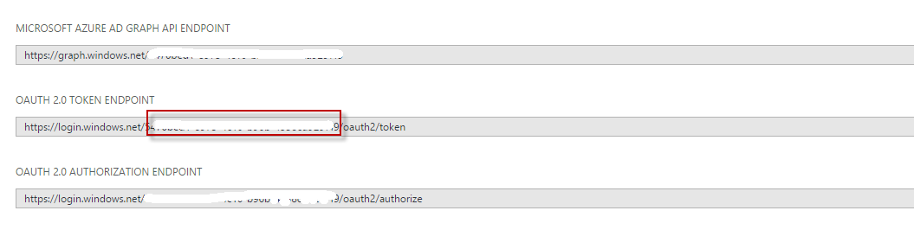

1. Click on Subscription:

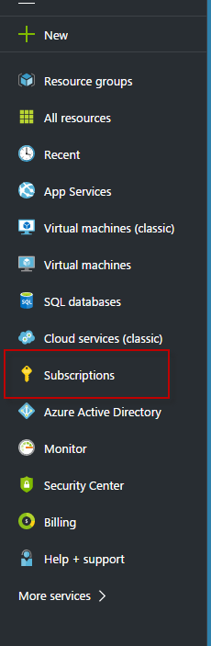

1. Click on subscription:

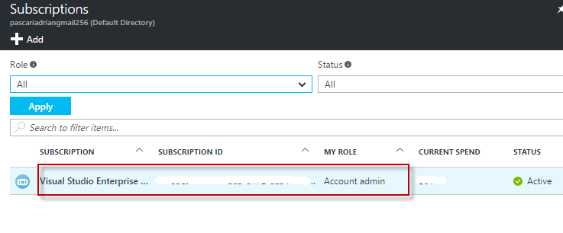

1. Click on Access control (IAM):

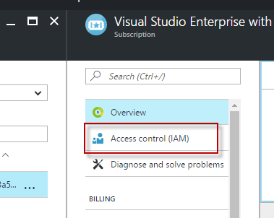

1. Click on Add:

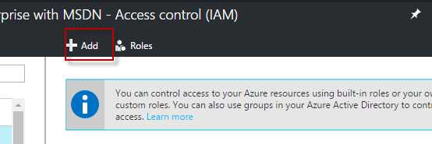

1. Click on Select role. Select Reader role:

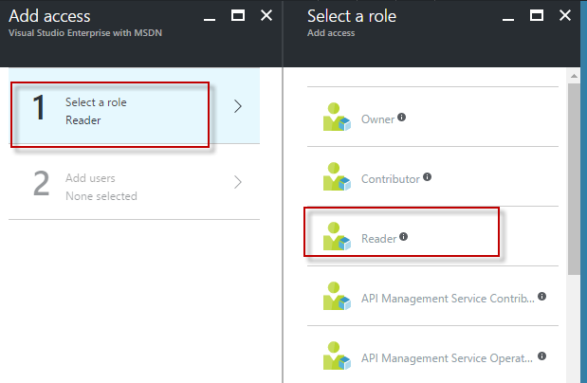

1. Click on Add user. Type EllipseMonitor. Click on the found application:

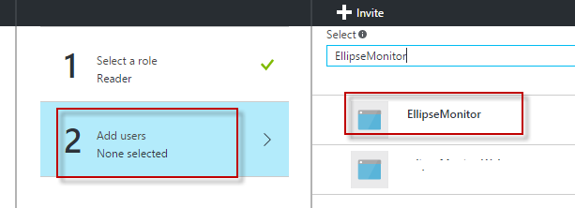

1. Click Select:

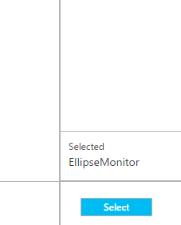

1. Click OK.
2. Application is displayed:

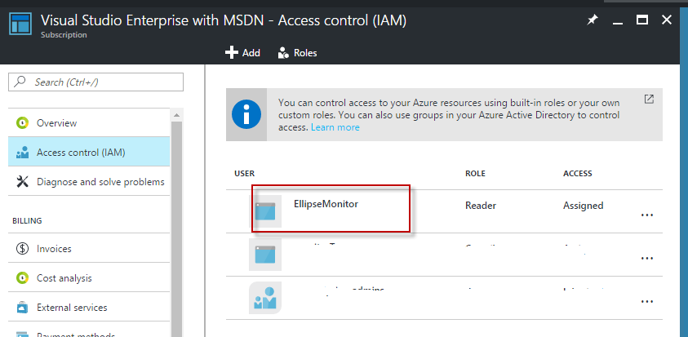

1. Go to Windows Azure web site <https://manage.windowsazure.com>
2. Be sure that your subscription is selected:

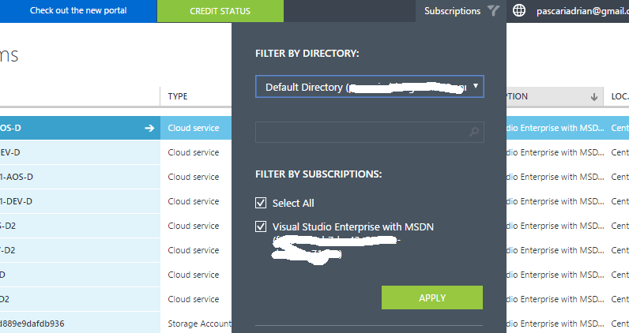

1. Click on settings:

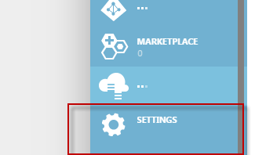

1. Click on manage certificate:

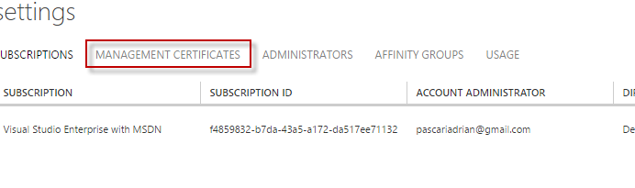

1. Click Upload and upload certificate:

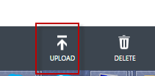

1. In the Key.txt(is the file with configuration info):

Enter the data(separated by comma):



Column1 = SubscriptionId

Column2 = put your subscription mail

Column3= TenantId(value you saved from step 20)

Column4= Client Id(value saved in step 18)

Column5 = ClientSecret(value saved in step 11)

Column 6 = Cert. thumbNumber. It is value from Azure config/ certioficate:

