# **CERTIFICATION**

We, the undersigned, certify that we have read and hereby recommend for acceptance by the Mzumbe University, a project report entitled **“ONLINE VOTING SYSTEM”** in a partial fulfillment of the requirements for awards of the Diploma in information Technology, (DIT).

**Major supervisor Name Internal Examiner Name**

**MR. LAURENT ………………………………**

**Signature…………………… Signature…………………….**

**Date………………………… Date: …………………............**

# **DECLARATION AND COPYRIGHT**

I, **BARAKA JOHN MABUMBA** do here by declare that the work contained in this project report entitled **online voting system** is my own. This report contains no material that has been submitted previously, in whole or part, for the award of academic degree or diploma. All sources that I have used or quoted have been indicated and acknowledged by means of complete references and paraphrasing.

**Signed**……………………….. **Date**……………………….

©2022

This report is a copyright of my own work as my final project in Mzumbe University copyright 2022 on intellectual property. It may not be reproduced in by any means in full or in part except for short extracts in fair dealings for research or private study, critical scholarly review or discourse with acknowledgement, without the written permission of Mzumbe University on behalf of myself.

# **DEDICATION**

I dedicated this project to God Almighty for He gave me strength, knowledge, understanding and protection.

I also dedicate this work to my Mother and Father, for their encouragement may God continue blessing you.

# **AKNOWLEDGEMENTS**

First, I would like to thank my Almighty GOD for giving me strength and good health from the beginning of this project titled **ONLINE VOTING SYSTEM** till the end. I extend my sincere and heartfelt thanks to my esteemed guider supervisor, MR. EMMANUEL WAMBURA, for providing me with the right guidance and advice at the crucial junctures and for showing me the right way.

Special thanks are extended to my Major supervisor **MR. LAURENT** who sacrificed most of his time in advising, guiding and tirelessly correcting me throughout the compilation of this Project.

Lastly, I would like to thanks my colleagues who contributed to the accomplishment of this project, through their advice, I really appreciate and gratitude your support. My God Bless you all.

**Thank you all.**

# **ABSTRACT**

Manual ways of applying for practical training areas due to lack of formal system is a problem that Universities have to go through particularly Mzumbe University**.** This study aims at developing a web-based system for supporting field applications to become easy and avoiding time consuming. This report is divided into different chapters as follows, Chapter one which gives the elaborations on the background of the study that the origin of online voting system also it gives objectives of this study which mainly is to reduce the problems associated with manual way of voting in Mzumbe University.

Chapter two is about literature review where it elaborates similar works performed by other authors or programmers on online voting system all over the world in this chapter explained different methods used in voting before online voting also in this chapter explained about security issues concerning online voting things like challenges of using online voting like those of hackers to interrupt to the system and cause damage in one way or another.

Chapter three is all about system methodology which explain about methods used in collecting data which made the use of this system which is interview and questionnaires whereas different questions formulated and obtained different results. Also in this chapter explained about system analysis that is functional requirements and requirements specifications that on what kind of device the system can be applied or used

Chapter four is about system development where it includes development tools like XAMMP, BROWSERS,PHP,HTML, bootstrap 4 together with CSS and others which are used in developing the system to its end functions, also in this chapter explains about different parts and pages available in the system like login, registration page and other pages present in the system, apart from those parts also in this chapter explains about testing of the system that the functions and non-function requirements of the system for example testing workflow of the system and data integrity also chapter explain about usability testing where it involve testing how system is easy to use and compatibility testing where it involves testing hardware platforms compatibility also include browser compatibility operating system compatibility and other devices like mobiles.

And the last chapter is about conclusion and recommendation where here provision of personal view about the system apart from that the lesson learnt from this project and lastly the recommendation concerning the system.

TABLE OF CONTENT

CERTIFICATION i

DECLARATION AND COPYRIGHT ii

DEDICATION iii

AKNOWLEDGEMENTS iv

ABSTRACT v

TABLE OF CONTENT vi

LIST OF FIGURE ix

LIST OF ABBREVIATIONS x

CHAPTER ONE 1

BACKGROUND AND PROBLEM STATEMENT 1

1.1 Introduction 1

1.2 background of the problem 1

1.3 Problem statement 2

1.4 OBJECTIVES 2

1.4.1 General Objectives 2

1.4.2 specific objectives 2

1.5 Significance and scope of the Technical solution 3

1.5.1 Significance 3

1.5.2 Scope 3

1.5.3 Conclusion 3

CHAPTER TWO 4

LITERATURE REVIEW 4

2.1 Introduction 4

2.2 Topic review 4

2.4 Domain review 5

2.4.1 Eastward Engineering College Voting System 5

2.5 Problem conclusion. 6

2.4 Domain review 6

2.4.1 A web based University Online Voting System (UOVS) Malaysia. 6

2.5 Problem conclusion. 6

CHAPTER THREE 7

REQUIREMENTS ELICITATIONS AND SYSTEM ANALYSIS 7

3.1 Introduction to Requirement Elicitation 7

3.2 Elicitation and classification of requirements. 8

3.2.1 Functional requirements 8

3.2.3 Non-function requirement 9

3.3 System Analysis 9

CHAPTER FOUR 11

SYSTEM DESIGN 11

4.1 Introduction to system design 11

4.2. System design methodology and technologies 11

4.2.1 System design methodology 11

4.3 Technologies and tools used 12

4.4.0 Database design 12

4.4.1 User case diagram 12

4.4 User interface Design 13

CHAPTER FIVE 14

SYSTEM IMPLEMENTATION 14

5.1 Introduction to system implementation 14

5.2 Functionalities implementation 14

5.3 Database implementation 16

5.4 User interface implementation 16

5.5 System testing and evaluation 17

CHAPTER SIX 18

CONCLUSION AND RECOMMENDATIONS 18

6.0 Summary of achieved objective 18

6.1 Conclusion 18

6.3 Recommendation 18

REFERENCES 19

# **LIST OF FIGURE**

Figure 1.4: System design methodology 12

Figure 2.4: User case diagram 13

Figure 3.4: User interface design 13

Figure 4.5: Admin account 14

Figure 5.5: User login 14

Figure 6.5: Home page 15

Figure 7.5: Data implementation 16

# **LIST OF ABBREVIATIONS**

|  |  |
| --- | --- |
| RDBMS | Relational Database Management System. |
| Wi-Fi | Wireless Fidelity. |
| MU | Mzumbe University. |
| OVS | Online Voting System |
| IEBBC | Independent Electoral and Boundaries Commission |
| US | United States |
| DRE | Direct recording electronic |
| MYSQL | My Structured Query Language |
| PHP | Hypertext Preprocessor |
| XML | Extensible Markup Language |
| RAM | Random Access Memory |
| GB | Gigabyte |
| ADMIN | Administrator |
| HTML | Hypertext Markup Language |
| CSS | Cascading Style Sheets |
| UML | Unified Modeling Language |
| GUI | Graphical User Interface |

# **CHAPTER ONE**

# **BACKGROUND AND PROBLEM STATEMENT**

* 1. **Introduction**

At Mzumbe University Voting process were using manual process that all of the student was grouped according to their programs that fall to their Faculties and Schools and also according to their levels like undergraduate’s student was having their own place also non-degrees was having their own place for voting. So were have the guard’s security to ensure voting process done at piece and no one can destroy the arrangement of how the voting process done.

Each of all programs has the same mode of conducting voting process and fall according to their schools and faculties. For example, SCHOOL OF PUBLIC ADMINISTRATION MANAGEMENT (SOPAM), SCHOOL OF BUSINESS (SOB), FACULTY OF SCIENCE AND TECHNOLOGY (FST), FACULTY OF LAW (FOL) and FACULTY OF SOCIAL SCIENCE (FSS) all of them have their own venue for conducting voting process. The voting process is conducted in every year of ending Semester two.

During to the time of voting process i see many situations happen like some of student were missing to vote, repetition of voting, time is not consumed, thieves of person selection and conflict within place of voting process done. Example when voting process done in Saturday there are students who live out of university campus many of them were missing because according were lived far to campus were don’t come to participate to the process of voting. That is because the process of voting is done manually all must coming together to select the leader and it’s not technological process according to our level of technology.

So, I create an Online Voting System (OVS) to solve manual process of voting as to ensure time consumed, no vote destroyed, all student was participated and there is no vote repetition.

* 1. **background of the problem**

Advancement of science and technology helps largely to simplifies works and life generally, but it has brought many challenges in all aspects of human life, socially, economically, politically and much more in education system. Education system of ten years ago is quite different with education system of current days and this is due to higher increases in innovation and advancement of science and technology which helps to make life much better and easy. Since education system it is wide concept and has very wide scope. So, this study basically was based on online voting system. In almost all institutions and universities, voting process were done manually. Although this advancement of science and technology seems to be helpful in voting process, but it is obviously only in some university like Mzumbe university has no apply it online, it is inversely because the voting process is done manually. By manually means that, when the student wants to vote for their leaders according to their interests, they have to go there physically, during voting time and has to vote. Leaders has to make sure all student were going to the place where supposed to be, therefore, this become challenging and cost full in terms of time and money for sheets and fund people who are participate to make sure the process is done well. Therefore, in order to make thing easy, we have to cope with the changing educational environment systems from manual to online system

* 1. **Problem statement**

Earlier before technology improved many people were using many way of election including Mzumbe University as case study were not have a system for online election process as a result despite technology improved but were still suffer with manual system of election but there is a way that were can used to solve the problems including that system I implement to solve manual process of election that affect much student to do not participate well during election process sometimes due were far from the university so were missing their right to choose their leaders. The proposed system will provide online voters registration forms for students where students will register and be allowed now to log in. Each registered user will have a password to log in. The system will compute and give the election results immediately.

* 1. **OBJECTIVES**

This part shows the general objective of the project and the specific objects.

* + 1. **General Objectives**

The overall objective of this project is to enhance fast voting process that make sure all student who are inside and outside the campus was participate well on voting process so it ensures the process of online voting done on time without any bulling, condemned and exploitation for some ones.

* + 1. **specific objectives**

1. To ensure voting process done without any votes missing, this is ensured because this process was done in personal individual account no one can see another person selection or hinder someone to vote may be when is not a student belong to Mzumbe university.
2. To design a centralized application tool in order to improve the voting process and feedback from what person select in the system.
3. To ensure all students are participate effectively and understand the advantage of online voting process due is easy and accessed anywhere.
   1. **Significance and scope of the Technical solution**
      1. **Significance**

The importance of the OVS is to ensure provision of improved voting services to the voters through fast, timely and convenient voting. The OVS should also be able to reduce the costs incurred by the paper-based voting system and also the workload that accompanies the hiring of clerks in the voting process. The OVS should be able to manage the elections effectively and ensure that security standards are functioning in an effective manner in order to deliver a credible election. The OVS is also important because it will increase the number of voters participating in the election as individuals will find it easier and more convenient to vote as the system will not restrict voters to cast their vote in different locations.

* + 1. **Scope**

**OVS** will be responsible for allowing student to make online voting process and displaying the results of selected leaders on their accounts.

Also when time for election reached if student does not be around the universities anywhere that his/her is there are done the election process online to their registered account that registered with university unique registration numbers and own password created for security.

The system will produce less effort and less labor intensive, as the primary cost and focus primary on creating, managing, and running a secure web voting portal.

* + 1. **Conclusion**

Generally, there have been an existing system which is manually oriented in making voting process, but the proposed web based system will be able to give chance a student to make online vote so as make easy for student to done on time and to ensure privacy of what selected in within individuals account no one can see outside.

# **CHAPTER TWO**

# **LITERATURE REVIEW**

# **2.1 Introduction**

This chapter documents the available relevant literature concerning the problem domain. The implication was that the researcher devoted sufficient time to reviewing research already undertaken on related problems. This was done to find out what data and other materials are already available from earlier research, and identify gaps that the present research may fill.

A literature review is as a reference of what has been published on a topic by accredited scholars and researchers about the topic of **online voting system**. This chapter consists of three sections. The first section will discuss about topic review, the second one will discuss about the Methodology, the third section will discuss about the Domain review, forth part is about the problem conclusion and conceptual frame work, and the lastly conclusion which will describe a briefly summary of the entire chapter.

# **2.2 Topic review**

**Election** is the process that gives the citizens the rights to select candidates to represent them in a democratic pattern. Election deals with the democracy and freewill of citizens, for this reason voting process is considered to be very critical and sensitive process, therefore election implementation must serve many requirements in order to deliver a trustworthy election. These requirements can be defined as user conventions requirements and delivery of secure voting process requirements.

Due to the fast development of network technology the world is going toward the use and implementation of the e-technology in every aspect of our life including e-governments. Online voting becomes one of these technologies.

**Online voting** refers to the use of hardware and software to establish an electronic system, useful in voting process, by generating an electronic ballot that replaces the paper ballot. E-voting was introduced by e-governments especially in Europe in order to serve voting convention by providing remote system so the voter can cast his/her vote whenever and wherever he/she can. These systems will increase voter’s participation and will speed up the votes counting. Introducing remote voting technique over the internet (e-voting) will serve voter’s convention. The main idea of this technology is to speed up the ballot counting and increase voters’ participation by providing remote voting process and social interaction platforms.

**Information system** refers to the set of interrelated components that collect, process, stores and distribute information to support decision making and control in the organization. Information systems contain information about the significant people, places and things within the organizations or in the environment surrounding it. Computer based information system depends on computer technology to process raw data into meaningful information. There is sharp distinction between computer and computer program on the one hand and the information system in the other hand. (Laudon & Laudon 2012). Electronic computers and related software programs are the technical foundation, the tools and materials of the modern information system. Computers provide the equipment for storing and processing information. **Computer programs or software** are set of operating instructions that direct and control computer processing. When looking for solutions that can solve organizational problems the knowledge of computers and computer programs work is important. (Laudon& Laudon, 2012).

The development of the **Web-Based Industrial Training Management System** offers a lot of advantages and meets the users’ needs. Among the significant advantages are all data are stored and kept in a database to ensure a systematic and efficient way

# **2.4 Domain review**

There are similar websites that have developed by other people from different places. The following are some of the systems;

# **2.4.1 Eastward Engineering College Voting System**

In this case study, users are individuals who interact with the system. All user interaction is performed remotely through the user's web browser. Users are provided with an online registration form before voting user should fill online form and submit details these details are compared with details in the schools database and if they match then user is provided with username and password using this information user can login and vote. If conditions are not correct entry will be canceled. It contains two level of user’s administrator level and voter level where each level has different functionality.

# **2.5 Problem conclusion.**

Here users and candidate were allowed to talk within the system this make sometimes conflict and confusion to user due if many candidates were texting inbox it made disturbance for user but in my system user vote and see result admin can add candidate that have specifications used for user to know who is that to select on time.

Existing problem proves that there is a need of the web based system called OVS with additional module that will be able to allow student to make online voting system process without any disturbance.

# **2.4 Domain review**

There are similar websites that have developed by other people from different places. The following are also another some of the systems;

# **2.4.1 A web based University Online Voting System (UOVS) Malaysia.**

It is a web based system developed to assist the administrator in managing the related activities voting process. The system includes several management process namely, student registration, mailing process, announcement and evaluation of the training. Students who will undergo the voting process are required to register through this system. Also, this system can automatically calculate the total vote gained by each selected candidates once the admin evaluated the respective students.

**Challenge of this system** is that it does not allow student to view result of the selected candidate on time. Still this is the problem that leads to time wastage in waiting for time to get the results.

# **2.5 Problem conclusion.**

From Different websites which have already being developed and used by different individual , due to the review some of the discovered problem that have not solved with those website developed are such as not allowing a student to make privacy voting process and to receive the results immediately. Existing problem proves that there is a need of the website **OVS**.

# **CHAPTER THREE**

# **REQUIREMENTS ELICITATIONS AND SYSTEM ANALYSIS**

# **3.1 Introduction to Requirement Elicitation**

**Requirements elicitation and analysis** is the process of deriving the system requirements through observation of existing systems, discussions with potential users and procurers, task analysis, and so on(Somerville, 2011). Also Coulin & Zowghi (2005) argues that requirements elicitation is the process of seeking, uncovering, acquiring, and elaborating requirements for computer based systems.

**Eliciting requirements** is the process of determining what the customers actually need a proposed system to do and of documenting that information in a way that will allow us to write a more formal requirements document later. Also it involves collecting requirements of a system from users, customers and other stakeholders. Success of requirement elicitation activities gives higher impact on the goals achievements set for requirement engineering which leads to the development of the correct application. The development of any software is indispensable from incorporating good practices of requirement elicitation. Requirement elicitation always aims at identifying functions and features of the system to be developed as expressed in different ways by users, customers, project funders, owners etc.

Since the end users are the ones who are finally going to use the system, their requirements need to be identified. This involves questioning the end users what their expectations were. The main requirements of the end user are that the system should be easy to use and take less time in understanding the process. In addition the important factor is to make simplification of whole process of field application.

**The techniques for requirement elicitation are as follow:-**

* **Questionnaire** is a set of written questions for obtaining information from individuals. Questionnaires often are used when there is a large number of people from whom information and opinions are needed (Dennis, Roth & Wixom, 2012, also they added that questionnaires can be done via distributed in electronic form, either via e-mail or on the Web.
* **Interview** is an activity performed to directly obtain information by asking the software designer and interviewees (Ramdhani1 et al 2018). The success of the interview depends on the skills the software designer has in gaining the trust of interviewees. Interview involves both structured and unstructured interviews.
* **Observation.** This is the method of data collection. It is the act of watching or observing phenomena of the existing system of applying for field in order to collect useful data for a project. It has a merit of getting actual and exact data as observer is present on the field of action. On the other hand it has a demerit of consuming so much time on data collection and can be costly as it forces someone to be there for data collection at a certain time frame.

# **3.2 Elicitation and classification of requirements**.

# **3.2.1 Functional requirements**

The functional requirements for a system describe what the system should do. A **Functional Requirement** (FR) is a description of the service that the software must offer. It describes a software system or its component. A function is nothing but inputs to the software system, its behavior, and outputs. Functional requirements are usually described in an abstract way that can be understood by system users. Login and Authentication Describe what the system should do.

These are statements of services the system should provide, how the system should react to particular inputs, and how the system should behave in particular situations (Ian Summerville, 2011). The functional requirements of the system basing on various categories are as follows:

**Registration and Login**

1. Only registered/ users who have their accounts shall be allowed to use the system.

2. For those users who are not registered/do not have account will be directed to the registration page.

3. The user shall be required to provide valid “Username” and “Password” as filled in the registration in order to be authenticated in the system

4. If user supplies an invalid or wrong username or password, the system shall keep that user on the login page and continue prompting for valid or right username-password pair.

5. If the user wants to login without filling the form, the system will require that field to be filled by username and password.

**Authorization**

1. Users of the system shall be grouped into two main groups which are Admin (owner) and student (normal user) also candidates who registered by admin

2. After successfully logging into the system, the system shall direct the users to relevant pages based on user group.

3. Each user shall have access rights to the functionalities assigned to him/her based on user group and role.

**User’s management**

1. The system shall provide appropriate views for the System administrator (owner) to see a list of all users.

2. Administrator shall be able to manage Field Management system by activating users of the system, assigning users according to the roles, editing user’s particulars and deleting user.

3. The system shall give a customer (student) the ability to be able to vote in account.

**3.2.3 Non-function requirement**

These are constraints on the services or functions offered by the system. They include timing constraints, constraints on the development process, and constraints imposed by standards (Ian Somerville, 2011). Examples of Non-Functional Requirements include security, usability, availability and performance requirements. The following are the non-functional requirement of the system.

# **3.3 System Analysis**

*The System Analysis phase involves concerted effort made to analyze the existing system, identification of the problems or challenges with the existing system and coming up with ways to solve the problem. For the purpose of this research work, the existing system has been analyzed which involves its mode of operations, the users of the system, the problems inherent and how possibly the problems could be either totally eliminated or reduced to minimal level. To be able to do this, a new system with certain features that eases its operation and eliminate existing problems must be designed. Hence, all the necessary tools usable in the system development life cycle will be employed to achieve this task.

# **CHAPTER FOUR**

# **SYSTEM DESIGN**

# **4.1 Introduction to system design**

The systems objectives Outlined during the feasibility study serve as the basis from which the work of system design is initiated. Much of the activities involved at this stage are of technical nature requiring a certain degree of experience in designing systems. Nevertheless, a system cannot be designed in isolation without the active involvement of the user. The data collected during feasibility study will we utilized systematically during the system design. It should, however be kept in mind that detailed study of the existing system is not necessarily over with the completion of the feasibility study. Designing a new system is a creative process, which calls for logical as well as lateral thinking. The logical approach involves systematic moves towards the end product keeping in mind the capabilities of the personnel and the equipment at each decision making step. The necessary logical design tools and specifications for the new system as well as the Programming Language used are further discussed in this chapter.

# **4.2. System design methodology and technologies**

This part is explain a little about what methodology has been used to develop this system “ONLINE VOTING SYSTEM” as well as technologies which has been used during development of this system.

# **4.2.1 System design methodology**

Methodology is a formalized approach to implementing the System Development Life Cycle (Dennis, Roth & Wixom, 2012),

**Methodology** is a systematic and theoretical analysis of the methods applied to a OVS, or can be referred as the theoretical analysis of the body of methods and principles associated with branch of knowledge. Based on technology evolution and current era, the methodology that is going to be used is **Prototyping with Agile Methodology (Incremental Development Method)** so as to capture requirements in concrete form and allow the change in requirements and extreme programming with lower administrative overhead. The below is diagram of incremental process methodology, from initial up to the end working flow.

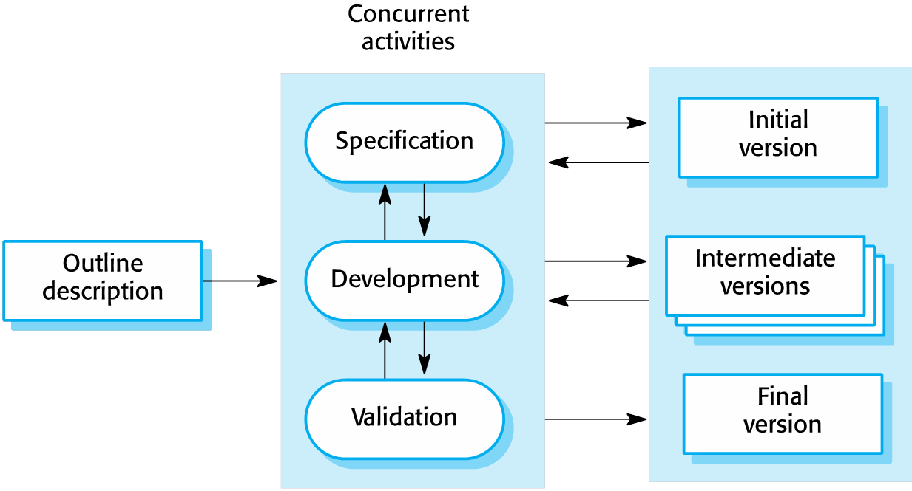

Figure 1.4: System design methodology

According to University Of Missouri, **Prototyping** is a process of building a model of a system. **Prototype** is employed to help system designer build an information system that intuitive and easy to manipulate for end users.

**Using agile methodology the scope of the project will be effectively met because;**

* The implementation process will respond to change over following a plan.
* User will interact with the development team over processes and tools during project lifetime.

# **4.3 Technologies and tools used**

* Frontend technology; php, java, css and html
* Backend technology; mysql
* Tools used; xamp and sublime text editor

# **4.4.0 Database design**

# **4.4.1 User case diagram**

User case diagram is graphical representation of the interactions among the elements of system. It is methodology used in system analysis for identifying, and organizing system requirement.

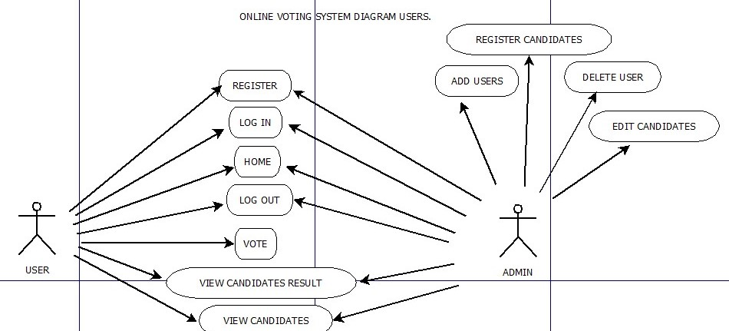

Figure 2.4: User case diagram

# **4.4 User interface Design**

A good user interface allows users to interact easily with the program. For ease of operation, below is the user interface that allows a user to easily get registered into the system.

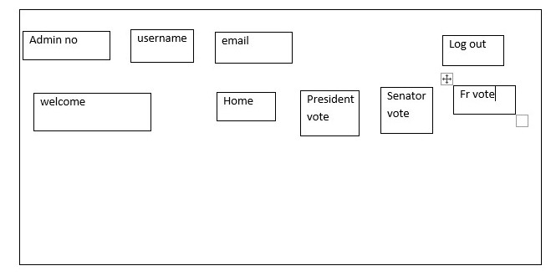

Figure 3.4: User interface design

# **CHAPTER FIVE**

# **SYSTEM IMPLEMENTATION**

# **5.1 Introduction to system implementation**

In this chapter, the design procedures are being translated into modules of program codes which when executed produces the required system. The program code, the installation procedure, operational guide, the testing of the new system to ensure it meets the required target as well as the change-over method to be adopted are all being undertaken during the implementation phase.

* 1. **Functionalities implementation**

1. System allows everyone to register except admin can registered on admin account only.

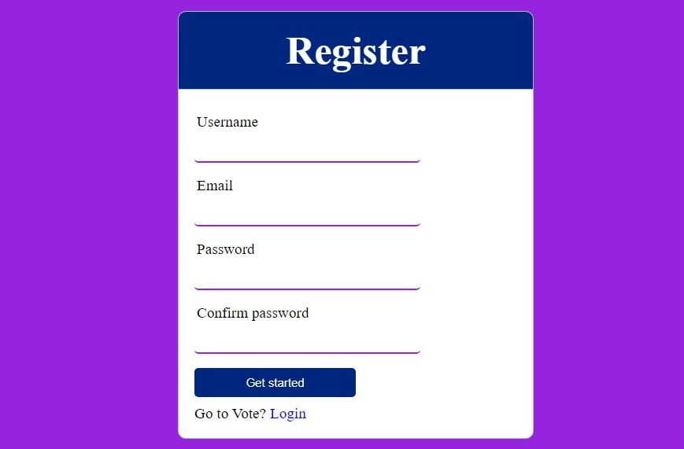

Figure 4.5: Admin account

1. System allow user to log in after registered.

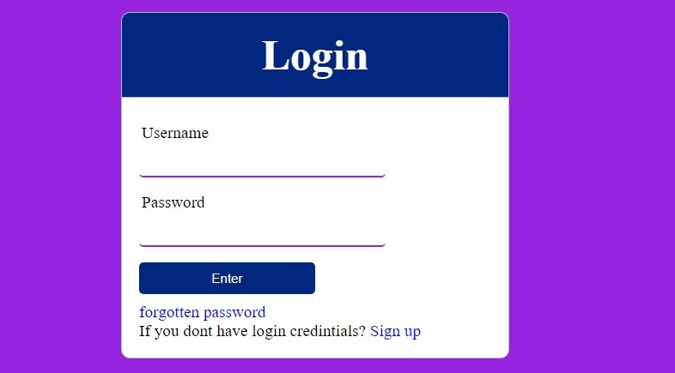

Figure 5.5: User login

1. Home page for choosing the selected option to vote the leaders.

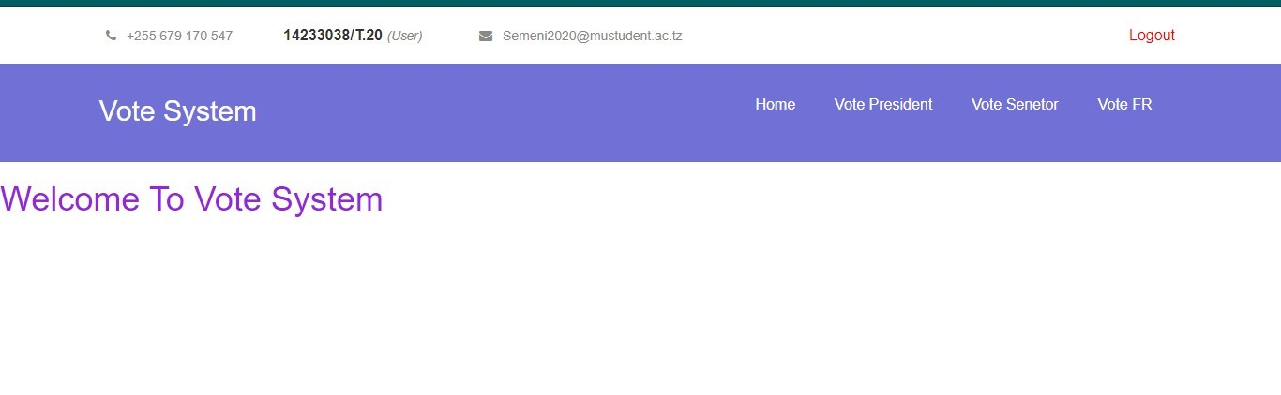

Figure 6.5: Home page

1. Student start to vote let’s starting with president part can click on vote battan and submit the selection not allowed to vote more than one time.

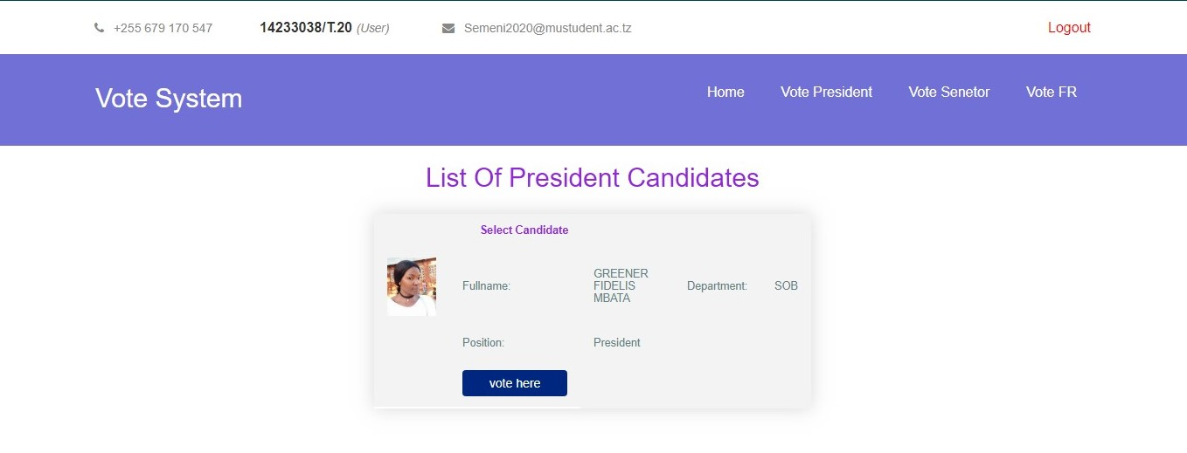

e) Also continue on senator part can do as former president process

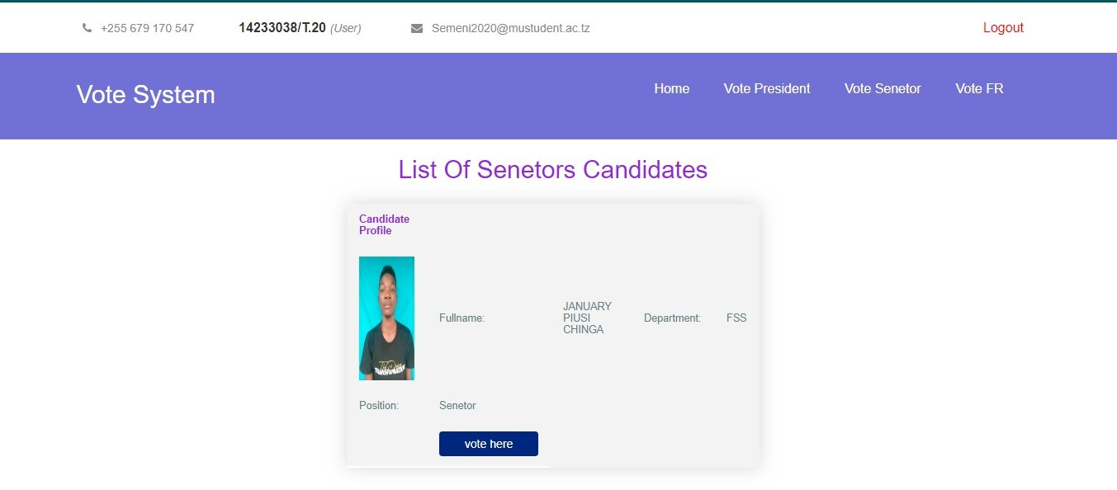

1. also select for FR position as well

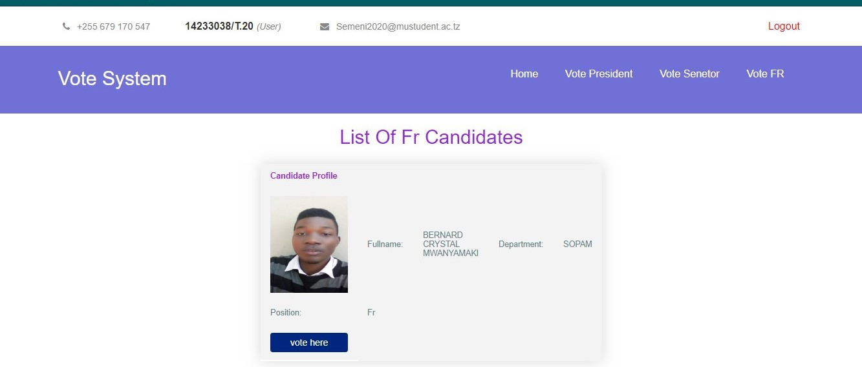

* 1. **Database implementation**

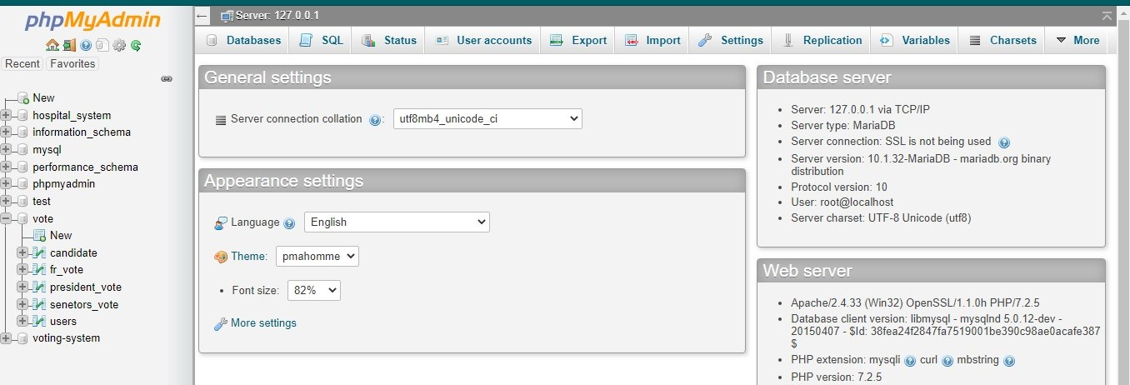

Figure 7.5: Data implementation

* 1. **User interface implementation**

User interface on home page is flexible and simple to use and to understand due the icons and option that appears on the page are user friendly even person without any guide to use can understand and perform online election process. There are greeting by displaying the username and email even there are problem there is admin contact that is inside the system.

# **5.5 System testing and evaluation**

This is the act of testing the proposed system to know if it is free from errors. It also validates that the overall system provides the units specified in the requirement. System testing is an activity that is carried out when the subsystems are integrated under some controls to make up the entire system.

**The processes and stages that are involved in system testing are as follows:**

* Unit Testing: This is the basic level of testing in which every unit that make up a module is being tested to ensure the accuracy of their operations. For each of the modules, the individual units that make up the modules were tested and accuracy was ensured before testing the module itself.
* Module Testing: This is the testing of the module made up of units as a standalone entity. All the modules were tested and they worked perfectly.
* Sub-System Testing: At this stage 4 of testing, some of the systems' modules are joined together to form a subsystem and were tested to ensure that the desired goal is fully achieved.
* Acceptance Testing: At this stage in the testing process, the new system is being tested by the user, using real data to ascertain that all the units, modules and the subsystems are properly integrated to interact with each other without errors or malfunctioning. However, the new system has undergone series of testing processes and is ascertained to have functioned as intended, as it meets the required specification.

# **CHAPTER SIX**

# **CONCLUSION AND RECOMMENDATIONS**

**6.0 Summary of achieved objective**

This project work discusses and designs a web based OVS which may be used in Mzumbe University, the project report is divided into chapters from chapter one to chapter six, chapter one of this project work address the general background, objectives, problems and significance of the research. Chapter two discusses the literate review and the system analysis. Chapter three deals with the requirement elicitation and system analysis, Chapter four deals with the design of newly system, chapter five explains about implementation of the newly developed system and finally chapter six discusses the general conclusion of all covered chapters and also a recommendation on the topic.

**6.1 Conclusion**

Manual process of voting system it needs more time, space, people to be around, cost of more money even thou it help and used up to now but we have to change according to the improvement of science and technology. Online voting system help student even were not around the university but if the election began were have open chance to get their right of choosing favorite leader to lead them.

# **6.3 Recommendation**

Mzumbe Universityis the among of worldwide open university in the world people from many different countries were joining to study from certificate to PHD also on issue of election process I recommend to use my system to favors people who are not be around during election time so in my system students are registered and vote candidates who are registered by administrator and were receiving the result immediately after complete the voting process. So here I recommend also due no one can destroy student election due all things done individual so my system working and have to start using.

**REFERENCES**

Amir Ngah, (2003) A Web Based Industrial Training Management System.

Cathy Schwalbe (2016), Information Technology Project Management. 8th edition Cengage Learning.

Coulin & Zowghi (2005) Requirement elicitations for complex systems.

Dennis, A. Roth, R.M & Wixom, B.H. (2012*). System Analysis and Design.*5th ed*.* RR Donnelley.

Laudon, K. C, & Laudon, J, P. (2012), Management Information System 12th Ed. New York; Prentice Hall.

Somerville, Ian (2011). *Software engineering*. 9th ed. Addison Wensley Publisher Limited.