Smart Contract Homework 1:

Exercise 1:

1)2)3) Code changed, picture submitted, approved by reviewers, merge done
https://github.com/Dauphine-Digital-Economics/Class-Directory/pull/41

4) Two reviews:
Kylian Santos: https://github.com/Dauphine-Digital-Economics/Class-Directory/pull/39#pullrequestreview-3679294558
Inès Damiche: https://github.com/Dauphine-Digital-Economics/Class-Directory/pull/47#pullrequestreview-3713303194

5) It says “Success! Your current Balance is 90060965245669870 Wei”, or 0.0900609652456699 ETH. I currently have 0.901 Sepolia ETH in my MetaMask. It is correct.

Exercise 2:

Part A:

1) The decrypted result is the same as the digest.
Transaction number: 0xb6664c387426e0a09a0b51b043f87e051c6d13020882f0f9109e10061eff6919

2) A pair of keys is generated with the RSA algorithm, a public and a private keys. The user keeps his private key (connecting his code editor to his GitHub account) and GitHub the public key. The private key allows to encrypt messages that GitHub can decrypt using the public key (every time the use makes a push to a repository), then recognizing the user by verifying the signature. The communication is handled by the SSH protocol.

The public key is given to platforms that are supposed to validate user identity, and the private key is used to encrypt messages directed to these platforms.

Part B:

Transaction number:
0xb6664c387426e0a09a0b51b043f87e051c6d13020882f0f9109e10061eff6919

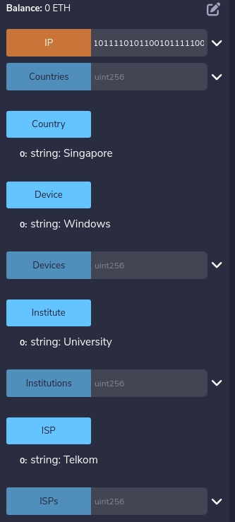

Network topology essay:

(Note: this essay is mostly based on the notes on one of my classmates. The notes not being complete, I could not do the whole assignment. I will focus more on the next homework. )

During the game, multiple network topologies were recreated using the students as nodes or bridges. Handwritten messages were then sent in a particular way at each round of the game, denoting the characteristics of the chosen network structure. Every time the message reached a new node, the student in charge of this “node” had to reinterpret the message in a given amount of time, then send it. Bridges would take messages from one node to another, reading the message, but not modifying it. The final answer was determined using a pre-selected consensus mechanism, that evolved throughout the rounds.

Similarly to a real network, some nodes were unreliable, as their transmissions were significantly different from the original message. The time allotted could be to short for correct reinterpretation, leading to summarized or truncated messages. The unreliability steams from the practical circumstances, not particularly from malevolent behavior.

About the consensus mechanisms of the game, we recognize some methods used in actual mainstream blockchains.
The first consensus was “The first message to arrive is the truth”. It shares similarities with the Solana consensus, which is a combination of the Proof-of-Stake (PoS) and Proof-of-History(PoH). Showing work for consensus is the main principle of Proof-of-Work (PoW), the consensus mechanism of the BTC blockchain.
Voting is akin to the Ethereum blockchain. Two thirds of the voters have to agree on a final decision. In the game, the group of voters could be limited to the bridges.

To choose a network structure and a consensus mechanism for a blockchain, multiple aspects should be considered. Using our experiences from the simulation game, let’s see the pros and cons of the different options.

A line network is direct, with each node only sending the message to one other node. It is however very sensitive to node failure, as only one failure in the line fully prevents the recovery of the initial message.

A mesh network is more complex and slower as each node will have to send a copy of the message to multiple nodes. However, it helps to recover the original message in case of failure of one or multiple nodes, depending on the consensus mechanism. It is thus more robust to node failure.

The main cause of error in the game seems to be the time given to each node to transmit the message correctly, especially when multiple copies had to be sent (mesh structure). There is a real tradeoff between speed, accuracy and robustness to node failure.

For example, I do not know which topology was chosen for each round.

