🔬 Project Summary: ElementMix – AI-Based Chemical Reaction Simulator

ElementMix is an intelligent and interactive chemical reaction simulator designed to predict the results of combining elements from the periodic table. This project was created to make chemistry more engaging, visual, and easier to understand, especially for students and educators.

Users can select any two elements using dropdown menus that display both the full name and its symbol (e.g., Sodium (Na), Chlorine (Cl)). Alternatively, users can type a custom formula (like Na + Cl or H₂ + O₂ + N₂) into a flexible input field. The system then analyzes the combination and provides a clean, structured output — including the final product, the balanced chemical equation, and a brief explanation of why the reaction occurs and where it is applied in real life.

If the reaction exists in the predefined database, it is returned instantly. If not, the system intelligently generates a result based on deep research logic built into the backend. The output is filtered and formatted for clarity, with colorful visual styling and structured spacing that enhances readability and learning.

Developed as part of an academic challenge, ElementMix showcases how deep scientific reasoning and smart technology can create powerful, user-friendly educational tools.

🔗 https://elementmix-isro-project.onrender.com/

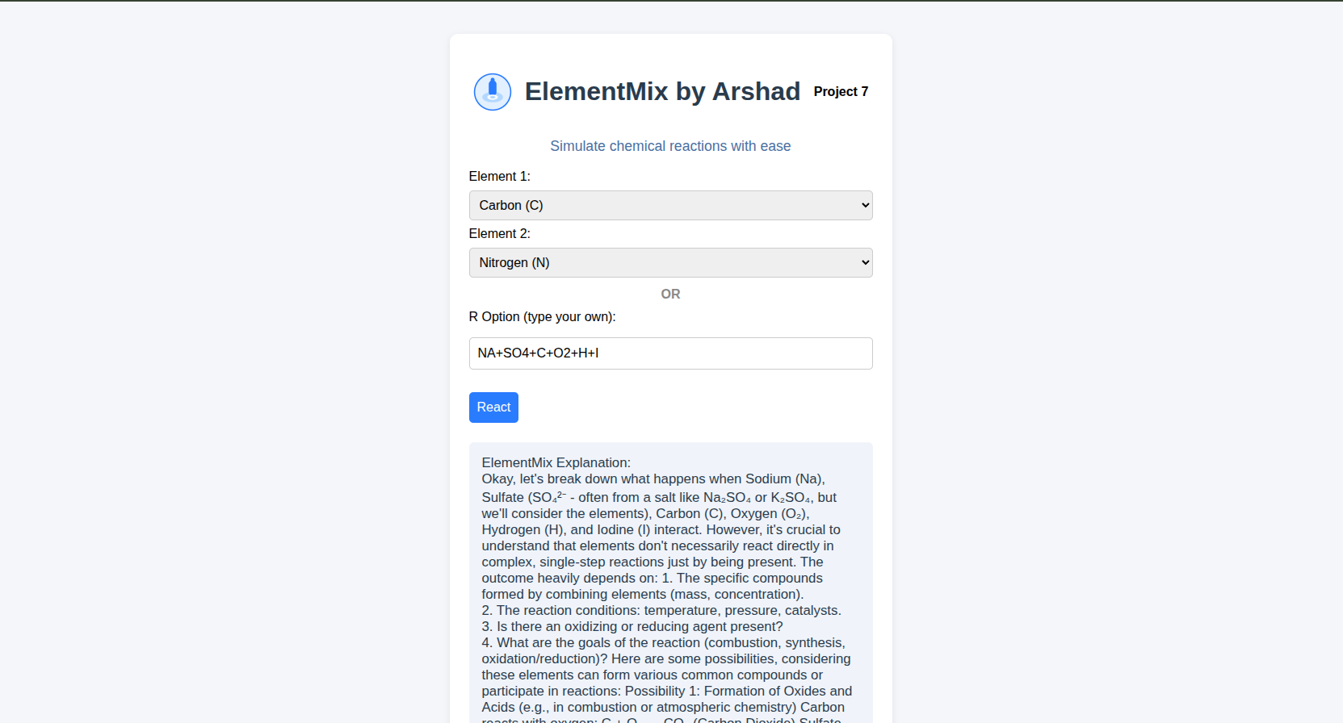

From :
Arshad Pasha
Final Year BCA-’A’
Seshadripuram Degree College, Mysore

