**GitHub & GitLab**

MY Website **Arshadpasha.tech , SEO is High**

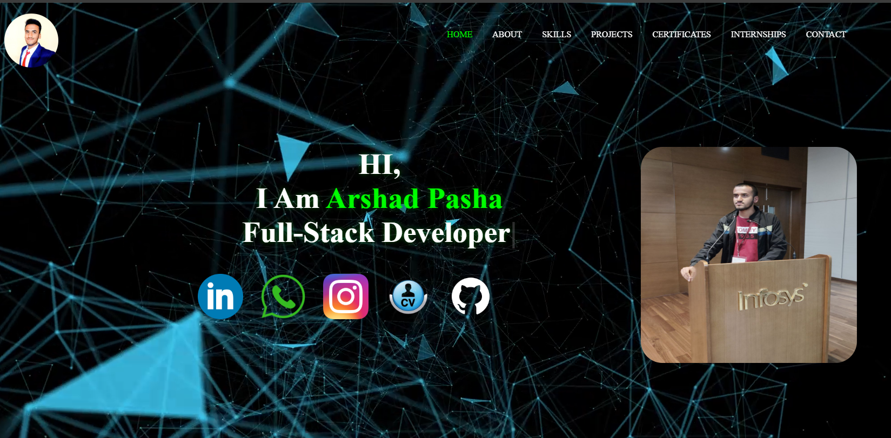

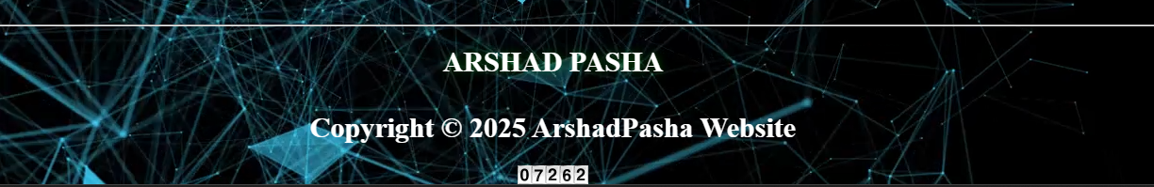

**Google Cloud Certificates**



