COSMONET AI
Version 2: Clean Humanized UI/UX Design Mockups
This version features a much cleaner, light background design focused on a realistic, professional, and corporate human-centric aesthetic.

1. Hero Banner & Navigation (Light Theme)
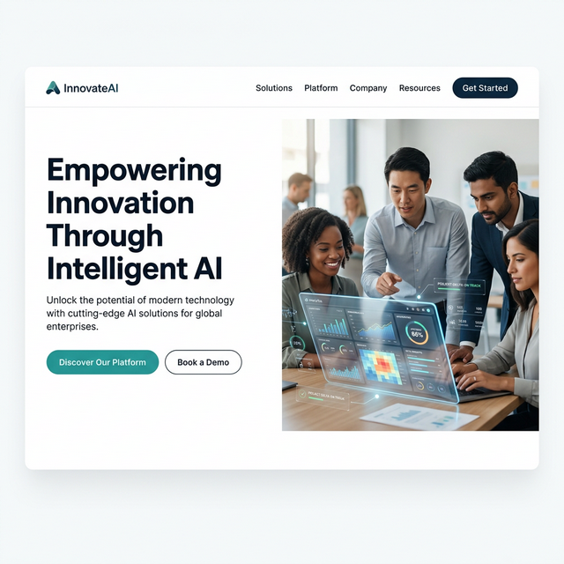
Mockup for: Hero Banner & Navigation (Light Theme)

2. Services Grid & Metrics Data
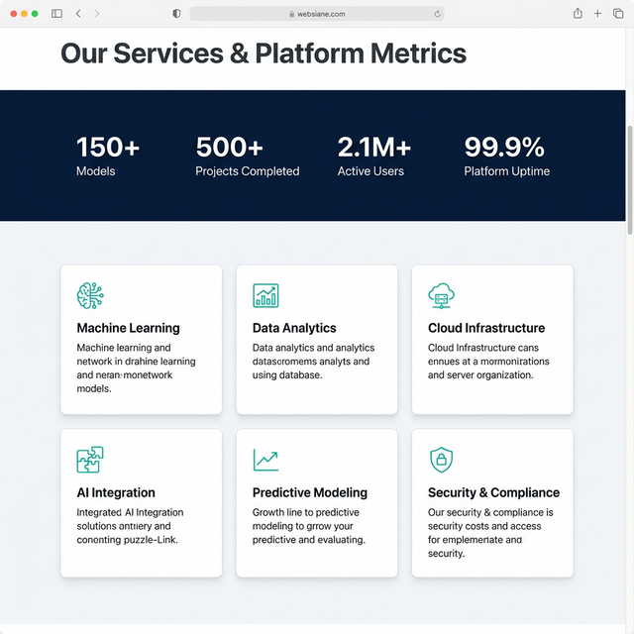
Mockup for: Services Grid & Metrics Data

3. About Us & Why Choose Us Features
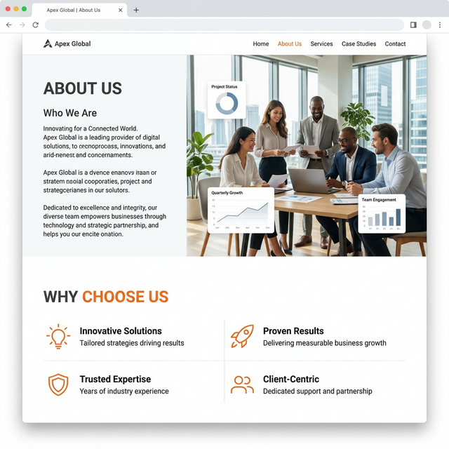
Mockup for: About Us & Why Choose Us Features

4. Contact Form & Dark Navy Footer
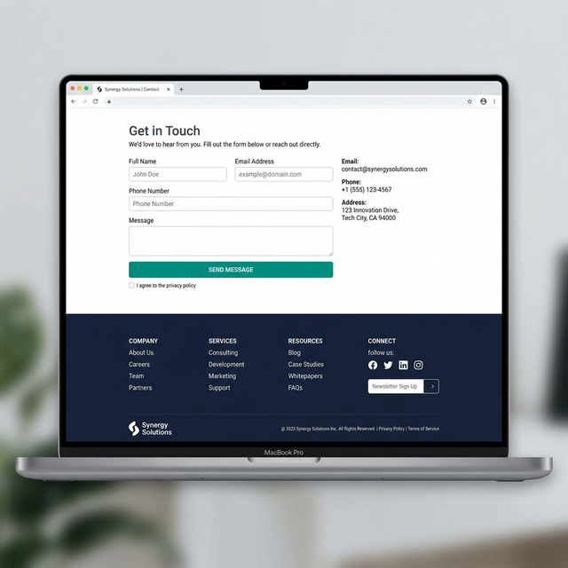
Mockup for: Contact Form & Dark Navy Footer

