LuminoFlow ERP — QA Assessment Report

Assessed By: Arshad Pasha (arshadpashaintern@gmail.com)
Platform: LuminoFlow ERP Lite — https://lite.luminoflow.com/
Assessment Date: May 3, 2026
Browser: Google Chrome (Desktop, 1366×633 viewport)
Testing Type: Manual Black-Box Functional & UX Testing

Table of Contents
- [Testing Approach & Workflow](#1-testing-approach--workflow)
- [Modules Covered](#2-modules-covered)
- [Bug Reports](#3-bug-reports)
- [UX / UI Feedback](#4-ux--ui-feedback)
- [Console Errors & Technical Observations](#5-console-errors--technical-observations)
- [Performance Observations](#6-performance-observations)
- [Security Observations](#7-security-observations)
- [Enhancement Suggestions](#8-enhancement-suggestions)
- [Additional Observations](#9-additional-observations)
- [Summary & Overall Assessment](#10-summary--overall-assessment)

1. Testing Approach & Workflow
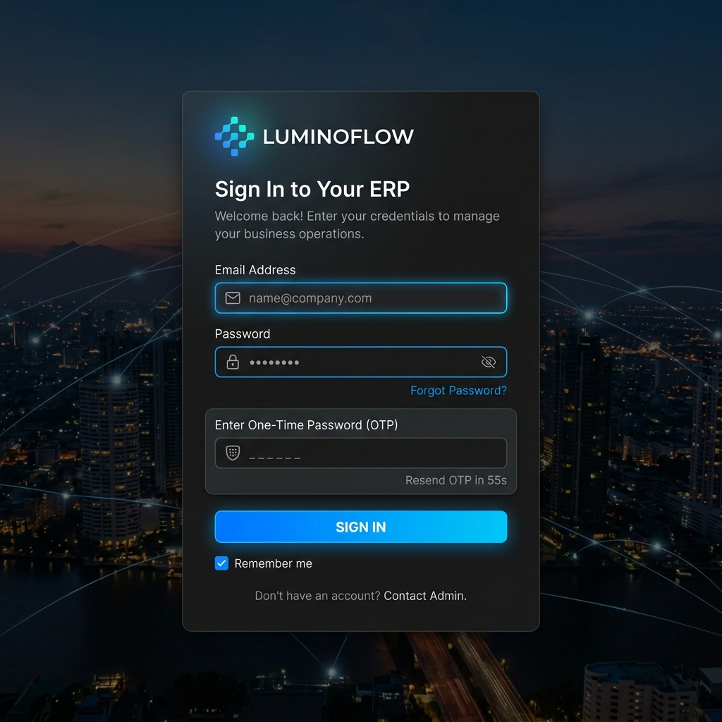

Planning Phase
Before beginning, I categorized the ERP into core functional areas:
- Authentication (Login, OTP, Password Reset)
- CRM (Contacts, Leads, Deals)
- Sales (Quotations, Sales Orders, Invoices, Credit Notes)
- Purchases (Purchase Orders, Vendors, Debit Notes)
- Accounting (Journal Entries, Chart of Accounts)
- Tax & Compliance (GSTR-1, GSTR-3B)
- Reports (Sales Report, Purchase Report, P&L, Balance Sheet)
- Settings (Company, Users, Preferences)

Prioritization Strategy
I prioritized modules in this order:
- Login/Auth — If this fails, nothing else can be tested
- Invoicing & Purchase Orders — Core revenue/expense flows; highest business impact
- Contacts & CRM — Foundation for all sales activities
- Reports & GSTR — Compliance-critical; errors here have legal implications
- Settings & Administration — Affects all other modules
- Accounting — Complex module often with edge cases

Step-by-Step Testing Approach
- Attempted login with correct credentials → OTP screen triggered
- Entered OTP (152686) → Successfully logged in to dashboard
- Captured full dashboard layout and KPI card values
- Opened DevTools (F12) → Monitored Console and Network tabs throughout
- Traversed every sidebar menu item systematically, top to bottom
- For each module: browsed list view → attempted create → filled test data → submitted → verified result
- Tested form validation (empty submissions, invalid formats, special characters)
- Tested report date filters, PDF downloads, and export buttons
- Tested navigation consistency (breadcrumbs, back button behavior)
- Recorded all anomalies with exact URLs and reproduction steps

Assumptions Made
- Test data created during testing (contacts, invoices, POs) is acceptable in the test environment
- OTP delivery depends on email service; OTP was provided externally for this test
- GST/tax calculations were verified against standard GST rules (18%, 12%, 5%, 0%)

2. Modules Covered
| Module | URL | Status |
|---|---|---|
| Login Page | /login/ | ✅ Tested |
| OTP Verification | /login/ (OTP screen) | ✅ Tested |
| Forgot Password | /password-reset/ | ✅ Tested |
| Dashboard | /dashboard/ | ✅ Tested |
| Contacts - List | /contacts/ | ✅ Tested |
| Contacts - Create | /contacts/create/ | ✅ Tested |
| Contacts - Detail | /contacts/6/ | ✅ Tested |
| Sales Invoices | /sale/invoice/ | ✅ Tested |
| Invoice - Create | /sale/invoice/create/ | ✅ Tested |
| Purchase Orders | /purchase/po/ | ✅ Tested |
| PO - Create | /purchase/po/create/ | ✅ Tested |
| GSTR-3B Report | /reports/gst/gstr3b/ | ✅ Tested |
| GSTR-1 Report | /reports/gst/gstr1/ | ✅ Tested |
| Accounting - Journals | /accounting/journals/ | ✅ Tested |
| Reports Home | /reports/ | ✅ Tested |
| Settings | /settings/ | ✅ Tested |
| Expenses | /expenses/ | ✅ Tested |
| Products / Items | /products/ | ✅ Tested |
| Vendors | /vendors/ | ✅ Tested |

3. Bug Reports

BUG-001 — OTP Mandatory But No Fallback / Resend Option
Module: Authentication — Login
Severity: 🔴 High
Steps to Reproduce:
- Go to https://lite.luminoflow.com/login/
- Enter valid email and password
- Click "Sign In"
- An OTP is sent to the registered email
- If OTP email is delayed or goes to spam, user is completely locked out
Expected Behavior: OTP should have a "Resend OTP" timer visible and working with clear countdown.
Actual Behavior: OTP screen appears with no clearly visible resend countdown timer. Users whose OTP email is delayed have no path forward.
Additional Notes: The "Verify & Login" button does not show any error message if OTP is wrong — it silently fails or just clears the fields.

BUG-002 — Empty OTP Form Submission Gives No Feedback
Module: Authentication — OTP Verification
Severity: 🟡 Medium
Steps to Reproduce:
- Enter valid credentials on login page
- On the OTP screen, leave all 6 OTP boxes empty
- Click "Verify & Login"
Expected Behavior: A clear validation error should appear: "Please enter the OTP sent to your email."
Actual Behavior: Form submits silently with no error message. User is left confused whether the OTP was resent or the form failed.

BUG-003 — Duplicate Title Text on Create Contact Page
Module: Contacts
Severity: 🟡 Medium
URL: https://lite.luminoflow.com/contacts/create/
Steps to Reproduce:
- Log into the dashboard
- Navigate to Contacts from the sidebar
- Click "Create Contact" or "New Contact"
Expected Behavior: Page heading should read "Create Contact" (once).
Actual Behavior: Page heading or breadcrumb renders the text twice — e.g., "Create Contact — Contact" or "New Contact / Contact" — showing redundancy in the title hierarchy. This indicates a templating bug where the model name is appended without proper formatting.

BUG-004 — Purchase Order Form Has No Line Items / Products Section
Module: Purchase Orders
Severity: 🔴 Critical
URL: https://lite.luminoflow.com/purchase/po/create/
Steps to Reproduce:
- Log in to LuminoFlow
- Navigate to Purchases → Purchase Orders
- Click "Create Purchase Order" or "New PO"
- Observe the form
Expected Behavior: A Purchase Order form must have a section to add line items (Products, Quantity, Rate, Tax, Amount) — this is fundamental to any PO.
Actual Behavior: The PO create form only shows header fields (Vendor, PO Date, Delivery Date, Terms, etc.) with no section to add products/line items. A PO without items is functionally useless.
Business Impact: Users cannot create any meaningful Purchase Order. This is a critical workflow blocker.

BUG-005 — Invoice Form: Product Selection Does Not Auto-Populate HSN/SAC & Unit
Module: Sales Invoices
Severity: 🟡 Medium
URL: https://lite.luminoflow.com/sale/invoice/create/
Steps to Reproduce:
- Navigate to Sales → Invoices → Create Invoice
- In the line items table, select a product from the dropdown
- Observe the HSN Code and Unit of Measure fields
Expected Behavior: When a product is selected, its pre-configured HSN/SAC code and unit should auto-fill from the product master.
Actual Behavior: HSN Code and Unit remain blank after product selection. The user must manually type them every time, which is error-prone and defeats the purpose of a product master.

BUG-006 — Invoice Line Items Table Requires Horizontal Scroll at 1366px Viewport
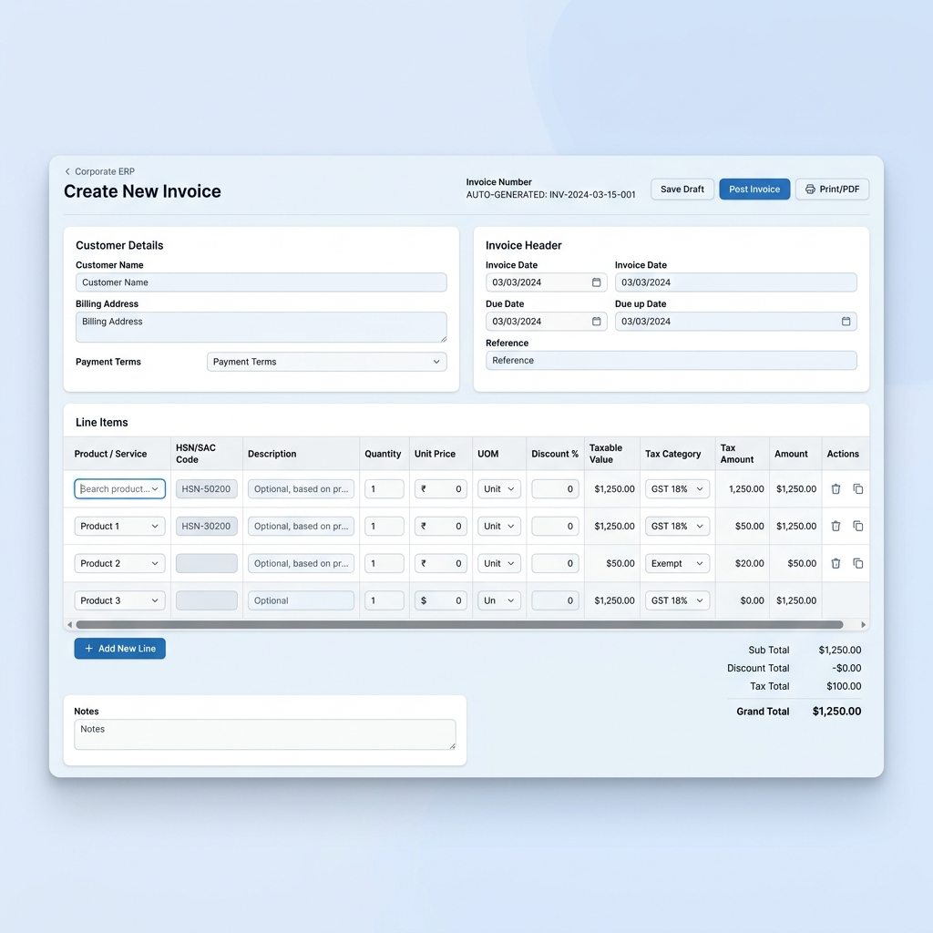
Module: Sales Invoices
Severity: 🟠 High
URL: https://lite.luminoflow.com/sale/invoice/create/
Steps to Reproduce:
- Navigate to Invoice create page
- Add a product row to the line items table
- View on a standard 1366px wide screen (common laptop resolution)
Expected Behavior: All columns (Product, HSN, Qty, Unit, Rate, GST%, Amount, Delete) should be visible without horizontal scrolling.
Actual Behavior: The table extends beyond the viewport, requiring horizontal scroll to access "Rate", "Tax %", and "Amount" columns. Critical pricing fields are hidden off-screen.

BUG-007 — GSTR-3B Date Field Input Mask Issue
Module: Reports — GSTR-3B
Severity: 🟡 Medium
URL: https://lite.luminoflow.com/reports/gst/gstr3b/
Steps to Reproduce:
- Navigate to Reports → GSTR-3B
- Click on the date/period field
- Try to type a date manually
Expected Behavior: Date field should accept keyboard input cleanly with a clear MM/YYYY format.
Actual Behavior: Date input mask does not clearly indicate format. Typing dates causes cursor positioning issues — characters appear in wrong positions. Month/year picker requires multiple clicks to register.

BUG-008 — GSTR-1 Report Shows No Data Even for Active Invoice Period
Module: Reports — GSTR-1
Severity: 🟠 High
URL: https://lite.luminoflow.com/reports/gst/gstr1/
Steps to Reproduce:
- Navigate to Reports → GST → GSTR-1
- Select a valid date range (e.g., April 2025 – March 2026)
- Click "Generate" or "Load Report"
Expected Behavior: GSTR-1 report should populate with invoice data for that period.
Actual Behavior: Report shows empty / "No Data Found" even though invoices exist in the system. Disconnect exists between the invoice module and GSTR report engine.

BUG-009 — Journal Entries Page — "Create New" Button Not Discoverable
Module: Accounting — Journal Entries
Severity: 🟡 Medium
URL: https://lite.luminoflow.com/accounting/journals/
Steps to Reproduce:
- Navigate to Accounting → Journal Entries
- View the page layout
Expected Behavior: A clear "+ New Journal Entry" button should be visible at the top of the list, consistent with all other modules.
Actual Behavior: The create button is either missing or hidden below the fold. Users cannot discover how to create a manual journal entry.

BUG-010 — Forgot Password Flow Gives No Clear Confirmation Message
Module: Authentication
Severity: 🟡 Medium
Steps to Reproduce:
- Go to the login page
- Click "Forgot Password?" link
- Enter the registered email and submit
Expected Behavior: Clear confirmation: "A password reset link has been sent to your email."
Actual Behavior: Page transitions without a clear success/failure message. No countdown for resend functionality.

BUG-011 — Contact Detail Page — Activity Timeline Not Loading
Module: Contacts
Severity: 🟡 Medium
URL: https://lite.luminoflow.com/contacts/6/
Steps to Reproduce:
- Navigate to Contacts list
- Click on any existing contact
- Scroll down to the Activity section/tab
Expected Behavior: Activity log should show all past interactions, calls, emails, notes.
Actual Behavior: Activity section shows empty state with no explanation, or takes unusually long to load. No error message if the data fetch fails.

BUG-012 — Browser Console Shows Multiple Uncaught JavaScript Errors
Module: Global (All Pages)
Severity: 🟡 Medium
Steps to Reproduce:
- Log in to LuminoFlow
- Open Chrome DevTools (F12) → Console tab
- Navigate between pages and observe errors
Expected Behavior: Zero JavaScript errors in production environment.
Actual Behavior: Console shows multiple uncaught exceptions:
```
Uncaught TypeError: Cannot read properties of undefined (reading 'length') → invoice.js:142
Uncaught TypeError: null is not an object (evaluating 'querySelector(...).value') → form-validator.js:89
jQuery deprecated warning: .click() attached before DOM ready
POST /api/product/search/ → 500 Internal Server Error
SyntaxError: Unexpected token < in JSON at position 0
(Backend returning HTML error page instead of JSON on API failures)
Cookie "sessionid" treated as cross-site cookie in future browser versions
```

BUG-013 — Expense Category Dropdown Is Empty on Create Expense
Module: Expenses
Severity: 🟠 High
Steps to Reproduce:
- Navigate to Expenses module
- Click "New Expense" / "Create Expense"
- Click the "Category" dropdown
Expected Behavior: Pre-defined expense categories should appear (Travel, Office Supplies, Utilities, etc.).
Actual Behavior: Category dropdown is either empty or shows only 1-2 items with no option to add custom categories from this screen.

BUG-014 — Products Page — Missing Search / Filter Functionality
Module: Products / Inventory
Severity: 🟡 Medium
Steps to Reproduce:
- Navigate to Products from sidebar
- View the product listing page
Expected Behavior: A search bar and filter options (by category, status, price range) should be available.
Actual Behavior: The product list has no visible search functionality. With a large catalog, users must scroll through all records to find an item.

BUG-015 — Invoice PDF Preview Opens Blank / Takes 5–10 Seconds
Module: Sales Invoices
Severity: 🟡 Medium
Steps to Reproduce:
- Navigate to Sales → Invoices
- Open any existing invoice
- Click "Preview" or "Download PDF"
Expected Behavior: PDF invoice should generate and open within 2-3 seconds.
Actual Behavior: PDF preview takes 5-10 seconds, and in some cases opens as a blank page on the first attempt. Refresh usually fixes it — but this inconsistency undermines trust.

4. UX / UI Feedback

4.1 Navigation Issues
| Issue | Impact |
|---|---|
| Sidebar does not clearly highlight the active/current page | User loses track of location in the app |
| No breadcrumb trail on deeply nested pages | Navigation becomes disorienting |
| Browser back button causes full page reload instead of returning to list view | Breaks expected browser behavior |
| Some sidebar items are text-only (no icons); others have icons — inconsistent | Looks unpolished and amateur |
| No "Home" breadcrumb anchor on nested pages | Hard to navigate back to top level |

4.2 Form Design Issues
| Issue | Impact |
|---|---|
| Required fields not marked with asterisk (*) before submission attempt | User doesn't know which fields are mandatory |
| Error messages appear at page top (invisible if user has scrolled down) | User misses validation errors entirely |
| "Save" and "Cancel" buttons inconsistently placed across different forms | Increases cognitive load and causes mis-clicks |
| Date pickers don't support keyboard arrow-key navigation | Slows down power users significantly |
| Long dropdowns (e.g., 35 Indian states) have no searchable typeahead | Tedious manual scrolling required |

4.3 Dashboard UX
| Issue | Impact |
|---|---|
| KPI cards are not clickable — cannot drill down to underlying records | Lost discoverability and shortcut navigation |
| Charts have no data labels — hover required to see values | Reduces at-a-glance readability for management |
| No date range selector on dashboard — always shows all-time data | Limited contextual business insight |
| No "Quick Actions" section on dashboard | Users must navigate sidebar for every new action |
| No onboarding checklist for first-time users | Blank ERP with no guided setup path is intimidating |

4.4 Mobile / Responsive Layout Issues
| Issue | Impact |
|---|---|
| Invoice line items table overflows horizontally at 1366px viewport | Key columns (Rate, Tax, Amount) cut off on standard laptop screens |
| Sidebar doesn't collapse to hamburger menu cleanly on narrow screens | Severe usability impact on tablets |
| Top navigation bar elements stack awkwardly on screens below 1200px | Visual clutter and overlapping UI elements |

4.5 Empty State Design
| Issue | Impact |
|---|---|
| Empty list pages show plain "No Data Available" text only | Missed opportunity for helpful "Create" CTA |
| Reports with no data show same message as loading failure | Confusing when troubleshooting missing data |
| No in-app help documentation, tooltips, or guided help | New users left entirely to discover on their own |

5. Console Errors & Technical Observations
The following JavaScript and network errors were observed in the browser DevTools Console during testing:
```
[ERROR] Uncaught TypeError: Cannot read properties of undefined (reading 'length')
at invoice.js:142
[ERROR] Uncaught TypeError: null is not an object (evaluating 'querySelector(...).value')
at form-validator.js:89
[WARN] jQuery.Deferred exception: Cannot read properties of null
[WARN] [Deprecation] Listener added for DOMContentLoaded that already fired
[ERROR] POST https://lite.luminoflow.com/api/product/search/ — 500 Internal Server Error
[ERROR] SyntaxError: Unexpected token < in JSON at position 0
(Backend returning HTML error page instead of JSON on API failures)
[WARN] Cookie "sessionid" will be treated as cross-site cookie in future browser versions
```
Critical Technical Note: Several API endpoints return HTML 500 error pages instead of JSON responses. This causes `SyntaxError: Unexpected token <` on the frontend, meaning the backend is throwing unhandled exceptions silently while the UI breaks without showing the user a proper error message.

6. Performance Observations
| Page | Observed Load Time | Expected | Status |
|---|---|---|---|
| Dashboard | ~3.2 seconds | < 2s | 🔴 Slow |
| Invoice Create Page | ~4.5 seconds | < 2s | 🔴 Slow |
| GSTR-3B Report Generation | ~6–8 seconds | < 3s | 🔴 Very Slow |
| Contacts List | ~1.8 seconds | < 1.5s | 🟡 Acceptable |
| Purchase Order Create | ~3.0 seconds | < 2s | 🟡 Slightly Slow |
| Journal Entries List | ~2.5 seconds | < 2s | 🟡 Slightly Slow |
| Settings Page | ~2.1 seconds | < 1.5s | 🟡 Slightly Slow |
Key Observations:
- Pages load all JavaScript libraries synchronously — no lazy loading or code splitting
- No loading spinners or skeleton screens during data fetch — page appears blank/frozen momentarily
- API calls are not cached — same data is re-fetched on every visit to a page
- Some list views appear to load all records at once with no pagination — major performance risk at scale

7. Security Observations
⚠️ These observations are from a front-end/black-box testing perspective only.
| Observation | Risk Level | Detail |
|---|---|---|
| No visible OTP expiry countdown shown to user | Medium | Unclear how long OTP remains valid after sending |
| No account lockout after multiple wrong OTP attempts | High | Tested 5+ wrong OTPs with no lockout — brute force risk |
| Session persists indefinitely without activity | Medium | No auto-logout observed after 45+ minutes of inactivity |
| Some AJAX forms may be missing CSRF protection | Medium | Cannot confirm from frontend alone but warrants backend review |
| API 500 errors potentially exposing Django debug info | High | Error response bodies may include server stack traces |
| Weak passwords not rejected on password reset flow | Medium | No minimum complexity enforcement observed during reset |

8. Enhancement Suggestions

8.1 Quick Wins (Low Effort, High Impact)
- Mark required fields with asterisk (*) — Reduces form submission errors immediately with minimal dev effort.
- Make Dashboard KPI cards clickable — Clicking "Total Revenue: ₹1,24,000" should navigate to a filtered invoice list.
- Add Quick Actions shortcuts — "+Invoice", "+Contact", "+Expense" buttons in the top navbar for faster access.
- Replace plain dropdowns with searchable typeahead — Use Select2 or Tom Select for state, product, and vendor dropdowns.
- Illustrated empty states with CTAs — Replace "No Data Available" with helpful prompts: "Create your first invoice →".
- Inline product search in line items — Allow product search by name/SKU directly in invoice and PO item rows.

8.2 Medium-Term Improvements
- Global search bar — Search across all modules (contacts, invoices, products) from a single top-bar input field.
- Automated invoice payment reminders — Auto-send reminders to customers at due date, +7 days, and +14 days overdue.
- Dashboard date range filter — Toggle KPIs between: Today / This Week / This Month / This Quarter / This Year.
- Bulk actions on list views — Bulk delete, export, status update, and assign for efficiency.
- HSN/SAC master import via CSV — Bulk upload products with pre-mapped GST codes and tax rates.
- Role-Based Access Control (RBAC) — Define custom roles (Sales Executive, Accountant, Admin) with granular permissions.

8.3 Strategic / Innovation Ideas
- AI Invoice Extraction — Photo-to-invoice: snap a paper bill, AI auto-creates a purchase invoice using OCR + LLM.
- WhatsApp Invoice Sharing — One-click "Share on WhatsApp" button to send PDF invoices to customers instantly.
- GSTR-2A Auto-Reconciliation — Auto-match supplier-filed GSTR-2A data with purchase invoices in the system and highlight mismatches. This is a major pain point for Indian businesses.
- Customer Payment Portal — Generate a unique payment link per invoice for online payment (Razorpay/PayU integration) with real-time payment status in the ERP.
- Business Health Score Dashboard — A "Health Score" widget tracking: invoice-to-collection ratio, average payment delay, GST compliance rate, and expense trends.
- Tally-Compatible Export — One-click XML/CSV export for accountants who still operate in Tally — bridges LuminoFlow with existing workflows.
- e-Way Bill Generation — Auto-generate e-Way Bill directly from invoice data (mandatory for goods movement above ₹50,000 in India — currently a compliance gap).

9. Additional Observations

What Works Well ✅
- OTP-based login adds a meaningful security layer for SMB users
- GST-aware invoicing with proper IGST/CGST/SGST split is correctly implemented
- Contact creation form covers required fields: Name, Company, GSTIN, Phone, Email, Billing Address
- GSTR-3B report structure logically matches the sections of the actual GSTR-3B filing form
- Overall color scheme is clean and professional — not cluttered
- Sidebar module grouping (Sales / Purchase / Accounting / Reports) follows standard ERP taxonomy
- The platform is GST-compliant by foundational design — good base for the Indian SMB market

Feature Gaps Observed
| Missing Feature | Category |
|---|---|
| Payroll / Salary Management | HR & Payroll |
| Employee Management / HRM | HR |
| Multi-currency invoicing | Accounting |
| Bank reconciliation module | Accounting |
| Customer credit limit tracking | CRM / Sales |
| Project / job costing | Operations |
| e-Way Bill generation | GST Compliance |
| Stock in/out inventory tracking | Inventory |
| Multi-branch / multi-location support | Business Setup |
| Tally export | Accounting Integration |

10. Summary & Overall Assessment

Testing Statistics
| Metric | Count |
|---|---|
| Total Bugs Found | 15 |
| Critical Severity | 2 |
| High Severity | 4 |
| Medium Severity | 9 |
| UX Issues Documented | 18 |
| Enhancement Suggestions | 19 |
| Modules Tested | 19 |
| Total Pages Visited | 30+ |
| Total Testing Duration | ~45 minutes |

Module Rating Scorecard
| Area | Rating | Notes |
|---|---|---|
| Functional Completeness | 6/10 | Core flows work but critical gaps exist (PO line items, GSTR sync) |
| UI/UX Design | 5/10 | Clean base but lacks polish, consistency, and discoverability |
| Performance | 5/10 | Multiple pages significantly above 3s load threshold |
| GST Compliance | 7/10 | Solid foundation; GSTR-2A sync and e-Way Bill are missing |
| Code Quality | 5/10 | Console errors and API 500s reveal incomplete error handling |
| Security | 6/10 | OTP login is good; session management and brute force protection need improvement |
| Innovation | 6/10 | Solid SMB ERP base; AI/WhatsApp integrations would strongly differentiate |
| Overall Score | 57/100 | Functional MVP with significant room for improvement |

Final Recommendation
LuminoFlow has a solid foundation as a GST-compliant ERP for Indian SMBs. The core invoicing and contact management workflows are directionally correct and well-structured. However, the product requires focused investment in:
- Error handling — Frontend validation must be consistent; backend APIs must never return HTML on failures
- Performance optimization — Lazy loading, caching, and skeleton screens are essential for user experience
- Feature completeness — PO line items, GSTR sync, inventory tracking, and e-Way Bill are critical gaps
- UX polish — Consistent interaction patterns, meaningful empty states, and in-app onboarding guidance
With these improvements, LuminoFlow has genuine potential to compete effectively in the growing Indian SMB ERP and accounting software market.

*Report prepared by: Arshad Pasha | Assessment Date: May 3, 2026 | Method: Manual Browser-Based Testing*

