PROBLEM STATEMENT:

RemediBot: Your Natural Health Advisor
- Many people prefer using home remedies to treat minor health issues such as cold, headache, stomach ache, and skin problems. However, finding the right remedy for specific issue can be challenging and people often seek information and advice from various sources, which may not always be reliable or accurate.
- To address this problem, a chatbot can be developed to provide users with a accurate and personalized information on home remedies for various health issues. The chatbot can also offer advice on the proper use and dosage of remedies, as well as precautions and possible side effects.
- The challenge in developing such as chatbot is to ensure that the information provided is accurate, reliable, and up-to-date. The chatbot should also be designed to understand natural language queries and provide responses that are easy to understand and actionable. Moreover, the chatbot should be able to adapt to different user profiles, preferences, and contexts, providing personalized recommendations based on the user’s health history and lifestyle.

INTRODUCTION:
REMEDIBOT is a chatbot that provides users with accurate and personalized information on home remedies for various health issues can be a useful tool in promoting self-care and empowering individuals to take control of their health. In this project, we propose the development of a chatbot that uses natural language processing and machine learning techniques to understand users' queries and provide them with relevant and reliable information on home remedies. The chatbot will be designed to adapt to different user profiles, preferences, and contexts, providing personalized recommendations based on the user's health history and lifestyle. To ensure the accuracy and reliability of the information provided, we will use reputable sources, such as medical journals and books on home remedies, and consult with healthcare professionals. We will also incorporate user feedback and continuously update the chatbot's knowledge base to ensure that it remains up-to-date and relevant. The chatbot will be tested with a diverse group of users to evaluate its effectiveness in providing accurate and personalized information on home remedies. The results of the study will provide insights into the potential of chatbots in promoting self-care and improving health outcomes. Overall, this project aims to develop a chatbot that is user-friendly, reliable, and effective in promoting the use of home remedies for minor health issues.

BACKGROUND RESEARCH:

Many of the existing systems have live chats through texts and some limitation such as there is no instant response given to the patients they have to wait for experts acknowledgement for a long time. Some of the processes may charge amount to live chat or telephony communication. However, the issue of these technologies are cost effective in clinical practice remains a consideration for future research studies.Such as Ada Health and YourMD are both AI-powered health chatbots that offer personalized advice on a range of medical issues. Both chatbots use natural language processing and machine learning to interpret queries and present users with personalized health advice. Ada Health and YourMD are designed to be intuitive and easy-to-use, giving users quick access to health advice. Ada Health and YourMD differ in that they provide diagnosis and advice rather than home remedies. Upon receiving a query, the chatbot will analyze it and provide a tailored diagnosis based on the user’s health history and information about their symptoms. The diagnosis is then presented alongside tailored recommendations for managing the issue.
Ada Health's chatbot does not provide personalized home remedies for medical issues. This is because the AI-powered chatbot is designed to provide tailored advice and diagnosis, rather than simply providing home remedies. When a query is sent to Ada Health, the chatbot first analyzes the user’s health history and information about their symptoms in order to generate an accurate diagnosis. The diagnosis is then presented alongside tailored recommendations for managing the issue based on the AI's analysis. This allows users to better understand the nature of their medical issue and make informed decisions about treatment and prevention. However, the lack of personalized home remedies can be seen as a limitation of Ada Health's chatbot since users may prefer home remedies over tailored advice or diagnosis.
In our proposed system the user can chat with the bot regarding the query through text. The system uses an expert system to answer the queries.This system can be used by the multiple users. The data of the chatbot stored in the database in the form of pattern-template. Bot will provide analgesics and food suggestions that means which food you have to take based on the disease.
Advantages:
- Reducing Health care cost
- Save the user time
- Avoiding hospital for even small problem

DATASET:
Datasets for a chatbot which provides home remedies could include medical information, home remedies, and tutorials. For medical information, this could include articles on various conditions and treatments, as well as information about common symptoms and warning signs. For home remedies, this could include herbal recipes and instructions on how to prepare them, along with potential risks associated with using home remedies. Finally, the datasets should also include tutorials on how to safely incorporate home remedies into medical treatments. For example, a dataset could include an article about the common cold, a recipe for a herbal tea that can help relieve cold symptoms, and a tutorial on how to use home remedies in conjunction with medical treatments for the best results.

PROJECT FLOW DIAGRAM:
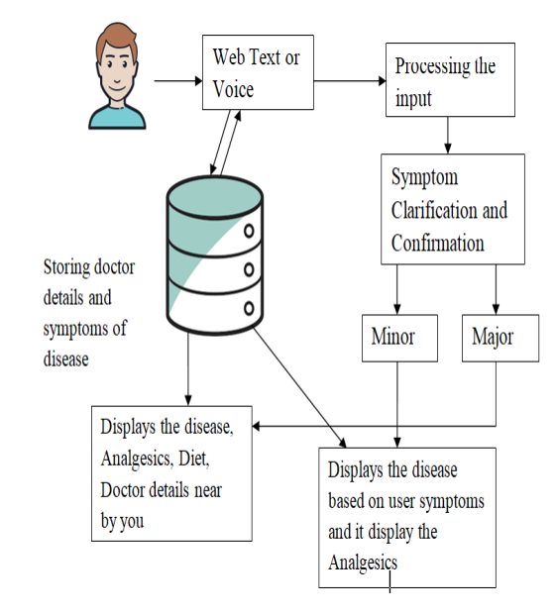

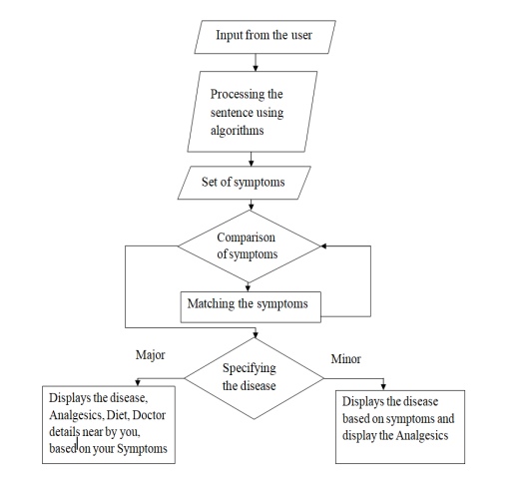

MODULES:
The modules for a chatbot which provides home remedies could include natural language processing, machine learning, and a database. The natural language processing module would be responsible for interpreting user queries and understanding the user's intent. The machine learning module would be used to generate personalized health advice based on a user's health history and information about their symptoms. Finally, the database would store all the necessary information, such as medical articles, home remedy recipes, tutorials, and potential risks associated with using home remedies.

ALGORITHM USED:
Recurrent Neural Network (RNN) algorithm
A recurrent neural network (RNN) is a type of artificial neural network that uses feedback connections to process sequential data. This makes RNNs well-suited for tasks such as natural language processing and understanding user intent. An RNN receives an input sequence and processes it by passing through hidden layers of neurons. These hidden layers are fed back into the network, creating a “memory” of the input. This allows the RNN to capture and analyze longer sequence.
Other algorithms that could be used in a chatbot which provides home remedies include tokenizers and transformers, random forests and decision trees, and k-means and hierarchical clustering. Tokenizers are used to break down user queries into smaller tokens that can then be analyzed. Transformers are used to capture the context of spoken or written language by learning the relationships between words. Random forests and decision trees are used to generate personalized health advice based on a user's health history and information about their symptoms. Finally, k-means and hierarchical clustering are used to efficiently store and retrieve data from the database.
Example:
As an example, a chatbot could use an RNN to interpret a user query like "I have a sore throat," by passing the query through its hidden layers of neurons. The RNN will then analyze the input sequence, looking for patterns and key words that indicate the user's intent. Based on the analysis, the RNN can generate suitable recommendations for home remedies based on the user's health history and symptoms. For example, if the user has reported a sore throat, the chatbot could recommend drinking hot tea with honey or taking a decongestant.

INTERNAL GUIDE SIGNATURE:
Mr. Md. Ahmed Mohiuddin
(Assistant Professor, CSE Dept)
TEAM MEMBERS SIGNATURE:
20QM1A0596- Tehmeena Begum
20QM1A05A3- V. Geetha Shivani
21QM5A0504- B. Sai Teja
20QM1A0569- P. Akash Yadav

