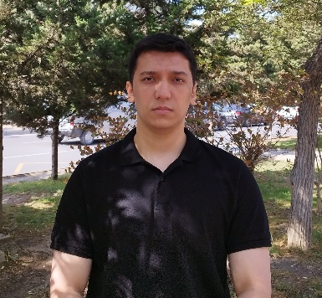**Alipasha Askerov**

Mail: [askerovpasha21@gmail.com](mailto:askerovpasha21@gmail.com)

Phone: +994 (055) 322 0718

Address: 37 Bakikhanov Street, Baku, Azerbaijan

Linkedin: <https://www.linkedin.com/in/alipasha-askerov-868213246/>

Portfolio: <https://alipashaskerov.vercel.app/>

Github: <https://github.com/pashaskerov21>

**Summary**

An ambitious and skilled Frontend Developer with 3+ years of experience specializing in HTML, CSS, JavaScript, and various frameworks like React JS, Next JS, and Angular JS. Adept at creating responsive, user-centric websites and collaborating with clients to meet their design and performance objectives. Continuously upgrading skills and passionate about delivering high-quality code.

**Skills**

**Programming Languages & Technologies:** HTML, CSS, SCSS, JavaScript, TypeScript, React JS, Next JS, Angular JS, jQuery, Redux, Formik, Yup, Axios, i18n, React hooks, React Router, Restful API, PHP, Laravel, MySQL, JSON, Git, GitHub, GitBash, styled-components, Bootstrap, Tailwind CSS, Figma, Adobe XD, Microsoft Office.

**User Experience (UX):** UX Design Principles, Usability Testing, Wireframing & Prototyping ,Information Architecture, Responsive Web Design

**Search Engine Optimization (SEO):** On-Page Optimization,Technical SEO**,** SEO Tools (Google Analytics, Google Search Console, SEMrush, Moz)**,** Content Strategy**,** Link Building

**Soft Skills:** Problem-solving, Communication, Teamwork, Creativity, Customer Service, Adaptability, Self-learning, Time Management, Accountability, Patience, Collaboration, Attention to Detail.

**Work Experience**

**Front End Developer**

*Proton MMC* – 12/2022 – 06/2024

* Collaborated in developing powerful websites, meeting client goals, and ensuring optimal design usability and performance.
* Self-directed, working effectively without supervision and adapting quickly to new skills and technologies.
* Developed responsive web pages tailored to client specifications.

**Front End Developer Intern**

*Proton MMC* – 10/2022 – 12/2022

**Automation Engineer**

*Azersu OJSC* – 02/2022 – 06/2022

**Education**

**Master's in Automation of Technological Processes and Production**

Azerbaijan State Oil and Industry University - 09/2022 - 07/2024

**Bachelor's in Process Automation Engineering**

Azerbaijan State Oil and Industry University - 09/2018 - 07/2022

**Language**

* English – Intermediate (B1)
* Azerbaijani – Native language