OOP COURSE PROJECT
TITLE :- Library Management System — A Desktop Application in Java using Swing and SQLite

Div :- C Group No :- 3 Day :- Thursday Date :- 22/10/2026
Presented by | Project Guide
  1) | Aarush Sangle | 22
  2) | Pashmee Salunkhe | 17
  3) | Rohan Rangapure | 13
  4) | Sanchali Patil | 19
  Dr. Priya Shelke

DEPARTMENT OF CSE-IOTCSBT
VISHWAKARMA INSTITUTE OF TECHNOLOGY, PUNE

ABSTRACT
A library, however small, has to answer three questions all day: what do we own, who has it, and when is it due back. A paper register answers none of them quickly. It cannot tell the librarian what is overdue today, it cannot stop the last copy of a title being lent twice, and it cannot add up a fine.
This project is a desktop Library Management System that answers those questions. It maintains a catalogue of books and a register of members, issues and accepts returns, renews loans, calculates overdue fines, and reports at a glance what needs attention. It is written in Java 17 with a Swing interface and stores everything in a single SQLite database file, so it runs on any machine with a Java runtime and needs no server, no account and no network connection.
The emphasis of the design is object-oriented rather than screen-oriented. The application is divided into two halves. A data layer, the single class LibraryDatabase, owns the database connection and every rule that must stay true — copy counts, per-member borrowing limits, renewal limits and fine calculation. An interface layer draws the five screens and passes on what the user typed, but never decides whether an action is permitted. The consequence is that a rule cannot be bypassed from a button, because no button is able to write to the database at all, and that the rules can be verified without opening a window.
The implementation comprises 39 classes and approximately 6,700 lines of Java. It is verified by 70 automated tests — 47 exercising the rules and the database directly, and 23 driving the real Swing screens — all of which pass. Every change pushed to the repository is built and tested automatically on both Windows and Linux.

Keywords: Library Management System, Object-Oriented Programming, Java, Swing, SQLite, JDBC, layered architecture, automated testing.

TABLE OF CONTENTS
ABSTRACT 2
Chapter 1 Introduction 4
1.1 Overview 4
1.2 Problem Statement 4
1.3 Motivation 4
1.4 Scope of the Project 5
1.5 Organisation of the Report 5
Chapter 2 Review of Existing Systems 6
2.1 The Paper Register 6
2.2 Spreadsheets 6
2.3 Commercial and Open-Source Library Systems 6
2.4 Observations 7
Chapter 3 Objectives 8
3.1 Primary Objectives 8
3.2 Secondary Objectives 8
Chapter 4 System Requirements 9
4.1 Hardware Requirements 9
4.2 Software Requirements 9
4.3 Functional Requirements 9
4.4 Non-Functional Requirements 10
Chapter 5 System Design 11
5.1 Architectural Design 11
5.2 Object-Oriented Design 12
5.3 Object-Oriented Concepts Applied 15
5.4 Database Design 16
5.5 Module Description 19
Chapter 6 Implementation 20
6.1 Technology Stack 20
6.2 Project Structure 20
6.3 Business Rules 20
6.4 Key Implementation Details 21
6.5 User Interface Features 24
Chapter 7 Testing 25
7.1 Testing Strategy 25
7.2 Rule and Database Test Cases 25
7.3 User Interface Test Cases 26
7.4 Continuous Integration 27
7.5 Test Results 27
Chapter 8 Results 28
8.1 Dashboard 28
8.2 Catalogue 29
8.3 Members 30
8.4 Circulation Desk 31
8.5 Settings 32
8.6 Summary of Results 32
Chapter 9 Conclusion 33
Chapter 10 Future Scope 34
REFERENCES 35

Chapter 1 Introduction

1.1 Overview
A Library Management System is software that keeps track of the books a library owns, the people who are allowed to borrow them, and the loans that connect the two. The system built in this project is a desktop application intended for a small library — a school, a college department or a community reading room — where a few hundred to a few thousand titles are issued across a few hundred members.
The application presents five screens: a dashboard summarising the state of the library, a catalogue of books, a register of members, a circulation desk where books are issued and returned, and a settings screen where the library's own rules are configured. All data is held in one SQLite database file, library.db, which sits beside the application. Copying that single file moves the entire library to another computer.

1.2 Problem Statement
Small libraries are commonly run from a paper register or a spreadsheet. Both record what happened, but neither enforces anything and neither answers questions quickly. Specifically:
- There is no reliable way to know how many copies of a title are actually on the shelf at this moment, so the same copy can be promised to two people.
- Finding out what is overdue means reading every row of the register and comparing dates by hand, so overdue books go unnoticed.
- Fines must be calculated manually for every late return, which is slow and inconsistent.
- Nothing prevents a member from borrowing far beyond a sensible limit, or from borrowing while they already have something overdue.
- A member's borrowing history is scattered across pages or sheets, so answering 'what has this person borrowed?' is tedious.
The problem, stated in one sentence: a small library needs a system that not only records loans but enforces the library's own rules automatically, and answers questions about the current state of the collection instantly.

1.3 Motivation
Two motivations shaped this project. The first is practical: the problem above is real, well-bounded and solvable by a student team within a semester, and the resulting software is genuinely usable rather than a demonstration.
The second is academic, and is the reason the project was chosen for an Object-Oriented Programming course. A library system is an unusually honest exercise in object-oriented design. It has clear entities with real behaviour (a Book knows how many copies are on the shelf; a Loan knows how late it is), a set of rules that must hold regardless of which screen is used, and five user interface screens that are different in content but identical in how the application treats them. Encapsulation, abstraction, inheritance and polymorphism are not bolted on to satisfy a rubric here; they are the natural solution to problems the project actually has.

1.4 Scope of the Project
The following are within the scope of this project:
- Cataloguing books with title, author, ISBN, category, publisher, year, shelf code and copy counts.
- Registering members with contact details, a membership type and a borrowing limit.
- Issuing, returning and renewing loans, with due dates derived automatically from a configurable loan period.
- Calculating, charging and waiving overdue fines, and recording payment.
- Reporting: counts, outstanding dues, an overdue list with borrower contact details, the most-borrowed titles and recent activity.
- Exporting books, members or loan history to CSV, and backing up the entire database to a single file.
The following are deliberately outside the scope:
- Multi-user or networked operation. The application is single-user by design; the database is a local file.
- Reservations, waiting lists and inter-library loans.
- Barcode or RFID hardware integration.
- Online public access catalogue (OPAC) or any web interface.
- Accounting beyond the recording of fines charged and paid.

1.5 Organisation of the Report
Chapter 2 reviews how small libraries are managed at present and what each approach fails to provide. Chapter 3 states the objectives of the project. Chapter 4 lists the hardware, software, functional and non-functional requirements. Chapter 5 presents the design: the layered architecture, the object-oriented class design, the mapping of object-oriented concepts onto the code, and the database schema. Chapter 6 describes the implementation, including the technology stack, the business rules and the key algorithms. Chapter 7 covers testing and continuous integration. Chapter 8 presents the results with screenshots of the working application. Chapters 9 and 10 give the conclusion and the future scope, followed by the references.

Chapter 2 Review of Existing Systems
Before designing the system, the ways small libraries are currently managed were examined. Three approaches are common, and each was considered in turn.

2.1 The Paper Register
The traditional method is a bound register: one line per issue, recording the book, the borrower, the date out and, later, the date returned. It is cheap, needs no equipment and is understood by everyone.
Its weaknesses follow directly from being a sequential record. Nothing in it represents the current state of the collection, so the only way to learn whether a copy is on the shelf is to walk to the shelf. Overdue items are invisible until somebody reads the whole register and compares every due date against today. Fines are arithmetic done by hand. Above all, a register records what happened but prevents nothing: there is no mechanism by which the book itself can refuse an impossible loan.

2.2 Spreadsheets
Many small libraries have moved to a spreadsheet, typically one sheet for books and another for issues. This is a genuine improvement: rows can be sorted and filtered, and a formula can flag a date that has passed.
The limitations are of a different kind. A spreadsheet has no concept of a transaction, so a user who updates the issue sheet but forgets the copy count leaves the two permanently inconsistent, with nothing to detect it. Validation is advisory at best — a cell can always be overtyped. Relationships between sheets are maintained by hand or by lookup formulas that break when rows move. And because the entire file is loaded and saved as one unit, two people cannot safely work on it at once.

2.3 Commercial and Open-Source Library Systems
Full integrated library systems such as Koha and Evergreen exist and are capable: they handle cataloguing to international standards, circulation, reservations, OPAC access and reporting.
For the libraries this project targets they are disproportionate. They are server applications requiring a database server, a web server and sustained administration; installation and upkeep assume technical staff that a school library does not have. Their cataloguing models are built around MARC records and authority control, which is far more than a few thousand titles require. The cost is not usually the licence — Koha is free — but the infrastructure and the expertise needed to keep it running.

2.4 Observations
Comparing the three approaches gives the following table.

Criterion | Paper register | Spreadsheet | Full ILS | This project
Enforces rules | No | Advisory only | Yes | Yes
Instant overdue list | No | Partly | Yes | Yes
Automatic fines | No | Partly | Yes | Yes
Consistency guaranteed | No | No | Yes | Yes
Setup effort | None | Low | High | Very low
Needs a server | No | No | Yes | No
Needs technical staff | No | No | Yes | No
Table 2.1 Comparison of existing approaches with the proposed system
The gap is clear. The lightweight options record but do not enforce; the option that enforces is too heavy to install and maintain. What a small library needs is something with the rule-enforcement and instant reporting of a real system, and the setup cost of a spreadsheet. That is the system this project builds.

Chapter 3 Objectives
The project set out to achieve the following objectives.

3.1 Primary Objectives

No. | Objective | How it is met
1 | Maintain a searchable catalogue of books with accurate copy counts | The Catalogue tab, backed by the books table, which records total and available copies and is updated inside the same transaction as every loan
2 | Register members and enforce a borrowing limit for each | The Members tab and the MembershipType enumeration, which carries a default limit per type that an individual record may override
3 | Issue, return and renew loans with due dates derived automatically | The Circulation tab and the issueBook, returnBook and renewLoan methods of the data layer
4 | Calculate overdue fines and record whether they were charged, waived or paid | The fineFor method and the fine and fine_paid columns of the loans table
5 | Place every rule in a single component so none can be bypassed | LibraryDatabase holds the only database connection in the application; no interface class can write to the database
6 | Report the state of the library at a glance | The Dashboard tab: counts, dues outstanding, an overdue list with contact details, most-borrowed titles and recent activity
Table 3.1 Primary objectives and how each is achieved

3.2 Secondary Objectives
- Keep the application dependency-free enough to run immediately after download: one external JAR, no installer, no server, no account.
- Support data portability through CSV export of books, members and loan history, and a one-file backup of the whole database.
- Make the rules verifiable without a display, so that correctness can be tested automatically rather than by clicking.
- Keep the interface usable by keyboard alone for a librarian working at speed.

Chapter 4 System Requirements

4.1 Hardware Requirements

Component | Minimum | Recommended
Processor | Any 64-bit x86 or ARM processor | Dual core, 2 GHz or better
Memory | 512 MB free RAM | 2 GB free RAM
Disk space | 50 MB for the application and the database | 500 MB to allow for backups and exports
Display | 1280 × 720 | 1366 × 768 or higher
Input | Keyboard and mouse | Keyboard and mouse
Table 4.1 Hardware requirements
The requirements are modest because the application is a single desktop process with a local database file. Any computer able to run a current Java runtime is sufficient.

4.2 Software Requirements

Software | Version | Purpose
Java Development Kit (JDK) | 17 or newer | Compiles and runs the application. The project is built and tested on JDK 17 and JDK 21
Operating system | Windows, Linux or macOS | Any system with a JDK and a graphical desktop. Batch launchers are supplied for Windows; the equivalent commands are documented for Linux and macOS
sqlite-jdbc | 3.50.3.0 | The JDBC driver for SQLite — the only external dependency, and it is bundled with the project
Git | Any recent version | Optional; used for version control during development
Table 4.2 Software requirements
No database server is required. SQLite is an embedded database: the driver links the database engine into the application itself, and the entire database is the single file library.db.

4.3 Functional Requirements

ID | Requirement
FR-1 | The system shall allow a book to be added, edited and deleted, recording title, author, ISBN, category, publisher, year, shelf code and number of copies.
FR-2 | The system shall allow the catalogue to be searched by title, author, ISBN or publisher, and filtered by category and by availability.
FR-3 | The system shall allow a member to be registered, edited and deleted, and shall allocate the next member code automatically.
FR-4 | The system shall issue a book to a member, recording the issue date and computing the due date from the configured loan period.
FR-5 | The system shall accept the return of a book, compute any fine due, and allow that fine to be charged or waived.
FR-6 | The system shall allow a loan that is not overdue to be renewed, up to a maximum of two renewals.
FR-7 | The system shall record a fine as paid when the librarian settles it.
FR-8 | The system shall refuse any issue that would break a borrowing rule, and shall state the reason in language the user can act on.
FR-9 | The system shall display current counts, outstanding dues and a list of overdue loans with borrower contact details.
FR-10 | The system shall export books, members and loan history to CSV files and back up the database to a single file.
FR-11 | The system shall allow the library name, loan period and fine rate to be configured and shall apply them to subsequent operations.
Table 4.3 Functional requirements

4.4 Non-Functional Requirements

ID | Category | Requirement
NFR-1 | Integrity | Copy counts shall never disagree with the recorded loans. Every operation that changes both shall run inside a single transaction.
NFR-2 | Reliability | Data shall survive the application being closed and reopened, and a partial failure shall leave no half-written record.
NFR-3 | Usability | Common actions shall be reachable from the keyboard, and every refusal shall be explained in plain language.
NFR-4 | Portability | The application shall run unmodified on any operating system with a JDK 17 or newer.
NFR-5 | Maintainability | Business rules shall reside in one component so that a rule can be changed in exactly one place.
NFR-6 | Testability | The rules shall be verifiable without a graphical display.
NFR-7 | Performance | Searching and listing shall remain responsive for a catalogue of several thousand titles; frequent queries shall be supported by indexes.
Table 4.4 Non-functional requirements

Chapter 5 System Design

5.1 Architectural Design
The application is organised into two layers over a database file. This separation is the central design decision of the project and everything else follows from it.
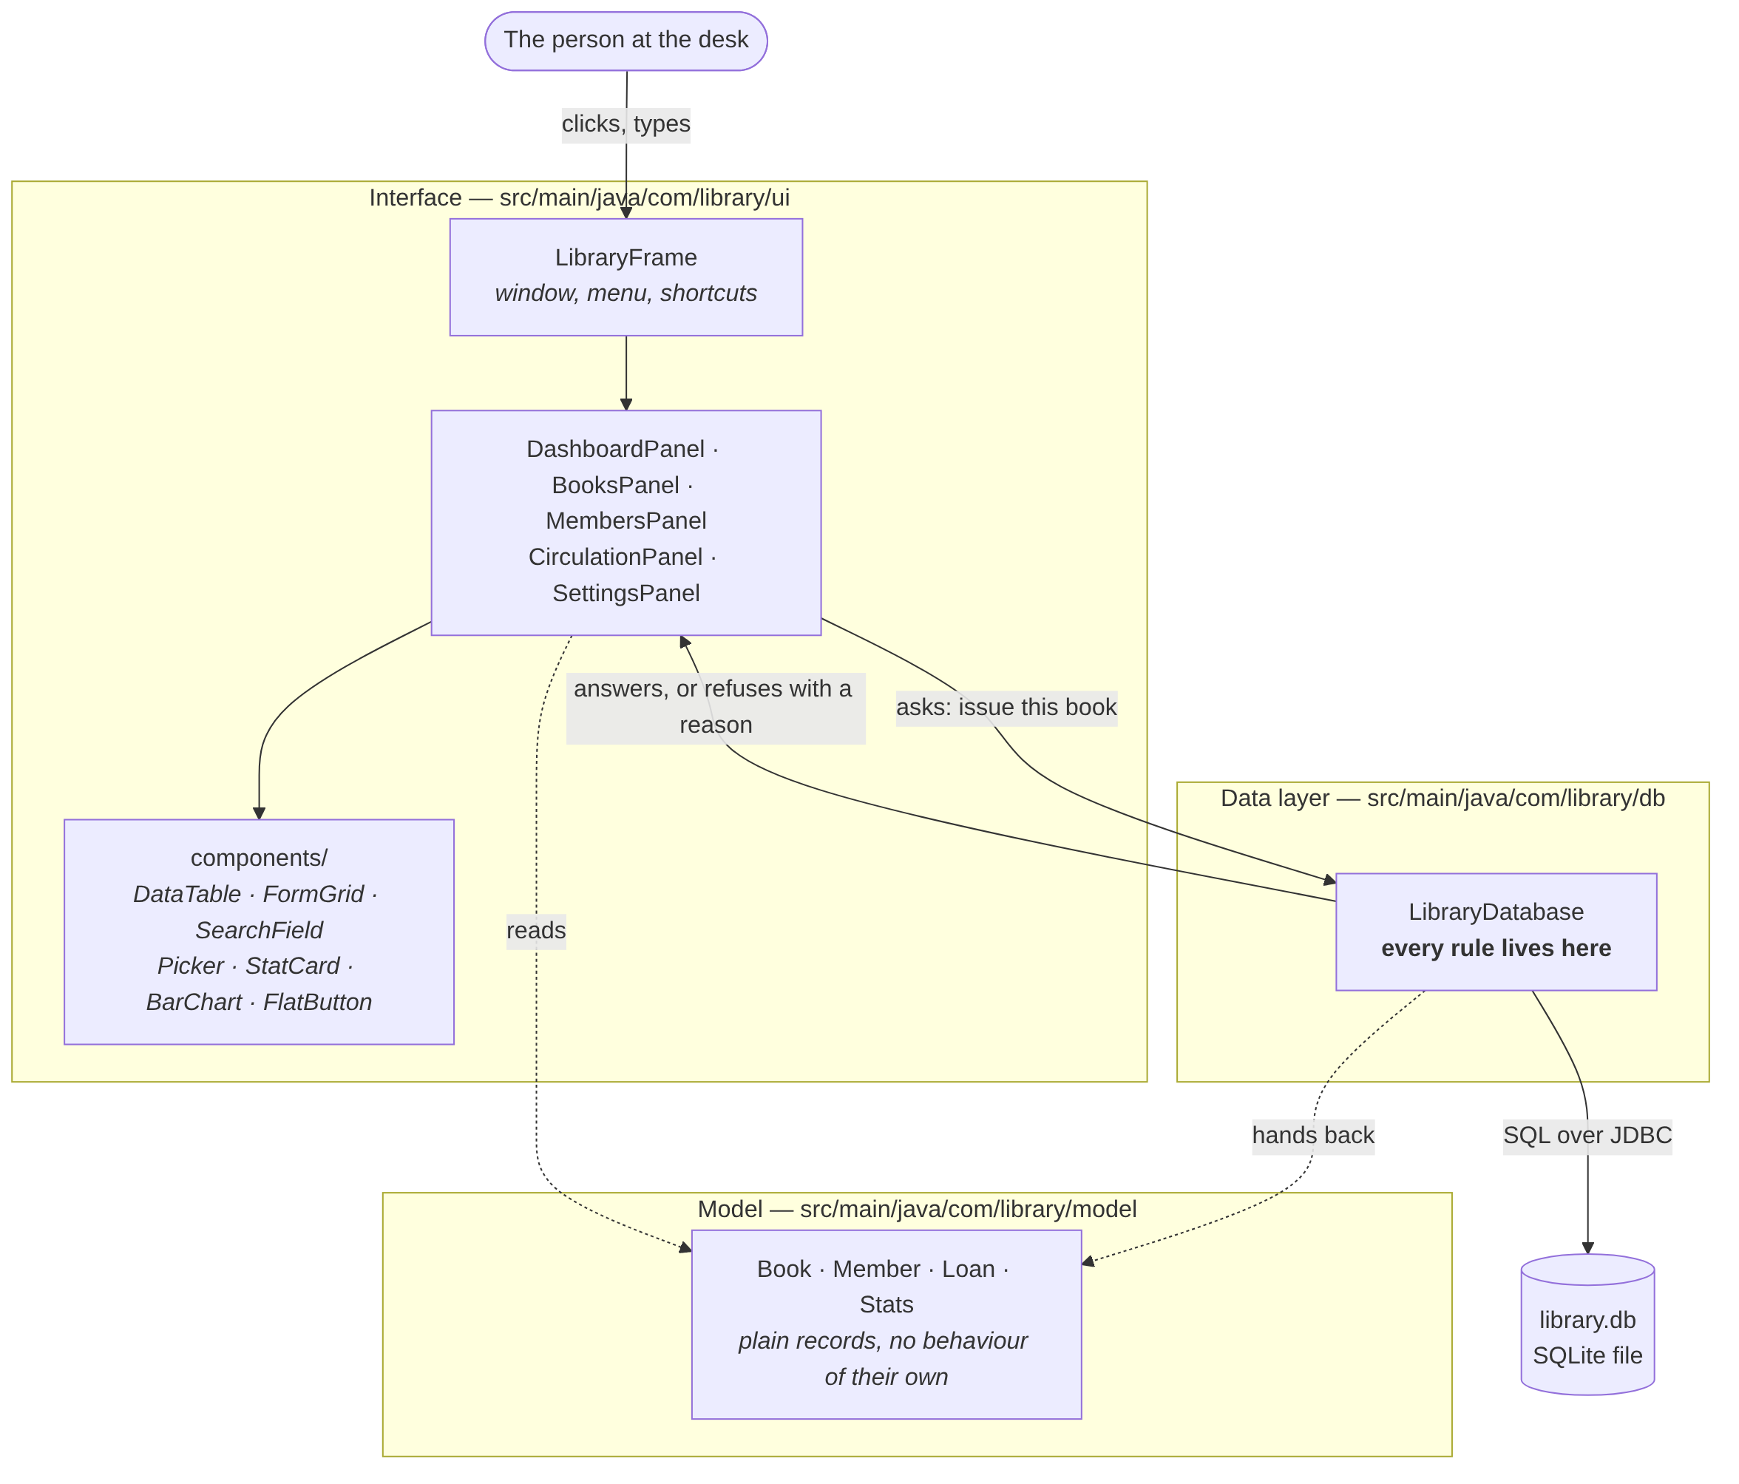
Figure 5.1 Layered architecture of the system
The interface layer contains the window and the five tabs. Its only responsibilities are to draw a screen, collect what the user typed and pass it on, and display whatever comes back — including a refusal. It contains no rule and takes no decision about whether an operation is permitted.
The data layer is one class, LibraryDatabase. It holds the only database connection in the application and exposes a method for every operation the interface may request. Each method validates its arguments against the library's rules, performs the work inside a transaction, and either returns a result or throws a LibraryException carrying a message written for the user.
Two properties follow from this arrangement, and both are claims the project can defend. First, a rule cannot be skipped by accident from a button, because no interface class is able to write to the database at all — the only route is through a method that checks first. Second, the rules can be tested with no window open, which is why 47 of the project's 70 tests execute in milliseconds on a machine with no display.

5.2 Object-Oriented Design
The classes fall into three groups: the domain model, the data layer and the interface layer.

5.2.1 The Domain Model
The model classes describe what a book, a member and a loan are. They are implemented as Java records: immutable, holding nothing but their own fields, with no database connection and therefore no ability to save themselves.
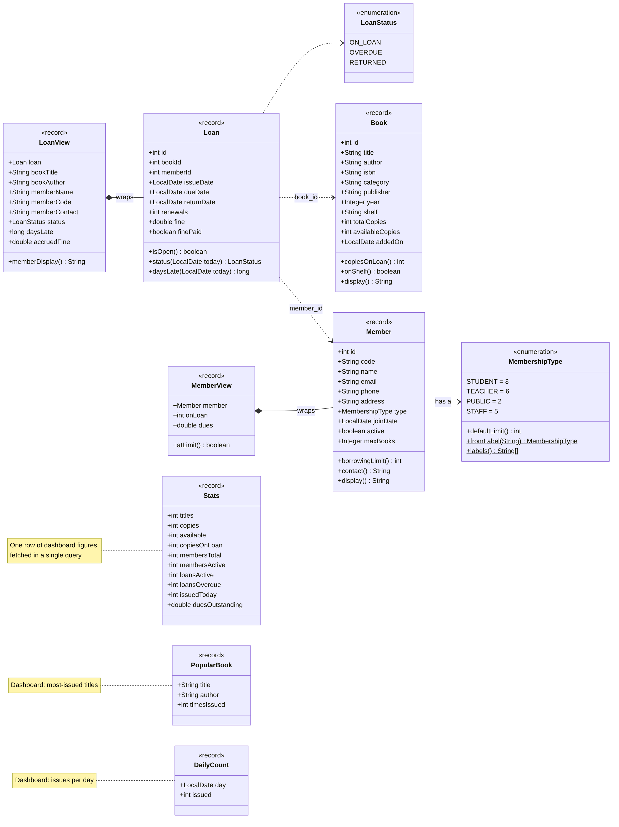
Figure 5.2 Class diagram of the domain model
The methods defined on these records are pure arithmetic over their own fields, which is precisely why they belong on the record rather than in the database class. Loan.daysLate subtracts two dates; Book.onShelf asks whether availableCopies is greater than zero; Member.borrowingLimit returns the member's own limit if one is set and the membership type's default otherwise. None of them touches SQL, so each can be tested in isolation.
Two points on this diagram are worth drawing attention to in review. A Loan holds bookId and memberId as integers rather than a Book and a Member object: this mirrors the foreign keys in the database exactly and prevents one loan from pulling an entire object graph into memory. When a screen needs the names as well, it asks for a LoanView, which is a Loan together with the book title, the borrower's name and contact, the status and the fine as it stands today — all obtained in a single SQL join rather than one query per row. Secondly, the status of a loan is computed, never stored, so it cannot fall out of step with the dates it is derived from.

5.2.2 The Data Layer
LibraryDatabase is the single door to the data. It accepts drafts from the forms, returns model objects, and throws LibraryException when a rule is broken.
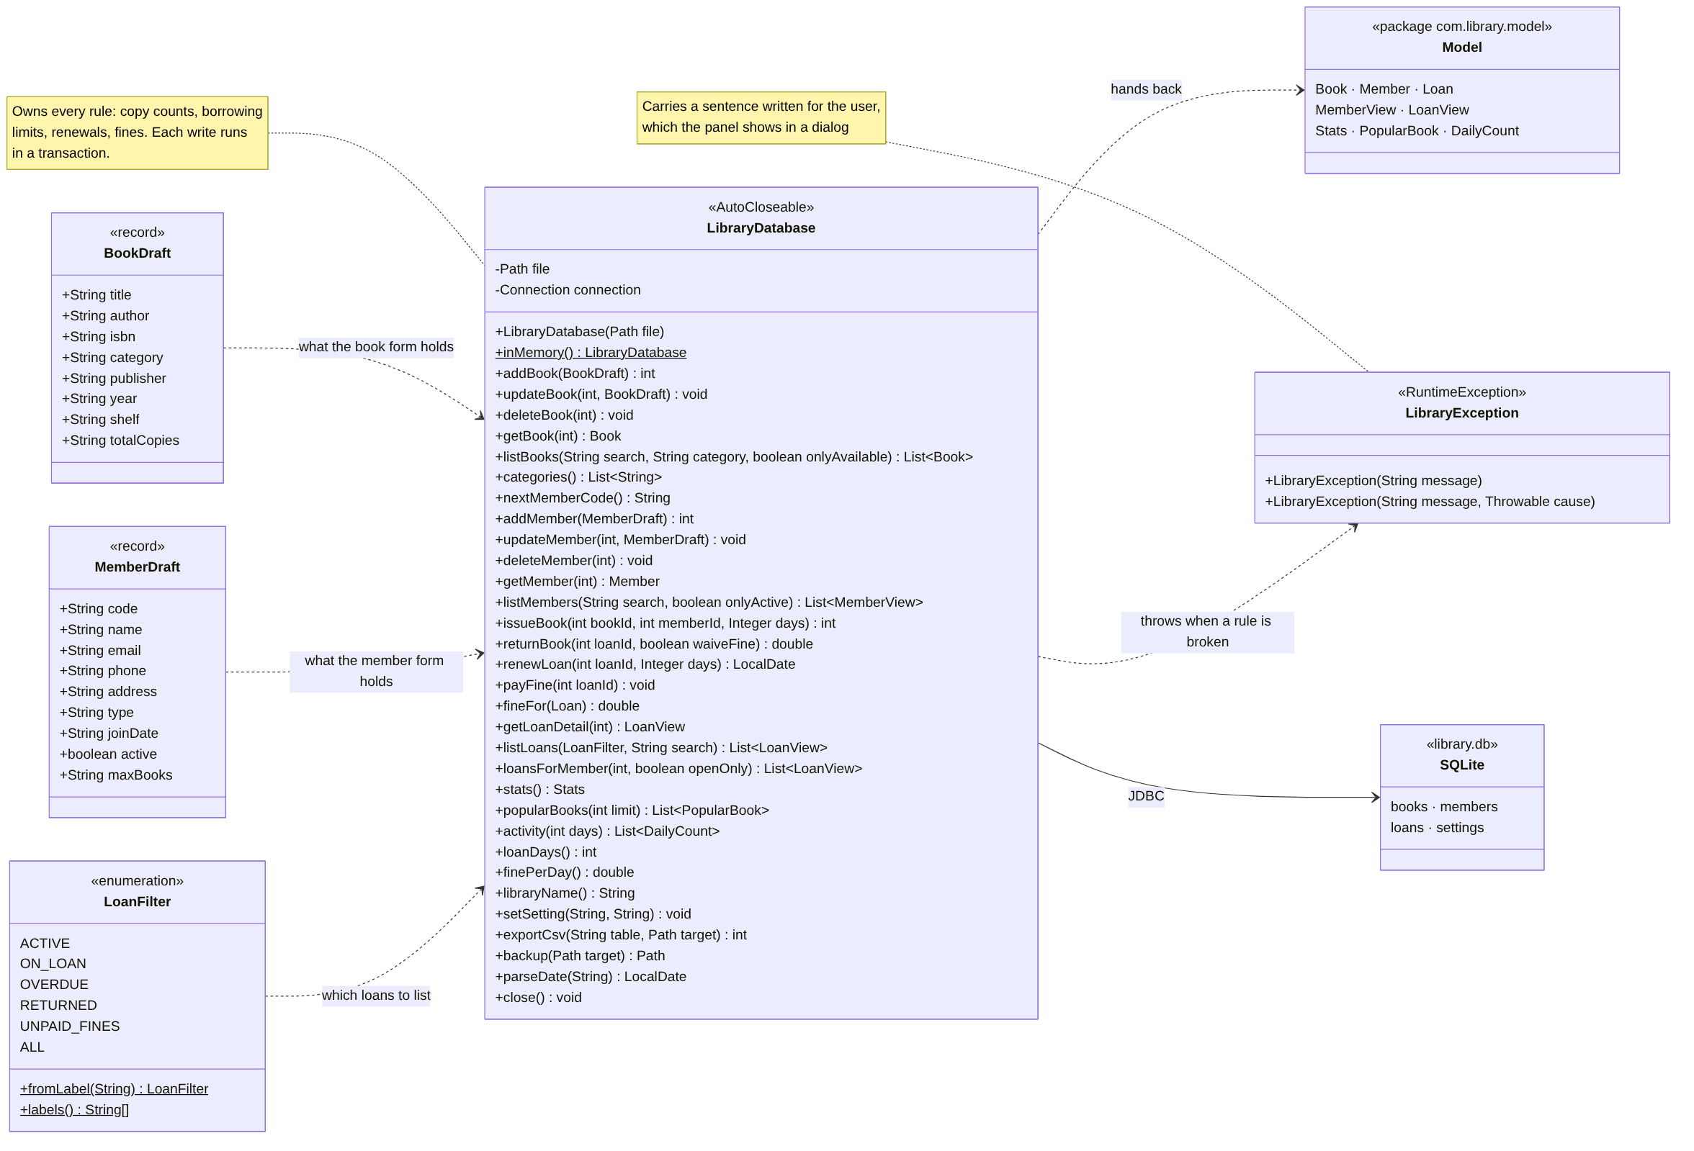
Figure 5.3 Class diagram of the data layer
The draft classes, BookDraft and MemberDraft, deserve a note. Every one of their fields is a String, including year and totalCopies, because a draft represents what a form contains rather than what a database row contains — the user may well have typed 'twenty' into a number box. The draft carries the text across unaltered and LibraryDatabase performs the checking, so validation happens in one place rather than being rewritten in each panel.

5.2.3 The Interface Layer
The window, LibraryFrame, holds a tabbed pane containing the five screens. Each screen extends the abstract class TabPanel.
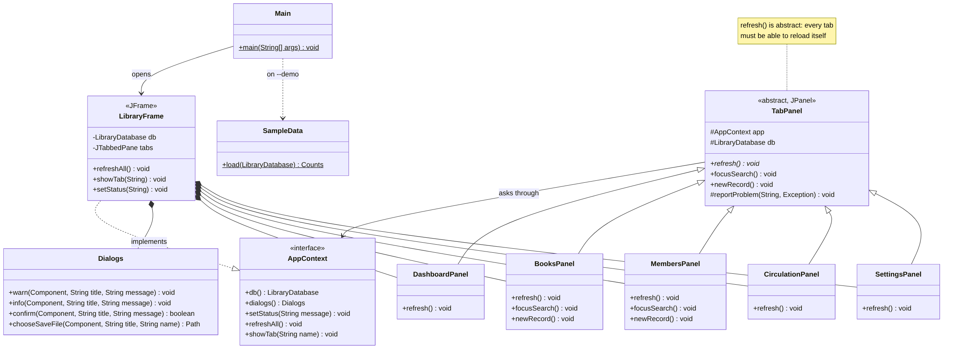
Figure 5.4 Class diagram of the window and its tabs
TabPanel defines the shape of a tab. Every screen must supply refresh(), meaning 'reload yourself from the database'. That single abstract method is what allows LibraryFrame to answer the F5 key by iterating over its tabs and calling one method on each, without knowing what any of them contains. focusSearch() and newRecord() have do-nothing default implementations so that Ctrl+F and Ctrl+N are safe to press on a tab that has no search box or form; the two panels that do have them override those methods.
AppContext is an interface listing exactly what a tab needs from the application: the database, the dialogs, the status bar and the ability to switch to another tab. LibraryFrame implements it. Because the tabs are written against the interface rather than against the frame, the user interface tests are able to supply a substitute, which is how 23 tests drive the real screens on a machine with no display.
The screens are assembled from a small set of reusable components rather than from raw Swing widgets.
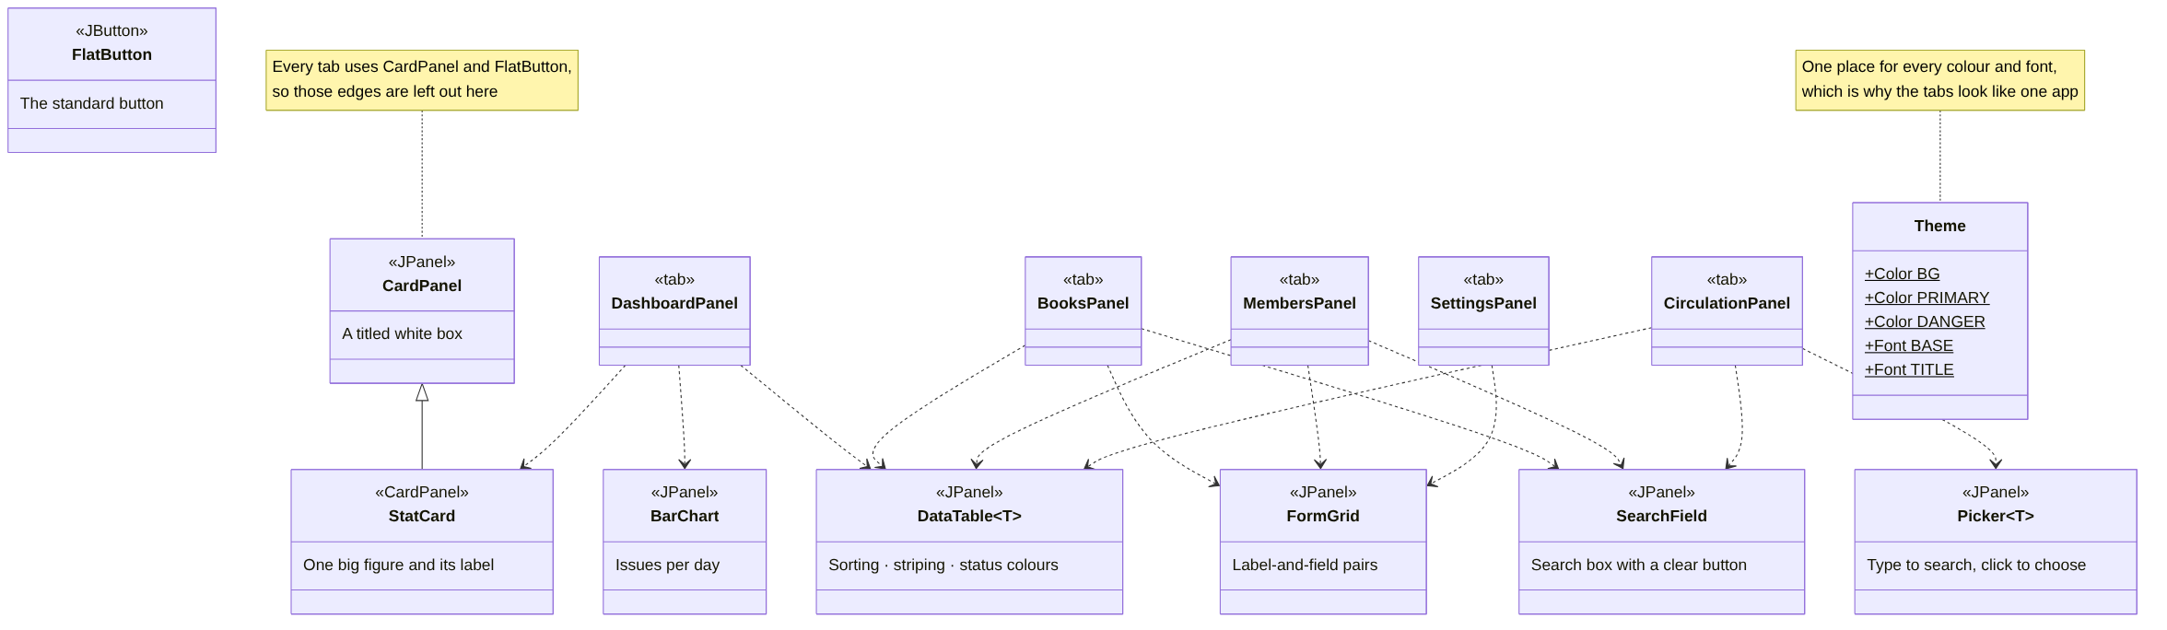
Figure 5.5 The reusable interface components and their users
DataTable<T> is generic over the row type and provides the sorting, row striping and status colouring that every table in the application needs; it is written once and used by four tabs. FormGrid lays out label-and-field pairs, Picker<T> is the type-to-search box used to choose a member and a book at the circulation desk, and CardPanel is the titled box they all sit in. Theme holds every colour and font in one place, which is why the five tabs look like a single application.

5.3 Object-Oriented Concepts Applied
Because this is a project for a course in Object-Oriented Programming, the table below maps each concept onto the place in the code where it is used and states what it achieves there. Every entry refers to code that exists in the submitted project.

Concept | Where it is used | What it achieves
Encapsulation | LibraryDatabase.connection is private final; the model records expose no setters | No code outside the data layer can touch the database. Because the records are immutable, an object handed to a panel cannot be altered behind the data layer's back
Abstraction | abstract class TabPanel with abstract void refresh(); interface AppContext | The window operates on 'a tab' without knowing which tab. A tab depends on an interface listing four capabilities, not on the concrete window class
Inheritance | DashboardPanel, BooksPanel, MembersPanel, CirculationPanel and SettingsPanel extend TabPanel; StatCard extends CardPanel; LibraryException extends RuntimeException | Shared state and behaviour — the AppContext reference, the database handle, error reporting — are written once in the base class
Polymorphism (overriding) | Each panel overrides refresh(); BooksPanel and MembersPanel also override focusSearch() and newRecord() | Pressing F5 calls refresh() through one TabPanel reference and each tab executes its own version, so adding a sixth tab requires no change to the window
Polymorphism (overloading) | listBooks() and listBooks(search, category, onlyAvailable); renewLoan(id, days) and renewLoan(id, days, maxRenewals) | Callers that want the default behaviour write the short form; tests that need to vary a parameter use the long one
Composition | LibraryFrame is composed of five panels and a Dialogs; LoanView contains a Loan; MemberView contains a Member | Behaviour is assembled from parts rather than inherited, which keeps the view classes independent of the records they wrap
Interfaces | AppContext; LibraryDatabase implements AutoCloseable | Tabs are testable without a window, and the database can be used in a try-with-resources block that closes it reliably
Generics | DataTable<T> and Picker<T> | DataTable<Book> and DataTable<LoanView> are the same class; the compiler keeps the row types apart, so selecting a row returns the right type with no cast
Enumerations | MembershipType (with a default limit per constant), LoanStatus, LoanFilter | The borrowing limits live beside the names they describe instead of in a chain of if statements, and the filter box cannot drift away from the query that answers it
Immutability | Book, Member, Loan, LoanView, MemberView and Stats are Java records | The model objects are safe to pass anywhere, cannot be modified by the interface, and need no defensive copying
Exception handling | LibraryException extends RuntimeException; TabPanel.reportProblem() routes it to a dialog | Every refusal reaches the user by the same path, carrying a sentence written for a person rather than a stack trace
Table 5.1 Object-oriented concepts and where each is applied

5.4 Database Design
All data is held in a single SQLite database. The schema consists of four tables and five indexes.
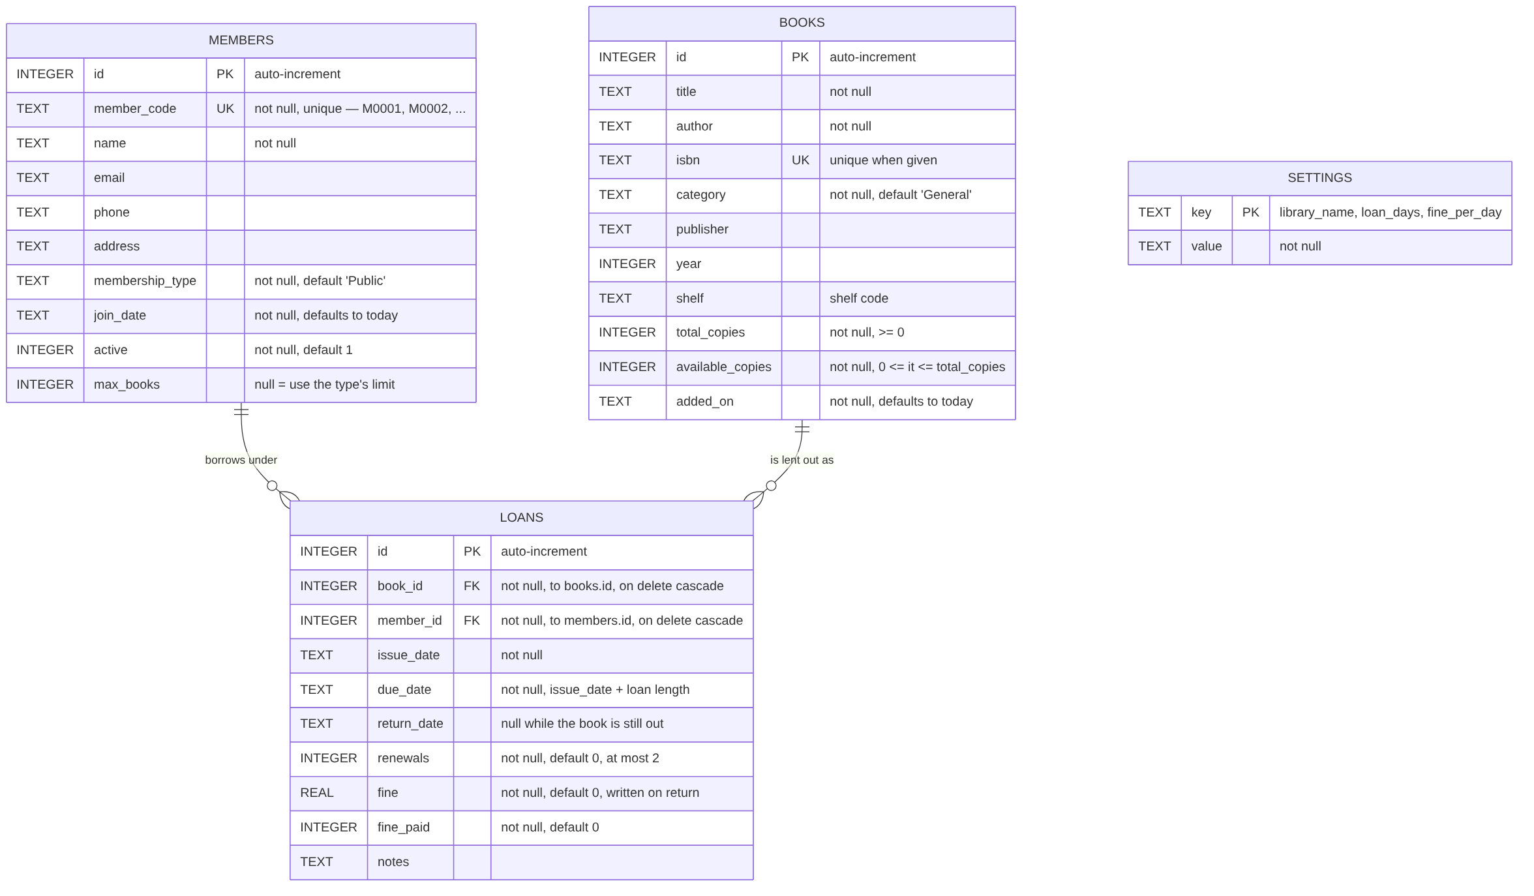
Figure 5.6 Entity-relationship diagram of the database

5.4.1 Entities and Relationships
There are two real-world entities — a book and a member — and one relationship between them. A loan is that relationship, made into a table of its own because it carries data that belongs to neither side: when the book went out, when it is due, when it came back and what was owed. Each member may have many loans and each book may be lent many times, so lending is a many-to-many relationship, resolved in the standard way through loans acting as the junction table. The settings table stands apart: it is a key-value store, so adding a new setting means adding a row rather than altering the schema.

5.4.2 Table Descriptions

Column | Type | Constraints | Description
id | INTEGER | PRIMARY KEY, AUTOINCREMENT | Surrogate key
title | TEXT | NOT NULL | Title of the book
author | TEXT | NOT NULL | Author's name
isbn | TEXT | UNIQUE | ISBN; may be empty, but no two books may share one
category | TEXT | NOT NULL, default 'General' | Subject category, used by the filter
publisher | TEXT | — | Publisher's name
year | INTEGER | — | Year of publication
shelf | TEXT | — | Shelf code used to find the book physically
total_copies | INTEGER | NOT NULL, CHECK (>= 0) | Copies owned
available_copies | INTEGER | NOT NULL, CHECK (>= 0 and <= total_copies) | Copies currently on the shelf
added_on | TEXT | NOT NULL, defaults to today | Date the title was catalogued
Table 5.2 The books table

Column | Type | Constraints | Description
id | INTEGER | PRIMARY KEY, AUTOINCREMENT | Surrogate key
member_code | TEXT | NOT NULL, UNIQUE | Human-readable code, allocated as M0001, M0002, …
name | TEXT | NOT NULL | Member's name
email, phone, address | TEXT | — | Contact details; the email is validated when supplied
membership_type | TEXT | NOT NULL, default 'Public' | Student, Teacher, Staff or Public
join_date | TEXT | NOT NULL, defaults to today | Date of registration
active | INTEGER | NOT NULL, default 1 | 0 suspends the member without deleting their history
max_books | INTEGER | — | Personal borrowing limit; when empty the membership type's default applies
Table 5.3 The members table

Column | Type | Constraints | Description
id | INTEGER | PRIMARY KEY, AUTOINCREMENT | Surrogate key
book_id | INTEGER | NOT NULL, FOREIGN KEY → books(id), ON DELETE CASCADE | The title that was lent
member_id | INTEGER | NOT NULL, FOREIGN KEY → members(id), ON DELETE CASCADE | The borrower
issue_date | TEXT | NOT NULL | Date the book went out
due_date | TEXT | NOT NULL | issue_date plus the configured loan period
return_date | TEXT | NULL while on loan | The single field that says whether a loan is finished
renewals | INTEGER | NOT NULL, default 0 | Number of renewals so far; at most two
fine | REAL | NOT NULL, default 0 | Fine recorded when the return was accepted
fine_paid | INTEGER | NOT NULL, default 0 | 1 once the fine has been settled or waived
notes | TEXT | — | Free text
Table 5.4 The loans table

5.4.3 Integrity and Indexing
Some rules are expressed in the schema itself and are therefore enforced before any Java runs: a book must have a title and an author; two books cannot share an ISBN; two members cannot share a member code; copy counts cannot go negative or exceed the number of copies owned; a loan cannot refer to a book or a member that does not exist.
Other rules cannot be expressed in a schema, and these are the reason the data layer exists: one copy per person per title, the per-member borrowing limit, the refusal to lend to a member with something overdue, the suspension of inactive members, the limit of two renewals, and the refusal to delete anything that is currently on loan.
The number of copies on the shelf could be derived by counting open loans on every query. Instead it is stored in the row and adjusted by one whenever a book is issued or returned, which makes the catalogue fast to display. The risk with any stored total is that it drifts away from the truth, so three defences are in place: a CHECK constraint that will not allow it outside the range 0 to total_copies; a transaction around every operation that touches both the loan and the count; and an automated test that issues and returns the entire sample library and then verifies that every count still agrees.

Index | Column | Query it supports
idx_loans_member | loans(member_id) | A member's borrowing history and current holdings
idx_loans_book | loans(book_id) | Whether a title is out, and with whom
idx_loans_due | loans(due_date) | The overdue list and the dashboard figures
idx_books_title | books(title) | Catalogue search and sorting
idx_members_name | members(name) | Member search
Table 5.5 Indexes and the queries they support

5.5 Module Description

Module | Responsibility
Dashboard | Summary counts, fines outstanding, the overdue list with borrower contact details, the most-borrowed titles and a chart of issues over the last fourteen days
Catalogue | Adding, editing and deleting books; search by title, author, ISBN or publisher; filtering by category and availability
Members | Registering, editing and deleting members; viewing each member's holdings, dues and complete borrowing history
Circulation | Issuing a book to a member, accepting returns, renewing loans, charging or waiving fines and marking them paid; filtering the loan list by status
Settings | Library name, loan period and fine rate; CSV export of books, members and loan history; backup of the database
Table 5.6 The five modules of the application

Chapter 6 Implementation

6.1 Technology Stack

Technology | Role | Reason for the choice
Java 17 | Language | Records, enumerations with fields and text blocks keep the model and the SQL short and readable. It is the oldest version the project supports, so the code runs on any newer JDK
Swing | User interface | Part of the JDK itself, so the application needs no user interface library, no installer and no runtime download
SQLite | Database | An embedded database: the whole library is one file and there is no server to install, configure or keep running
JDBC with sqlite-jdbc 3.50.3.0 | Database driver | The standard Java database API; this driver embeds the SQLite engine. It is the only external dependency and is bundled with the project
Git and GitHub | Version control | Full history of the work, with the source and its documentation kept together
GitHub Actions | Continuous integration | Builds the project and runs all 70 tests on every push, on Windows and on Linux
Table 6.1 Technology stack and the reason for each choice

6.2 Project Structure
The source is organised so that the package a class lives in states its responsibility.
java-library-management/
build.bat run.bat test.bat compile, run and test
lib/sqlite-jdbc-3.50.3.0.jar the only dependency
src/main/java/com/library/
Main.java entry point, command line
SampleData.java demonstration data
model/ Book, Member, Loan, views, enums
db/ LibraryDatabase and the rules
ui/ window, five tabs, theme, dialogs
components/ DataTable, FormGrid, Picker, ...
src/test/java/com/library/ 70 automated tests
docs/ diagrams and screenshots
The project contains 39 classes and approximately 6,700 lines of Java. It is compiled with javac directly; no build tool such as Maven or Gradle is required, which keeps the project runnable immediately after download.

6.3 Business Rules
The following rules are enforced by the data layer. Each is checked before any change is written, and a violation raises a LibraryException whose message is shown to the user.

No. | Rule | Rationale
1 | A copy must be on the shelf before it can be issued | Prevents promising the same physical copy to two people
2 | A member may hold only one copy of a given title | Spreads a limited number of copies across more readers
3 | A member may hold at most their borrowing limit: Student 3, Teacher 6, Staff 5, Public 2, or a personal override | Keeps the collection circulating
4 | A member with an overdue book may not borrow again | Gives the librarian leverage to recover late books
5 | An inactive member may not borrow | Allows suspension without deleting borrowing history
6 | A loan may be renewed at most twice, and only while it is not already overdue | Stops a title being held indefinitely
7 | A book or member with an open loan cannot be deleted | Protects referential integrity and the audit trail
8 | Every operation that changes two things runs inside one transaction | Copy counts can never drift out of step with the loans
Table 6.2 Business rules enforced by the data layer

6.4 Key Implementation Details

6.4.1 Issuing a Book
issueBook is the method in which most of the rules meet. It validates in order, refusing with a specific message at the first rule broken, and only then writes.
public int issueBook(int bookId, int memberId, Integer days) {
Book book = getBook(bookId);
Member member = getMember(memberId);
if (!member.active()) {
throw new LibraryException(
member.name() + "'s membership is inactive.");
}
if (book.availableCopies() < 1) {
throw new LibraryException(
"No copies of '" + book.title() + "' are on the shelf.");
}
List<LoanView> open = loansForMember(memberId, true);
int limit = member.borrowingLimit();
if (open.size() >= limit) {
throw new LibraryException(member.name() + " already holds "
+ open.size() + " of " + limit + " permitted books.");
}
for (LoanView view : open) {
if (view.loan().bookId() == bookId) {
throw new LibraryException(
member.name() + " already has a copy of this title.");
}
}
long overdue = open.stream()
.filter(v -> v.status() == LoanStatus.OVERDUE).count();
if (overdue > 0) {
throw new LibraryException(member.name() + " has " + overdue
+ " overdue book(s). Settle those before issuing another.");
}
LocalDate issue = today();
LocalDate due = issue.plusDays(
days == null || days < 1 ? loanDays() : days);
return inTransaction(() -> {
/* insert the loan, then decrement available_copies */
});
}
Listing 6.1 Rule checking in issueBook (abridged)
Two aspects of this method are worth noting. The messages name the member and the title rather than reporting a code, because the message is shown to the librarian verbatim. And the write is the last thing that happens: the loan row and the decrement of available_copies occur together inside inTransaction, so no failure can leave one without the other.

6.4.2 Calculating a Fine
A fine is days late multiplied by the daily rate. The subtlety is that a fine means something different before and after the book comes back: while the book is still out the figure is provisional and grows each day, and once the return has been accepted it is a fixed, recorded amount.
public double fineFor(Loan loan) {
if (!loan.isOpen()) {
return loan.fine(); // settled: the recorded amount
}
long late = ChronoUnit.DAYS.between(loan.dueDate(), today());
return late <= 0 ? 0 : round(late * finePerDay());
}
Listing 6.2 Fine calculation
For example, with the default settings of a fourteen-day loan and a fine of 2.00 per day: a book borrowed on 1 October is due back on 15 October. If it is returned on 18 October it is three days late, so the fine is 3 × 2.00 = 6.00. The amount is written to the loan row only when the return is accepted, and at that moment the librarian may charge it or waive it.

6.4.3 Transactions
Every operation that changes more than one thing is wrapped by a single generic helper, so the pattern is written once rather than at each call site.
private <T> T inTransaction(SqlWork<T> work) {
try {
connection.setAutoCommit(false);
try {
T result = work.run();
connection.commit();
return result;
} catch (SQLException | RuntimeException exc) {
connection.rollback();
throw exc;
} finally {
connection.setAutoCommit(true);
}
} catch (SQLException exc) {
throw wrap(exc);
}
}
Listing 6.3 The transaction helper
This is also an example of generics in use: the helper returns whatever type the work produces — an int loan identifier for issueBook, a double fine for returnBook — without casting.

6.4.4 Polymorphic Refresh
The abstract method on TabPanel allows the window to reload every screen without knowing what any of them contains.
public abstract class TabPanel extends JPanel {
protected final AppContext app;
protected final LibraryDatabase db;

/** Reload this tab from the database. */
public abstract void refresh();

/** Default: a tab with no search box ignores Ctrl+F. */
public void focusSearch() { }

protected void reportProblem(String title, Exception exc) {
app.dialogs().warn(this, title, exc.getMessage());
}
}
Listing 6.4 The abstract tab (abridged)
reportProblem is the single exit through which every refusal reaches the user: a panel catches the LibraryException and hands its message to the dialog. No panel writes its own error popup, so every refusal in the application looks and behaves the same.

6.5 User Interface Features
- Keyboard operation. Ctrl+1 to Ctrl+5 jump straight to a tab, Ctrl+F moves to the search box, Ctrl+N starts a new record, F5 reloads every tab, F1 lists the shortcuts and Escape clears the search.
- Status colouring. Overdue loans are shown in red and titles with no copies left on the shelf in orange, so the rows that need attention are visible without reading them.
- Live search. The catalogue and member lists narrow as the librarian types; at the circulation desk a type-to-search picker is used to choose the member and the book.
- Sortable tables. Clicking a column heading sorts by that column; clicking again reverses the order.
- Demonstration data. Running the application with --demo fills an empty library with sample books, members and loans, including some already overdue, so the system can be shown immediately.

Chapter 7 Testing

7.1 Testing Strategy
The project is verified by 70 automated tests, divided into two suites that test the application at two different levels.
The first suite tests the rules and the database directly, with no user interface involved. These tests run against an in-memory SQLite database created by LibraryDatabase.inMemory(), so each test starts with a clean library, completes in milliseconds and leaves nothing on disk. This suite is only possible because the rules live in the data layer rather than in the screens — it is the practical benefit of the architecture described in Section 5.1.
The second suite constructs the real Swing panels and drives them: it fills in forms, presses buttons and reads back what the tables show. The panels are given a substitute AppContext instead of a real window, which is what allows these tests to run on a machine with no display.
The test harness is written specifically for this project rather than using JUnit, so that the tests can be run with a single command and no additional download — consistent with the project's aim of having one dependency.

7.2 Rule and Database Test Cases
A representative selection of the 47 tests in the first suite:

No. | Test case | Expected result | Status
1 | Issue a book that is on the shelf | Loan created; available copies reduced by one | Pass
2 | Issue the last copy, then attempt another | Second attempt refused: no copies on the shelf | Pass
3 | Issue the same title twice to one member | Refused: member already has a copy of this title | Pass
4 | Issue beyond the member's borrowing limit | Refused, naming the limit and the number held | Pass
5 | Issue to a member holding an overdue book | Refused, naming the number of overdue books | Pass
6 | Issue to an inactive member | Refused: membership inactive | Pass
7 | Return a book three days late | Fine of three times the daily rate recorded | Pass
8 | Return a book on the due date | No fine | Pass
9 | Return late and waive the fine | Nothing owed afterwards | Pass
10 | Renew a loan that is not yet overdue | Due date extended; renewal count increased | Pass
11 | Renew a third time | Refused: renewal limit reached | Pass
12 | Renew a loan that is already overdue | Refused | Pass
13 | Delete a book that is on loan | Refused | Pass
14 | Delete a member holding a book | Refused | Pass
15 | Issue and return the whole sample library | Every copy count still consistent | Pass
16 | Close the database and reopen the file | All data still present | Pass
17 | Export a table to CSV | File written containing the records | Pass
18 | Back up the database and reopen the copy | Copy opens as a valid database | Pass
Table 7.1 Representative rule and database test cases (18 of 47)

7.3 User Interface Test Cases
A representative selection of the 23 tests in the second suite:

No. | Test case | Expected result | Status
1 | Build and refresh every tab | All five tabs construct and load without error | Pass
2 | Dashboard with sample data | Counts shown match the database | Pass
3 | Search and filter the catalogue | The list narrows to the matching titles | Pass
4 | Add, edit and delete a book from the form | The catalogue updates after each action | Pass
5 | Save a book with invalid details | Reported to the user and not saved | Pass
6 | Register a member with a malformed email | Reported to the user and not saved | Pass
7 | Create a new member | Next member code and the type's limit filled in automatically | Pass
8 | Issue and return a book at the desk | Loan appears, then closes; copy returns to the shelf | Pass
9 | Issue to a member with an overdue book | Refused and explained in a dialog | Pass
10 | Accept an overdue return and settle the fine | Fine recorded, then marked paid | Pass
11 | Buttons with no loan selected | Disabled | Pass
12 | Change the rules on the Settings tab | New loans use the new loan period and fine rate | Pass
13 | Enter nonsense values in the settings | Rejected | Pass
14 | Export to CSV, then cancel an export | File written; cancelling writes nothing | Pass
Table 7.2 Representative user interface test cases (14 of 23)

7.4 Continuous Integration
Every push to the repository triggers an automated build on GitHub Actions, which runs the project in two environments:
- Windows with JDK 21, using the documented build.bat and test.bat scripts. The Windows runner has a desktop session, so the Swing tests execute in full rather than skipping.
- Linux with JDK 17 — the oldest version the project claims to support — compiling with javac directly and running the Swing suite under a virtual display.
Testing on the minimum supported JDK keeps the claim made in the documentation honest, and testing on two operating systems confirms the portability requirement NFR-4.

7.5 Test Results

Suite | Tests | Passed | Failed
Rules and database | 47 | 47 | 0
User interface | 23 | 23 | 0
Total | 70 | 70 | 0
Table 7.3 Test results
All 70 tests pass, and have passed on every continuous integration run of the project to date.

Chapter 8 Results
The system was completed and is fully operational. This chapter presents each screen of the working application, loaded with the demonstration data supplied with the project.

8.1 Dashboard
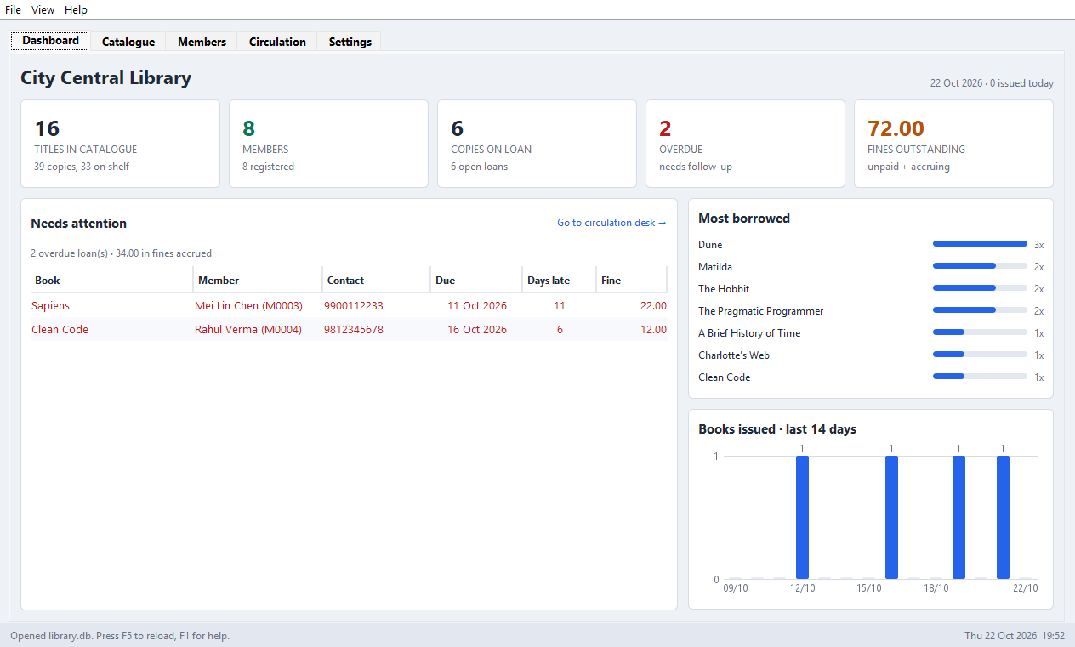
Figure 8.1 The dashboard
The dashboard is the screen that opens first. Across the top are the figures that describe the library at this moment: titles catalogued, members registered, copies on loan, items overdue and total fines outstanding. Below on the left is the list that needs attention — every overdue loan with the borrower's name, telephone number, due date, days late and fine accrued, so that the librarian can act without looking anything else up. On the right are the most-borrowed titles and a chart of issues over the last fourteen days.

8.2 Catalogue
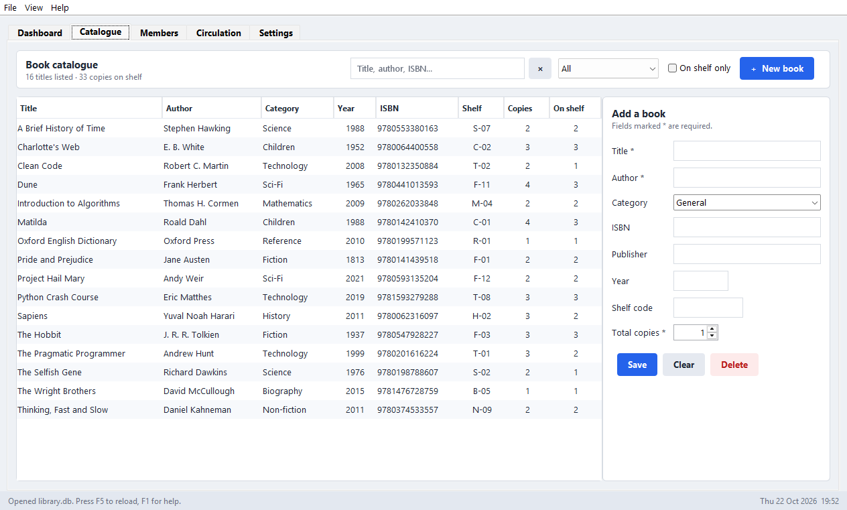
Figure 8.2 The catalogue tab
Every book the library owns, with the number of copies owned and the number currently on the shelf. The search box matches on title, author, ISBN or publisher as the user types, and the list can be narrowed to a single category or to titles with copies available. Selecting a row loads it into the form on the right for editing; the New book button clears the form for a fresh entry. Titles with no copies left on the shelf are shown in orange.

8.3 Members
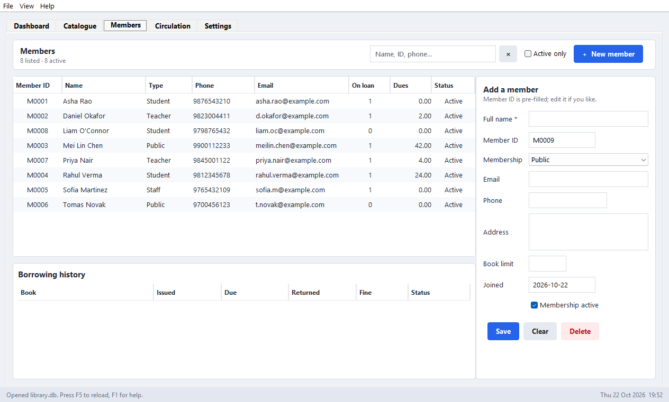
Figure 8.3 The members tab
Everyone entitled to borrow, with their membership type, contact details, the number of books they are holding and what they owe. Selecting a member fills the form and also loads their complete borrowing history in the panel underneath — every book they have ever taken, with the dates and any fine. A new member is allocated the next member code automatically and inherits the borrowing limit of the membership type chosen.

8.4 Circulation Desk
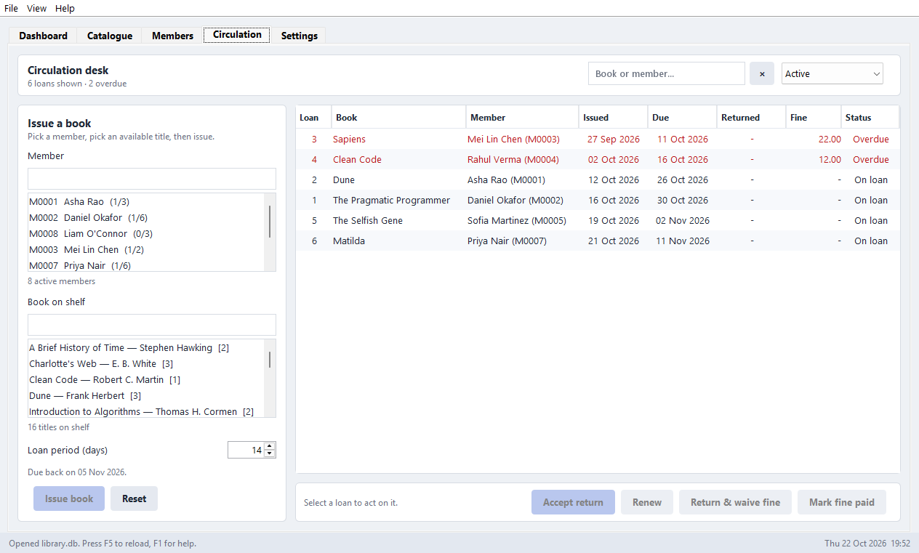
Figure 8.4 The circulation desk
The screen where the day's work happens. The librarian picks a member and a book using the type-to-search boxes on the left and presses Issue book; the loan appears on the right with its due date and the catalogue immediately shows one fewer copy on the shelf. Selecting an existing loan enables the actions that apply to it: accept the return, renew it, return and waive the fine, or mark a fine paid. Overdue rows are red, and the status filter at the top right narrows the list to active, overdue, returned or unpaid-fine loans.

8.5 Settings
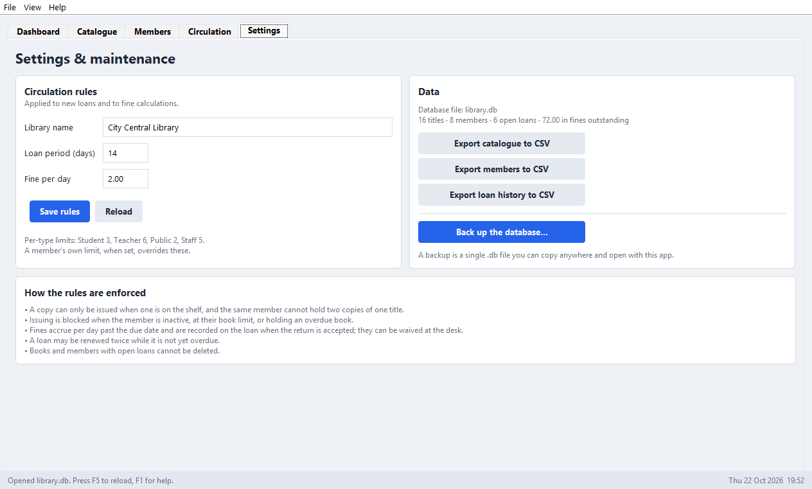
Figure 8.5 The settings tab
The library's own rules: its name, the loan period in days and the fine charged per day. Changing these affects new loans and fines still accruing; loans already issued keep the due date they were given. The right-hand side holds the data tools — export of the catalogue, the member list or the full loan history to CSV for use in a spreadsheet, and a one-click backup of the entire database to a single file.

8.6 Summary of Results

Objective | Result
Searchable catalogue with accurate copy counts | Achieved; verified by tests 1, 2 and 15 of Table 7.1
Members with enforced borrowing limits | Achieved; verified by tests 4 and 6
Issue, return and renewal with automatic due dates | Achieved; verified by tests 1, 7, 10, 11 and 12
Automatic fine calculation and settlement | Achieved; verified by tests 7, 8 and 9
All rules in one component | Achieved; LibraryDatabase holds the only connection, and 47 tests exercise the rules with no interface present
Reporting at a glance | Achieved; dashboard figures verified against the database by interface test 2
Data portability | Achieved; CSV export and database backup verified by tests 17 and 18
Table 8.1 Objectives against results

Chapter 9 Conclusion
This project set out to build a library management system that does not merely record what happened but enforces the library's own rules, and that a small library can actually install and use. Both aims were met. The finished application maintains a catalogue and a member register, issues and accepts returns, renews loans, calculates and settles fines, reports the state of the collection at a glance, and refuses — with an explanation — any action that would break a rule. It runs from a single download on any computer with a Java runtime, storing everything in one file.
The outcome that matters most for a course in Object-Oriented Programming is not the feature list but the structure underneath it. Dividing the application into a data layer that owns the rules and an interface layer that owns only the screens produced three concrete benefits, each of which can be demonstrated rather than merely claimed. A rule cannot be bypassed from a button, because no interface class can write to the database at all. A rule can be changed in exactly one place. And the rules can be verified without opening a window, which is why 47 of the 70 tests run in milliseconds with no display attached.
The object-oriented features of Java were used where they solved a real problem rather than to satisfy a checklist. An abstract class with one abstract method lets the window reload five different screens without knowing what any of them contains. An interface lets the screens be tested without a window. Records give model objects that cannot be altered behind the data layer's back. An enumeration keeps each membership type's borrowing limit beside its name instead of in a chain of conditionals. A generic table class serves four tabs with four different row types and no casting. In each case the language feature was chosen because the alternative was worse.
The project comprises 39 classes and approximately 6,700 lines of Java with a single external dependency, and is verified by 70 automated tests that are run on two operating systems and two versions of Java on every push to the repository. All of them pass.

Chapter 10 Future Scope
The system is complete for the scope defined in Section 1.4. The following extensions would be the natural next steps, and the architecture accommodates each of them without restructuring.

Extension | Description | Effect on design
Reservations and a waiting list | Allow a member to reserve a title whose copies are all out, and notify them when one is returned | A new reservations table and a corresponding group of methods on the data layer; the return path would consult it before returning a copy to the shelf
Barcode scanning | Scan a book and a membership card instead of typing to search for them | None to the rules. A barcode reader behaves as a keyboard, so the existing pickers would receive the code directly
Multi-user access | Allow more than one librarian to work at once | The largest change: SQLite would be replaced by a client-server database. Because every query is confined to LibraryDatabase, the change is bounded to one class
Automatic reminders | Send an email or SMS before a book falls due and again when it is overdue | A scheduled task reading the same overdue query the dashboard uses; the contact details are already stored
Fine payment history | Record part payments and keep a receipt trail rather than a single paid flag | A payments table referencing loans; the fine_paid flag becomes a derived value
Reporting and analytics | Borrowing trends by category, by month and by membership type, exportable for a library committee | Additional queries on the existing schema; no change to the tables is required
Table 10.1 Possible extensions and their effect on the design
That most of these extensions are additions rather than rewrites is itself a result of the design. Because the rules are confined to a single class and the screens hold none of them, a new capability is added by extending that class and giving it a screen — not by revisiting logic scattered across the interface.

REFERENCES
[1] Oracle Corporation, "Java Platform, Standard Edition 17 API Specification". Available: https://docs.oracle.com/en/java/javase/17/docs/api/
[2] Oracle Corporation, "The Java Tutorials: Creating a GUI With Swing". Available: https://docs.oracle.com/javase/tutorial/uiswing/
[3] Oracle Corporation, "JDBC Basics — The Java Tutorials". Available: https://docs.oracle.com/javase/tutorial/jdbc/
[4] SQLite Consortium, "SQLite Documentation". Available: https://www.sqlite.org/docs.html
[5] SQLite Consortium, "Datatypes In SQLite Version 3". Available: https://www.sqlite.org/datatype3.html
[6] T. L. Saito and contributors, "sqlite-jdbc: SQLite JDBC Driver", version 3.50.3.0. Available: https://github.com/xerial/sqlite-jdbc
[7] J. Bloch, Effective Java, 3rd ed. Boston, MA: Addison-Wesley, 2018.
[8] E. Gamma, R. Helm, R. Johnson and J. Vlissides, Design Patterns: Elements of Reusable Object-Oriented Software. Reading, MA: Addison-Wesley, 1994.
[9] M. Fowler, Patterns of Enterprise Application Architecture. Boston, MA: Addison-Wesley, 2002.
[10] R. Elmasri and S. B. Navathe, Fundamentals of Database Systems, 7th ed. Hoboken, NJ: Pearson, 2016.
[11] H. Schildt, Java: The Complete Reference, 12th ed. New York, NY: McGraw-Hill, 2021.
[12] Koha Community, "Koha Library Software". Available: https://koha-community.org/

