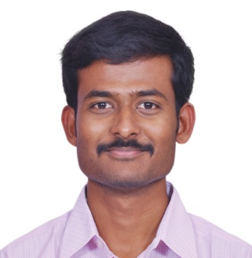

Design Patterns

**Require JS**

**ReactJS**

**SASS**

**Node JS**

Asset Performance Management Application

Platform: Web, Mobile, Tablets, IPAD

APM Safety module provides reduction of hazards and risk associated with industrial operational safety

Smart TV Platform Application

Platform: Panasonic, Samsung

Released more than 15 application in Indian market and non-Indian market applications in Panasonic and 2 application in Samsung TV platform

Set Top Box Application

Platform: Web streaming set top box

Developed VOD application and Appstore portal which has developer, users and admin logins linked with RDBMS and supported payment gateway integration.

2011-2014

Tata Elxsi Limited,

Bangalore

**Software Engineer**

Development of smart TV, set top box and Appstore applications.

Smart TV: Samsung, Panasonic.

Set top box: Roku, Boxee.

Keywords: HTML 5, Javascript, CSS3, Angular JS, PHP, Laravel, XML, Json, Mysql, Payment gateway Integration, Social media login and integration, Jquery, Pagespeed

Completed Secondary Education with 85%

**Secondary Education**

2004-2005

SSLC

ABOUT ME

DOB: 13.03.1990

Marital status: Married

Language: English, Tamil, Kannada

**EXPERIENCE**

ADDRESS

No.201/1, G10, Rsun Susmitham Apartmant,

FCI Road, Kadugodi, Channasandra,

Bangalore.

2014-Present

Indecomm Global

Service, Bangalore

**Senior Software Engineer**

Development of Asset Performance management web application software.

Keywords: HTML 5, Javascript, CSS3, KnockoutJS, AngularJS, ReactJS, Bootstrap, SASS, Require JS, Jquery, Yeoman, Node JS, Grunt, Gulp.

**PERSONAL DETAILS**

User Experience

Web development

**000**

WHO AM I

I Love what I do and the people I get to work with. I learn new things daily to make me a faster, more efficient and productive developer.

2005-2007

HSC

**Higher Secondary**

Completed Higher secondary education in computer science department with 82%

2007-2011

Engineering

**Bachelor of Engineering**

Completed Engineering in computer science under Anna university chennai, *First class with Distinction*

**EDUCATION**

**Angular JS**

**JQuery**

**PHP**

**UI**

**hh**

**MYSQL**

**Knockout JS**

**Bootstrap**

→ <ashokvelan@gmail.com>

✶ http://pashokkumar.github.io

(M) 99801 46618

ashokkumar-p-64822170

**PROJECTS**

**TECHNOLOGY**

Responsive

Frameworks

Optimization

**PRACTICE AREAS**

Technical Lead

ASHOKKUMAR P

