The macro application can be run from CATIA. For the macro to be available, the library that contains the two essential macros must be added to the macro libraries.

After the macros are available in the visual basics editor, the application can be run using the Tools 🡪 Macro 🡪Macros 🡪 Functionality (macro library) 🡪TableGenerator (assembly macro) or by pressing Alt + F11 and using the F5 method of running the same macro in the same macro library.

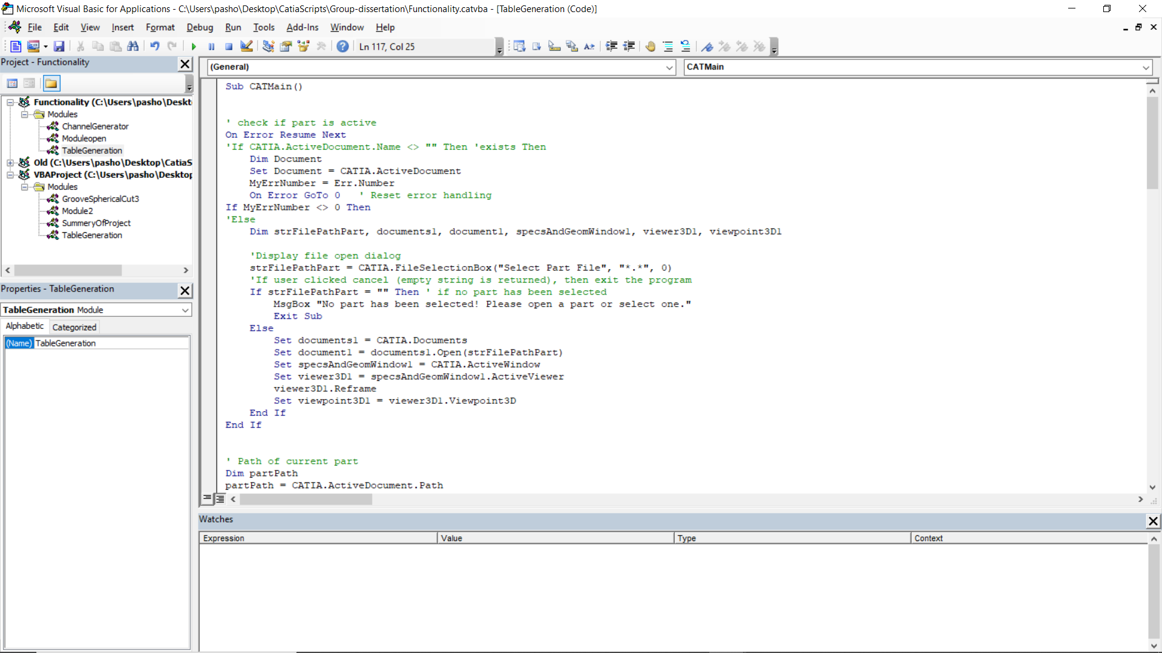

This is the assembly macro inside the visual basics of CATIA.

The macro can be run with or without a part being loaded.

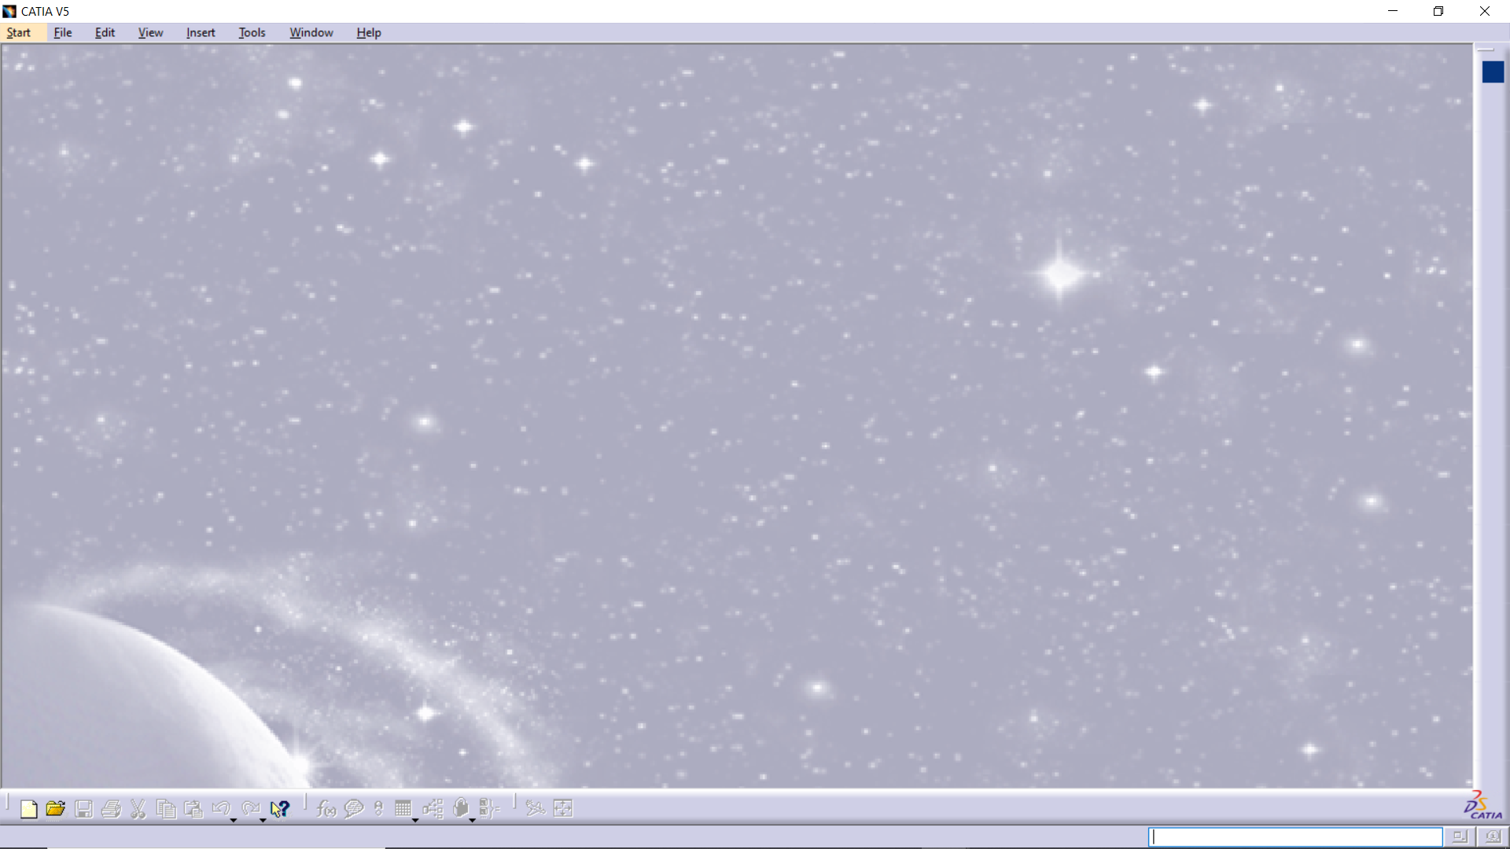

If there is not part loaded, it prompts the user to select a part that will be edited.

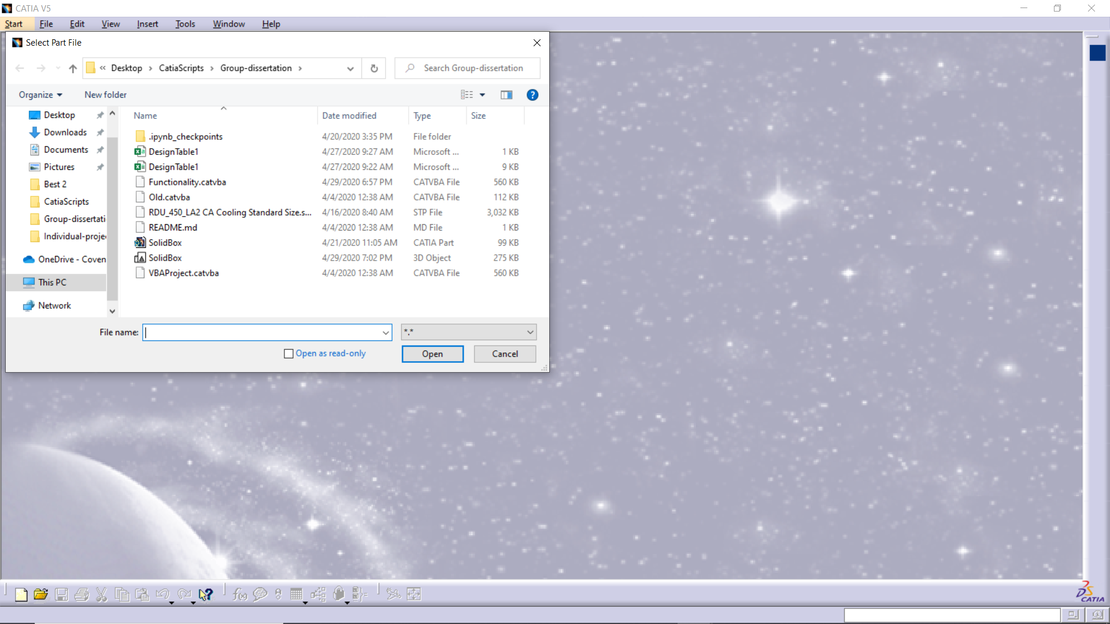

Or if there is already a part loaded the macro will do the channel generation on that part.

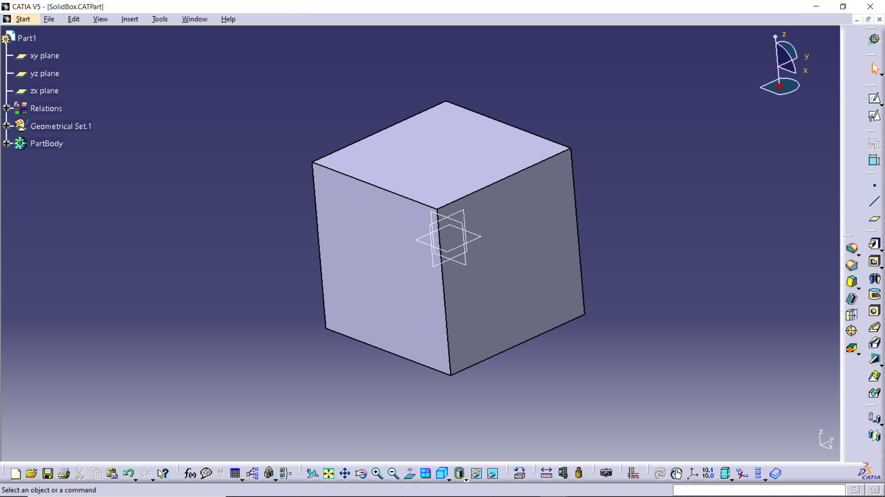

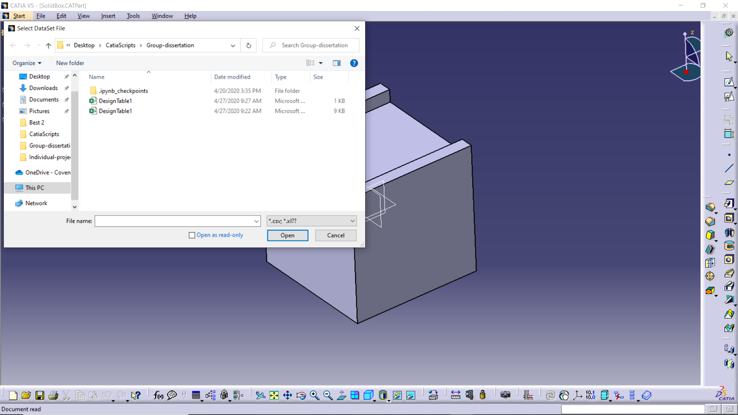

Then it prompts the user again, but this time it requires a datasheet that contains the positions of the channels.

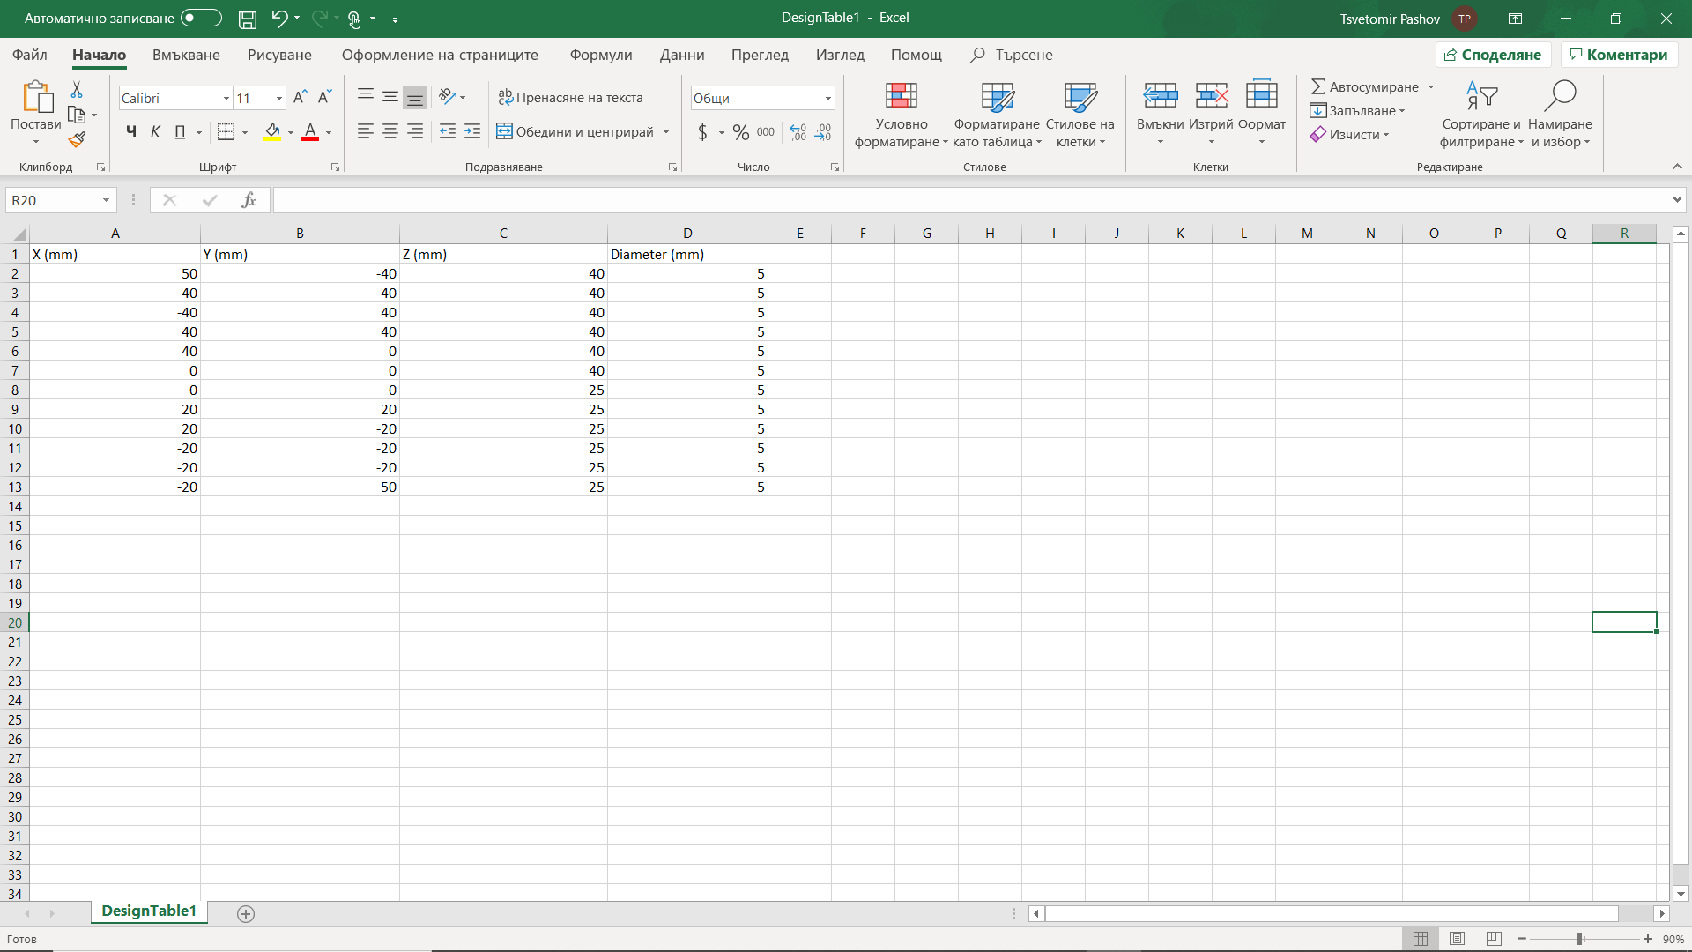

This is a simple representation of what the expected datasheet is.

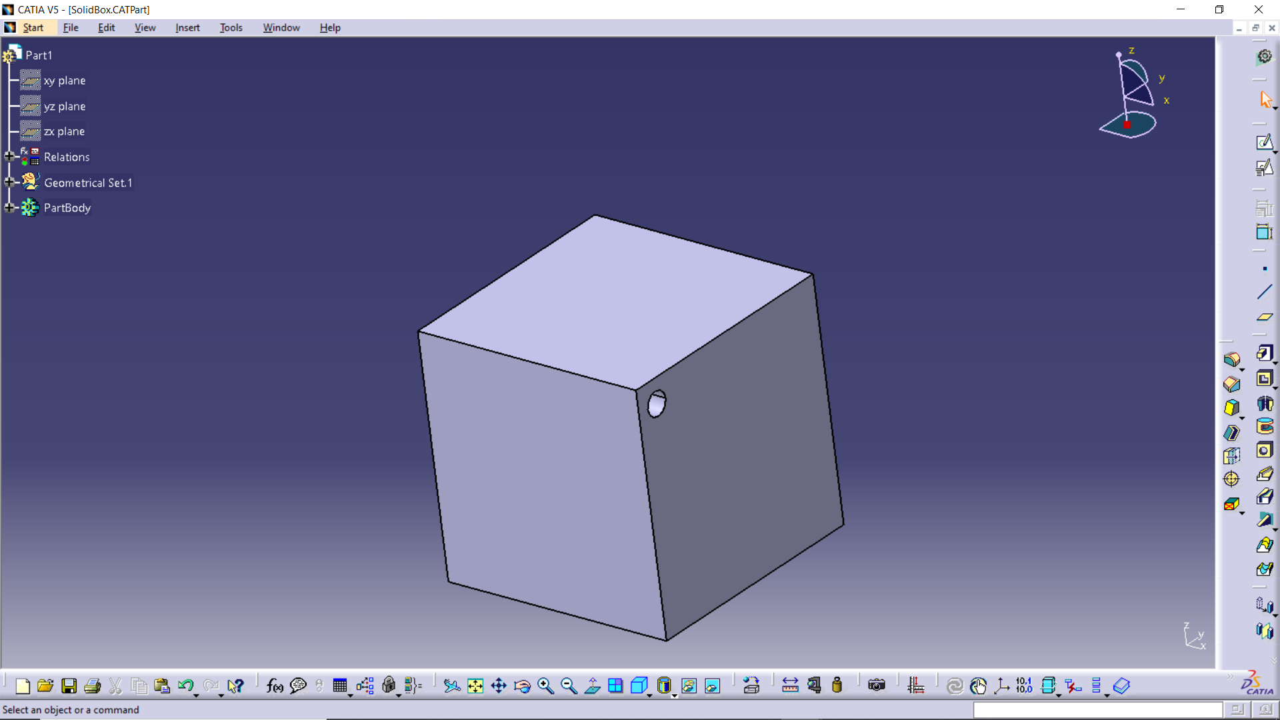

Then it starts to generate the channels

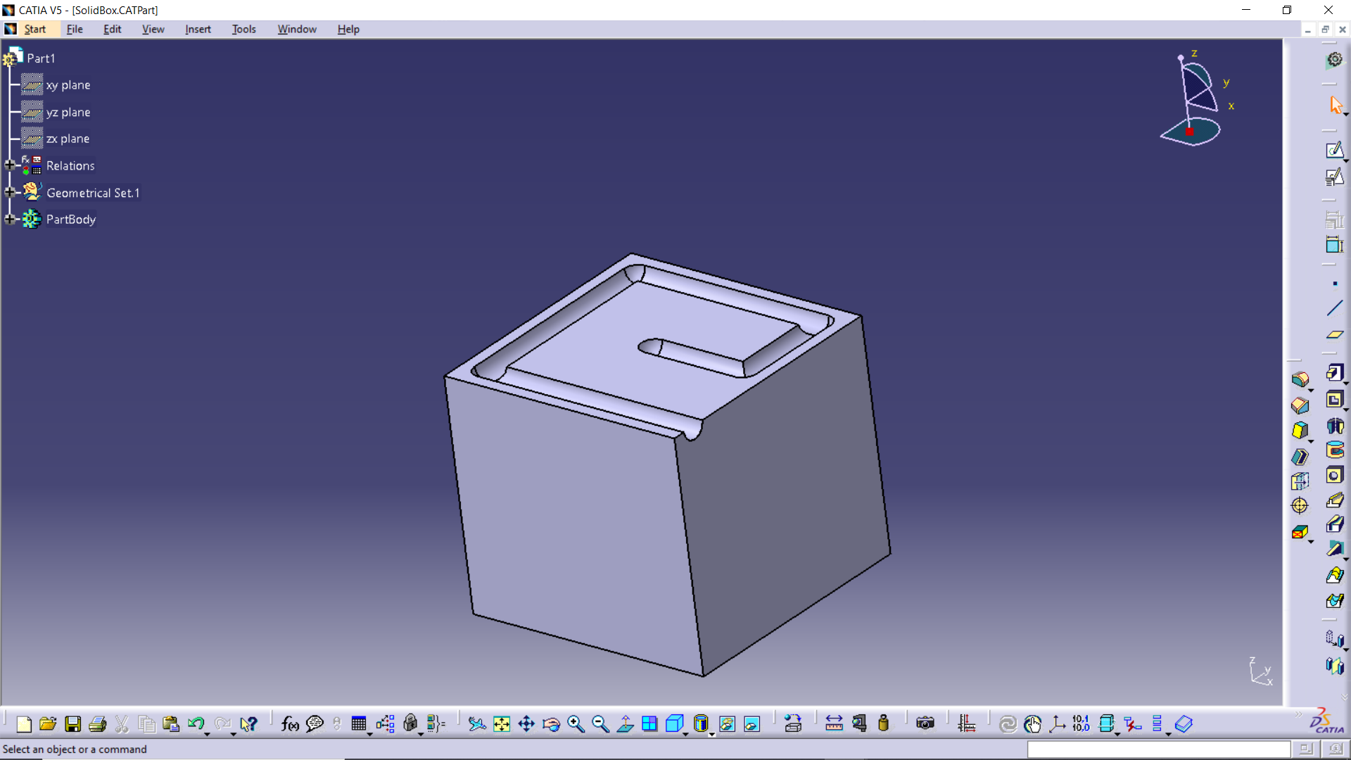

The thickness of the top surface of the box is reduced to show the channel that is generated.

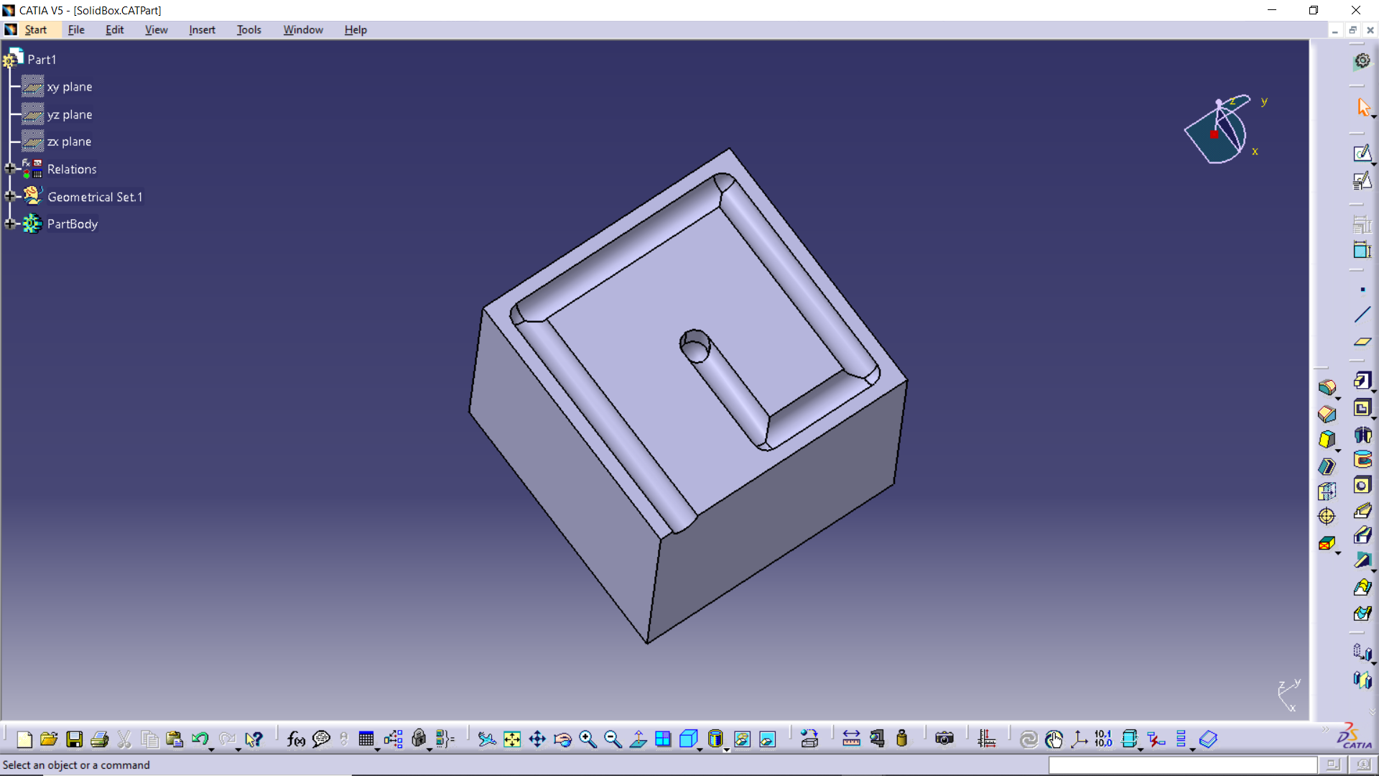

Showing a channel generated vertical downwards.

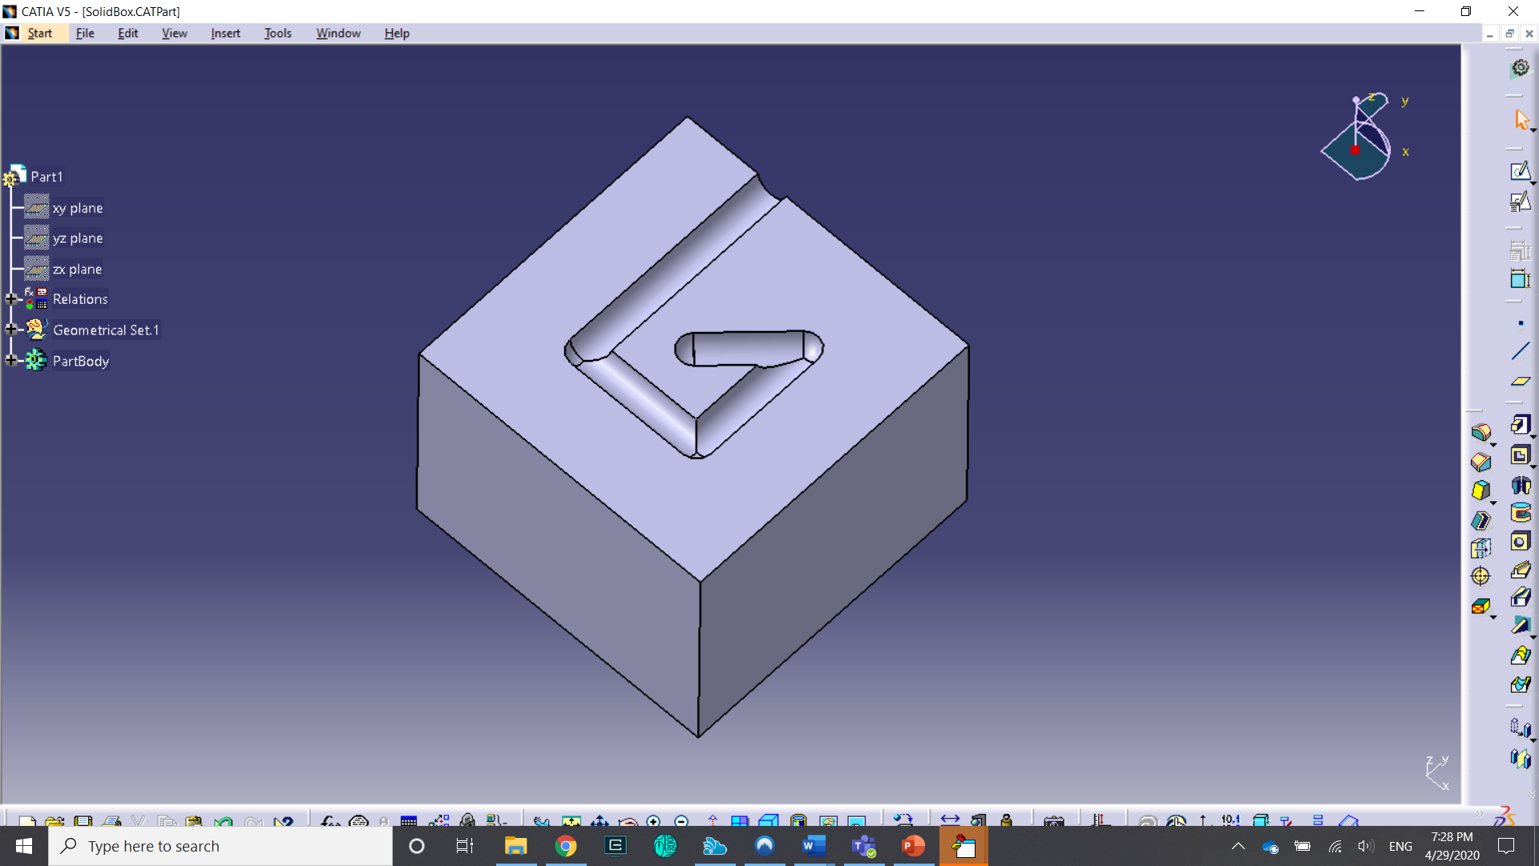

Further reduction of the top surface thickness.

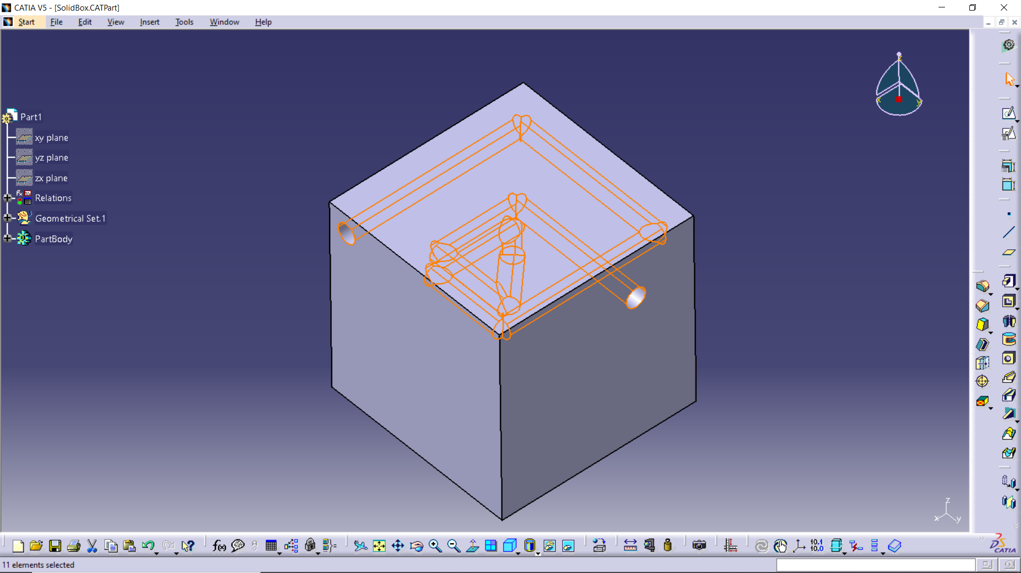

The final representation of the internal layout can be seen.