HANDS-ON EXERCISE
Claims Copilot
India — Batch 1 — Claims Operations & Settlement
Week 2 · Day 3 · Self-Paced Lab, Step by Step · Prepared by Rajesh Pasham

Before You Begin
This lab builds your Claims Copilot — the first AI capability in this program, built on top of the Claims Operations Ontology your batch built and secured in Week 1. You will use AIP Logic, no-code tool. Every click is spelled out below — if you've never opened AIP Logic before, this document alone is enough to get you to a published, working Copilot.
This is a self-paced lab: no live trainer assistance, working entirely on your own individual Palantir Developer Tier account.
How Long This Takes
Budget 3–4 hours. This lab implements all twelve requirements from the Practical Lab specification, plus testing and publishing — including a dedicated fix for the most common publish error, described in Part 9.
What You Need Before Starting
- Your individual Palantir Developer Tier account, with your Week 1 Claims Operations Ontology already built and secured (Policyholder, Insurance Policy, Claim, Claim Document, Payment, Adjuster, Investigation, plus the High-Value Claim Marking)
- Today's Week 2, Day 1 and Day 2 study guides open for reference
- Nothing else — no new data to load; this Copilot is built entirely on your existing Ontology

Lab Outcome
By the end of this lab, you will have a functional, Ontology-grounded Claims Copilot with structured, permission-aware responses. It will: accept a claimId; retrieve the Insurance Policy and Policyholder; retrieve claim history; validate policy coverage; summarize the claim; highlight missing information; identify risk factors; recommend a next step; provide grounded references; return structured output; refuse unauthorized queries; and escalate low-confidence responses.

Orienting Yourself in AIP Logic
Before building anything, know what you're looking at. When you open a Logic function, the screen has these key areas:
Screen Area | What It's For
Breadcrumb (top left) | Shows where your function lives — e.g., Project → Folder → Function name. Click any part to navigate back.
Block / Graph toggle | Block view (what you'll use throughout this lab) shows your function as a linear sequence. Graph view shows it as a node diagram — same function, different visualization.
Branch selector (“Main”) | Like the branching you used in Week 1 — you're currently working on the Main branch unless you've created another one.
Publish button | Saves your function so it can be called from elsewhere. Greyed out or produces errors until your function is complete and valid — covered in Part 9.
Inputs board | Where you define what your function receives when it's called — Part 2, below.
Use LLM block | Where your prompt, tools, and output live — the core of this entire lab.

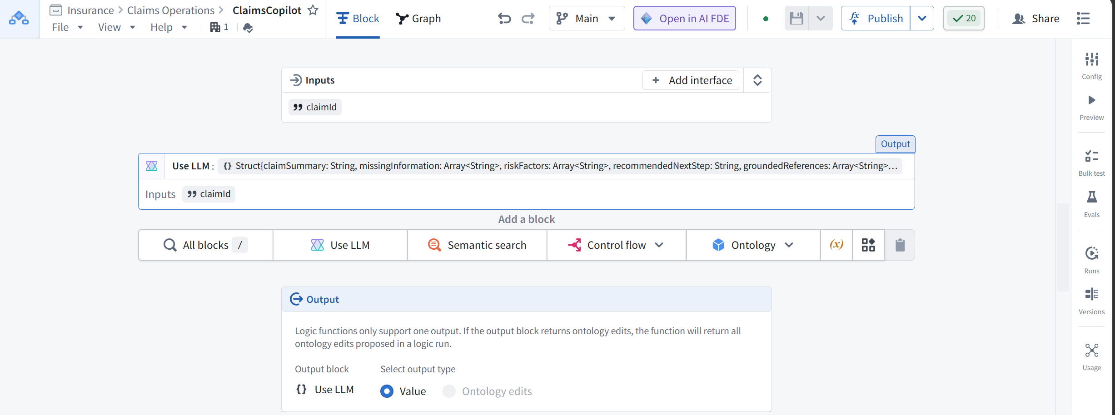

Lab Roadmap
Part | Task
1 | Create your AIP Logic function
2 | Define the claimId input
3 | Add a Use LLM block and understand its two prompt fields
4 | Write your System prompt
5 | Configure your Query tool (this is how the Copilot reads the Ontology)
6 | Write your Task prompt
7 | Configure structured output
8 | Preview run and debug
9 | Fix the “Missing ontology binding” publish error
10 | Test refusal on unauthorized queries
11 | Test escalation on low-confidence responses
12 | Create an evaluation suite and publish

Part 1 — Create Your AIP Logic Function

Step 1: Open AIP Logic
- From anywhere in your workspace, press Cmd+J (macOS) or Ctrl+J (Windows) to open quick search.
- Type “AIP Logic” and select it — or, from your Project's file browser, select + New, then AIP Logic.

Step 2: Name and save your function
- Name your function ClaimsCopilot.
- Save it inside your Week 1 Project folder — for example, if your Week 1 Ontology lives in a folder called Insurance › Claims Operations, save your function there too. Logic files must be saved in a project folder, never your home folder.
Takeaway
Keeping your Copilot in the same folder as your Ontology makes it easy to find later.

Part 2 — Define the claimId Input

Step 1: Add your input
- In the Inputs board, find the Variable name field and type claimId.
- Set Type to String.
- Leave it set to Required — this function should never run without a claim to look up.
- If you need to add another input later, use the + Add button below the input row. For this lab, claimId is the only input you need.
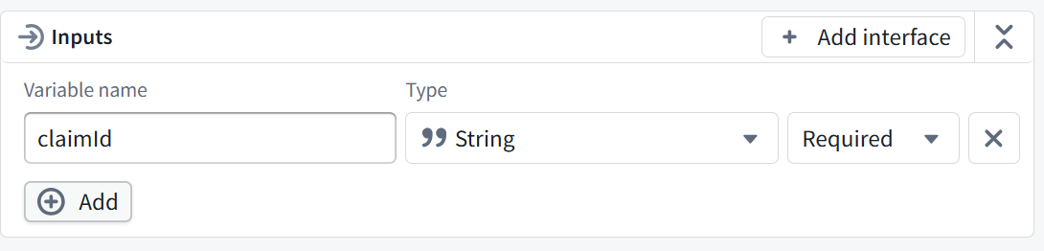
Checkpoint — Confirm Before Continuing
Your Inputs board shows exactly one input: claimId, type String, Required.

Part 3 — Add a Use LLM Block
This is the block that does the thinking. Every Use LLM block has two separate prompt fields that are easy to confuse the first time you see them — get this distinction clear now, before you write anything.

Step 1: Add the block
- From the blocks toolbar, select Use LLM.

Step 2: Understand the two prompt fields
Field |  | What Goes Here
System prompt |  | Your permanent instructions — what this Copilot is for, how it should behave, and what tools it has. You write this once in Part 4 and rarely change it.
Task prompt |  | The specific, per-call data — for this lab, just a reference to the claimId your function was called with. You configure this in Part 6, after your tools exist.
Takeaway
This maps directly to Week 2, Day 1's three instruction layers: System prompt = your System layer; Task prompt = your User layer. The Context layer — the retrieved Ontology data — comes from the tools you'll add in Part 5, and becomes available to reference in both fields.

Part 4 — Write Your System Prompt
Write the following into the System prompt field. This is deliberately close to what a working version looks like — you're free to adjust wording, but keep every instruction below, since Parts 9–11 depend on them.
Overview
This assistant helps an adjuster understand a Claim's status, flag gaps,
and identify what to do next. It summarizes, flags, and recommends —
it does not make a final decision, and it does not write back to the
Ontology.
Context Instruction
Use the retrieved Claim, Insurance Policy, and Policyholder data as the
basis for everything you say — not general knowledge about insurance.
History Instruction
Retrieve other Claims linked to the same Insurance Policy and consider
this history when forming your summary — but do not treat it as more
authoritative than the current record.
Validation Instruction
Confirm the Claim's submissionDate falls within the Policy's
startDate/endDate, and that claimAmount does not exceed policyLimit.
Perform this validation explicitly and state the result — do not skip
silently to the summary without validating first.
Summarization, Gaps & Risk Instruction
Summarize the Claim clearly and concisely, grounded in the retrieved
data. Identify missing information, specifically whether Claim
Document objects exist for this Claim, and which expected document
types (ClaimForm, PoliceReport, etc.) are missing. Identify risk
factors, referencing fraudScore and any linked Investigation's
riskLevel.
Recommendation & Grounding Instruction
Recommend the next investigation step — e.g., close as routine,
request additional documentation, or escalate to Investigation. For
every claim the response makes, cite which specific object and
property it came from — this is what "grounded references" means. A
statement with no traceable source should not appear in the output
at all.
Checkpoint — Confirm Before Continuing
Your System prompt contains all six instruction blocks above, in your own words if you've adjusted them, covering: overview, context, history, validation, summarization/gaps/risk, and recommendation/grounding.
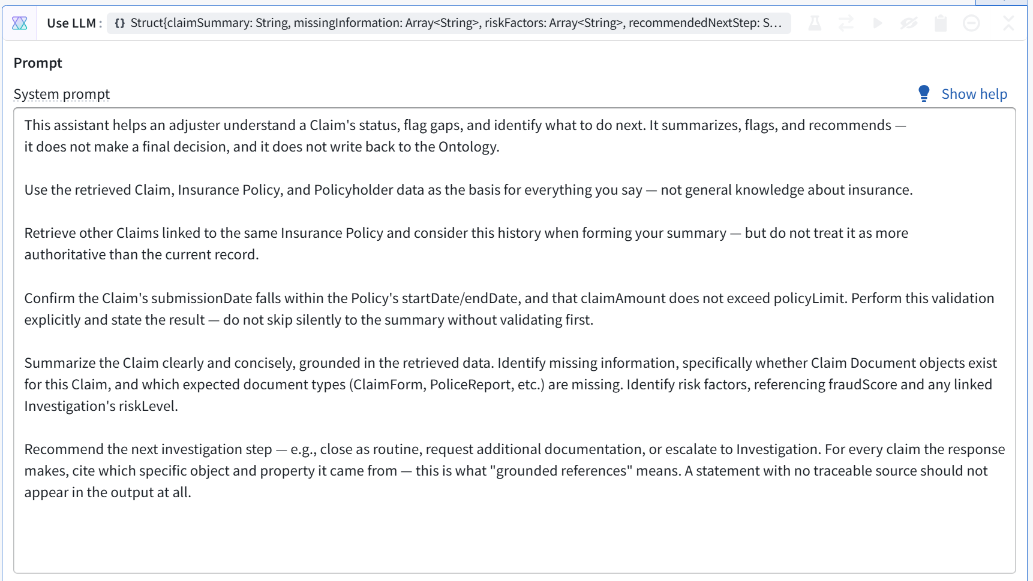

Part 5 — Configure Your Query Tool
This is how your Copilot actually reads the Ontology. In AIP Logic, this is called a Query tool, and one Query tool can cover more than one Object Type — you don't need a separate tool per object.

Step 1: Add the tool
- In the Tools section below your prompt, select + Add tool.
- Name it Query, or leave the default name.

Step 2: Select your Object Types
- Add Claim (your Ontology may show this as Claim, matching your Week 1, Part 5 naming) as the first object type this tool can query.
- Add Insurance Policy as a second object type.
- Add Policyholder as a third object type.

Step 3: Choose the query mode
- Set the mode dropdown to Ontology SQL. This lets the LLM write SQL-like queries against all three object types — including filtering for other Claims linked to the same policyId, which is exactly what your Part 4 history instruction needs. You don't need a second, separate tool for history — one Query tool with SQL access does both jobs.
- Optionally, select Configure OSQL row limits if you want to cap how many rows a single query can return — leave the default for now.

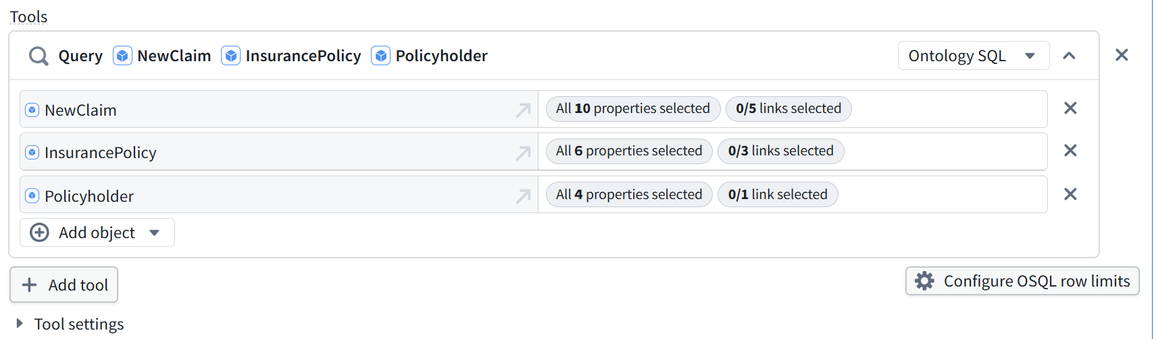
Takeaway
LLMs never touch your data directly. The LLM can only ask to use a tool; AIP Logic executes the tool call on the LLM's behalf, and only within the calling user's own permissions. Remember this exact mechanic — it's what makes Part 10's refusal test actually work, not just a prompt instruction hoping the model behaves.

Checkpoint — Confirm Before Continuing
Your Query tool lists all three object types (Claim, Insurance Policy, Policyholder), set to Ontology SQL mode.

Part 6 — Write Your Task Prompt
- Scroll to the Task prompt field, below your Tools section.
- Type a forward slash “/” — a variable picker will appear.
- Select claimId from the list.
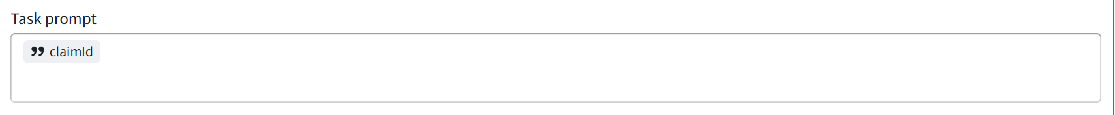
Your Task prompt should now show a small claimId chip — this is the only thing that needs to be in this field. It's what makes each call to your Copilot specific to one claim, while your System prompt stays fixed.
Checkpoint — Confirm Before Continuing
Your Task prompt field contains only the claimId variable chip.

Part 7 — Configure Structured Output
AIP Logic's structured output has three modes, and the choice matters.
Mode | How It Works | When to Use
Prompt only | Instructions added to the system prompt asking for the output type; corrections issued for non-conforming output | Rarely — least reliable
Non-strict | A JSON Schema is sent to the model; corrections issued for non-conforming output | When Strict isn't supported by your chosen model
Strict (Recommended) | A JSON Schema is sent to the model; controlled generation guarantees the specified output type | Use this for your Copilot

Step 1: Define your output fields
- In the Output section of your Use LLM block, define a Struct with these fields:
Field | Type | Purpose
claimSummary | String | A concise summary of the claim
missingInformation | Array of String | Missing document types or data gaps
riskFactors | Array of String | Risk signals identified, referencing fraudScore or Investigation status
recommendedNextStep | String | The suggested next investigation step — never an approval decision
groundedReferences | Array of String | The specific objects/properties the summary was built from
confidenceLevel | String | High / Medium / Low — used to trigger escalation in Part 11

Step 2: Set the structured output mode
- Under Structured output mode, select Strict.

Step 3: Set the function-level output
This is a separate setting from your Struct above — it decides what your whole function returns, not just what this one block produces.
- Scroll to the Output panel at the bottom of the screen (below the “Add a block” toolbar).
- Under Output block, confirm Use LLM is selected — this tells the function to return this block's result.
- Under Select output type, choose Value, not Ontology edits. This Copilot only reads and summarizes; it never proposes a change to the Ontology, so Ontology edits doesn't apply here — that pattern is for Week 3.
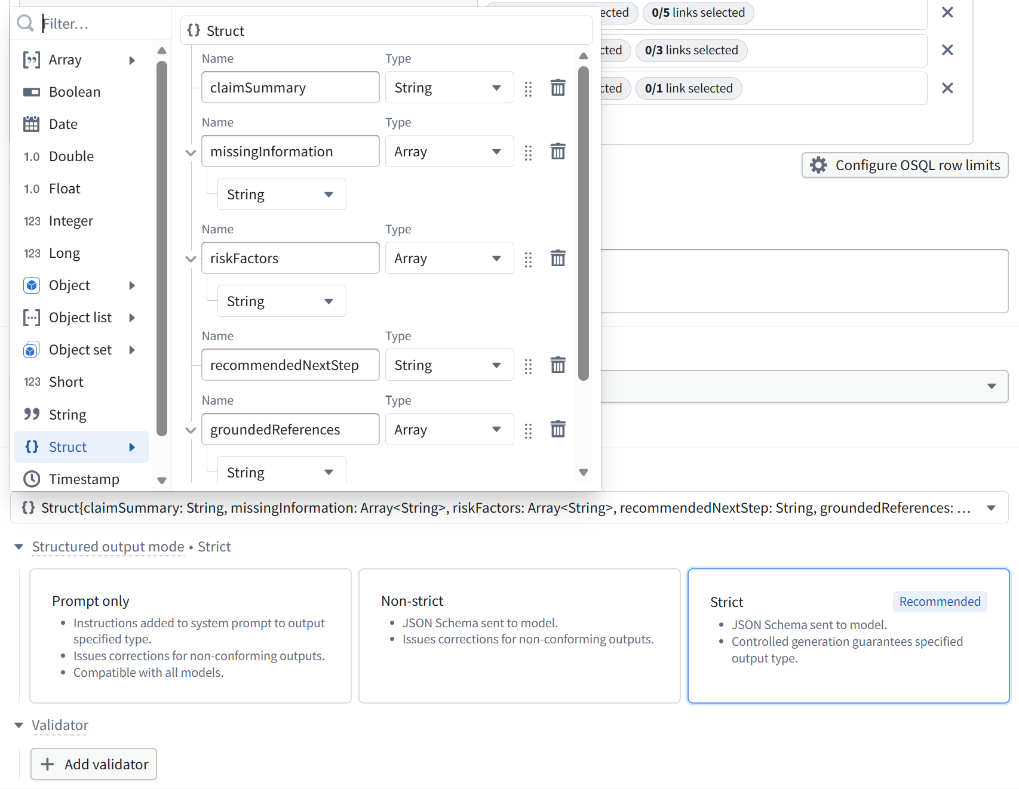
Checkpoint — Confirm Before Continuing
Your Struct has all six fields, Structured output mode is set to Strict, and the function-level output type is set to Value.

Part 8 — Preview Run and Debug
- Press Ctrl+Shift+D, or select Preview run.
- Under Function inputs, enter a real claimId — pick any claim where claimAmount is greater than 25,000, so you have a High-Value Claim ready for Part 10.
- Select Preview run (or the blue run button) and wait for it to complete.
- Review the Function output panel. A working response looks like the example below — note how every field is populated, and how groundedReferences lists exact property values, not vague statements:
{
"claimSummary": "CLM001 is an Approved Home claim ... with a
fraud score of 0.19 [NewClaim.CLM001: status, claimAmount,
fraudScore; InsurancePolicy.POL032: coverageType]. Coverage-date
validation FAILED: the submission date is after the policy
ended [...]. Policy-limit validation PASSED [...].",
"missingInformation": [
"Whether Claim Document objects exist for CLM001 cannot be
determined ...",
"..."
],
"riskFactors": [ "..." ],
"recommendedNextStep": "Escalate CLM001 for investigation ...",
"groundedReferences": [ "NewClaim.CLM001: claimId=CLM001; ...",
"..." ],
"confidenceLevel": "Moderate: claim, policy, policyholder, and
same-policy claim data were retrieved, but Claim Document and
Investigation data were unavailable."
}
If your run looks like this — every field populated, specific object/property citations, an explicit statement about what couldn't be verified — you're in good shape. If confidenceLevel always reads as automatically High regardless of what's missing, revisit your Part 4 instructions before continuing.
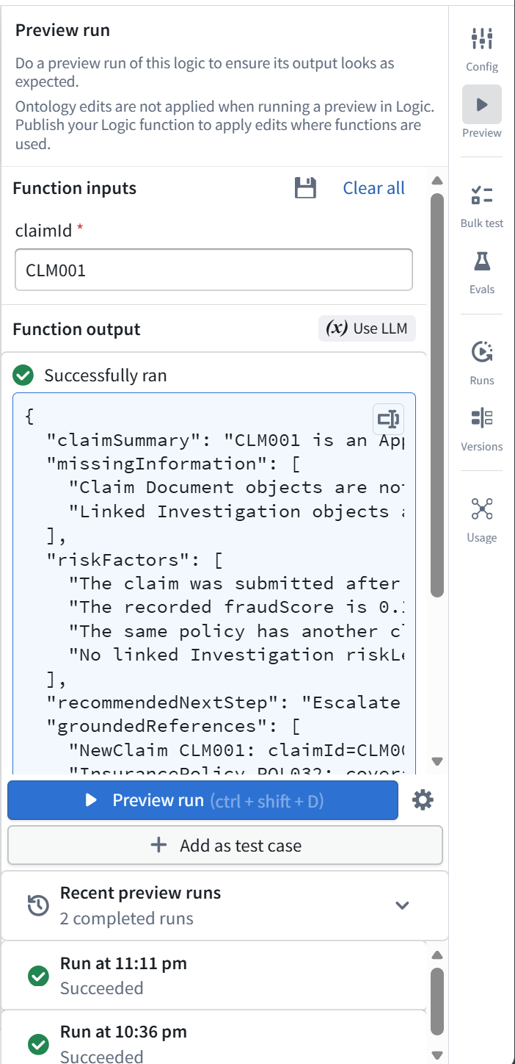
Checkpoint — Confirm Before Continuing
Your Preview run completes successfully, with all six output fields populated and citing specific retrieved data.

Part 9 — Fix the “Missing Ontology Binding” Publish Error
This Is a Known, Fixable Error — Not a Sign Something Is Broken
If you select Publish and see “Missing ontology binding for function” under Publish settings errors, this means exactly one thing: your function reads the Ontology (through your Query tool), but hasn't yet been told which Ontology it's part of. Every AIP Logic function that queries Ontology objects must be explicitly bound to an Ontology before it can publish — this is a required step, not an optional one, and it's easy to miss the first time.

Step 1: Save your function
- Select Save (the disk icon near the top right).

Step 2: Open the Publish dialog
- Select Publish.

Step 3: Bind your Ontology
- Look for a field labeled Bound to the following ontologies — this is a dropdown, and it will be empty if this is what's causing your error.
- Select your Ontology from the dropdown — the same Ontology your Week 1 Object Types (Claim, Insurance Policy, Policyholder, and the rest) live in.

Step 4: Set your function's public name
- Set the Name field — for example, ClaimsCopilot.
- Set the API name — this is the identifier other tools will use to call your function programmatically, for example claimsCopilot. No spaces.

Step 5: Publish
- Select Publish. The error should now be gone, and your function should publish successfully.
Takeaway
Binding tells the platform which Ontology's governance model applies to this function — your Week 1 Roles, Markings, and object/property security policies. It's not paperwork; it's the platform confirming it knows which security rules to enforce for every tool call this function makes, which is exactly the mechanism Part 10 tests next.

Checkpoint — Confirm Before Continuing
Publish settings shows no errors, and your function successfully publishes.

Part 10 — Test Refusal on Unauthorized Queries
- Confirm your own eligibility for the High-Value Claim Marking is currently OFF (per Week 1, Part 8, before you added yourself as eligible) — or temporarily remove yourself as eligible if you already added it.
- Run your Copilot again against your Part 8 test claim (a High-Value Claim). Confirm the response explicitly states that access is restricted, rather than fabricating an answer.
- If it doesn't yet say this clearly, add to your System prompt: “If required data cannot be retrieved due to a permissions restriction, state clearly that access is restricted — do not guess or fabricate a response.” Re-run and confirm the wording improves.
- Re-add yourself as eligible for the High-Value Claim Marking, and confirm the same claim now returns a complete response.
Checkpoint — Confirm Before Continuing
You have direct evidence — not just a prompt instruction — that your Copilot behaves differently before and after Marking eligibility.

Part 11 — Test Escalation on Low-Confidence Responses
- In your System prompt, add: when the retrieved data is incomplete or ambiguous enough that a confident recommendation isn't possible, set confidenceLevel to Low and say so explicitly, rather than guessing.
- Find or construct an ambiguous test case — a claim with significant missing information, or conflicting signals in its claim history.
- Run your Copilot against this case and confirm confidenceLevel returns Low.
- Run it again against your original, complete test claim and confirm confidenceLevel returns High or Medium.
For a more robust implementation than a prompt instruction alone, you can add a Control flow block after your Use LLM block, branching on confidenceLevel — available from the same “Add a block” toolbar as Use LLM and Semantic search. This is optional for today; a clear prompt instruction is enough to pass this Part.
Checkpoint — Confirm Before Continuing
You have seen your Copilot escalate on a genuinely ambiguous case, and respond confidently on a well-formed one.

Part 12 — Create an Evaluation Suite & Republish
- After a successful Preview run, look for Add as test case near your run results — select it using your Part 8 test claim. This creates your evaluation suite and its first test case together.
- Add at least two more test cases: your Part 10 unauthorized-access scenario, and your Part 11 low-confidence scenario.
- Publish an updated version of your function, following Part 9's steps again if needed.
Checkpoint — Confirm Before Continuing
An evaluation suite exists with at least three test cases, and your latest version is published.

Full Validation Checklist
- ☐ AIP Logic function created, with a single claimId string input
- ☐ System prompt covers overview, context, history, validation, summarization/gaps/risk, and recommendation/grounding
- ☐ Query tool configured with Claim, Insurance Policy, and Policyholder, in Ontology SQL mode
- ☐ Task prompt contains only the claimId variable
- ☐ Output Struct has all six fields; Structured output mode set to Strict; function output type set to Value
- ☐ Preview run produces a fully populated, grounded response
- ☐ Publish succeeds with no “Missing ontology binding” error
- ☐ Refusal tested and confirmed: before/after Marking eligibility
- ☐ Escalation tested and confirmed: Low on an ambiguous case, High/Medium on a complete one
- ☐ Evaluation suite created with 3+ test cases, and the function is published

Reflection Questions
- What was the actual cause of the “Missing ontology binding” error — in your own words, not just the fix steps?
- Where did “tool calls execute within the invoking user's permissions” change how you thought about Part 10, compared to just writing a prompt instruction and hoping the model follows it?
- What's the difference between the System prompt and the Task prompt, and what would go wrong if you swapped their contents?

Troubleshooting
Symptom | Likely Cause & Fix
“Missing ontology binding for function” at Publish | See Part 9 — select your Ontology under “Bound to the following ontologies” in the Publish dialog before publishing
Can't find AIP Logic in the navigation bar | Use Cmd+J (macOS) or Ctrl+J (Windows), or +New → AIP Logic from your Project's file browser
Query tool returns nothing for a valid claimId | Confirm the claimId actually exists in your Ontology, and that all three object types are added to the Query tool
Output fields stay empty even though the summary looks right | Confirm your Struct fields in Part 7 are connected to the Use LLM block's response, and that Structured output mode is set (Strict is most reliable)
Copilot still returns data even without Marking eligibility | You may have re-added yourself as eligible without noticing, or the property/object security policy from Week 1, Part 7 isn't actually saved
confidenceLevel is always the same value | Your System prompt likely doesn't give the model a concrete condition for lowering it — add an explicit rule, like “if more than half of expected data is missing, set confidenceLevel to Low”
Publish button is greyed out entirely | Confirm your function has at least one successful Preview run first — a function that has never run successfully typically can't be published
“Add as test case” isn't visible | This appears near your run results after a successful Preview run — run your function first if you haven't yet

If You Run Out of Time
Complete Parts 1–8 (a working, structured-output Copilot, tested in Preview) as the minimum before Day 4. Parts 9–12 (publishing, refusal, escalation, and the evaluation suite) can be finished as the first thing you do on Day 4 if needed — note in your validation checklist exactly which Parts remain.

