**Upliftment of Agriculture through a**

**Cloud Web-based Solution**

Ravindra Kumar Jonwal

Pashupati Nath Verma

Manoj Yadav

14CO135 mail:ravindra.jonwal007@gmail.com

14CO130 mail:verma2471995@gmail.com

14CO156 mail:[man007yadav@gmail.com](mailto:man007yadav@gmail.com)

**Abstract:**

**India’s population is mostly dominated by villagers as almost 75% of population resides in villages. Economic development largely depends on the standards of living of its rural masses. But farmers are suffering from various problems due to lack of education, lack of training unawareness regarding technology and most important shortage of financial support. This paper discusses an innovative solution which proposes a user friendly Agricultural website, Smart Agro Help for farmers and research scholars to put a full stop on their problems. This is carried out by software projects using DBMS and ASP.NET. As most of the farmers are illiterate so we have included a good regional language support, user friendly Graphical User Interface (GUI) with graphical navigations and Agricultural training videos which will give information about crops, fertilizers and training in their regional languages.**

**Markets’ information with updated prices for various Agricultural commodities are also available on this website. The GUI is designed such a way that even an illiterate person can easily operate this website which graphical navigation control. Timely suggestions are also provided either through mailing or open discussion portal .Weather notifications are also provided through the website.**

**Keywords:**

**Cloud Computing, SaaS (Software as a Service), PaaS (Platform as a Service), IaaS (Infrastructure as a Service), ICT (Information Communication Technology), Mobile Cloud Computing (MCC), NCDEX (National Commodity and Derivatives Exchange), APMC (Agricultural Produce Market Committee).**

**I. INTRODUCTION**

Agriculture in India still mostly depends on monsoon. As population of the country is increasing day by day, there is need to increase the Agricultural productivity by creating awareness and promoting modern farming techniques which is the current need of the time. Farmers are not aware of advancement of technology in Agriculture fields .So they are being constantly exploited by politicians, businessmen and bureaucrats .Various schemes and facilities are not reaching to the farmers which sometimes leads to shootouts and even suicides [10].

Similarly Research scholars need to do research on particular kind of crops, fertilizers and various farming related techniques. They need in depth content of particular subject matter. They have to refer information from a lot of textual and web sites which is always hectic and time consuming. So to solve that issue we are building a website, Smart AgroHelp which will reduce the problems faced by both the research scholars and farmers to a large extent.

**II. LITERATURE REVIEW:**

A rigorous analysis of literature is done by our team. Out of which there are several factors which affect the yield of crops[10].Further ,farmers have to make certain decisions on these factors while doing any farming activity and such decisions vary from geographical region to region so the weather conditioning have great significance in good farming practices.

Similarly monsoon depression can be consider as a single factor which leads to the distribution of rainfall in all over India [11].

There has been a lot of work being done in this field.

The research paper [1] proposes various ways in which farmers can utilize MCC (Mobile Cloud Computing on their handsets using application called AgroMobile, to assist them for relatively better cultivation and marketing.

In research paper [2], author uses the concept of Horticulture and Android to introduce a “Farmer Helping Service” system that will provide the detail information of fruits, vegetables and flowers in audio format to the farmers. But issue with this system is that language choice is not present and it is specified only for Gujarat. It should wide useful for entire nation farmers. Pictorial/Graphical representation of crop is lacking. Method of Scientific technique and efficient use of fertilizer is not present in the application.

The [4]research paper discusses about Rural Entrepreneurship and Development of Villages, measures for Development of Rural Entrepreneurs in India, roles of Rural Entrepreneurs in Economic Development and benefits from Rural Entrepreneurship. But the problems with this approach are:

i. Management problems

ii. Lack of knowledge about IT

iii. Legal Formalities

Rural entrepreneurs find it extremely difficult in complying with various legal formalities in obtaining licenses due to illiteracy and ignorance.

The [5] paper intends to focus on the survey of application of image processing in agriculture field such as imaging techniques for Crop Management, nutrient deficiencies detection, weed detection and fruit grading. The analysis of the parameters has proved to be accurate and less time consuming as compared to traditional methods.The paper discusses about improving farming practices by using modern technology, some of which require infrastructure like wireless sensor networks and irrigation machine etc., which might be expensive for economically weak farmers.

This research paper [6] discusses the joint effort of Non-Government social Organization and Engineers, to help farmers and ease the task of Government and avoid losses occurring due to mismanagement. But there is no direct link of information to farmers. As NGO's and government officials are involve so there will be time delay which results in decrease of productivity of farming. It is also not going to help farmers as they are illiterate and require some kind of guidance before getting familiar with these new technologies.

The research paper [7] discusses about an online agriculture decision support system to assist the farmer for making a good decision in particular situation. To implement that decision support system, one requires the high end configuration of computers which is not feasible for farmers.

At present the Indian farmers depends on conventional sources of farming which are not reliable with respect to the modern scenario[12,13].So new technology methods needs to be used to reduce overburden on the farmers.

**III. GAP ANALYSIS**:

The current Agricultural system in our country is far away from reaping the benefits of the modern technology. This has hindered the Agricultural production from reaching its full potential in our country. There are various gaps in the current system which can be filled by taking adopting new ideas and measures.

The present system lacks a single web platform service which provides solution to all the farmers and Agricultural researchers’ problems. There are a lot of websites which provide information about various crops, fertilizers, Government schemes, market information, climate etc. But they are standalone websites i.e. a particular website provides information about only a particular field. For example, a website will provide information about only fertilizers and another about Government schemes and so on. This creates a lot of problems for the farmers and the Agricultural researchers’ while gathering information about them. An initiative would be to provide a web platform which provides a solution to this problem by giving information about all these fields together and providing a link to other useful websites for more information, if needed. This would save a lot of time and effort of the farmers and the Agricultural researchers.

Most of the farmers in the country are near the poverty line and their economic status is poor. Modern Agriculture farming requires a lot inputs in the form of modern agricultural equipment, commodities like good quality fertilizers and other irrigation sources like water pumps etc. These may be quite expensive and out of the reach of such farmers. A solution to the above problem would be to provide information about various bank loan schemes which provide financial support to economically weaker farmers with easy repayments. Another idea could be to provide a web platform or application to provide Agricultural equipment’s leasing to farmers in their local areas. There are several initiatives by various companies like Escorts India, in the country for setting up a nation-wide dealers’ network to provide expensive farm machinery at affordable rates to small and marginal farmers on rental basis. The machinery like Rotopuddler, wet leveler, automatic tray seeding machine, weeder, and a unique harvester, are costly at about Rs 40 lakh and are out of reach of many farmers.The dealers can post information about Agricultural equipment like tractors, ploughs, sprayers, harvesters and irrigation machines which they want to rent on such websites. This would be beneficial to both the parties and would help farmers’ sustain their income and rent machinery on individual capacity.

Another issue or gap in the present system is the absence of an active communication network between the farmers, NGOs and the Agricultural experts or officers. The present system doesn’t provide a means to connect farmers in rural areas with the Agricultural experts or officers, NGO’s and the other farmers in the local area. At present there is no website or application which connects farmers with other farmers in the local area as well as the Agricultural experts and NGO’s for their queries. Implementing this feature by creating an active online forum which supports Regional languages would be beneficial and would help in sharing valuable information which would help in improving agricultural knowledge of the farmers. The farmers can post their queries in the forum in their local language which could be then answered by the Agricultural experts and other farmers in the local area. This would help in building an active communication network between the farmers, NGO’s and the Agricultural experts in the areas.

The current Agricultural websites don’t provide any facility or feature where the farmers are notified about the various Government and NGOs conducted Agricultural Training events being organized in their areas. There can be such a feature where the NGO’s and Agricultural experts can provide or notify farmers in their areas about such events as well as post related Training videos related to that event that would benefit the farmers in knowing more about modern farming techniques. This would help in promoting modern farming techniques with a farther reach.

The current system also lacks the existence of an E-Marketing portal where the farmers can directly sell their produce online to other Market exporters and buyers in their local areas. Most of the farmers find it difficult to sell their agricultural produce due to absence of markets or not well connected to such markets. An E-Marketing portal can be developed to resolve this issue.

Large buyer’s link can made available with the help NGOs. Crop rates can be fixed directly by dealing with NCDEX (National Commodity and Derivatives Exchange), large buyers and APMC (Agricultural Produce Market Committee). Supply of materials to farmers and crops to buyers can be managed via this web portal.

**IV. ACTUAL WORK:**

This paper introduces the concept of implementation of cloud computing in the Karnataka agricultural sector. It intends to introduce cloud computing model with two core parts in it. The first part is to monitor and fulfil user requirements with a user-friendly and faster approach, and the other one to store all relevant data in a centralized location – cloud.

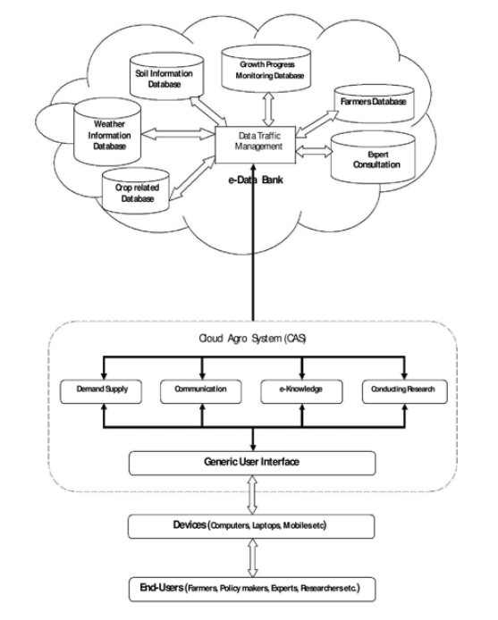

Fig. Cloud Agro System (CAS) Model for Smart Agro Help

1. **Cloud Agro System**: This part of the system can be used to monitor the overall functionalities of the system and render the needed services. The system will have online service facilities available to all the users, from any part of the Karnataka state and at any time. In order to render these services, the Agro system may have the following services:

• **Demand-supply**: It can provide an up to date picture of the current demand and supply information of agro products in different parts of the Karnataka state. It helps the farmers in deciding on selection of the crops. It also provides room to go for a comparative analysis of the demand and supply chain.

• **Communication**: The majority of rural population in Karnataka state are illiterate, who are in general farmers. Therefore, the system will provide services in their local language, which is Kannada also. The system will also have audio-visual facilities to disseminate information.

• **Communication Devices**: The mobile services in Karnataka have covered almost all parts of the state and almost each family has access to it. Though majority of the local farmers have never heard of Information and Communication Technology (ICT), they are used to with mobile services. Thus, the system incorporates mobile services and helps the farmers in acquiring information from e-data bank from anywhere, at any time, through mobile phones.

• **E-Knowledge sharing**: The system also keeps provision to have online communication with the experts/consultants and attend online training programs using the Community Service Centres (CSC) as the local information bases. The system is not restricted to only local information; cloud agro is a global ICT approach. The system, therefore, will collect and disseminate agriculture related global information to the local farmers. This will be specifically useful if they need information that is not locally available or not yet implemented in the state. Also farmers can be made aware of recent agro related concepts, such as “Organic cultivation” using this global ICT approach.

**• Conducting Research**: It will help the national and local researchers to extract agricultural data in Karnataka directly from the e-data bank and analyse them in order to contribute to the Indian agricultural sector of the nation. The research findings will be kept in the e-data bank and will be available to all its stake holders.

1. **E-Data Bank**: It is a central data bank and it can be used to store all the agriculture related information in a centralized cloud, which will be available to all the users at anytime, anywhere. The main concept behind having an e-data bank is to disseminate vital information to the local farmers in decision making. In order to do so, the e-data bank includes the following databases:

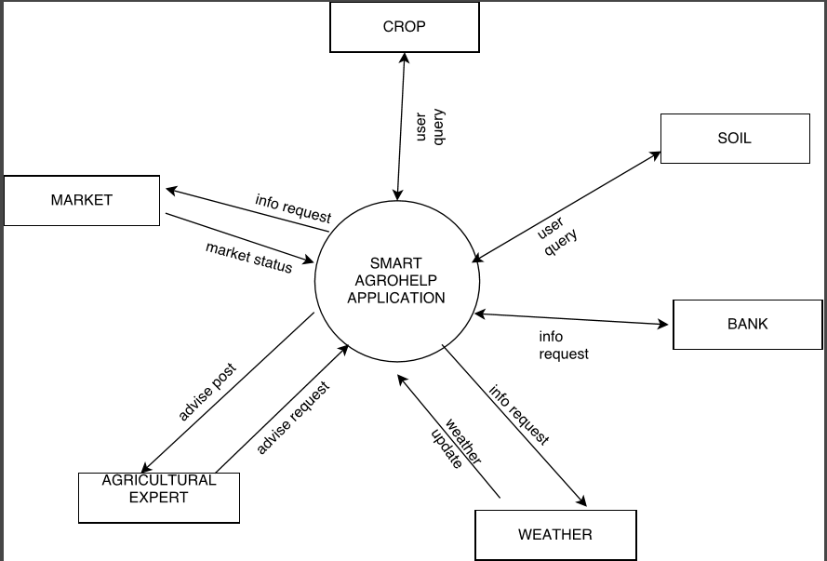

Fig. Context Diagram

✓ **Crop related information**: It captures information related to all the crops grown in recent past in different regions. This will help the local farmers of different parts of the state in crop related decision making.

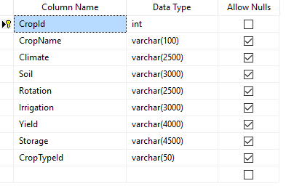

Fig. Database for crop information

✓ **Weather information**: It stores the region specific weather information and also the weather forecast for a specific duration. It will benefit the farmers in decision making related to selection of crops.

✓ **Soil Information**: Soil information also plays a vital role in crop related decision making. So, this section provides information on nature of soil of different parts of the state. It can also provide the trend of soil in past and will help in forecasting the future trend of soil.

✓ **Growth progress monitoring**: It monitors and captures data on crop growth in different regions on a regular interval. This will be specifically useful in comparing the crop growth region wise and also comparing it with past data will bring a clearer picture.

**✓ Farmers Data**: It captures the region wise farmer related data, to monitor and study the involvement of local farmers in State agricultural sector. It will help the policy makers in designing State agricultural policies. This will also help in identifying the core agricultural areas, so that the policy makers can take decision on encouraging and promoting agriculture. This may help in overcoming problems such as unemployment and rural-urban migration.

✓ **Expert Consultation**: It provides solutions to common problems that farmers frequently experience. It can also have a provision to post unattended problems seeking for solutions from the experts. It will also have a bundle of frequently asked questions (FAQs) and their answers to make the response reach the farmers faster.

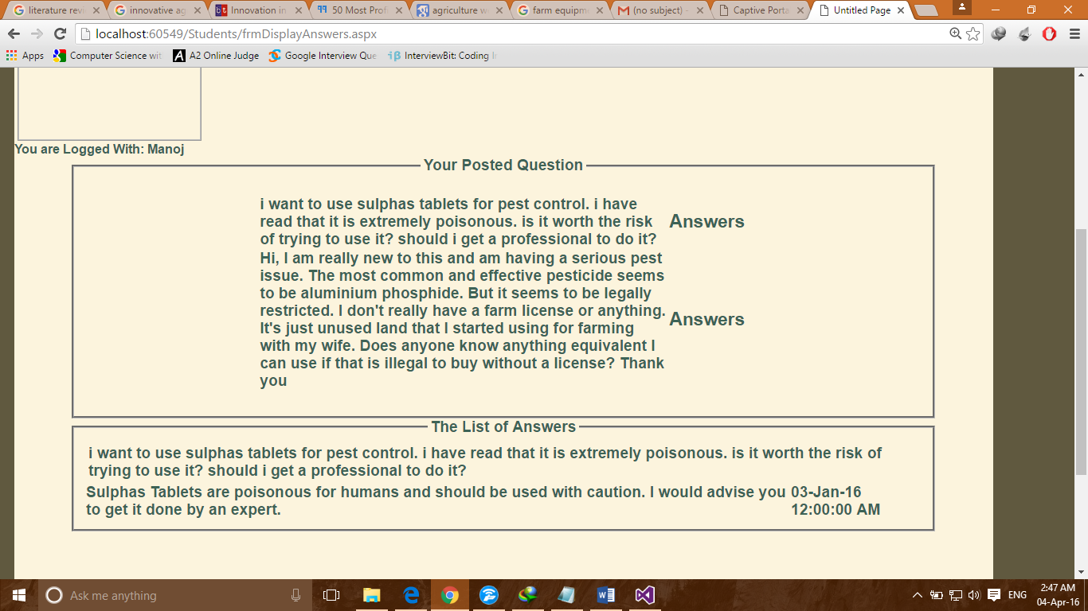

Fig. Online Queries Page

✓ **Support for different Regional languages:**

The website is a multi-lingual website with support for three languages right now (English, Hindi and Kannada).

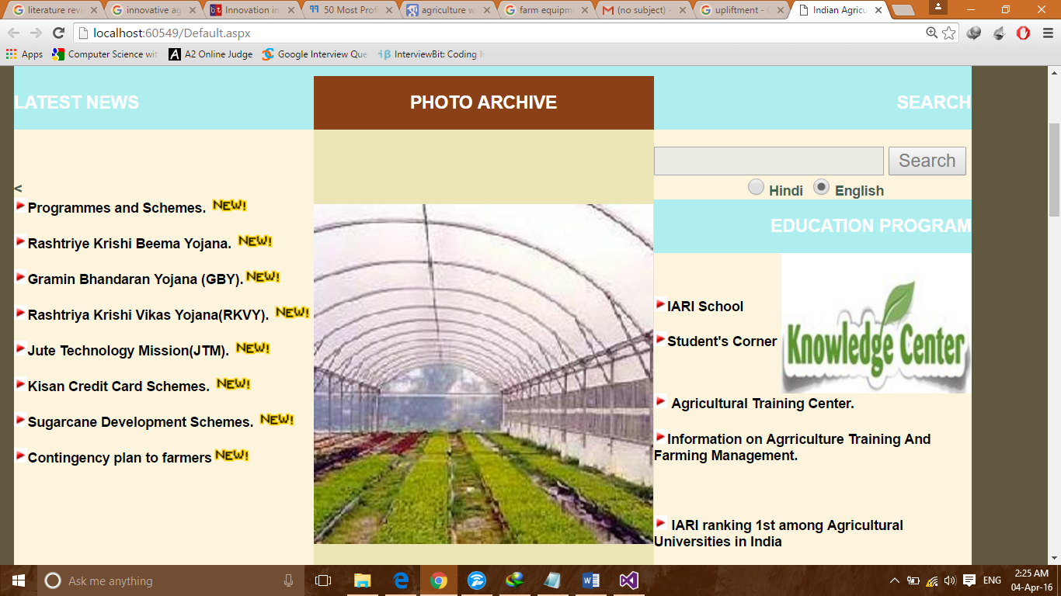

Homepage in English

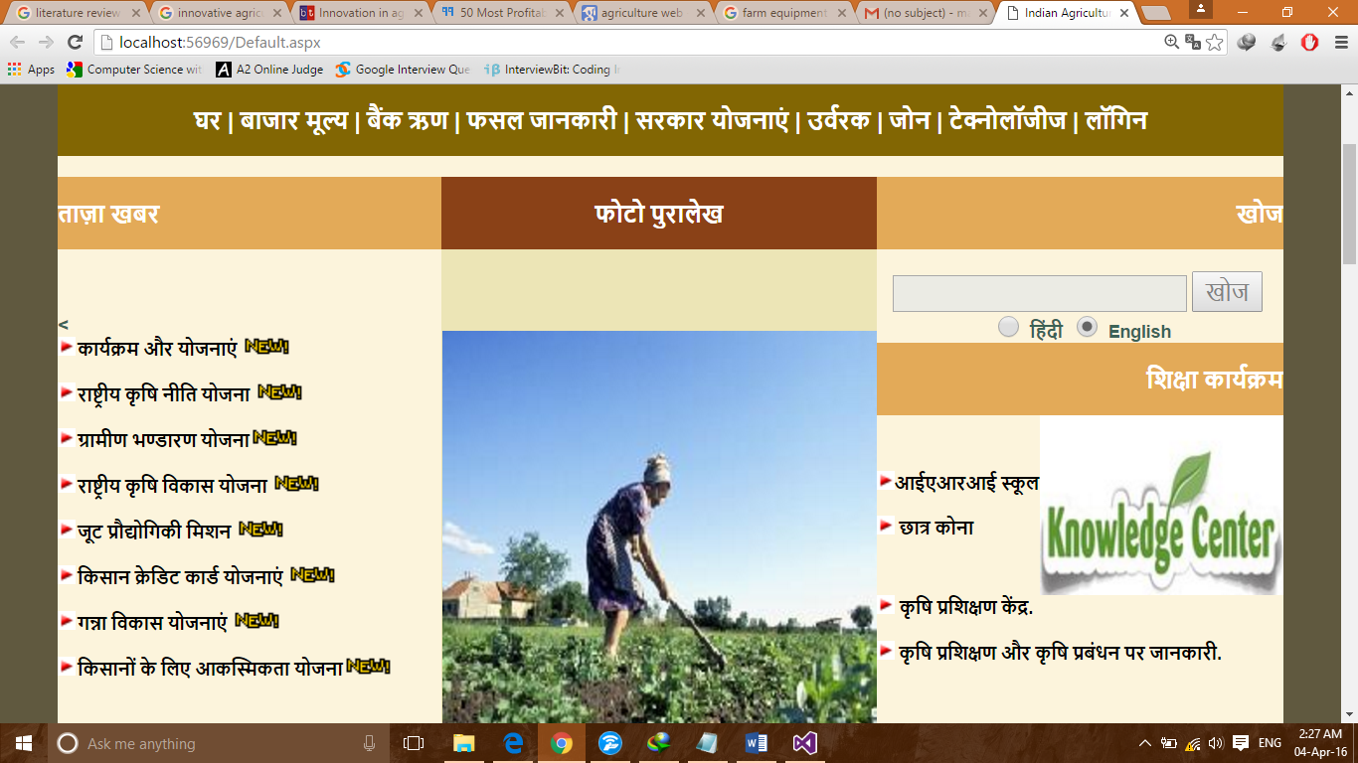

Homepage in Hindi

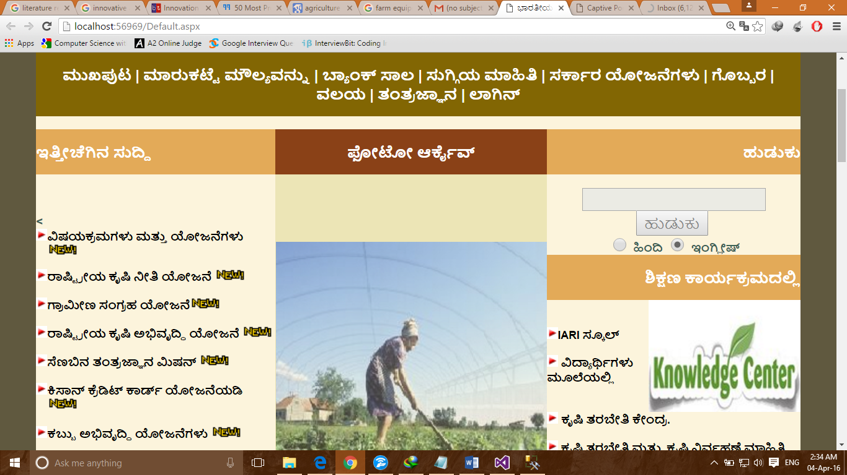

Homepage in Kannada

**BENEFITS OF THE PROPOSED MODEL**

The suggested model, if implemented properly, will benefit all the concerned sectors to a great extent. Following are the main advantages of using the suggested model:

1. Data management: The data will be managed by the service provider, a team of professionals. That guarantees a better and organized management of data.
2. Data readiness: The model provides data from the e-data bank databases to its entire stakeholder at any time and at any location.
3. Local and global Communication: The model makes the communication between different users much faster, easier and cheaper. Also the communication will be secured.
4. Rural-urban migration: A major problem of Karnataka is rural-urban migration. It can be reduced as the model provides its services all over the Karnataka at any time no matter how remote the place is. This will also help in controlling unemployment problem in the state.
5. Motivation: It will motivate the farmers and researchers to get involved more and more into agriculture as any communication will be result oriented. That will result in overall development of this sector in the state.
6. Security: It provides an enhanced security as the resources will be stored in cloud and will be maintained centrally by the service providers. Thus, it is not a cause of concern for its users.
7. Reduction of technical issues: It cuts short the man power, maintenance and infrastructure requirement drastically, as it will be provided by the service providers.
8. Overall economy: Implementation of the suggested model will help in uplifting the agricultural sector of the state. That will boost the overall development of the economy. It is due to the mass involvement of different stakeholders, as the system will monitor and deliver progress report whenever and wherever needed.

**V. FURTHER IMPROVEMENTS**

A lot features have been put up to make the more user friendly and this project can be further improved by making it more mobile friendly by changing its mobile view to be contain more graphics. We can link educational institutions to provide training to the farmers in their regional language through audio, video, animations support.

The website can be extended to support more Regional languages and more areas in the country. A little more work can be done on its GUI to allow easier navigation for the farmers’ ease. Automatic database updating can be achieved to reduce manual effort. A blogging facility can be provided, where people with successful ideas in agricultural field can create their blogs and share valuable information with the rest.

We can also use some advance API’s to implement the face-recognition technique to give easier accessibility to farmers through mobile services.

**VI. CONCLUSION:**

This paper highlights the use of software engineering tools and techniques in developing a website portal which can fulfil the basic requirements of farmers and research students. Still there is a lot of scope for further improvement as mentioned above in the website.

This cloud web based system idea would improve the socio-economic lifestyle of farmers and with the best use any kind of person can make use of the website.

**References:**

1**)** Paper Title: AgroMobile: A Cloud-Based Framework for Agriculturists on Mobile Platform

Author(s)**:** Shitala Prasad, Sateesh K. Peddoju and Debashis Ghosh, Department of Computer Science and Engineering,. Indian Council of Agriculture Research, 2004,’Handbook of Agriculture’New Delhi, pp1-12.Department of Electronics and Communication Engineering, IIT Roorkee, 247667, India

2) Paper Title: An Android Application for Farmers to Disseminate Horticulture Information

Author(s): Vimal B. Patel Assistant Professor College of Agri-Busniess Management, Navsari Agriculture University, Navsari, India, 396450

3) Paper Title: Agriculture Crop Pattern Using Data Mining Techniques

Author(s): G. Nasrin Dept. of computer Science, Jamal Mohamed College,Tiruchirappalli, TN, India

Fathima, Rese R.Geetha, Assistant Professor , Dept. of computer Science, Jamal Mohamed College, Tiruchirappalli, TN, India

4) Paper Title: Problems Faced By Rural Entrepreneurs and Remedies to Solve

Author(s): Sandeep Saxena (M.B.A., Gautam Budha Technical University, Lucknow, India)

5) Paper Title: Digital Image Processing Applications in Agriculture: A Survey

Author(s): Janwale Asaram Pandurng, Department of Computer Science, Balbhim Art’s, Commerce & Science CollegeBeed (MS) - India Santosh S. Lomte, Department of Computer Science, Everest Educational Society's, College of Engineering & Technology, Aurangabad (MS)- India

6) Paper Title: Upliftment of Socio-Economical Life Style of Farmers through Farmer’s Data Network Author(s): Tanuja R.Patil, Rajashekhar G.Patil, Diwakar Kulkarni, Shamshuddin K, Asso.Professor, President,Asst.Professor B.V.B.College of Engineering and Technology, Hubli, Karnataka, India, RajaGanga Federation

7) Paper Title: Software Engineering Decision Support System for Agriculture Domain

Author(s): Dr.N.V.Kalyankar, R.G.Joshi

8) Paper Title: Design Science Research Based Blended Approach for Usability Driven Requirements Gathering and Application Development Kadam S.K.,June 2009 ‘Shetkari’ Government of Maharashtra, Agriculture Dept. Author(s):Lasanthi De Silva, Jeevani Goonetillake, Gihan Wikramanayake University of Colombo School of Computing Colombo, Sri Lanka Tamara Ginige School of Business, Australian Catholic University Sydney, Australia Giuliana Vitiello, Monica Sebillo, Pasquale Di Giovanni, Genoveffa Tortora, Maurizio Tucci University of Salerno, Italy

9) Paper Title: Research about Based-SOA Agriculture Management Information System

Author(s): Duan Yan Computer and Information Engineering College Beijing University of Agriculture Beijing, 102206, P.R. China

10) Indian Council of Agriculture Research, 2004,’Handbook of Agriculture’New Delhi, pp1-12.

11) Kadam S.K., June2009 ‘Shetkari’ Government of Maharashtra, Agriculture Dept.

12) S. C. Mittal, “Role of Information Technology in agriculture and its Scope in India”,www.iffco.nic.in/applications/brihaspat.nsf/0/.../$FILE/it_fai.pdf, (2012).

13) E. M. Porcari, “Connecting People, Technology and Knowledge for Agricultural Innovation: Ubiquitous networks and cloud computing”, (2009) May10,<http://ictkm.cgiar.org/other_activities/2252_Porcari>_ Ubiquitous_ networks_ and_cloud_computing__2_.pdf.

14) Kumar, L. S. S.; A. C. Aggarwala,” Agriculture in India.”Fertilizer measurement: <http://14.139.158.118/bioinfo_db/STBNR1/>

15)http://www.cloudtweaks.com/2011/12/infographic-value-of-cloudcomputing-services-through-the-years/

16)http://www.portal.bsa.org/cloudscorecard20/

17) Jayade, K. G., Gaikwad, C. J, “Cloud Computing for Agricultural Information Management in India”.

18)[www.searchcio.techtarget.com/definition/ICTinformation](http://www.searchcio.techtarget.com/definition/ICTinformation)

19) Dr. Rajesh Prasad, Sagar B.Jadhav, Shantanu S.Panhale, Chetan S. Mohture, “Review of Cloud Computing and Its Application”, IJARCET, Volume 2, Issue 1, January 2013.

20) Alexandros Kaloxylos, Robert Eigenmann, Frederick Teye; “Farm management systems and the Future Internet era”, September 2012.