Technical Report

1. Code Analysis

1.1 Class Diagram

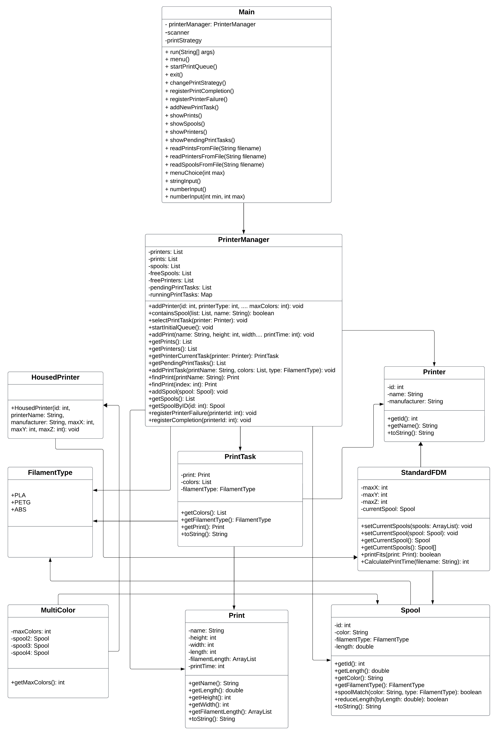

1.2 Code Smells

Several code smells have been identified when analyzing the existing code of the application. Following are the details on each of them:

1. Where: Main.java  
   Whats wrong: Main class contains too many lines of code (fields/methods).  
   Why is it wrong: The Main class code has grown to such huge proportions that it is difficult to work with.  
   Possible solution: Extraction. This includes dividing a part of a Main class behavior into separate components.  
   Name of code smell: Bloaters (Large Class)
2. Where: PrinterManager.java  
   Whats wrong: PrinterManager class contains too many lines of code (fields/methods).  
   Why is it wrong: The PrinterManager class code has grown to such huge proportions that it is difficult to work with.  
   Possible solution: Extraction. This includes dividing a part of a PrinterManager class behavior into separate components.  
   Name of code smell: Bloaters (Large Class)
3. Where: selectPrintTask method in PrinterManager.java  
   Whats wrong: selectPrintTask() method contains too many lines of code.  
   Why is it wrong: Long method is difficult to understand and maintain. Furthermore, it provides an ideal hiding place for unwanted duplicate code.  
   Possible solution: Extraction. This includes splitting up part of a selectPrintTask method into separate method.  
   Name of code smell: Bloaters (Long Method)

2. Refactoring

2.1 Applying Software Principles

2.2 Facade Pattern

PrinterFacade.java introduced to hide the complexity….

3. Design Patterns

3.1 Singleton Pattern

PrinterManager.java class is singleton….

3.2 Factory Pattern

PrinterFactory.java added to ...

PrintTaskFactory.java added to ...

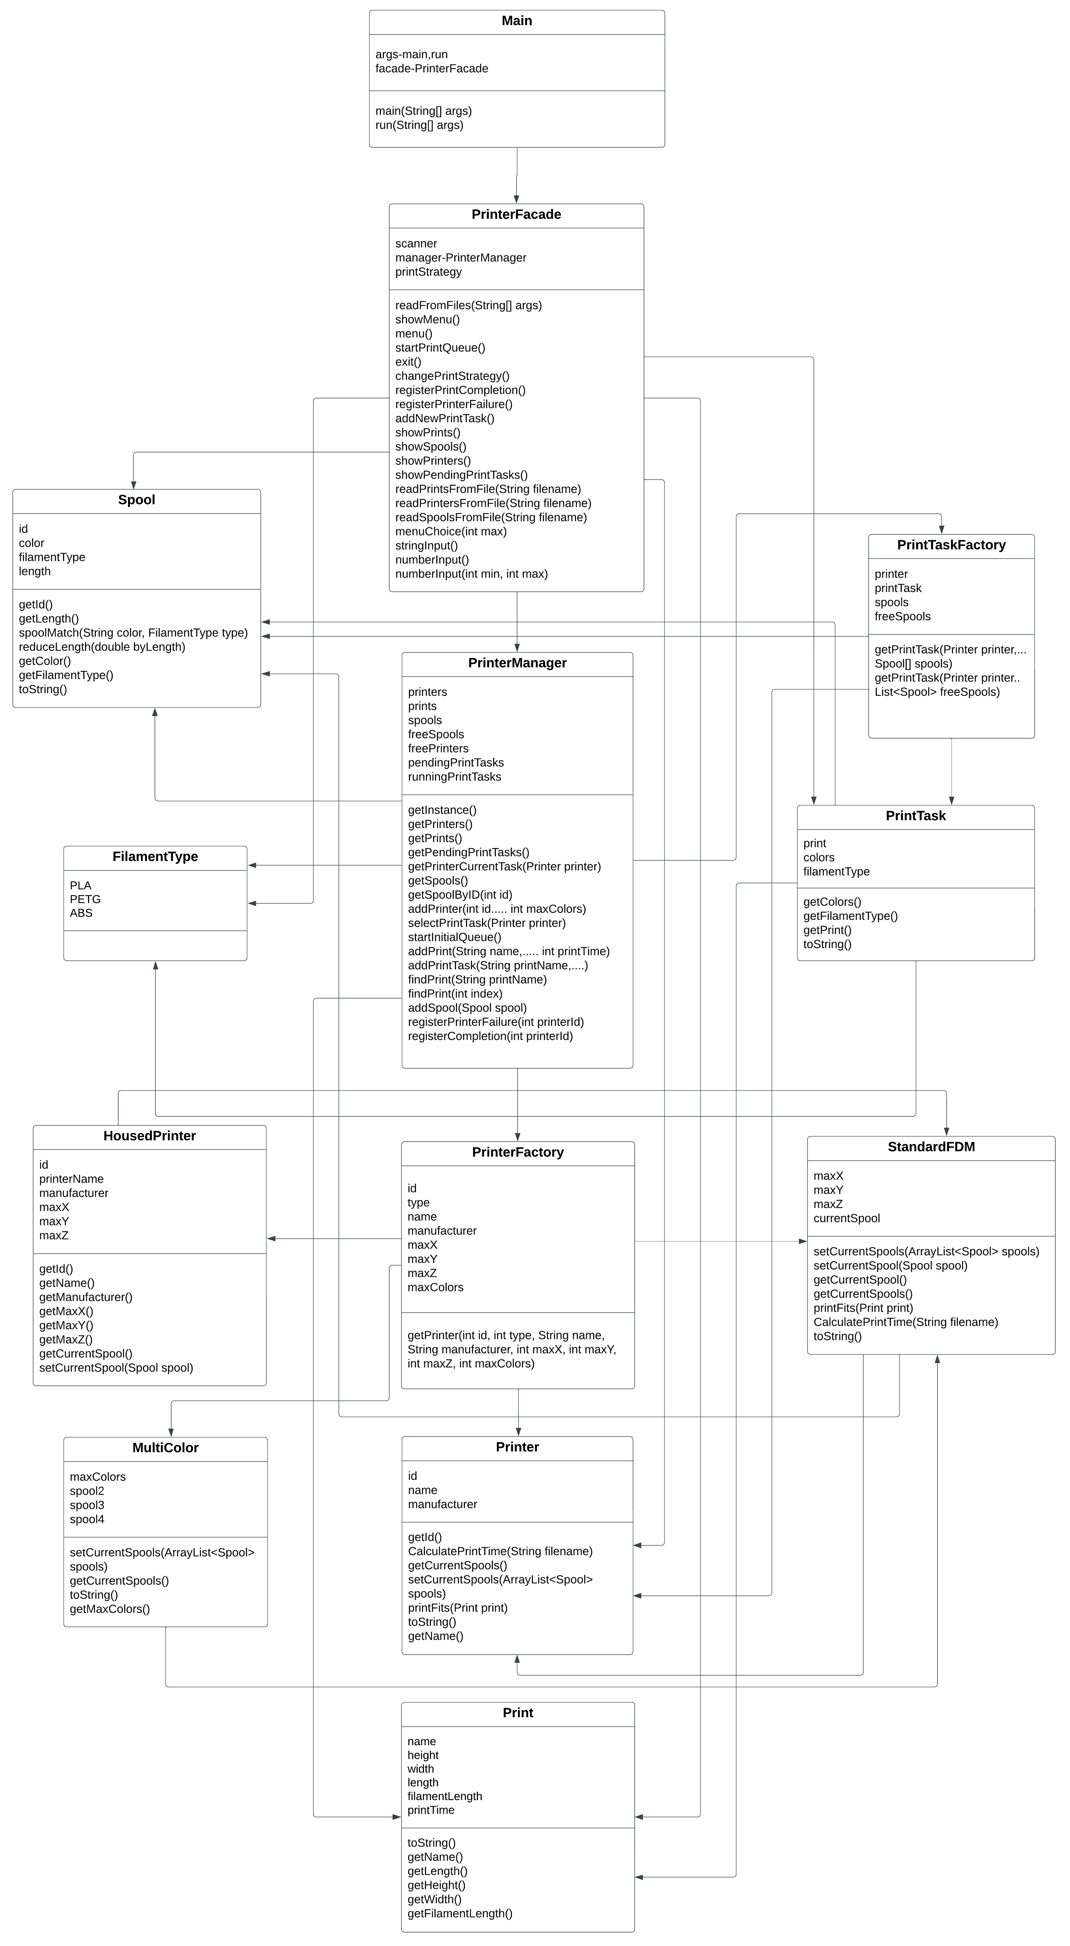

4. Expansion of the System

4.1 Expansion-1:

An additional option in the menu that displays the dashboard.

Following data will be displayed:

- Number of times a spool has been changed.  
 - Total number of prints fulfilled.

5. Testing

6. Conclusion