1).

Statically Typed Language – Every variable and every expression has a type that is know at compile time.
Dynamically Typed Language – These language do not require any pre-defined data type for any variable as it is interpreted at runtime by the machine itself.
Strongly Typed Language- These language should be declaration of every variable with a data type.
Loosely typed Language- These language do not require declaration of variable with a data type.

Java is Statically typed, Dynamically typed and strongly typed language.

2).

Case Sensitive – The language can differentiate upper case and lower case is case sensitive language.
Eg-:Person – it should be class name
person – it should be variable name

Case insensitive – The language ignore the deferent between the upper case and lower case.

Eg:-myPerson,myperson both name represent same identifiers.

Case Sensitive-Insensitive – The language consider the both way of case sensitive and case insensitive.

Java is the case sensitive programming language.

3).

Identity Conversion – A conversion from a type to that same is permitted for any type.

Eg:- int myInt1 = 30;
int myInt2 :
myInt1 = myInt2;

4).

Primitive widening conversion -

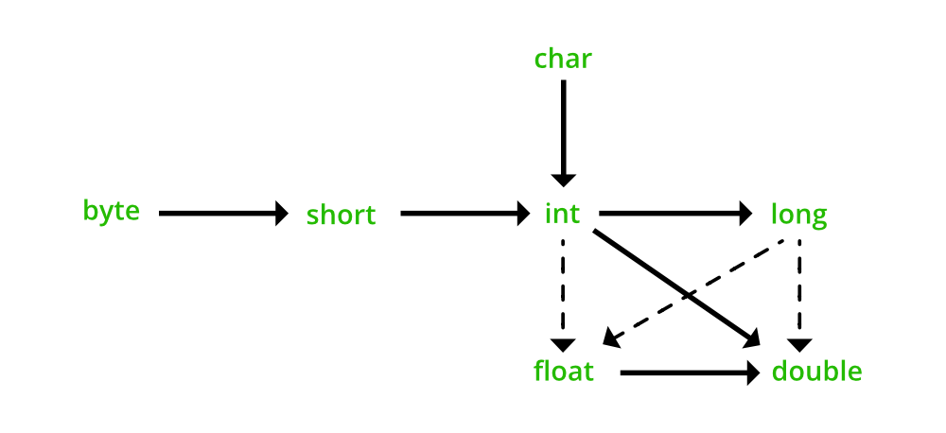
-These concept says smaller capacity data type can convert to larger type.
-Double data type longer than int data type but double can convert to int data type because of double variable data filling structure differ to integer type . Therefore can be convert to integer data type to floating point data type.

5).

Compile time constant- Identify the constant when it compile time.

Eg:- int myInt1 = 50;

Run time constant – when identify the constant when it run time.

Eg:- int myInt1 = cal(5);

6).

