# Second-year-OOP-project

This is a web site created using Angular in the front-end and Spring as the API in the back-end. the database used is mongoDB

## Overall GUI screenshots

### User visualizing all the vehicles

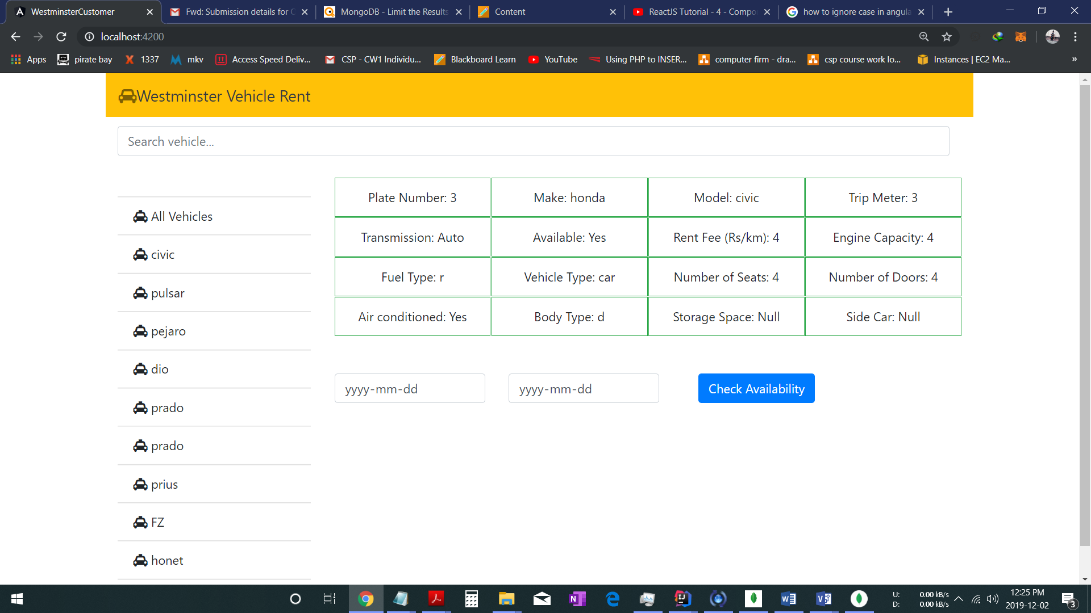

### User able to filter the vehicles with model

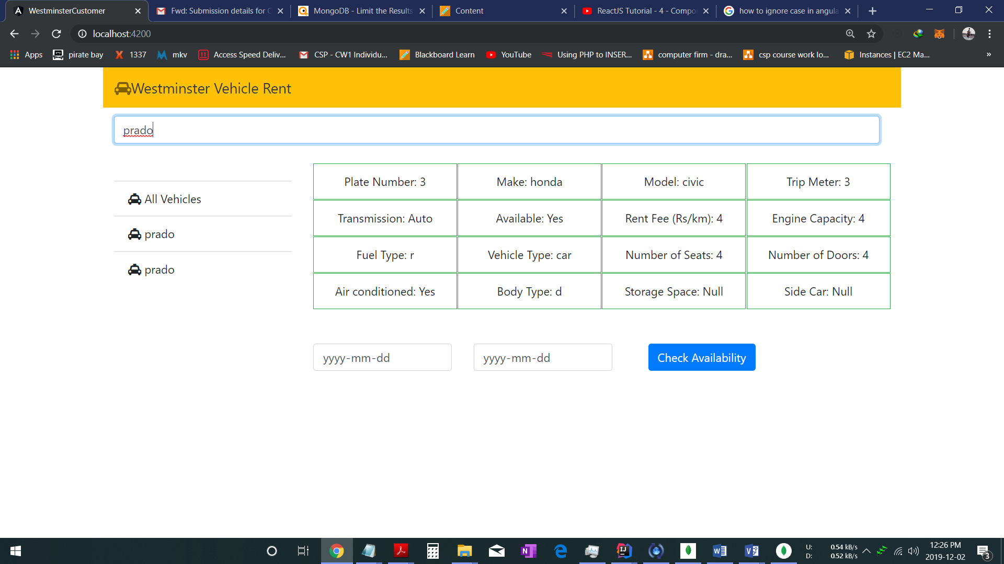

### User able to filter the vehicles with make

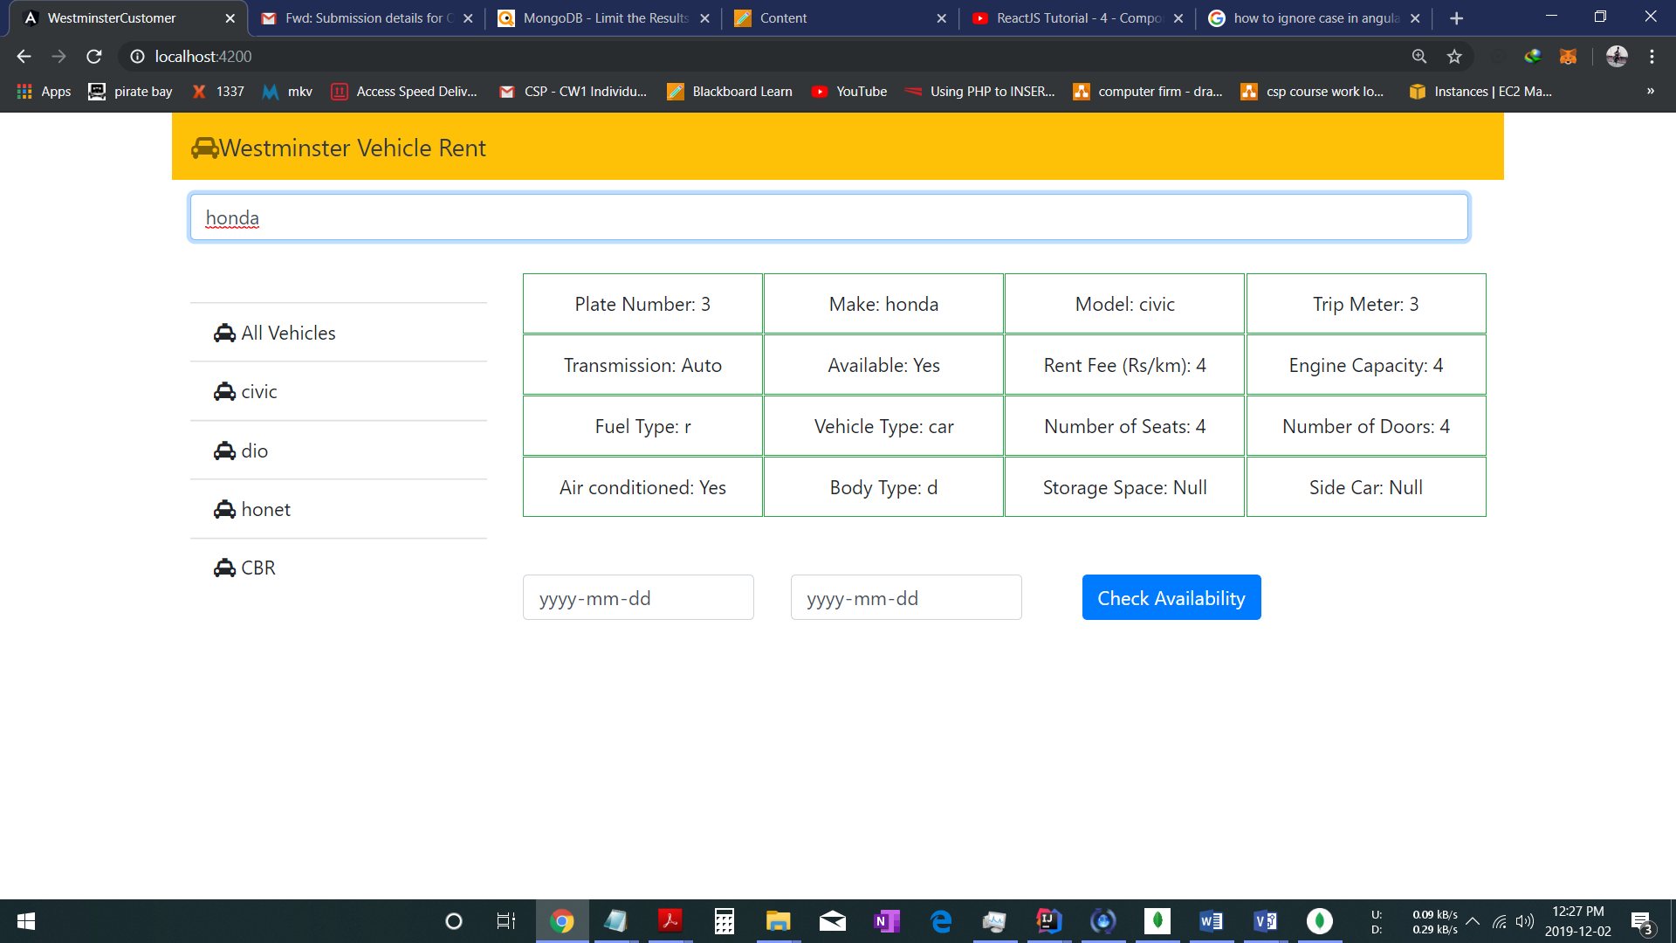

### 

## Checking the availability of the vehicle in specific dates

### Checking for a date which is booked

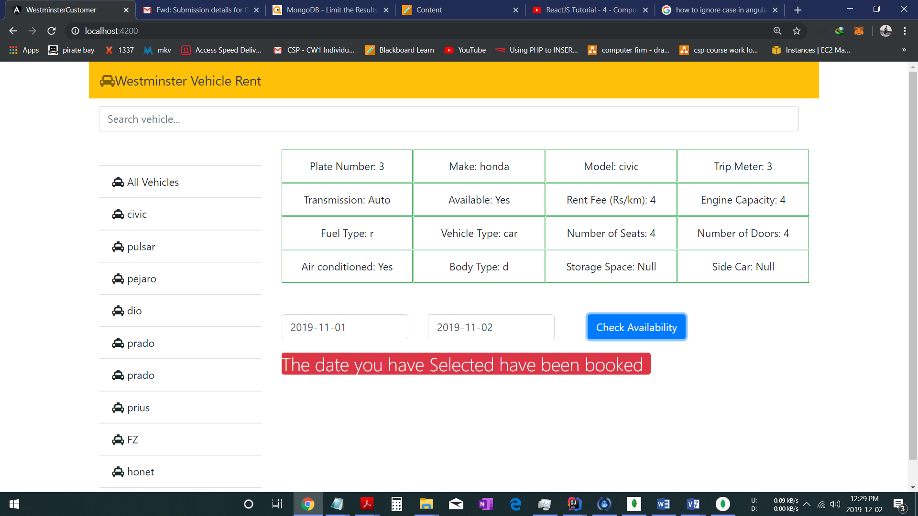

### Trying to book a date which is in between of a booked range of dates

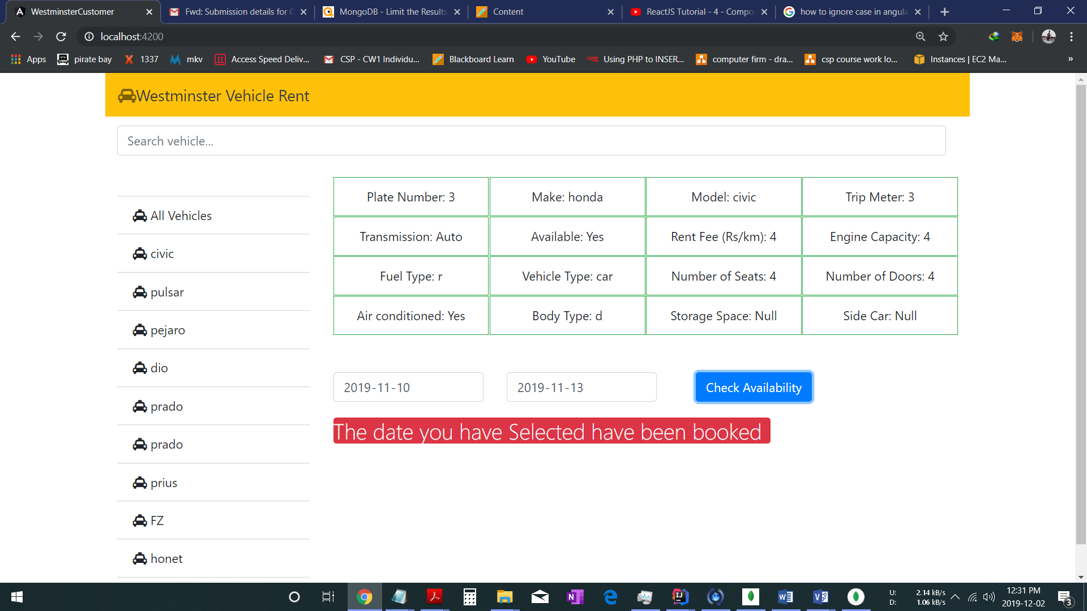

### Trying to book for a date which has not booked

