# Introduction

Allocator is the resource management system that developed for the NSBM organization as a Integration project for the second year. Allocator comes with desktop application and web application that allow users to allocate and manage resources such as time tables, lecture halss, practical labs easily. This application supports with the various users such as academic staff, students, lecturers and admistration. Main purpose of this project is to allow users to mamange and track resource management with locally and remotely with the use of centralized database to avoid conflicts during the day today operation.

## Purpose

The main purpose of the application is to submit the Integration project assignment for the second year. NSBM organization shift to Homagama green university and there after they informed students about resource management via emails. Students have to come to the office to allocate lecture halls for the meetings of their student clubs such as FOSS community, CS club etc.. These students are coming from different areas and it takes lots of time to reach to the campus. I t will waste their time.So with the helpof this application students and academic staff can allocate lecture halls remotely. So it will help to increase productivity and time saving.

Students and staff can do lots of function using same application. Earlier students have to check their emails to get time tables and hall allocation informations, but thanks to the Allocator they can view their schedules, make allocations in same application.they do not need to bother with opening many tabs.

## Scope

The scope of the application is to allow both academic staff and the students good interaction with the resources of NSBM organization in productive manner. So we came up with to different application types.Desktop application which is only used by the staff and web application for staff, students, lecturers and administration. We have came up with centralized database to ensure data entegrity and accurasy of the application to avoid conflicts.

## Background

This document is providing by the second year batch 4 students of School of Computing, NSBM as a assignment based on subject called Integration Project.

|  |  |
| --- | --- |
| Index Number | Name |
| 10568999 | Liyanage P Perera |
|  |  |
|  |  |
|  |  |
|  |  |

## Assumptions and Constraints

* At the moment the application only supports with the School of computing.
* All the time tables are fixed and cannot change at the later time.
* Desktop application is supports with only academic staff.

# Functional Requirements

## Context

### ER Diagram

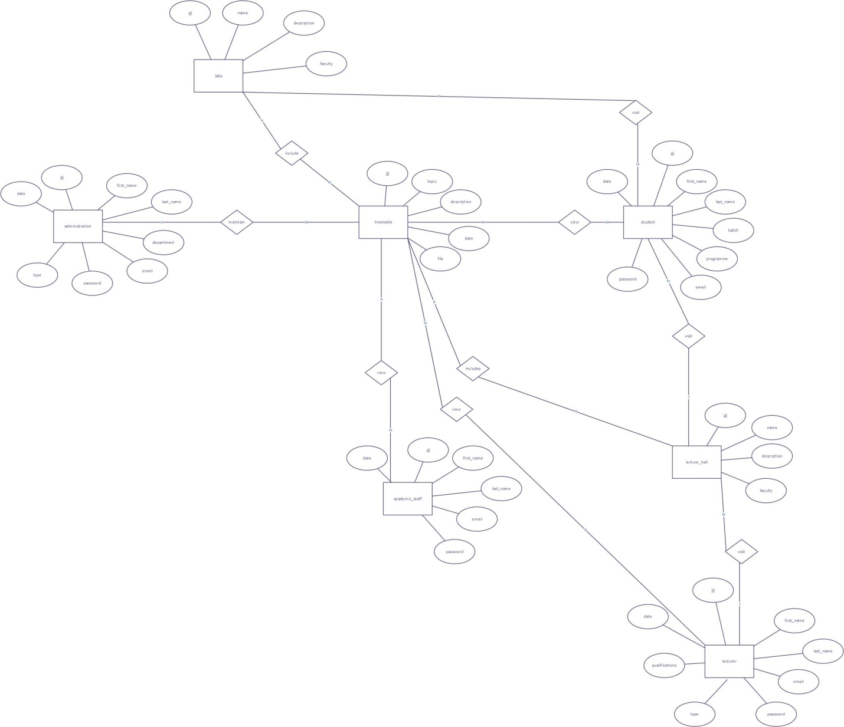

### Use case diagram

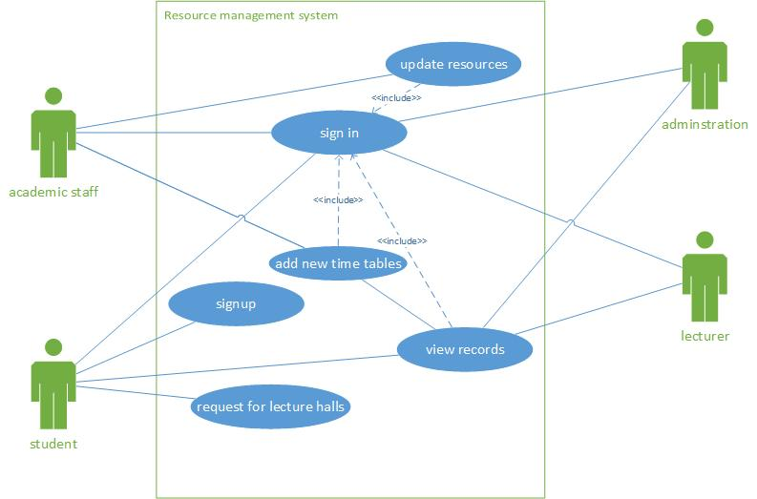

## User requirements

* The application have different levels of user accounts with different privileges. Academic staff must have all the maintaning privileges and other three account types must have only readable privileges.
* Application must use centraliced database to provide most correct and updatable information of the resources.
* All the loggin informations can be viewed by the maintaining group.
* System should provide accurate and most efficient informations to its different king of users to fullfill their all aspects from the sysytems.

## Data flow diagrams

### Level 0 DFD

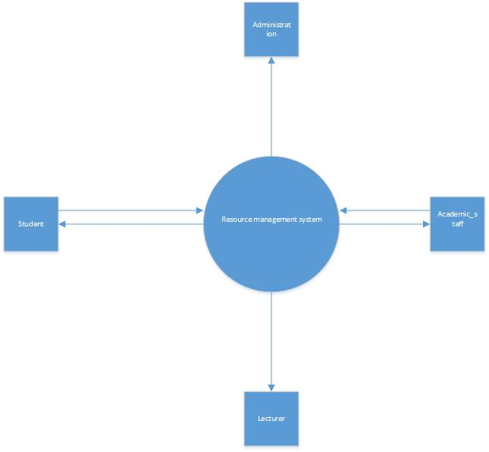

### Level 1 DFD

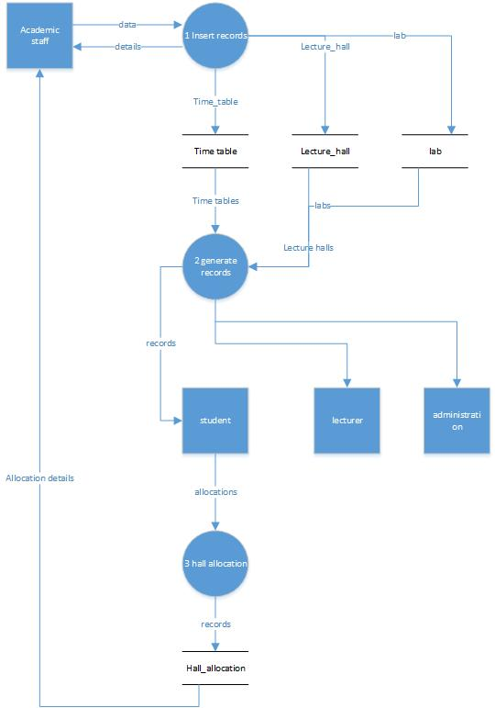

## Functional requirements

* The system contains many timetables that specific according to the different batches.So system should filter the schedules and show them only for the appropriate students that it belongs to.
* Only successfully authenticated users must allow to claim benefits of the application.
* System should must succesfully response to the multiple users without stucking.Specially mornings time and the lunch time the user traffic can be increased. Application must successfully resistance for those kind of situations.

# Other requirements

## Interface requirements

### User interfaces

### Hardware interfaces

Since thw application is combination ofweb application and a desktop application it does not have any direct predefined hardware interdafes.