Table of Contents
Use Case Diagram 2
Class Diagram 3
Architecture Diagram 4
Developing the api (Application Programing interface) 5
Key Models Used by Distributors to Manage Products and Quotations 7
DTOs for Products, Quotations, and Stock Updates 8
Data: Handling Database Operations 10
Overall Architecture Components of The Gadget Hub API 11
Database Setup for The Gadget Hub and Distributors 12
Distributor and Gadget Hub Desktop Applications 14
The Gadget Hub Website 17
Home Page 17
View Item Page 19
Cart Page 20
Notification page 21
1. Introduction 22
2. Objectives and Tasks 22
3. Test Items 22
5. Features to be tested 23
6. Features Not to Be Tested 23
7.Test Cases 24
25
25
32

Use Case Diagram
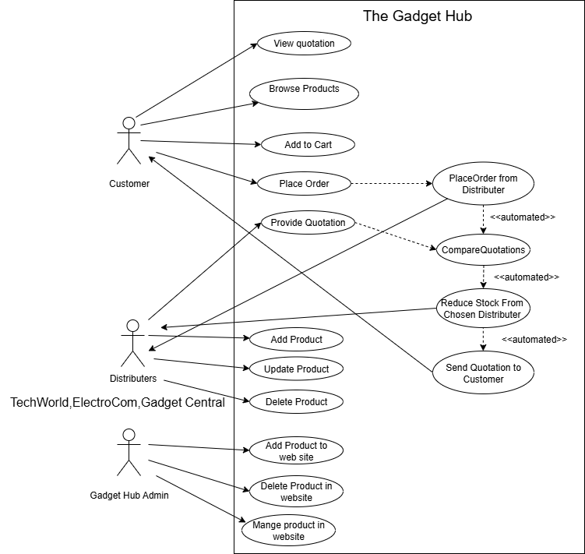
In The Gadget Hub system, customers can search for products, add items to a cart, view quotations, and place orders. When an order is placed, Gadget Hub sends the request to all three distributors, who each respond with a quotation. Gadget Hub then compares the quotations, selects the best one, reduces stock accordingly, and sends the final quotation to the customer. Distributors can also add, update, and delete products in their own inventories. Meanwhile, the Gadget Hub Admin is responsible for adding products to the website, deleting products, and managing the overall product catalog visible to customers

Class Diagram
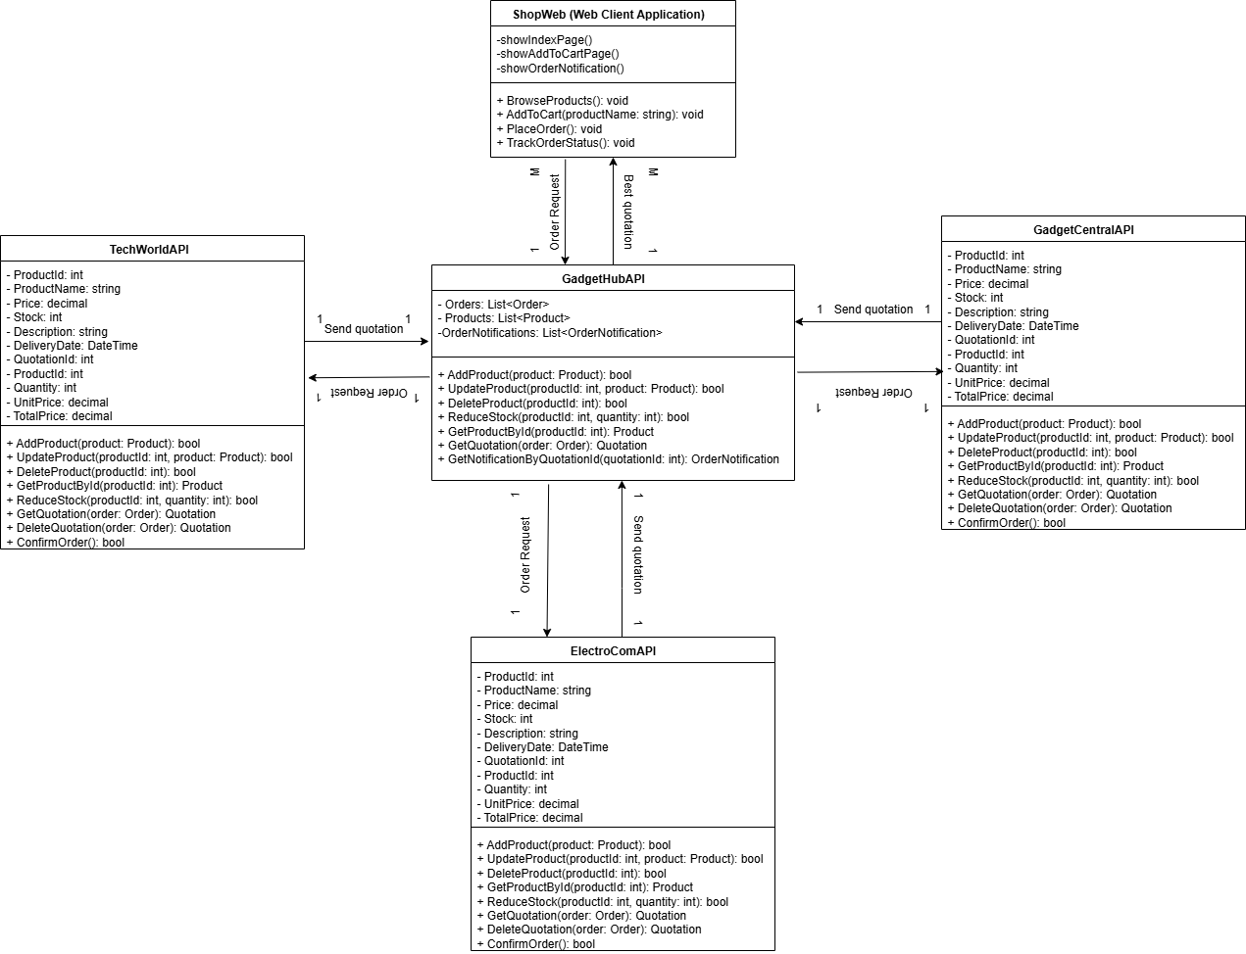

This class diagram models The Gadget Hub system, showing how the ShopWeb application, GadgetHubAPI, and three distributor APIs interact. Customers use ShopWeb to browse products and place orders. Many ShopWeb clients connect to a single GadgetHubAPI, which manages orders and requests price quotes from distributors (ElectroComAPI, TechWorldAPI, GadgetCentralAPI). GadgetHubAPI communicates individually with each distributor API—one instance of GadgetHubAPI corresponds to one instance of each distributor API. Each distributor responds with product availability and pricing. GadgetHubAPI compares these quotations and places orders with the best cess to fulfill customer orders efficiently.

Architecture Diagram
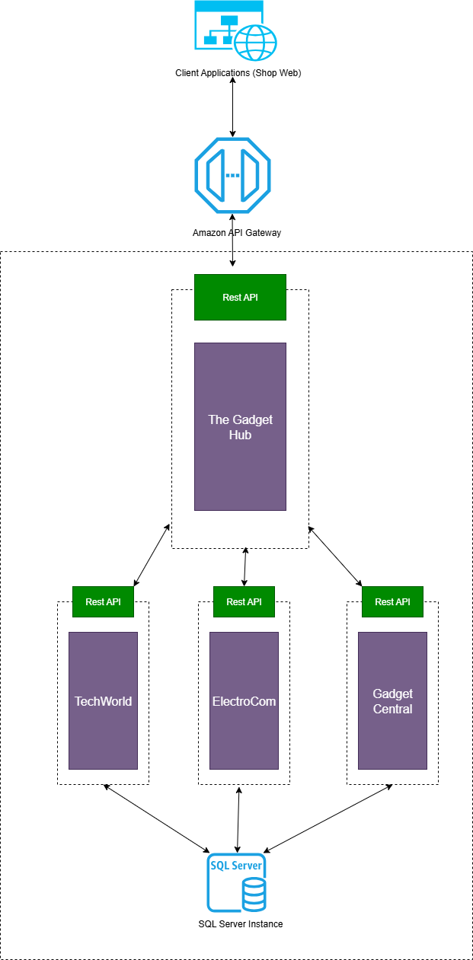

This diagram shows a RESTful web service architecture where customer orders from the Shop Web are sent through an API Gateway to The Gadget Hub. The Gadget Hub requests quotations from three distributors: TechWorld, ElectroCom, and Gadget Central. Each distributor checks their database for the requested product ID and quantity, then sends back a quotation that includes the price and delivery date. The Gadget Hub compares these quotations, selects the distributor offering the lowest price, calculates the total price based on the quantity, and returns the result to the customer. This ensures customers receive the best price and earliest delivery by coordinating communication through REST APIs in real-time.

Developing the api (Application Programing interface)

The system works with three distributors — TechWorld, ElectroCom, and Gadget Central. Each distributor has its own API that works in the same way. They all let The Gadget Hub send requests to get price quotes for products by sending product IDs and quantities. Each distributor then replies with details like price, how many items are in stock, and how long delivery will take. The APIs allow The Gadget Hub to create new quotation requests, get details about quotations, see all quotations, update orders if needed, and cancel orders. Because all three distributors use the same kind of API, The Gadget Hub can easily ask for and compare prices from all of them, then place orders with the best option.

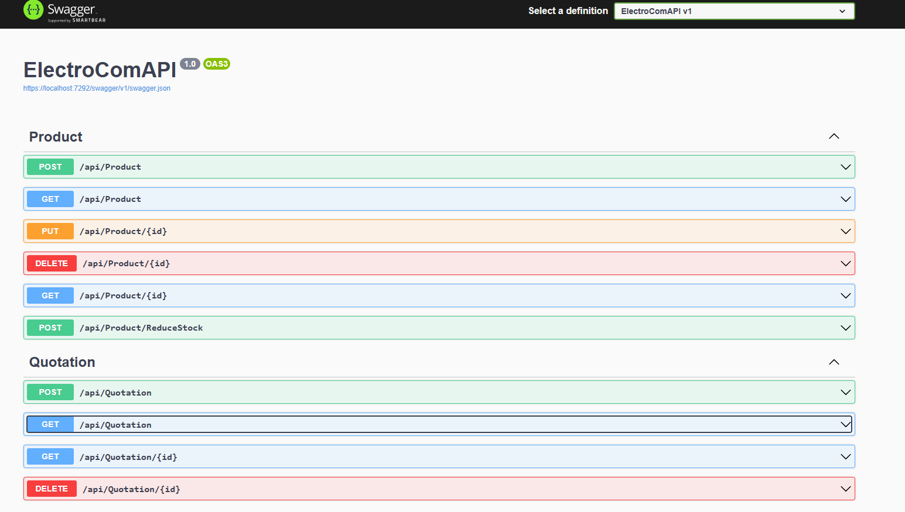
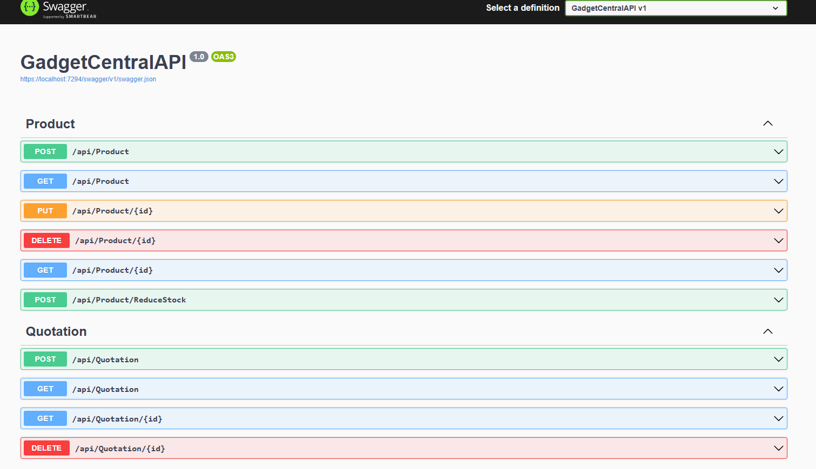

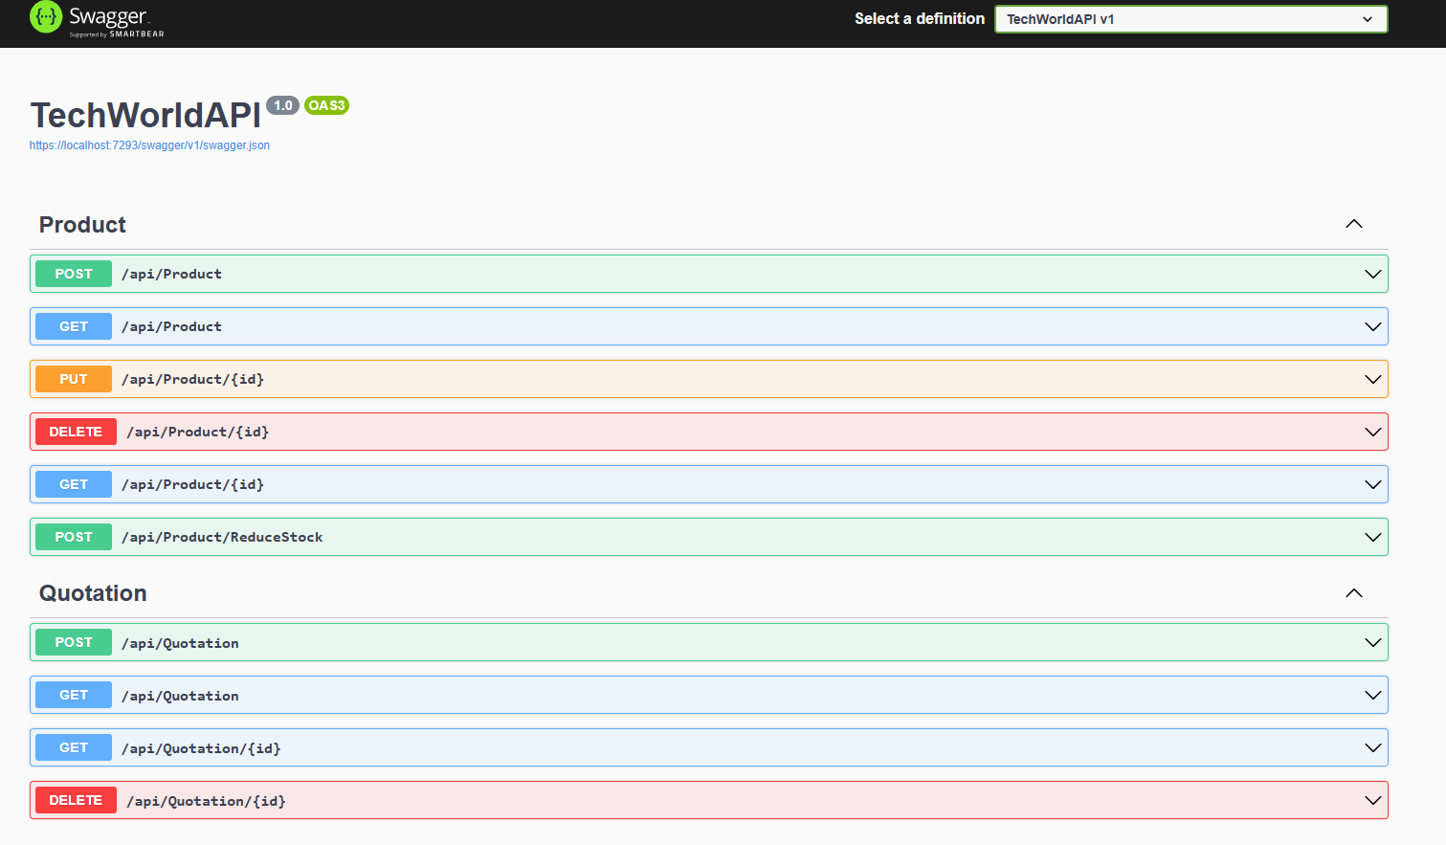

The API includes three main controllers to manage orders, products, and stock reduction. The OrdersController handles placing customer orders by finding the best quotation from distributors and returning a notification ID, and it also allows retrieving order notifications by ID. The ProductController manages product data with endpoints to create, retrieve (all or by ID), update, and delete products. The StockReductionController handles requests to reduce stock levels at a specific distributor by accepting distributor name and product quantities, then updating the stock accordingly. All controllers use standard RESTful HTTP methods to provide clear and consistent ways to manage orders, products, and inventory updates.

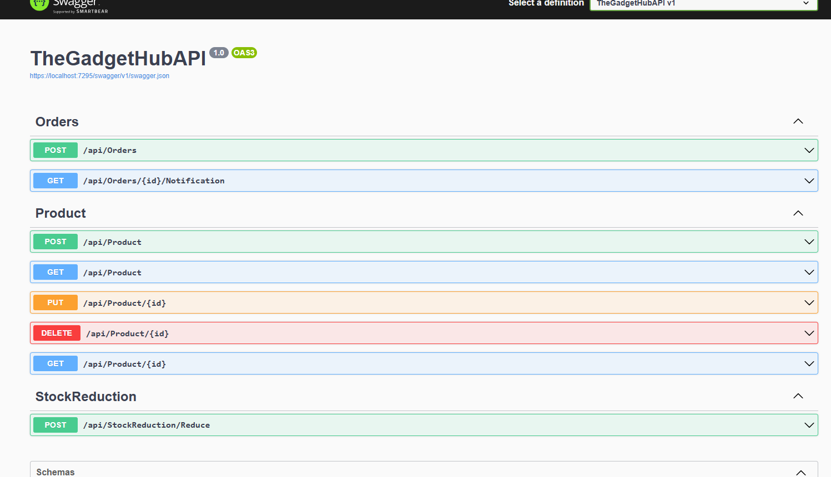

Key Models Used by Distributors to Manage Products and Quotations

The distributor APIs use model files to represent key data entities such as Products, Quotations, and Quotation Items. The Product model defines product details including ID, name, price, available stock, description, and delivery date. The Quotation model stores information about a price quote, including the customer name, creation date, delivery date, total amount, and a list of associated quotation items. Each Quotation Item links a specific product to a quotation and includes details like quantity, unit price, and total price. Together, these models structure how distributors manage their inventory, generate price quotations, and handle order-related data consistently across their services.
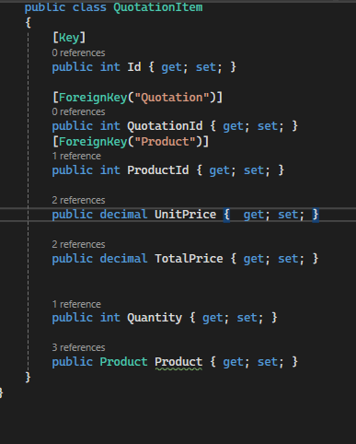
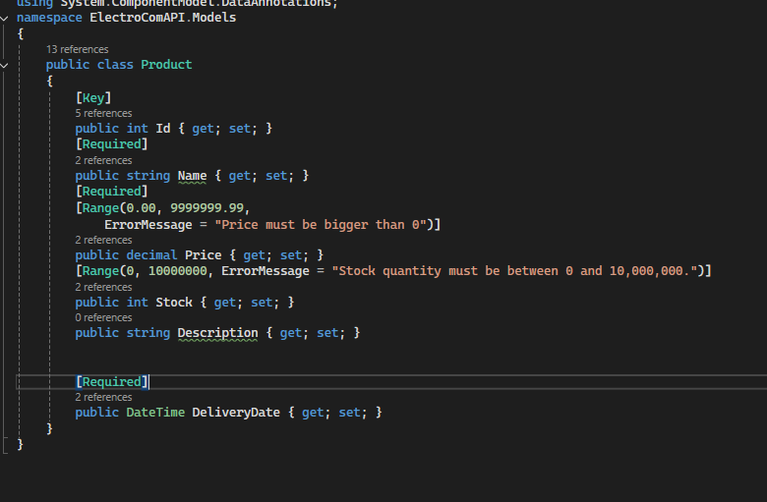

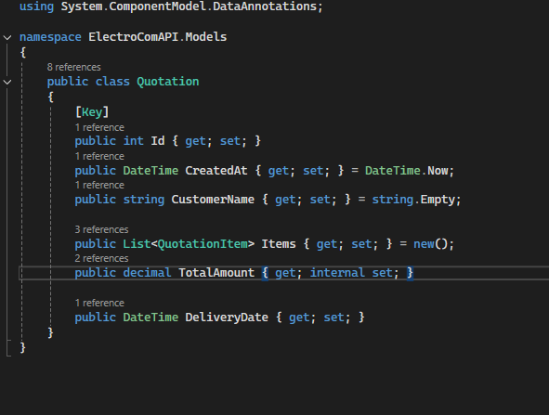

DTOs for Products, Quotations, and Stock Updates

The distributor APIs use various DTOs to structure data sent and received through their endpoints. The ProductReadDTO defines the product details returned to clients, including ID, name, price, stock, description, and delivery date. The ProductWriteDTO specifies the data required when creating or updating products, ensuring fields like name and price are validated. For quotations, QuotationCreateDTO carries customer information and a list of requested product IDs with quantities, while QuotationResponseDto returns detailed quotation results including total amount, delivery date, and itemized details such as product name, unit price, and total price. Lastly, the ReduceStockRequestDTO and ReduceStockItemDTO are used to request stock reductions for specified products and quantities. Together, these DTOs help keep data exchange clear and consistent between clients and distributors.
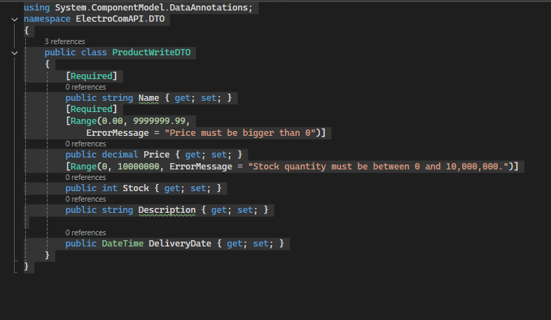
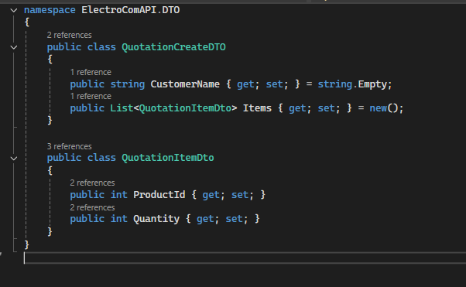
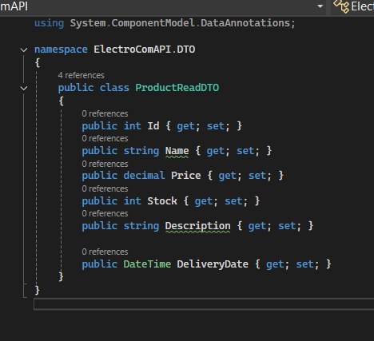

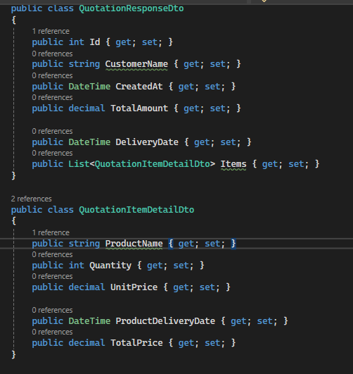

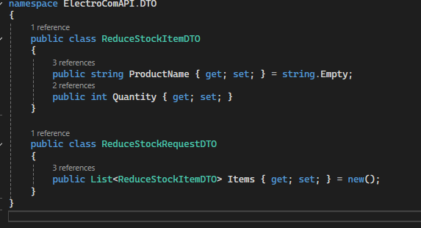

Data: Handling Database Operations

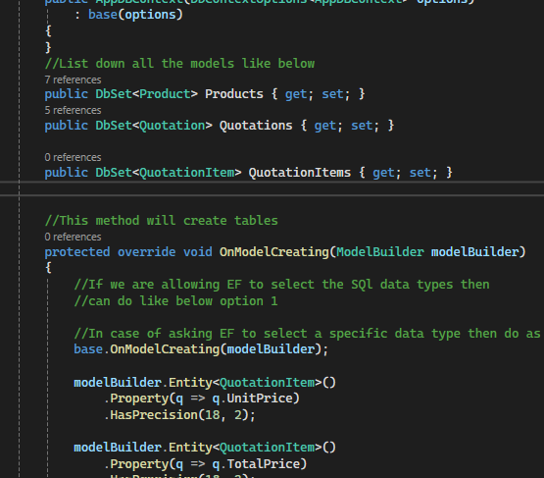
The Data folder contains the core classes responsible for managing database access and operations. The AppDBContext class sets up the connection to the database using Entity Framework Core and defines the tables for Products, Quotations, and QuotationItems. It also configures the data types and precision for price-related fields. The ProductRepo class provides methods to create, update, delete, and retrieve product records, encapsulating all product-related data logic to keep it separate from the API controllers. Similarly, the QuotationRepo class handles creating quotations automatically based on requested products and quantities, retrieving all quotations or a specific one by ID, and deleting quotations. These repository classes simplify working with the database and ensure a clean separation between data management and business logic.
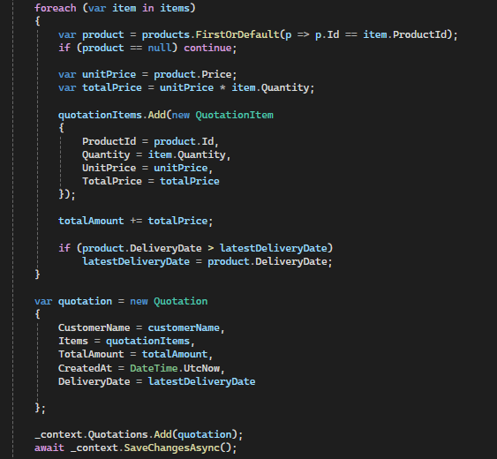


Overall Architecture Components of The Gadget Hub API
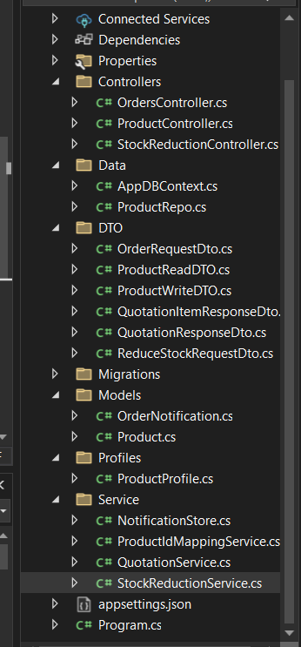

The Models define the core data structures for the system. The Product model holds basic product information such as ID, name, and description. The OrderNotification model represents notifications sent after an order is placed, including the supplier name, list of quoted items, total price, creation time, and delivery date.
The DTOs specify the data formats used to communicate between the API and clients. These include DTOs for reading and writing product details, placing orders with product IDs and quantities, and receiving detailed quotation responses that contain pricing and delivery information. DTOs help keep the internal models separate from the data exposed externally and simplify validation and data transfer.
The Data layer contains the AppDBContext, which sets up the database tables for products and handles database interactions via Entity Framework Core. The ProductRepo encapsulates all product-related data operations such as creating, updating, deleting, and retrieving products, providing a clean interface for data access.
The Service layer contains classes that handle the main business logic and communication with distributors. The QuotationService collects quotations from multiple distributors and selects the best offer based on price and delivery time. The StockReductionService sends requests to reduce stock at the selected distributor after an order is placed. The ProductIdMappingService helps match product names to distributor-specific product IDs. The NotificationStore temporarily saves order notifications for customers to check their order status.

Database Setup for The Gadget Hub and Distributors
This system uses four separate databases: ElectroComDB, GadgetCentralAPIDB, TechWorldDB, and TheGadgetHubAPIDB. Each distributor database stores its own product and stock data. The Gadget Hub database manages product listings and handles communication with distributors
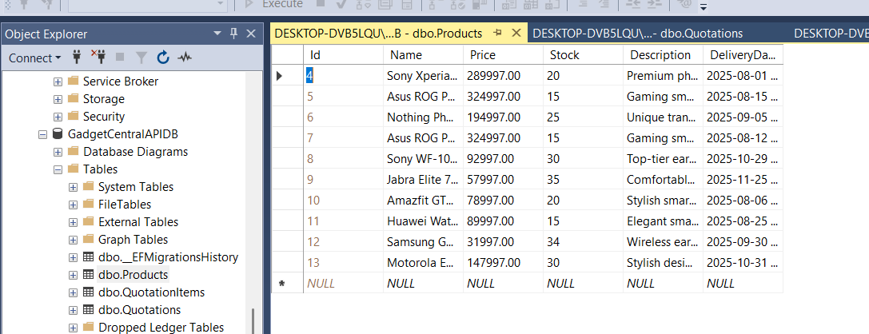

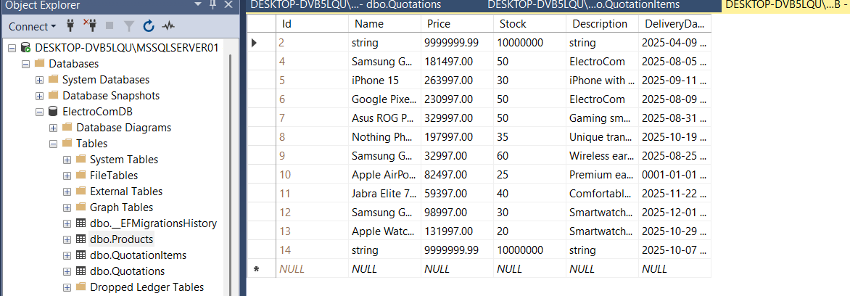
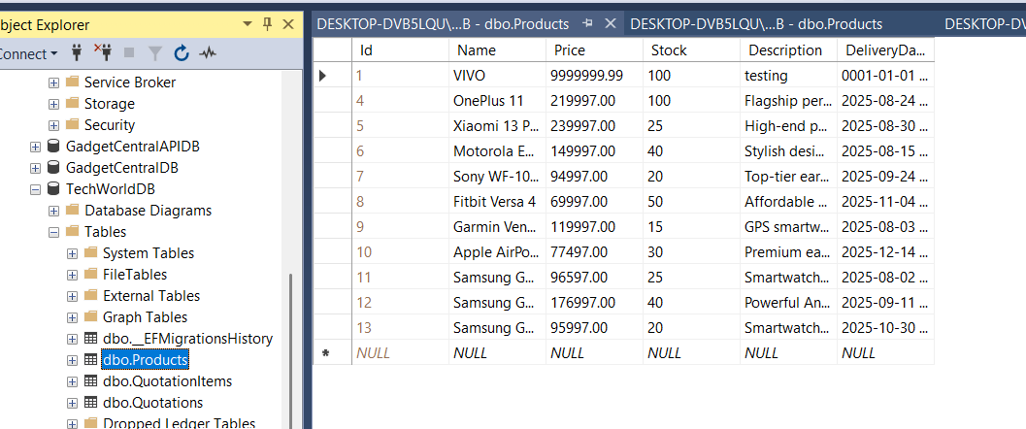

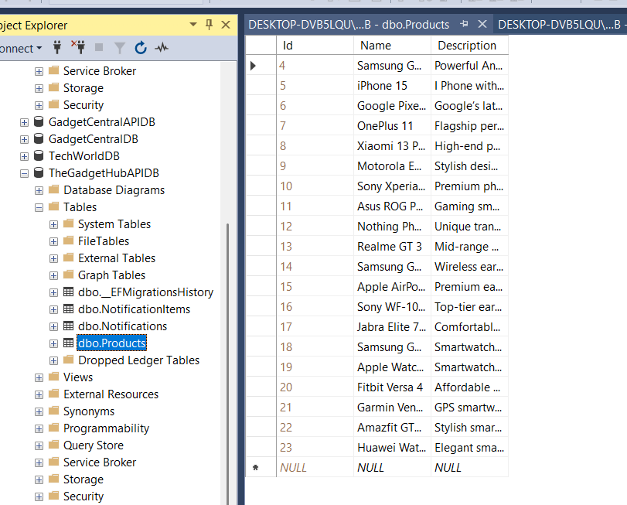

Distributor and Gadget Hub Desktop Applications

I created three desktop applications for the distributors (ElectroCom, TechWorld, and GadgetCentral) to add, update, and delete their own products. I also developed a desktop application for The Gadget Hub, which allows the Gadget Hub to view the products available at each distributor and add those products to their own website. This ensures that the website only shows products that distributors have in stock, so customer orders can always be fulfilled.

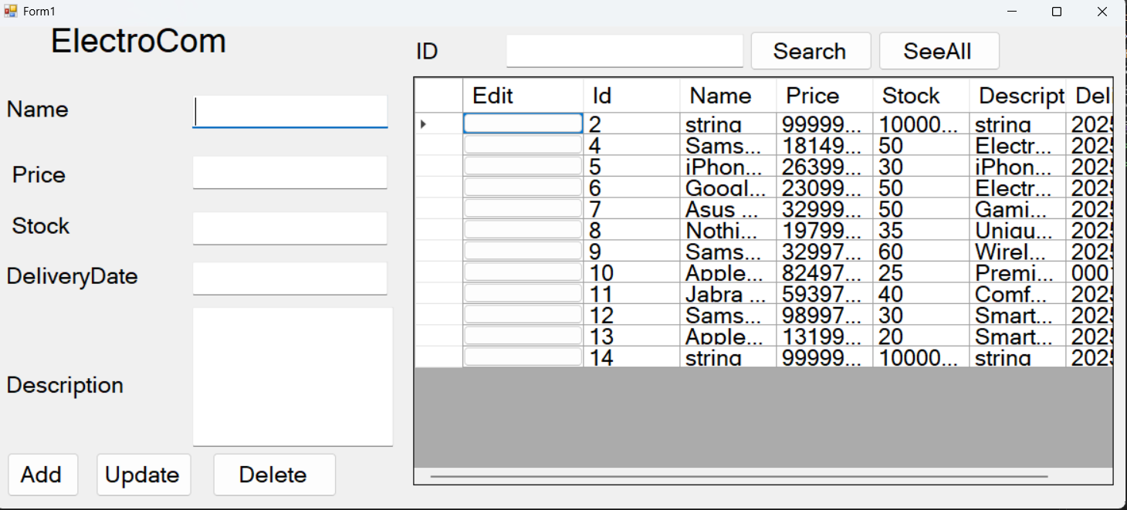

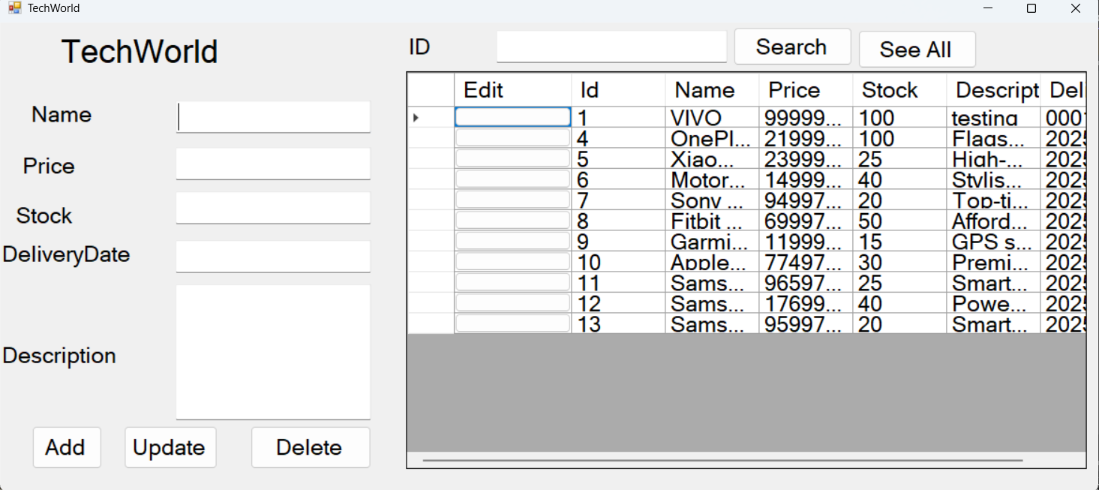

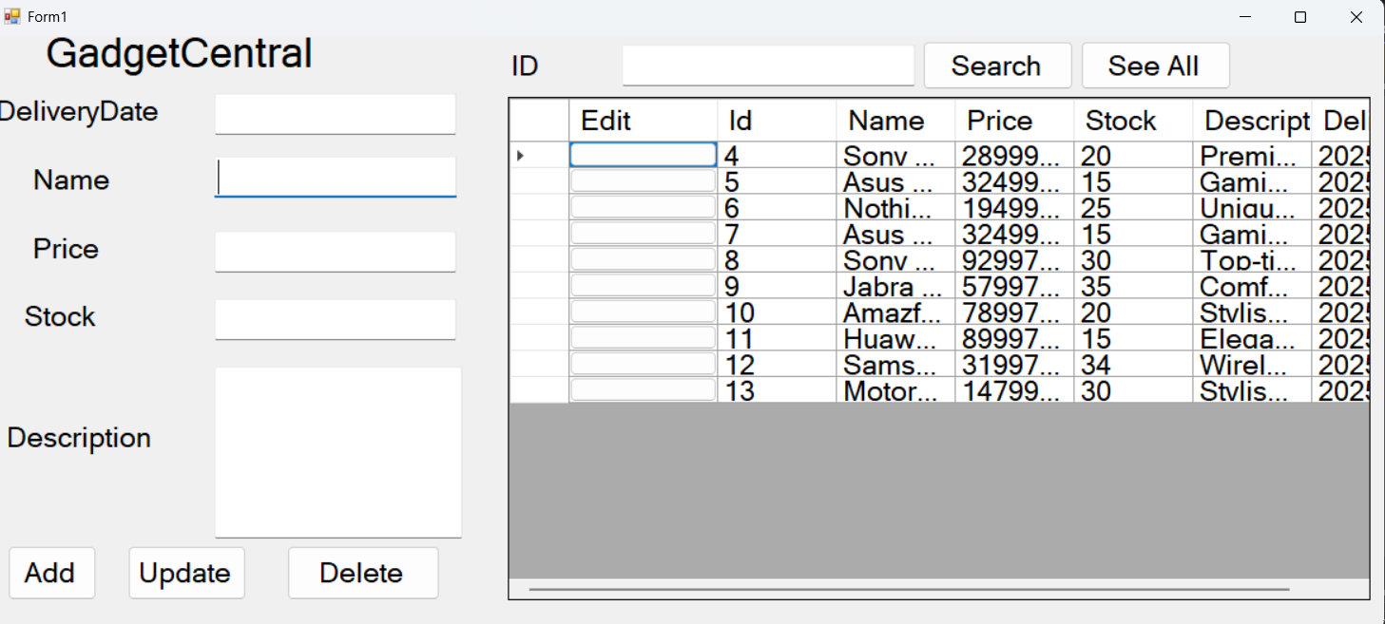

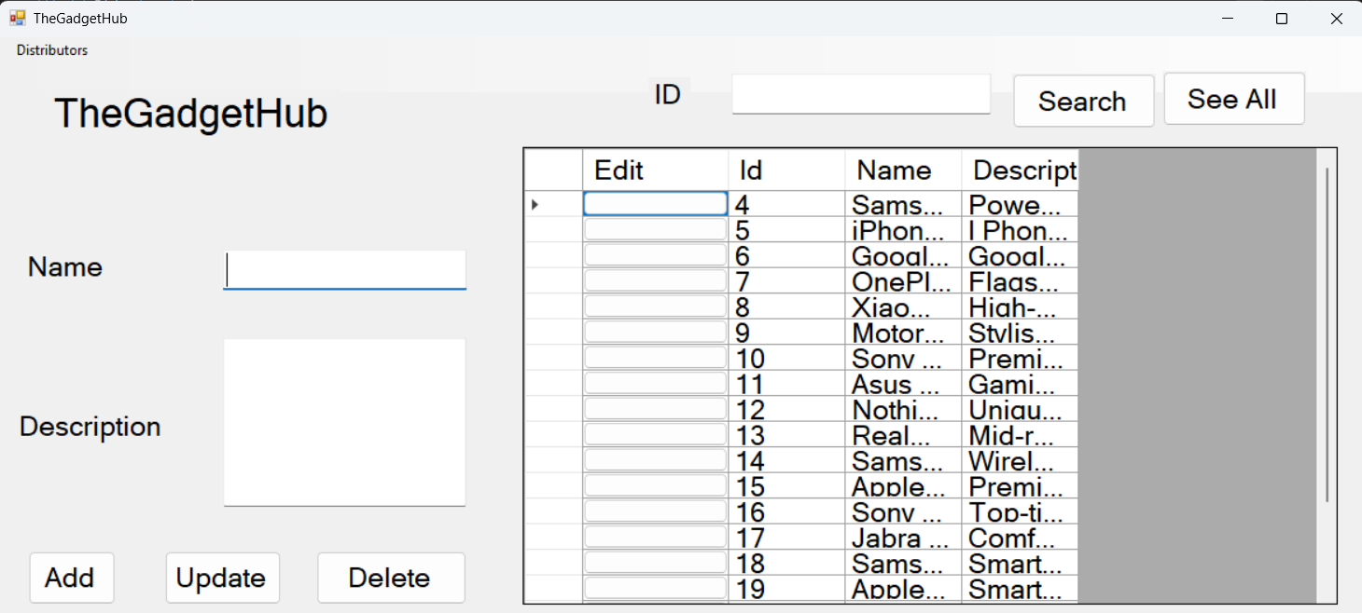
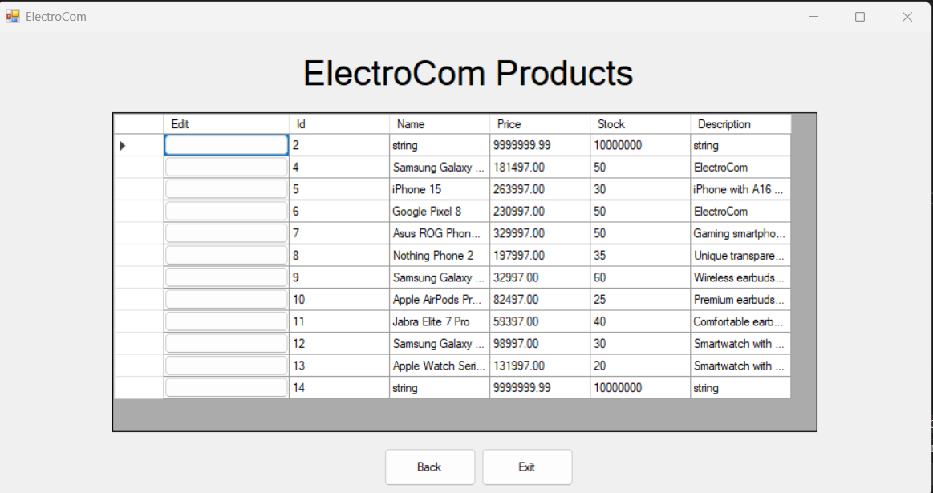

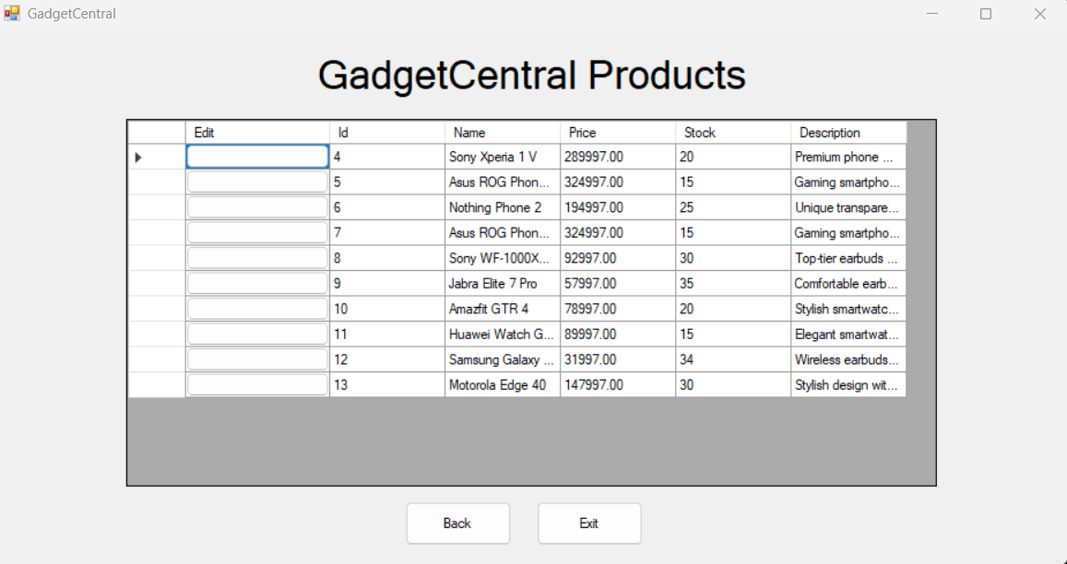

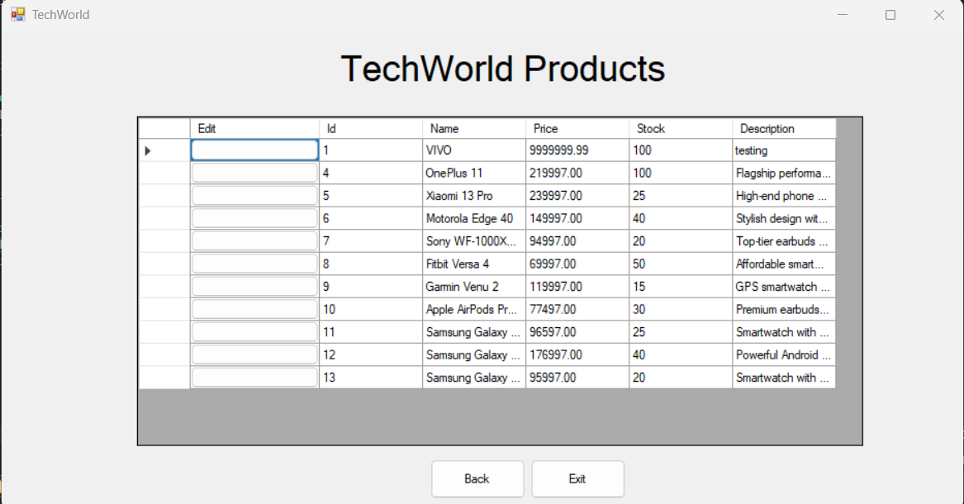

The Gadget Hub Website

Home Page


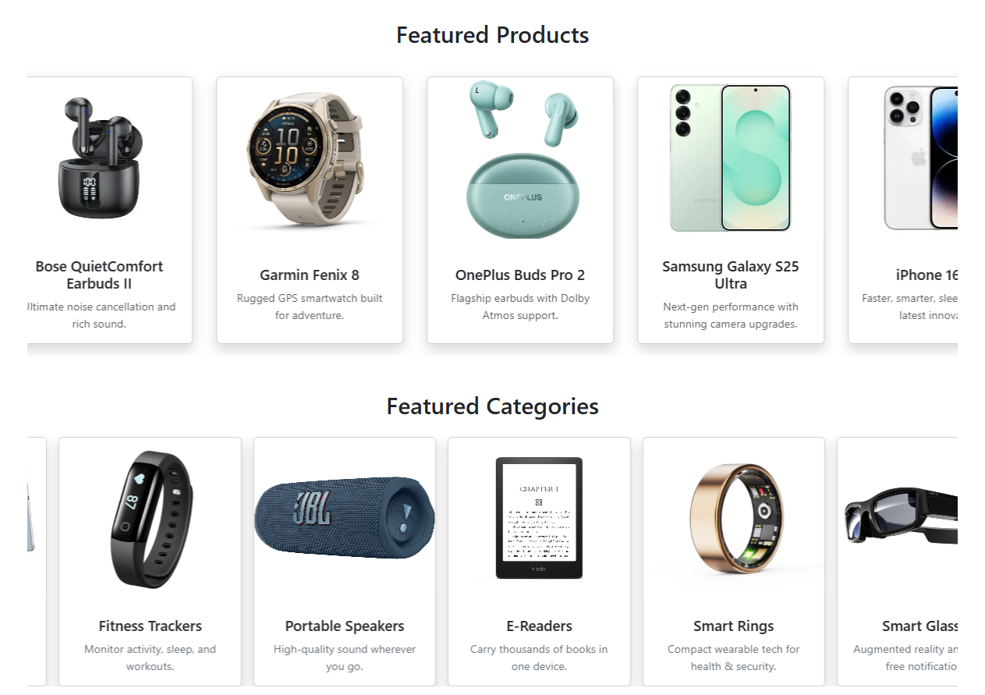
Featured Products cards scroll smoothly left, while Featured Categories cards scroll right.

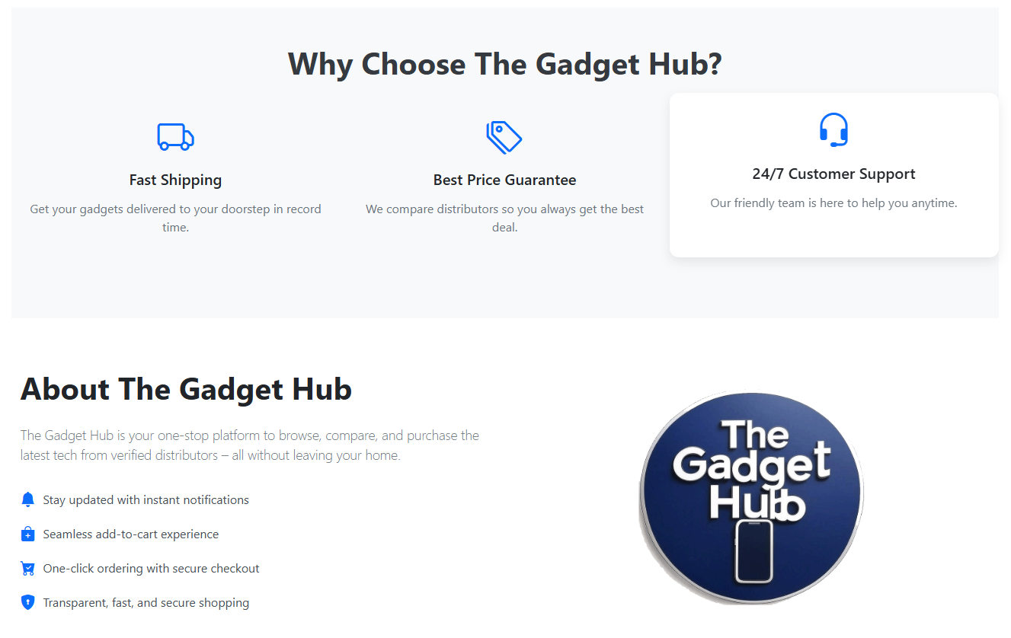

The testimonial slider automatically advances to the next slide every 8 seconds, allowing smooth, timed customer feedback rotation.
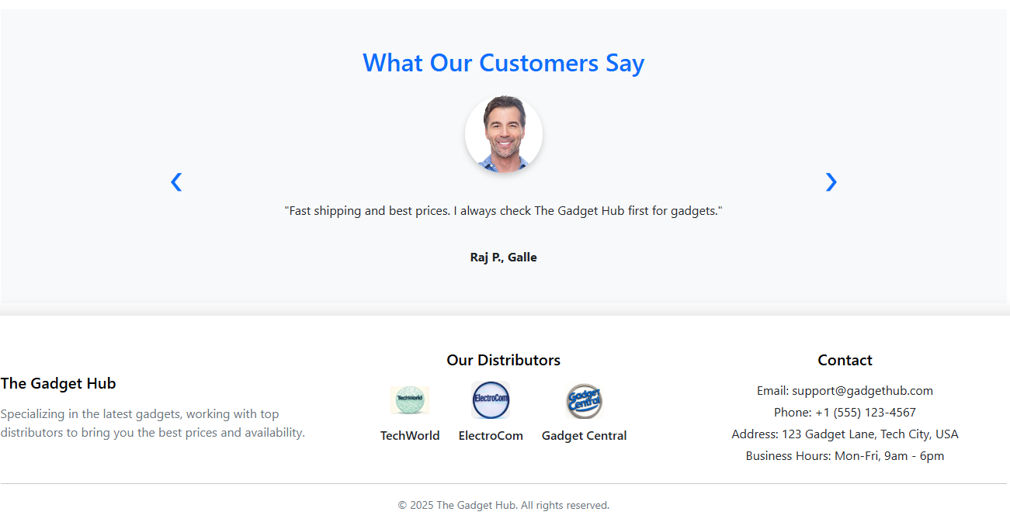

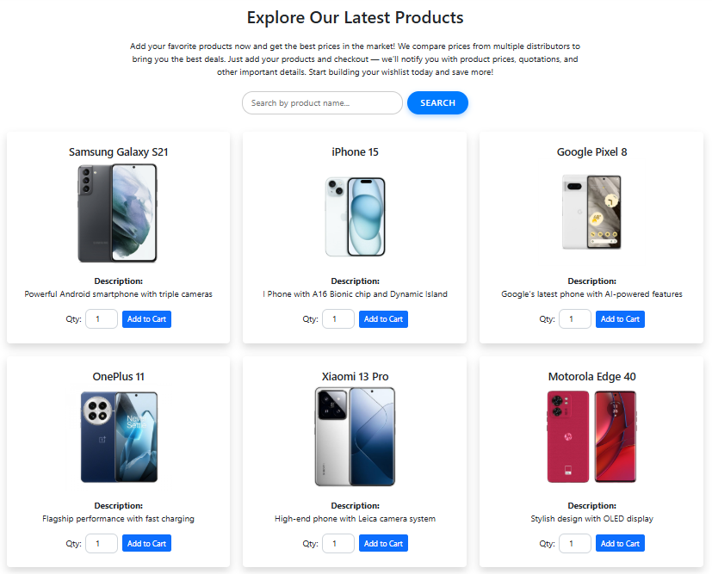
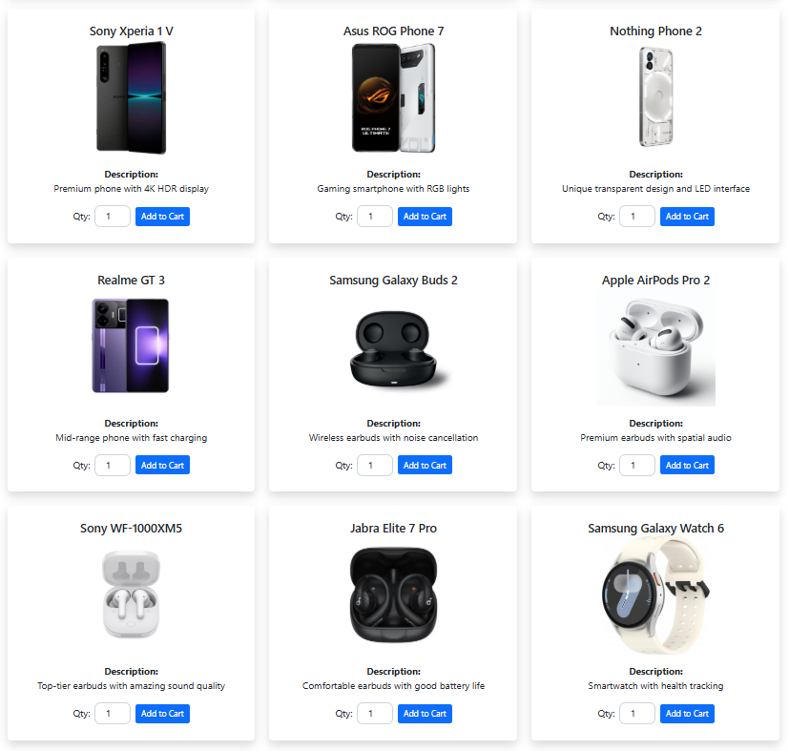
View Item Page

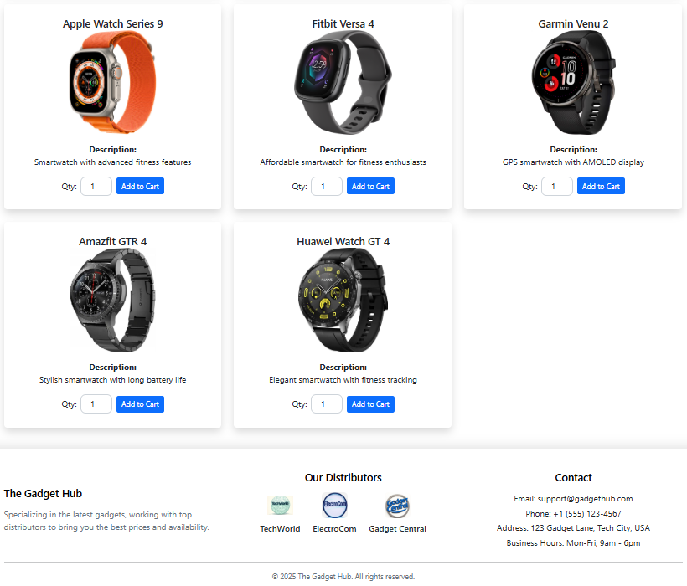

Cart Page
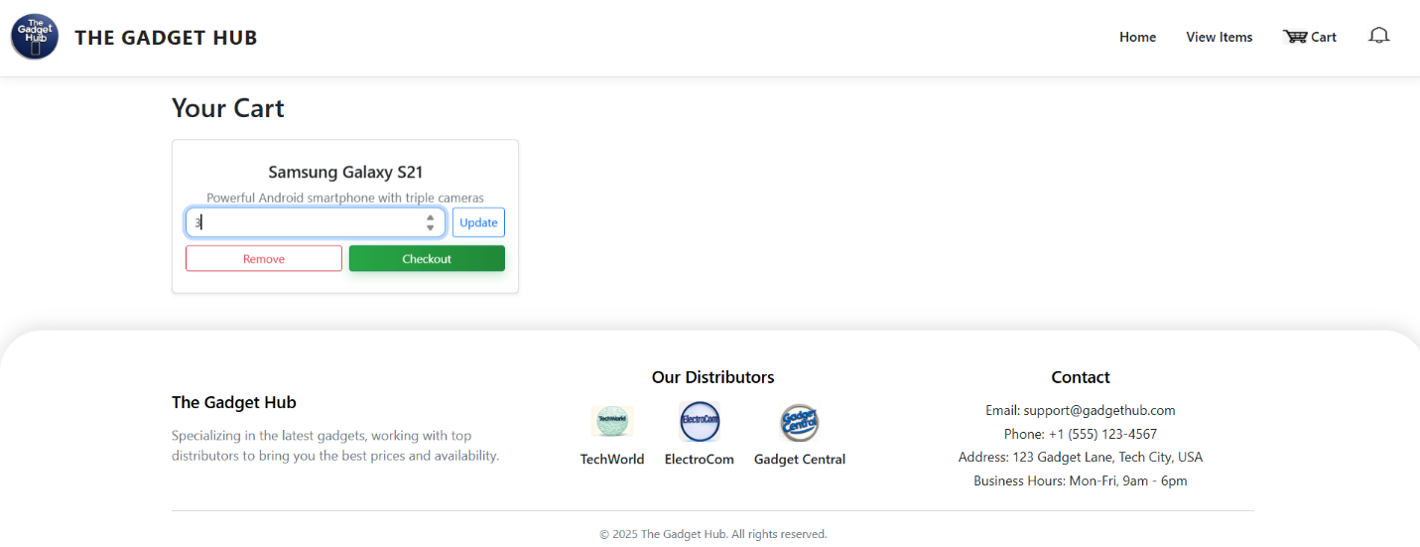

Notification page
(You’ll receive quotation updates through the Notifications page, keeping you informed instantly and conveniently)
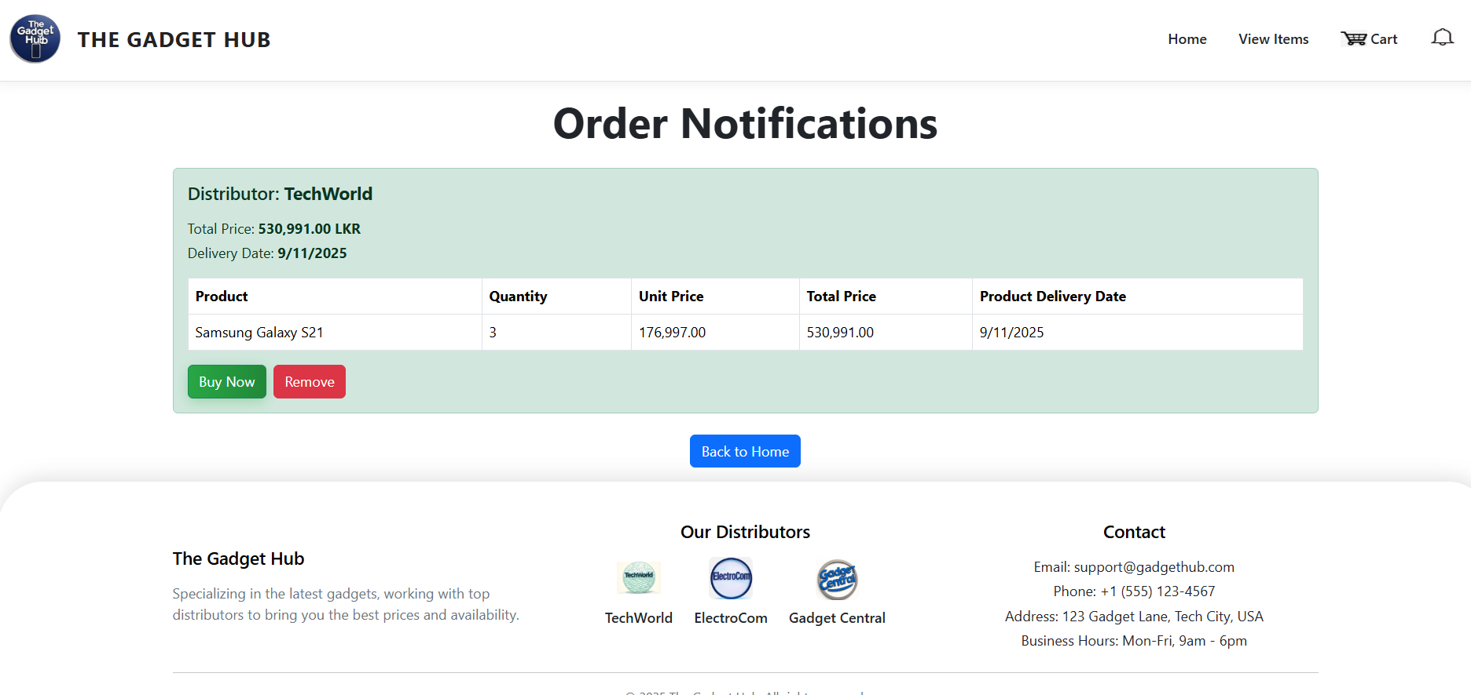
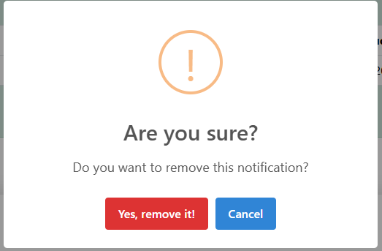
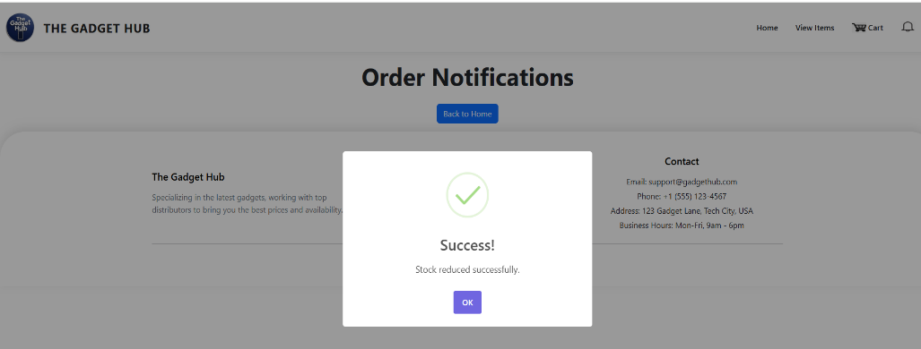
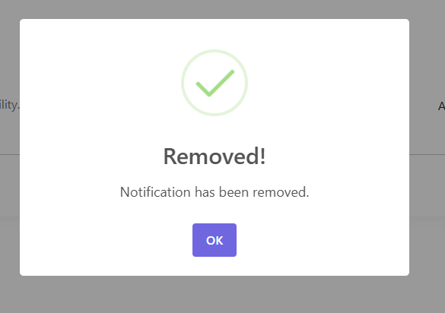

1. Introduction

This test plan outlines the testing strategy for the Gadget Hub system, which connects customers to three distributors (ElectroCom, TechWorldAPI, and GadgetCentral) through a centralized platform for product search, quotations, ordering, and inventory management. The goal is to validate that the system performs as expected across all major functional areas, including API integration, product management, quotation handling, cart functionality, and ordering processes.

2. Objectives and Tasks

Objectives
- Ensure all CRUD operations for Products and Quotations work as expected in all three distributor APIs.
- Validate Gadget Hub's ability to retrieve, compare, and return the best quotations.
- Confirm that customer interactions such as searching, cart management, and order placement function correctly.
- Verify that stock reductions and error handling operate correctly.
Tasks
- Test GET, POST, PUT, DELETE methods for Products and Quotations via APIs.
- Validate custom methods such as stock reduction, quotation generation, and best price selection.
- Ensure customer-facing functions (search, cart, checkout) behave as expected.

3. Test Items
- ElectroCom API
- TechWorldAPI
- GadgetCentral API
- TheGadgetHub API (admin/product management/quotation comparison)
- Customer website functionalities (Search, Cart, Order)

5. Features to be tested
Feature | Test Cases
GET Product | TC01, TC11, TC21, TC31
POST Product | TC02, TC12, TC22, TC32
GET Product by ID | TC03, TC13, TC23, TC33
PUT Product | TC04, TC14, TC24, TC34
Reduce Stock | TC05, TC15, TC25, TC35, TC41
DELETE Product | TC06, TC16, TC26, TC36
POST Quotation | TC07, TC17, TC27
GET All Quotations | TC08, TC18, TC28
GET Quotation by ID | TC09, TC19, TC29
DELETE Quotation | TC10, TC20, TC30
Get Best Quotation URL | TC37
Get Quotation by URL | TC38
Search Product | TC39
Cart Quantity Check | TC40
Checkout with Best Price | TC40 (dup)
Distributor Stock Reduction after Purchase | TC41
Distributor Unavailable Error Handling | TC42
Checkout Total Price | TC43

6. Features Not to Be Tested
The features not included in this test plan are the desktop applications developed for the distributors (ElectroCom, TechWorld, and GadgetCentral) and The Gadget Hub. These applications allow distributors to add, update, delete, and search their own products, and enable The Gadget Hub to view available distributor products and add them to the website. Since these desktop apps handle inventory management separately, and the same functionalities are covered through API testing, their testing is considered out of scope for this plan. The focus remains on validating the APIs and the customer-facing website features.

7.Test Cases

Test case no.1
