Recommender Systems - Course Project Report
Cumulative report template - Parts 1, 2, and 3
Team | Group 17
Members | Quang Nguyen & Dat Minh Lam
For Part 3 track: select one | A / B / C
GitHub repository link | https://github.com/pasiones/recommender-system-project-g17

1. Part 1 - Data, Protocol and Baselines

1.1 Data characterization
MovieLens 1M contains 6,040 users, 3,883 catalogue movies (3,706 rated), and 1,000,209 ratings. Full-catalogue density is 4.2647%; rated-item density is 4.4684%. Activity spans 2000-04-25 23:05:32 to 2003-02-28 17:49:50 UTC. The most popular 10% of rated movies receive 44.45% of ratings. The figures show the interaction long tail, rating distribution and bursty monthly activity (Lecture 5.1, slide 5). Timestamps measure rating entry, not viewing.
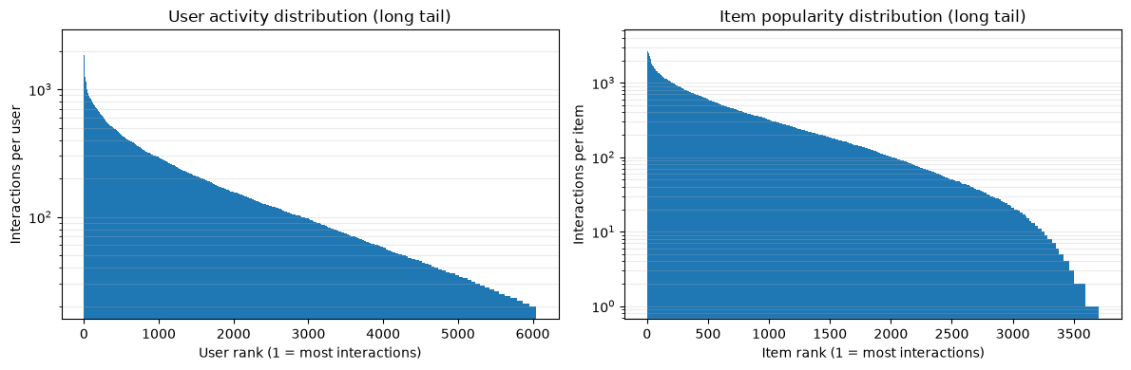
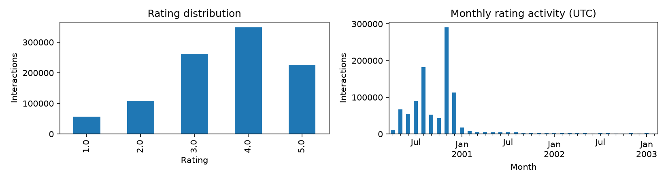

1.2 Preprocessing and feedback treatment
No low-activity filtering is applied (thresholds 1; 0 rows removed), preserving cold-start cases and avoiding future-informed eligibility. Ratings >=4 are binary positives; lower ratings are not positive training signals and are excluded, as already seen. Each user-item pair contributes once to similarity. This matches a top-N preference task rather than rating prediction (Lecture 1.2, slides 5-10).

1.3 Train/validation/test split
A global chronological 80/10/10 target split keeps equal timestamps together by moving each cut right. Training ends 2000-12-02 14:52:18 UTC; validation ends 2000-12-29 23:42:47 UTC. Sizes are [800168, 100020, 100021]. Strict temporal separation simulates future prediction (Lecture 3.1, slide 4); bursty entry activity makes calendar durations unequal. Select settings on validation, then refit once on train+validation for test.

1.4 Evaluation protocol
Rank all 3883 catalogue items except a user's previously rated items; do not sample negatives. Assume catalogue metadata is known at recommendation time; this can include movies not yet observed in training. Macro-average Precision@10 (denominator 10), Recall@10 and binary NDCG@10 over the 1188 test users with at least one positive; exclude 21 users with no positives. Coverage is the union of these users' top-10 lists divided by the full catalogue (Lecture 3.1, slides 7-9). Include 29 cold users, with training-positive popularity fallback when no positive profile exists. No updates occur during the test period. Ties use ascending movie ID. Seed 42 is recorded; algorithms are deterministic.

1.5 Baseline methods and settings
Item-kNN uses binary positive co-occurrence with cosine or Jaccard similarity and zero diagonal. Keep the top k neighbors per source item, then sum their similarities over the user's positive history. Search k in {20,50,100} for both similarities (six trials); maximize validation NDCG@10, then Recall and Precision. Selected cosine, k=100, validation NDCG=0.268549. This balances neighborhood breadth empirically (Lecture 1.2, slides 5-10; Lecture 3.1, slide 10). Popularity compares all-time versus the last 180 days before the fit cutoff, counting all ratings versus positives only (four variants). Zero-score candidates remain in the full-catalogue ranking.

1.6 Results and analysis
Model | P@10 | R@10 | NDCG@10 | Coverage
item_knn_cosine_k100 | 0.2209 | 0.0632 | 0.2425 | 0.0649
pop_all_time_all_ratings | 0.1918 | 0.0525 | 0.2070 | 0.0379
pop_all_time_positive | 0.2009 | 0.0573 | 0.2183 | 0.0363
pop_recent_180d_all_ratings | 0.1933 | 0.0541 | 0.2084 | 0.0355
pop_recent_180d_positive | 0.2006 | 0.0571 | 0.2172 | 0.0361
The standardized workbook and CSV contain all five test configurations; validation_grid.csv contains all six tuning trials. The highest observed test NDCG is item_knn_cosine_k100. These point estimates do not establish statistical significance. Global temporal splitting changes the user population and includes cold users, so results describe future rating-entry behavior rather than randomly held-out preferences. Low coverage reveals concentration even when ranking accuracy is competitive.

2. Part 2 - Models and Honest Comparison

3. Part 3 - Beyond Accuracy

4. Discussion and Conclusions
Part 1 establishes a reproducible temporal protocol. Remaining limitations include unobserved exposure, a static catalogue assumption, and ratings as imperfect relevance labels. Parts 2 and 3 are not yet performed.

5. Contribution Statement
In the group, we divided our group work into 2. Minh and Quang both took part in the preprocessing process and data characterization. While Minh focused on the Baseline methods and analysis, Quang focused on testing and verifying the methods, and checking the documentation for sufficient information.
Minh wrote the Part 1.6 analysis results while Quang focus on writing 1.1, 1.2 and 1.3 for the documentation. We both discuss together on how to proceed the first part.

6. Use of AI Assistants
OpenAI Codex assisted with reading requirements, correcting and implementing Python baselines, evaluation, tests and report generation. Team members must review and understand the implementation and verify this disclosure before submission.

References
Course lectures: 1.2 slides 5-10; 3.1 slides 4, 7-10; 5.1 slide 5. MovieLens 1M: https://grouplens.org/datasets/movielens/1m/. Metric reference: scikit-learn ndcg_score (verified by test_part_1.py).

