Program Structure

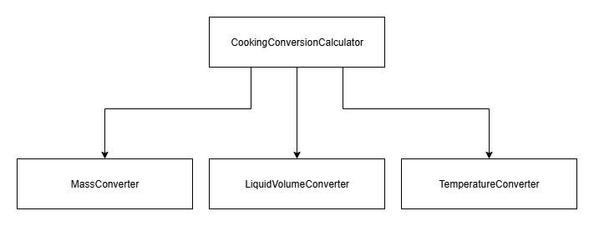

Top-down Integration
Unit under test | List of Stubs/Drivers | result | Stub’s return value | Expected results | Actual results | Pass/Fail/No run
CookingConversionCalculator | TemperatureConverter | 86.0 | 86.0 | 86.0 | 62.0 | Fail
CookingConversionCalculator | MassConverter | 125.0 | 125.0 | 125.0 | 125.0 | Pass
CookingConversionCalculator | LiquidVolumeConverter | 250.0 | 250.0 | 250.0 | 250.0 | Pass

Bottom-up Integration
Unit under test | List of Stubs/Drivers | result | Stub’s return value | Expected results | Actual results | Pass/Fail/No run
LiquidVolumeConverter | JUnit Test | 250.0 | - | 250.0 | 250.0 | Pass
LiquidVolumeConverter | JUnit Test | 16.0 | - | 16.0 | 16.0 | Pass
LiquidVolumeConverter | JUnit Test | 45.0 | - | 45.0 | 45.0 | Pass
LiquidVolumeConverter | JUnit Test | 20.0 | - | 20.0 | 20.0 | Pass
LiquidVolumeConverter | JUnit Test | 147.87 | - | 147.87 | 147.87 | Pass
LiquidVolumeConverter | JUnit Test | 2839.056 | - | 2839.056 | 2839.056 | Pass
LiquidVolumeConverter | JUnit Test | 6.622 | - | 6.622 | 6.622 | Pass
LiquidVolumeConverter | JUnit Test | 0.272 | - | 0.272 | 0.272 | Pass
LiquidVolumeConverter | JUnit Test | 19.017 | - | 19.017 | 19.017 | Pass
LiquidVolumeConverter | JUnit Test | 10.57 | - | 10.57 | 10.57 | Pass
LiquidVolumeConverter | JUnit Test | 2.904 | - | 2.904 | 2.904 | Pass
MassConverter | JUnit Test | 250.0 | - | 250.0 | 250.0 | Pass
MassConverter | JUnit Test | 64.0 | - | 64.0 | 64.0 | Pass
MassConverter | JUnit Test | 15.0 | - | 15.0 | 15.0 | Pass
MassConverter | JUnit Test | 85.047 | - | 85.047 | 85.047 | Pass
MassConverter | JUnit Test | 1.362 | - | 1.362 | 1.362 | Pass
MassConverter | JUnit Test | 0.14 | - | 0.14 | 0.14 | Pass
MassConverter | JUnit Test | 6.615 | - | 6.615 | 6.615 | Pass
TemperatureConverter | JUnit Test | 0.0 | - | 30.0 | 0.0 | Fail
TemperatureConverter | JUnit Test | 62.0 | - | 86.0 | 62.0 | Fail
CookingConversionCalculator | JUnit Test | 64.0 | - | 64.0 | 64.0 | Pass
CookingConversionCalculator | JUnit Test | 20.0 | - | 20.0 | 20.0 | Pass
CookingConversionCalculator | JUnit Test | 0.0 | - | 30.0 | 0.0 | Fail

