**Evaluation of the Bike-sharing system on vehicle traffic in Oslo**

**Abstract:**

This study investigates the potential of bike-sharing programs to alleviate traffic congestion in urban environments, with a particular focus on Oslo. By examining various indicators such as traffic volume, vehicle type trends, and bike-sharing usage patterns, the analysis seeks to determine the effectiveness of bike-sharing as a sustainable transportation alternative. The study is centered around three key areas in Oslo, utilizing comprehensive traffic and bike-sharing data collected between 2020 and 2024.

**Introduction:**

In recent years, many cities have been adopting bicycle-sharing systems, services that allow individuals to use shared bicycles at a low cost. These systems are gaining popularity due to their ability to provide a sustainable and convenient alternative to traditional modes of transportation. This report aims to assess the positive impact of bike-sharing systems on traffic congestion, with a particular focus on the city of Oslo.

**Bike-Sharing Background**

Bicycle-sharing programs generally feature two types of systems: docking and dockless. Docking systems allow users to rent bicycles from designated stations equipped with tech-enabled racks, returning them to any other station within the network. In contrast, dockless systems operate without fixed stations, utilizing smart technology instead. Both systems often employ smartphone web mapping to help users locate available bikes and stations. As of July 2020, Google Maps includes bike-share systems in its route planning recommendations.

These systems offer numerous advantages, including reducing city traffic, lowering pollution levels, and promoting social health benefits. Cycling is an excellent form of exercise and stress relief, making bike-sharing systems a valuable asset for urban environments.

* Similar projects in other cities

To effectively assess the impact of bike-sharing systems on city congestion, it's crucial to explore how these systems have influenced urban mobility on a global scale.

The Meddin Bike-Sharing World Map is a comprehensive resource that tracks bike-sharing services globally. In the 2022 report ([link](https://bikesharingworldmap.com/reports/bswm_mid2022report.pdf)) it’s possible to have a look on the number Bike-sharing systems per year in the world:

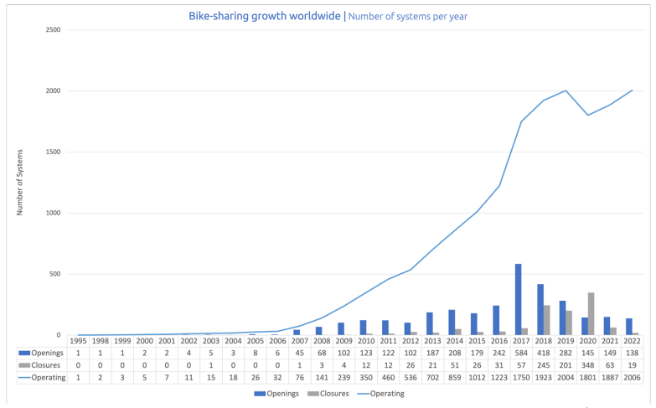

It’s possible to notice a little decrease during the COVID-19 period but after that the growth is strong again (in August 2022 the world had 1914 systems).

Other different projects wanted to evaluate the bike sharing impact on the city mobility. A 2015 Transport Reviews study examined bike-share systems in five cities, including Washington, D.C., and Minneapolis. It found that bike-share rides replaced car trips 8% of the time in D.C. and nearly 20% in Minneapolis ([link](https://www.tandfonline.com/doi/full/10.1080/01441647.2015.1033036)). Another study showed that Washington, D.C.'s Capital Bikeshare reduced traffic congestion by 2-3% ([link](https://papers.ssrn.com/sol3/papers.cfm?abstract_id=2649978)). In 2017, research in Beijing and Shanghai linked the rise of dockless bike shares to fewer car trips under five kilometers ([link](https://dialogue.earth/en/uncategorized/9887-time-to-regulate-china-s-booming-bike-share-sector/)).

As a general overview we can conclude this section presenting two outcomes of the mid-2022 paper. The geographical spread of bike-sharing systems shows a significant predominance in Europe and Asia, accounting for 85% of the operational networks:

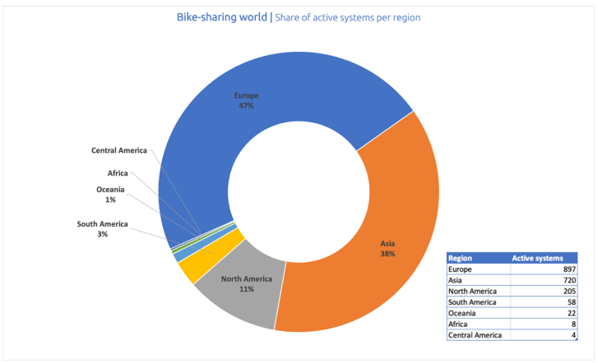

In terms of fleet size, Asia emerges as the clear leader, controlling a substantial 95% share of bikes:

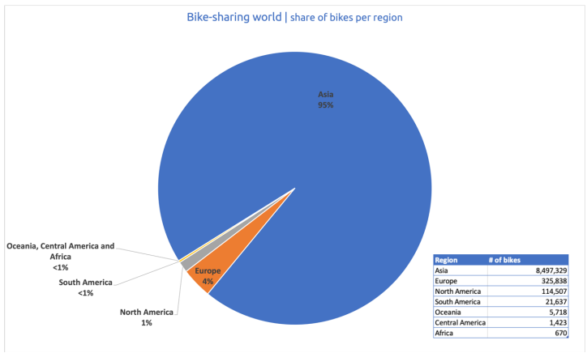

* + **Case Study: OSLO**

The availability of open-source data and Oslo's characteristics as a smart and green city were the main motivations for choosing the capital of Norway as the primary subject of this study.

In 2019, Oslo was honored as the European Green Capital, a recognition of the city's successful delivery on ambitious climate and environmental goals over several decades. Cities compete openly for this title, submitting detailed reports on their progress over the past five to ten years, their present achievements, and their future strategies. Evaluation criteria encompass 12 key indicators such as reducing greenhouse gas emissions, enhancing air and water quality, fostering environmental innovation, promoting access to green spaces, conserving biodiversity, and advancing sustainable transportation solutions.

Oslo achieved the highest possible rank in 8 out of 12 indicators. One of these is Public Transport.

Public transportation in Oslo is renowned for its green initiatives, reflecting the city's commitment to sustainability. The transportation network includes extensive tram, bus, metro (T-bane), and ferry services, all operated with a focus on reducing environmental impact. Notably, Oslo's bike-sharing system enhances eco-friendly mobility options, promoting bicycle use as a sustainable means of transportation throughout the city. These initiatives underscore Oslo's dedication to promote a greener urban environment through efficient and environmentally conscious public transport solutions.

The public transport company in Oslo published a report in 2021 which has the aim to analyze the transportation usage after COVID-19. Along the city the green form of public transportation are as this graph show:

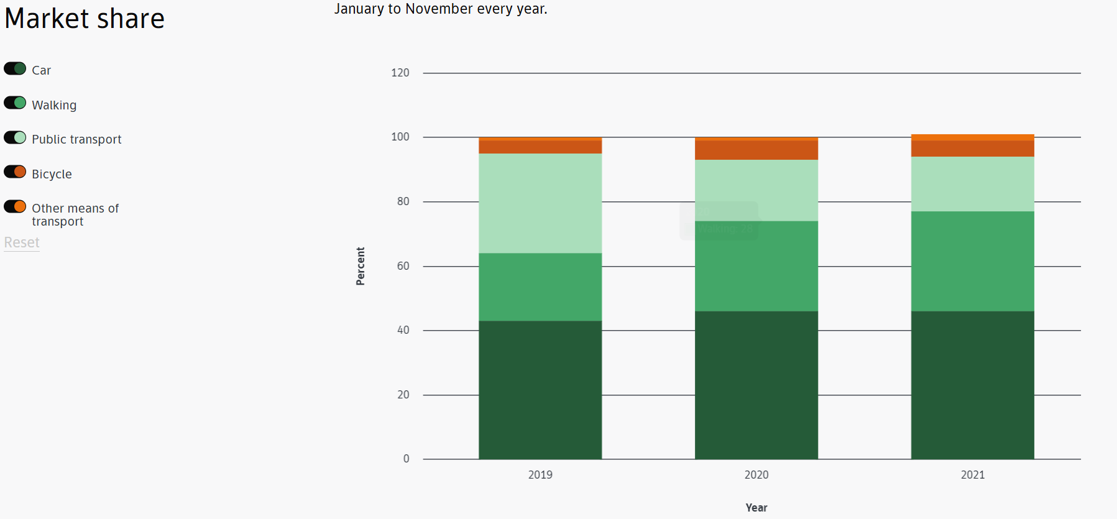

For simplicity the focus of this project will be only one form of green transportation: shared bicycle system.

In conclusion, the goal is to analyze the traffic volume in a specific part of the city throughout the year and assess the impact of the bike-sharing system on this traffic. The evaluation is based on several indicators, which will be defined below in the report.

* Technology accessibility

In Oslo, smart mobility and public transportation have been significantly digitalized to enhance convenience and efficiency. The city has embraced technology to streamline travel by integrating digital platforms for bike-sharing, electric scooters, and public transit services. Through apps like Ruter, residents and visitors can easily access real-time information, book rides, and pay seamlessly.

Regarding bike-sharing services, all options are accessible via smartphone apps. Examples include Bolt, Voi, and Donkey Republic, but the most used and supported service is Oslo Bysykkel. Users can rent either standard or electric bikes through the Oslo Bysykkel app, which displays the locations of available bikes and docking stations. The app enables easy bike rental and return, allowing users to unlock and lock bikes directly from their smartphones.

Oslo Bysykkel offers various pricing options to suit different usage patterns. For a standard bike, a single ride costs approximately €2 for up to 60 minutes. Frequent users can opt for a monthly pass at €15, which provides unlimited 60-minute rides within the month. An annual pass is available for €55, granting unlimited 60-minute rides throughout the year.

* Datasets

To conduct a comprehensive analysis, we selected three areas geographically close to the city center that feature both car and bike paths. Additionally, we ensured that the traffic dataset for these areas is complete.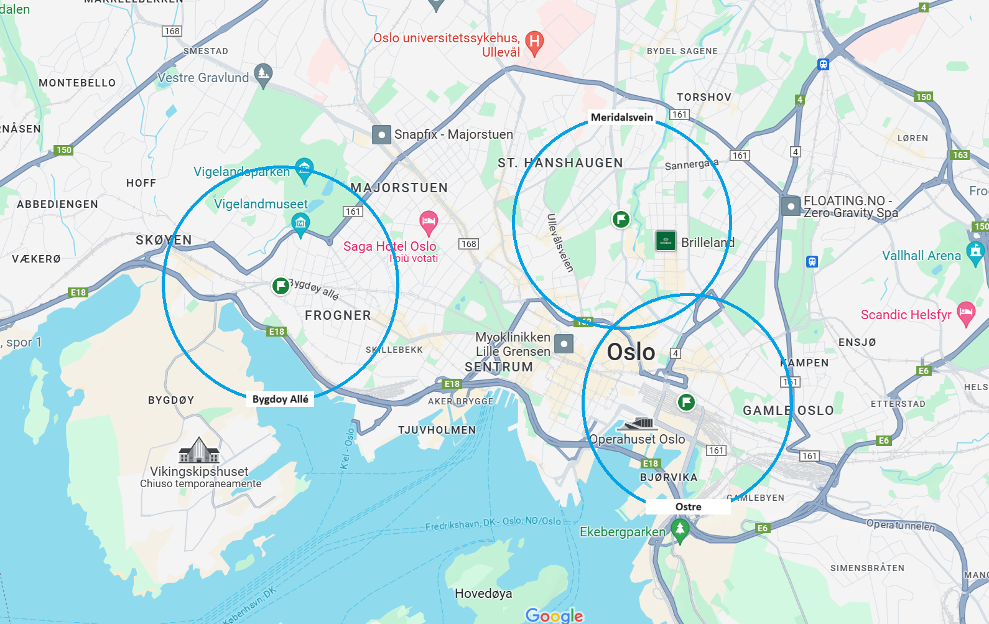

On the map, you can see the three traffic sensor points, which are placed in:

* Bygdøy Allé
* Meridalsveien
* Østre Gate

For each of these locations, the report aims to analyze the impact of the bike-sharing system on the traffic within a 1 km radius.   
  
All datasets used in this analysis were obtained from reliable Norwegian sources and translated from Norwegian to English prior to use. This ensures consistency and comprehensibility for analysis. The time span for the bike-sharing and traffic data extends from 2020 to 2024, with a particular focus on 2024 in a separate traffic dataset.

We can identify three main data sources for this project, two of them are related to the traffic vehicle and the last one depicts the bike-sharing system usage in oslo.

### 

### **Traffic Dataset**

**Description and Purpose**:

The traffic dataset includes data collected by the Norwegian Public Roads Administration from 2020 to 2024. This data is gathered through point measurements and stretch measurements using equipment installed along the roads. [Trafikkdata.no](http://trafikkdata.no) provides point measurements from traffic registration stations on state, county, and some municipal roads.

This dataset is essential for analyzing long-term traffic trends and understanding the general flow of vehicular traffic in Oslo. The data are recorded hourly and include details such as traffic volume, confidence interval values for the traffic volume, percentage of the time period covered by the traffic measurement, number of total, included, and invalid days in the measurement period, length of the invalid data period, quality grade of the measurement length as a percentage, specific lane where the traffic measurement is taken, and the number of vehicles under and over 5.6 meters in length.

**Additional Columns**: To facilitate detailed analysis, additional columns were created using formulas and data transformations:

**Year**, **Month**, **Day_of_Week**: Extracted from the 'From' column to identify the year, month, and day of the week of the measurement.

**Light_Vehicles** and **Heavy_Vehicles**: Calculated from the original columns to distinguish between light and heavy vehicles.

* **Light_Vehicles** = under_5_6m
* **Heavy_Vehicles** = Sum of all vehicle categories over 5.6 meters.

**Traffic_Volume_Check**: Sum of light and heavy vehicles to verify the traffic volume data.

* **Traffic_Volume_Check** = Light_Vehicles + Heavy_Vehicles

**Traffic_Volume_Difference**: Difference between the reported traffic volume and the calculated traffic volume.

* **Traffic_Volume_Difference** = Traffic_volume - Traffic_Volume_Check

**Monthly_Traffic_Volume**: Aggregated traffic volume for each month.

* **Monthly_Traffic_Volume** = Sum of Traffic_volume grouped by YearMonth

**season**: Categorization of months into seasons.

* **season** = Categorized based on Month (e.g., Winter: Dec-Feb, Spring: Mar-May)

**day_type**: Categorization of days into workdays, weekends, and holidays based on Norwegian holidays and weekends.

### **Hourly Traffic Dataset 2024**

**Description and Purpose**: This dataset provides detailed hourly traffic data for 2024, essential for understanding hourly traffic variations and the impact of bike-sharing during different times of the day. Focusing on a single year allows for a precise analysis of daily and hourly traffic fluctuations.

The dataset includes the identifier and name of the traffic registration point, the reference to the road where the traffic is measured, the period of measurement (combined date and time), total volume of traffic recorded and other features very similar to the monthly dataset described above.

**Additional Columns**:

* **Year**, **Month**, **Day**, **Hour**, **Day_of_Week**: Extracted from the timestamp for detailed temporal analysis.
* **Light_Vehicles** and **Heavy_Vehicles**: Distinction between light and heavy vehicles.
* **Heavy_Vehicle_Ratio**: Ratio of heavy vehicles to total traffic volume.
  + **Heavy_Vehicle_Ratio** = Heavy_Vehicles / Traffic_Volume
* **is_weekend** and **is_rush_hour**: Indicators for weekends and rush hours.
  + **is_weekend** = 1 if Day_of_Week is Saturday or Sunday, else 0
  + **is_rush_hour** = 1 if Hour is between 7-9 AM or 4-6 PM on weekdays, else 0
* **season** and **traffic_volume_category**: Seasonal and traffic volume categorizations.
  + **season** = Categorized based on Month (e.g., Winter: Dec-Feb, Spring: Mar-May)
  + **traffic_volume_category** = Quantile-based categorization of Traffic_Volume into Low, Medium, and High.

### **Bike-Sharing Dataset**

**Description and Purpose**: The bike-sharing dataset, obtained via web scraping from the [Oslo City Bike service](https://oslobysykkel.no/en/open-data/historical), includes detailed trip information from 2020 to 2024. The data were merged to create a cohesive dataset. This dataset is crucial for analyzing bike usage patterns in the selected areas of Oslo.

**Original Columns**: The dataset includes the start and end times of the bike trip, names and IDs of the start and end stations, and coordinates of the start and end stations.

**Additional Columns**: Several new columns were added to enhance the analysis:

* **duration_minutes**: Duration of the trip in minutes.
  + **duration_minutes** = (ended_at - started_at) / 60
* **day_of_week**, **hour_of_day**: Day of the week and hour when the trip started.
  + **day_of_week** = Extracted from started_at (0 = Monday, 6 = Sunday)
  + **hour_of_day** = Extracted from started_at
* **distance_km**: Straight-line distance between the start and end stations.
  + **distance_km** = Calculated using the Haversine formula based on start_station_latitude, start_station_longitude, end_station_latitude, and end_station_longitude
* **is_rush_hour** and **is_weekend**: Indicators for rush hours and weekends.
  + **is_rush_hour** = 1 if hour_of_day is between 7-9 AM or 4-6 PM on weekdays, else 0
  + **is_weekend** = 1 if day_of_week is Saturday or Sunday, else 0
* **season** and **is_round_trip**: Season and indicator for round trips.
  + **season** = Categorized based on started_at (Winter: Dec-Feb, Spring: Mar-May)
  + **is_round_trip** = 1 if start_station_id equals end_station_id, else 0

indicators

The analysis of the impact of the bike-sharing system on the city traffic requires the definition of some indicators which will allow a better understanding of the bicycle usage and traffic conditions over time.

1. **Percentage Trend of Long Vehicles** [12m - 18.5m] (Bus Usage):Tracks the usage of longer buses, which are significant contributors to urban traffic congestion, especially in areas where they intersect with bike-sharing stations.

2. **Average Daily Traffic Volume with Hourly Data** (Comparing Workday vs Non-workday): Provides a detailed view of traffic patterns throughout the day and on different types of days, helping to assess how bike-sharing affects peak traffic hours and daily congestion levels.

3. **Annual/Seasonal Traffic Trends vs Bike-Sharing Trends**: Compares long-term trends in vehicular traffic with bike-sharing adoption over annual and seasonal cycles, indicating potential impacts on congestion throughout the year.

4. **Most Popular Bike-Sharing Stations** (Correlating with Traffic in Key Areas): Analyzes whether high-traffic areas coincide with popular bike-sharing stations, revealing shifts in commuting behavior and aiding in optimal station placement.

### **Indicator 1: percentage trend of medium-long vehicles over the years.**

In Oslo, particularly in the city center, buses predominantly belong to one company and typically range in length from 12 to 18.75 meters. In 2020 ([link](https://press.mantruckandbus.com/corporate/going-green-127-man-lions-city-buses-hit-the-road-in-oslo/)), the Oslo bus company placed an order for over one hundred new buses that align with these specifications.

The bus usage trends are essential for evaluating the impact of bike sharing systems on urban traffic in Oslo. Smart cities strive to optimize mobility by efficiently integrating various transportation modes.

The line plot indicates distinct usage patterns across three areas: Bygdøy Allé exhibits the highest bus usage, contrasting with Østre, closer to Oslo's main train station, where long vehicles like buses are not that popular.

Notably, Maridalsveien shows a lack of traffic data for most of 2020, significantly affecting that year's analysis. While the reason for this data gap isn't within the scope of this project, it underscores the importance of comprehensive data collection for accurate assessments.

The chart shows a notable pattern where bus usage exhibits a light peak every year during May across all three areas: Bygoy, Østre, and Maridalsveien. This recurring trend suggests a seasonal increase in bus ridership during this month, which could be attributed to various factors such as better weather conditions encouraging public transport use, the end of the academic year, or possibly the beginning of tourist season in Oslo

The varying popularity of bus systems in different neighborhoods suggests a slight impact of bike sharing on urban mobility. Further exploration is warranted to understand how the availability of bike sharing stations influences vehicle traffic across Oslo, guiding strategic decisions on station placement and infrastructure development.

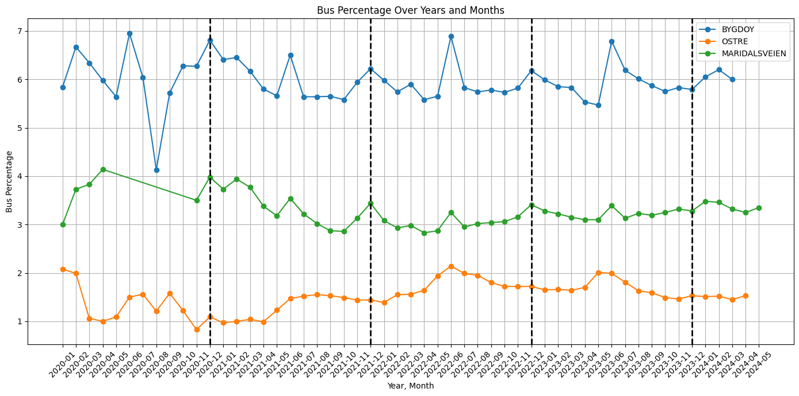

### **Indicator 2: Average Daily Traffic Volume and bike-sharing duration with Hourly Data (Comparing Workday vs Non-workday)**

**Introduction**

The second indicator aims to provide a detailed short term view of traffic patterns and bike-sharing usage.

Understanding how traffic volume is distributed across the three designated areas of Oslo can help identify where implementing a bike-sharing solution would be most beneficial.

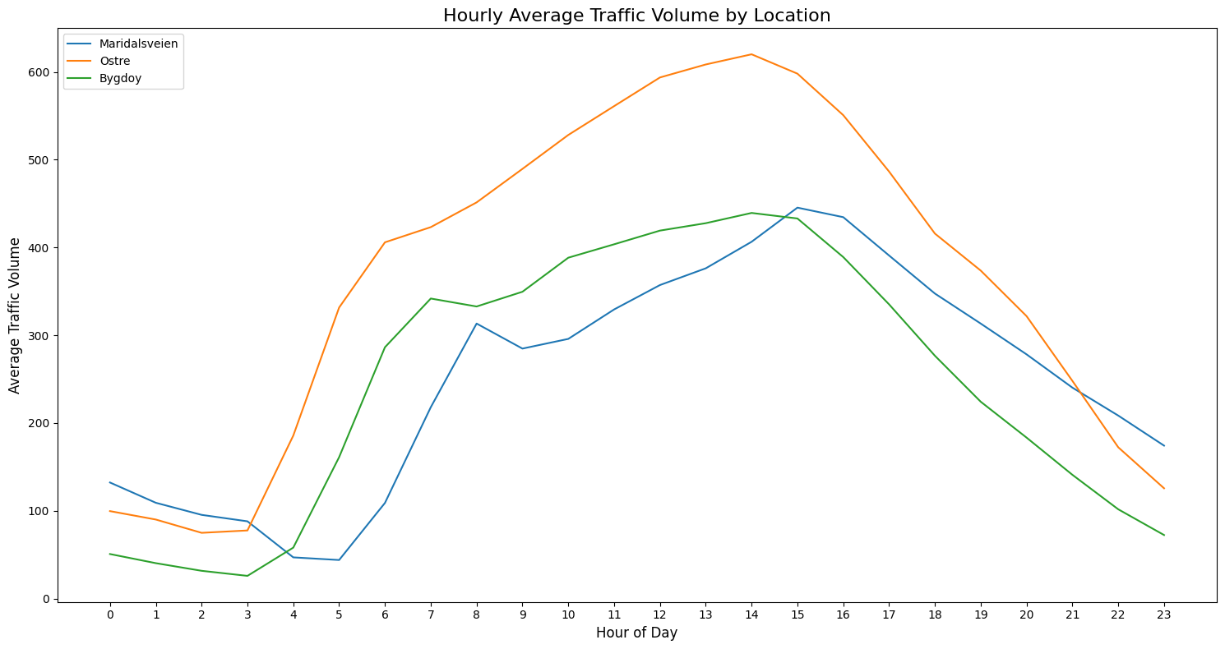

The graph displays hourly average traffic volume for three Oslo locations: Maridalsveien, Østre and Bygdøy. All three show increased traffic in the morning, peaking midday, and declining in the evening. Østre has the highest traffic volume, peaking around 3 PM, indicating significant commuter traffic. Maridalsveien peaks around 4 PM with moderate traffic, while Bygdøy Allé has the lowest and most evenly spread traffic, peaking just below 400 vehicles at 3 PM.

Østre's high traffic suggests a strong need for bike-sharing to alleviate congestion, especially during peak hours.

Moreover, the previous analysis of bus usage patterns highlights a crucial point: in areas where traditional public transportation is less favored, bike-sharing systems could fill the gap, providing a convenient and environmentally friendly mode of transport. As such, Østre represents a prime candidate for targeted bike-sharing interventions, especially during peak commuter times, to help mitigate congestion and improve urban mobility.

Maridalsveien could also benefit from bike-sharing during its late afternoon peak. Bygdøy, with lower but consistent traffic, might use bike-sharing for daily transportation needs.

Later in this report, the Østre area will be analyzed in greater detail.

Additionally, it is crucial to examine how transportation patterns shift during weekends and holidays compared to regular workdays. Understanding these differences can provide insights into varying transportation needs and the potential for bike-sharing to offer flexible solutions. The subsequent graphs will compare the average number of vehicles and the average duration of bike-sharing trips on workdays versus non-workdays. This comparison will highlight any significant variations in traffic volume and bike usage.

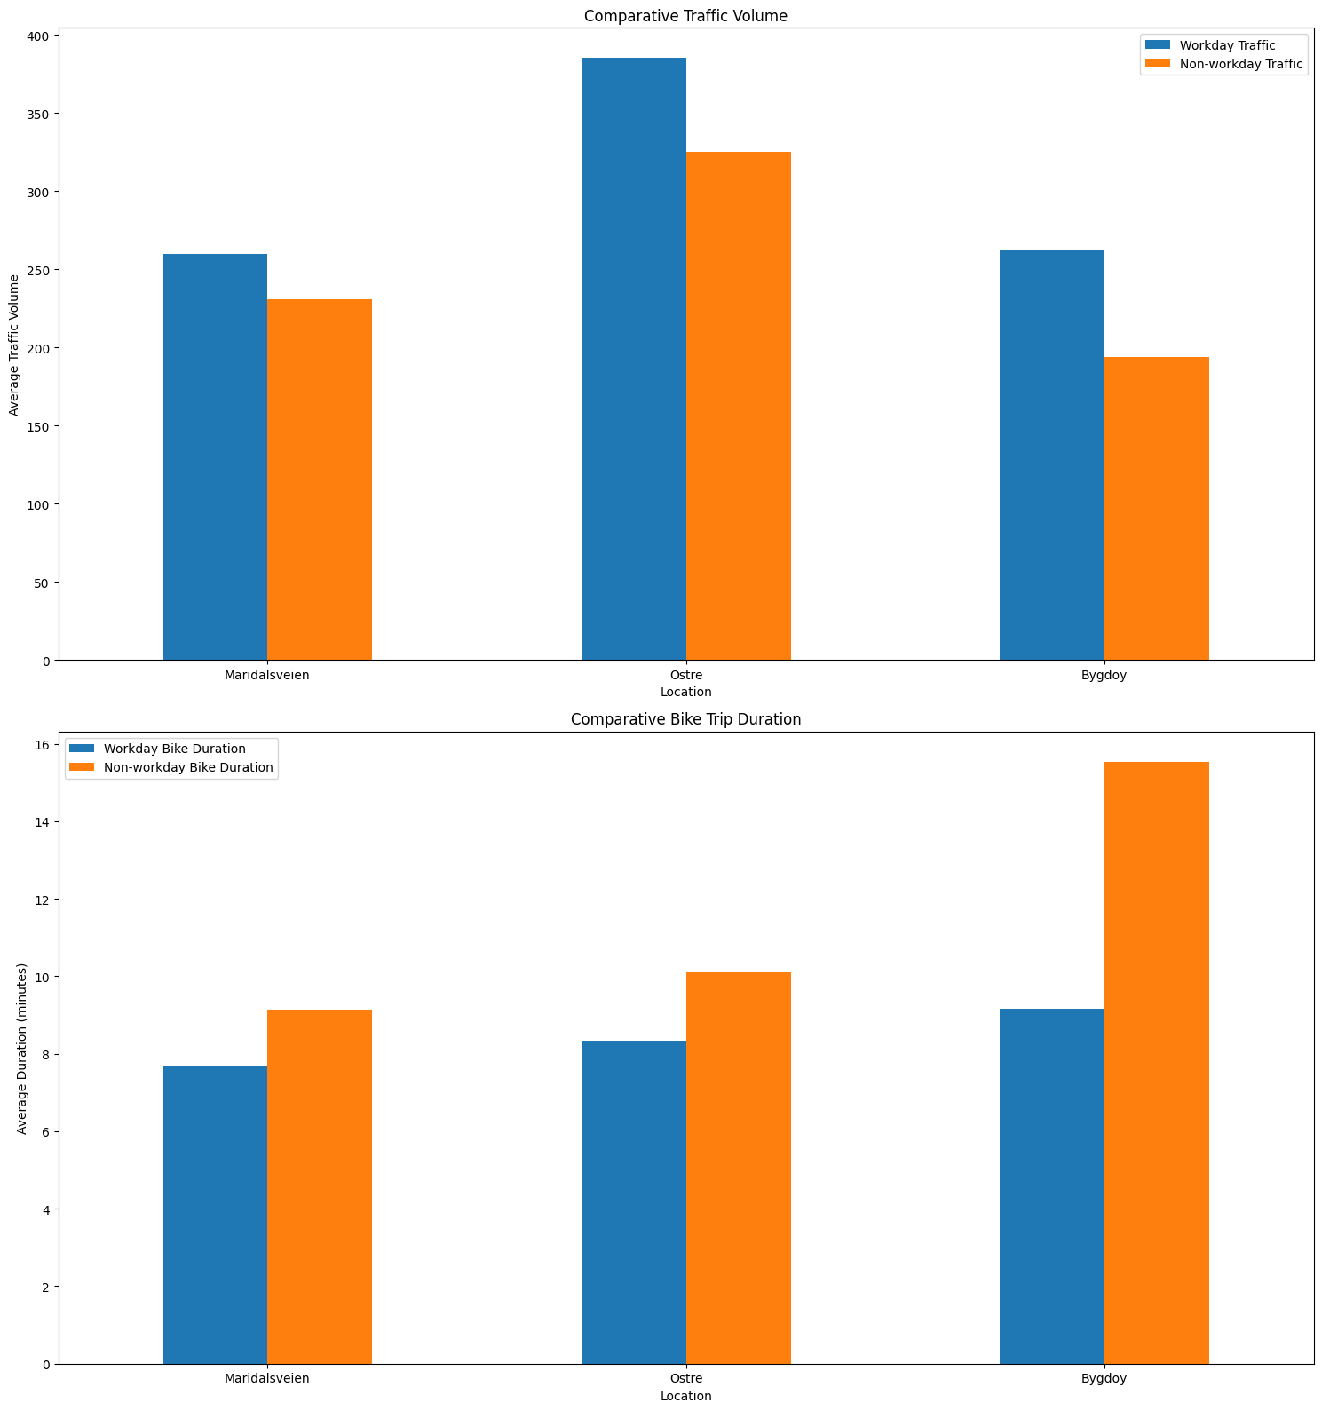

The analysis of average daily traffic volume and bike trip duration reveals distinct patterns between workdays and non-workdays across the three areas studied: Maridalsveien, Østre, and Bygdøy. Overall, traffic volumes are consistently higher on workdays, reflecting typical commuting behaviors.

Regarding bike trip durations, there is a noticeable trend of longer trips on non-workdays, suggesting a more recreational or leisurely use of the bike-sharing system during weekends and holidays. Bygdøy Allé exhibits the most significant difference, with an average trip duration of 15.54 minutes on non-workdays compared to 9.16 minutes on workdays.

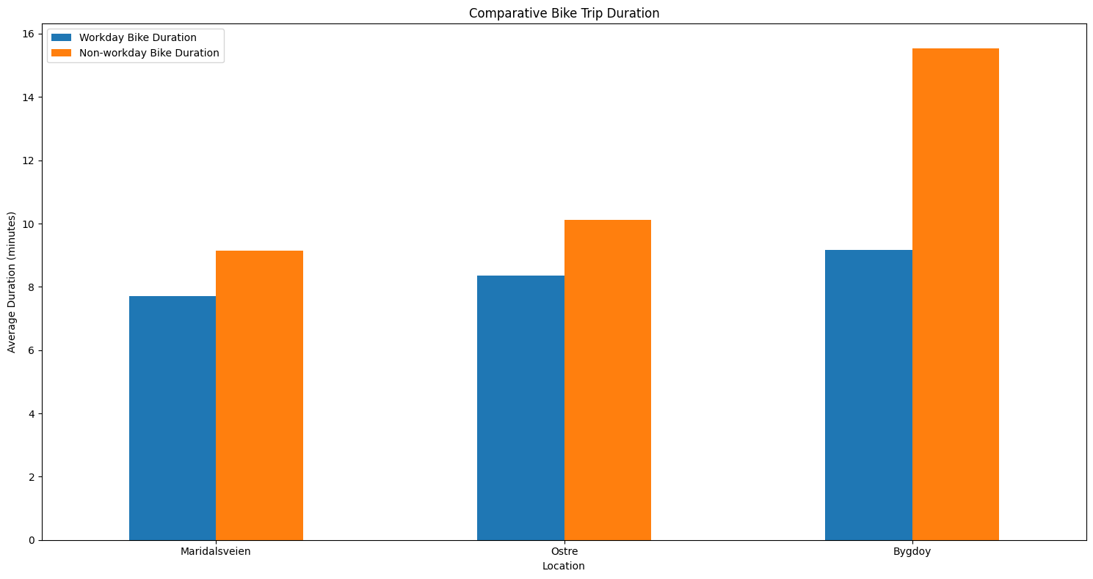

These observations indicate that while bike-sharing systems are utilized for daily commutes on workdays, they are more likely to be used for longer, possibly recreational rides on non-workdays. This dual usage highlights the importance of the bike-sharing system in both reducing daily traffic congestion and promoting sustainable transportation options for leisure activities.

For a concise comparison between traffic volume trends and bike-sharing duration trends, this study will focus on the Østre area.

**Comment on Østre Graphs (One Example)**

The graph illustrates the relationship between the average hourly traffic volume and the average bike trip duration in the Østre area during workdays. The data is displayed for each hour of the day, from 0 to 23 (midnight to 11 PM).

The two distinct peaks in traffic volume during the morning (8-9 AM) and evening (4-5 PM) correspond to typical commuter patterns, reflecting the rush hours in Østre.

The alignment of bike trip duration peaks with the morning and evening traffic peaks suggests that bike-sharing is a popular alternative during rush hours. This could be due to daily travelers opting for bikes to avoid traffic congestion or for shorter, more efficient travel within the city.

The steady bike trip durations during midday imply a consistent use of bike-sharing services even outside peak hours, possibly for errands, short trips, or leisure.

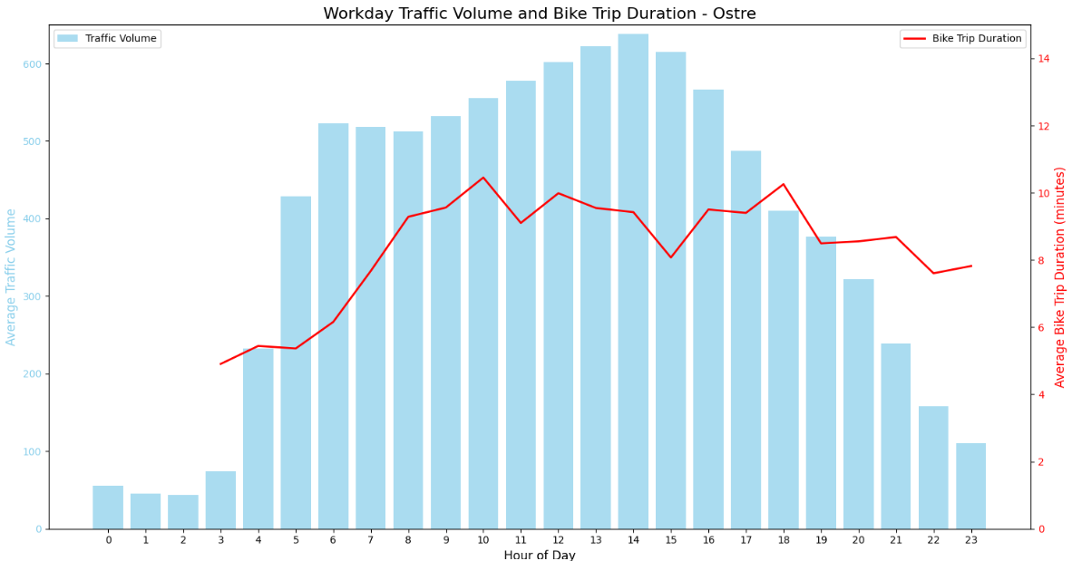

In contrast, the average bike trip duration on weekends and holidays is notably longer on non-workdays as we noticed before.

The non-workday chart exhibits a more gradual increase in traffic volume, peaking during midday, which aligns with recreational and leisure activities rather than commuting.

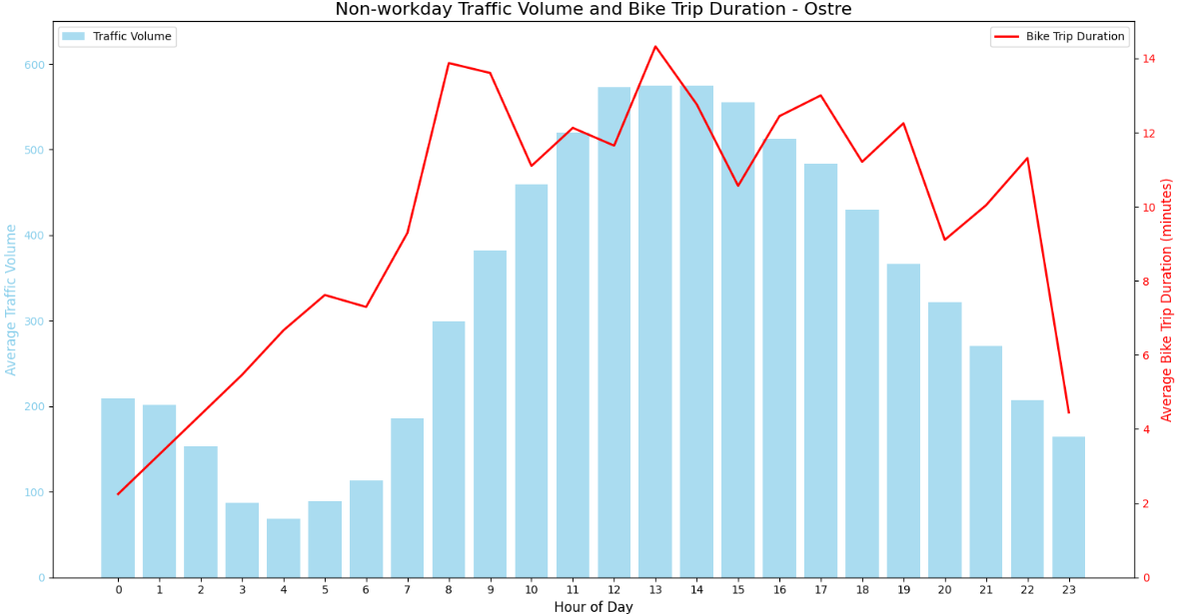

The analysis reveals distinct patterns between workdays and non-workdays. On workdays, bike-sharing usage closely aligns with peak traffic hours, suggesting it serves as an effective alternative for commuters, potentially reducing vehicle congestion during critical times. On non-workdays, bike-sharing experiences higher and more varied usage throughout the day, indicating its importance in supporting recreational and leisure activities.

The fact that bicycle trips follow a similar trend to vehicle traffic suggests that both modes of transportation are valuable under suitable weather conditions and appropriate distances. By analyzing the three areas covered in this report, it becomes clear that a robust bike-sharing system would be particularly beneficial in Østre, which has been identified as the area with the highest traffic volume.

### 

### **Indicator 3: Annual/Seasonal Traffic Trends vs Bike-Sharing Trends**

A long-term evaluation of the bike-sharing impact can help to identify seasonal trends across the three areas of Oslo under consideration. The line plots below provide visual comparisons of average daily traffic volume and number bike trips.

#### 

This plot reveals that areas near the city center (Østre and MARIDALSVEIEN) experience higher levels of bicycle usage compared to Bygdøy. Spring sees a peak in bike-sharing activity, while Summer shows a decline, likely due to residents being away on holiday. MARIDALSVEIEN and Østre exhibit similar patterns of seasonal fluctuations, with Østre generally having higher bike trips. Bygdøy Allé consistently shows lower bike-sharing activity, indicating a less central or less popular area for biking.

#### **Østre Area Trends**

#### Choosing the Østre city area is possible to evaluate the seasonal average number of bike trips compared to the traffic volume. The following line plot focuses on the period from Winter 2019 to Summer 2024.

#### 

Overall, both traffic volume and bike trips show significant seasonal fluctuations. Activity generally peaks in Spring, likely due to favorable weather conditions that encourage both driving and biking. However, there is a noticeable decline in both metrics during Summer, possibly because many residents leave Oslo for holidays. Winters show varied trends, with some winters exhibiting low bike usage due to harsh weather and others showing relatively higher activity.

Yearly comparisons reveal interesting shifts. From 2019 to 2020, traffic volume remained stable, while bike trips increased slightly in Spring. A significant drop in bike trips occurred during Summer 2020, followed by a gradual increase in 2021. Notably, Summer 2022 saw a rise in traffic volume but a decrease in bike trips, indicating changing transportation preferences. The latest data from 2023 to 2024 shows continued fluctuations, with lower bike trips in Winter 2024 and Spring 2024.

The graph suggests a complex interaction between seasonal weather conditions and transportation preferences. Favorable Spring weather boosts both driving and biking, while Summer holidays reduce overall activity. Variations in traffic volume may also reflect changes in urban policies or infrastructure.

### **Indicator 4: Most Popular Bike-Sharing Stations**

### It’s noticeable from the previous indicator analysis that Østre is the area of the Oslo city where most of the bike trips occur based on this report analysis.

It’s also interesting having a broader view by looking at the geographical locations of the bike-sharing stations in this area.

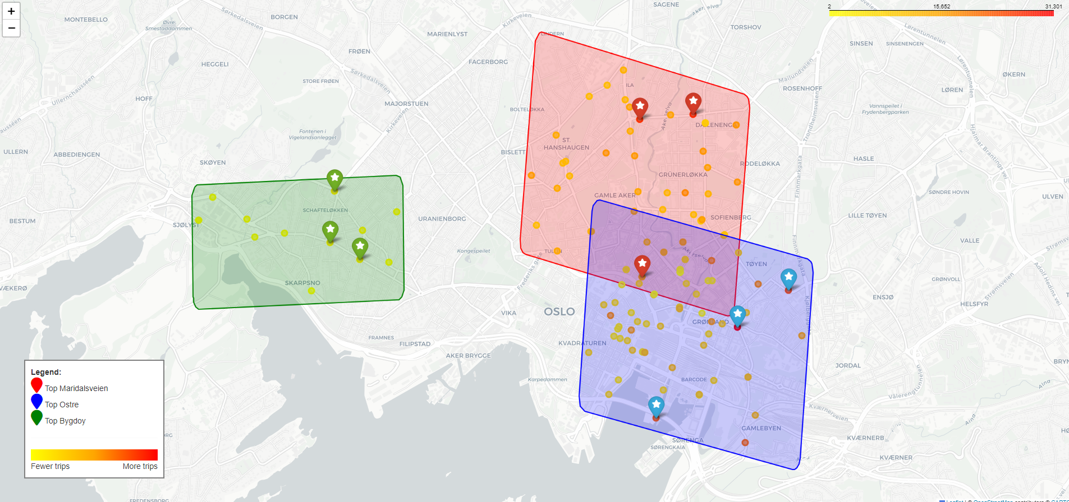

**Map Analysis:**

The map provides a detailed visual representation of bike-sharing station distributions across key areas in Oslo chosen in this report. Each area is highlighted with distinct colors: red for Maridalsveien, blue for Østre, and green for Bygdøy. The colored zones outline the regions with the highest concentrations of bike trips, with Østre clearly standing out as the area with the most significant activity.

In Østre, the top stations—Helga Helgesens plass, Tøyen skole, and Sukkerbiten—record the highest number of trips, marked by the most intense colors on the map. This contrasts sharply with Bygdøy, where bike-sharing activity is notably lower, as shown by the lighter color intensity.

The map also reflects the broader distribution of bike-sharing stations in each area. In Maridalsveien, the stations at Ringnes Park, Alexander Kiellands Plass, and Torggata are the primary hubs, but the volume of trips here is still lower compared to Østre. The gradient color scale, ranging from yellow to red, effectively highlights the variation in bike usage, with red indicating stations with higher trip counts.

This geographic visualization reinforces the earlier analysis by demonstrating that Østre is the focal point for bike-sharing in Oslo, both in terms of the number of stations and the volume of trips.

**Correlation:**

The analysis of the relationship between bike-sharing rides and traffic volume across the three locations (Maridalsveien, Østre and Bygdøy) reveals distinct patterns and correlations that vary by location and season.

The following analysis will refer to overall correlation as the aggregated traffic and bike sharing data for each month.

In **Maridalsveien**, the overall correlation between bike-sharing rides and traffic volume is relatively weak, at 0.28. This suggests a slight positive relationship, where increases in bike-sharing are mildly associated with increases in traffic. Also when the correlation for each year is considered independently the outcome is slightly the same. 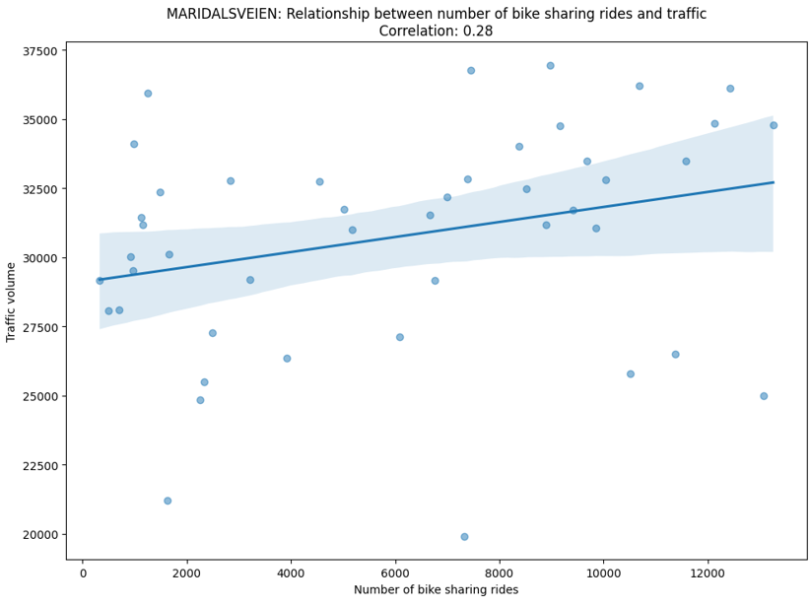

However, the coefficient of determination (R²) is only 0.08, indicating that just 8% of the variation in traffic volume can be explained by the number of bike-sharing rides. This low R² value implies that other factors likely play a more significant role in influencing traffic in this area.

Seasonally, the correlation is much stronger in summer and autumn, with values of 0.60 and 0.71, respectively, suggesting that during these warmer months, the relationship between bike-sharing and traffic is more pronounced. Conversely, in winter and spring, the correlation turns negative, which could reflect the impact of adverse weather on both traffic and bike-sharing usage.

In **Østre** the overall correlation is notably stronger, at 0.57, indicating a moderate positive relationship between bike-sharing and traffic volume. Here, the R² value is 0.33, meaning that 33% of the variation in traffic can be attributed to bike-sharing activity, a much stronger relationship compared to Maridalsveien.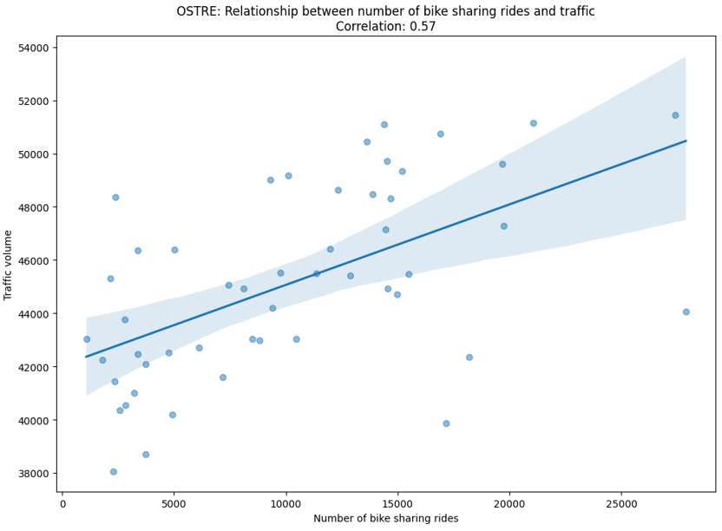

Making a yearly correlation reveals the same: Østre shows a stronger relationship than Maridalsveien.

Seasonal analysis shows that this relationship is particularly strong in autumn (0.84) and summer (0.60), reflecting increased bike-sharing activity's influence on traffic during these times. The weakest correlations are seen in winter and spring, where the connection between bike-sharing and traffic is minimal.

In **Bygdøy Allé** the correlation between bike-sharing and traffic volume is similar to Maridalsveien, with a weak positive relationship of 0.26. But if single year correlations are considered the outcome is slightly different: it’s noticeable that bike-sharing is having a slight impact on reducing the traffic congestion in this area of Oslo. It’s important to note that in 2024 not a lot of data are available yet so the correlation value has to be considered carefully.

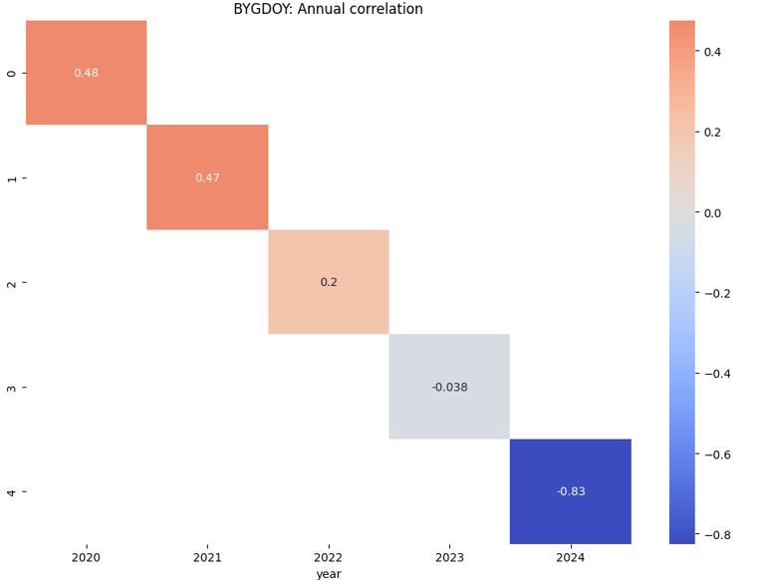

Among the three locations, Østre shows the strongest correlation, suggesting that bike-sharing growth also increases traffic, particularly during certain seasons. In contrast, Maridalsveien and Bygdøy Allé exhibit weaker relationships, but looking at the yearly correlation in Bygdøy Allé it is clear how the bike sharing system is impacting vehicle congestion.

Overall, the analysis highlights that the relationship between bike-sharing and traffic volume varies significantly by location and season. While bike-sharing can influence traffic patterns, particularly in warmer months and in certain areas like Østre, it is not the primary driver of traffic in these regions. Other factors, such as weather, seasonal activities, and external events like the pandemic, likely play more significant roles in shaping traffic volumes.

**Conclusion**

This project evaluated the impact of bike-sharing on traffic congestion in Oslo, a city known for its green initiatives and comprehensive data availability. By analyzing traffic and bike-sharing patterns across three key areas, Bygdøy, Østre, and Maridalsveien, from January 2020 to May 2024, we gained valuable insights into the interaction between bike-sharing and urban traffic.

The analysis shows that bike-sharing is more popular on weekends and holidays, indicating its use for leisure and recreation. However, in congested areas like Østre, both short-term (rush hour) and long-term (seasonal) trends suggest that bike-sharing is also being adopted as a practical commuting alternative, especially during peak traffic hours. Additionally, bike-sharing provided a safer transportation option during the COVID-19 pandemic, reducing the risk of contagion.

The findings also highlight two areas with potential for further improvement. In Bygdøy Allé, where bike-sharing usage is lowest, a negative correlation between traffic volume and bike-sharing suggests that increasing bike-sharing could further reduce traffic. In contrast, Østre, with the highest bike-sharing usage but also rising traffic volumes, would benefit from more docking stations. Given that Østre has the lowest bus usage, enhancing bike-sharing infrastructure could provide a greener transportation option for the area.

Overall, the results indicate that bike-sharing can effectively reduce traffic congestion in Oslo by offering a flexible and sustainable transportation alternative. Its dual role, serving commuters during peak hours and leisure seekers on non-workdays, underscores its versatility and potential to significantly impact urban mobility. These insights support the continued expansion and integration of bike-sharing systems in Oslo's transportation strategy, paving the way for future technological advancements and broader implementation across the city.