GC:

Flight plan felvitele

<http://paparazzi.enac.fr/wiki/GCS>

<http://planner.ardupilot.com/>

kattintással a következő fordulópont

Introduction

The [versatile](http://paparazzi.enac.fr/wiki/GCS_Configuration) Paparazzi Ground Control Station is an operator control unit ground control software for unmanned aircraft. It allows to visualize and control an unmanned aircraft during development and operation, both indoors and outdoors. With a flexible software architecture it supports multiple UA types/autopilot projects. The purpose of the **G**round **C**ontrol **S**tation is real-time monitoring of an UA.

Features

The Paparazzi GroundControlStation is a feature-rich application with fully customizable views, each containing a collection of the most useful interface components for a particular purpose.

* Simultaneous flying **multi UAS** support
* Multi-system support (multiple procotols, multiple autopilots/projects) by writing a IVY Plugin
* 2D Map capable of displaying Google Satellite, OpenStreetMaps Images and Microsoft Satellite Maps
* Mission planning
* **Realtime movable waypoints**
* Realtime flightplan adjustments if needed
* System status overview
* **Realtime** Airframe **in Air tuning** and calibration
* Supports rotary and fixed-wing e.g. Airplanes, helicopters, coaxial and quadrotors
* Definable **Hotkeys** for quick simple in the field control
* **Voice** status output
* Full freely **configurable GUI layout**

Configuration Options

The [GCS is highly configurable](http://paparazzi.enac.fr/wiki/GCS_Configuration) and modules can be added, removed, or resized as needed. In addition to this the GCS has many **command line options** which can be used when launching the GCS   
See the [**GCS configuration**](http://paparazzi.enac.fr/wiki/GCS_Configuration) page for details.

Simulation of Flightplan

Your flight plans can, and should, always be tested prior to a real autonomous flight. Testing end adjusting is possible from within the same GCS. See the [simulation](http://paparazzi.enac.fr/wiki/Simulation) page for details.

Options

Strips

Each A/C has an associated strip that displays information about the A/C and provides buttons for common commands. The strip has the following layout by default. Paparazzi GCS is very flexible and the strip can have more or less buttons according to your configuration.

[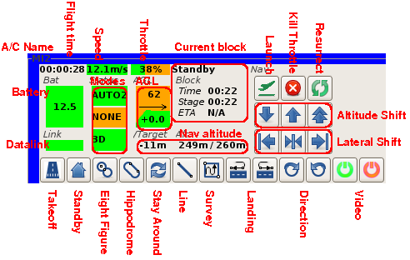](http://paparazzi.enac.fr/wiki/File:Strip.png)

**Displayed information**

* Left: Flight information
* Center: Navigation information
* Right: Navigation control
* Bottom: Custom navigation and setting buttons

**Actions**

Every change in the waypoints (position or/and [altitude](http://paparazzi.enac.fr/wiki/Altitude_definitions)) must be confirmed with the dialog box that appears after the move. A modified waypoint remains animated on the map and the GCS continues to re-send the move request until confirmation is received from the aircraft. When clicked, the **Mark**button places a mark on the map at the A/C position. A snapshot from the video plugin is associated to this mark and can be viewed by moving the mouse over the mark. A click on the mark opens a dialog box allowing to delete the mark. A click on the colored bar at the top selects the corresponding A/C in the [Notebook](http://paparazzi.enac.fr/wiki/GCS#notebook).

Map

[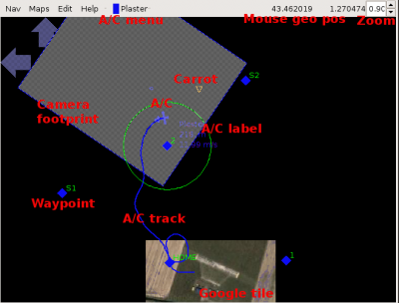](http://paparazzi.enac.fr/wiki/File:GCSmap.png)

[http://paparazzi.enac.fr/w/skins/common/images/magnify-clip.png](http://paparazzi.enac.fr/wiki/File:GCSmap.png)

Sample map showing the various features

**Display**

The map display contains the following information:

* The A/C track: it can be erased *via* the *Clear track* option from the A/C menu.
* The A/C label (in clear blue near the A/C) contains the name of the A/C (Plaster), it's altitude (218 m) and it's ground speed (11.99 m/s). This option default is off. It can be activated with the *A/C label* option from the A/C menu.
* The carrot (the orange triangle). This is the point the A/C is following during autonomous navigation.
* The waypoints defined in the flight plan (blue diamonds).
* The intended trajectory is shown as a green line, in this example a circle around waypoint 2.
* The default background is black. [Maps](http://paparazzi.enac.fr/wiki/Maps) can be loaded to provide navigation reference.
* The camera footprint (the grey polygon) is representative of the swath of land currently seen by the onboard camera. This option default is off. It can be activated with the *Cam footprint* option from the A/C menu. see also[Pan_Tilt_Camera](http://paparazzi.enac.fr/wiki/Pan_Tilt_Camera)
* The WGS84 coordinates of the mouse cursor are displayed at the top right hand corner (43.462019 1.270474).
* A UTM kilometric grid can be added to the background *via* the *UTM grid* option from the *Nav* menu.
* The [height Above Ground Level (AGL)](http://paparazzi.enac.fr/wiki/Altitude_definitions) displays the ground altitude of the mouse near the geographic position in the top right hand corner. The [SRTM](http://srtm.usgs.gov/) option must be enabled in the *Nav* menu and the height data must be downloaded as described [here](http://paparazzi.enac.fr/wiki/Maps#Height_Data).

**Navigation**

You can pan/zoom the map using the following:

* Pan with the blue arrows on the map or use the arrow keys on the keyboard
* zoom in/out with the mouse scroll wheel, the page up/page down buttons or the small up/down buttons at the top right hand corner where the zoom factor is displayed
* fit the map to the window, in order to see all the waypoints and A/C, with the **f** key or the *Fit* option from the *Nav* menu;
* center the map on an A/C with the *Center A/C* option from the corresponding A/C menu.

**Map Photo Tiles**

The default black background can be automatically filled with calibrated satellite photo tiles from Openstreetmaps, Google Maps or MS Maps. Note: If you download too much map data from Google into the GCS you may be blocked for downloading further map data for 24 hours. With OpenStreetmaps data and MS data there is no such limitation.   
See the [Maps](http://paparazzi.enac.fr/wiki/Maps) page for more info.

**Waypoint Editing**

The properties of any waypoint in the currently loaded flight plan can be modified by two methods:

* Drag and drop the waypoints to a new location (a confirmation dialog will appear).
* A single left click on a waypoint opens a dialog box where you can edit the waypoint's coordinates and altitude.

Waypoint edits are sent to the aircraft immediately upon confirmation in the dialog box. The GCS will re-send the data and the waypoint will animate until the aircraft confirms receipt of the move request. New waypoints cannot be added during flight.   
See the [Flight plans](http://paparazzi.enac.fr/wiki/Flight_Plans) and [Flight Plan Editor](http://paparazzi.enac.fr/wiki/Flight_Plan_Editor) pages for more information on waypoints.

Notebook

The notebook frame contains one page for each running aircraft. Each aircraft page is itself divided into subpages displaying telemetry data and giving access to the autopilot tuning parameters.

Note that the colored tabs at the top of this section allow the user to select among multiple aircraft.

**Flight Plan**

[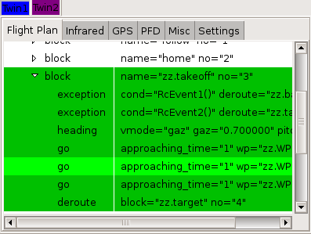](http://paparazzi.enac.fr/wiki/File:GCSfp.png)

The full tree of the flight plan is given in this page. The current block and the current stage are highlighted. A double-click on a block allows the operator to immediately switch navigation to this block.   
See the [Flight plans](http://paparazzi.enac.fr/wiki/Flight_Plans) and [Flight Plan Editor](http://paparazzi.enac.fr/wiki/Flight_Plan_Editor) pages for more information on flight plans.

**Settings**

[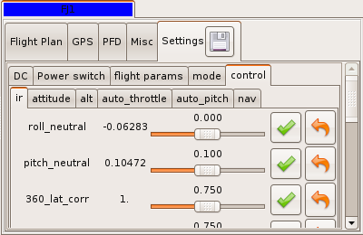](http://paparazzi.enac.fr/wiki/File:GCSsettings.png)

The setting page allows the operator to change variable values during flight. The layout of the page is generated from the dl_settings section of the settings.xml file, one tab is associated to every section and sub-section.

On each line is displayed (from left to right), the name of the variable, its current value (periodically sent by the A/C), a slider or radio buttons for user input, and commit/undo buttons. Also note, clicking on the current value will send a request to obtain the current value from the aircraft.   
See the [Telemetry](http://paparazzi.enac.fr/wiki/Telemetry#Settings) page for more information on settings.   
The save button of this tab opens the following popup which proposes to the user to save the current values in the airframe file (according to the param attribute in the [setttings](http://paparazzi.enac.fr/wiki/Telemetry#Settings) configuration file). The values of the checked rows will be saved in the airframe file (or any other file) for further use. Units (e.g. deg or rad) are taken into account. **It is recommended to backup the airframe file before overwriting it with this utility** (even if time-stamped copy of the airframe file is actually automatically done).

Symetrically, the Upload button of this dialog button will send all the checked values of the airframe file to the live aircraft.

[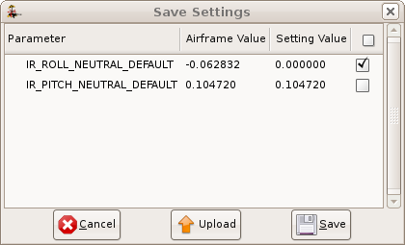](http://paparazzi.enac.fr/wiki/File:Save_settings.png)

**PFD**

[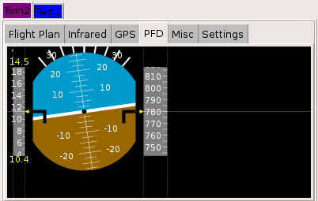](http://paparazzi.enac.fr/wiki/File:GCSpfd.png)

The Primary Flight Display contains an artificial horizon and two scales displaying the current ground speed (left side) and the altitude (right side). Minimum and maximum speeds are shown under and above the speed scale. A click on the scale resets these values to the current speed value.

**GPS, Infrared, Wind**

The **GPS** page gives the list of satellites tracked by the receiver and their respective signal strengths in dB. (35 is low, 45 is excellent) and if they are used to compute the fix (green: used, red:not used). This page may help to tune the position of the receiver on the aircraft relatively to other components (e.g. datalink and video transmitters).

[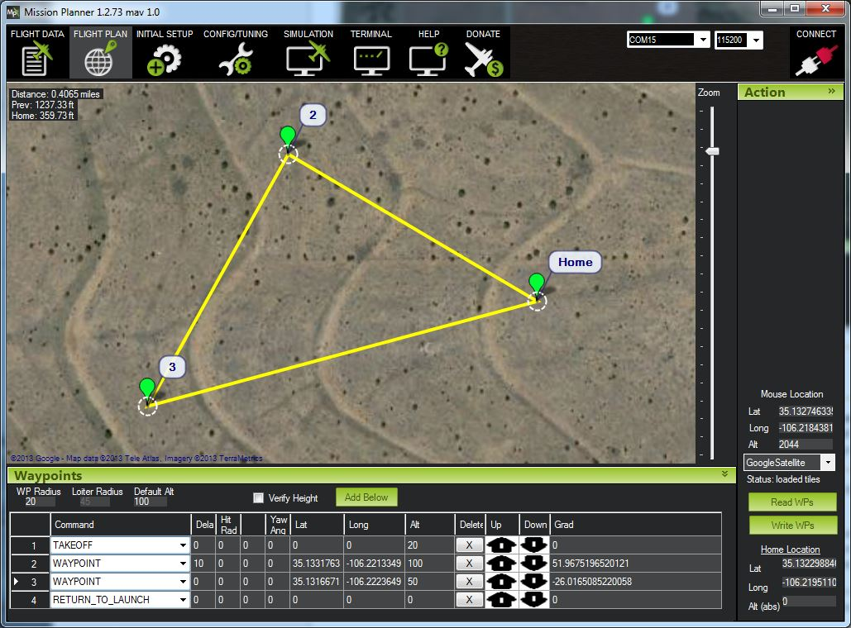](http://planner.ardupilot.com/wp-content/uploads/sites/5/2013/08/MissionPlanning.jpg)

**Basic waypoint commands**

**WAYPOINT**

|  |  |  |  |
| --- | --- | --- | --- |
| Option | Alt | Lat | Lon |
| Delay (seconds) | Altitude (meters) | Latitude | Longitude |

* Mavlink command is NAV_WAYPOINT
* Delay option is triggered after the craft reaches the waypoint radius. The Next command is loaded after the delay.
* Delay time is in seconds, the default is 0

Waypoint Option Bitmask – no yet available in the Mission Planner

|  |  |  |  |
| --- | --- | --- | --- |
| bit 0 | Altitude is stored | 0: Absolute | 1: Relative |
| bit 1 | Change Alt between WP | 0: Gradually | 1: ASAP |
| bit 2 |  |  |  |
| bit 3 | Req.to hit WP.alt to continue | 0: No | 1: Yes |
| bit 4 | Relative to Home | 0: No | 1: Yes |
| bit 5 |  |  |  |
| bit 6 |  |  |  |
| bit 7 | Move to next Command | 0: YES | 1: Loiter until commanded |

**LOITER_UNLIM**

|  |  |  |  |
| --- | --- | --- | --- |
| Option | Alt | Lat | Lon |
| N/A | N/A | N/A | N/A |

* Will cause the craft to begin to Loiter at the current location when the command is invoked.

**LOITER_TIME**

|  |  |  |  |
| --- | --- | --- | --- |
| Option | Alt | Lat | Lon |
| Time in seconds | Altitude (in meters) | Latitude | Longitude |

* Will cause the craft to begin to Loiter at the current location when the command is invoked.
* Optionally give a location to loiter at that wp – The clock starts ticking after the WP is reached.

**LOITER_TURNS**

|  |  |  |  |
| --- | --- | --- | --- |
| Option | Alt | Lat | Lon |
| Number of turns (N x 360°) | N/A | N/A | N/A |

* Will cause the craft to begin to orbit the current location when the command is invoked.

**RETURN_TO_LAUNCH**

|  |  |  |  |
| --- | --- | --- | --- |
| Option | Alt | Lat | Lon |
| N/A | Altitude (meters) | N/A | N/A |

* Will cause the craft to return to the home position set when the craft is armed (requires GPS Lock!)
* If Altitude is 0, craft will return to home at the altitude specified by the Mission Planner

**LAND**

|  |  |  |  |
| --- | --- | --- | --- |
| Option | Alt | Lat | Lon |
| N/A | N/A | N/A | N/A |

* Will cause the craft to land at the current location when the command is invoked.
* If you have Sonar, the craft will stop holding position at 3 meters and drop straight down.
* The motors will not stop on their own, you must exit the AP mode to cut the engines

**TAKEOFF**

|  |  |  |  |
| --- | --- | --- | --- |
| Option | Alt | Lat | Lon |
| N/A | Altitude (meters) | N/A | N/A |

* Will cause the craft to take off and hold position until the altitude is reached.

**CONDITION_DELAY**

|  |  |  |  |
| --- | --- | --- | --- |
| N/A | N/A | Time in Seconds | N/A |

* Will delay the execution of the next conditional command.

**CONDITION_DISTANCE**

|  |  |  |  |
| --- | --- | --- | --- |
| N/A | N/A | Distance (meters) | N/A |

* Will override the next waypoint altitude.
* Useful when used after a delay or distance conditional command

**CONDITION_CHANGE_ALT**

|  |  |  |  |
| --- | --- | --- | --- |
| Option | Alt | Lat | Lon |
| N/A | Altitude (meters) | N/A | N/A |

* Will override the next waypoint altitude.
* Useful when used after a delay or distance conditional command

**CONDITION_YAW**

|  |  |  |  |
| --- | --- | --- | --- |
| Option | Alt | Lat | Lon |
| Direction (1=clockwise, 0=counter) | Relative: amount (degrees), Absolute: ending angle(degrees) | Speed (meters/s) | Relative angle change = 1, Absolute = 0 |

* Fine grain controls of the Yaw

**DO_SET_MODE**

|  |  |  |  |
| --- | --- | --- | --- |
| Option | Alt | Lat | Lon |
|  |  |  |  |

* Not Implemented

**DO_JUMP**

|  |  |  |  |
| --- | --- | --- | --- |
| Option | Alt | Lat | Lon |
| The desired command index |  | # of Jumps |  |

**DO_CHANGE_SPEED**

|  |  |  |  |
| --- | --- | --- | --- |
| Option | Alt | Lat | Lon |
| Speed (in meters/s) |  |  |  |

* Speed change will stick until reboot

**DO_SET_RELAY**

|  |  |  |  |
| --- | --- | --- | --- |
| Option | Alt | Lat | Lon |
| 1 = on, 0 = off, -1 = toggle | N/A | N/A | N/A |

* Toggling the Relay will turn an off relay on and vice versa

**DO_REPEAT_RELAY**

|  |  |  |  |
| --- | --- | --- | --- |
| Option | Alt | Lat | Lon |
| N/A | # of repetitions | cycle time (in seconds) | >N/A |

* Toggling the Relay will turn an off relay on and vice versa

**DO_SET_SERVO**

|  |  |  |  |
| --- | --- | --- | --- |
| Option | Alt | Lat | Lon |
| Servo channel (1-8) | PWM (1000-2000) | N/A | N/A |

**DO_REPEAT_SERVO**

|  |  |  |  |
| --- | --- | --- | --- |
| Option | Alt | Lat | Lon |
| Servo channel (5-8) | PWM (1000-2000) | # of repetitions | cycle time (in seconds) |

**DO_CONTROL_VIDEO**

|  |  |  |  |
| --- | --- | --- | --- |
| Option | Alt | Lat | Lon |
|  |  |  |  |

**DO_SET_ROI**

|  |  |  |  |
| --- | --- | --- | --- |
| Yaw tracking option | ALtitude (in meters) | Latitude | Longitude |

* Setting will persist until reboot
* The location is optional
* The option is a number from 0 to 4
* MAV_ROI_NONE = 0: Yaw will hold it’s current angle
* MAV_ROI_WPNEXT = 1: Yaw will point at next WP
* MAV_ROI_WPINDEX = 2: Yaw will point at the desired WP at the index #
* MAV_ROI_LOCATION = 3: Yaw will point at the indicated location (The location in the command)
* MAV_ROI_TARGET = 4: Not implemented

**Note: When you’re using the Jump command, remember that waypoint logic can be a bit confusing. A waypoint command means “start heading to this WP”, not “wait until you get to this WP.” So, for example, if you put a “Jump to WP1″ command in-between WP4 and WP5, the aircraft will never get to WP5. That’s because once it starts heading in the direction of WP5, it then executes the next command, which is the jump, and that takes priority. So in that instance, if you want the aircraft to hit WP5, you’d create a fake WP6 and issue the Jump command after that.**

**A full guide to MAVLink command and parameter syntax for developers can be found in the Developer section. (Click on Community, select Developer, then look in the table of contents.**

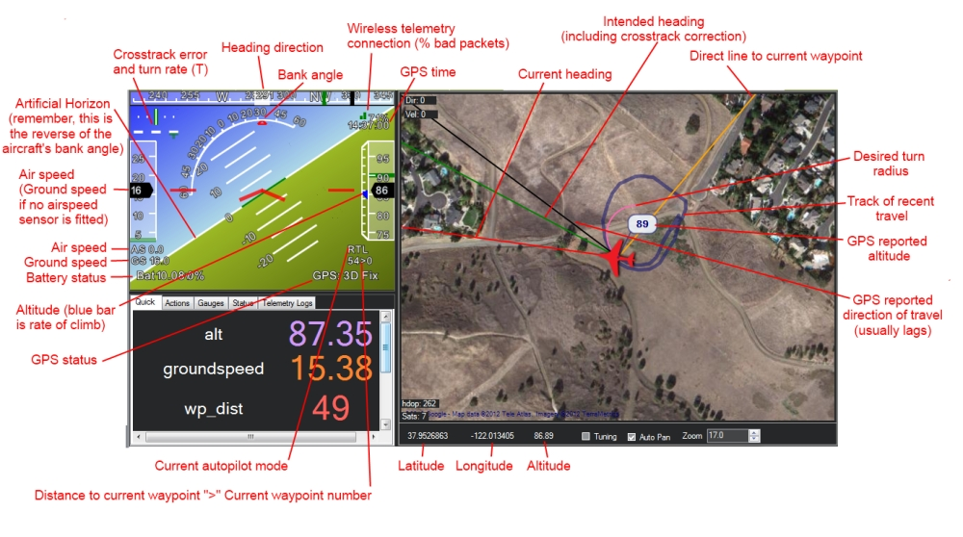  
The above is the main Ground Station view of the Mission Planner, showing the Heads-up Display (HUD). Once you have connected via MAVLink over USB or wireless telemetry the dials and position on this screen will display the telemetry sent by APM.

A few tips:

* The map will only show current position when you have GPS lock or are using a flight simulator
* Remember how artificial horizons work: when the aircraft tilts to the right, the horizon tilts to the left. (Just tilt your head and you’ll see what I mean).
* For APM:Plane status, the output meaning is as follows:
  + “WPDist” : Distance to next waypoint in meters
  + “Bearing ERR”: How far your UAV is from the perfect line to the next waypoint
  + “Alt ERR”: How far your UAV is from the target altitude
  + “WP”: Next waypoint to hit
  + “Mode”: Current autopilot mode.
* “APM:Plane output” means the autopilot’s outputs on the first four channels
* You can issues mode changes and other action commands in the air with the Mission Planner and other GCSs, but note that you must be under autopilot control for them to take effect. When your RC toggle switch is in the Manual position, you are no longer under autopilot control and no commands will take effect. You must be in one of the other positions (Stabilize, Fly-by-Wire, Auto or any other autopilot-controlled mode) for MAVlink commands to take effect.
* You can change the voice used in the speech synthesis in the Ease of Access center in Windows Control Panel. Go to the “Text to Speech” options.
* If you double-click the HUD it will popout, allowing you to run the hud full screen on a second screen.
* If you double-click on the Speed Guage you can modify the max scale you want to display.
* If you enable the Tuning checkbox and double-click tuning you can graph any data that is available in the status tab. This means you can have alt, attitude, or many other options in real time.
* You can use custom imagery instead of Google Maps. Press control-F. This allows you to upload your own orthophotos. Use will require Globalmapper, as this is currently one of the key steps in exporting in the required format for use in the planner.

# error

**ERR (an error message):**

SubSystem and Error codes listed below

1: Main (never used)

2: Radio

ECode 1: “Late Frame” which means the APM’s onboard ppm encoder did not provide an update for at least 2 seconds

ECode 0: error resolved which means the ppm encoder started providing data again

3: Compass

ECode 1: the compass failed to initialise (likely a hardware issue)

ECode 2: failure while trying to read a single value from the compass (probably a hardware issue)

ECode 0: above errors resolved

4: Optical flow

Ecode 1: failed to initialise (likely a hardware issue)

5: Throttle failsafe

ECode 1: throttle dropped below FS_THR_VALUE meaning likely loss of contact between RX/TX

ECode 0: above error resolve meaning RX/TX contact likely restored

6: Battery failsafe

ECode 1: battery voltage dropped below LOW_VOLT or total battery capacity used exceeded BATT_CAPACITY

7: GPS failsafe

ECode 1: GPS lock lost for at least 5 seconds

ECode 0: GPS lock restored

8: GCS (Ground station) failsafe

ECode 1: updates from ground station joystick lost for at least 5 seconds

ECode 0: updates from ground station restored

9: Fence

ECode 1: altitude fence breached

ECode 2: circular fence breached

ECode 3: both altitude and circular fences breached

ECode 0: vehicle is back within the fences

10: Flight Mode

ECode 0 ~ 10: the vehicle was unable to enter the desired flight mode

(0=Stabilize, 1=Acro, 2=AltHold, 3=Auto, 4=Guided, 5=Loiter, 6=RTL, 7=Circle, 8=Position, 9=Land, 10=OF_Loiter)