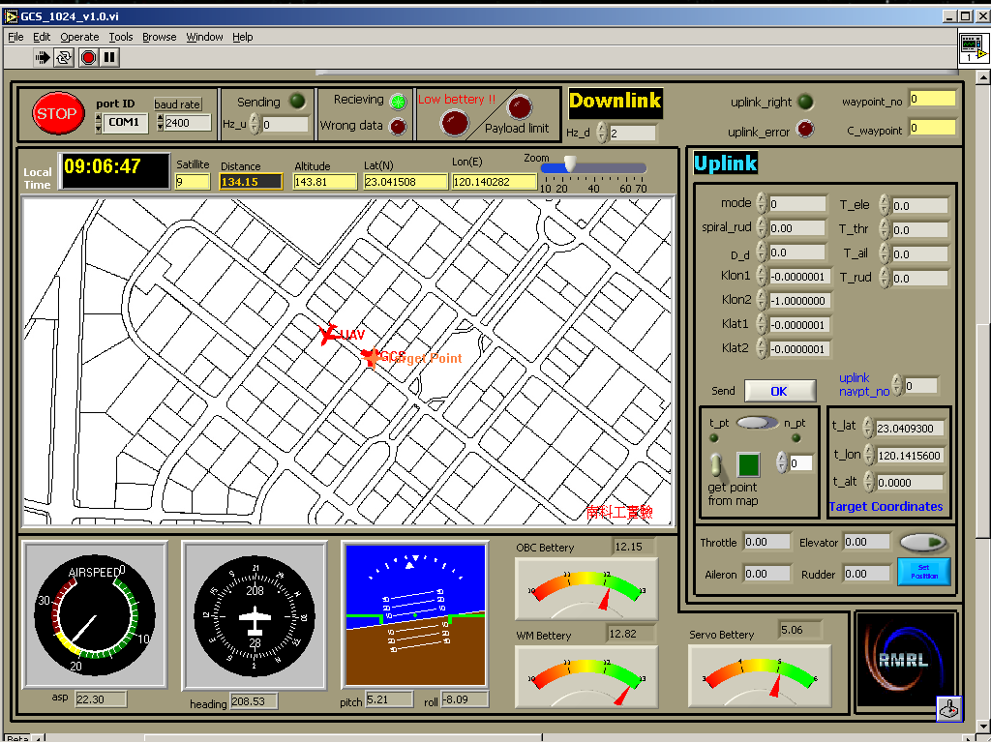

**Institute of Aeronautics & Astronautics, National Cheng Kung University, Tainan 701, Taiwan**

http://api.ning.com/files/ga5AVWy8xTu8cx9rHdzJ73Epc*dzb0uy*UPe0O8wFxogMF6WNRW8StK3x-xzkG2iBk16kNFpYTZe80NgM8kbXOiyxrEwUXIt/GroundControlStation.pdf

http://www.rodiangroup.com/uav-ground-control-station.html

<https://code.google.com/p/ardupilot-mega/wiki/HappyKillmore>

http://www.vikingaero.com/images/WEGCS_RW_DellXT2.jpg

http://www.vikingaero.com/uav_ground_control_station.html