GIF? Or Jiff?
J
GIF
As many of us know, the actual correct way to pronounce GIF according to its creators is with a soft g sound or if spelled out, jiff. But many people still cling to the hard g sounding pronunciation. My question is, does how a person pronounce GIF change at all based on some characteristic factors. To help answer this, I will first try to answer the following three questions…
Does a person’s country or location effect how one pronounces GIF?
Does a person’s gender effect how they pronounce GIF?
Lastly, does age play any role in how one pronounces GIF?
To provide some background information, the data that I will be using to try and answer these questions comes from a 2017 Stack Overflow survey. This dataset included some 64,000 respondents from many different countries and backgrounds. These respondents are generally going to lean more towards the tech oriented side of things and it is unknown how this may alter the results.
To start things off I took a look at the split in pronunciation without filtering. The resulting values I received were roughly 27% of people choosing the soft g method verse about 67% of people use the hard g.
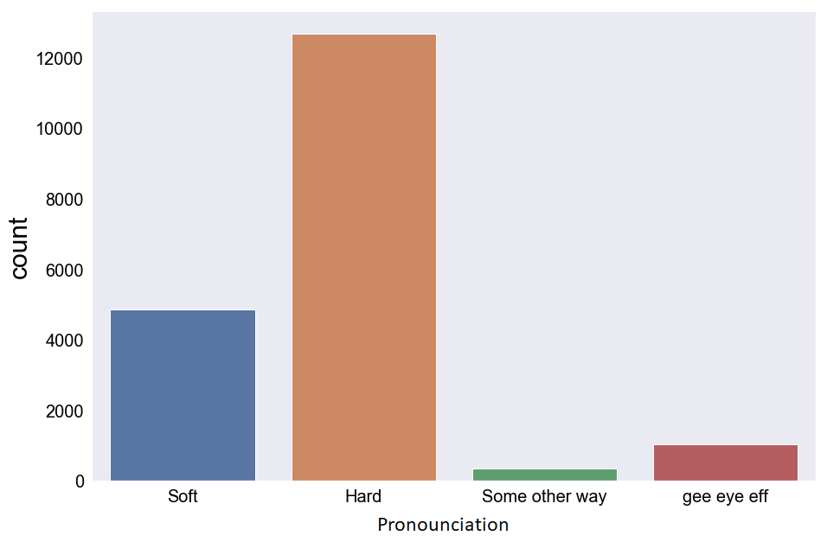
So far this result really just sets a baseline. Now let’s take a look into the results after I was able to break the data down to what country a person is from.
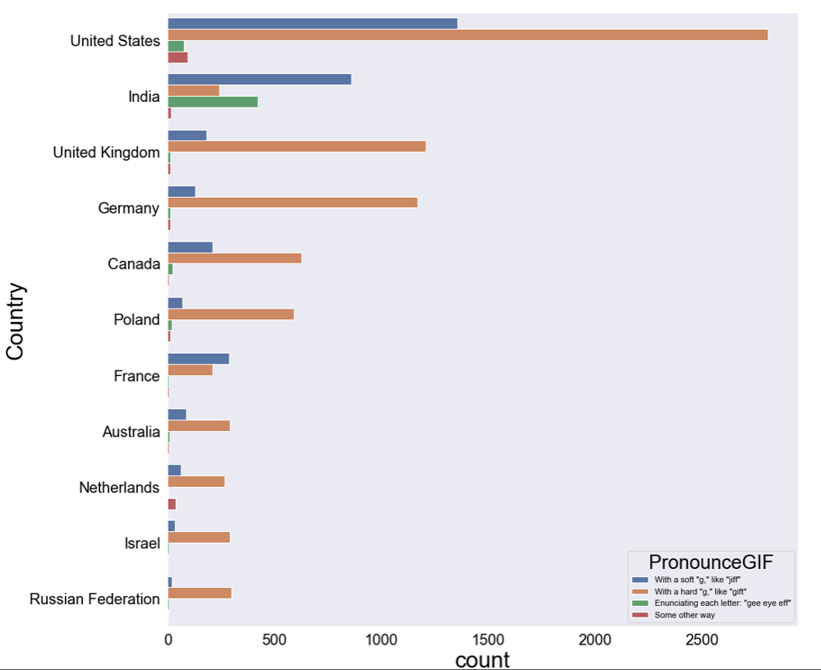
To help manage this data and for the sake of presenting it clearly, I limited the number of countries to be broken down to the countries which responded in the top 11. Below this the number of participants became quite limited so the effect that one or two people had could start to skew the data. To start looking into the results now. It seems clear that India does not adhere to the general pattern that the other countries followed. It seems like many of the respondents from India instead preferred to say each letter individually like G-I-F. Based on the above figure it can also be seen that the people from the United States, India, and France also seem to pronounce the hard g and soft g GIF at a different ratio than the rest of the countries. The rest of the countries were generally using the soft g way about 13% of the time. Whereas the US was at 31%, India was 55%, and France was also 55%. With regard to where a person is from and to whether or not it could influence how they sat GIF. That answer is found to be yes.

Now looking to the second question of whether or not gender plays any sort of role in the pronunciation of GIF.
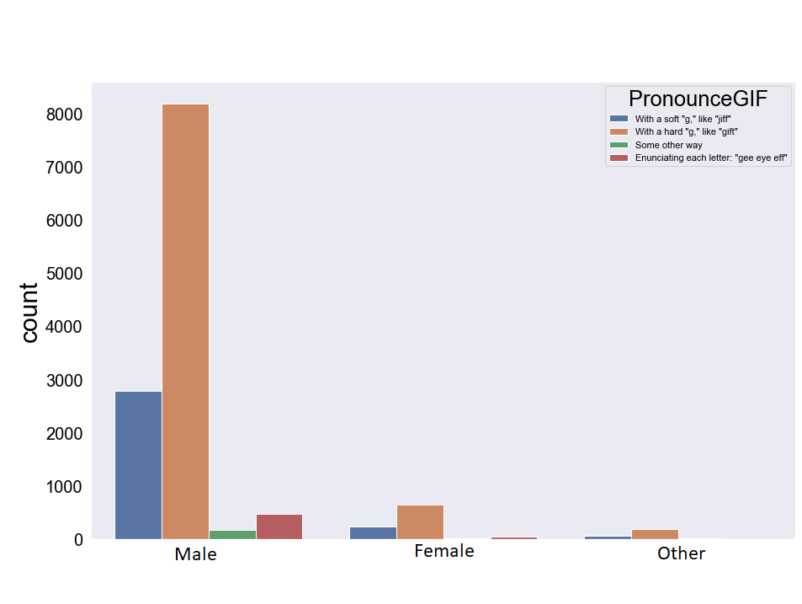
As can be seen from the bar graph above there were considerably more males responding than females in this study so definitive results will be hard to come by. But from the data that is available the following table displays the hard g or soft g sound likelihood.
Gender | Soft ‘g’ sound | Hard ‘g’ sound
Male | 70% | 24%
Female | 66% | 26%
Other | 69% | 24%

So the results appear to indicate that gender does not make any significant impact to how a person pronounces GIF.

As for the last question left to try and answer, there was no exact respondent age distribution so I was forced to use used an approximation based on how many years the person has been in the workforce.
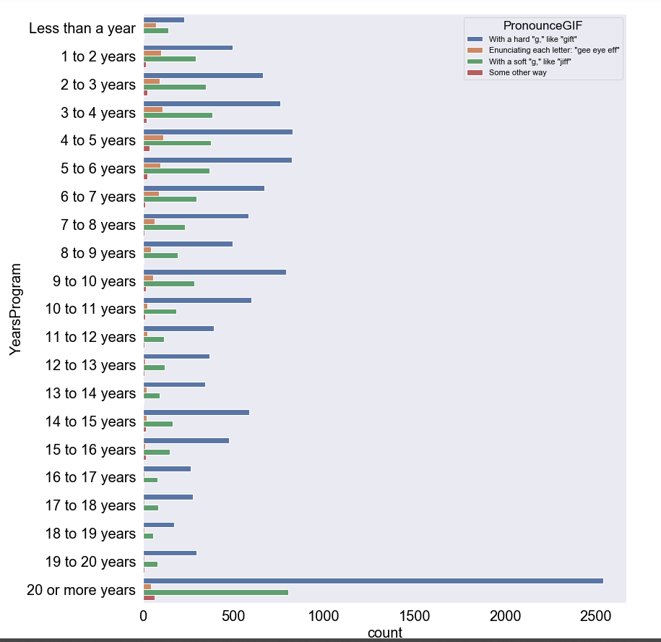
Above you can see the visualization of the results that I had made after breaking down the data. It can be clearly seen that the majority of respondents have 20 years or more of working experience. This data was further broken down into a ratio percentage between soft and hard pronunciation and those results can be found below.
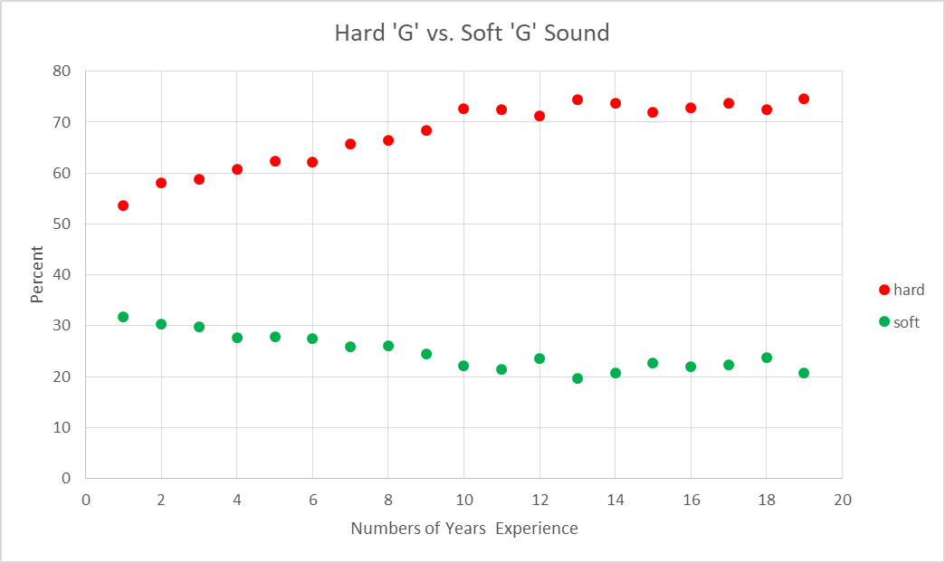
From this dataset it appears that there could be as much as a 20 point swing, from 55% younger to 75% older, with how with likely a person is use the hard g version GIF between a younger person and an older one. Now looking at the soft g version GIF, it appears that there may be up to a 10 point swing from the 32% younger to 21% older generation.
To summarize, the goal of this effort was to try to determine whether or not how a person pronounces GIF differs based on several different factors. From the survey data I was able to find that a person’s location does play a role how they pronounce GIF. The goal was to see if gender played any significant role in the pronunciation and from this data that also appears to only have a minimal effect in how one says GIF. Lastly looked at was roughly the age of an individual and how much of an effect that may play. This factor does appear to have significant enough effect to be used as a predictor for whether a person will use the hard or soft g pronunciation of GIF.

