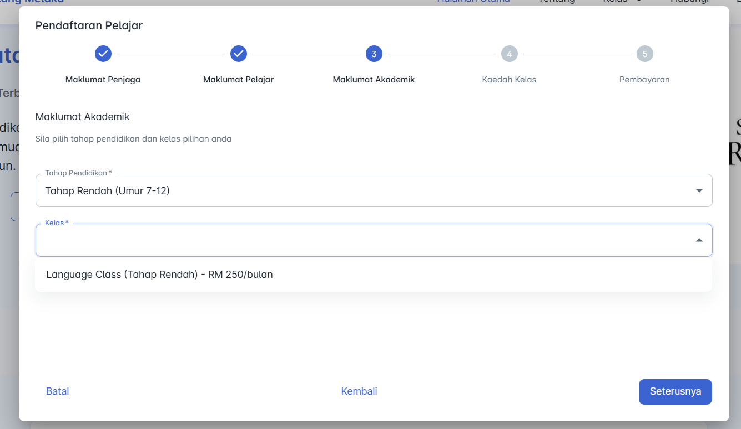
Client Form from Frontend need to have class . Cause wanna know the price to make first payment .

File Directory : icim-portal-element > icims-website > dialogs-form > api.ts
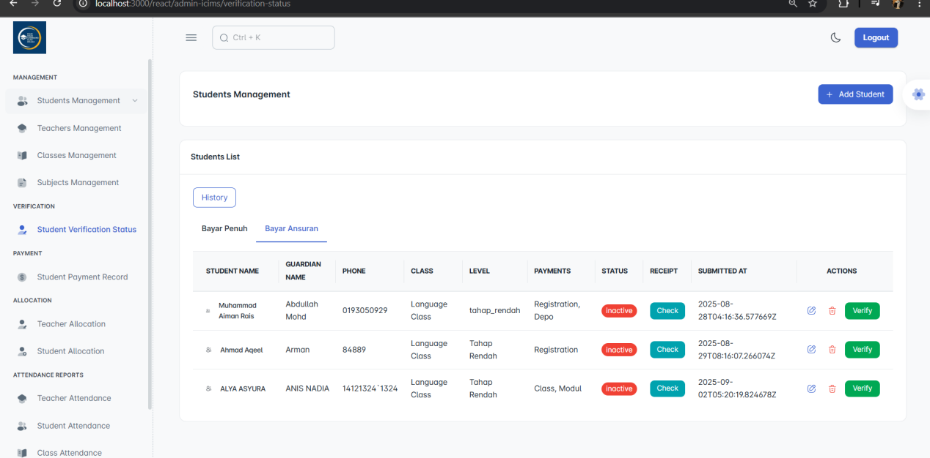
File Directory : icim-portal-element > admin-dashboard >pages >VerificationStatus>api.ts
*example
All the student self-registered will go here . Admin can :
1.Verify (change status to = “active”)
2.View Receipt

2 Tabs in Student Verification Status:
1. Bayar Penuh - if user choose all
2.Bayar Ansuran - if user choose either one .
here . this is just for the first registration. Monthly payment will be fix every month according to Class Price .
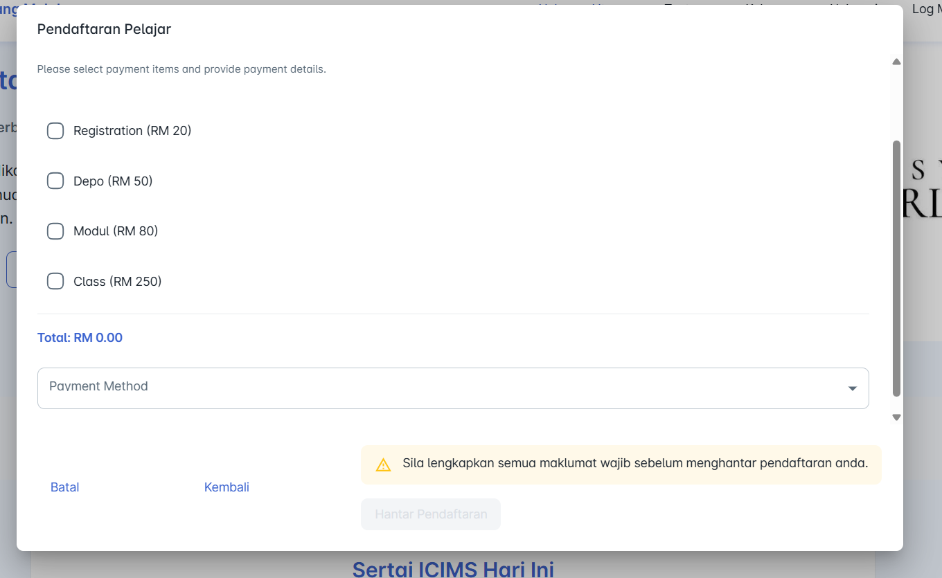

Diagram A

This is for every month payment.
Can add month if cleint pay an advance .
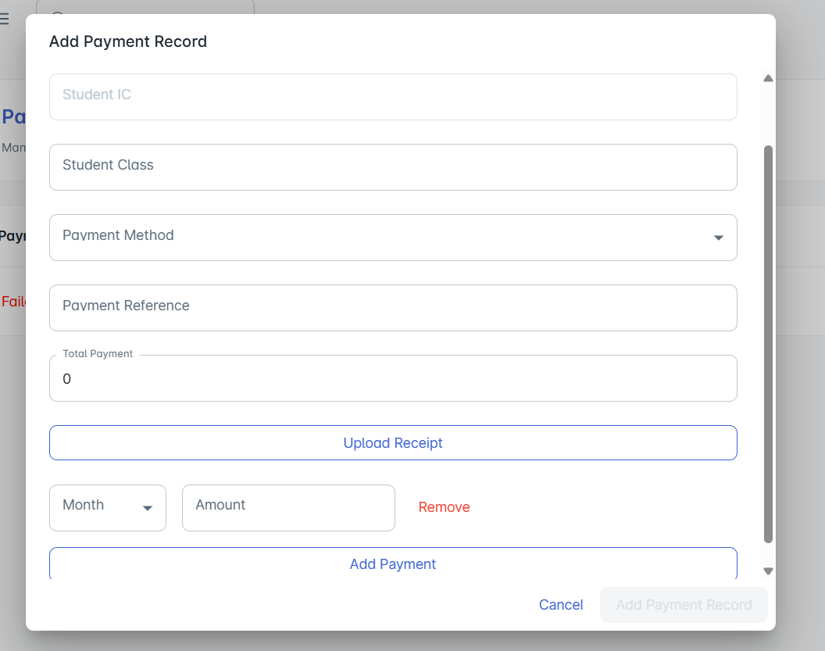
File Directory : icim-portal-element > admin-dashboard >pages >PaymentRecord>api.ts
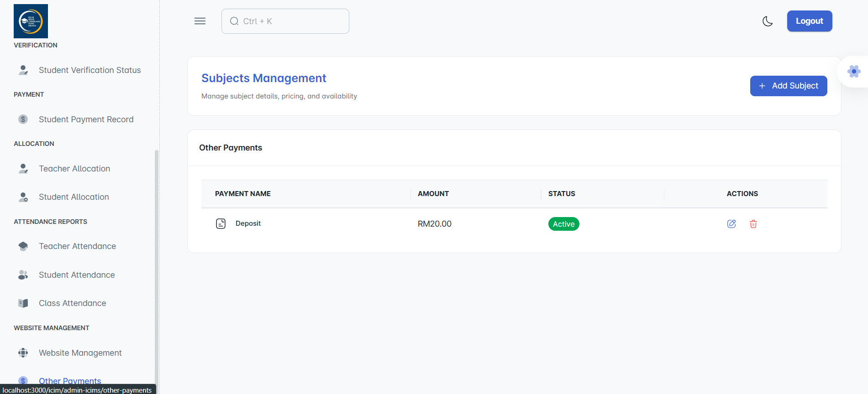
I ave created this to make the FORM CLIENT SIDE dynamic at for choices. Just like shows in diagram A.

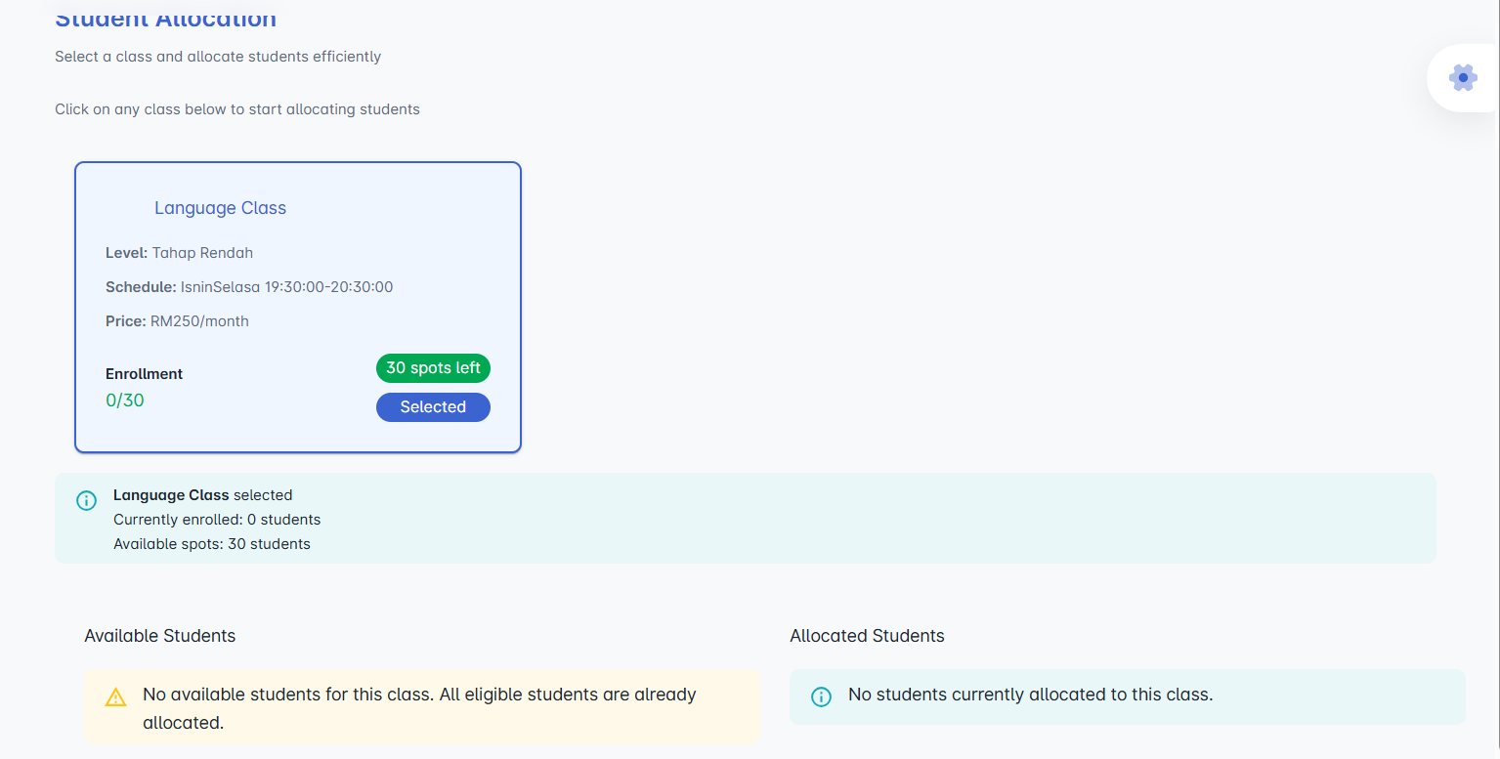

File Directory : icim-portal-element > admin-dashboard >pages >StudentAllocation>api.ts
It should shows the available student. But no . HAHAH
then Im not trying yet to allocate student ..

