Andrew Garzon

Alexandra Meany

ENGL 121

11 April 2021

Seattle is a city that has been experiencing a lot of growth, both in economic opportunity, and in the amount of people experiencing homelessness. The likes of Amazon, Microsoft, Nintendo of America, and other tech companies have contributed to the city’s booming tech economy rife with computer scientists and software engineers, but at the same time, the high demand for jobs and housing has driven up the prices of mortgage and rent to unaffordable levels for many. The average rent for an apartment across Seattle in February 2021 is $1,872, which is a little more than half that of Manhattan Island, averaging around $3,615. Around ten years ago, the average rent in Seattle barely broke a grand. Many couldn’t keep up with the rising rent prices and as such were forced out of their homes. Combine that with the lack of affordable housing, and then you have Seattle’s current homelessness crisis, made worse by the COVID-19 pandemic. Worse yet, Seattle has a bad track record of trying to herd around its population of people experiencing homelessness by making many places inhospitable or otherwise inaccessible for people to set up tents or sleep for the night. The fact that the city even put effort into this gives one an idea of the city’s response to a situation like this. Not only does it make the city inhospitable for people on hard times, it makes the city inhospitable for everyone else, its own residents included.

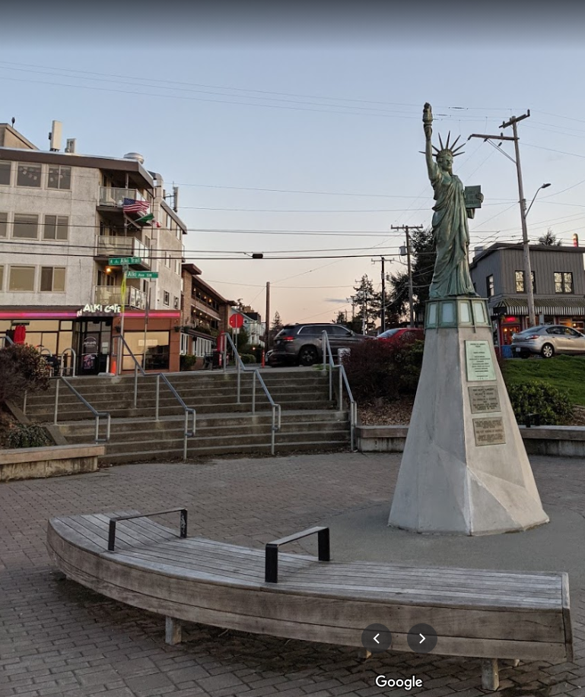

This is a photo of the Statue of Liberty on Alki Beach in Seattle. Notice the bench in the foreground, and the metal armrests on the bench. This reminds me of the Unpleasant Design episode of 99% Invisible, where they brought up how cities are using benches with dividers so as to deter people from sleeping on them. You’d have to be pretty short in order to fit in between those bars, and it makes them a bit uncomfortable should the bench ever be crowded. Especially on a hot summer day, they’ll probably burn you.

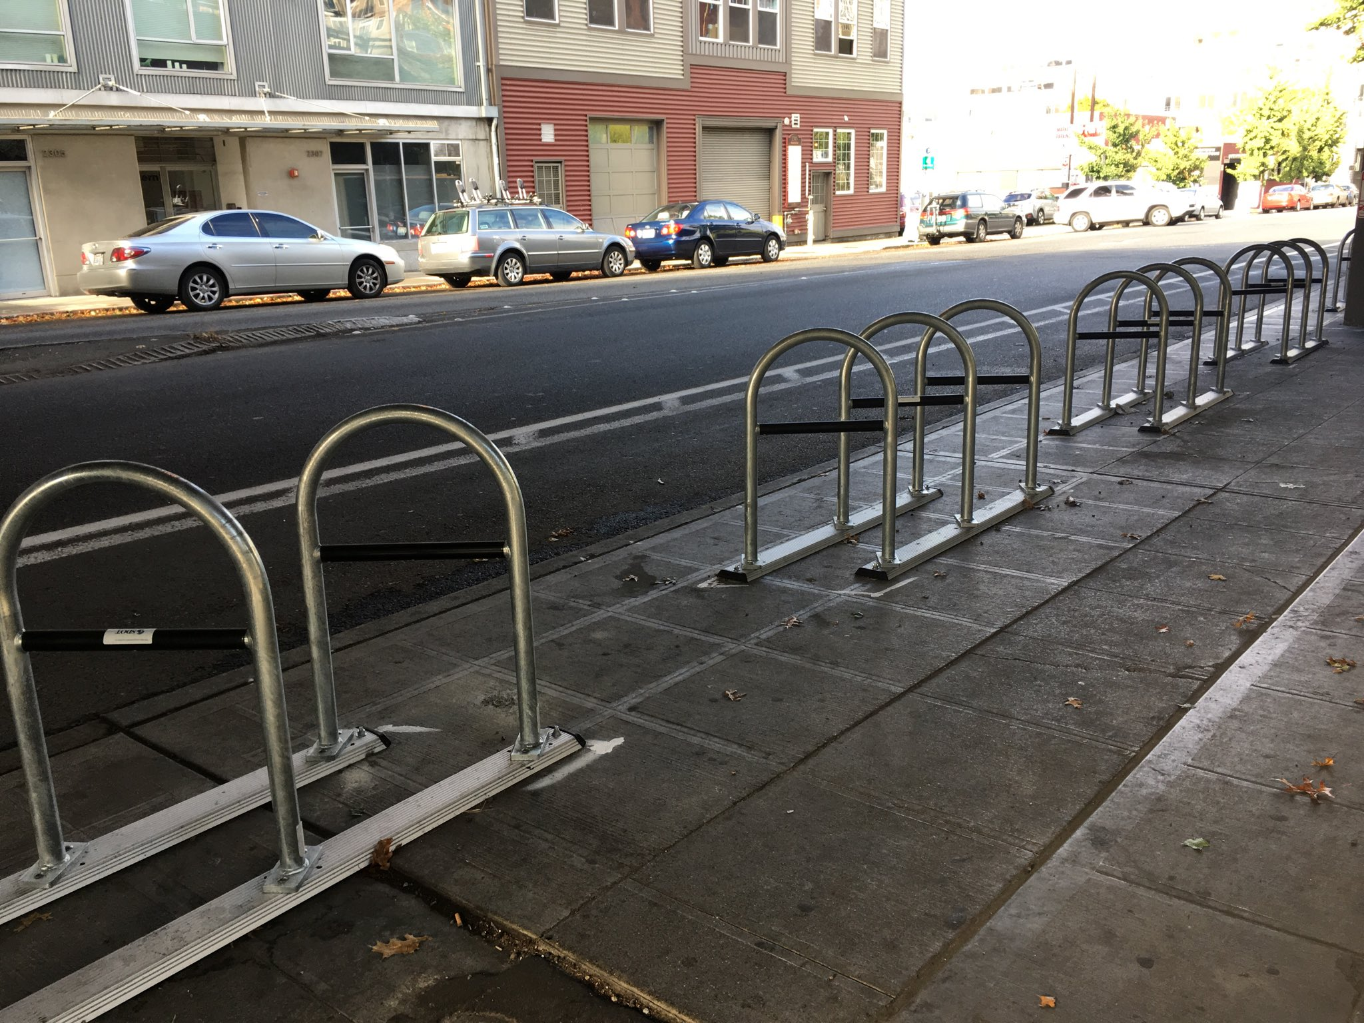

In early 2018, Seattle installed these bike racks underneath a Highway 99 overpass after clearing out a homeless camp there, to deter future camps from forming. Many have criticised the bike racks for being in an unnecessary location where no one would think to park their bikes, added purely to keep people out. Animosity against the Seattle Police Department was already brewing when people saw them clearing out homeless camps, with resentment going into full overdrive after the George Floyd protests in the area. It’s not uncommon to see a sticker saying “Defund SPD” on a street sign in the city, and frankly their funding should go to help those who are homeless, not kick them out of an area.

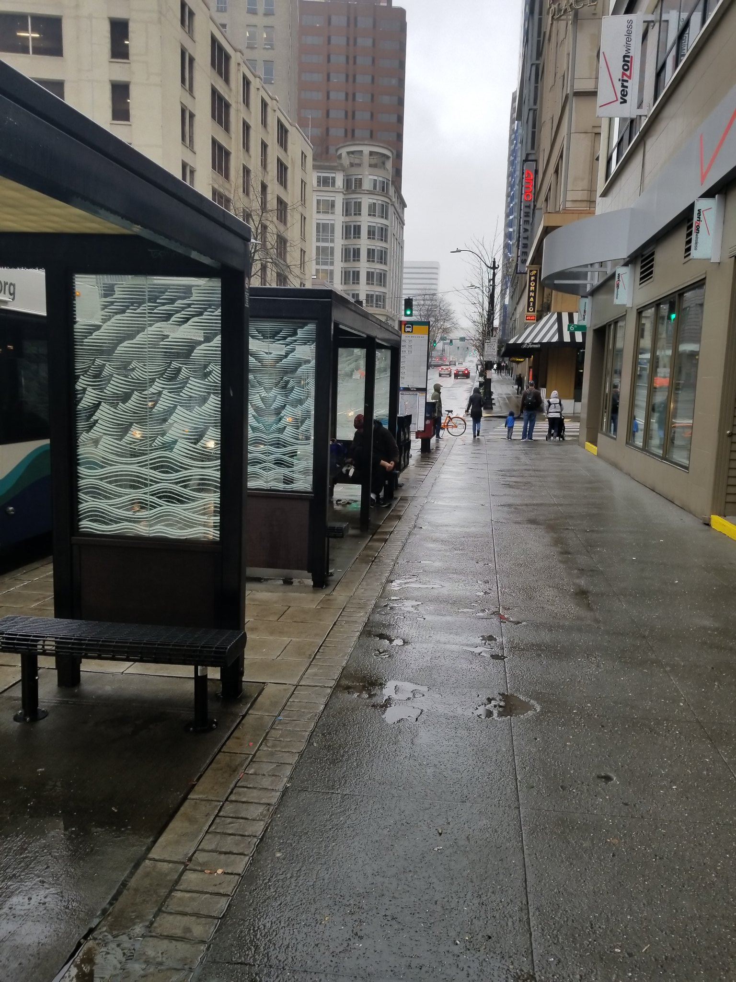

And, probably the most visible and widespread example of hostile architecture in Seattle, the bus stops. The benches are short in height, length, and width, and the covering barely protects one from the weather, much less if it’s raining sideways. Not only would it be uncomfortable for people experiencing homelessness to find shelter here, it makes waiting for the bus pretty unbearable when it rains 9 months out of the year. You don’t really see this outside of Downtown, which really makes you wonder what they were thinking when they designed these.

Only as of recent has the city formed the Unsheltered Outreach Response Team, aimed at solving problems that affect the homeless and getting them into shelters and eventually more permanent housing. This is a good start, but only time will tell if it is effective. In the meantime, the city should own up to its actions and make the place more livable whilst they help individuals one at a time, and they can start by removing anything that makes the city, well, unlivable. Because solving homelessness is a multi-faceted endeavour that can’t be solved in one night.

Works Cited:

“Seattle, WA Rental Market Trends.” *Apartments for Rent – RENTCafé*, www.rentcafe.com/average-rent-market-trends/us/wa/seattle/.

Staff, KIRO 7 News. “New Strategy Plan Tackles Homelessness in Seattle.” *KIRO 7 News Seattle*, KIRO 7 News Seattle, 28 Oct. 2020, www.kiro7.com/news/local/after-scathing-letter-seattle-council-votes-restore-funding-homeless-outreach-team/EYPFHO634ZC6DPNHS7PKPUJSNM/.

“New Anti-Homeless Architecture: Seattle Uses Bike Racks to Block Rough Sleepers.” *The Guardian*, Guardian News and Media, 24 Jan. 2018, www.theguardian.com/cities/2018/jan/24/anti-homeless-architecture-seattle-bike-racks-block-rough-sleepers.

Savransky, Becca. “A Look Back at What Seattle Rents Were like in Your Neighborhood at the Beginning of the Decade.” *Seattlepi.com*, Seattle Post-Intelligencer, 18 Sept. 2020, www.seattlepi.com/realestate/article/A-look-back-at-what-Seattle-rents-were-like-in-14900315.php.

99pi. “Unpleasant Design & Hostile Urban Architecture.” *99% Invisible*, 1 Jan. 1970, 99percentinvisible.org/episode/unpleasant-design-hostile-urban-architecture/.

In this piece I wanted to practise writing persuasive arguments so that I can learn about what to do and what not to do when making a point about a certain topic that you want to convey to a wide audience, in this case, giving my feelings on the homelessness crisis in Seattle, and my opinion on what to do. This hits close to home since I grew up in the Seattle area for more than 15 years and have seen it change over time, and at this point intervention is desperately needed. Something I definitely learnt was making sure to keep my tone of voice firm but respectful, with informality only to serve for emotional effect. I figured I’d open up with an introductory paragraph before writing commentary on a few photos, and then wrapping up with a conclusion. Overall, it served to be a fun and enlightening experience.