Andrew Garzon

Alexandra Meany

ENGL 121

23 May 2021

Wall Street, the Housing Market, and Seattle’s Homeless Situation

The 2008 stock market crash was nasty, to say the least. Trillions of dollars were lost and many banks and other financial institutions closed their doors one fateful day in September when the government declined to guarantee loans for the Lehman Brothers, causing them to file for Chapter 11 bankruptcy, with the effects having lasting ripples still being felt today. Since this economic recession directly affected the housing market, people defaulted on their mortgage payments and foreclosures were a dime a dozen, forcing many people out of their homes with some never to return. It demonstrates how, contrary to what some may believe, homelessness is overwhelmingly no fault of the people who experience it, and that drug abuse and crime aren’t the main catalysts; it’s the work of the economy moving too quickly for them to keep up, a force that is completely out of their control. Hence it is important that for those who bore the full brunt of it, we should build a support system to help them recover after their devastating losses. It was never these peoples’ fault that the great financial recession happened in the first place, and neither is it their fault that they’re still feeling the effects of it. It’s time that we rehabilitate our homeless populations, not only getting them into stable and sustainable housing, but also helping them find reliable jobs and educational opportunities that will enable them to thrive and return to a sense of well-being and prosperity. Not only would it help these people in need, but it would also be of benefit to the rest of us, helping the economy recover after its devastating tumble and making our cities and country better off for everyone.

Traders and stock market analysts react to the 2008 crash. Image Source: The Washington Post

It’s estimated that around 10 million Americans lost their homes due to the Great Recession of 2007-2008, when, following a housing bubble burst in 2006, mortgage delinquencies and an increase in subprime lending led to many financial institutions going bankrupt. The biggest one to close was the Lehman Brothers, which single-handedly caused one of the biggest stock market crashes in history, causing catastrophic damage to the housing market. Foreclosures were up a record of 81 percent in 2008 alone, because people could no longer afford the exorbitant prices of their homes that some already had to go to great lengths to make ends meet. It was awful seeing the aftermath of the crash, with people’s bank accounts being virtually wiped clean since FDIC insurance can only cover so much, 401k portfolios losing a lot of their value overnight, and some having to give up their homes left and right along with almost everything else they had. Many are still broken over what happened more than twelve years ago, and frankly, it should be a priority that we help those hardest hit recover, since they had no control over this and it’s about time they started the healing process. They’ve been waiting for an answer to their problems, and it’s time we ended that wait.

Median home prices in the United States from 1951 to 2020. Note the peak in prices around 2006 and the subsequent dip in 2008. Source: DQYDJ

The near-collapse of the housing market, compounded with the rise in housing and rent prices in Seattle in recent years, have greatly contributed to the homeless crisis the city battles with to this day. It makes for an all-around precarious situation. Seattle has become one of the nation’s (and even the world’s) biggest tech hubs rivaling the likes of Silicon Valley, thanks to it being home to many multinational corporations such as Amazon, Starbucks, Valve, Microsoft, Nintendo of America, and others, and as such people flocking here from all over the world to work for these firms. And where there’s job opportunities, there also needs to be housing to shelter those looking for such jobs, which creates demand for such housing, driving up the housing prices even more after they were already made high following the effects of the housing bubble and market crash. This ended forcing many out onto the streets because they can’t afford to live there anymore, and not everyone has the opportunity to work for such large firms, leading to the present crisis that we have today.

The number of people experiencing homelessness in Seattle is continually growing by the day, as housing in the area becomes more and more unaffordable as we speak. Yet more and more skyscrapers, and the cranes that construct them, pop up on the skyline with only very well-off people being able to afford them. There are more than enough vacant spaces to house Seattle’s population experiencing homeless, yet for some reason they’re not being filled. The city’s reputation is being tarnished due to the lack of coordinated effort to solve the crisis, and there’s an ever growing urgent need for an intervention as soon as possible. It would be best for not only them, but the rest of us as well, to get these people back on their feet and to a status that they can find themselves comfortable with. The question must be asked: Is there anything being done about this?

Homelessness in Seattle. Source: The Seattle Times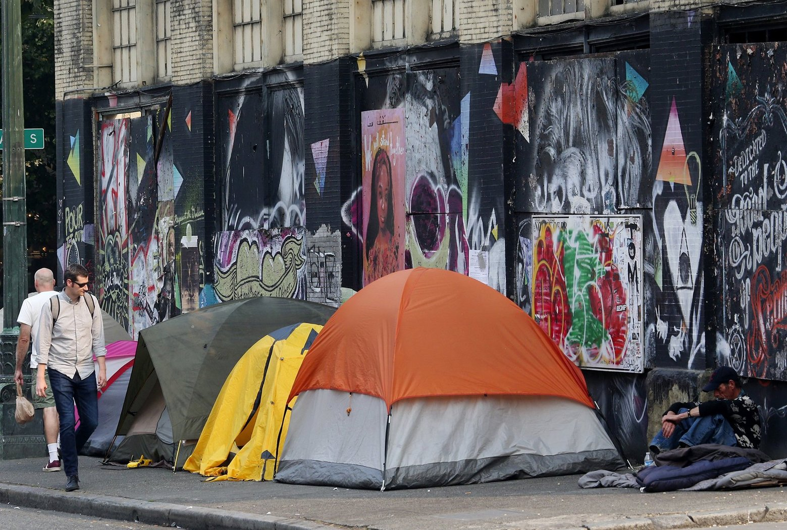

Well fortunately, this is where the likes of the Compass Housing Alliance come in. The Compass Housing Alliance is an organisation based in Seattle that helps people experiencing homelessness find shelter, transitional and affordable housing, and employment. They also have many other services not usually found in programs that assist people experiencing homelessness, such as dedicated showers and laundromats where people can wash both themselves and their clothes, but even banking and valid US street addresses, needed to apply for services that require such. They’ve helped many thousands of people in their hundred-year lifetime, ranging from providing simple refuge for a few days to working with people for many months to get them up on their feet after falling on hard times. Honestly, the program is a godsend and there needs to be more programs like it; there aren’t enough of them that can support the ever-growing population of people experiencing homeless, and without unilateral support from both corporations and city and state governments, it’ll be next to impossible to do so. If we want to solve homelessness, it’s important that the forces which contributed to it acknowledge the problem and work together to correct it.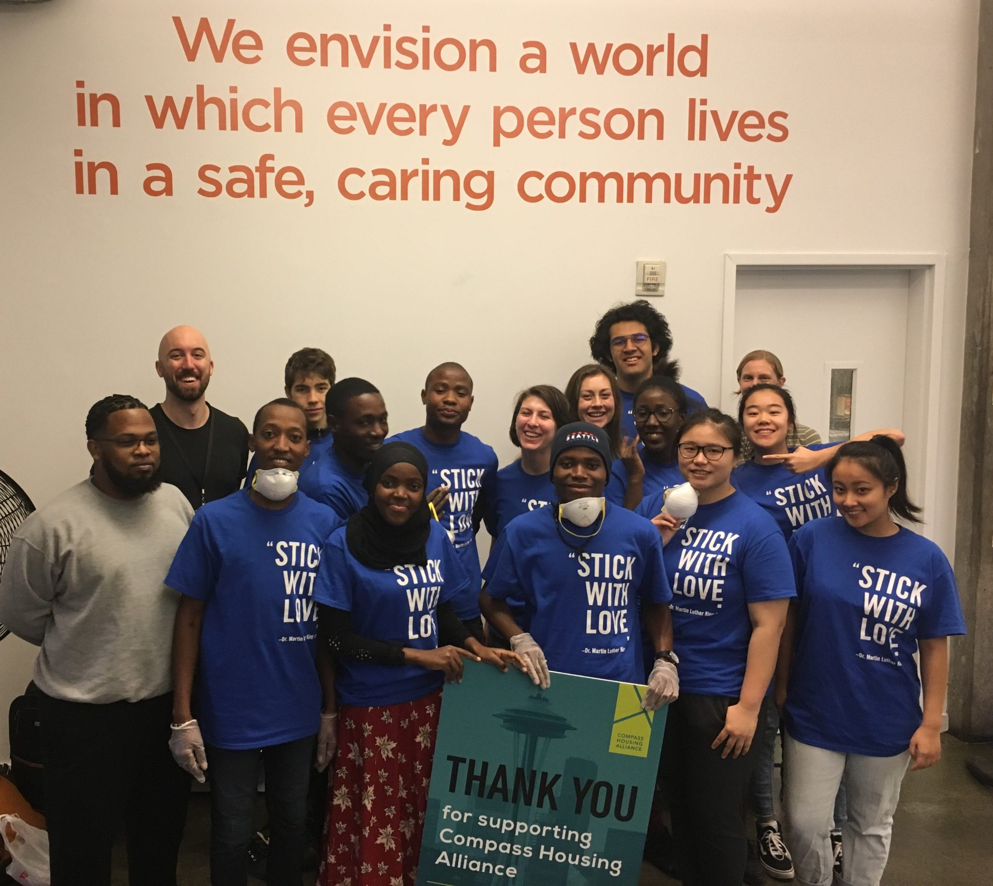

Members of the Compass Housing Alliance in Seattle. Source: Resolution to End Homelessness

The question is, why should we invest in programs like these to begin with? Well for starters, finding employment for the unhoused is a primary goal amongst programs that aid the unhoused, and a rise in employment has a direct impact on the economy; Higher earnings lead to more spending which benefits both local businesses and the utilities they use to keep them running, which causes them to be able to hire more people and circulate more money, keeping businesses open and the economy strong. It also allows more funds and labour to contribute to organisations aimed at assisting those experiencing homelessness, making for a positive feedback loop. Being that the economy is primarily of interest for large corporations and the government, giving aid in helping the unhoused would pay back economic dividends for them. Another incentive for providing permanent housing to the homeless also has benefits on everyone else, in that healthcare costs, emergency room fees, and rates of hospitalisation are decreased, which translates to a lesser cost for taxpayers. It’s great news for everyone all around, for both those who want to see a decrease in the number of people experiencing homelessness and those who want to pay less taxes, especially in a country where having health insurance is a real concern. And one more incentive to build a support system for people experiencing homelessness is just that it’s the right thing to do, regardless of how one looks at it. At the end of the day, people experiencing homelessness are nonetheless just as human as the rest of us, and it’s important that we extend an olive branch to those in need, since they rely on our support to be able to help themselves in the first place. It’s not easy to rebound from homelessness, but with the right people and resources, the transition is made a lot easier than it should be.

As soon as we begin to invest in rehabilitation programs to address our populations of people experiencing homelessness, we’ll see both our cities and economies begin to revitalise, which makes everyone happier and more well-off. With a coordinated effort, the effects of the 2008 crisis will be behind us at an accelerated pace, and we will all reap the benefits of our effort. Organising such a movement will be the hardest part of the entire process, and it will inevitably come with its own set of hurdles. But if we don’t do anything to collectively address the issue at hand and instead let our disagreements get in the way, we’re going to be experiencing the same problems for a longer period of time, and more money and effort will be spent on the same outdated techniques that ultimately solve nothing in the long term, compared to us biting the bullet and trying something new. Homelessness is a multifaceted issue with many nuances that make it difficult to address, but with the right minds, tools, and approach, the effort put into solving it will pay off greatly. It’s time we’ve come together to contribute to a greater cause, and set aside some of our resources we have into being good Samaritans and helping those in need.

Works Cited:

Sorkin, Andrew Ross. “Lehman Files for Bankruptcy; Merrill Is Sold.” *The New York  
 Times*, The New York Times, 14 Sept. 2008.

Shalby, Colleen. “The Financial Crisis Hit 10 Years Ago. For Some, It Feels like  
 Yesterday.” *Los Angeles Times*, Los Angeles Times, 15 Sept. 2018.

Byun, Kathryn J. “The U.S. Housing Bubble and Bust: Impacts on Employment.” *U.S.  
 Bureau of Labor Statistics Latest Numbers*, U.S. Bureau of Labor Statistics, Dec.  
 2010.

Christie, Les. “Foreclosures up a Record 81% in 2008.” *CNNMoney*, Cable News  
 Network, 15 Jan. 2009.

Groover, Heidi. “Seattle-Area Housing Market Is 'on Steroids'; See What's Happening  
 near You.” *The Seattle Times*, The Seattle Times Company, 8 Apr. 2021.

Steele, Mary. “Our 2019 Impact.” *Compass Housing Alliance*, Compass Housing  
 Alliance, Sept. 2020.

Lister, Jonathan. “How Does Hiring Additional Employees Affect the Economy?” *Small  
 Business - Chron.com*, Chron.com, 26 Oct. 2016.

Garrett, Daniel G. “The business case for ending homelessness: having a home improves  
 health, reduces healthcare utilization and costs.” American health & drug benefits  
 vol. 5,1 (2012): 17-9.

Writing this entry was quite an enlightening experience for me. I’ve never done anything like it before, and I’ve learnt a lot in the process. Initially I wrote a rough first draft using the knowledge that I did know, which I then revised as I did my research. I honestly knew nothing about the 2008 market crash before writing this, and even then I still don’t fully understand it, but at least now I have a little more knowledge on how the housing and stock markets work, and how it can be influenced by a bunch of different factors. Initially I wanted to write an academic research paper, but I figured that it would be too formal and stiff to appeal to a wider audience, so I then settled on writing an opinion piece like you’d find in the New York Times or the Wall Street Journal. Initially I didn’t have a very clear or well-defined thesis, and I can thank peer-review for helping point that out. I initially wanted to go in-depth on all the effects of the 2008 crisis, but then I realised I wouldn’t have space to form my argument, so I had to keep it shorter than what I wanted to write. I feel I did a good job in researching evidence for my argument, but believe I could have made my argument a bit more nuanced and explicit, as I feel it’s a bit muted in tone. Then again, I felt it would be best if I kept the mood of my piece formal and diplomatic rather than fierce and colloquial, because I believe one would take me more seriously if I kept it chill and didn’t soapbox. After all, this is supposed to be an opinion piece, and not a speech at a rally. And if I am to write for a broader audience outside the university, I have to make sure I don’t hit a nerve or say something that could be potentially offensive. I believe that if I received a bit more aid in drafting convincing arguments and rhetorical tactics, that I could be a little more bold in my message without going overboard. Oftentimes I doubt my own writing and hold myself to some kind of high standard as if I were writing for some kind of peer-reviewed journal, even though that’s not what I’m doing. And with everything being online this quarter, I feel like I’ve missed out on a lot of useful information that could have been to my benefit. Even with these limitations, I gave it my best effort, and feel pretty proud about what I’ve done here. I hope I’ll be able to write with more confidence in the future, and not just in academic contexts.