**REPORT PROJECT**

Topic: **ROOM RESERVATION**

**Prepared By Group 4**

Đào Phương Nam

Nguyễn Lâm Công Danh

Lê Hoàng Thuận

Trần Công Liêm

**Table Of Contents**

1. **Introduction the project**…………………………

I.1 Introduction………………………………….

I.2. Function…………………………………….

1. **Technology**…………………………………………

II.1. Github………………………………………

II.2. .NET Core………………………………….

1. **Diagram**……………………………………………

III.1 Use case……………………………………

III.1.A Customer…………………………..

III.1.B Admin………………………………

III.2 Class Diagram…………………………….

III.3 User Interface…………………………….

1. **Introduction the project:**
2. Introduction:

- Disadvantage of having to come directly to make a reservation ?, No time?, Especially in the current situation of Covid epidemic? Our team decided to create this product. Our product is a reservation room application. Through this app it is easier to make reservations for customers. No need to come directly. The application's operating rules are as follows: the user must have an account on the app. We will have a home page to give an overview of the product. The user will choose to enter a room. Fill out the necessary information. Next is to choose the service. Select next to proceed to the payment page. And will finally receive a notification of successful booking. This project will consist of 3 parts: introduction to products and features, technology to be used, and schematic modeling.

2. Function:

* Admin:
* Function 1: CRUD Room
* Function 2: CRUD User
* Function 3: Report document
* Function 4: Send bill to customer email
* Function 5: Send message, nofitication to customer
* Customer:
* Function 1: Search
* Function 2: Add to cart
* Function 3: Update Account
* Function 4: Order History
* Function 5: Print bill
* Function 6: Comment
* Function 7: Feedback

1. **Technology:**
2. **Github**

* Github is a system that helps programmers to manage projects and code. In addition, Github also allows clone projects to personal computers, managing the progress of members when participating in the project.
* Feature:
* Follow everyone's project activity.
* View software development progress, projects.
* Manage all projects, code you've uploaded.
* Steps to manipulate with Github on the computer

Step 1:

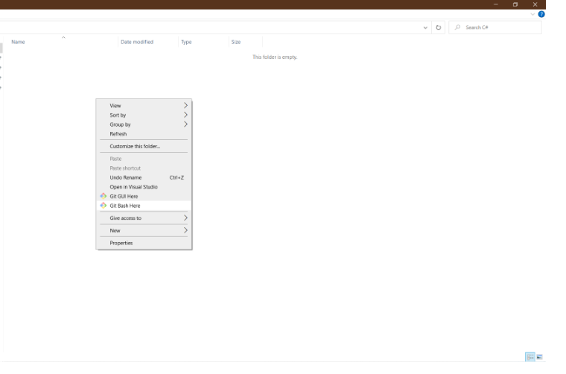

Step 2:

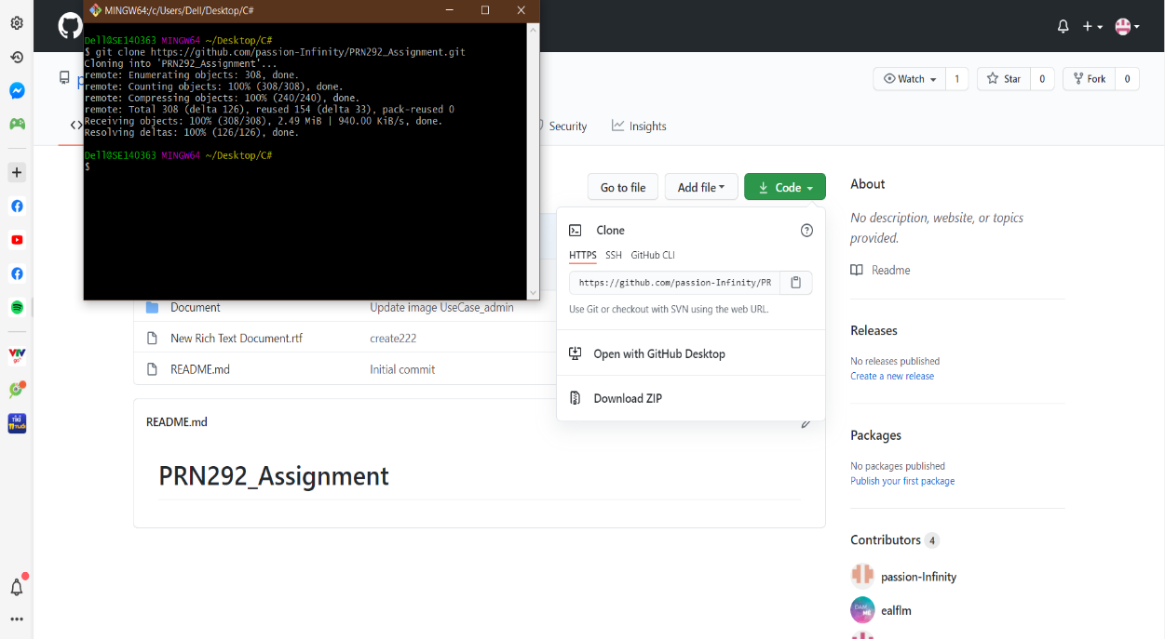

Step 3:

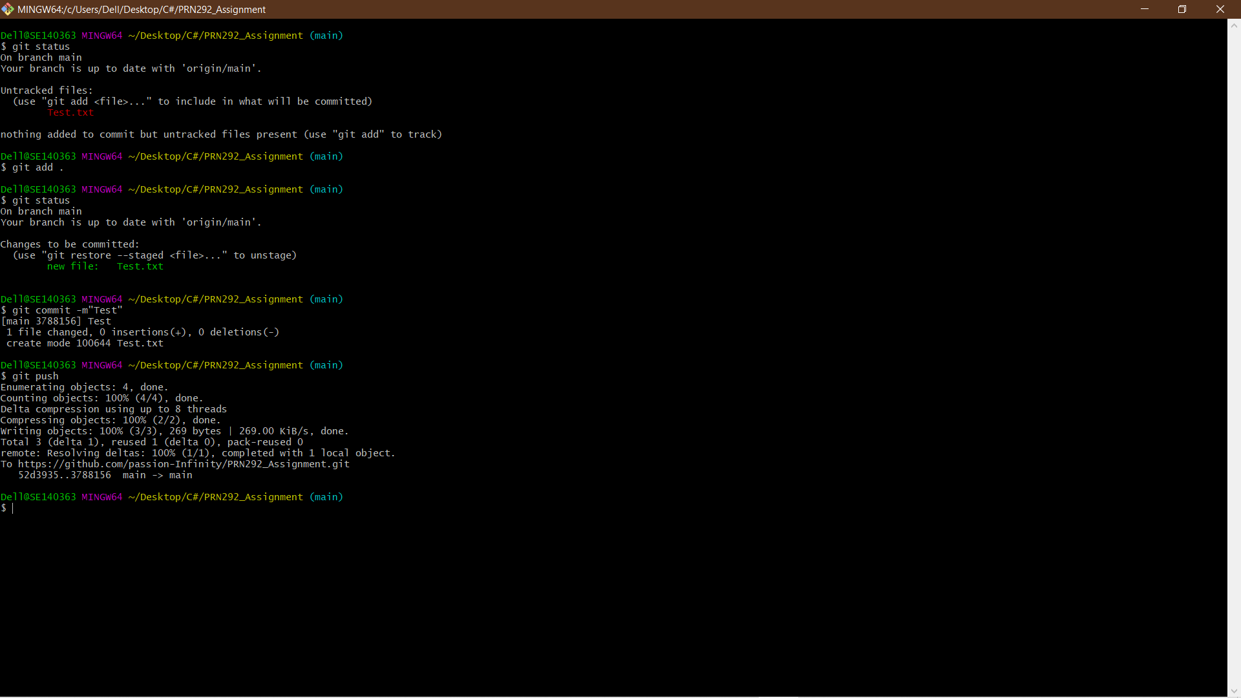

1. .NET Core:
2. Diagram:

III.1/ Use case

III.1.A/ Customer:

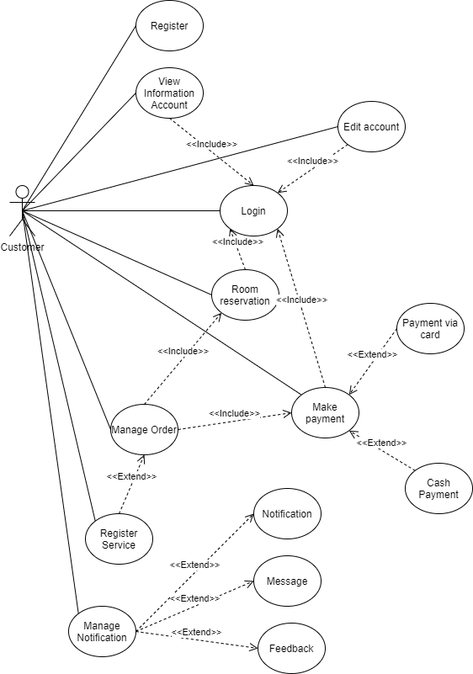

|  |  |
| --- | --- |
| **Usecase** | Register |
| **Short Description** | Register account to become a member of the application. |
| **Pre-Conditions** |  |
| **Post-Conditions** |  |
| **Main flow** | _Guest must provide mandatory information:   * UserID. * Password. * Confirm Password. * Email. * Identity card.   _Guest provides supplementary information: FullName, PhoneNumber, Address  _Guest clicks on Register button.  _System checks the information which guest provided  _System creates new account for guest that registers to this application.  _Guest becomes a member of this application. |
| **Alternative flow(s)** | _If guest clicks on the Reset button, all the field will be reset.  _If the mandatory information that guest provided, is missed or not exactly, system notifys the error. All cases are :   * UserID has existed in Database. * Password is less than 6 characters or more than 30 characters. * Confirm Password and Password are not the same. * Email is invalid or has existed in database. * Identity card has any is digit not a character. * Any fields are blank.   _If the suplementary information that guest provided, is invalid form, system nofitfys the error. All cases are :   * PhoneNumber has any character is not a digit. * Birthday is not along with format “dd/MM/yyyy”.   _System must be inserted the date that guest register to become member.  _If server notifys any error when it’s processing, system must be writen report into Log file. |

|  |  |
| --- | --- |
| **Usecase** | Login |
| **Short Description** | Login application to use any function of member. |
| **Pre-Conditions** | Register |
| **Post-Conditions** |  |
| **Main flow** | _Guest inputs the login information:   * User ID. * Password.   _Guest clicks on the Login button.  _System checks the Login ID and Password.  _If Login ID and Password are valid, system will move member to HomePage.  _ If a wrong password is given thrice in succession, that account will be locked and the customer will not be able to use it. When an invalid password is entered a warning is given to the user that his account is going to get locked. |
| **Alternative flow(s)** | _If guest clicks on “Reset” button, the Login ID field and Password field are blank.  _If Login ID field or Password field is invalid form or blank when guest clicks on the “Login” button, system will notify the error.  _If server notifies any error when it’s processing, system must be writen report into Log file. |

|  |  |
| --- | --- |
| **Usecase** | View Information Account |
| **Short Description** | Show all of member’s information. |
| **Pre-Conditions** | Login |
| **Post-Conditions** |  |
| **Main flow** | _Guest login to this application.  _Members click on the icon (User Information) to show their information in another window.  _Members can see all of their information which they provided here. |
| **Alternative flow(s)** | _If guest have not logined yet, system will comeback the window login then requests user login to continue.  _If account login did not exist, system will comeback the window registration then request user register an account to use the service.  _If any information edit is invalid, system will notify the error.  _If server notifies any error when it’s processing, system must be writen report into Log file. |

|  |  |
| --- | --- |
| **Usecase** | Edit Account |
| **Short Description** | Edit member’s information. |
| **Pre-Conditions** | Login |
| **Post-Conditions** |  |
| **Main flow** | _Guest login to this application.  _Members click on the icon (User Information) to go to another window which show their details and then members can edit their information, and access the private information page.  _Members edit information and save this action.  _System checks this information and saves it on the server.  _System notify report to member. |
| **Alternative flow(s)** | _If any information edit is invalid, system will notify the error.  _If server notifies any error when it’s processing, system must be writen report into Log file. |

|  |  |
| --- | --- |
| **Usecase** | Room reservation |
| **Short Description** | Help users reserve room. |
| **Pre-Conditions** | Login |
| **Post-Conditions** |  |
| **Main flow** | _Guest login to this application.  _Members click on the the icon (Reservation) to start reserve room.  _Members can search the type of room, price, number of people in a room, etc… which they want to reserve.  _Members choose room.  _Members provide information include: FullName, Phone, Email, Identity card of the people who will check in the room.  _Members choose the start date of the reservation.  _Members choose the end date of the reservation.  _System will show the status of the room “Available” or “Unavailable”.  _If status of the room is “Unavailable”, members must choose another room to reserve.  _System will show the max number of people in the room which they were reserved.  _If need, members can check into the checkbox to choose service which we provide for during the time they reserve.  _If members check, System will show the list of service then members can choose service which they want.  _If not check, do nothing.  _System depends on all the information of the room, service, how long members reserve and then show the total.  _If finish, members click on the button “Next”, system will go to another window to review all the order and make payment. |
| **Alternative flow(s)** | _If any information edit is invalid, system will notify the error.  _If server notifies any error when it’s processing, system must be writen report into Log file. |

|  |  |
| --- | --- |
| **Usecase** | Manage Order |
| **Short Description** | Help users review the order and choose payment method. |
| **Pre-Conditions** | Room reservation |
| **Post-Conditions** |  |
| **Main flow** | _Members have finished selecting room.  _Members can choose register service to be served during the time they reserve room (if guest need).  _Member can choose the payment method by Payment Viacard or Cash Payment. |
| **Alternative flow(s)** | _If any information edit is invalid, system will notify the error.  _If server notifies any error when it’s processing, system must be writen report into Log file. |

|  |  |
| --- | --- |
| **Usecase** | Register Service |
| **Short Description** | Help members choose service of the room. |
| **Pre-Conditions** | Room reservation |
| **Post-Conditions** |  |
| **Main flow** | - After choose the room, customer can click to chose the service for room by click icon  - Customer choose necessary services (if need).  - Customer click “Save” icon.  - The system recognizes the customer’s selected items |
| **Alternative flow(s)** |  |

|  |  |
| --- | --- |
| **Usecase** | Manage Notification |
| **Short Description** | Help members contact with application or administrator. |
| **Pre-Conditions** | Room reservation |
| **Post-Conditions** |  |
| **Main flow** | _System provides 3 main ways for members to interact with the system and admin.  _Notification: This window page contains manually updating information.  _Message: This tool allows members contracting online with admin.  _Feedback: This sector collecting member’s respones about system, services, errors, … helping admin upgrades quality. |
| **Alternative flow(s)** | _If any information edit is invalid, system will notify the error.  _If server notifies any error when it’s processing, system must be writen report into Log file. |

|  |  |
| --- | --- |
| **Usecase** | Notification |
| **Short Description** | Showing updating information. |
| **Pre-Conditions** |  |
| **Post-Conditions** |  |
| **Main flow** | _When members click to the Notification link.  _System will transfer to a new page that contains detail information and news. |
| **Alternative flow(s)** | _If any information edit is invalid, system will notify the error.  _If server notifies any error when it’s processing, system must be writen report into Log file. |

|  |  |
| --- | --- |
| **Usecase** | Message |
| **Short Description** | Communicating tool betweem members and admin. |
| **Pre-Conditions** |  |
| **Post-Conditions** |  |
| **Main flow** | _When members want to interact with admin, they need to input content.  _Members then click the “Send” button.  _ System collects request then delivers the message to the admin’s message box.  _ There will be a system’s notification for members when message was sent. |
| **Alternative flow(s)** | _If any information edit is invalid, system will notify the error.  _If server notifies any error when it’s processing, system must be writen report into Log file. |

|  |  |
| --- | --- |
| **Usecase** | Feedback |
| **Short Description** | Collecting feedback about room reservation. |
| **Pre-Conditions** |  |
| **Post-Conditions** |  |
| **Main flow** | _Members give comments and feedback about room reservation.  _Members then click the “Send” button.  _System identify content and show on feedback table. |
| **Alternative flow(s)** | _If any information edit is invalid, system will notify the error.  _If server notifies any error when it’s processing, system must be writen report into Log file. |

III.1.B/ Admin:

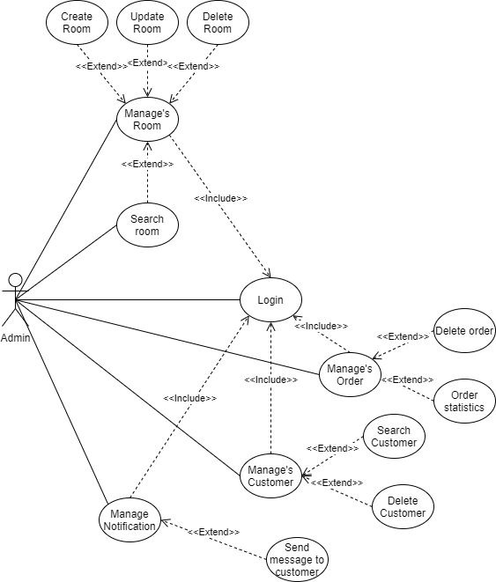

III.2 Class Diagram

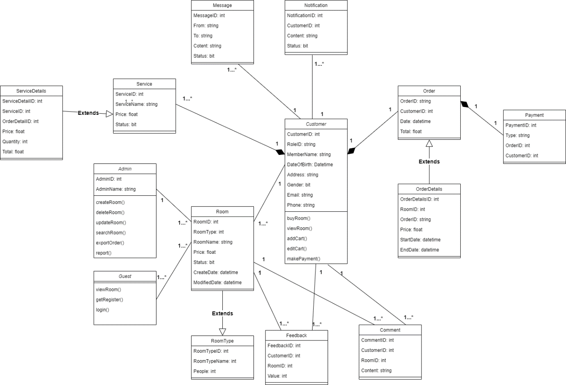

**III.3 User Interface**

**III.3.1 Admin**

III.3.1.1 Home Page

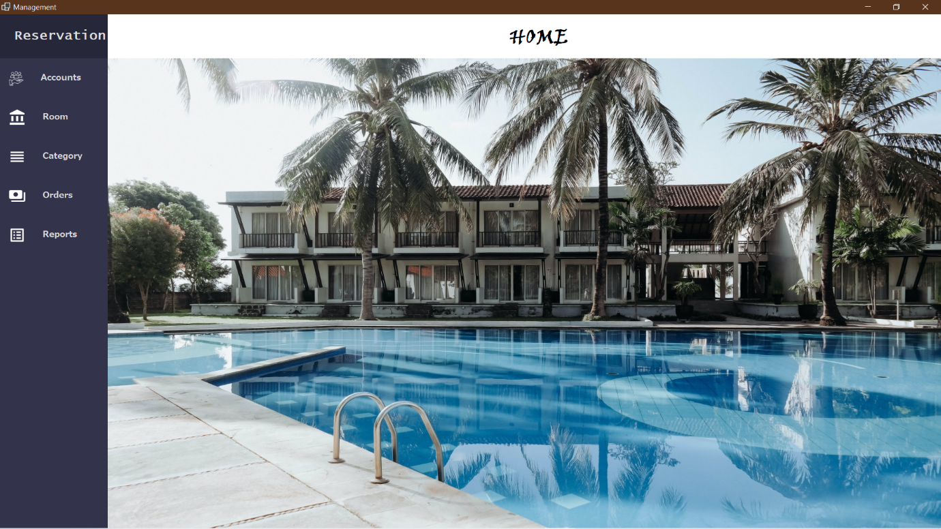

|  |  |  |  |  |  |
| --- | --- | --- | --- | --- | --- |
| **Name** | **Type** | **Event** | **Validation** | **Description** | **Status** |
| Account | Button | Click |  | Manage customer |  |
| Room | Button | Click |  | Manage room |  |
| Category | Button | Click |  | Manage Category |  |
| Order | Button | Click |  | Manage Room |  |
| Report | Button | Click |  | Manage Report |  |
| Reservation | Label |  |  | Show information |  |
| Home | Label |  |  | Show information |  |
| Image | Panel |  |  | Show image for home page |  |

III.3.1.1 Account

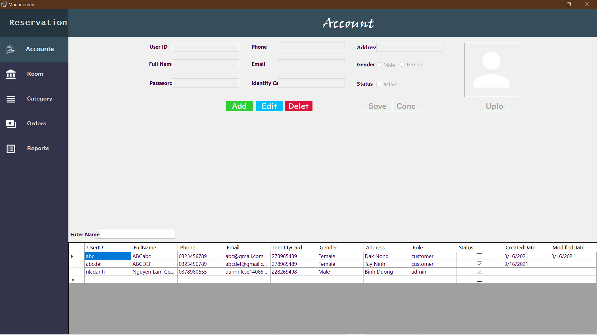

|  |  |  |  |  |  |
| --- | --- | --- | --- | --- | --- |
| **Name** | **Type** | **Event** | **Validation** | **Description** | **Status** |
| UserID | Textbox |  | String, not null | Input Customer’s UserID |  |
| FullName | Textbox |  | String, not null | Input Customer’s FullName |  |
| Password | Textbox |  | String, not null | Input Customer’s Password |  |
| Phone | Textbox |  | String, not null | Input Customer’s Phone |  |
| Email | Textbox |  | String, not null | Input Customer’s Email |  |
| Identify Card | Textbox |  | String, not null | Input Customer’s Indentify Card |  |
| Address | Textbox |  | String, not null | Input Customer’s Address |  |
| Gender(Male) | Radio Button |  | Click | Select Customer’s Gender |  |
| Gender(Female) | Radio Button |  | Click | Input Customer’s Gender |  |
| Status | CheckBox |  | Select | Input Customer’s Status |  |
| Enter name | Textbox |  | String, not null | Input Customer’s Name to Search |  |
| Add | Button | Click | Click | Add customer to the data |  |
| Edit | Button | Click | Click | Edit customer to the data |  |
| Delete | Button | Click | Click | Delete Customer’s from the database |  |
| Save | Button | Click | Click | Save any change in this form |  |
| Cancel | Button | Click | Click | Cancel the task |  |
| Upload | Button | Click | Click | Upload the image to Picture |  |
| Table | DataGirdView |  |  | Display data to Customer |  |
| Picture | PictureBox |  |  | Display Image |  |

III.3.1.3 Room

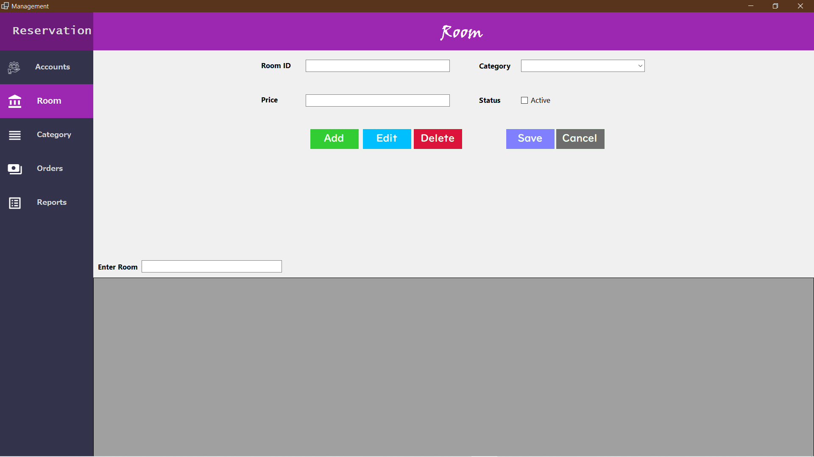

|  |  |  |  |  |  |
| --- | --- | --- | --- | --- | --- |
| **Name** | **Type** | **Event** | **Validation** | **Description** | **Status** |
| RoomID | Textbox |  | String, not null | Input RoomID |  |
| Category | ComboBox |  | Not null | Select Category for Room |  |
| Price | Textbox |  | Float, not null | Input Price for Room |  |
| Status | Checkbox |  | Boolean, not null | Choose Status (Active or not) |  |
| Add | Button | Click | Click | Add room to the data |  |
| Edit | Button | Click | Click | Edit room to the data |  |
| Delete | Button | Click | Click | Delete Room from the database |  |
| Save | Button | Click | Click | Save any change in this form |  |
| Cancel | Button | Click | Click | Cancel the task |  |
| Enter name | Textbox |  | String, not null | Input Room Name to Search |  |
| Table | DataGirdView |  |  | Display data |  |