|  |  |
| --- | --- |
| **Usecase** | Register |
| **Short Description** | Registering account to become a member of the application. |
| **Pre-Conditions** |  |
| **Post-Conditions** |  |
| **Main flow** | _Guest must provide mandatory information:   * UserID. * Password. * Confirm Password. * Email. * Identity card.   _Guest provides supplementary information: FullName, PhoneNumber, Address  _Guest clicks on Register button.  _System checks the information which guest provided  _System creates new account for guest that registers to this application.  _Guest becomes a member of this application. |
| **Alternative flow(s)** | _If guest clicks on the Reset button, all the field will be reset.  _If the mandatory information that guest provided, is missed or not exactly, system notifys the error. All cases are :   * UserID has existed in Database. * Password is less than 6 characters or more than 30 characters. * Confirm Password and Password are not the same. * Email is invalid or has existed in database. * Identity card has any is digit not a character. * Any fields are blank.   _If the suplementary information that guest provided, is invalid form, system nofitfys the error. All cases are :   * PhoneNumber has any character is not a digit. * Birthday is not along with format “dd/MM/yyyy”.   _System must be inserted the date that guest register to become member.  _If server notifys any error when it’s processing, system must be writen report into Log file. |

|  |  |
| --- | --- |
| **Usecase** | Login |
| **Short Description** | Login application to use any function of member. |
| **Pre-Conditions** | Register |
| **Post-Conditions** |  |
| **Main flow** | _ Inputs the login information:   * User ID. * Password.   _Guest clicks on the Login button.  _System checks the Login ID and Password.  _If Login ID and Password are valid, system will move member to HomePage.  _ If a wrong password is given thrice in succession, that account will be locked and the customer will not be able to use it. When an invalid password is entered a warning is given to the user that his account is going to get locked. |
| **Alternative flow(s)** | _If guest clicks on “Reset” button, the Login ID field and Password field are blank.  _If Login ID field or Password field is invalid form or blank when guest clicks on the “Login” button, system will notify the error.  _If server notifies any error when it’s processing, system must be writen report into Log file. |

_System will show the total price for the their reservation.

|  |  |
| --- | --- |
| **Usecase** | View Information Account |
| **Short Description** | Showing all of member’s information. |
| **Pre-Conditions** | Login |
| **Post-Conditions** |  |
| **Main flow** | _Guest login to this application.  _Members click on the icon (User Information) to show their information in another window.  _Members can see all of their information which they provided here. |
| **Alternative flow(s)** | _If guest have not logined yet, system will comeback the window login then requests user login to continue.  _If account login did not exist, system will comeback the window registration then request user register an account to use the service.  _If any information edit is invalid, system will notify the error.  _If server notifies any error when it’s processing, system must be writen report into Log file. |

|  |  |
| --- | --- |
| **Usecase** | Edit Account |
| **Short Description** | Editing member’s information. |
| **Pre-Conditions** | Login |
| **Post-Conditions** |  |
| **Main flow** | _Guest login to this application.  _Members click on the icon (User Information) to go to another window which show their details and then members can edit their information, and access the private information page.  _Members edit information and save this action.  _System checks this information and saves it on the server.  _System notify report to member. |
| **Alternative flow(s)** | _If any information edit is invalid, system will notify the error.  _If server notifies any error when it’s processing, system must be writen report into Log file. |

|  |  |
| --- | --- |
| **Usecase** | Room reservation |
| **Short Description** | Helping users reserve room. |
| **Pre-Conditions** | Login |
| **Post-Conditions** |  |
| **Main flow** | _Guest login to this application.  _Members click on the the icon (Reservation) to start reserve room.  _Members can search the type of room, price, number of people in a room, etc… which they want to reserve.  _Members choose room.  _Members provide information include: FullName, Phone, Email, Identity card of the people who will check in the room.  _Members choose the start date of the reservation.  _Members choose the end date of the reservation.  _System will show the status of the room “Available” or “Unavailable”.  _If status of the room is “Unavailable”, members must choose another room to reserve.  _System will show the max number of people in the room which they were reserved.  _If need, members can check into the checkbox to choose service which we provide for during the time they reserve.  _If members check, System will show the list of service then members can choose service which they want.  _If not check, do nothing.  _System depends on all the information of the room, service, how long members reserve and then show the total.  _If finish, members click on the button “Next”, system will go to another window to review all the order and make payment. |
| **Alternative flow(s)** | _If any information edit is invalid, system will notify the error.  _If server notifies any error when it’s processing, system must be writen report into Log file. |

|  |  |
| --- | --- |
| **Usecase** | Manage Order |
| **Short Description** | Helping users review the order and choose payment method. |
| **Pre-Conditions** | Room reservation |
| **Post-Conditions** |  |
| **Main flow** | _Members have finished selecting room.  _Members can choose register service to be served during the time they reserve room (if guest need).  _Member can choose the payment method by Payment Viacard or Cash Payment.  _ |
| **Alternative flow(s)** | _If any information edit is invalid, system will notify the error.  _If server notifies any error when it’s processing, system must be writen report into Log file. |

|  |  |
| --- | --- |
| **Usecase** | Register Service |
| **Short Description** | Helping members choose service of the room. |
| **Pre-Conditions** | Room reservation |
| **Post-Conditions** |  |
| **Main flow** |  |
| **Alternative flow(s)** | _If any information edit is invalid, system will notify the error.  _If server notifies any error when it’s processing, system must be writen report into Log file. |

|  |  |
| --- | --- |
| **Usecase** | Manage Notification |
| **Short Description** | Supporting members contact with application or administrator. |
| **Pre-Conditions** | Room reservation |
| **Post-Conditions** |  |
| **Main flow** | _System provides 3 main ways for members to interact with the system and admin.  _Notification: This window page contains manually updating information.  _Message: This tool allows members contracting online with admin.  _Feedback: This sector collecting member’s respones about system, services, errors, … helping admin upgrades quality. |
| **Alternative flow(s)** | _If any information edit is invalid, system will notify the error.  _If server notifies any error when it’s processing, system must be writen report into Log file. |

|  |  |
| --- | --- |
| **Usecase** | Notification |
| **Short Description** | Showing updating information. |
| **Pre-Conditions** |  |
| **Post-Conditions** |  |
| **Main flow** | _When members click to the Notification link.  _System will transfer to a new page that contains detail information and news. |
| **Alternative flow(s)** | _If any information edit is invalid, system will notify the error.  _If server notifies any error when it’s processing, system must be writen report into Log file. |

|  |  |
| --- | --- |
| **Usecase** | Message |
| **Short Description** | Communicating tool betweem members and admin. |
| **Pre-Conditions** |  |
| **Post-Conditions** |  |
| **Main flow** | _When members want to interact with admin, they need to input content.  _Members then click the “Send” button.  _ System collects request then delivers the message to the admin’s message box.  _ There will be a system’s notification for members when message was sent. |
| **Alternative flow(s)** | _If any information edit is invalid, system will notify the error.  _If server notifies any error when it’s processing, system must be writen report into Log file. |

|  |  |
| --- | --- |
| **Usecase** | Feedback |
| **Short Description** | Collecting feedback about room reservation. |
| **Pre-Conditions** |  |
| **Post-Conditions** |  |
| **Main flow** | _Members give comments and feedback about room reservation.  _Members then click the “Send” button.  _System identify content and show on feedback table. |
| **Alternative flow(s)** | _If any information edit is invalid, system will notify the error.  _If server notifies any error when it’s processing, system must be writen report into Log file. |

|  |  |
| --- | --- |
| **Usecase** | Manage’s Room |
| **Short Description** | Helping Admin manage system. |
| **Pre-Conditions** | Login with Admin’s account. |
| **Post-Conditions** |  |
| **Main flow** | _Admin login into the application.  _Admin control system’s functions such as add, edit, delete and save, etc…  _Admin can manage some information such as: RoomID, Category, Price and Status. |
| **Alternative flow(s)** | _If any information edit is invalid, system will notify the error.  _If server notifies any error when it’s processing, system must be writen report into Log file. |

|  |  |
| --- | --- |
| **Usecase** | Create Room |
| **Short Description** | Allowing Admin creates new room and provides information’s room. |
| **Pre-Conditions** | Login with Admin’s accout. |
| **Post-Conditions** |  |
| **Main flow** | _Admin click button “Add”.  _Admin provide mandatory information to create new room: RoomID, Category, Price, and check (or not) the Status.  _Admin click button “Save”.  _System saves data input into DataBase.  _Application shows the new information on the table. |
| **Alternative flow(s)** | _If any information edit is invalid, system will notify the error.  _If server notifies any error when it’s processing, system must be writen report into Log file. |

|  |  |
| --- | --- |
| **Usecase** | Edit Room |
| **Short Description** | Allowing Admin updates new room’s information. |
| **Pre-Conditions** | Login with Admin’s accout. |
| **Post-Conditions** |  |
| **Main flow** | _Admin chooses the room’s information want to update.  _Admin edits data needed to update room’s information (as the status’s room).  _Admin click button “Save” to finish.  _System saves the new data into DataBase.  __Application shows the new information on the table. |
| **Alternative flow(s)** | _If any information edit is invalid, system will notify the error.  _If server notifies any error when it’s processing, system must be writen report into Log file. |

|  |  |
| --- | --- |
| **Usecase** | Delete Room |
| **Short Description** | Allowing Admin delete the room’s information. |
| **Pre-Conditions** | Login with Admin’s accout. |
| **Post-Conditions** |  |
| **Main flow** | _Admin chooses the room want to delete.  _Admin click button “Delete”.  _System will show the message box to comfirm.  _If admin click button “Yes”, system will delete the room’s information in Database.  _If admin click button “No”, do nothing.  _The application will update the UI and show information on the table. |
| **Alternative flow(s)** | _If any information edit is invalid, system will notify the error.  _If server notifies any error when it’s processing, system must be writen report into Log file. |

|  |  |
| --- | --- |
| **Usecase** | Category Room |
| **Short Description** | Allowing Admin manage CRUD of room’s type. |
| **Pre-Conditions** | Login with Admin’s accout. |
| **Post-Conditions** |  |
| **Main flow** | _ Admin login into the application.  _Admin control system’s functions such as add, edit, delete.  _Admin can manage some information such as: RoomTypeID, RoomTypeName, number of People. |
| **Alternative flow(s)** | _If any information edit is invalid, system will notify the error.  _If server notifies any error when it’s processing, system must be writen report into Log file. |

|  |  |
| --- | --- |
| **Usecase** | Manage’s Customer |
| **Short Description** | Allowing Admin manages the users’ information. |
| **Pre-Conditions** | Login with Admin’s accout. |
| **Post-Conditions** |  |
| **Main flow** | _ Admin login into the application.  _ Admin control system’s functions such as add, edit, delete, save and search.  _Admin can manage information of User. |
| **Alternative flow(s)** | _If any information edit is invalid, system will notify the error.  _If server notifies any error when it’s processing, system must be writen report into Log file. |

|  |  |
| --- | --- |
| **Usecase** | Add Account |
| **Short Description** | Allowing Admin add the user’s information. |
| **Pre-Conditions** | Login with Admin’s accout. |
| **Post-Conditions** |  |
| **Main flow** | _ Admin login into the application.  _Admin must click button “Add” to start input data to add new information account.  _System allows admin input data on textboxes.  _Admin provides mandatory information: UserID, FullName, Password, Phone, Email, Identity Card, Address, Gender and check (or not) the Status.  _Admin click button “Save” to finish or click button “Cancle” to remove on data was inputed and disable all textboxes.  _ System saves the data into Database.  _All information will refresh and show again on the table. |
| **Alternative flow(s)** | _If any information edit is invalid, system will notify the error.  _If server notifies any error when it’s processing, system must be writen report into Log file. |

|  |  |
| --- | --- |
| **Usecase** | Edit Account |
| **Short Description** | Allowing Admin edit the user’s information. |
| **Pre-Conditions** | Login with Admin’s accout. |
| **Post-Conditions** |  |
| **Main flow** | _ Admin login into the application.  _ Admin chooses the user’s information want to edit.  _All information will auto fill into the textboxes.  _Admin click button “Edit” to start edit information.  _After admin edited, click button “Save” to finish or click button “Cancle” to canle action edit.  _System saves new information was edited into Database.  _All information will refresh and show again on the table. |
| **Alternative flow(s)** | _If any information edit is invalid, system will notify the error.  _If server notifies any error when it’s processing, system must be writen report into Log file. |

|  |  |
| --- | --- |
| **Usecase** | Delete account |
| **Short Description** | Allowing Admin delete the room’s information. |
| **Pre-Conditions** | Login with Admin’s accout. |
| **Post-Conditions** |  |
| **Main flow** | _ Admin login into the application.  _Admin chooses the user’s information want to delete.  _Admin click button “Delete”.  _System shows a message box to confirm.  _If admin click button “Yes”, all information will delete else if admin click button “No, do nothing.  _All information will refresh and show again on the table. |
| **Alternative flow(s)** | _If any information edit is invalid, system will notify the error.  _If server notifies any error when it’s processing, system must be writen report into Log file. |

|  |  |
| --- | --- |
| **Usecase** | Manage’s Order |
| **Short Description** | Allowing Admin manages the users’ information. |
| **Pre-Conditions** | Login with Admin’s accout. |
| **Post-Conditions** |  |
| **Main flow** | _ Admin login into the application.  _ Showing information of the bill. |
| **Alternative flow(s)** | _If any information edit is invalid, system will notify the error.  _If server notifies any error when it’s processing, system must be writen report into Log file. |

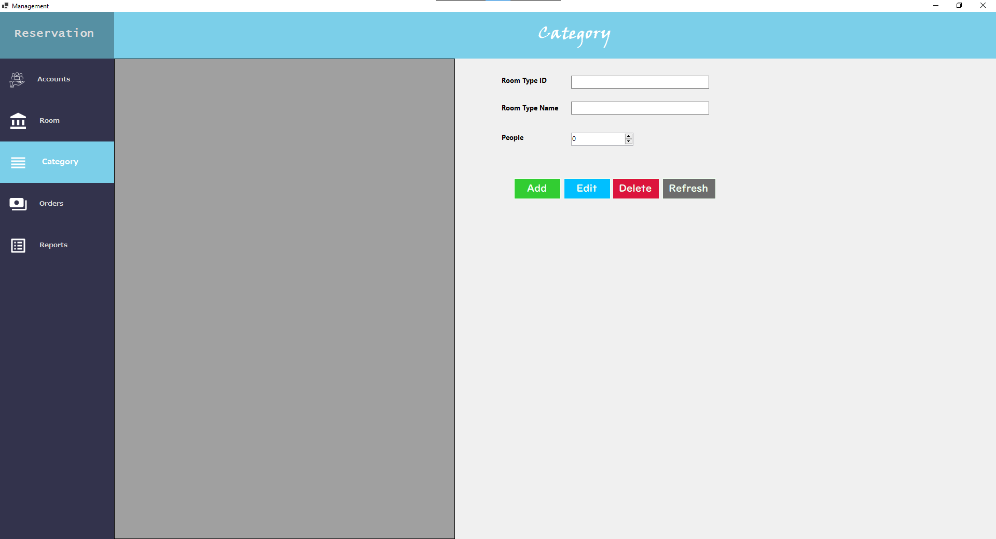

|  |  |  |  |  |  |
| --- | --- | --- | --- | --- | --- |
| **Name** | **Type** | **Event** | **Validation** | **Description** | **Status** |
| Room Type ID | TextBox |  | int, not null | Input id of room’s type |  |
| Room Type Name | TextBox |  | String, not null, | Input name of room’s type |  |
| People | Check Box |  | Stick | Limiting number of people in a room |  |
| Add | Button |  | Click | Add new room’s information |  |
| Edit | Button |  | Click | Edit room’s information |  |
| Delete | Button |  | Click | Delete room’s information |  |

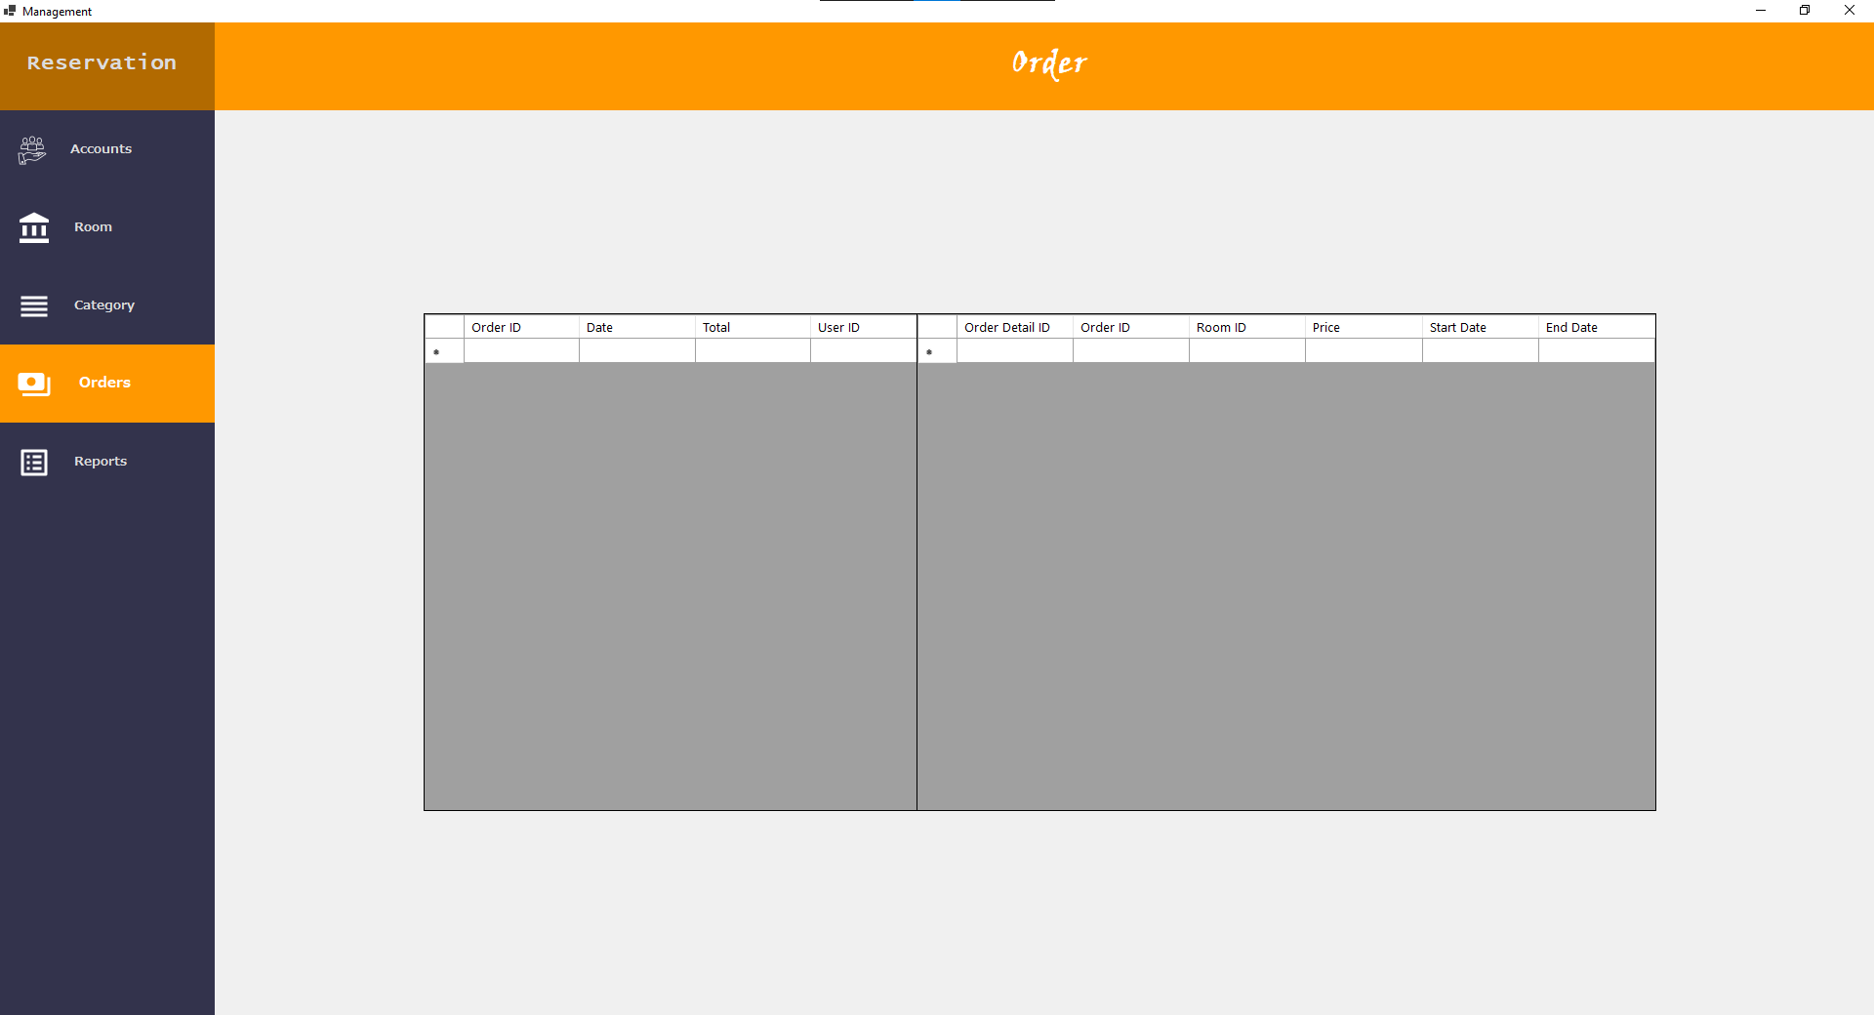

|  |  |  |  |  |  |
| --- | --- | --- | --- | --- | --- |
| **Name** | **Type** | **Event** | **Validation** | **Description** | **Status** |
| Table Order | DataGridView |  |  | Containing context of the bill |  |
| Date | DataGridView |  | Read Only |  |  |
| Total | DataGridView |  | Read Only |  |  |
| User ID | DataGridView |  | Read Only |  |  |
| Table Order Details | DataGridView |  |  | Containing details of the bill |  |
| Order Detail ID | DataGridView |  | Read Only |  |  |
| Order ID | DataGridView |  | Read Only |  |  |
| Room ID | DataGridView |  | Read Only |  |  |
| Price | DataGridView |  | Read Only |  |  |
| Start Date | DataGridView |  | Read Only |  |  |
| End Date | DataGridView |  | Read Only |  |  |

a